Employee Sentiment Analysis
Eisha Zahid

Summary
This report analyses 2191 workplace emails sent by 10 employees between January 2010 and December 2011. Messages were labelled for sentiment, gathered into monthly scores per employee, ranked each month, and screened for employees showing a pattern of negative messages – ‘flight risk’. A linear regression model was also tested to see whether monthly sentiment score can be predicted from basic communication behaviour.
Communication in this dataset skews positive overall, 69.6% of messages. Six of ten employees were flagged as potential flight risks, and the predictive model explained a moderate share of the variance in monthly score, R² = 0.670, driven mainly by how many messages an employee sends per month.

1. Approach and Methodology
Each email was scored with VADER, a lexicon-based sentiment analyser, with boundaries set as compound score ≥ 0.05 = Positive, ≤ -0.05 = Negative, otherwise Neutra. VADER was chosen for being fast, deterministic, and needing no training data. Though, as a bag-of-words method it struggles with sarcasm and the messy structure of forwarded email threads which common in this dataset. A transformer model would likely do better, but at the cost of transparency and speed.
Each label was converted to a score, Positive = +1, Negative = -1, Neutral = 0, and summed per employee, per calendar month, resetting monthly. Employees were then ranked each month into a Top 3, most positive, and Bottom 3, most negative, with ties broken alphabetically. ‘Flight risk’ was flagged when an employee sent 4 or more negative messages within any rolling 30-day window. Finally, a linear regression model was trained on employee-month rows to predict monthly score from message count and average message length - features chosen because they don't leak the sentiment labels themselves.

2. Key Findings from Exploratory Data Analysis
The dataset spans 24 months with no missing values. Message volume is fairly even across employees (lydia.delgado@enron.com and john.arnold@enron.com are the most active; rhonda.denton@enron.com and kayne.coulter@enron.com the least). 69.6% of messages are Positive, 23.2% Neutral, and 7.2% Negative - typical of workplace email, where polite and transactional language reads as mildly positive under VADER. Negative messages also tend to run noticeably longer than positive or neutral ones, consistent with people writing more when raising a problem.
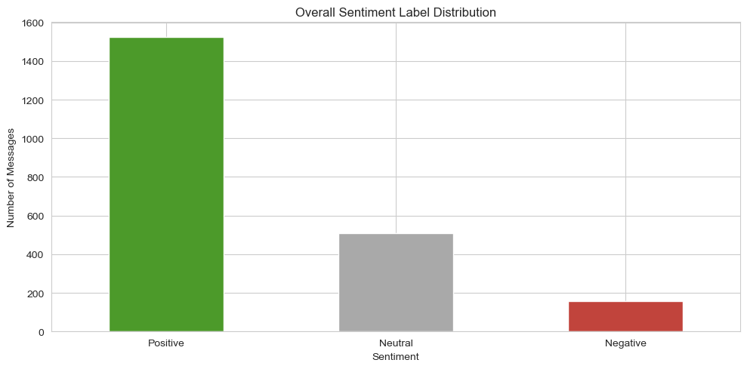
Figure 1. Overall sentiment distribution.
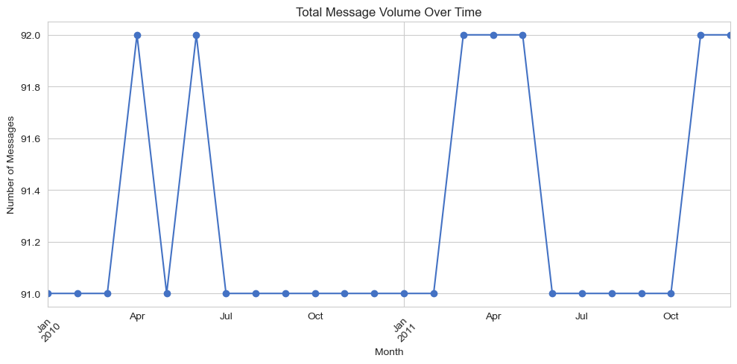
Figure 2. Message volume over time.
Message volume fluctuates month to month with no strong long-term trend, and the sentiment mix stays fairly stable across the two years, with Positive consistently dominant.

3. Employee Scoring and Ranking
Summing +1/0/-1 per employee per month produced 240 employee-month score records. Because the score is a running sum rather than an average, employees who send more messages naturally accumulate larger swings, which is something to keep in mind when comparing scores across employees with different volumes.
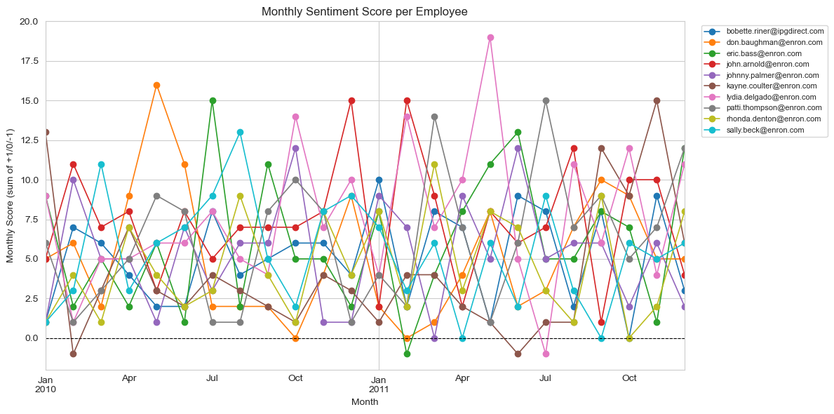
Figure 3. Monthly sentiment score per employee, Jan 2010 – Dec 2011.
Ranking each month by score, john.arnold@enron.com appears in the Top 3 most often with 13 of 24 months, while kayne.coulter@enron.com appears in the Bottom 3 most often with 12 of 24 months - suggesting kayne.coulter@enron.com's tone is the most consistently negative of the group.
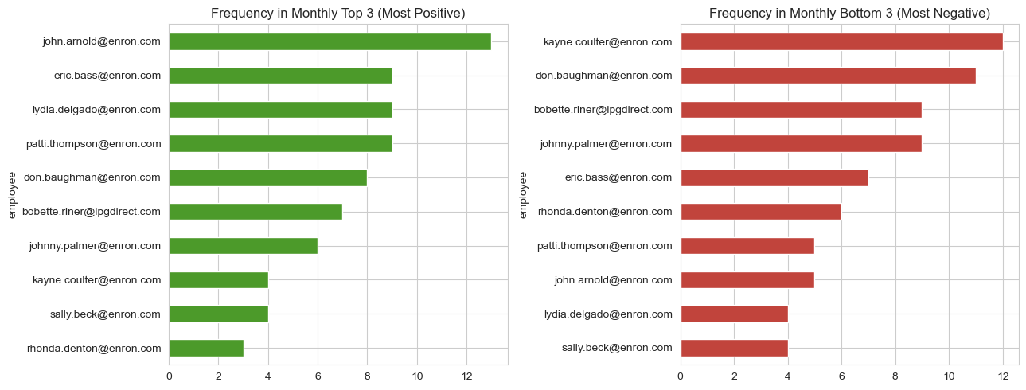
Figure 4. Frequency of appearing in the monthly Top 3 / Bottom 3.

4. Flight Risk Identification
An employee is flagged as a ‘flight risk’ if they send 4+ negative messages within any rolling 30-day window. Six employees crossed this threshold: bobette.riner@ipgdirect.com, don.baughman@enron.com, john.arnold@enron.com, johnny.palmer@enron.com, kayne.coulter@enron.com, and sally.beck@enron.com. Notably, sally.beck@enron.com crossed with the largest margin with 5 in one window, despite not being a frequent Bottom-3 member overall – ‘flight risk’ captures a short, concentrated burst of negativity, a different signal than the month's overall net tone.
Employee | Max Negative Msgs / 30-Day Window | Flight Risk
sally.beck@enron.com | 5 | Yes
bobette.riner@ipgdirect.com | 4 | Yes
don.baughman@enron.com | 4 | Yes
john.arnold@enron.com | 4 | Yes
johnny.palmer@enron.com | 4 | Yes
kayne.coulter@enron.com | 4 | Yes
lydia.delgado@enron.com | 3 | No
patti.thompson@enron.com | 3 | No
eric.bass@enron.com | 2 | No
rhonda.denton@enron.com | 2 | No

5. Predictive Model — Overview and Evaluation
A linear regression model predicts monthly sentiment score from message_count, avg_word_count, and avg_char_count, using an 80/20 train-test split and 240 employee-month rows. On the test set: R² = 0.670, MAE = 1.551, RMSE = 1.961. message_count is by far the strongest driver (coefficient +0.62) - employees who send more messages accumulate a larger score simply through volume, since score is a sum, not a rate. Message length contributes comparatively little (avg_word_count: +0.033, avg_char_count: -0.003).
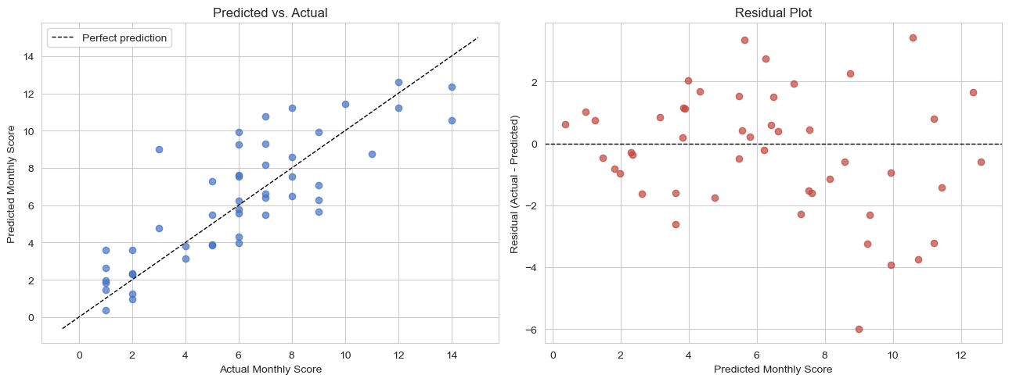
Figure 5. Predicted vs. actual score (left) and residuals (right) on the test set.
With only 10 employees across 24 months, this small sample limits how far the model can generalize - it's best read as a demonstration of approach rather than a production-ready predictor. Normalizing score by message count, adding lagged prior-month score, or trying a non-linear model are natural next steps with more data.

6. Conclusions and Limitations
- Sentiment skews strongly positive, consistent with typical workplace communication norms.
- john.arnold@enron.com trends most positive; kayne.coulter@enron.com trends most negative, across 24 months of rankings.
- 6 of 10 employees (60%) were flagged as ‘flight risks’.
- A message-volume-driven linear model explains a moderate share of score variance (R² = 0.670); richer features would likely improve it.
- VADER is a transparent starting point but struggles with sarcasm and forwarded-email structure; a transformer-based model is a natural next iteration.
- The dataset's small size (10 employees) limits statistical confidence — findings should be read as directional, not definitive.

