Design Plan: styles

High end fashion

Eishi Smith

CEGEP Heritage College

420-H10-HR: Web Programming

Marissa Cleroux

October 6th, 2023

Styles is a high end fashion brand that aims to rival the likes of COMME des GARCONS, vetements, Louis Vuitton and Gucci. We will sell things like quality graphic tees, accessories like hats, bags and shoes, pants and crewnecks.

The website’s purpose is to inform people about our brand’s values, story and to sell our products directly to consumers all over the world. As is the theme with most websites similar to this one, it will be very minimalistic and a bit artsy to entice the fashion world. There will be a main page, that will be highly stylized with the logo, a blue background, big, easy-to-read white text and the navigation. The second page will also be blue, but will feature a picture of where we started (in Tokyo) and text about our humble beginnings. The third page will be the products, cataloged and easy to find with a more light academia aesthetic to ease the eyes as when visiting my page, most of the user’s time will probably be spent on this page. The fourth page will be pictures of the staff with a description of each of their stories. It’s a small enterprise and I want to convey that with this picture. I would like the background colour to feel comfortable and will therefore use a dark, cool color, like purple black. We also have a single store, located in the heart of Shibuya, Tokyo. I will include directions and hours of operation in this page with a white patterned background in the fifth page. Lastly, the sixth page will be information on our social handles, personal and business and out upcoming events (if applicable) and a prompt to contact us directly through email or mobile. This is, of course, a high end brand so our target audience is the top of the fashion world, to be sold at designer stores.



I will be using these colours along with black and white.

Dark Blue : #071952

Dark Teal : #088395

Light Teal : #35A29F

Yellow : #F2F7A1

White : #FFF

Black : #000

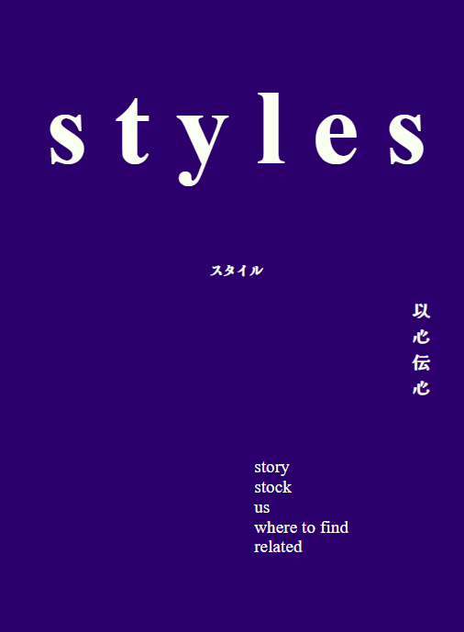

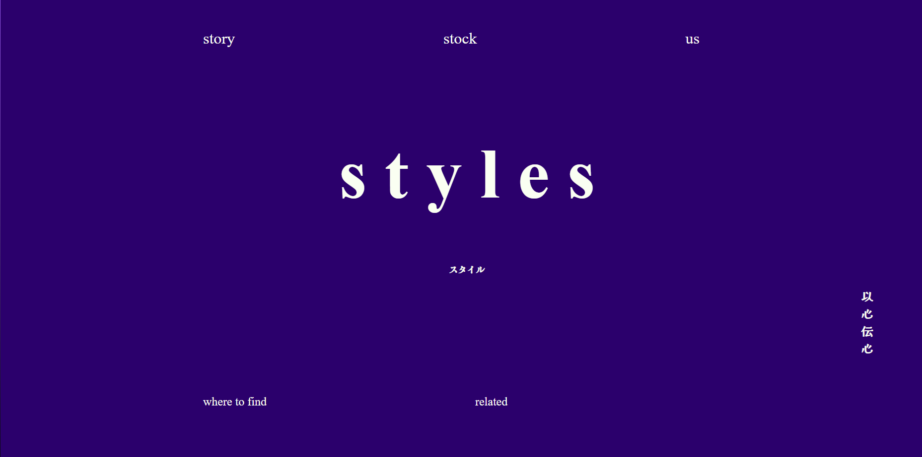

The styles text is my logo.