Running the Server
Run the server before running the client, as otherwise the client cannot connect to the server. Start the server by going to the <SERVER> directory and running the BW4TServer.bat file (Windows) or BW4TServer.sh.command (OSX). This should open the Server window (Figure 1). Note, this takes some time.

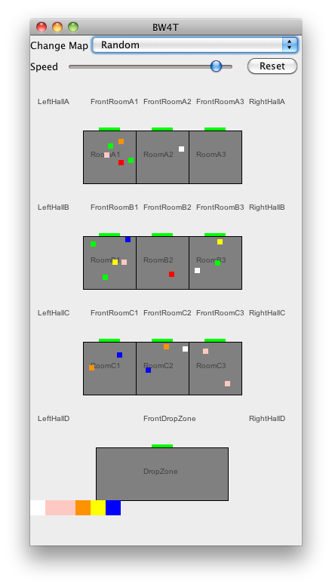
Illustration 1. Server window showing the actual state overview window of the Environment.

