Loading and creating new maps

Using the map editor
The Map Editor is a tool for editing maps for the BW4T server (Illustration 1). Double click the jar file <GOAL>/environments/BW4TServer/mapeditor.jar to start the map editor.
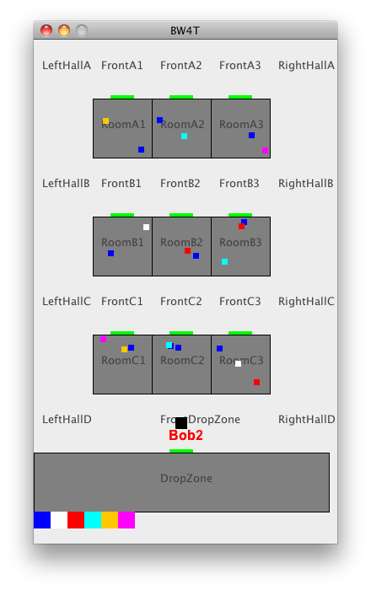 | 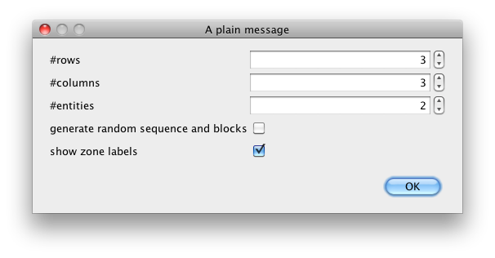
Illustration 1: A typical map as visualized by the server | Illustration 2: The map size dialog

After starting up, the map size dialog (Illustration 2) appears, which can be used as follows.
Enter the number of rows.
- Enter the number of columns.
- Enter the number of entities. This indicates the maximum number of bots that this environment can create. These can be either java-, goal- or humanbots. The entities will be named BotX where X runs from 1 to the number of entities you requested. They are all placed initially in front of the drop zone.
- Choose whether you want random goal sequence and block generation. If you check this box, the server will add a random goal sequence with 2/3*N blocks where N is the number of rooms on your map. It will also add 2.5*N blocks of random color to the rooms. In the random option, you can not edit any details on the map.
- Choose whether you want the zone labels to be visible in the server render window.
If you did not select 'generate random sequence and blocks', you proceed to the map editor page (Illustration 3).
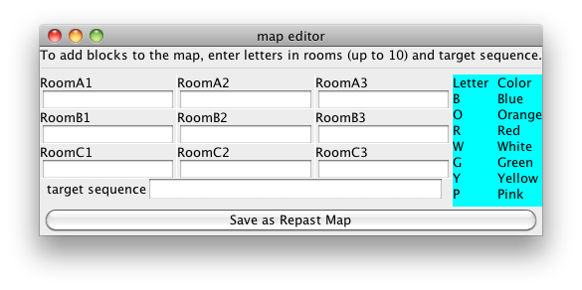Illustration 3: Map Editor

In the Map editor GUI () you can add blocks to rooms and to the target sequence. To add blocks to rooms, click in the text box under the room label and type one or more letters, where each letter represents a block of a particular color. To add blocks to the target sequence, type the letters of the colors you want to add in the target sequence text box. Do not type spaces between letters as every character is associated with one block. When you're done, press save.

Manual Editing
It is also possible to manually edit a map as it is a plain text XML file.

- Copy an existing map file in the <SERVER>/maps folder to a new file.
- Open the copied map with a text editor. You can then edit the colors in the rooms. Each <blocks>COL</blocks> line inside a <zones> of type ROOM adds another block to the room. The currently available colors are BLUE, ORANGE, RED, WHITE, GREEN, YELLOW AND PINK. A room has place for at most 10 blocks.
- You can change the number of rooms by adding or removing <zones> of type ROOM and position the rooms correctly on the map by editing the <x> <y> <width> and <height> inside the room's <boundingbox>. Also you need to add a <door> properly positioned on the border of the room.
- You can edit the goal sequence by adding <sequence> items to the map, with colors as mentioned above.
- You can prevent multiple entities to enter corridor zones by putting true in the item <oneBotPerCorridorZone> in the map.
- You can add entities to the environment by creating more <entities> items. Make sure they have a unique <name> and that their start position is in a different <zone> if you have <oneBotPerCorrridorZone> set to true.
- You can let the server pick a random sequence of a given length by setting the <randomSequence> to a positive value. These random blocks are added to the existing sequence items and the random blocks are placed randomly on the map.
- You can let the server pick random extra blocks to be placed in the rooms on the map by putting a positive number in the <randomBlocks> in the map. Note that this addition is on top of all blocks that are already placed in the map; so normally you leave the room zones empty when using this option.
- You can set per-zone visibility of the zone namelabel in the server map renderer, using a <renderOptions> <labelVisible> false </labelVisible> </renderOptions> block to disable visibility.
- Save the map in the <SERVER>/maps directory.
- Edit the map initialization parameter for the server to your new map file. See the section on customizing the server settings. If you now start the server and your new map should be loaded.

If you use oneBotPerCorridorZone, you should use attach all entities in the map to an agent. If you do not, the unused entities remain invisible inside the frontdropzone, blocking access to the dropzone for the other entities.

