

Blocks World For Teams using GOAL
Maaike Harbers, Wouter Pasman, Birna van Riemsdijk
September, 2013

Introduction
This document describes how to install Blocks World For Teams (BW4T) for use with GOAL. BW4T is a client-server system. The server is responsible for the administration, simulation and visualization of the virtual world: it keeps track of robots, rooms, blocks, connected GOAL agents, etc. The server uses Repast, software to simulate virtual environments, to do part of this administration. The client is GOAL, which runs a multi-agent system (MAS) and connects to the server. The agents in the GOAL client get percepts from the server, and send actions to the server. Client and server can run on a different computer. This document describes how to install the BW4T server, configure it, place the BW4T client in GOAL, configure the MAS file, and run the system.
We use the following names to refer to directories of BW4T:
- <GOAL> refers to the directory where you installed GOAL.
- <SERVER> refers to <GOAL>/environments/BW4T2/BW4TServer/.

System requirements
To use BW4T you need Java JDK 6 or higher. The BW4T2 environment has been tested on Windows 7 and OSX.

Installing the server
- Download and install Repast2.0 BETA from our mirror ii.tudelft.nl/repast.
- Install Repast in the default installation directory which is:
on Windows C:\RepastSimphony-2.0-beta and on OSX /Applications/Repast-Simphony-2.0.0-beta. If you choose to install it in another directory, see Custom server installation below (or make a link from the default install location).

Custom server installation
If you use a non-default install directory for Repast, you need to fix the server startup script as follows.
- Go to the <SERVER> directory and open the BW4TServer.bat (windows) or BW4TServer.sh.command (OSX) file in a text editor.
- Change the Repast variable to the directory that you installed Repast in.
- Save your changes

Running the Server
Run the server before running the client, as otherwise the client cannot connect to the server. Start the server by going to the <SERVER> directory and running the BW4TServer.bat file (Windows) or BW4TServer.sh.command (OSX). This should open the Server window (Figure 1). Note, this takes some time.

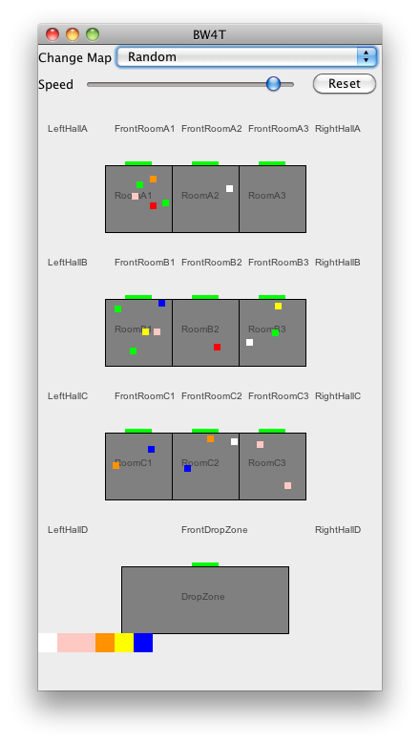
Illustration 1. Server window showing the actual state overview window of the Environment.

Running the Client
Before running the client, make sure that the server is running (see above).
- Start GOAL.
- Open the bw4t2.mas2g located in <GOAL>/GOALagents/BW4T2
- Run the bw4t2.mas2g file in GOAL to create the agents in correspondence with the specification in the mas2g file.
- Start (un-pause) the agents by again pressing the run button in GOAL.
Note that the server shows only connected entities, so the bots only appear after the GOAL MAS has been started (See Illustration 2).
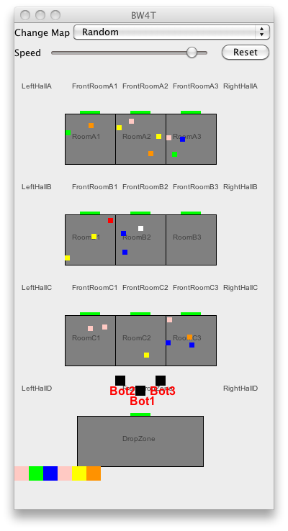
Illustration 2: Bots are shown only after the entities have been connected to GOAL agents.

Restarting, pausing and resuming the system
To pause the system, select the entire MAS in GOAL, and press the pause button. To resume, select the MAS in GOAL and press run. You can also run and pause environment or agents individually but of course you can get errors if the agents run while the environment is paused so this is not recommended.
To restart the system, do the following
- In GOAL, kill the MAS by selecting the MAS and pressing .
- In Repast, Press Reset, or choose a new map from the Change Map menu.
- Run the MAS in GOAL as described above.

