Running the Client
Before running the client, make sure that the server is running (see above).
- Start GOAL.
- Open the bw4t2.mas2g located in <GOAL>/GOALagents/BW4T2
- Run the bw4t2.mas2g file in GOAL to create the agents in correspondence with the specification in the mas2g file.
- Start (un-pause) the agents by again pressing the run button in GOAL.
Note that the server shows only connected entities, so the bots only appear after the GOAL MAS has been started (See Illustration 1).
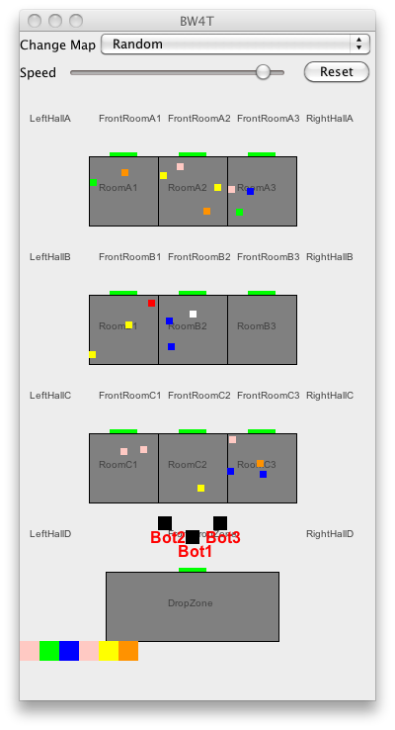
Illustration 1: Bots are shown only after the entities have been connected to GOAL agents.

