Human Interface
BW4T bots can also be controlled by humans instead of agents. Figure 1 shows a screenshot of the user interface (GUI) that enables humans to control a bot. Whereas the Server interface shows the positions of all bots and all blocks (Figure 2), the human GUI only shows the bot's own position and the blocks in the room where the bot is in.

The human interface has, from top to bottom, the following four areas:
- the button area showing bot buttons having the names of the other bots and an 'all' button
- the map area showing the rooms, hallways and drop zone,
- a row of blocks showing the current state of the sequence
- a chat area showing exchanged text messages.

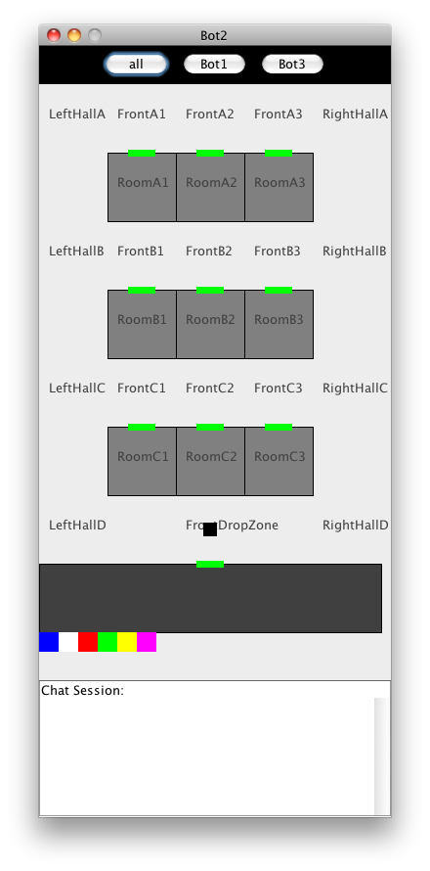 | 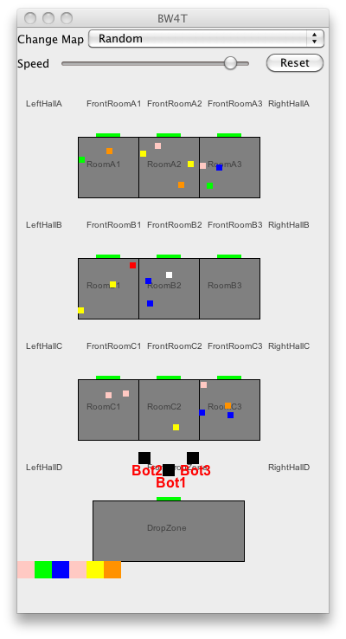
Illustration1: Human User Interface | Illustration 2: Server Interface

Enable Human Interface(s)
The simple way to start a humanbot is to load and run the provided bw4thuman.mas2g.
To add a humanbot manually to an already existing MAS, you need to enable one or more human interfaces, as follows:
- Modify the humancount parameter in the mas2g file. Check the advanced run settings of the GOAL instructions document for details.
- Set the launchgui parameter in the mas2g file true. Check the advanced run settings of the GOAL instructions document for details.
- Ensure that the humanbot.goal, message.mod2g and messageTranslation.pl files are in your project folder.
- Add the line “humanbot.goal”. to the agentfiles section in your mas.
- Add the line “when [type=human,max=1]@env do launch *:humanbot” to the launchpolicy section of the mas2g file. Note that in order for the humanbot.goal program to work correctly, your agents should get the same name as the EIS entities. The '*' in this mas line ensures this.

Usage
To use the interface, the user clicks with the left (occasionally the right) mouse button in the GUI. Depending on where the user clicks, different menus appear. The user then picks the appropriate action from the menu to execute that action. Below the possibilities are explained.

Click on bot buttons
By clicking on a bot button, the user can send a request or question to that bot, or to all bots if the 'all' button is used. Typical requests are to go to a room or to find a particular color. Typical questions are how far the bot is from completing the request.

Click on room or dropzone
By clicking on a room, the user can order his bot to go to that room, tell everybody something about that room or ask something about that room.

Click on blocks
By clicking on a block (particularly, those below the drop zone), the user can tell everybody something about that block, or ask others for information about that block.

Click on hallway
By clicking on a hallway, the user can point to an exact (X,Y) location to go to. Also it is possible to tell all others roughly where one is in the hallway.

Click on chat area
Clicking on the chat area gives a number of standard answers: yes, no, don't know, ok, etc. It is not possible to use free text because the non-human agents can only process these pre-specified messages. The specification document gives more details on how messages are processed by non-human agents.

