Human Interface
BW4T bots can also be controlled by humans instead of agents. Figure 1 shows a screenshot of the user interface (GUI) that enables humans to control a bot. Whereas the Server interface shows the positions of all bots and all blocks (Figure 2), the human GUI only shows the bot's own position and the blocks in the room where the bot is in.

The human interface has, from top to bottom, the following four areas:
- the button area showing bot buttons having the names of the other bots and an 'all' button
- the map area showing the rooms, hallways and drop zone,
- a row of blocks showing the current state of the sequence
- a chat area showing exchanged text messages.

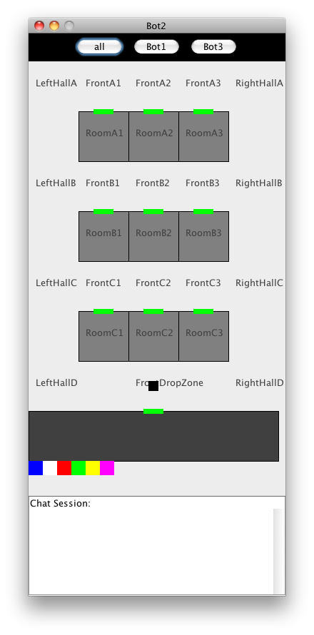 | 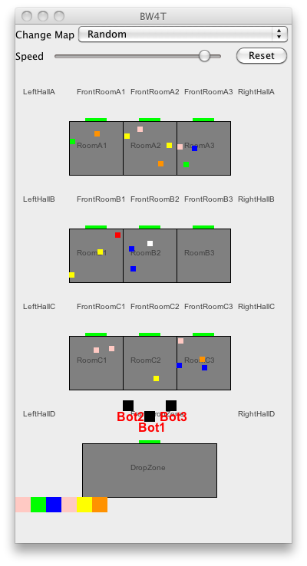
Illustration 1: Human User Interface | Illustration 2: Server Interface

