Training Journal App
  - PRODUCT CONCEPT & INITIAL DEVELOPMENT BRIEF | October 2026
Purpose: Share the overall vision and a practical first-version scope with a developer. This is a discussion draft, not a final technical specification.

1. Product vision
A minimalist, mobile-first strength-training journal that feels as easy to use as Apple Notes but includes structured exercise logging, optional 1RM-based load calculations, training history, and lightweight coaching tools. The same app should support someone programming for themselves and a coach assigning workouts to clients.
Guiding idea: A workout is a customizable page—not a rigid form. Keep writing and training friction low.

2. Design and navigation
- Minimal home screen with four destinations: Current Workouts; Workout History; Exercise Database; Progress Tracker.
- Separate Personal and Coaching contexts, ideally via a simple toggle. Personal mode should remain uncluttered even when coaching features exist.
- A prominent + action to create a workout. Clear typography, little visual noise, and phone-friendly controls.
- Workout pages use collapsible blocks. Show a one-line summary while collapsed; tap to edit or log details. Support reordering blocks.

3. Modular workout editor
Each workout is built from insertable blocks using a (+) menu:
- Text / notes: Free-form warm-ups, exercise instructions, coaching cues and session notes.
- Exercise: Sets, reps and loads, with optional percent-of-1RM fields on a per-set basis.
- Later block types: Timers, supersets/circuits and conditioning intervals can follow after the core editor works well.
Use Edit mode to build workouts and Train mode to record actual completion. Prescribed weight and actual performed weight/reps should be distinct so clients can deviate from the plan without erasing it.

4. Exercise database and calculation rules
- One exercise database, with optional 1RM/training-max data for major compound lifts. Accessory exercises use straightforward weight-and-reps logging; percentages must never be mandatory.
- For percentage-based sets: prescribed load = selected 1RM or training max × set-specific percentage, rounded to a configurable equipment increment (e.g., nearest 5 lb). A workout can mix percentage-based and manually prescribed sets.
- Track all completed sets, then show “last performed” (weight × reps) and “heaviest recorded” (weight × reps) in the exercise card. Tapping history opens past sessions.
- Store each client’s 1RM and training history independently. Updates to maxes affect future prescriptions but must not retroactively alter completed sessions.
- Exercise identity, units (lb/kg), per-hand versus total dumbbell loading, and rounding conventions should be agreed during implementation.

5. Coaching experience
Coaching mode adds a client list, client profiles, shared workout templates, assignments and client progress. Keep it an extension of the journal rather than a separate complicated dashboard.
- Coach writes one workout or week in a template library.
- Coach selects one or several clients, optionally selects a prescribed date, and assigns the template.
- Each client sees the assigned workout under Current Workouts with loads calculated from their own 1RM/training max.
- Client independently logs sets/reps/weights; coach can review completed sessions and historical performance.
- Edits or logs in a client’s copy do not modify the master template or another client’s assignment.

6. Progress tracker
Keep v1 lightweight: simple exercise-specific timelines of recorded load/reps, changes in stored or estimated 1RM where relevant, and a count of completed sessions over time. Avoid advanced analytics initially.

7. Suggested first version (MVP)
Include in initial build | Defer until later
Four-section home screen; Personal/Coaching toggle | Payments, messaging and appointment scheduling
Modular text + collapsible exercise blocks; reorder and duplicate | Advanced timer, circuit and superset builders
Editable sets/reps/weights; optional per-set percentages | Complex periodization automation
Exercise history, last and best recorded performance | Rich performance dashboards and wearables
Reusable templates, client accounts and workout assignment | Marketplace, nutrition and social features
Client logging, coach review, basic progress charts | Multiple organizations / advanced team administration

8. Important technical behaviors
- Protect client data through authenticated accounts and permissions: coaches should access only their own clients; clients only their own workouts and data.
- Save assignments as client-specific instances linked to a template, with versioning/snapshots sufficient to preserve completed-workout history.
- Support drafts, completion status, dates, and durable data storage. Plan for offline logging/sync conflicts if that is an early product requirement.
- Distinguish planned versus actual load; preserve historical records when maxes or templates change.
- Design reusable data models for exercises, training maxes, sets, workout blocks, templates, assignments and completed sessions.

9. Example workflow
Coach creates “Upper Body A”: a text warm-up, Bench Press (8 @ 60%, 5 @ 75%, 3 @ 85%), Dumbbell Row (3 × 10, manually selected load), and coaching notes. The workout looks like four compact blocks on the page. The coach assigns it to two clients. Their bench loads calculate from their respective stored maxes. Each client expands an exercise to log actual results; the coach reviews both sessions afterward.

10. Questions to settle with developer
- Platform for v1 (iPhone only, cross-platform mobile, or mobile-friendly web app)?
- How will clients join a coach (invitation, code, email), and can a client also use Personal mode?
- Will assigned workouts need to function offline from day one?
- Should the same exercise support both manual and percentage-based sets in one block? (Recommended: yes.)
- What is the expected budget, timeline, ongoing hosting cost, and maintenance ownership?
- Who owns the source code, design, intellectual property and access to production infrastructure?
Priority: Prove the journal editor + exercise history + single-coach/client assignment flow before adding broader fitness-business features.

Visual design appendix
Conceptual mobile-screen mockups based on our discussions. These illustrate layout and behavior, not final branding or working app screens.

1. Minimal home screen
Four clear destinations, with a prominent new-workout action.
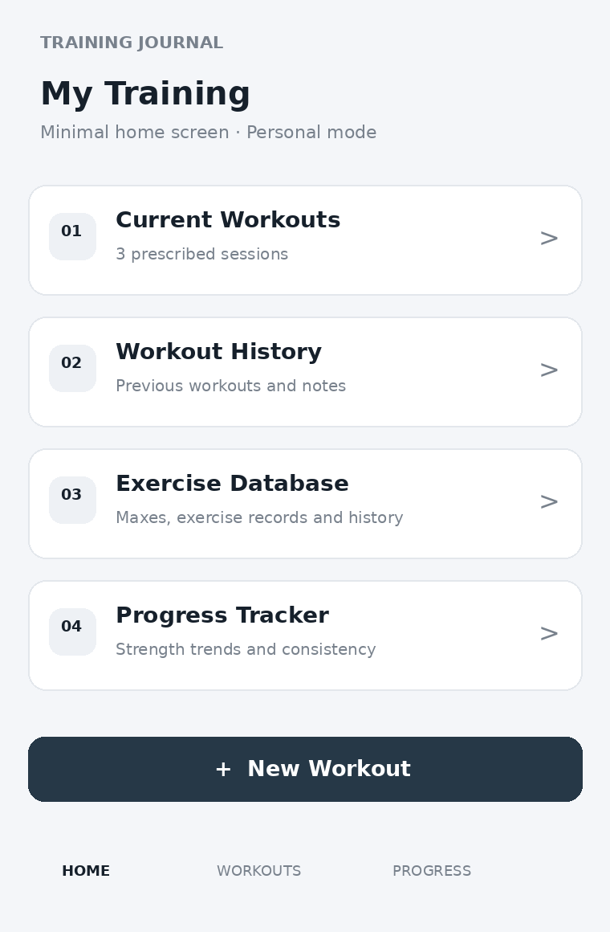
Illustrative wireframe · not to scale

2. Collapsed workout journal
Compact exercise cards plus free-form text blocks keep the page uncluttered.
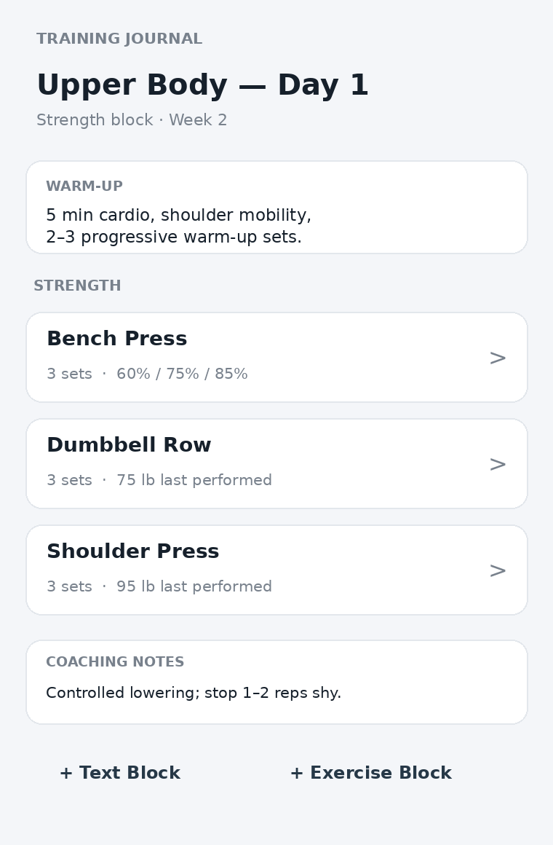
Illustrative wireframe · not to scale

3. Expanded exercise block
Each set can have its own reps and 1RM percentage; load is calculated automatically.
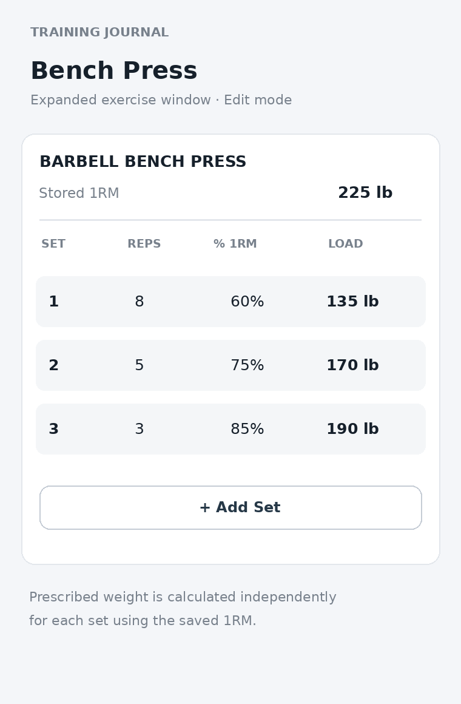
Illustrative wireframe · not to scale

4. Coaching assignment
The coach selects a shared template and multiple clients; load is personalized per client.
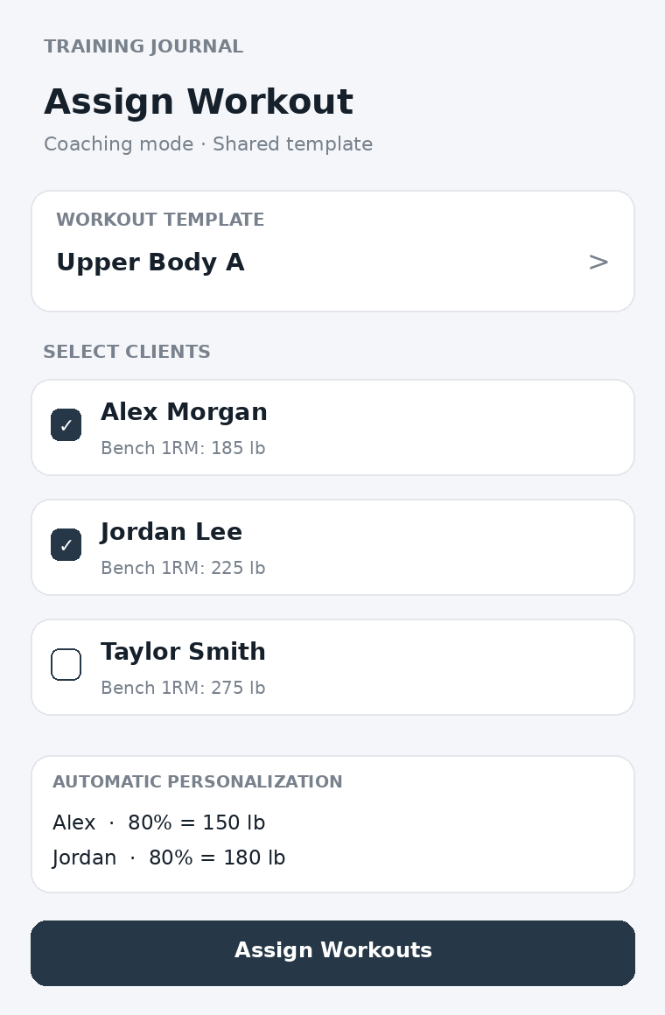
Illustrative wireframe · not to scale

