Glamoré
  - Cosmetics Retail Database and Application

DATABASE MANAGEMENT SYSTEMS II
Final Project: Enterprise Database Application Development Using Oracle APEX
Prepared by:
Ei Thinzar Naing (2310060002)
Sitt Min Pyae Sone (2408270004)
Lecturer: Ajarn Shvura
Submission date: 9 Oct 2026

Abstract
Glamoré is a database application developed to support the daily operations of a cosmetics retail business. The system manages products, brands, categories, customers, orders, order details, payments, delivery services, stock managers, and stock transactions. These ten related tables provide a structured way to store and manage retail information and support useful queries and reports.
The application is developed using Oracle APEX, providing a user-friendly interface with a beauty-themed design. Oracle SQL is used to create and define the database tables, relationships, constraints, and data, as well as to support the ER diagram.
The project demonstrates important database concepts, including table relationships, normalization, SQL queries, data manipulation, and transaction control. The current prototype uses manual product stock updates. This report presents the system design, implementation, application features, and testing status.

Business Problem and System Description
1.1 Business Problem
A cosmetics retail business needs to manage a large amount of information, including products, brands, customers, orders, payments, deliveries, and stock. Managing this information manually can make it difficult to keep records organized and can lead to duplicating or inconsistent data. It can also make it harder to track customer orders, product availability, and stock transactions.

1.2 Need for a Database
A database is needed to store the business information in a structured and organized way. By using related tables, information can be stored separately while still being connected through primary and foreign keys. This makes it easier to add, update, search, and retrieve information while reducing unnecessary duplication.

1.3 Glamoré System
Glamoré is a cosmetics retail database application developed using Oracle APEX. The application provides a user-friendly interface for managing and viewing retail information. Users can interact with the database through forms, reports, editable grids, dashboards, and charts.

1.4 Main Information Managed
The system manages ten main areas of the business:
- Customers – customer details and contact information.
- Orders – customer order information.
- Order Details – products and quantities included in each order.
- Products – cosmetic products, prices, brands, categories, and stock quantities.
- Categories – product categories.
- Brands – brand information.
- Stock Managers – information about employees managing stock.
- Stock Transactions – records of stock movements.
- Payments – payment information for orders.
- Delivery Services – delivery company and service information.

Entity Relationship Diagram and Major Relationships

The ER diagram shows the ten tables in the Glamoré database and how they are connected through primary and foreign keys.
The major relationships are:
- 1:N: Customers → Orders
- 1:N: Delivery Services → Orders
- 1:N: Orders → Order Details
- 1:N: Products → Order Details
- 1:N: Brands → Products
- 1:N: Categories → Products
- 1:N: Stock Managers → Stock Transactions
- 1:N: Products → Stock Transactions
- 1:1: Orders → Payments
- M:N: Orders ↔ Order Details ↔ Products
These relationships allow the database to organize customer orders, products, payments, deliveries, and stock information while reducing unnecessary duplication.
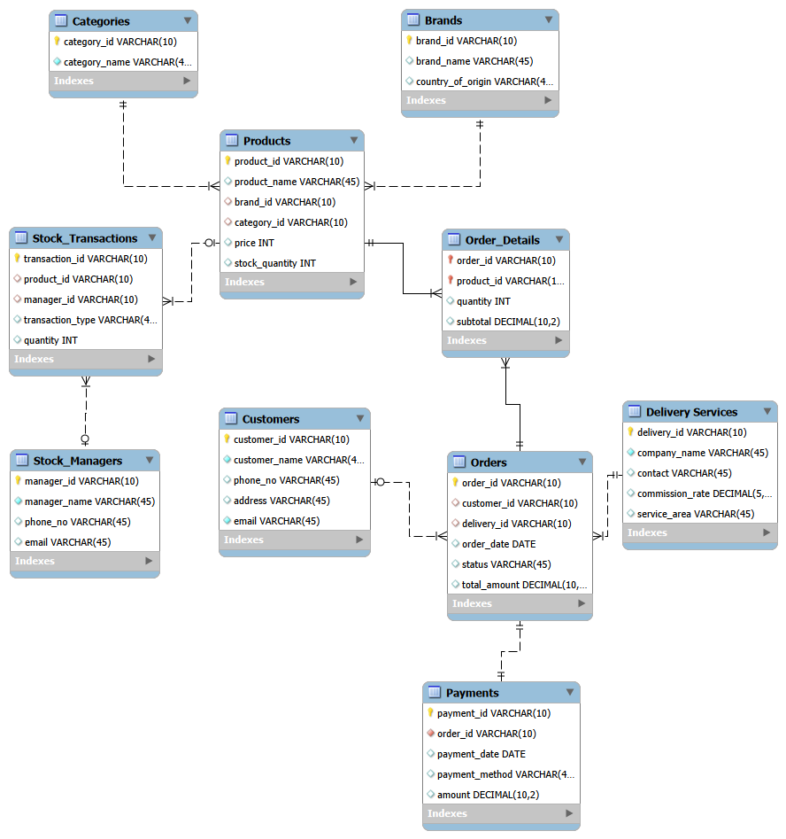
Fig 1: Entity Relationship Diagram of Glamoré

Normalization

The Glamoré database is designed to satisfy Third Normal Form (3NF) by organizing data into separate related tables and reducing unnecessary duplication.
- 1NF: Each table contains atomic values, and each record can be uniquely identified by a primary key.
- 2NF: All non-key attributes depend on the entire primary key. Related information is separated into appropriate tables, such as Products, Brands, and Categories.
- 3NF: Non-key attributes depend only on the primary key and not on other non-key attributes. For example, brand information is stored in the Brands table instead of being repeated in the Products table.
Therefore, the database structure reduces data duplication and helps maintain consistency while allowing the tables to be connected through foreign keys.

Table, Constraint Summary and Sample Data

The Glamoré database consists of ten related tables designed to organize the main information of the cosmetics retail business. These tables are Customers, Orders, Order Details, Products, Categories, Brands, Stock Managers, Stock Transactions, Payments, and Delivery Services. Each table has a specific purpose and stores information related to one part of the business.
Primary keys are used to uniquely identify each record in a table. Foreign keys are used to connect related tables and maintain relationships between the data. For example, the customer_id in the Orders table connects each order to a customer, while the product_id in Order Details connects an ordered product to the Products table. These constraints help maintain data consistency and prevent invalid relationships between records.

Constraint type | Where it is applied
PRIMARY KEY | Every table & Order_Details uses a composite key (Order_ID, Product_ID)
FOREIGN KEY | Products → Brands, Categories; Orders → Customers, Delivery_Services; Order_Details → Orders, Products; Stock_Transactions → Products, Stock_Managers; Payment → Orders
NOT NULL | Required identifiers, names, dates, quantities and amounts
UNIQUE | Category name, brand name, and Payment.Order_ID (one payment per order)
DEFAULT | Products.Price (0.00), Orders.Status (Pending), Orders.Total_Amount (0.00)
CHECK | Non-negative price, stock and order total; positive whole-number quantities; positive payment amount; commission rate between 0 and 1; valid order status (Pending, Completed, Shipped, Cancelled); valid stock movement type (IN, OUT)
ON DELETE CASCADE | Order_Details.Order_ID, so the line items of a deleted order are removed with it

The sample data was created to represent a realistic cosmetics retail business. It includes different customers, cosmetic products, brands, categories, orders, order details, payments, delivery services, stock managers, and stock transactions. The products include different types of beauty items such as skincare, makeup, perfume, and beauty accessories.
The sample data also includes multiple orders and products so that the relationships between customers, orders, and products can be demonstrated. Payment and delivery records are connected to the appropriate orders, while stock transactions are connected to products and stock managers. Overall, the sample data provides enough realistic information to demonstrate the database structure and test the main functions of the Glamoré Oracle APEX application.

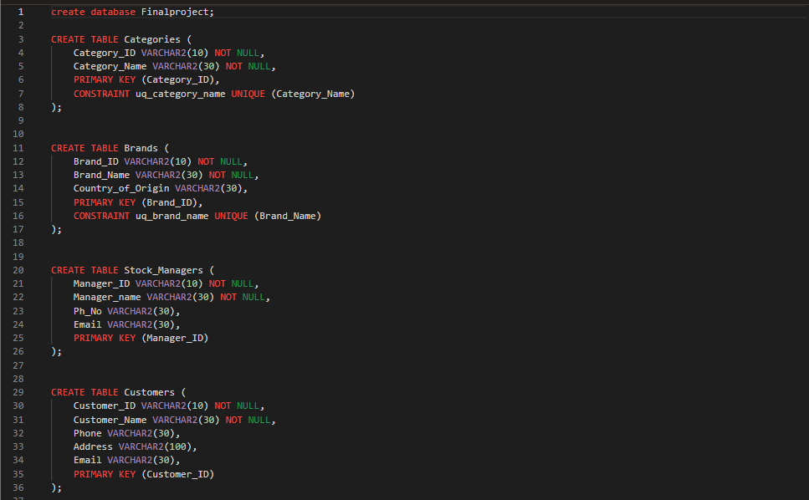
Figure 2: Table creation script: Categories, Brands, Stock_Managers and Customers

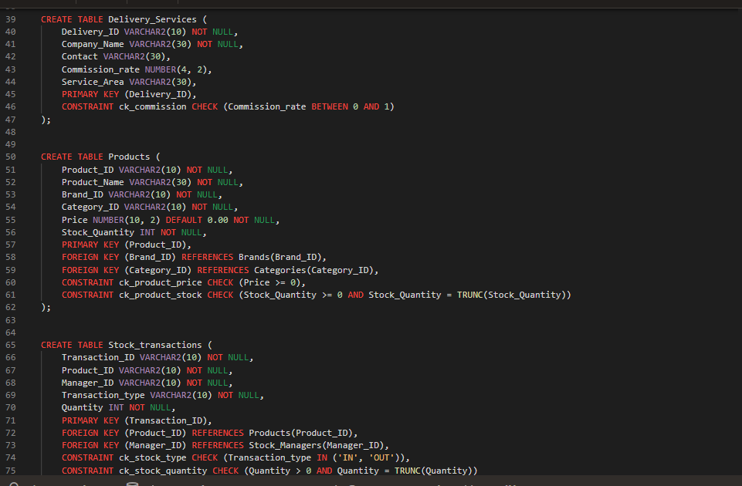
Figure 3: Table creation script: Delivery_Services, Products and Stock_Transactions

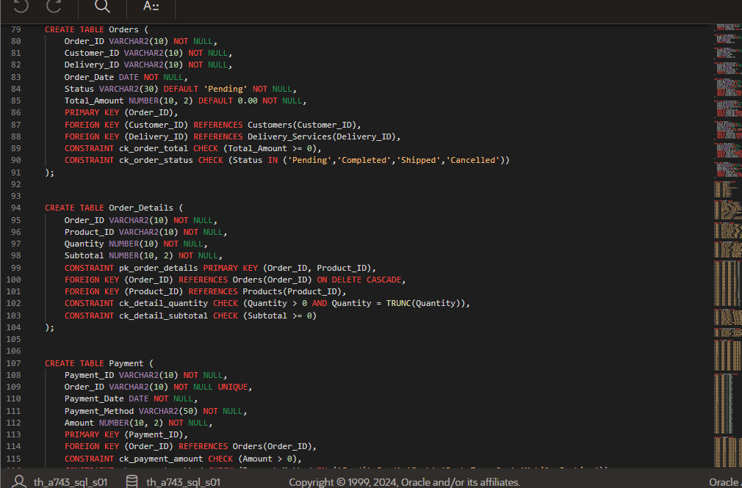
Figure 4: Table creation script: Orders, Order_Details and Payment

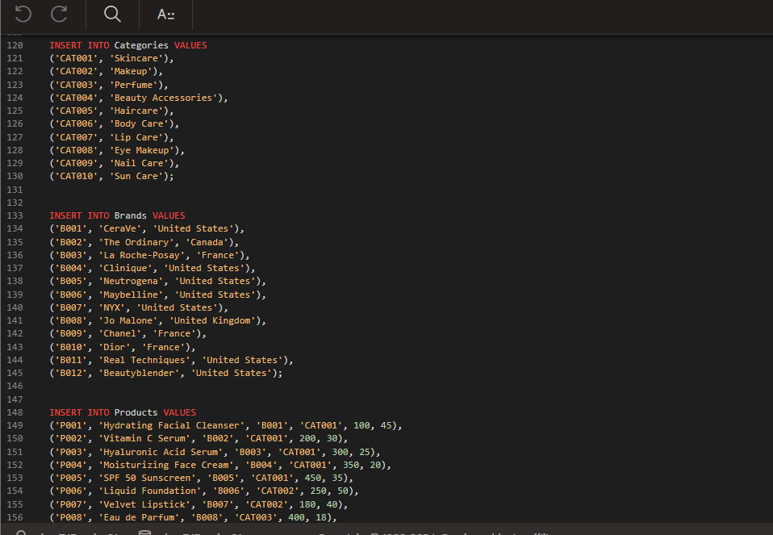
Figure 5: Sample data: Categories, Brands and Products (start)

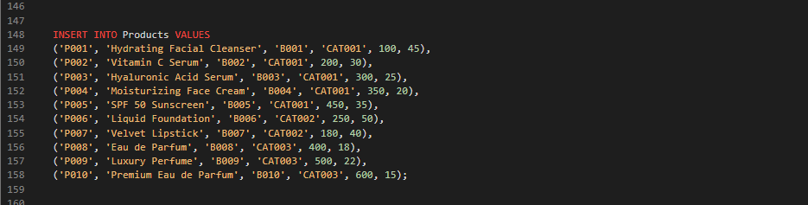
Figure 6: Sample data: Products

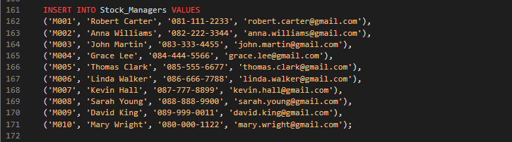
Figure 7: Sample data: Stock_Managers

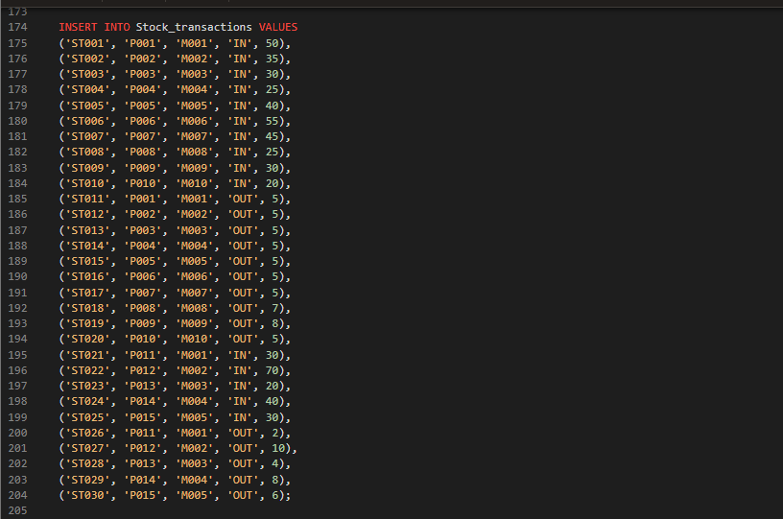
Figure 8: Sample data: Stock_Transactions

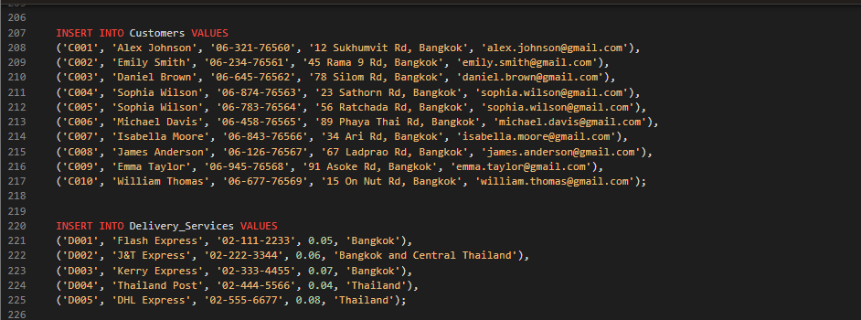
Figure 9: Sample data: Customers and Delivery_Services

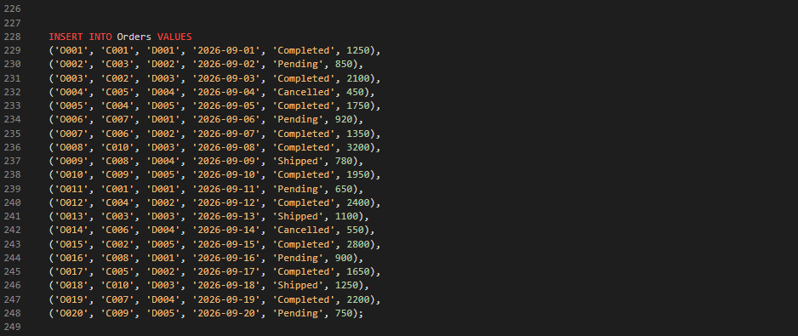
Figure 10: Sample data: Orders

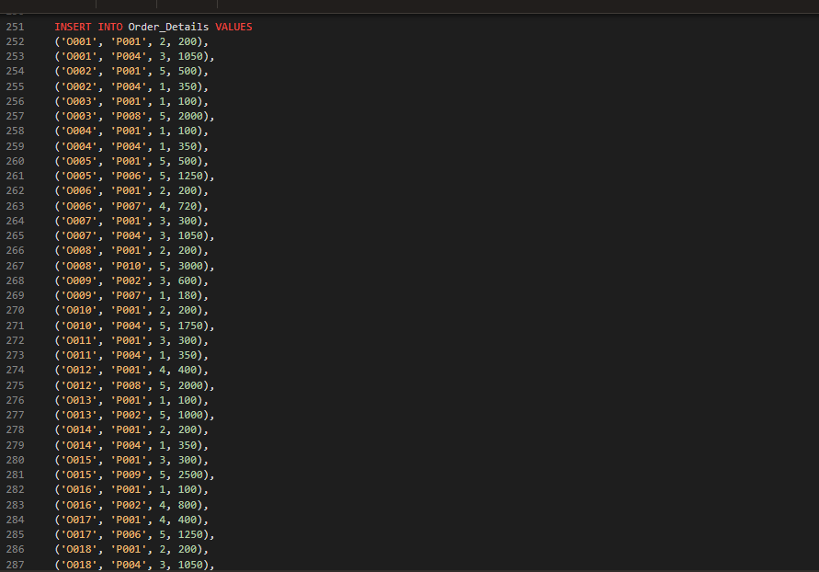
Figure 11: Sample data: Order_Details

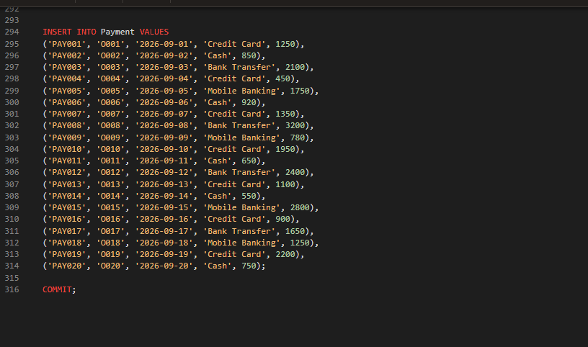
Figure 12: Sample data: Payment and COMMIT

SQL Queries, Views, Transactions and Security
5.1 SQL Queries
The Glamoré database uses SQL to manage, retrieve, and manipulate the information stored in the database. SQL queries are used to retrieve specific information from the tables and to support common business operations. For example, queries can be used to display customer information, find products based on their category or brand, view customer orders, calculate order totals, and retrieve stock transaction information. These queries allow the system to obtain useful information from the related tables without changing the original data.
SQL queries can also use operations such as SELECT, INSERT, UPDATE, and DELETE to manage database records. SELECT is used to retrieve data, while INSERT adds new records to a table. UPDATE is used when existing information needs to be changed and DELETE removes records when they are no longer required. Conditions, sorting, grouping, and joining can be used to make the queries more useful and to retrieve information from multiple related tables.
The queries used in the project are shown below. Each figure states the purpose of the query and its result.
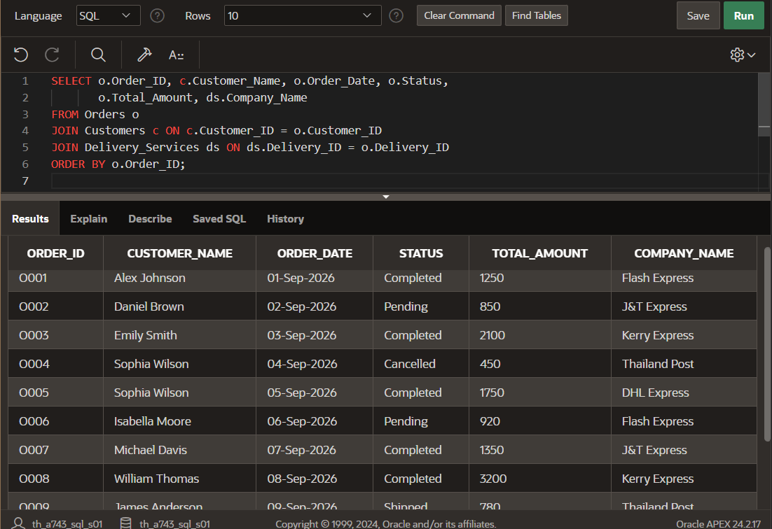
Figure 13: Multi-table JOIN: lists each order with its customer name and delivery company (Orders, Customers, Delivery_Services).
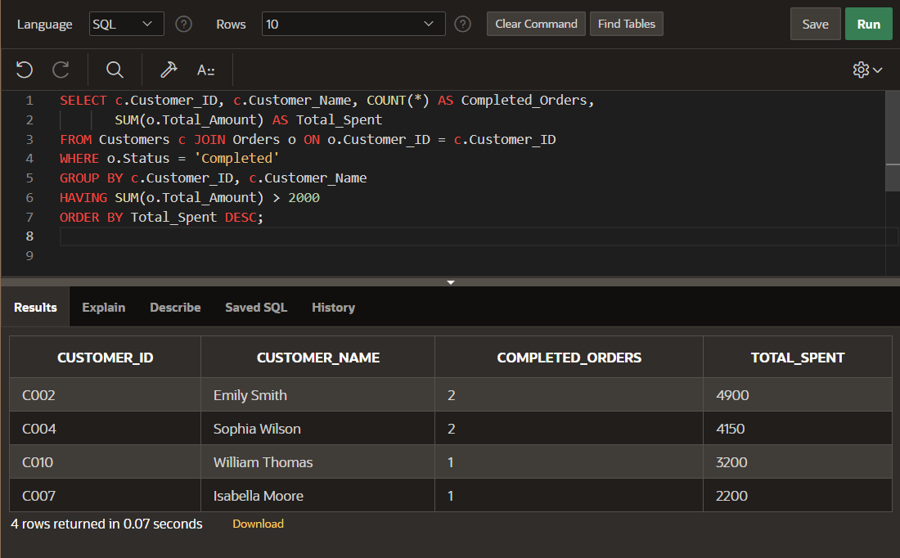
Figure 14: GROUP BY with HAVING: customers whose completed orders total more than 2,000. The query returns 4 rows.
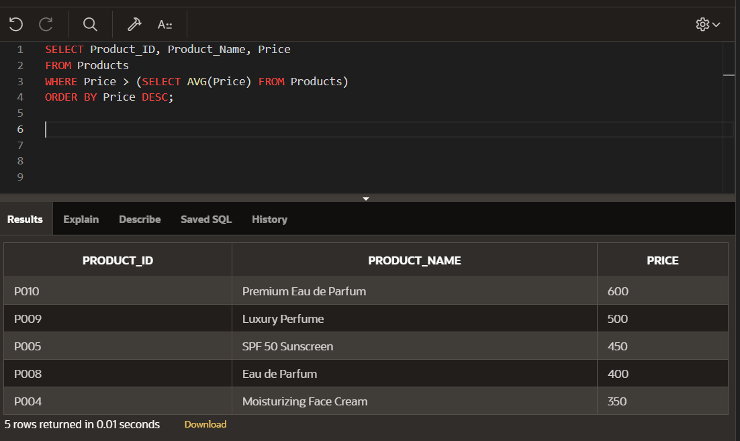
Figure 15: Subquery in the WHERE clause: products priced above the average product price. The query returns 5 rows.
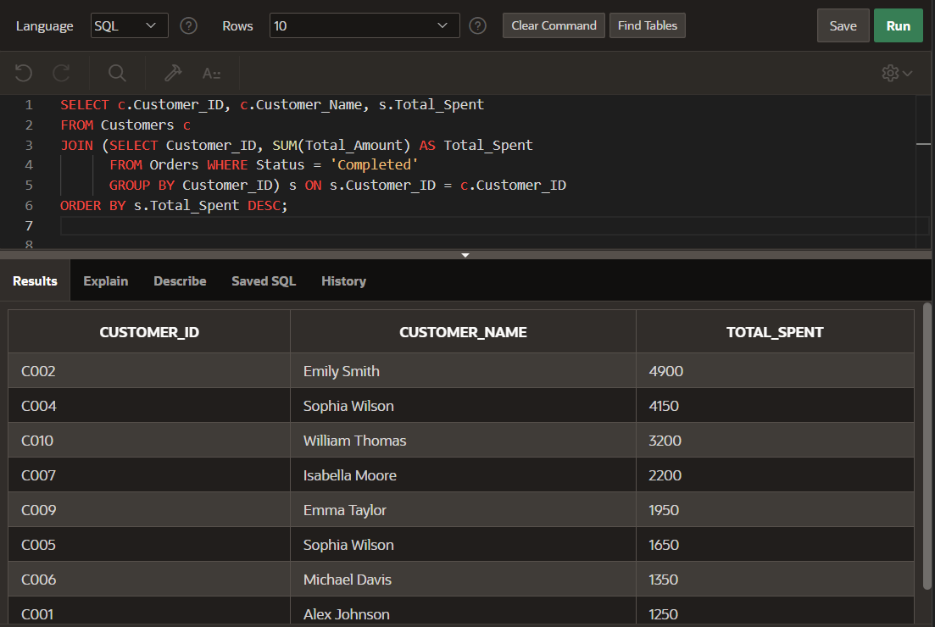
Figure 16: Subquery in the FROM clause: each customer’s total spending on completed orders is calculated in an inline view and joined back to Customers.

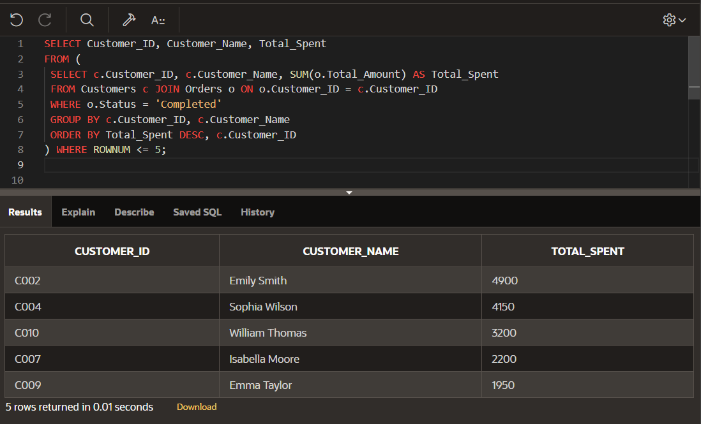
Figure 17: Top-N query using an inline subquery and ROWNUM: the five highest-spending customers.

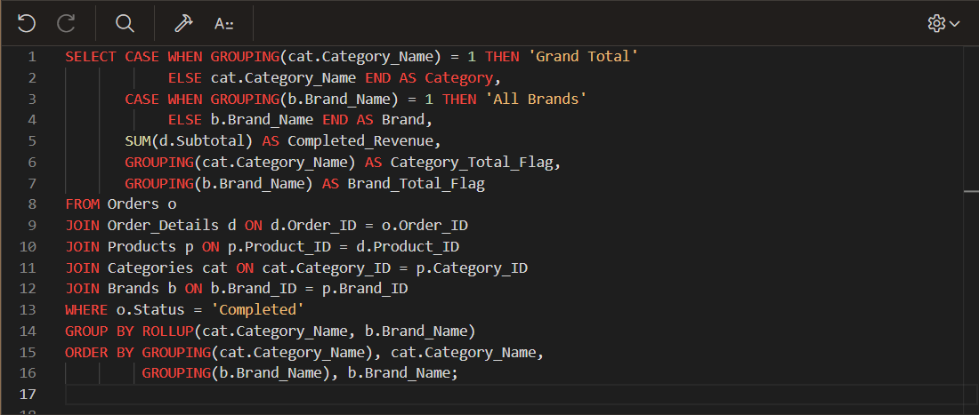
Figure 18: ROLLUP with GROUPING( ): completed revenue by category and brand, with category subtotals and a grand total (query).

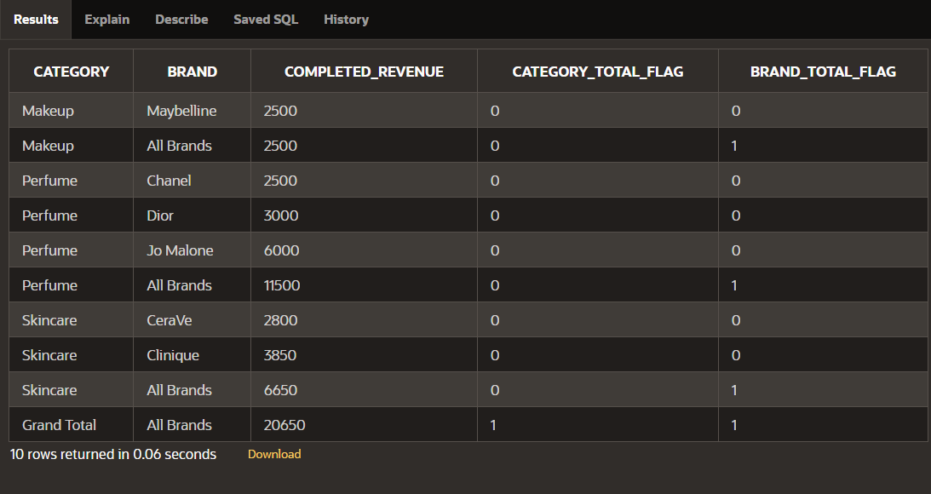
Figure 19: ROLLUP with GROUPING( ): result showing subtotals and the grand total of 20,650; the GROUPING flags mark the subtotal rows.

5.2 Views
Views can be used to provide a simplified way of displaying information from multiple related tables. Instead of repeatedly writing a complex query, a view can store the query definition and allow the required information to be accessed more easily. For the Glamoré system, views can be used to combine information such as customers and their orders, products with their brands and categories, or orders with payment information. This makes commonly required information easier to retrieve while keeping the original tables organized.
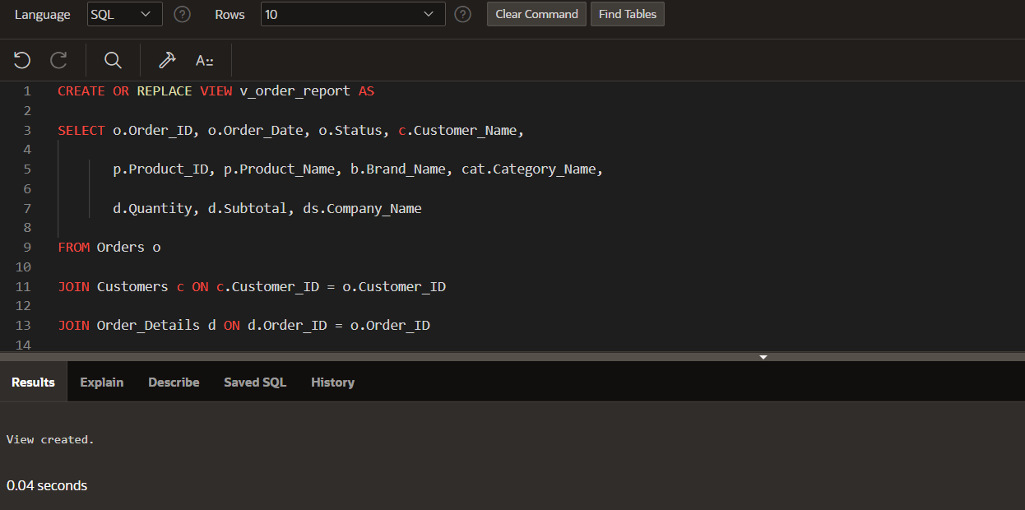
Figure 20: View V_ORDER_REPORT (multi-table view): joins Orders, Customers, Order_Details, Products, Brands, Categories and Delivery_Services.
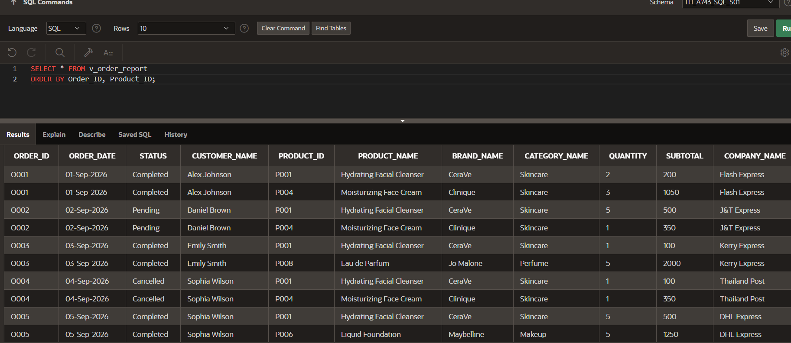
Figure 21: Output of V_ORDER_REPORT, ordered by order and product.
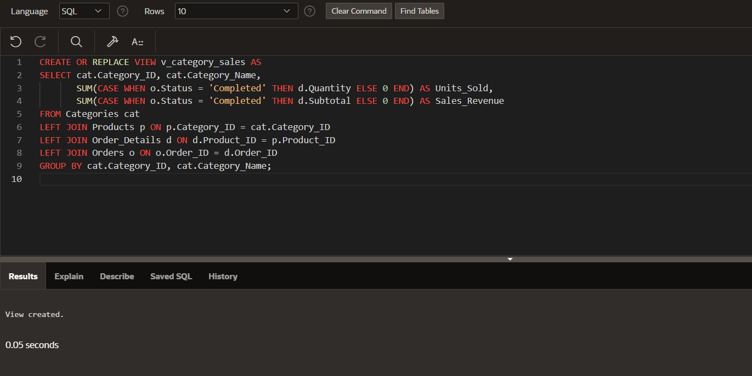
Figure 22: View V_CATEGORY_SALES (aggregate/summary view): units sold and sales revenue per category from completed orders.
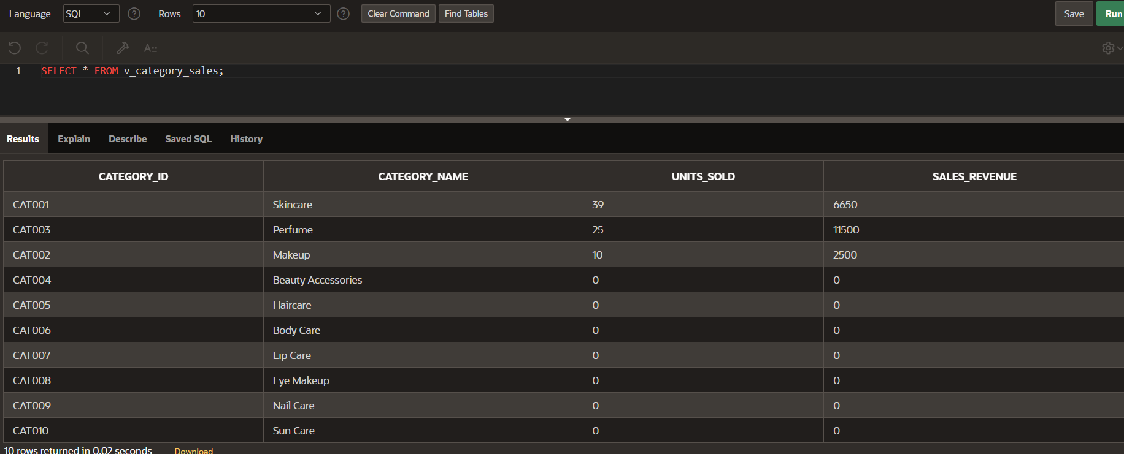
Figure 23: Output of V_CATEGORY_SALES.
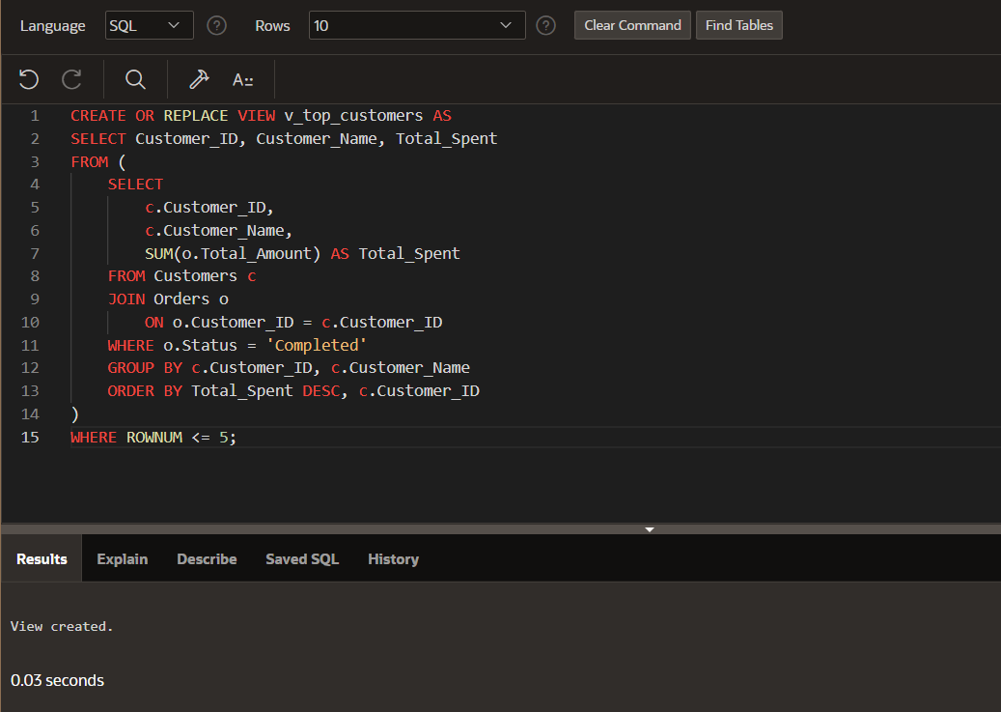
Figure 24: View V_TOP_CUSTOMERS (Top-N view): the five customers with the highest completed-order spending, using an inline subquery and ROWNUM.
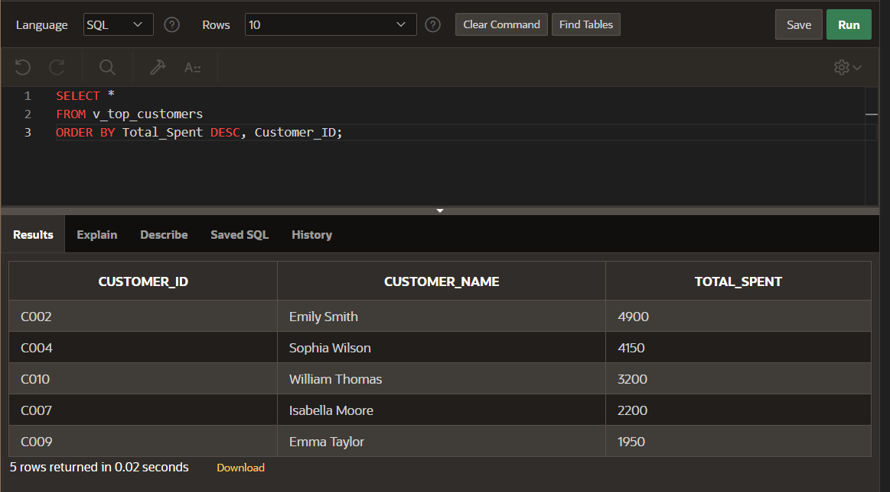
Figure 25: Output of V_TOP_CUSTOMERS (5 rows returned).
5.3 Transactions
Transactions are important when performing database operations that involve changes to data. Transaction group-related operations together so that the changes can be completed successfully as a single unit. For example, when processing an order, information may need to be added to the Orders table and Order Details table. Transaction control helps ensure that related changes are handled consistently. SQL transaction commands such as COMMIT can be used to permanently save changes, while ROLLBACK can be used to undo changes when an error occurs.
The script below demonstrates COMMIT and ROLLBACK together with INSERT, UPDATE and a conditional DELETE that uses a subquery.

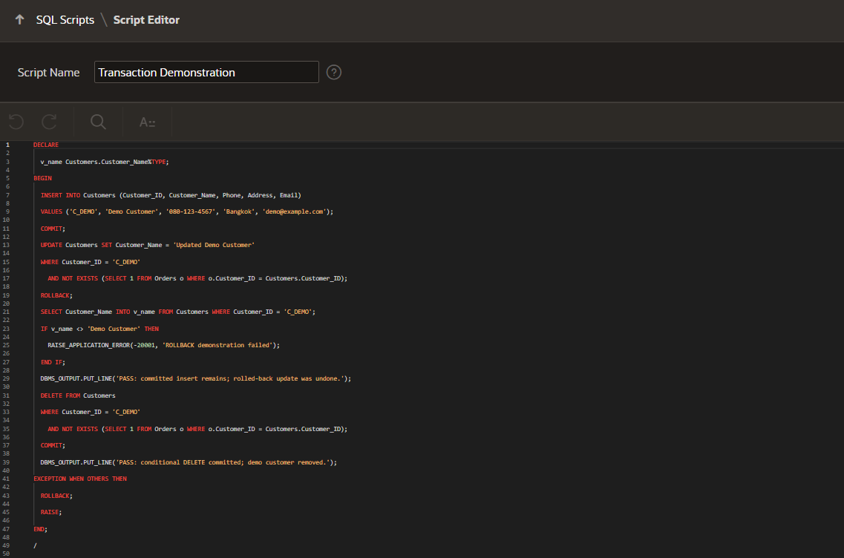
Figure 26: Transaction demonstration script (INSERT, UPDATE, conditional DELETE with a subquery, COMMIT and ROLLBACK).

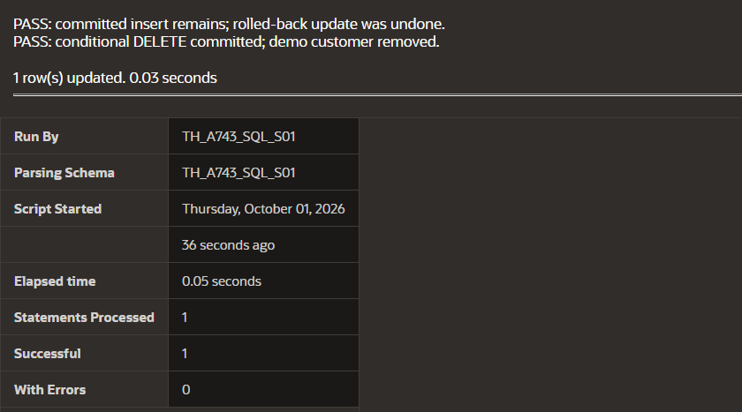
Figure 27: Output of the transaction demonstration: the committed insert remains, the rolled-back update is undone, and the conditional delete is committed.

5.4 Security
Database security is used to protect the information stored in the Glamoré system from unauthorized access or inappropriate changes. Access to the database should be controlled through appropriate user permissions and privileges. Users should only be given the level of access required for their responsibilities. Primary keys, foreign keys, and other constraints also provide a level of data protection by helping prevent invalid or inconsistent records. Oracle APEX authentication and authorization can additionally be used to control who can access the application and its functions.
The application authorization scheme used to restrict access is shown below.

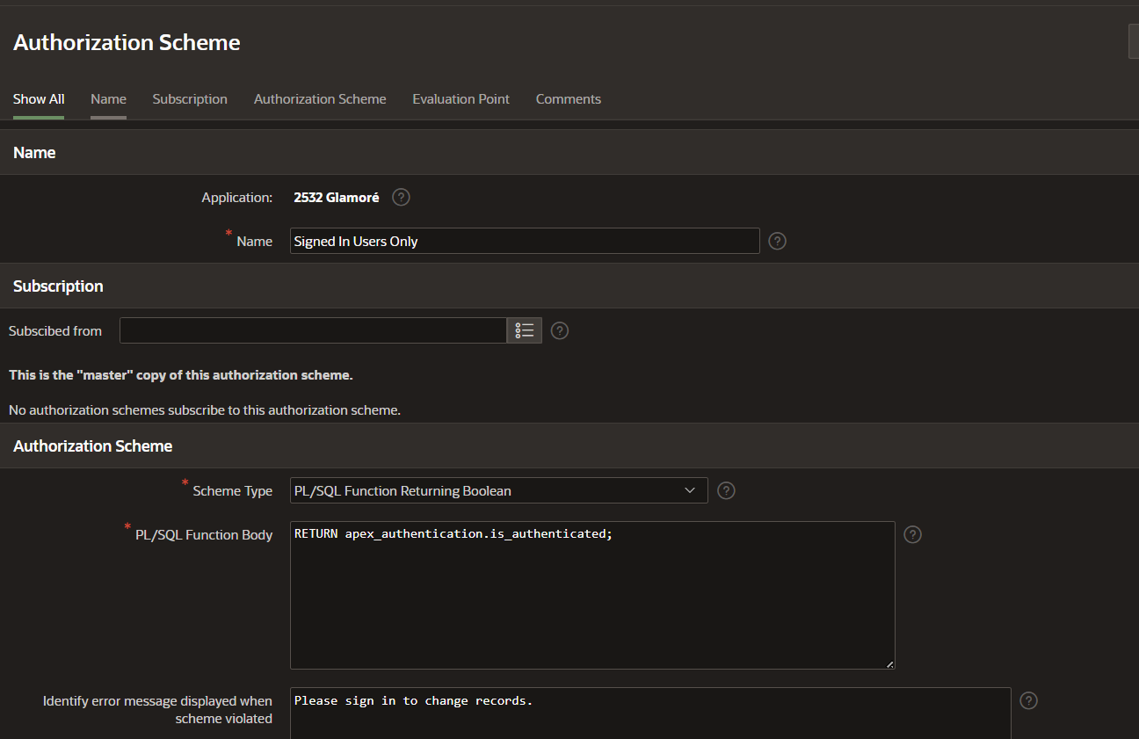
Figure 28: APEX authorization scheme “Signed In Users Only”.
5.5 Database Roles & GRANT Privileges
Database roles and GRANT privileges were not implemented because the provided Oracle Academy environment does not give our accounts the required administrative privileges. The proposed access design gives reporting users SELECT access to reporting views and managers access to maintain relevant records. Oracle APEX sign-in and authorization are used for application access control.

Oracle APEX Application
Page / feature | Purpose and component
Home | Welcome region, beauty image and links to Products, Customers, Orders and Dashboard
Dashboard | Category-sales bar chart and order-status donut chart
Customers | Interactive report and data-entry form
Orders | Interactive grid with customer/delivery labels and an order form. Editable for updating order status and delivery service.
Products | Editable interactive grid for product maintenance
Brands | Editable interactive grid for brand maintenance
Categories | Category maintenance, with related product information where configured
Delivery Services | Service maintenance and a general Thailand map
Stock Managers | Manager maintenance grid
Stock Transactions | Stock movement report and entry form with product/manager choices
Payment | Payment report and form for recording payments against existing orders.

6.1 Application Pages, Reports, Grids and Charts
The application was created in Oracle APEX App Builder using the implemented database tables. Reports, editable grids, and forms were configured to support viewing and maintaining records. Charts were added to the dashboard, and navigation links connected the main pages. The Glamoré theme was applied, followed by testing of the main application functions.

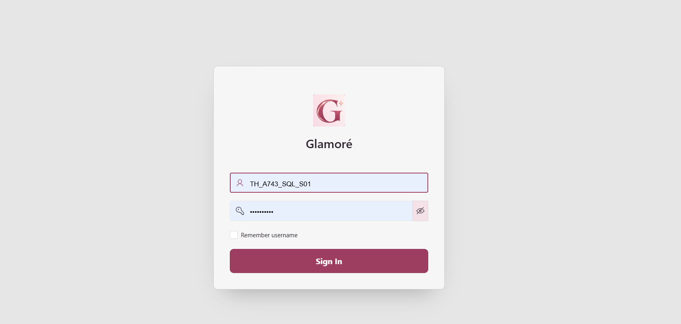
Figure 29: Login page.
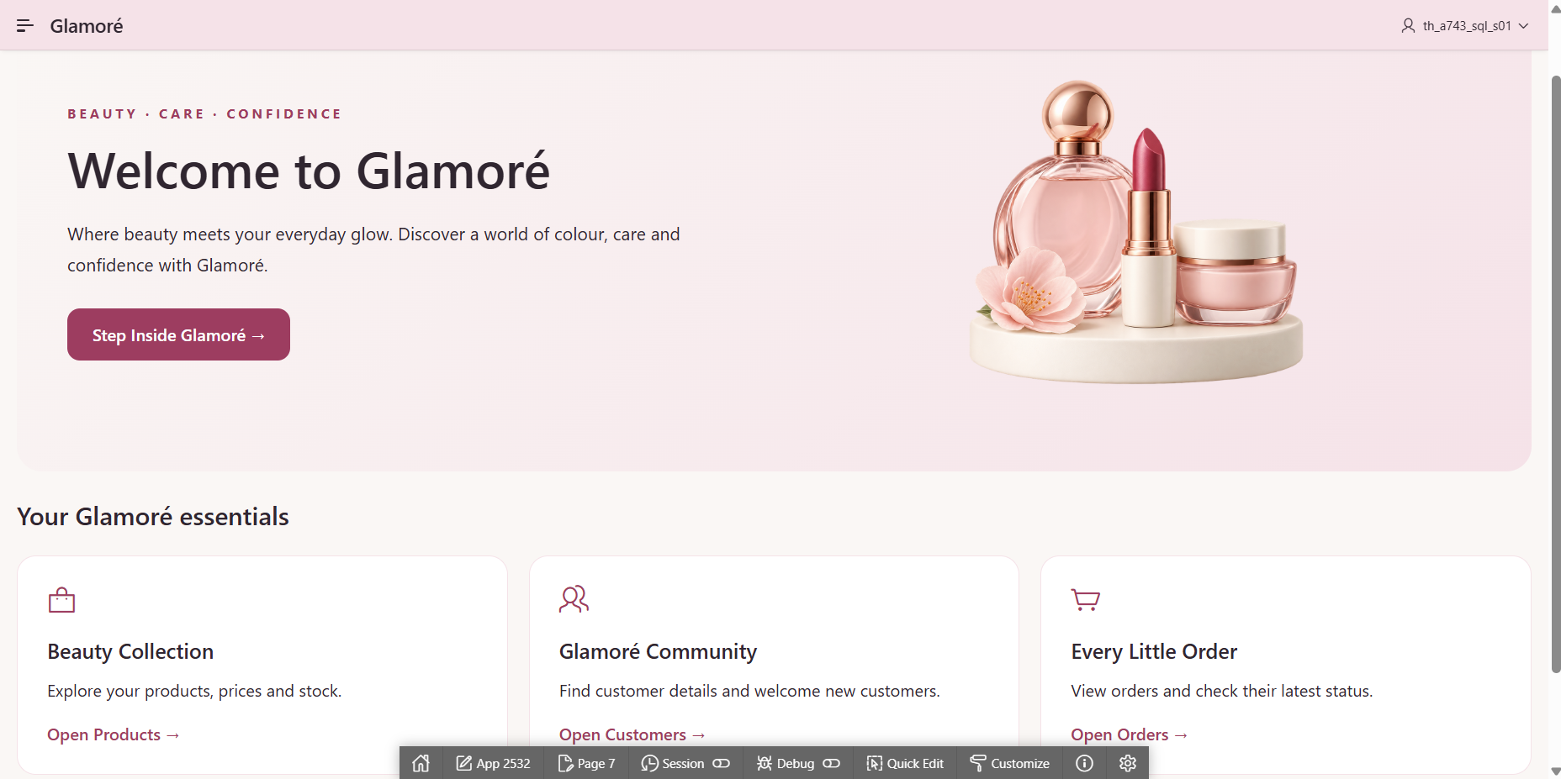
Figure 30: Home page with links to the main functions.
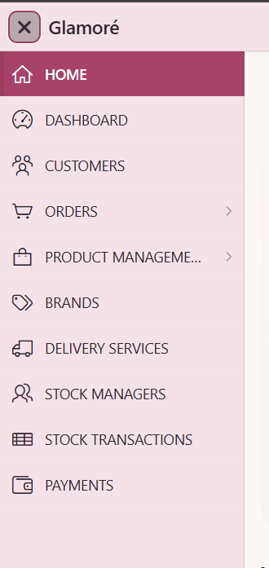

Figure 31: Navigation menu.
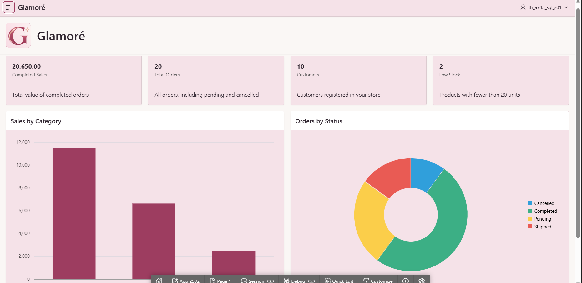
Figure 32: Dashboard with a category-sales bar chart and an order-status donut chart.

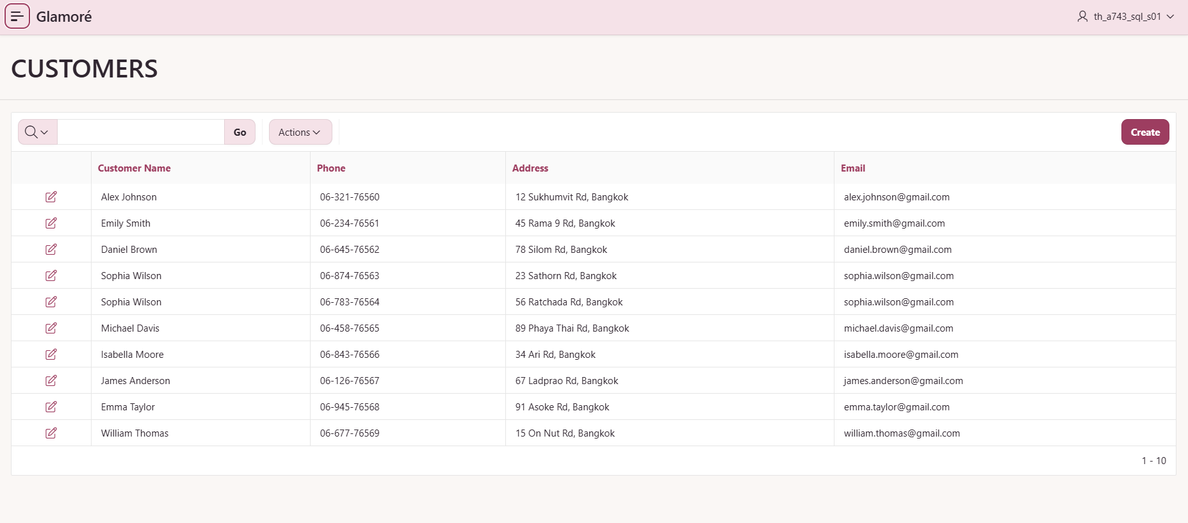
Figure 33: Customers: interactive report.

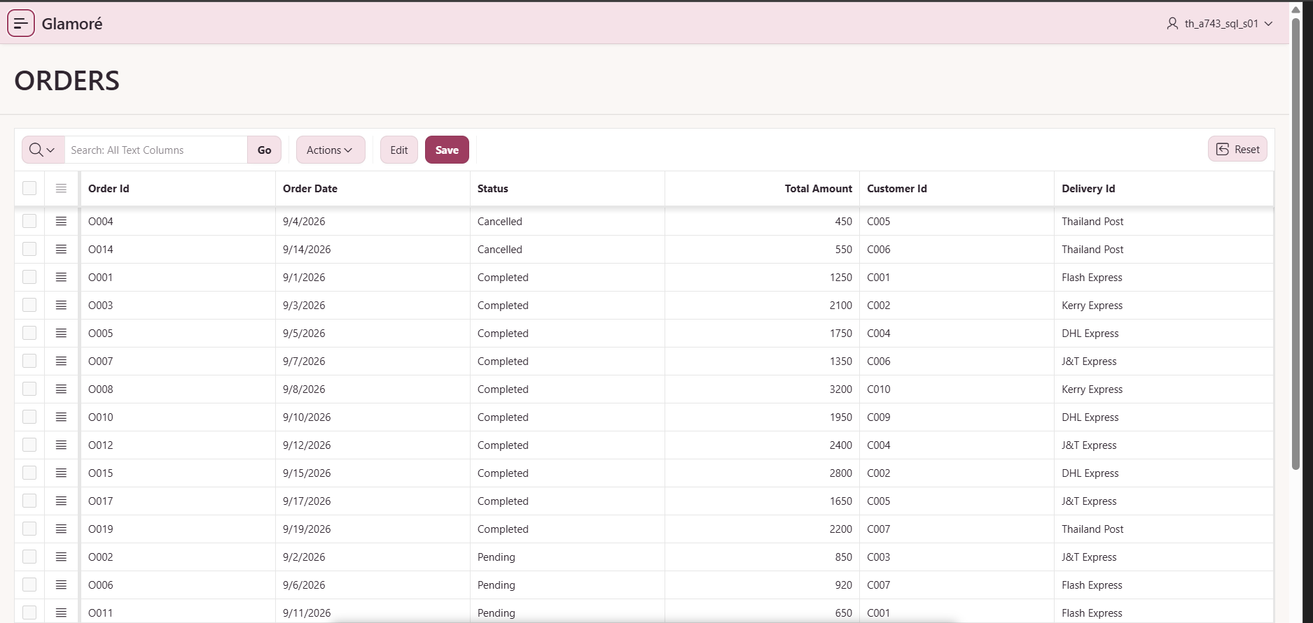
Figure 34: Orders: interactive grid with customer and delivery labels.

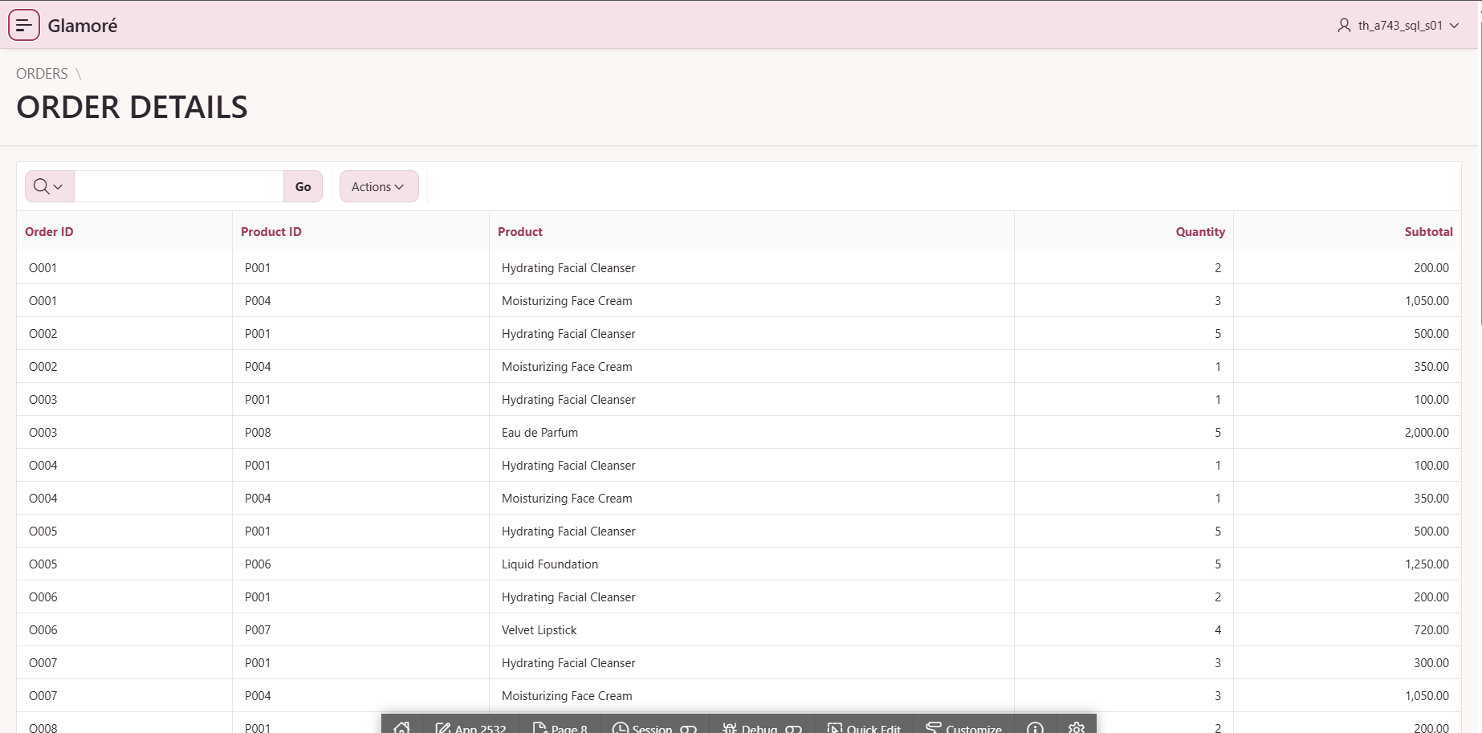
Figure 35: Order Details: report of products and quantities in each order.

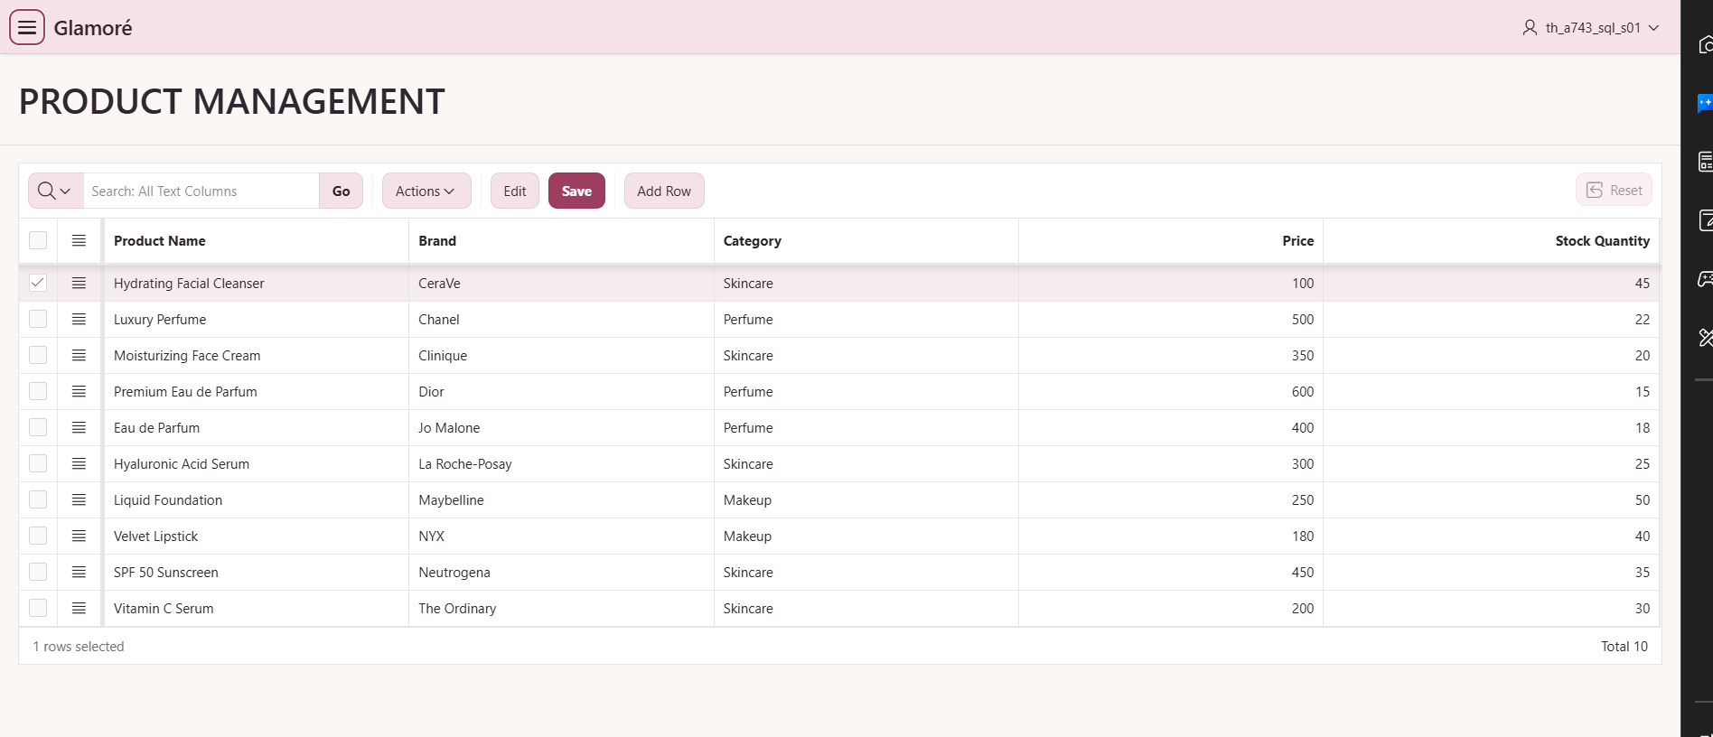
Figure 36: Product Management: editable interactive grid.

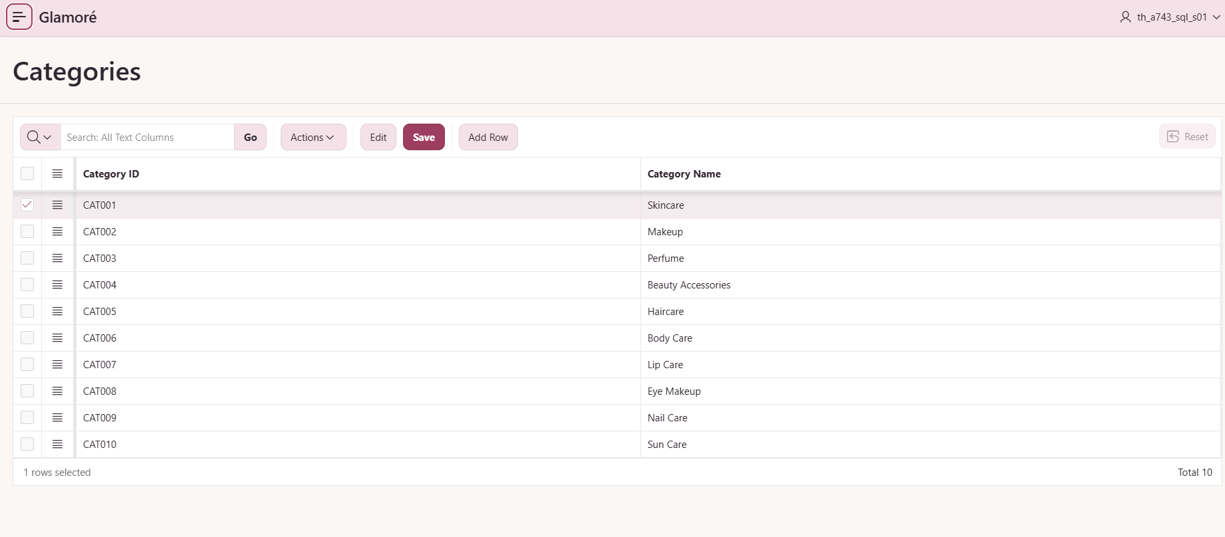
Figure 37: Categories: category maintenance.

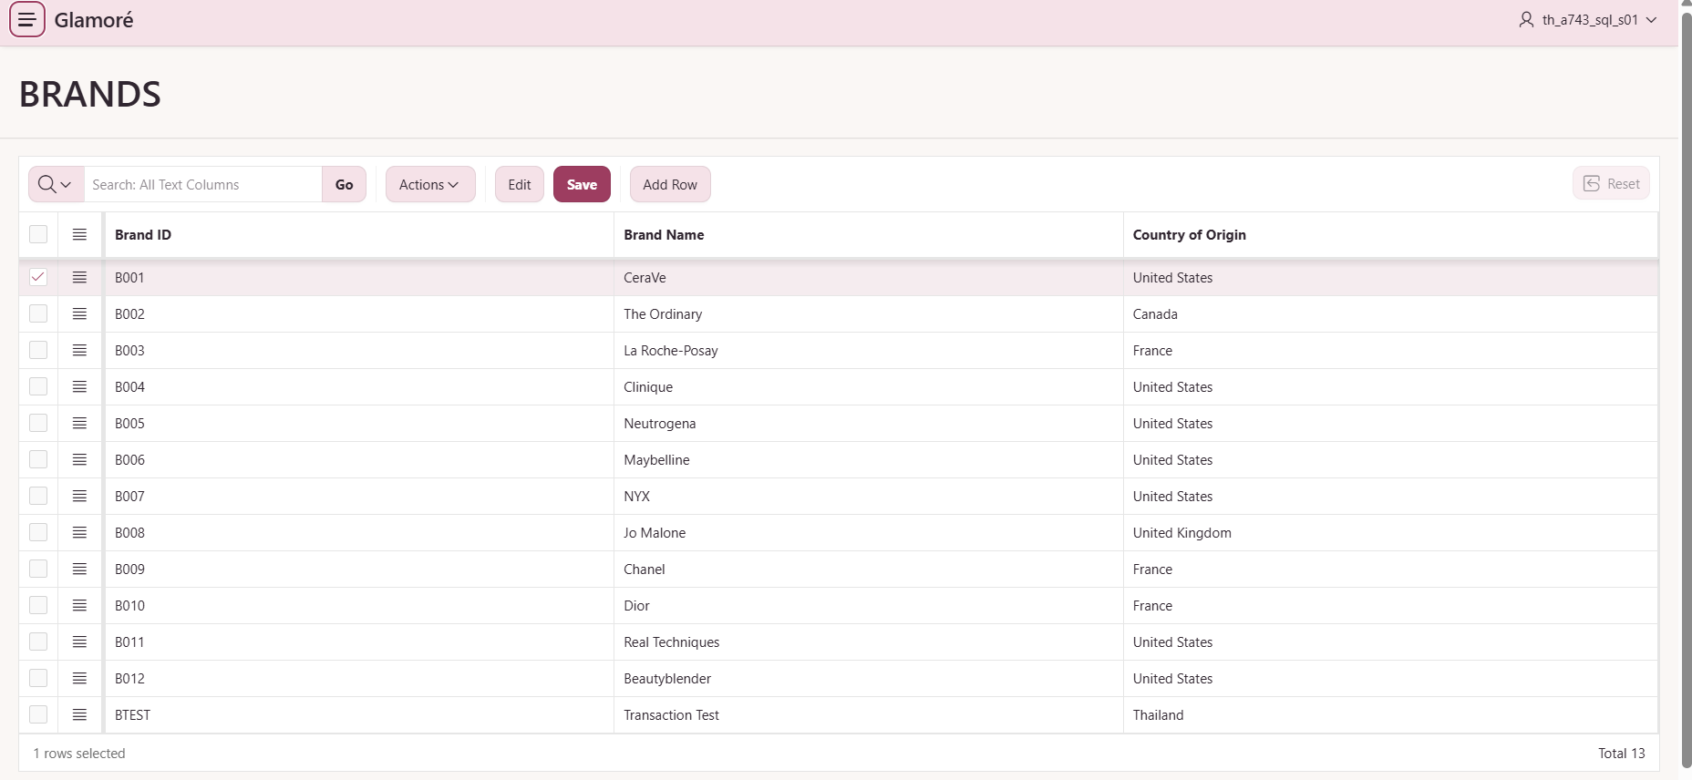
Figure 38: Brands: editable interactive grid.

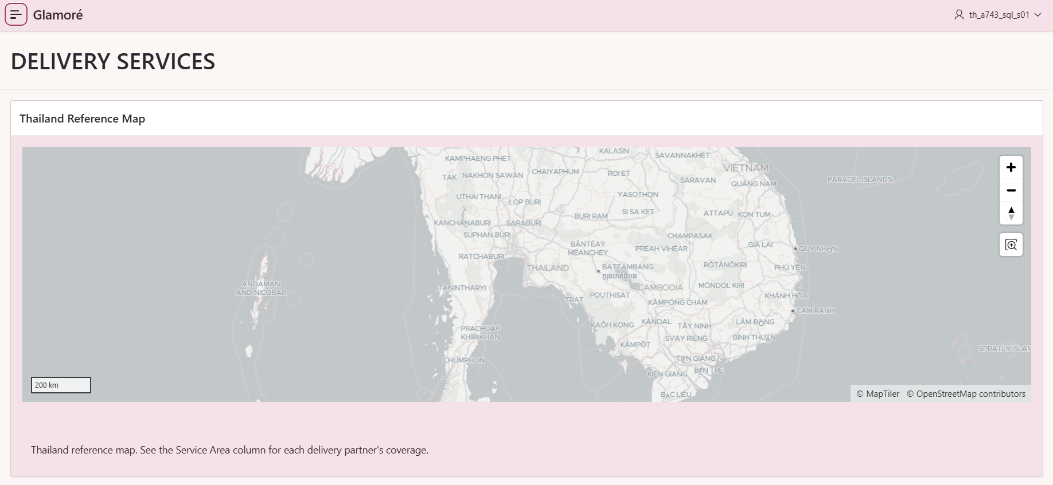
Figure 39: Delivery Services: reference map of Thailand
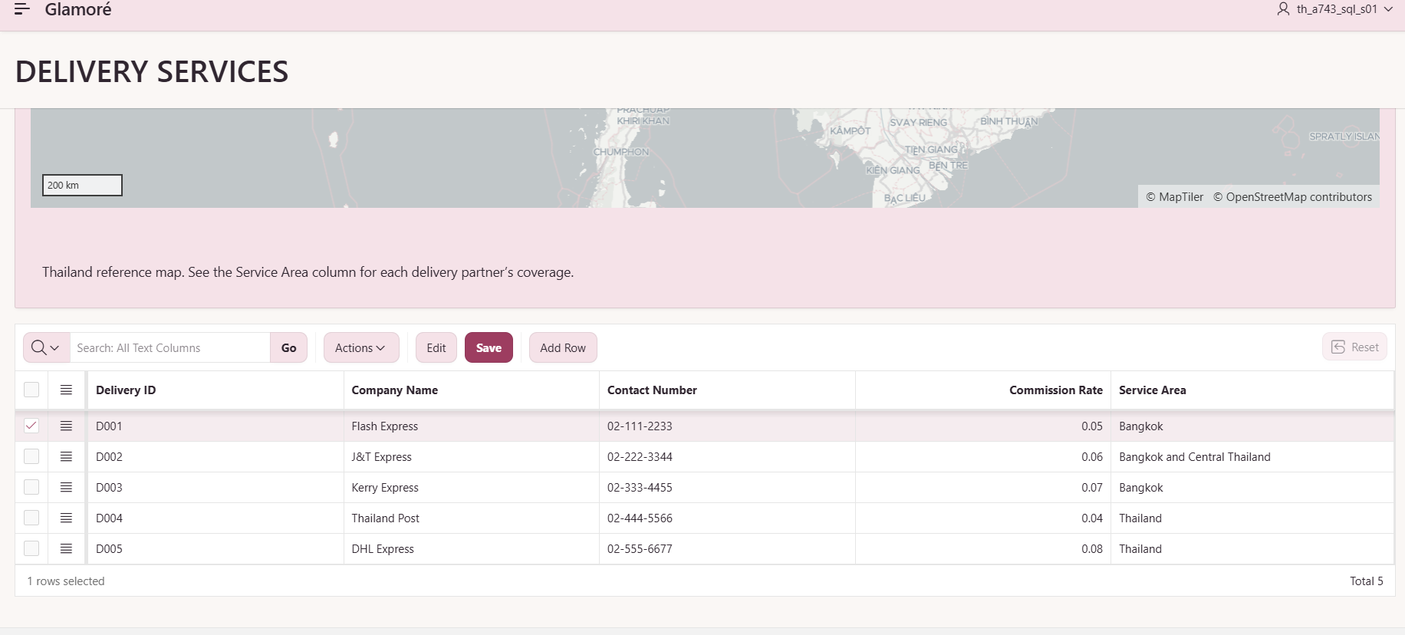
Figure 40: Delivery Services: service maintenance with map.

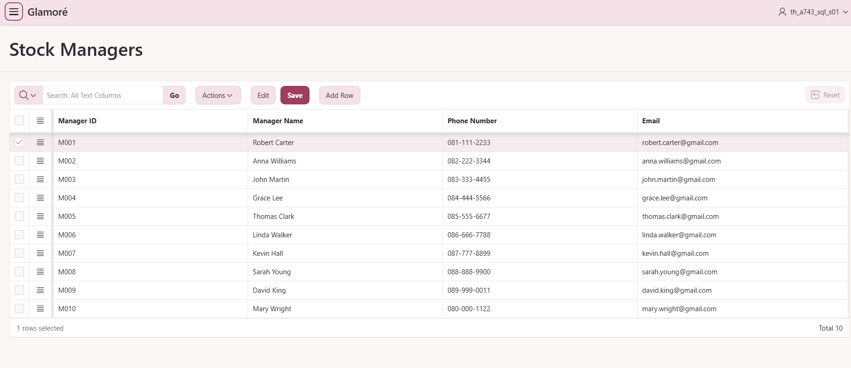
Figure 41: Stock Managers: maintenance manager grid.

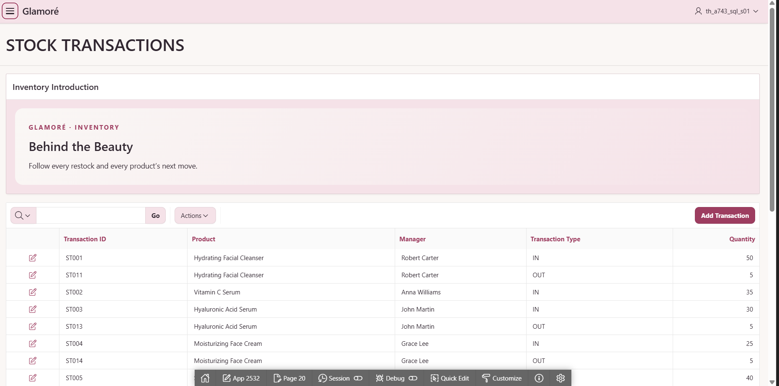
Figure 42: Stock Transactions: stock movement report and entry form.

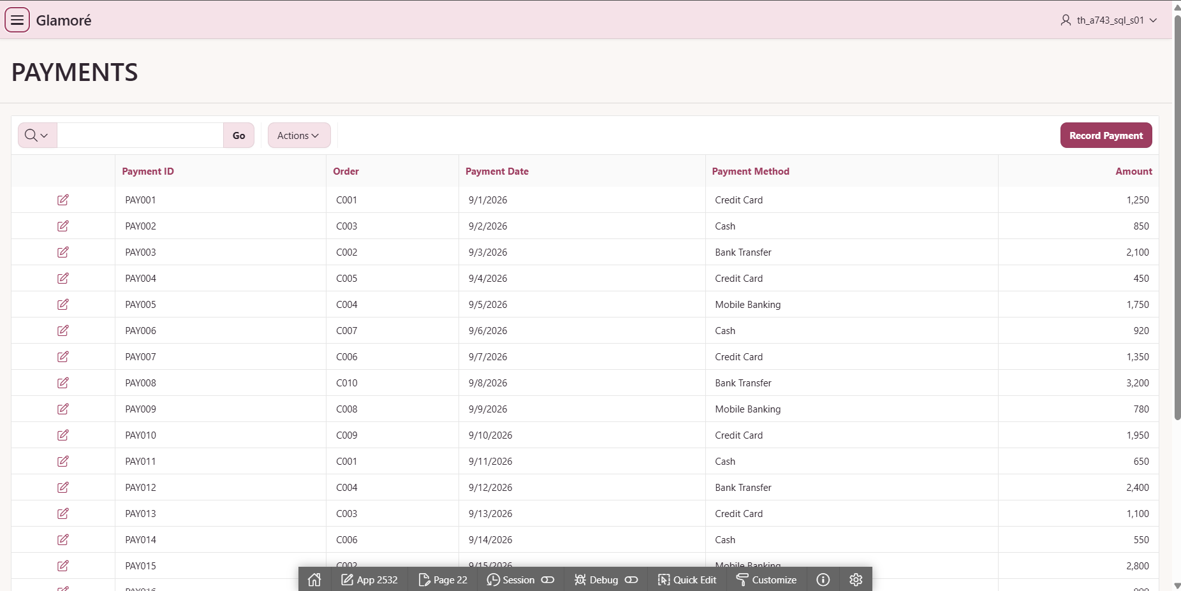
Figure 43: Payments: payment report.

6.2 CRUD Functions
The application supports the main CRUD operations used in database systems:
- Create: Users can add new records, such as adding a new customer or product.
- Read: Users can view existing records stored in the database.
- Update: Users can modify existing information when changes are required.
- Delete: Users can remove records when they are no longer needed, subject to the database constraints.
These functions demonstrate that the APEX application can interact with the underlying database and perform basic data management operations.

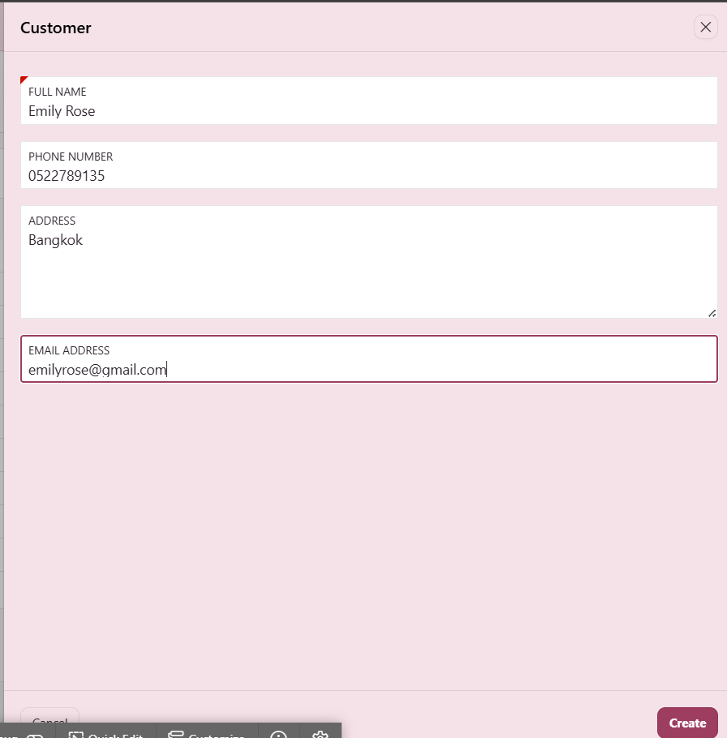
Figure 44: Create form for a new customer (Create function).

Testing and validation
Testing covers application operations, database constraints, relationship behaviour and reporting consistency. Functional tests use temporary records so that add, edit and delete operations can be checked without damaging the seed data. Constraint tests intentionally submit invalid values and expect Oracle to reject them. Reporting tests compare chart or view totals with independent queries. A test is considered passed only when the expected behavior is observed and recorded.

7.1 Application and functional tests
Test | Expected result | Current evidence/status
Customer CRUD | Create, edit and delete an eligible test customer | Passed. Test customer created, edited and deleted
Products grid | Saved price/stock change appears after refresh | Passed. Saved price change still shown after refresh.
Brands grid | Add, edit and delete a temporary brand | Passed. Temporary brand added, edited and deleted.
Stock record entry | Valid movement is persisted | Passed. New movement appears in the report.
Automatic stock change | Movement changes Products balance | Did not work; current workflow is manual
Payment creation | Valid payment saves with required ID/order | Passed.
Two charts | Current category revenue and status counts | Passed (Fig 23 & Fig 45). Chart totals match the SQL results.
Sign-in required | Users who are not signed in cannot open the application pages or change records | Passed. The login page appears when opening the application without signing in (Fig 29).

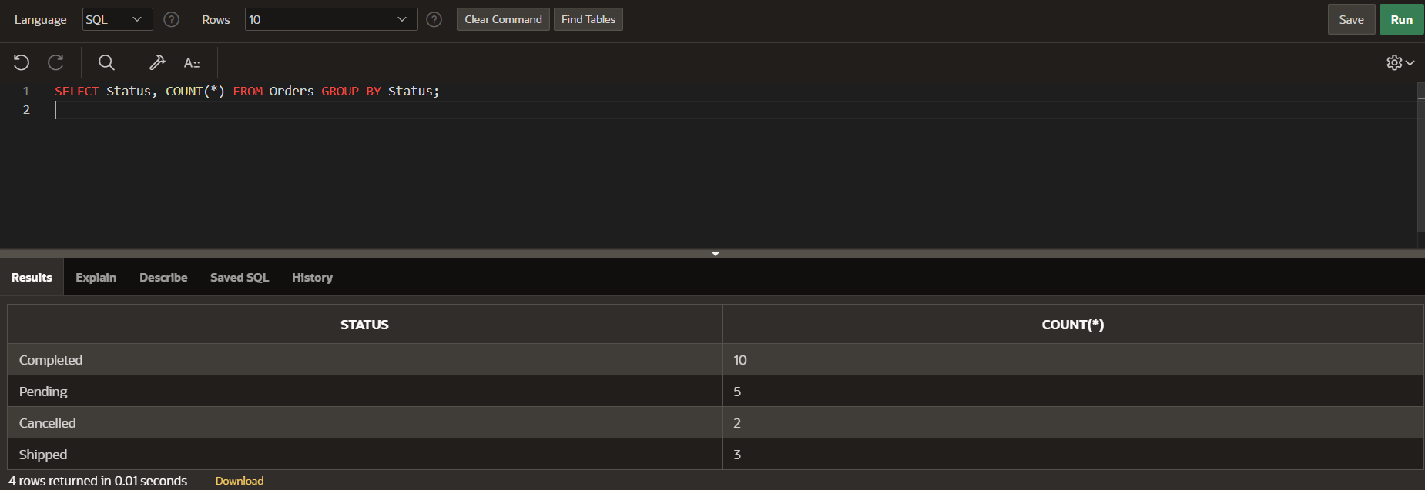
Figure 45: Output of the order status

7.2 Database constraint tests
Attempt | Expected Oracle behaviour
Set product price to −1 | CHECK constraint rejects the update
Set order-item quantity to 0 | CHECK constraint rejects the update
Use an invalid stock movement type | CHECK constraint rejects the update
Reference a missing customer | Foreign key rejects the change
Create a second payment for one order | Unique constraint rejects the duplicate
Set a required name to NULL | NOT NULL rejects the update
Insert an existing primary key | Primary key rejects the duplicate
Delete an order with a payment | Foreign key blocks deletion

All eight constraint tests passed. The database rejected the tested invalid operations, and the test script rolled back any test changes. Fig 46 shows the results.
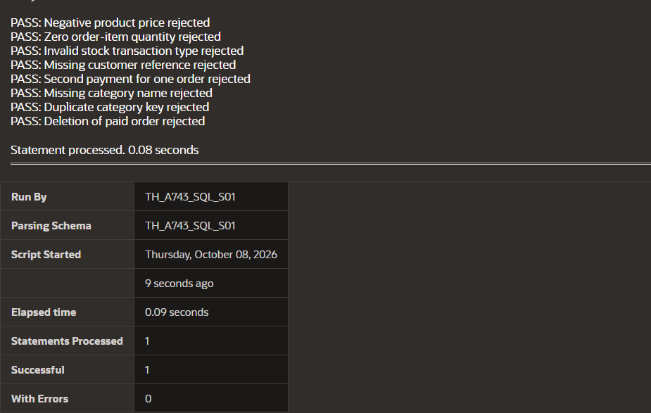
Figure 46: Output of the automated constraint test script.
7.3 Report, chart and relationship tests
Save a temporary product change, refresh the Products grid and verify the stored value through SQL. Save a temporary order change and verify that the order report and status chart reflect it after refresh. Compare the category chart with V_CATEGORY_SALES and ensure that only completed orders contribute to completed sales revenue. Attempt to delete a referenced master record and verify that the relationship prevents an orphan. Remove temporary records or roll back test transactions after the checks.
7.4 Limitations
The following limitations remain in the current prototype:
- Stock quantities require manual updates after recording transactions.
- The Thailand map does not show delivery locations or live tracking.

8. Conclusion
The Glamoré project successfully demonstrates the design and development of a database application for a cosmetics retail business. The system organizes important business information, including customers, products, brands, categories, orders, order details, payments, delivery services, stock managers, and stock transactions.
The database was designed using primary keys, foreign keys, relationships, and normalization principles to maintain data consistency and reduce unnecessary duplication. The database structure also allows information from different parts of the business to be connected and managed efficiently.
Oracle APEX was used to develop the application interface, while SQL was used to create and manage the database structure and support the ER diagram. The application provides basic CRUD functions that allow users to create, view, update, and delete relevant records.
Overall, the Glamoré project provides a practical example of how database concepts can be applied to a real-world retail business. The system can be further improved in the future by adding more advanced features, improving security, and automating additional business processes such as stock management and order processing.

9. Division of work
- Ei Thinzar Naing handles ER diagram, Oracle Apex and final report.
- Sitt Min Pyae Sone handles Database tables and sample data, Oracle Apex and final report.

