

Linguage: Online Language Learning System
Final Project Report

Course: BSC/ITE321 System Analysis, Design, and Implementation
Instructor: Zakariyya Bature
Submission date: 7 October 2026
Group members:
Ei Thinzar Naing (2310060002)
Khin Thant Zin (2512220004)
Retaj Sultan B Alsulami (2510240004)
Rifal Sultan B Alsulami (2510240005)

Introduction
Linguage is an online language learning system that helps users learn different languages through courses, lessons, and practice. It brings language selection, level selection, progress tracking, and subscriptions into one platform. The project includes a use case diagram, an ER diagram, and Figma interface designs.
Language courses can be expensive and have fixed schedules. Free materials are often scattered across different sources, making it difficult to follow a clear learning path. Some learners also do not know their starting level or how to track their progress. Linguage aims to make learning more organized and flexible for students, workers, travelers, and anyone interested in learning a language.
The main objectives are to provide courses for different languages and levels, support vocabulary and language-skill practice, show learning progress, and allow users to manage their profiles and subscriptions. The system encourages a short daily routine, with a sample goal of 20 minutes per day.
There are two main actors. Learners use the system to study and manage their accounts. Administrators manage courses, lessons, user accounts, and subscriptions.

System Requirements
The following requirements summarize the presentation slides and use case diagram.
Functional requirements | Description
Account management | Register, log in, log out, and manage profile information.
Learning setup | Choose a language and level and enroll in a course.
Lessons and practice | Browse and take lessons; practice vocabulary, listening, speaking, and writing; accept voice input.
Progress tracking | Store learning progress and let learners view their courses, lessons, and completion.
Subscriptions | Purchase or cancel a subscription.
Administration | Manage course content, add/edit/delete lessons, manage users and subscriptions, and view reports.

Non-functional requirements | Description
Compatibility | Support access from different devices.
Performance | Aim for a response time of less than three seconds.
Availability | Aim to provide access 24 hours a day, throughout the year.
Support hours | Provide telephone help during business hours.
Access control | Restrict profitability information to authorized staff.

The system provides a free learning option and premium subscriptions. The prototype displays monthly and yearly plans with additional access to courses and practice activities.

Use Case Diagram
The use case diagram shows how learners and administrators interact with Linguage. Both actors log in, while their other activities depend on their roles.
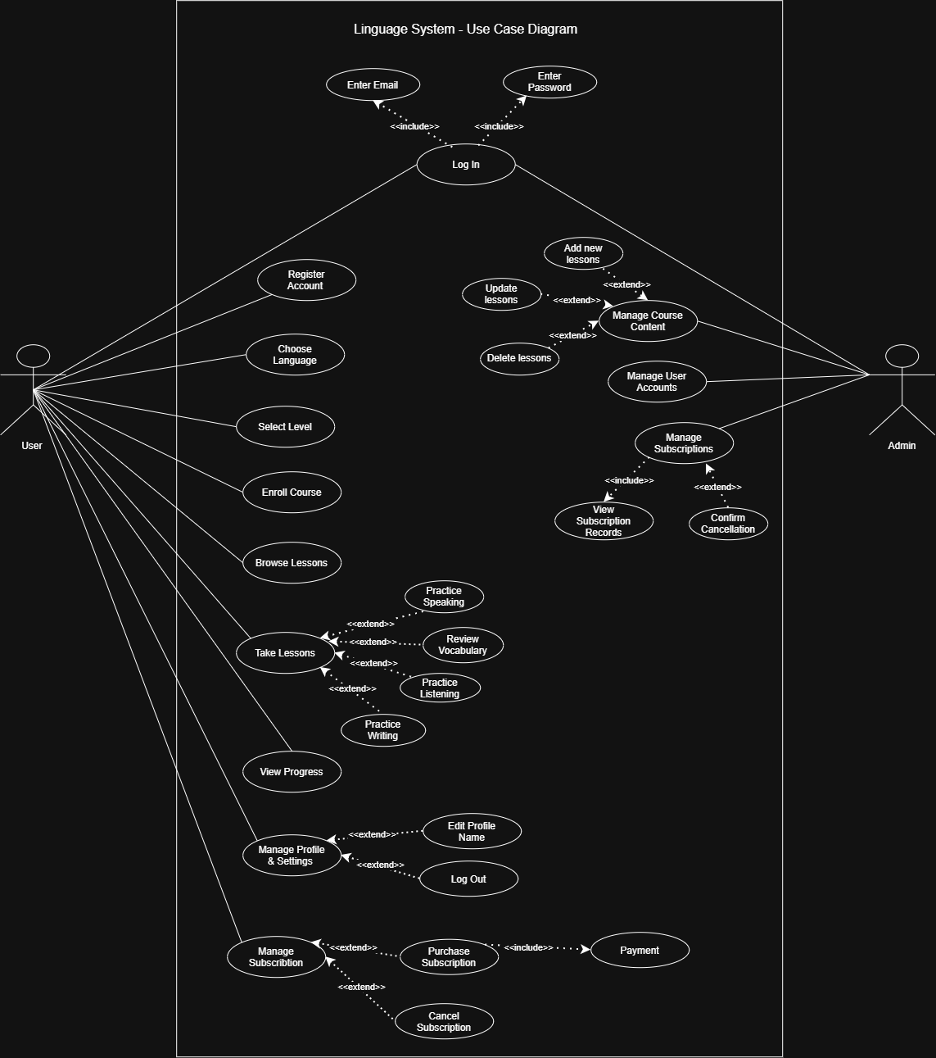
Learners register, choose a language and level, enroll in courses, browse lessons, take lessons, practice language skills, and view progress. They can also manage their profiles and subscriptions. Administrators manage course content, user accounts, and subscriptions, including viewing records and confirming cancellations.
The diagram uses «include» for required actions, such as payment during a subscription purchase. It uses «extend» for additional actions, such as selecting a practice activity or editing a profile.

ER Diagram
The ER diagram represents the main information stored by the system and the relationships between it.
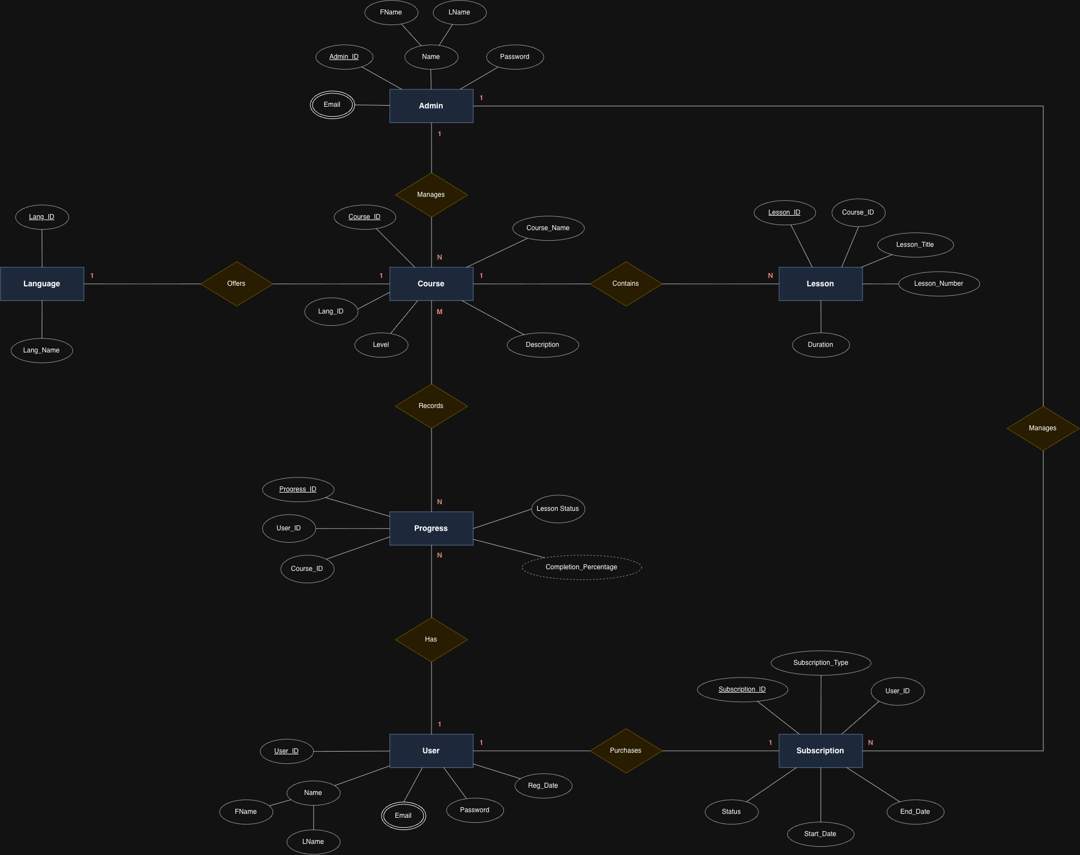

Entity | Main information
Admin | Admin_ID, name, email, and password.
User | User_ID, name, email, password, and registration date.
Language | Lang_ID and language name.
Course | Course_ID, language reference, course name, level, and description.
Lesson | Lesson_ID, course reference, title, number, and duration.
Progress | Progress_ID, user and course references, lesson status, and completion percentage.
Subscription | Subscription_ID, user reference, type, status, start date, and end date.

Each course contains lessons, and each learner has progress records. Administrators manage courses and subscriptions. Underlined attributes represent primary keys. Attributes such as User_ID, Course_ID, and Lang_ID connect related records.

Relationships shown in the diagram
Relationship | Cardinality | Description
Admin manages Course | 1: N | One admin manages multiple courses. Each course is managed by one admin.
Admin manages Subscription | 1: N | One admin manages multiple subscriptions. Each subscription is managed by one admin.
Language offers Course | 1: N | One language offers many courses. Each course belongs to one language.
Course contains Lesson | 1: N | One course contains multiple lessons. Each lesson belongs to one course.
Course records Progress | 1: N | One course has many progress records. Each progress record belongs to one course.
User has Progress | 1: N | One learner can have multiple progress records. Each progress record belongs to one user.
User purchases Subscription | 1:1 | Each user has one subscription record. Each subscription belongs to one user.
User studies Course through Progress | M: N | One user can study many courses, and one course can have many users. The Progress entity connects each user to a course and records their learning progress.

Figma Interface Design
Figma Link: https://www.figma.com/design/dRLC0BOCLYjy1IvLS35wuo/Linguage?node-id=0-1&t=cMnUzT3ljIhf7hv5-1
The Figma designs include both learner and administrator interfaces.

User Interfaces
The user interface is designed for learners to choose languages, take lessons, practice their skills, and track progress. Users can also manage their profiles and subscriptions. Some pages have different versions for beginners, old learners, and premium users. The user layouts are shown below, followed by descriptions of each page.
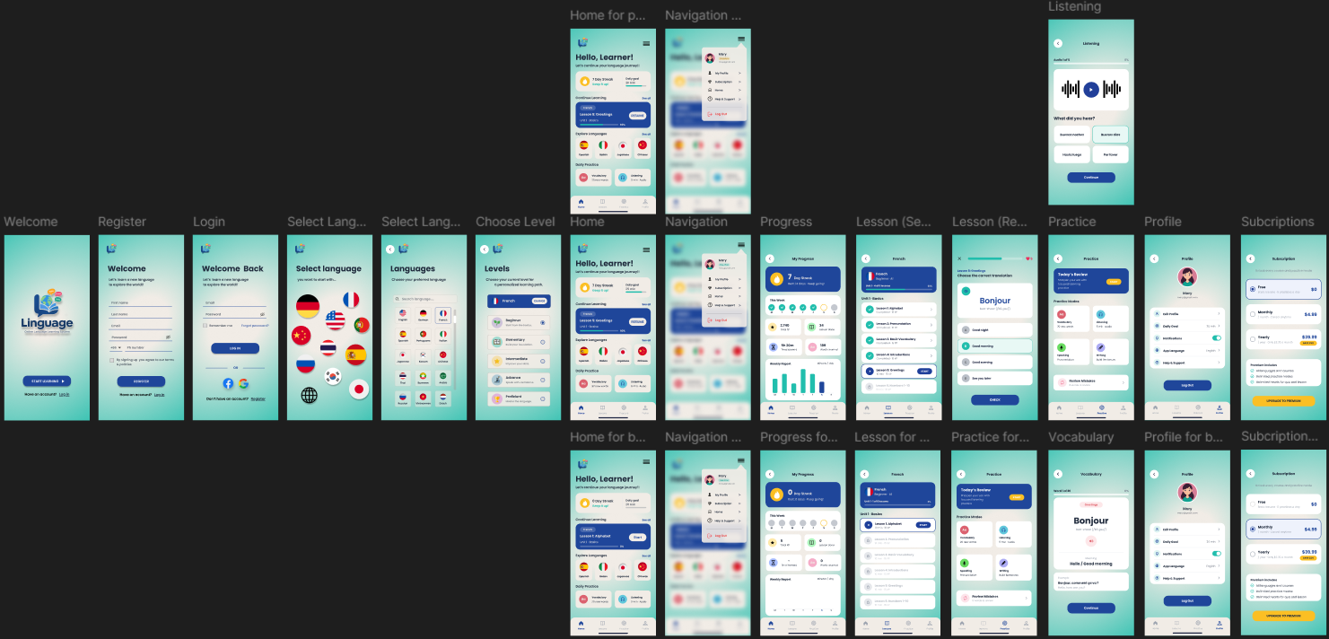
1. Welcome Page
Introduces Linguage with its logo. Users can select “Start Learning” or log in to an existing account.
2. Registration Page
Allows new users to create an account by entering their name, email, password, and phone number. Users accept the terms before registering.
3. Login Page
Allows users to access their accounts using an email and password. It also includes password recovery and social login options.
4. Select Language Page
Introduces language selection through country flags. Users choose the language they want to learn.
5. Languages Page
Displays available languages with names and flags. A search field helps users find their preferred language.
6. Level Selection Page
Allows users to select their current language level, from Beginner to Proficient. This helps them choose a suitable learning path.
7. Home Page
The home page has three versions: beginner, old learner, and premium learner. It shows the daily goal, learning streak, current lesson, language choices, and practice shortcuts. Beginners can start their first lesson, while old learners can resume learning.
8. Navigation Menu
The navigation menu has three versions for beginners, old learners, and premium users. It opens as a popup with access to Profile, Subscription, Home, Help & Support, and Log Out. The premium version also displays the user’s premium status.
9. Progress Page
The progress page has two versions: beginner and old learner. It displays the learning streak, weekly activity, XP, completed lessons, study time, and words learned. The beginner version starts with no recorded activity, while the old learner version shows accumulated progress.
10. Lessons Page
The lessons page has two versions: beginner and old learner. It displays the course progress and lesson list. Beginners start with the first lesson, while old learners can see completed lessons and continue to the next available lesson.
11. Lesson Activity Page
Presents a translation question with audio and multiple answer choices. Users select an answer and press “Check,” while the progress bar and hearts appear at the top.
12. Practice Page
The practice page has two versions: beginner and old learner. Both offer vocabulary, listening, speaking, and writing activities, along with a daily review and a “Review Mistakes” option.
13. Vocabulary Page
Displays a word with its pronunciation, meaning, audio, and example sentence. Users press “Continue” to move to the next word.
14. Profile Page
Shows the learner’s picture, name, and email. Users can access profile editing, daily goals, notifications, app language, support, and logout.
15. Listening Page
Allows users to play an audio clip and choose what they heard from several answers. A progress indicator shows their position in the activity.
16. Subscription Page
The subscription page has two versions: free and premium user. Both display the Free, Monthly, and Yearly plans with their prices and benefits. The free version shows the Free plan selected, while the premium version shows the Monthly plan selected.

Admin Interfaces
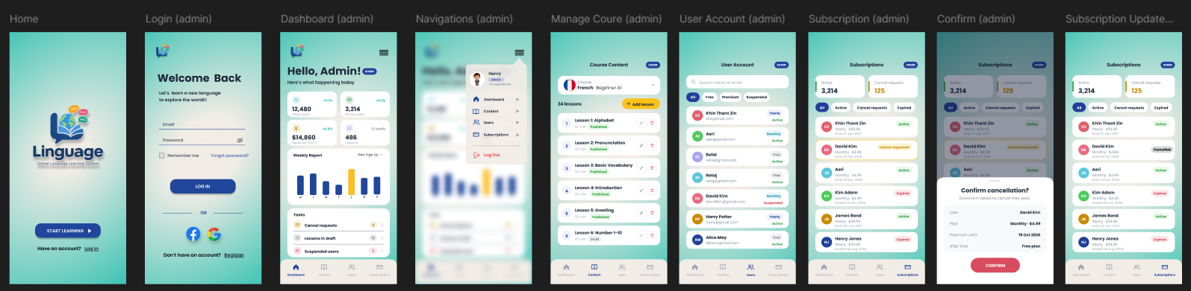
The admin interface allows administrators to monitor the system and manage learning content, user accounts, and subscriptions. It includes a dashboard, management pages, and subscription cancellation screens. The admin layouts are shown below, followed by descriptions of each page.
1. Welcome Page
Displays the Linguage logo and provides access to the login page through the “Log In” link.
2. Admin Login Page
Allows administrators to sign in using their email and password. It also includes “Remember me” and password recovery options.
3. Admin Dashboard
Shows an overview of total users, active subscriptions, revenue, and lessons. A weekly chart displays new sign-ups, while the task list highlights cancellation requests, draft lessons, and suspended users.
4. Admin Navigation Menu
Opens as a popup with the administrator’s profile and role. It provides quick access to Dashboard, Content, Users, Subscriptions, and Log Out.
5. Course Content Page
Allows administrators to select a course and manage its lessons. Each lesson shows its title, duration, and publication status, with options to add, edit, or delete lessons.
6. User Account Page
Displays user accounts with their names, emails, subscription plans, and account statuses. Administrators can search for users and filter the list by All, Free, Premium, or Suspended.
7. Subscription Management Page
Shows subscription records, including users, plans, end dates, and statuses. Administrators can filter active subscriptions, cancellation requests, and expired plans.
8. Cancellation Confirmation Popup
Displays the selected user’s cancellation details, including their plan and premium access end date. The administrator can confirm the cancellation using the “Confirm” button.
9. Updated Subscription Page
Shows the subscription list after a cancellation is confirmed. The selected user’s status changes to “Cancelled,” allowing the administrator to see the updated record

Conclusion
Linguage proposes a flexible online language learning system that organizes courses, lessons, practice, progress, and subscriptions in one place. The presentation defines the learning problem and main requirements. The use case diagram explains learner and administrator actions, the ER diagram identifies the main information, and the Figma screens show the intended learner and administrator experience.

