Skill Gap Recommender for IT Students & Fresh Graduates

  - Using Skill Patterns and LLM to Help Students Choose What to Learn Next

CSC 357 – AI Capstone Final Project Report
Name: Ei Thinzar Naing
ID: 2310060002
Date: 8 October 2026

Introduction
AI is slowly changing what companies expect from IT employees. However, this change is not the same for every job. Some jobs are changing fast, and other jobs barely change at all. Students and new graduates often rely on career advice that is useful in general, but not specific to their exact situation. So, it doesn’t always reflect exactly what companies are really asking for and what is happening in the job market right now.
This project has two main stages that work together. The first stage is data mining using association mining. Real IT job posts were studied to find how AI skills and normal IT skills show up together in different jobs, and which non-AI jobs are changing the most because of AI. Second, those patterns are used as real proof for AI Language model (LLM), which turns them into a short, easy, personal tip about which skill a student should learn next. This recommendation system will show on a simple website anyone can use.
This report explains the problem, the research that helped guide the project, how the system was built, how it works, what we found when testing it, its weak points, and what we learned at the end.

Problem Definition
As more companies use AI, many normal IT jobs (like Data Analyst, System Administrator, or QA Tester) are starting to need AI skills too. But it is not clear which jobs are changing the most, or which skills usually go together. Students and new graduates usually only get general advice, so they don't know which skills are worth learning for the job they want. This project builds a tool that looks at a student's target job and tells them which skills matter most, based on how AI skills and normal IT skills appear together in real job posts.

Who This is For
- University or college students studying in Computer Science and IT areas
- New graduates and early-career job seekers applying for IT jobs
- Career advisors and teachers who help students decide what to learn next.

Why This Problem Matters
The dataset used in this project has 22,673 records across 19 job types. Table 1 shows how many posts in each job type ask for at least one AI skill.

Job Type | Number of Posts | % Asking for AI Skills
ML/AI Engineer | 373 | 98.9%
Data Scientist | 520 | 95.4%
Data Engineer | 1,362 | 34.7%
Data/BI Analyst | 2,102 | 23.0%
Cloud Engineer | 290 | 14.8%
Software Engineer/Developer | 7,886 | 14.3%
Security Engineer/Analyst | 1,901 | 6.3%
DevOps/SRE | 896 | 5.0%
Infrastructure Engineer | 545 | 4.4%
UX/UI Designer | 311 | 4.18%
Database Administrator | 466 | 3.4%
IT Analyst | 32 | 3.12%
Test Engineer | 1,024 | 2.3%
IT Manager | 133 | 2.26%
Other IT | 1,644 | 2.13%
Network Engineer | 1,527 | 1.7%
Systems Administrator | 655 | 1.2%
QA/Quality Assurance | 1,833 | 0.8%
IT Support/Help Desk | 812 | 0.7%
Table 1. Percentage of job posts that mention an AI skill, by IT job type.
The difference is very big. Almost all ML/AI Engineer (98.9%) and Data Scientist (95.4%) job posts ask for AI skills. In contrast, QA/Quality Assurance (0.8%) and IT Support/Help Desk (0.7%) job posts almost never do. Some jobs are in between Data Engineer (34.7%), Data/BI Analyst (23.0%), and Software Engineer/Developer (14.3%). These percentages mean they are changing a little, but not fully. This is exactly the kind of detail that general career advice misses, and it’s the main reason this project is useful.

Related Work
This project is inspired by a paper by Jyothika & Bheemana Bhuvan (2026), called “ AI-Powered Skill Gap Identification and Career Guidance Platform Using Machine Learning and Natural Language Processing”, published in INTERNATIONAL JOURNAL OF MANAGEMENT RESEARCH AND REVIEW, Vol. 16(1).

The Problem They Studied

3.2 The AI Method They Used

3.3 The Data They Used

3.4 How Their System Worked

3.5 How They Tested it

3.6 How This Project is Different or simpler

Methodology
This project follows these steps:
Problem → Data → Cleaning the Data (ETL) → Data Mining (Association) → Model / LLM → Output → Website → Testing.

Data Used
The dataset used in this project is the Kaggle dataset "1.3M LinkedIn Jobs & Skills (2024)", which contains job postings scraped from LinkedIn in January 2024. It has two linked files: “linkedin_job_postings.csv”, which holds general posting information (title, company, location, level), and “job_skills.csv”, which holds the list of skills each posting requires.

Cleaning Data (Extract, Transform, Load Process)
The primary challenge was consolidating two large, separately scraped files into one clean, industry-specific, analysis-ready dataset.
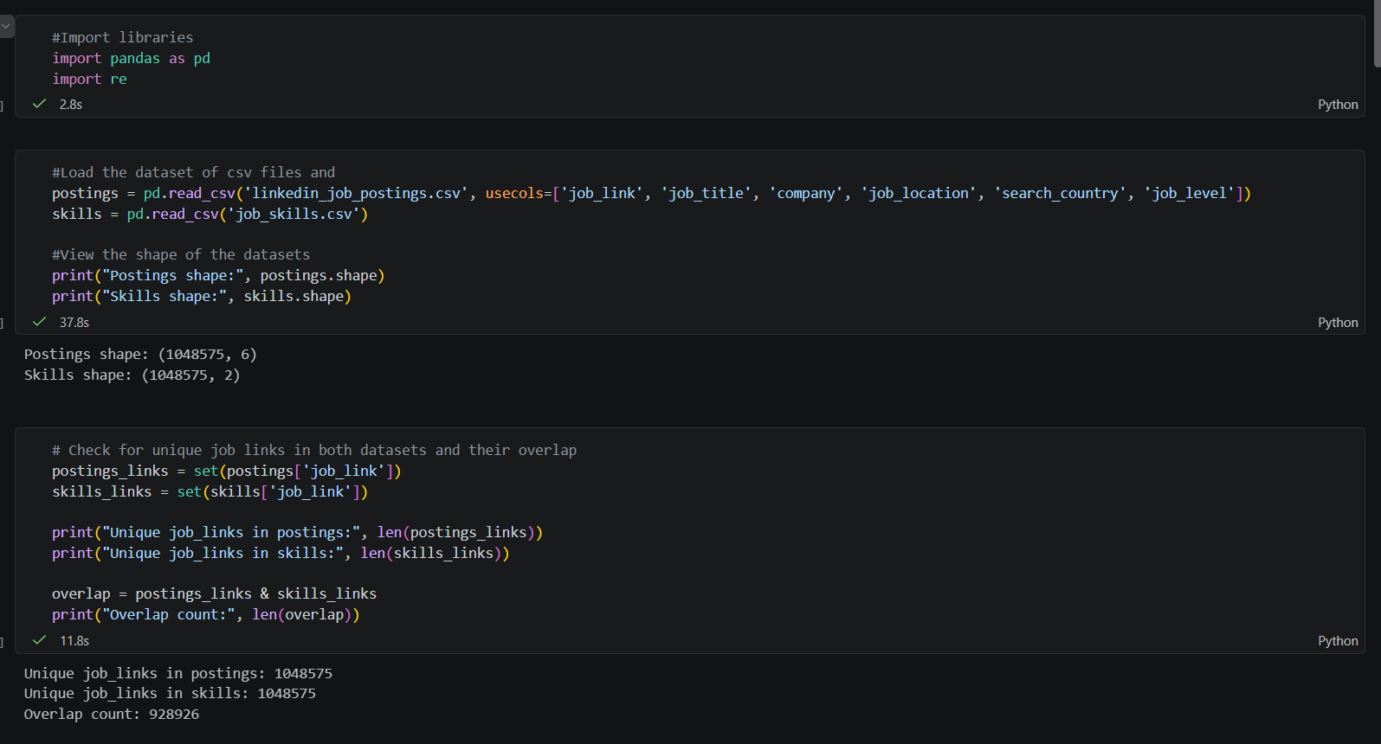

Data Integration: The pandas.merge( ) function was used to join two datasets on the shared job_link key, combining job title, location, company data with each posting’s required skills into a single data frame of 928,926 matched records.
Data Reduction: A .str.contains( ) regex filter was applied to job_title column using a list of IT-specific keywords (e.g., “software engineer”, “data analyst”) for reducing the dataset from all industries. Exclusion terms were also applied to remove false positives from unrelated fields.
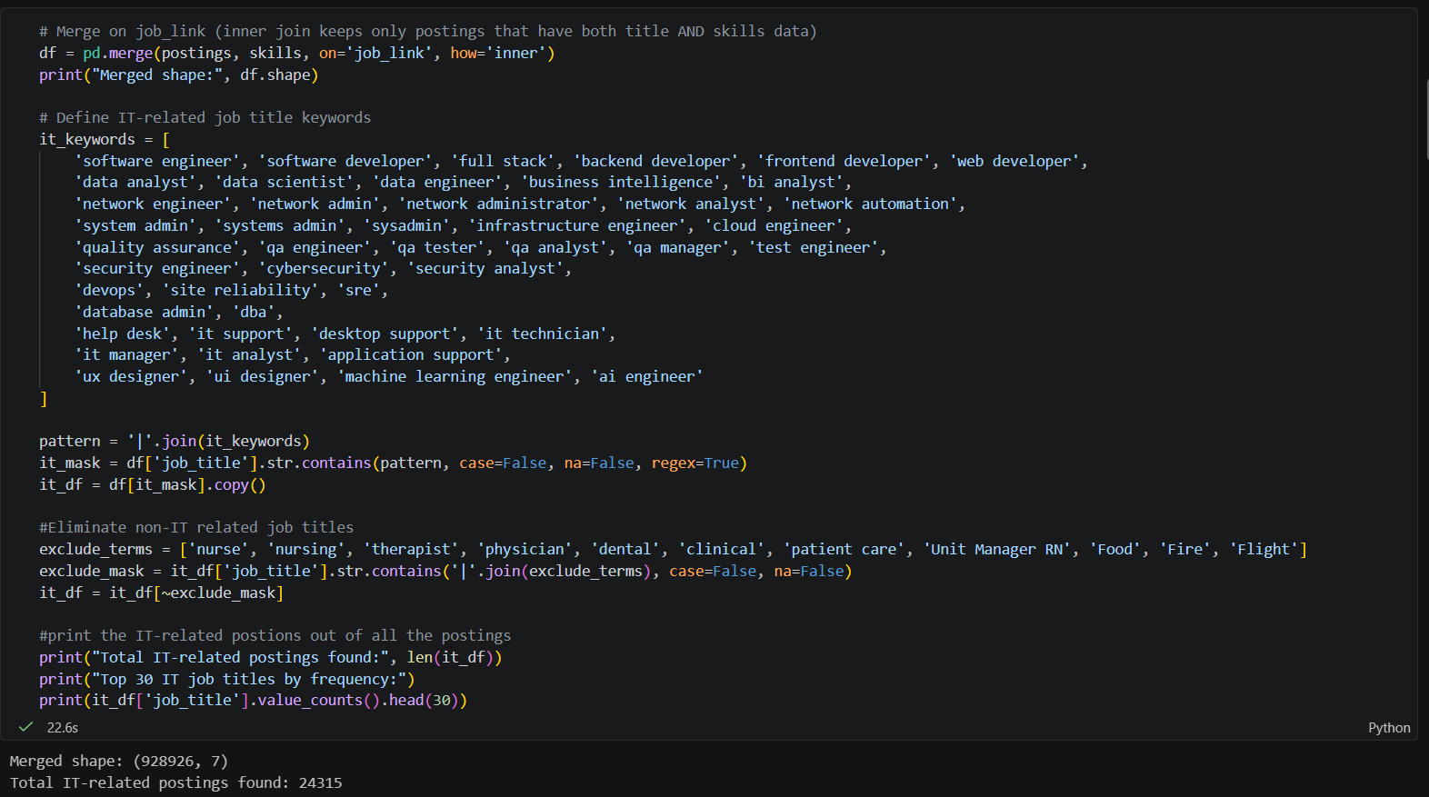

Data Transformation (Categorization): A custom Python function mapped each of the many raw job title variants (e.g., “Senior Software Engineer”, “Lead Software Engineer”) into 19 consolidated job role categories using keyword-based logic, enabling consistent comparison across roles.
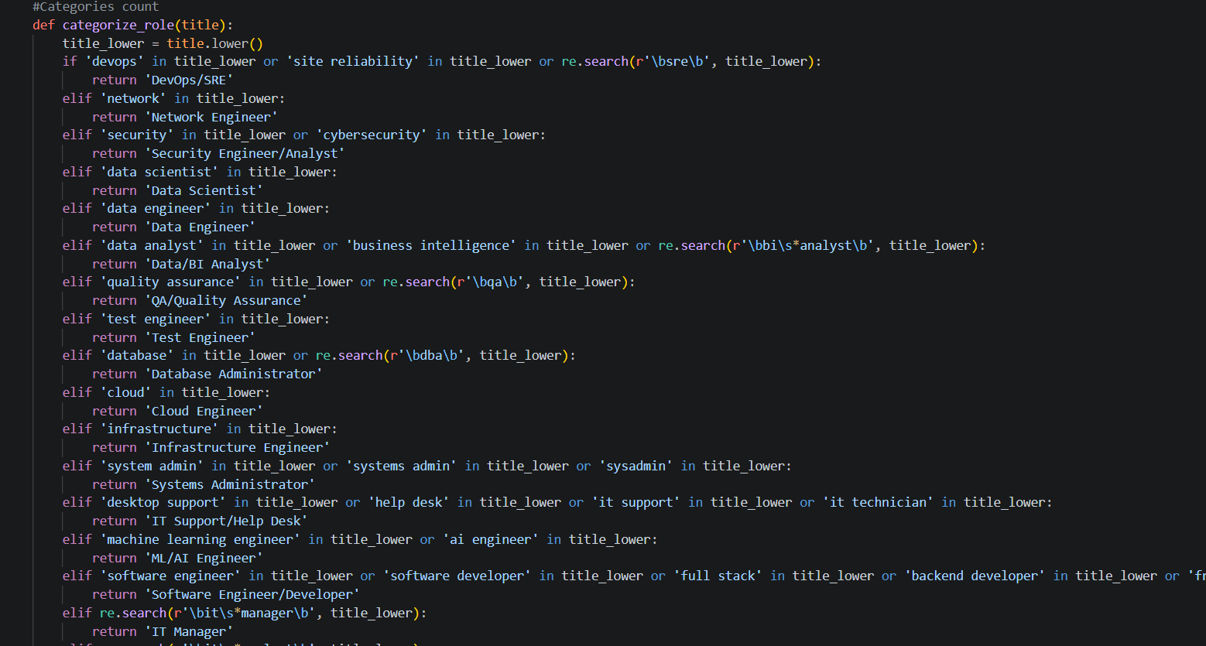
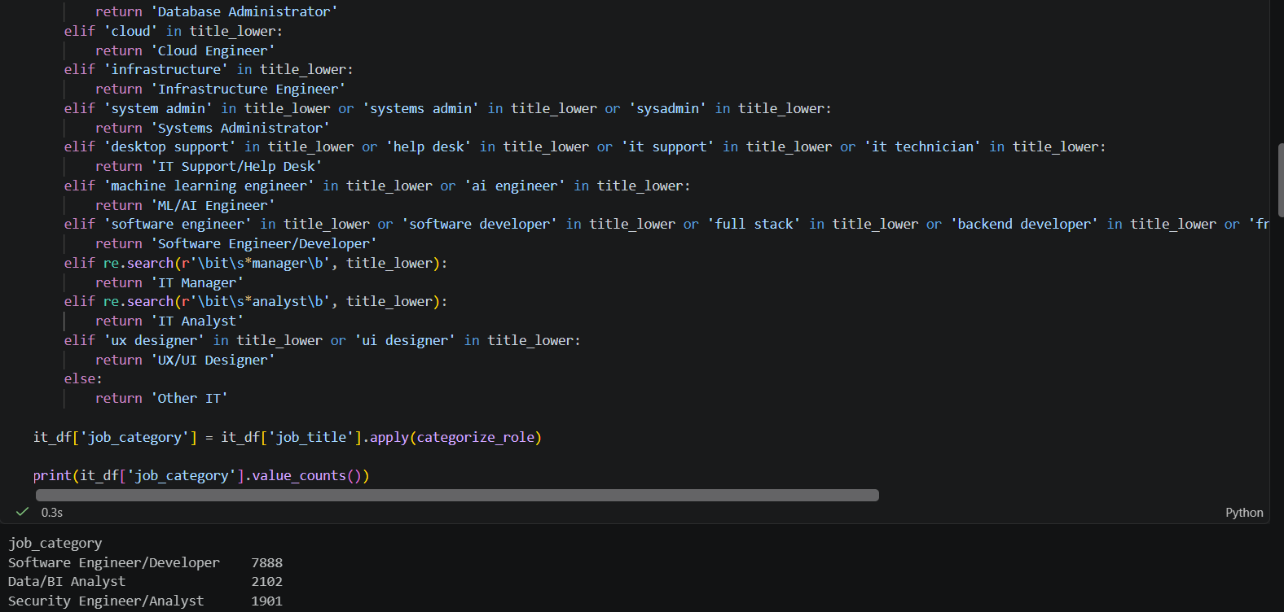

Data Transformation (List Conversion): The job_skills column, originally a single comma-separated text string per posting, was split into a Python list of individual skills using str.split(‘,’). It produces the item format required for association rule mining.
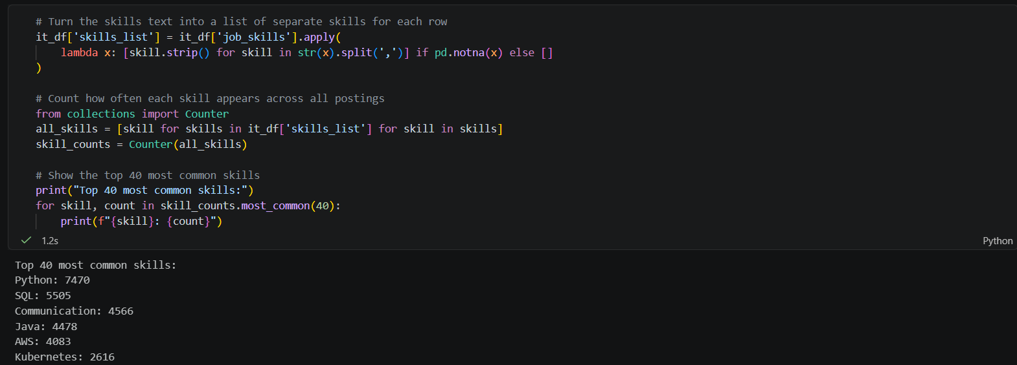

Data Discretization (AI Tagging): Each individual skill was labeled as either AI-related or Traditional by matching against a keyword dictionary (e.g., “machine learning”), and each posting was flagged with a has_ai_skill Boolean based on whether any AI-related skill was present.
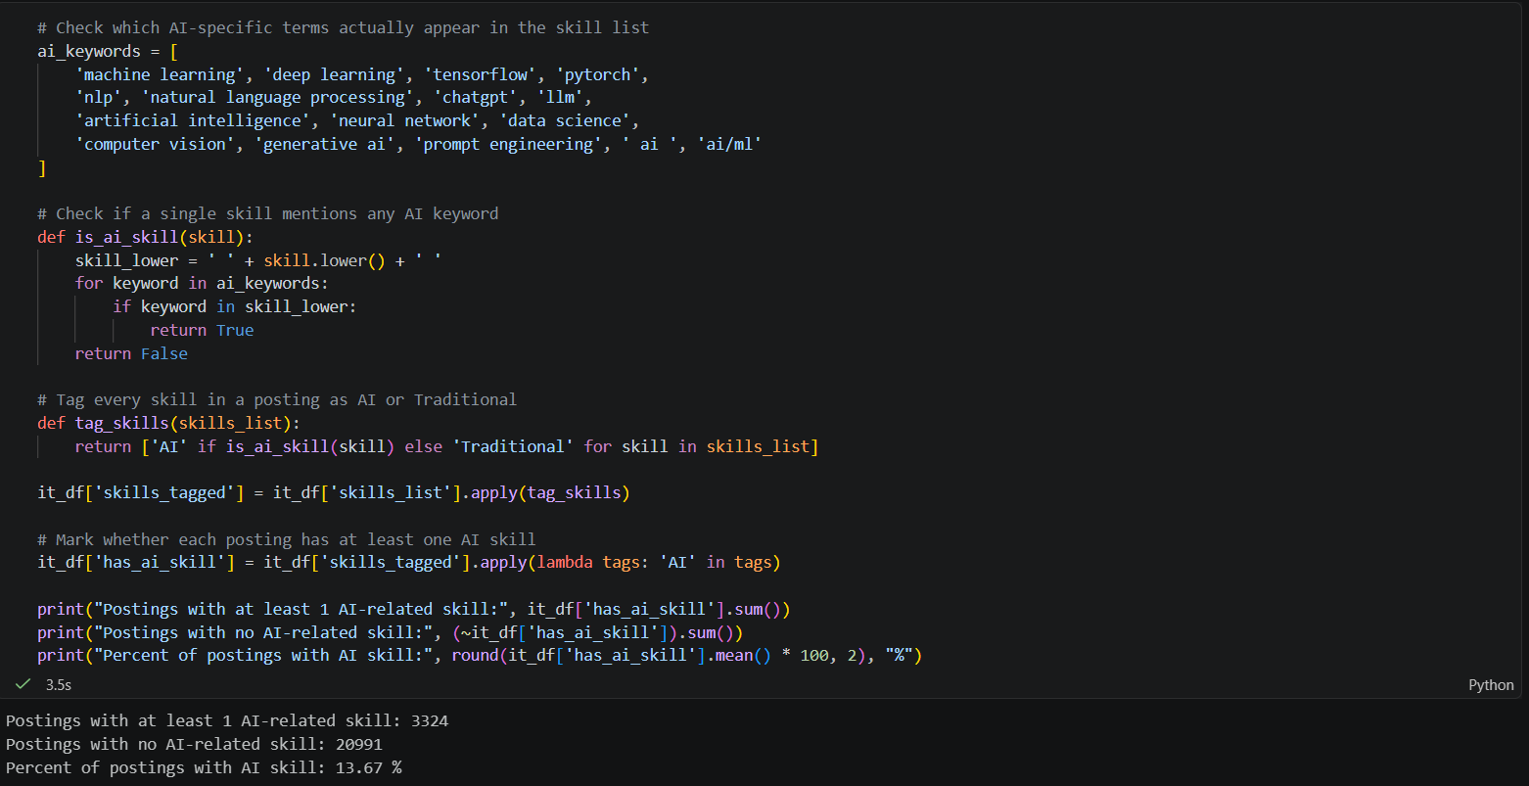
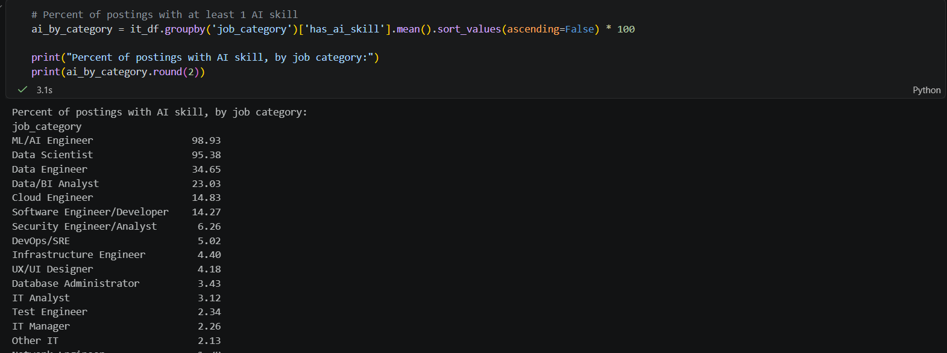

Data Cleaning: Postings with an empty skills list after splitting were removed and stray double-quoted characters within text fields were stripped of file-parsing errors.
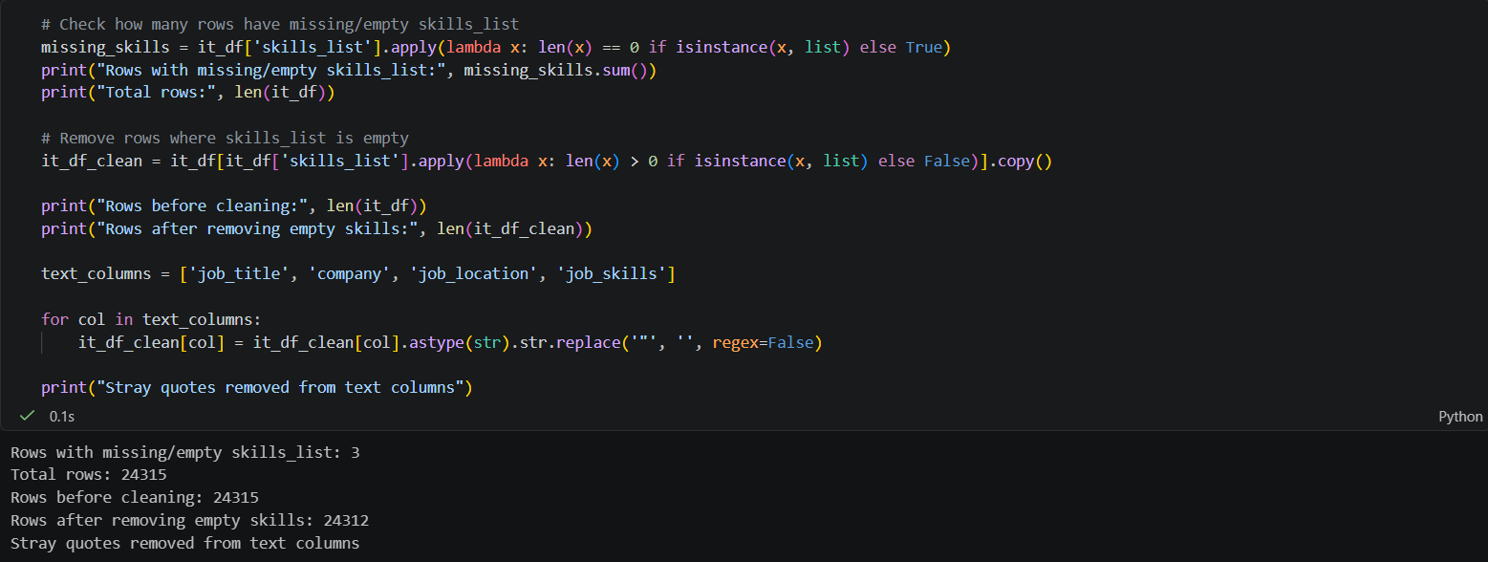
Export: The final processed dataset was exported and is ready to be imported into AI studio for the data mining phase.
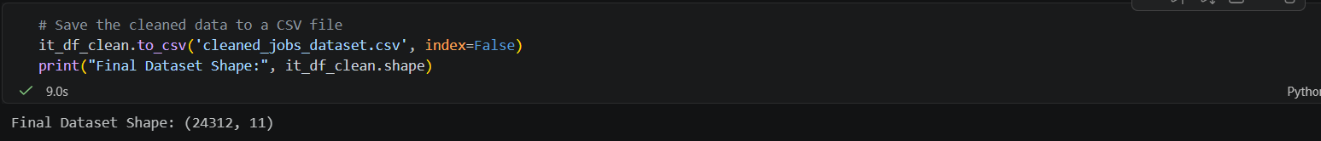

Data Mining (Association)
The cleaned data was loaded into a tool called RapidMiner Studio. It was processed using FP-Growth that finds common skill groups, and then Create Association Rules, which turns those groups into "if you have skill A, you probably also need skill B" rules.
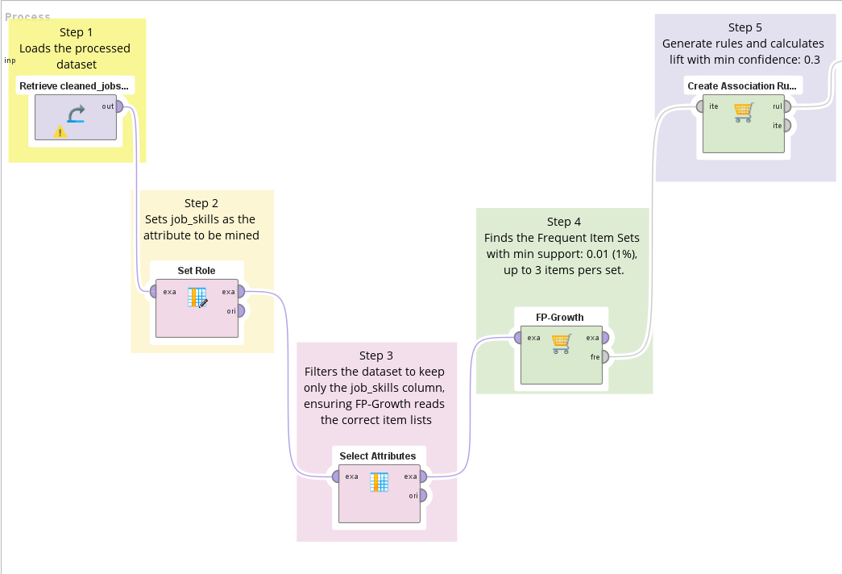

Step 1 (Retrieve): Loads the processed dataset that was exported from the Python ETL.
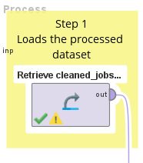
Step 2 (Set Role): Sets job_skills as the attribute to be mined, setting it as the target column for the association rule algorithm.
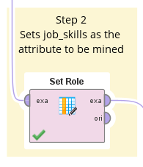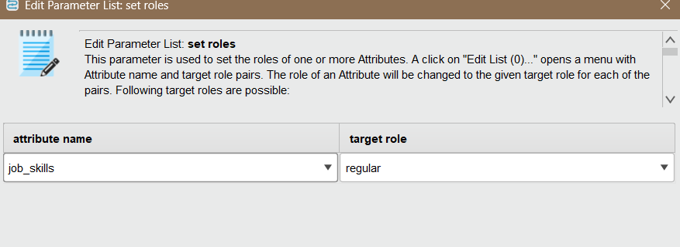
Step 3 (Select Attributes): Filters the dataset to keep only the job_skills column, ensuring FP-Growth reads the correct item list.
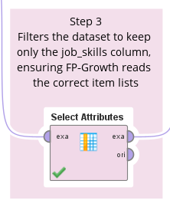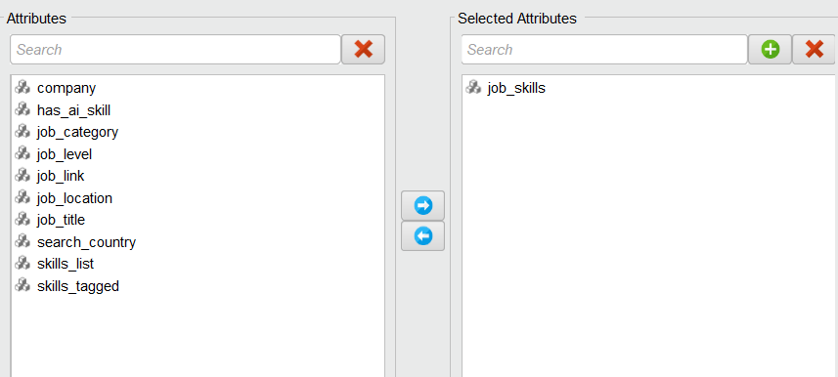
Technique: The Association Mining technique was used via the FP-Growth algorithm. FP-Growth efficiently identifies frequent item sets without needing to generate all possible combinations.
Step 4 (FP-Growth): Found the Frequent Item Sets. The Min Support was set to 0.01 to capture meaningful skill co-occurrence patterns without overwhelming the system, and item sets were capped at a maximum of 4 items pers set, resulting in 2,005 frequent item sets.
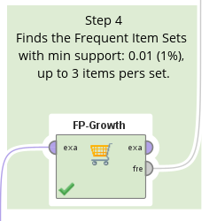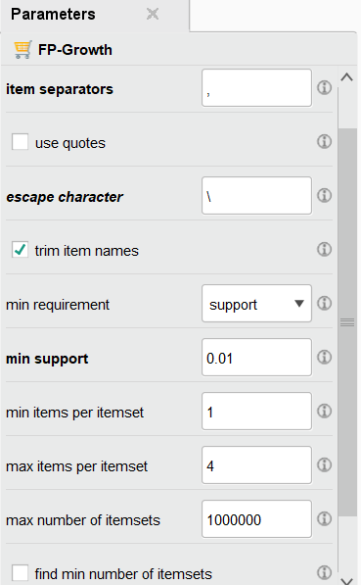
Step 5 (Create Association Rule): Generated the actionable rules and calculated Lift and Confidence. The Min Confidence was set to 0.3, with gain theta set to 2.0 and Laplace k set to 1.0 as default smoothing parameters.
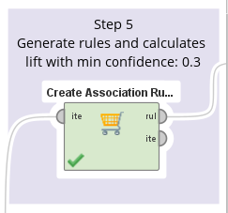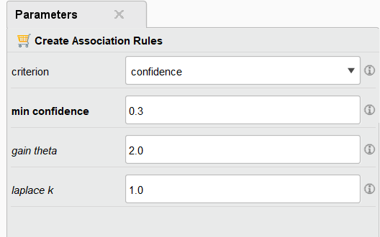

Output
FP-Growth: first identifies which skill combinations occur frequently enough in the dataset to be considered meaningful. This process found 2,005 frequent item sets, ranging from single skills up to combinations of 4 skills (Total Max. Size: 4).
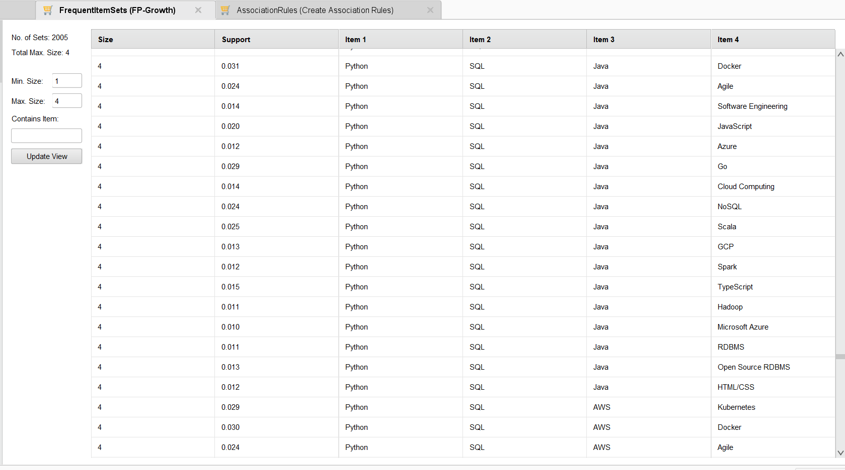

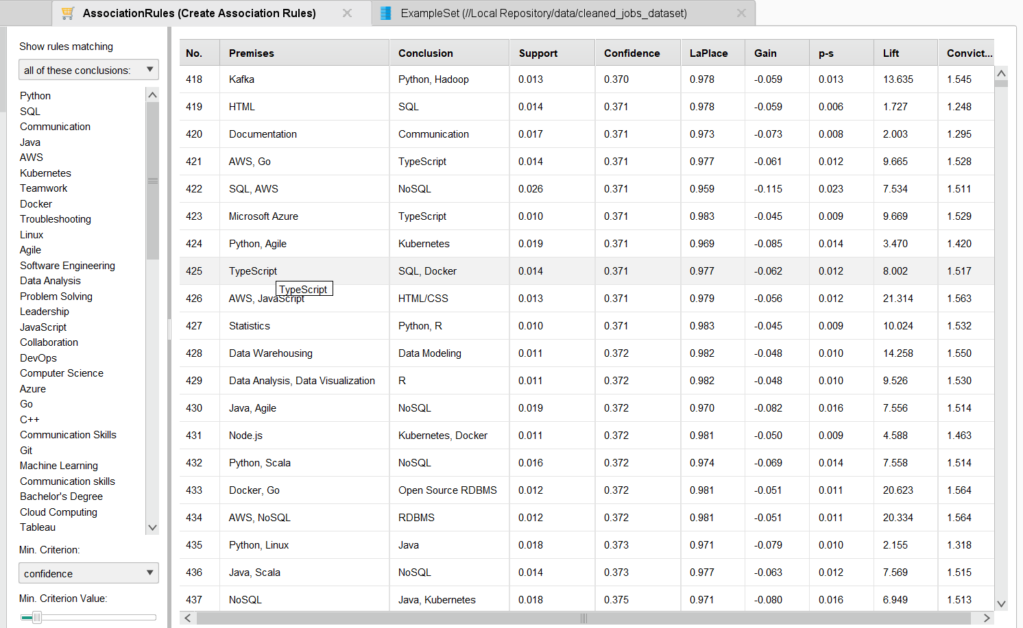
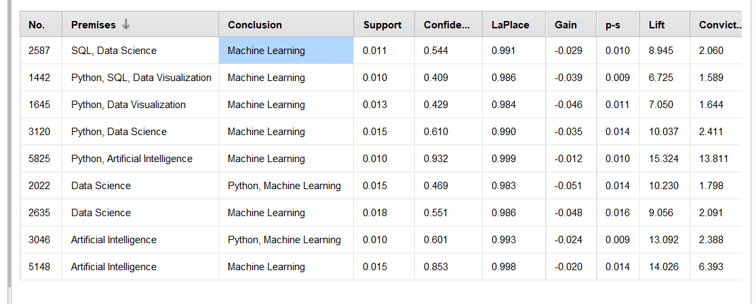
Association Rule: If a job posting requires Artificial Intelligence (premise), it also requires Machine Learning (conclusion) in 85.3% of cases, and this pattern appears in 1.5% of all postings.

Using LLM to Give Advice
- When a student enters their current skills and their target job, the system looks through the skill patterns and keeps only the ones that match the student's current skills. It then sorts them by confidence and lift and keeps the top 8.
- These top patterns are turned into simple written evidence and placed inside a message (called a prompt) that describes the student's skills, their target job, and the patterns found.
- This prompt is sent to Google's Gemini AI model (called gemini-3.6-flash). The AI is asked to reply with a simple list of 4 skills, each with a short, plain-English reason based on the evidence given.
- If the AI service has a temporary problem, the system automatically tries again, up to 3 times, waiting a little longer each time, before showing an error.

The Website
The system runs as a simple website made with Streamlit. A student types in their current skills and their target IT job. The website then shows a numbered list of skill suggestions with reasons, and a section the student can open to see the exact skill patterns (with confidence and lift numbers) used to make that suggestion. This way, the student can see why the AI made each suggestion, instead of just trusting it blindly.

How we Tested it
Testing was done in two ways:
(a) checking “support, confidence, and lift” from the Data Mining step
(b) manually checking the AI's final suggestions across several example students, some aiming for high-AI jobs and some aiming for low-AI jobs, explained more in Section 7.

System Architecture
The system works in five simple steps, moving from raw job data to a helpful, personal recommendation system:
Step | Tools Used
Cleaning the data | Python, pandas
Finding skill patterns | RapidMiner AI Studio (FP-Growth, Create Association Rule)
Making AI Recommendation | Google Gemini API (google-genai, gemini-3.6-flash)
Website | Streamlit
Keeping the API key safe | Python-dotenv (.env file)

Implementation
The project is built from two connected parts. The first part (ETL.ipynb, Final_project.rmp) creates Association_rules.csv and Frequent_item_sets.csv. The second part (skill_recommender.ipynb for testing, and webpage.py as the final website).

Step by Step: What Each Part of the Code Does

Step 1: Loads the outside code libraries needed later, such as pandas (for reading tables), dotenv (for reading the hidden API key file), and the Gemini AI tool.
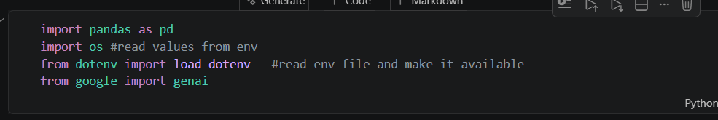

Step 2 (Load the API key): Reads the Gemini API key from the hidden .env file and starts a connection to Google's AI service. It also prints a quick check to confirm the key loaded correctly.
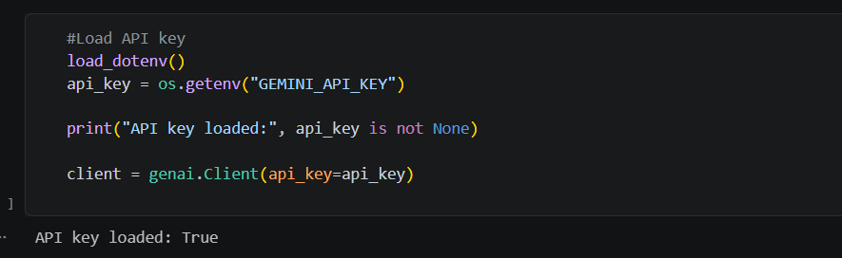

Step 3 (Load the skill patterns): Opens Association_rules.csv (the file exported from RapidMiner) into a table the code can work with and cleans up the column names.
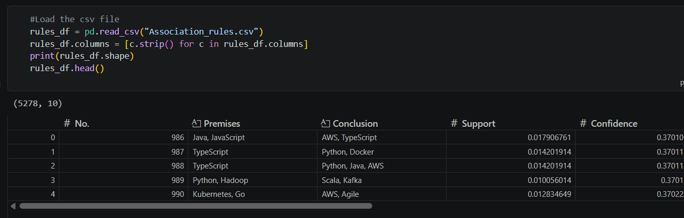

Step 4 (Filter the patterns): split_skills( ) turns a skill list like "SQL, Excel" into a clean list of separate words. Then, get_relevant_rules( ) keeps only the patterns that match the student's current skills, and sorts them so the strongest.
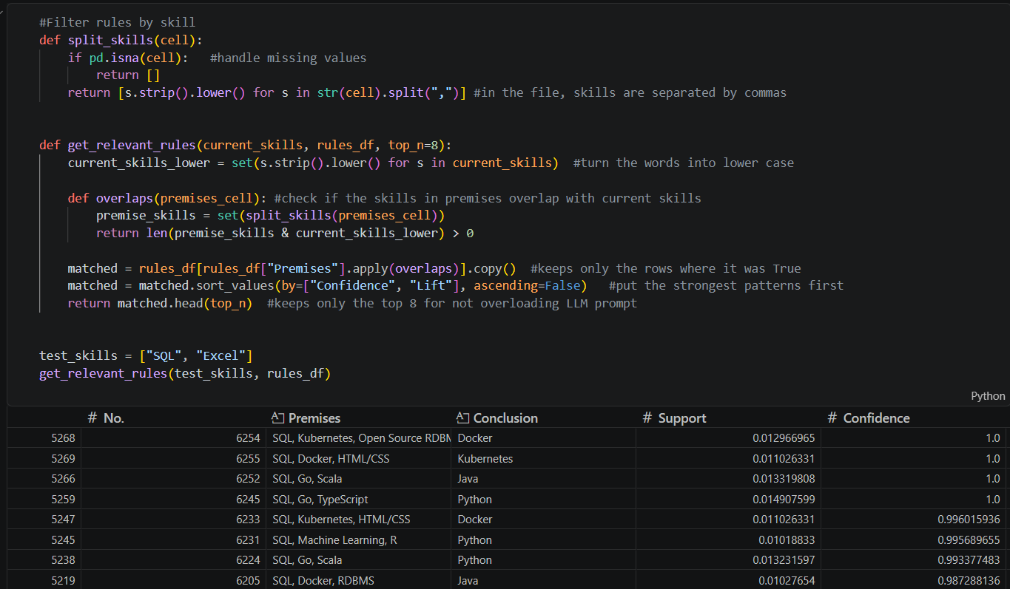

Step 5 (Build the message for the AI): build_prompt( ) takes the matched patterns and turns them into simple sentences (for example, "If someone has SQL, job postings often also require Python"), then places them inside one message that also includes the student's skills and target job.
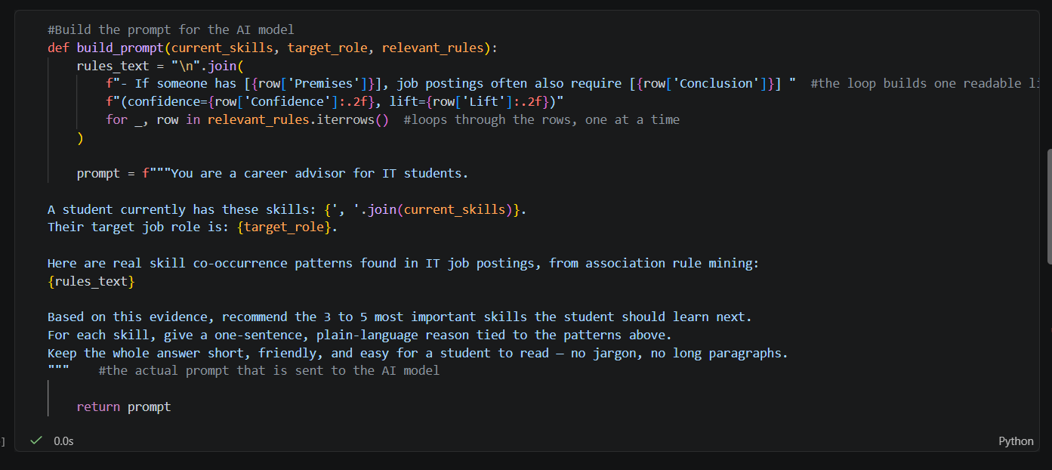

Step 6 (Ask the AI): get_recommendation( ) sends that message to the Gemini AI model and asks for a short list of 3 to 5 skills, each with a simple reason. The website version of this step also automatically retries a few times if the AI service is temporarily busy.
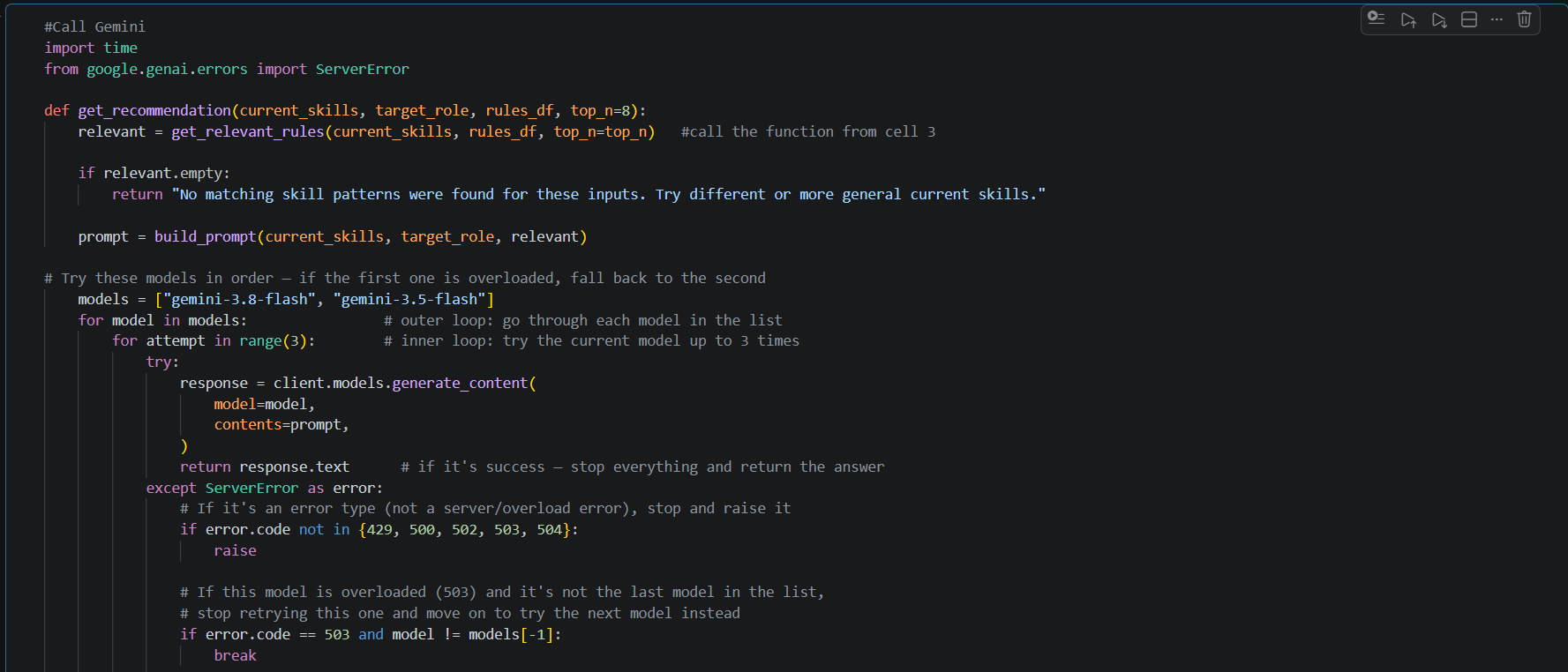
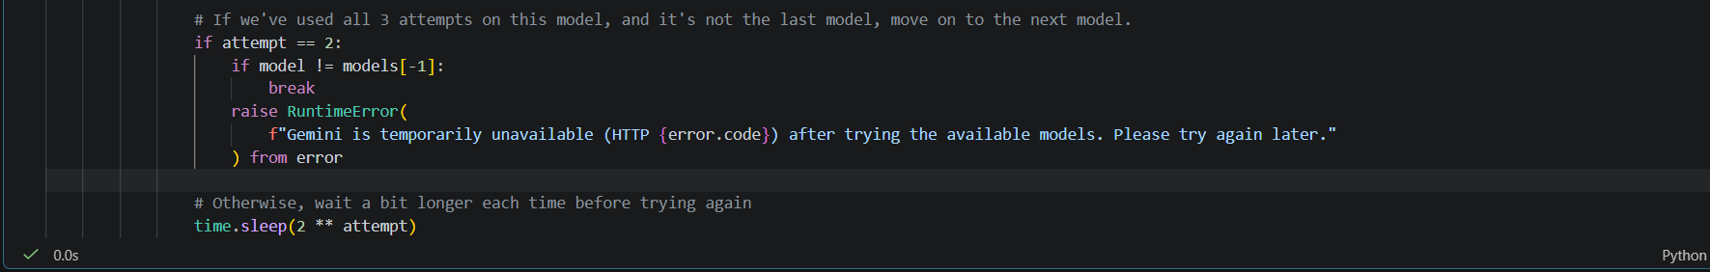
Step 7 (Testing): The last steps simply call get_recommendation( ) with example students (for example, someone who knows SQL and Excel aiming for Data Analyst) to check that the whole process works and gives a sensible answer.
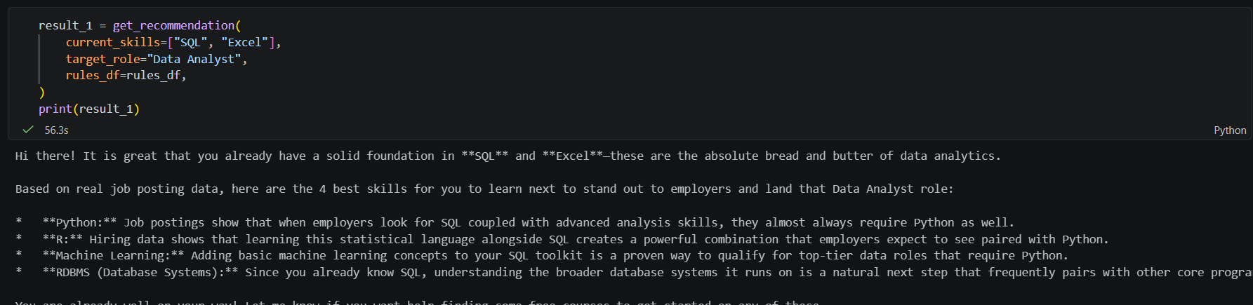
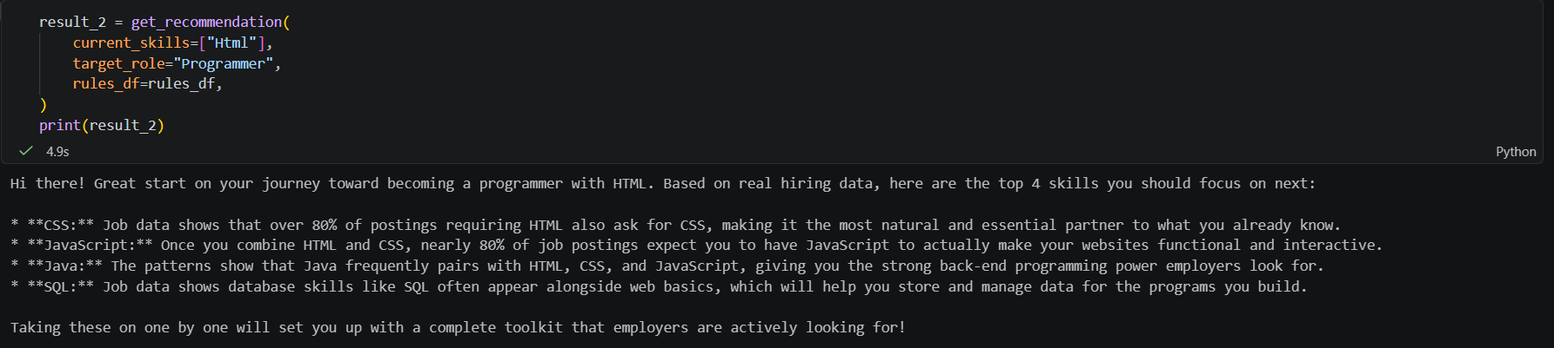
Step 8 (Creating webpage): The webpage is created by using Streamlit in “webpage.py”.
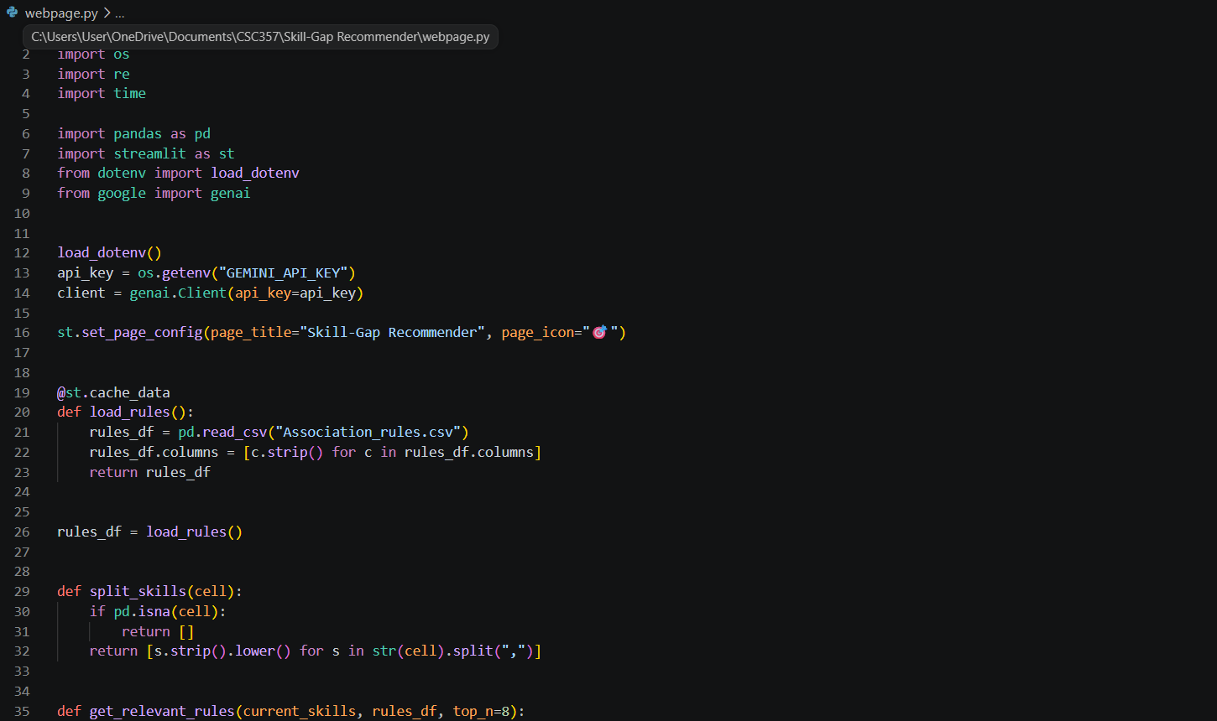
Step 9 (Running webpage): Run “python -m streamlit run webpage.py” in the terminal.
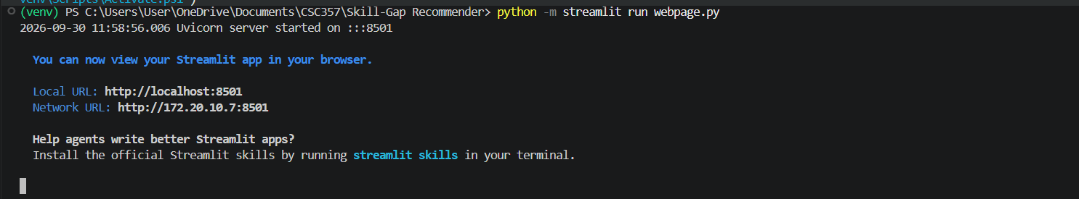

Keeping the Key Safe
The Gemini API key is kept in a separate file called .env, using a tool called python-dotenv. This file is never uploaded to GitHub, because it is listed inside .gitignore. This keeps API keys and passwords out of the submitted project. Anyone who wants to run this project just needs their own key and to install a few packages (google-genai, pandas, python-dotenv, streamlit).

Project Files
- Job_skills.csv & linkedin_job_postings.csv – the original datasets that is used for this project
- ETL.ipynb – Cleans the data and sorts jobs into IT categories
- Cleaned_jobs_dataset.csv – the cleaned, sorted job data
- Final_project.rmp – the RapidMiner steps (FP-Growth + Create Association Rules)
- Association_rules.csv & Frequent_item_sets.csv – The skill patterns found from Data Mining process
- Skill_recommender.ipynb – the LLM recommendation code and test examples
- webpage.py – the final website that students can use

Results / Evaluation

What the Data Mining Found
The skill pattern results directly answer this project's main question. As Table 1 shows, AI skills are mostly needed in a small group of jobs (ML/AI Engineer, Data Scientist), somewhat needed in related data jobs (Data Engineer, Data/BI Analyst, Cloud Engineer, Software Engineer/Developer), and almost never needed in hands-on jobs (QA, IT Support, Systems Administrator, Network Engineer). This proves that AI is not changing every IT job the same way, which is exactly the idea this whole project is based on.

Example Result
For a student who already knows SQL and Excel and wants to become a Data Analyst, the system suggested:
- Python (because SQL often appears together with programming skills in job posts)
- R (because SQL and R often appear together in data jobs)
- Machine Learning (because it often appears together with SQL and R in more advanced data jobs)
- RDBMS (because strong database knowledge naturally goes with SQL).
Every suggestion was backed by a real pattern, with its confidence and lift numbers shown to the student in the "evidence" section.
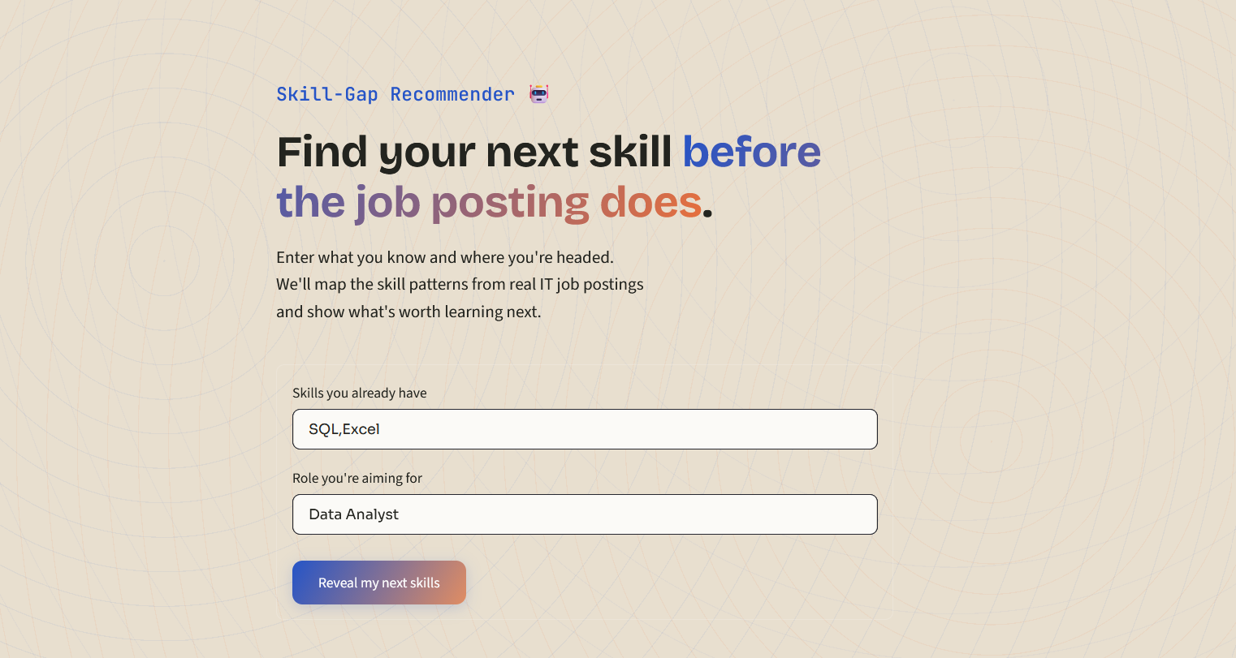
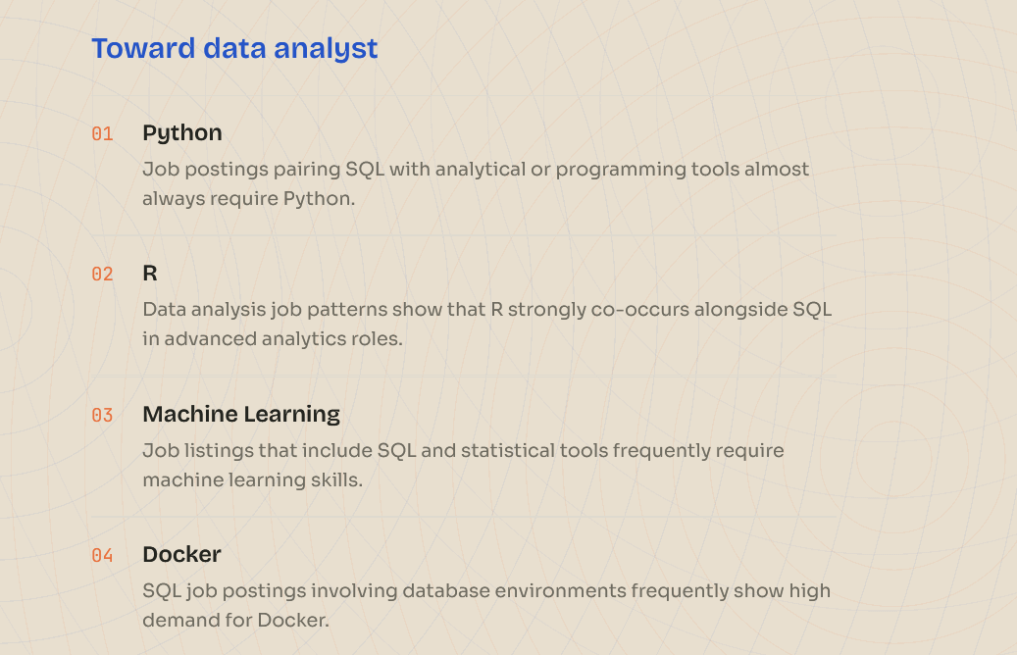
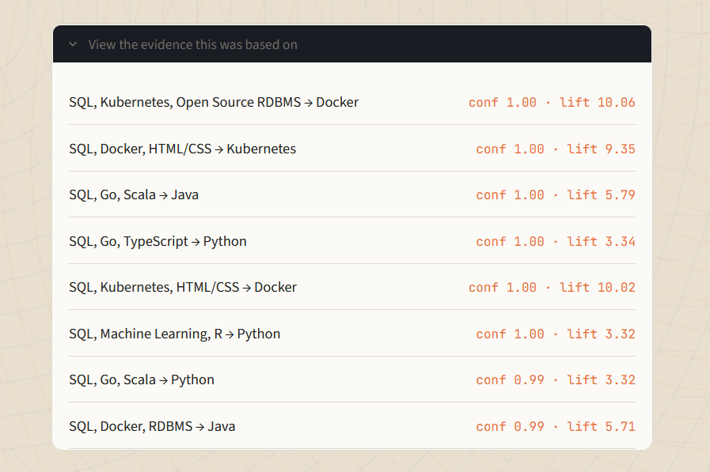

Testing Across Different Jobs
The system was also tested with students aiming for different job types: some with high AI use (Data Scientist, Data/BI Analyst) and some with low AI use (QA/Quality Assurance, Network Engineer, Systems Administrator, DevOps/SRE). For high-AI jobs, the suggestions usually included AI-related skills. For low-AI jobs, the suggestions stayed mostly traditional, or the system said it could not find a strong pattern. This matches what Table 1 already showed, proving that the tool's answers change based on real data, not random guesses.
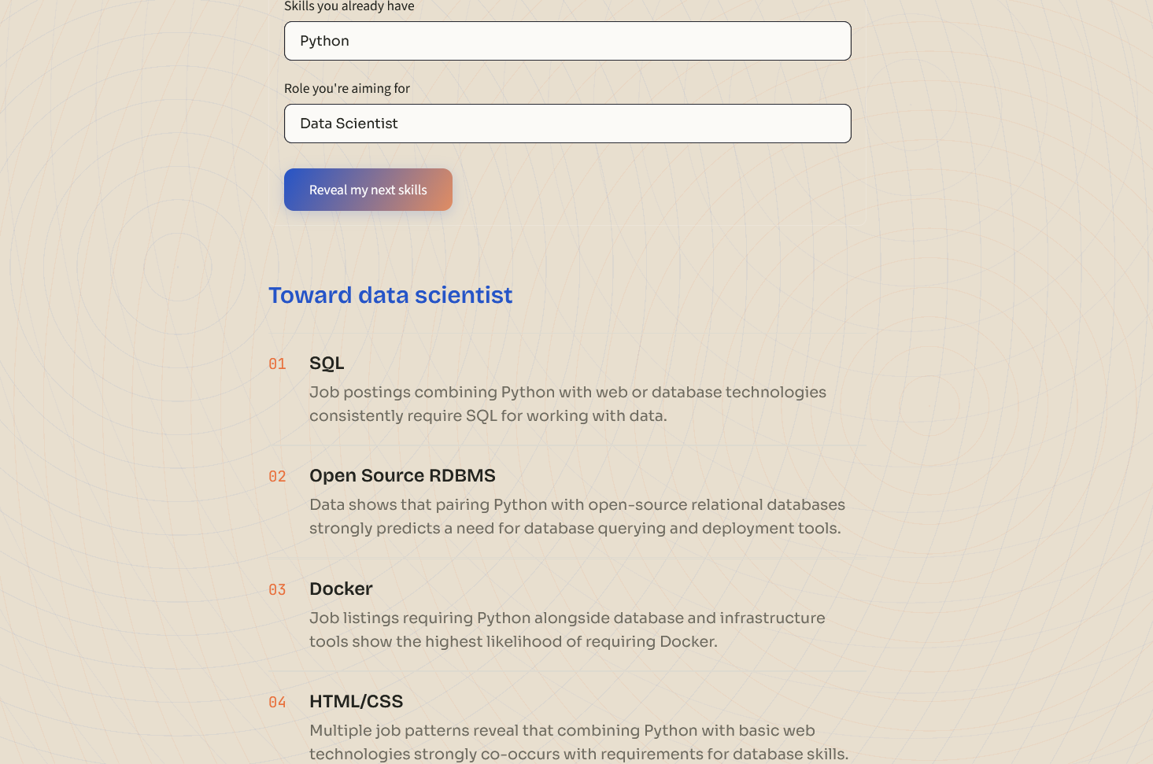
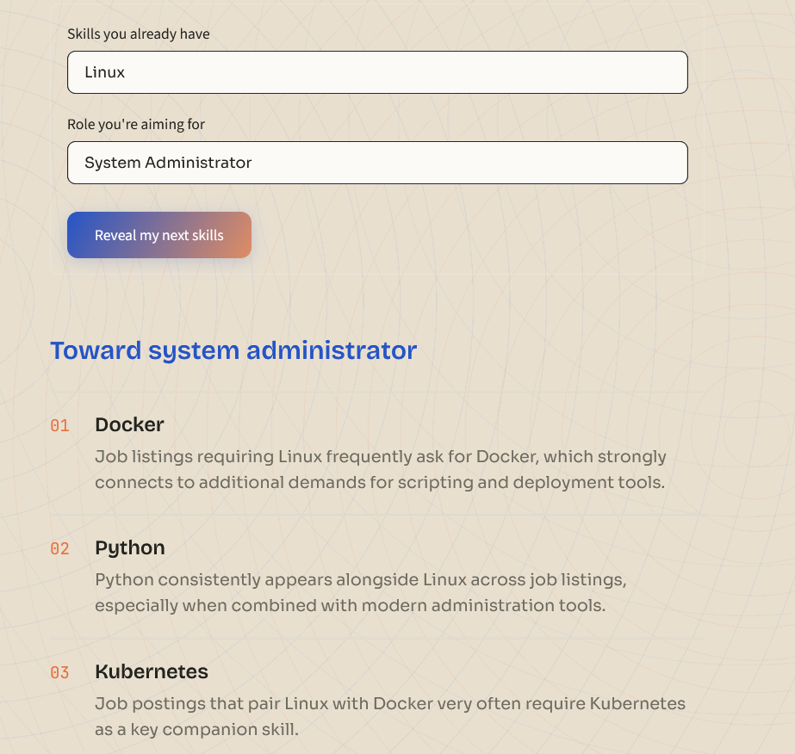

How Testing Was Done
Testing in this project was done by checking and reading results carefully, not through a big formal study. The skill patterns were checked using normal numbers like support, confidence, and lift. The final AI suggestions were checked by reading through several example students and making sure the answers made sense and matched the real data. There were no big groups of test users and no official scoring system, which is explained more in the next section.

Limitations
- There was no big, formal test (like comparing results to expert answers or asking a group of real users). Testing was done by carefully checking a small number of examples.
- The settings used to find skill patterns were chosen to keep the number of patterns manageable. This means some rare but possibly useful skill patterns were left out, so unusual skill combinations sometimes get no result at all.
- The skill list only includes exactly what was written in the job posts. Similar skills (like "SQL" and "RDBMS") are treated as different, which suggestions can sometimes feel repeated.
- AI skills were found using a fixed list of keywords. This means some AI skills written in an unusual way might have been missed, since the list is not perfect or complete.
- The Gemini AI model changed while this project was being built (an older model stopped working), and the AI service can sometimes fail for a short time. The system tries again automatically, but if it still fails after 3 tries, there is no other backup plan.

Conclusion

