IEFBR14

- Null or dummy program used to allocate or delete datasets.

//CREATE JOB A50,’ARICH’
//STEP3 EXEC PGM=IEFBR14
//DD1 DD DSN=COBOL.DATA1,DISP=(NEW,KEEP),UNIT=SYSDA,
// SPACE=(TRK,(4,2)),
// DCB=(LRECL=80,RECFM=FB,BKSIZE=800)
//

In this example a dummy data set called COBOL.DATA1 is created. This is a new data set and is to be kept after termination of the job. It is to reside on the SYSDA, and will be allocated 4 tracks of primary space and 2 tracks of secondary space. It will have a logical record length of 80 bytes, a fixed block format, and a block size of 800 bytes.

IEBGENER

- Copies sequential data sets from one device to another
- Create a PDS from a sequential dataset
- Expand or add members to a PDS
- Produce an edited dataset
- Reblock or change logical record lengths of a dataset

Example 1;

// JOB CARD
// STEP1 EXEC PGM=IEBGENER, REGION=0M
// SYSPRINT DD SYSOUT=*
// SYSUT1 DD DSN=DSNNAME, DISP=SHR INPUT DATA
// SYSUT2 DD DSN=DSNNAME, DISP=SHR OUTPUT DATA
// SYSIN DD DUMMY
//

Example 2:

//CSNEW86A JOB A123,SRIRAM,CLASS=M,MSGCLASS=T,MSGLEVEL=(1,1),
// NOTIFY=CSNEW86,TIME=1
//STEP1 EXEC PGM=IEBGENER
//SYSOUT DD SYSOUT=*
//SYSPRINT DD SYSOUT=*
//SYSUT1 DD DSN=CSNEW86.EXERCISE.PDS(EMP1),DISP=SHR
// DD DSN=CSNEW86.EXERCISE.PDS(EMP2),DISP=SHR
//SYSUT2 DD DSN=CSNEW86.EXERCISE.PDS(EMP4),DISP=SHR,
// LIKE=CSNEW86.FILE1.PS
//SYSIN DD DUMMY
//

IEBCOPY for partitioned data sets

- Backup (unload)
- Restore (reload)
- Copy
- Compress
- Updates
Example 1:
// JOB CARD
// STEP1 EXEC PGM=IEBCOPY, REGION=0M
// SYSPRINT DD SYSOUT=*
// DD1 DD DSN=Esm1, DISP=SHR INPUT DATA
// DD2 DD DSN=ESM2, DISP=NEW,unit=tape1 OUTPUT DATA
// SYSIN DD*
COPY INDD=DD1,OUTDD=DD2
/*
//
The first dataset is defined in the DD1 statement. this file is shared among users. The characteristics of the second dataset is defined in the DD2 statement.

//SYSIN DD *
COPY INDD=DD1,OUTDD=DD2
/*

This statement specifies that the dataset defined DD! Will be input data set while that defined DD2 will be the output data set. ESM1 will be copied into ESM2.

Compressing data sets

// STEP1 EXEC PGM=IEBCOPY, REGION=0M
// SYSPRINT DD SYSOUT=*
// DD1 DD DSN=COBOL.ESM1, DISP=SHR INPUT DATA
// SYSIN DD*
COPY INDD=DD1,OUTDD=DD1
/*
//

If you take look at this JCL u will realize that both the INDD & OUTDD statements reference the same dataset. Ie. The one defined in the DD1 statement. Executing this job will result in all members of the partitioned data set called COBOL.ESM1being compressed together, resulting in the release of wasted space between records and data set members.

Example 2:

//CSNEW86A JOB A123,SRI,CLASS=M,MSGCLASS=T,NOTIFY=CSNEW86,
// MSGLEVEL=(1,1),TIME=1
//STEP1 EXEC PGM=IEBCOPY
//SYSPRINT DD SYSOUT=*
//SYSOUT DD SYSOUT=*
//DD1 DD DSN=CSNEW87.OJT.PDS,DISP=SHR
//DD2 DD DSN=CSNEW86.OJT.PDS,DISP=(NEW,CATLG,DELETE),
// LIKE=CSNEW86.EXERCISE.PDS
//SYSIN DD *
COPY INDD=DD1,OUTDD=DD2
/*
//

IEBCOMPR

- Compare one PDS to another
- Compare one sequential dataset to another sequential dataset on a record by record basis.

Example 1:

//JOB1 JOB A50,’ARICH’
// STEP1 EXEC PGM=IEBCOMPR, REGION=0M
// SYSPRINT DD SYSOUT=*
// DD1 DD DSN=ESM1.SOURCE, DISP=SHR
// DD2 DD DSN=ESM2.SOURCE, DISP=SHR
// SYSIN DD*
COMPARE TYPORG=PO
/*
//

Example 2:

//CSNEW86A JOB A123,SRI,CLASS=M,MSGCLASS=T,NOTIFY=CSNEW86,
// MSGLEVEL=(1,1),TIME=1
//STEP1 EXEC PGM=IEBCOMPR
//SYSPRINT DD SYSOUT=*
//SYSOUT DD SYSOUT=*
//SYSUT1 DD DSN=CSNEW86.EXERCISE.PDS(EMP3),DISP=SHR
//SYSUT2 DD DSN=CSNEW86.EXERCISE.PDS(EMP4),DISP=SHR
//SYSIN DD *
COMPARE TYPORG=PS
/*
//

IEBEDIT

- Copy Job Steps.
- Create an Output Job Stream.
- Edit and Copy a Job Stream.

Example 1: Copy One Job

In this example, one job (JOBA), including all of its job steps, is copied into the output data set. The input data set contains three jobs: JOBA, JOBB and JOBC.

//EDIT1 JOB ...
//STEP1 EXEC PGM=IEBEDIT
//SYSPRINT DD SYSOUT=A
//SYSUT1 DD DSNAME=INJOBS,UNIT=tape,
// DISP=(OLD,KEEP),VOL=SER=001234
//SYSUT2 DD DSNAME=OUTTAPE,UNIT=tape,DISP=(NEW,KEEP),
// VOL=SER=001235,DCB=(RECFM=FB,LRECL=80,BLKSIZE=80),
//SYSIN DD *
EDIT START=JOBA
/*

The control statements are discussed below:

- SYSUT1 DD defines the input data set, INJOBS. The data set resides on a standard labeled tape volume (001234).
- SYSUT2 DD defines the output data set, called OUTTAPE. The data set is to reside as the first data set on a standard labeled tape volume (001235). The system will select an optimal block size.
- SYSIN DD defines the control data set, which follows in the input stream.
- EDIT indicates that JOBA is to be copied in its entirety.

IEHPROGM

- Scratches datasets or members of a PDS on a DASD vol.
- Renames datasets or members
- Catalogs or Uncatalogs a dataset
- Builds or deletes a catalog index
- Builds or deletes a generation index (define GDG)

Example 1: IEHPROGM (FOR CATALOGING DATA SETS)

//IEH JOB A50,’ARICH’
//S1 EXEC PGM=IEHPROGM
//SYSPRINT DD SYSOUT=*
//SYSUT1 DD UNIT=3390, VOL=SER=SMS005
//SYSUT2 DD UNIT=TAPE,VOL=SER=SMS007
//SYSIN DD *
CATLG DSNAME=DATA1,VOL=SER=SMS007
/*
//

In SYSUT1 and the permanently mounted unit, is identified. This is the volume called SMS005. In SYSUT2 the location of the data set that is to be cataloged is identified. The data set resides on volume SMS007 of the device called TAPE. CATLG statement identifies the name of the file (DATA1) and the device and serial number that it currently resides on.

Example 2:

//CSNEW86A JOB A123,SRI,CLASS=M,MSGCLASS=T,NOTIFY=CSNEW86,
// MSGLEVEL=(1,1),TIME=1
//STEP1 EXEC PGM=IEHPROGM
//SYSPRINT DD SYSOUT=*
//SYSOUT DD SYSOUT=*
//* *********** TO RENAME ******************
//* DD1 DD DISP=SHR,UNIT=3390,VOL=SER=SMS004
//*SYSIN DD *
//* RENAME MEMBER=E2,DSNAME=CSNEW86.EXERCISE.PDS, X
//* VOL=3390=DEV003,NEWNAME=EMP2
//* /*
//* ************* TO SCRATCH *******************
//*SYSIN DD *
//* SCRATCH MEMBER=EMP4,DSNAME=CSNEW86.EXERCISE.PDS,VOL=3390=DEV003
//* /*
//* *********** TO CATALOG **************
//*SYSIN DD *
//* CATLG DSNAME=CSNEW86.SAMPLE.PDS,VOL=3390=SMS003
//* /*
//* ************ TO UNCATALOG ***********
//SYSIN DD *
UNCATLG DSNAME=CSNEW86.BACKUP.PDS
/*
//

IEHINITT

- Label Magnetic Tape Volumes.

Example 1:

In this example, serial numbers 001234, 001235 and 001236 are placed on three tape volumes. The labels are written in EBCDIC at 800 bits per inch. Each volume labeled is mounted, when it is required, on a single 9-track tape unit.

//LABEL1 JOB ...
//STEP1 EXEC PGM=IEHINITT
//SYSPRINT DD SYSOUT=A
//LABEL DD DCB=DEN=2,UNIT=(tape,1,DEFER)
//SYSIN DD *
LABEL INITT SER=001234,NUMBTAPE=3
/*

The control statements are discussed below:

- LABEL DD defines the tape unit used in the labeling operation.
- SYSIN DD defines the control data set, which follows in the input stream.
- LABEL INITT specifies the number of tapes to be labeled (3), beginning with 001234.

IEHLIST

- List all or part of a catalog
- List the entries of a directory in a PDS
- List the VTOC of a DASD volume or dataset

Example 1:

An CVOL named SYSCTLG.V111111, residing on a disk volume (111111), is listed.

//CATLIST JOB ...
//STEP1 EXEC PGM=IEHLIST
//SYSPRINT DD SYSOUT=A
//DD2 DD UNIT=disk,VOLUME=SER=111111,DISP=OLD
//SYSIN DD *
LISTCTLG VOL=disk=111111
/*

IEBIMAGE

- Create a Copy Modification Module.
- Create a Character Arrangement Table Module.
- Create a 3800 or 4248 Forms Control Buffer Module.
- Create a Graphic Character Modification Module.
- Create a Library Character Set Module.

Example:

The vertical spacing and channel codes for an 11-inch form are specified, and the module is added to the SYS1.IMAGELIB data set as a new member.

//FCBMOD1 JOB ...
//STEP1 EXEC PGM=IEBIMAGE
//SYSUT1 DD DSNAME=SYS1.IMAGELIB,DISP=OLD
//SYSPRINT DD SYSOUT=A
//SYSIN DD *
FCB CH1=1,CH12=80,LPI=8
NAME IJ
/*

The control statements are discussed below:

- The SYSUT1 DD statement includes DISP=OLD to ensure that no other job can modify the data set while this job is executing.
- CH1=1 specifies channel 1 code for line 1, allowing for positioning at line 1.
- CH12=80 specifies channel 12 code for line 80, allowing for positioning at line 80 and a unit exception indication at line 80 (the last printable line on the page.)
- LPI=8 specifies that the entire form is to be at a vertical spacing of 8 lines per inch. Because the SIZE parameter is omitted, the form length defaults to 11 inches. Because there are 10 inches of printable space in an 11-inch form, 80 lines are printed at 8 lines per inch.
- The name of the new FCB module is IJ; it is stored as a member of the SYS1.IMAGELIB data set.

IEHMOVE

- Copy a Volume of Data Sets (on Tape or Disk).
- Load an Unloaded Data Set.
- Move a Volume of Data Sets.
- Move Partitioned Data Sets.
- Move Sequential Data Sets.
- Unload a Sequential Data Sets.

Example :

In this example, three sequential data sets (SEQSET1, SEQSET2, and SEQSET3) are moved from a disk volume to three separate disk volumes. Each of the three receiving volumes is mounted when it is required by IEHMOVE. The source data sets are not cataloged. Space is allocated by IEHMOVE.

//MOVEDS JOB ...
//STEP1 EXEC PGM=IEHMOVE
//SYSPRINT DD SYSOUT=A
//SYSUT1 DD UNIT=disk,VOLUME=SER=333333,DISP=OLD
//DD1 DD UNIT=disk,VOLUME=SER=111111
//DD2 DD UNIT=(disk,,DEFER),DISP=OLD,
// VOLUME=(PRIVATE,,SER=(222222))
//DD3 DD VOLUME=(PRIVATE,RETAIN,SER=(444444)),
// UNIT=disk,DISP=OLD
//SYSIN DD *
MOVE DSNAME=SEQSET1,TO=disk=222222,FROM=disk=444444
MOVE DSNAME=SEQSET2,TO=disk=222333,FROM=disk=444444
MOVE DSNAME=SEQSET3,TO=disk=222444,FROM=disk=444444
/*

The control statements are discussed below:

- SYSUT1 DD defines the disk device that is to contain the work data set.
- DD1 DD defines the system residence device.
- DD2 DD defines the device on which the receiving volumes will be mounted as they are required.
- DD3 DD defines a device on which the source volume is mounted. Because the RETAIN subparameter is included, the volume remains mounted until the job has completed.
- SYSIN DD defines the control data set, which follows in the input stream.
- MOVE moves the source data sets to volumes 222222, 222333, and 222444, respectively. The source data sets are scratched.

IEBUPDTE

- Changes Data Set Organisation.
- Enter a Procedure into a Procedure Library.
- Include Changes to Members or Sequential Data Sets.
- Insert Records into a Partitioned Data Sets or PDSE
- Modify Partitioned or Sequential Data Sets or a PDSE

Example :

In this example, a block of three logical records is inserted into an existing member, and the updated member is placed in the existing partitioned data set.

//UPDATE JOB ...
//STEP1 EXEC PGM=IEBUPDTE,PARM=MOD
//SYSPRINT DD SYSOUT=A
//SYSUT1 DD DSNAME=PDS,UNIT=disk,DISP=(OLD,KEEP),
// VOLUME=SER=111112
//SYSUT2 DD DSNAME=PDS,UNIT=disk,DISP=(OLD,KEEP),
// VOLUME=SER=111112
//SYSIN DD *
./ CHANGE NAME=RENUM,LIST=ALL,LEVEL=01,SOURCE=0
./ NUMBER SEQ1=15,NEW1=20,INCR=5,INSERT=YES

(Data statement 1)
(Data statement 2)
(Data statement 3)

/*

The control statements are discussed below:

- SYSUT1 and SYSUT2 DD define the partitioned data set (PDS).
- SYSIN DD defines the control data set, which follows in the input stream.
- The CHANGE function statement identifies the input member RENUM. The entire member is listed in the message data set.
- The NUMBER detail statement specifies the insert operation and controls the renumbering operation as described below.
- The data statements are the logical records to be inserted. (Sequence numbers are assigned when the data statements are inserted.)

SORT UTILITY

The sort function in the SORT utility takes records from an input file, sorts the records, and places them in an output file.

In order to sort a file, the following must be addressed:

- The name of the file that is to be sorted.
- The name of the file in which the sorted file is to be stored.
- The location of the record from which to start sorting.
- The location of the record at which to stop sorting, or the length from the starting point, for which the sort is to be implemented.
- Whether the records are to be sorted in ascending or descending order.
- The type of data stored in the data set that us being sorted. For example, it can be character, packed, etc.

Parameters on SORT Command

The SORT command is used to specify features specific to the sort itself. The syntax of this command;
SORT FIELDS =(start-location, length, sort-sequence, format)
Start-location is the position from which length number of bytes will be used as the sort criteria. Sort-sequence specifies whether the file is to be sorted in ascending or descending order. Format specifies the type of data that will be sorted.

Example 1:

//SORT1 JOB … …
//STEP1 EXEC PGM=SORT
//SYSOUT DD SYSOUT=A
//SYSPRINT DD SYSOUT=A
//SORTIN DD DSN=MTRGXXX.TRG.DATA,DISP=SHR
//SORTOUT DD DSN=MTRGXXX.RECORDS.SORT, DISP= (NEW, CATLG, DELETE),
//UNIT=SYSDA, SPACE=(CYL,(1,1),RLSE)),
//DCB=(RECFM=FB,LRECL=80,BLKSIZE=800)
//SORTWK01 DD UNIT=SYSDA,SPACE=(CYL,(2,1),RLSE)
//SORTWK02 DD UNIT=SYSDA,SPACE=(CYL,(2,1),RLSE)
//SYSIN DD*
SORT FIELDS=(2,5,CH,A)
/*

Example 2:

//CSNEW85A JOB A123,SUNIL,CLASS=A,MSGCLASS=T,PRTY=1,MSGLEVEL=(1,1),
// NOTIFY=CSNEW85,TIME=1
//STEP1 EXEC PGM=SORT
//SORTIN DD DSN=CSNEW85.SUNIL1.PDS(MEMI),DISP=SHR
//SORTOUT DD SYSOUT=*
//SYSOUT DD SYSOUT=*
//SYSPRINT DD SYSOUT=*
//SYSIN DD *
SORT FIELDS=(6,1,CH,A)
INREC FIELDS=(6,16)
/*
//

MERGE UTILITY

The MERGE function combines one or more stored input files into a single, ordered, sequential file. Merging faster and more efficient, since the input files are already in sorted order before they are merged together.

The syntax of the MERGE command coded in the SORT utility is identical to the SORT command:
MERGE FIELDS=(start-location, length, merge-sequence, format)
Start-location is the starting location in the record from where the merge is initiated. Length is the number of bytes, from this start location, that are to be used as the merge criteria. Merge-sequence specifies whether the file is to be merged in the ascending or descending order. Format specifies the format of the data that is being merged.

Rules for coding

- The record format of all input files that are being merged must be the same.
- If the input files are composed of fixed length records, then the logical record length of these files must also be the same.
- If the input files contain block sizes of different lengths, then those with larger block sizes should be placed before those with smaller block sizes.
- The ddname of the input files that are to be merged must begin with the letters SORTIN, followed by digit number. The digit number for all files that are to be merged must be in ascending order.

Example 1:
//JOB1 JOB A50,’ARICH’
//STEP1 EXEC PGM=SORT
//SYSOUT DD SYSOUT=A
//SYSPRINT DD SYSOUT=A
//SORTIN01 DD DSN=MTRG.DATA1,DISP=SHR
//SORTIN02 DD DSN=MTRG.DATA2,DISP=SHR
//SORTIN03 DD DSN=MTRG.DATA3,DISP=SHR
//OUTFILE DD DSN=MTRG.MERGE,DISP=(NEW,CATLG,DELETE),
// UNIT=SYSDA,
// SPACE=(CYL,(2,1),RLSE),
// DCB=(RECFM=FB,LRECL=80,BLKSIZE=800)
//SYSIN DD *
MERGE FIELDS=(1,3,A,CH)
/*
//

Example 2:

//CSNEW85A JOB A123,SUNIL,CLASS=A,MSGCLASS=T,PRTY=1,MSGLEVEL=(1,1),
// NOTIFY=CSNEW85,TIME=1
//STEP1 EXEC PGM=SORT
//SORTIN1 DD DSN=CSNEW85.SUNIL1.PDS(MEMI),DISP=SHR
//SORTIN2 DD DSN=CSNEW85.SUNIL1.PDS(MEMI1),DISP=SHR
//SYSPRINT DD SYSOUT=*
//SYSOUT DD SYSOUT=*
//SORTOUT DD DSN=CSNEW85.SUNIL1.PDS(MEMI1),DISP=SHR
//SYSIN DD *
MERGE FIELDS=(1,5,CH,A)
/*
//

GENERATION DATA GROUPS (GDG)

Defining a generation data group

The DEFINE GENERATIONDATAGROUP command creates a catalog entry for a Generation Data Group (GDG).

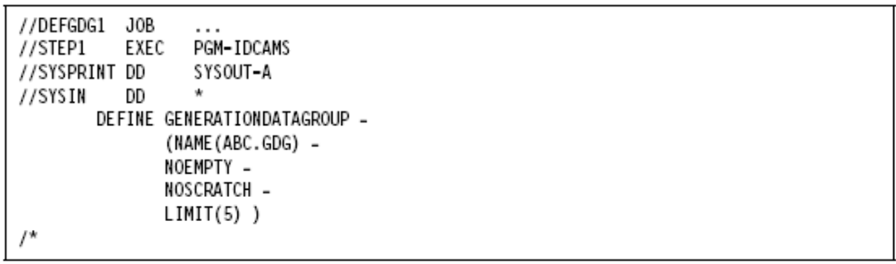

Creating your own model

//JOB1 JOB A50,’ARICH’
//STEP1 EXEC PGM=IDCAMS
//SYSIN DD *
DEFINE GDG(NAME(ACCOUNTS.MONTHLY) -
LIMIT(5) -
NOEMPTY -
SCRATCH)
//STEP2 EXEC PGMIEFBR14
//MODEL1 DD DSN=ACCOUNTS,MONTHLY,
// DISP=(NEW,KEEP,DELETE),
// UNIT=SYSDA,
// SPACE=(TRK,0),
// DCB=(LRECL=80,RECFM=FB,BLKSIZE=800)

The following JCL creates the index for the GDG:

//SYSIN DD *
DEFINE GDG(NAME(ACCOUNTS.MONTHLY) -
LIMIT(5) -
NOEMPTY -
SCRATCH)

and this JCL creates the model:

//STEP2 EXEC PGMIEFBR14
//MODEL1 DD DSN=ACCOUNTS,MONTHLY,
// DISP=(NEW,KEEP,DELETE),
// UNIT=SYSDA,
// SPACE=(TRK,0),
// DCB=(LRECL=80,RECFM=FB,BLKSIZE=800)

Creating a Generation Data set

//STEP3 EXEC PGM=GDG1
//FILE1 DD DSN=ACOUNTS.MONTHLY(+1),
// DISP=(NEW,CATLG,DELETE),UNIT=SYSDA,
// DCB=(MODEL.DCB,REFCM=FB,LRECL=80,BLKSIZE=800)

The program GDG1 is executed. A new generation data set belonging to the GDG ACCOUNTS.MONTHLY is created via the statement:

//MODEL1 DD DSN=ACCOUNTS.MONTHLY(+1)

The syntax (+1) creates a new generation relative to the current generation which is referenced as generation 0. all existing generations are pushed down by one level at the end of the job. The generation numbers will not be updated until the end of the job.

Deleting Generation Data Group Index

The GDG index can be deleted using DELETE parameter in the IBM supplied IDCAMS utility . deletion of the index will result in references to any generation data sets of the same name generating an error. Thus resulting in abnormal termination of the job or job step.

//JOB1 JOB A50,’ARICH’
//S1 EXEC PGM=IDCAMS
//SYSIN DD *
DELETE(ACCOUNTS.MONTHLY)GDG
/*

PURGE coded on DELETE statement

The PURGE parameter can be coded in conjunction with the DELETE statement to delete the GDG index, even if its retention period has not expired. When a data set is created a retention period is automatically record for it. When this period is up, the system automatically deletes that data set from the system. The PURGE parameter can be used to override this retention period.

//JOB1 JOB A50,’ARICH’
//S1 EXEC PGM=IDCAMS
//SYSIN DD *
DELETE(ACCOUNTS.MONTHLY)GDG PURGE
/*

FORCE CODED ON DELETE STATEMENT.

The force parameter can be coded on the DELETE statement to delete the GDG index, the model and all related generation data sets, if they exist.

//JOB1 JOB A50,’ARICH’
//S1 EXEC PGM=IDCAMS
//SYSIN DD *
DELETE(ACCOUNTS.MONTHLY)GDG FORCE
/*

CONCATENATING GENERATION OF A GDG

//JON1 JOB A50,’ARICH’
//S1 EXEC PGM=PRM1
//DD1 DD DSN=ACCOUNTS.MONTHLY,DISP=SHR
//DD2 DD DSN=ACCOUNTS.MASTER,DISP=(NEW,CATLG,DELETE),
// UNIT=SYSDA, SPACE=(CYL,(10,2),RLSE),
// DCB=(RECFM=FB,LRECL=80,BLKSIZE=800)
//

In this example since ACCOUNTS.MONTHLY is a GDG file all generations that belong to it are concatenated together into ACCOUNTS.MASTER . the remaining parameters coded on DD2 specify features for ACCOUNTS.MASTER.

ENTRY-SEQUENCED DATA SET (ESDS)

An ESDS VSAM data set contains records in the order in which they were entered and can only be accessed by relative byte address. An ESDS is similar to a sequential data set.

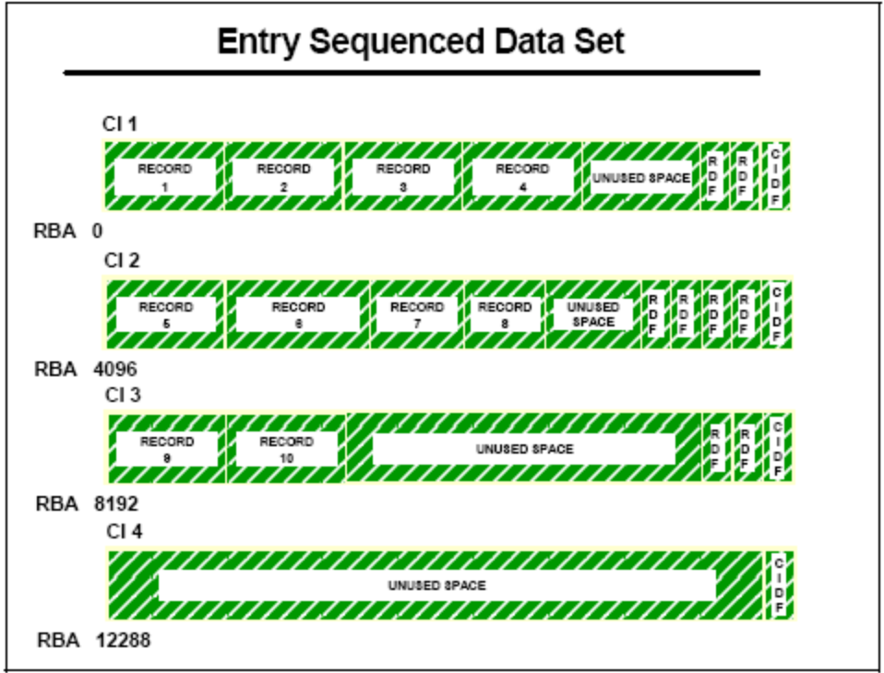

An ESDS is comparable to a sequential non-VSAM data set in the sense that records are sequenced by the order of their entry in the data set, rather than by key field in the logical record, which could be fixed or variable length records.

All new records are placed at the end of the data set. There is no split concept. Existing records can never be deleted. As far as VSAM is concerned, the record is not deleted. It is the responsibility of the application program to identify that record as invalid. If the application wants to delete a record, it must flag that record as inactive.

Records can be updated, but without length change. To change the length of a record, you must either store it at the end of the data set as a new record, or override an existing record of the same length that you have flagged as inactive.

ESDS types of access

A record can be accessed sequentially or directly by its RBA. The specific RBA is converted to CCHHR terms, in order to prepare the locate record CCW for the I/O operation:

- Sequential access

VSAM automatically retrieves records in stored sequence. Sequential access can be started
from the beginning or somewhere in the middle of a data set. If processing is to begin in the
middle of a data set, RBA positioning is necessary before sequential access can be
performed.

- Direct (or random) access

When a record is loaded or added, VSAM notes its RBA. To retrieve records directly, you
must supply the RBA for the record as a search argument. Although an ESDS does not
contain an index component, you can build an alternate index to keep track of these RBAs.

JCL to Create ESDS

//CRTESDS JOB A123,SUNIL,CLASS=A,MSGCLASS=T,PRTY=1,MSGLEVEL=(1,1),
// NOTIFY=USERID,TIME=1
//STEP EXEC PGM=IDCAMS
//SYSPRINT DD SYSOUT=*
//SYSOUT DD SYSOUT=*
//SYSIN DD *
DEFINE CLUSTER -
(NAME(CSNEW85.VSAM.ESDS1)-
TRACKS(5,3) -
CISZ(512) -
RECORDSIZE(80,80) -
NONINDEXED) -
DATA -
(NAME(CSNEW85.ESDS1.DATA))
/*
//

RELATIVE RECORD DATA SET (RRDS)

An RRDS VSAM data set contains records in order by relative-record number and can only be accessed by this number. Relative records can be fixed-length or variable-length.

An relative record data set consists of a number of pre-formatted fixed-length slots. Each slot has
a unique relative record number (RRN), and the slots are sequenced by ascending relative record number. These slots are grouped in CIs.

Each fixed length logical record occupies a slot, and is stored and retrieved by the relative record number of that slot. The position of a logical record is fixed and its relative record number (RRN) cannot change. The logical records are grouped in CIs.
Because the slot can either contain data or be empty, a data record can be inserted or deleted without affecting the position of other data records in the RRDS organization. The RDF shows whether the slot is occupied or empty. Free space is not provided because the entire data set is divided into fixed-length slots.There may be empty spaces in the CI, referred to as unused space,
because they can never be used. This is a result of CI internal fragmentation.

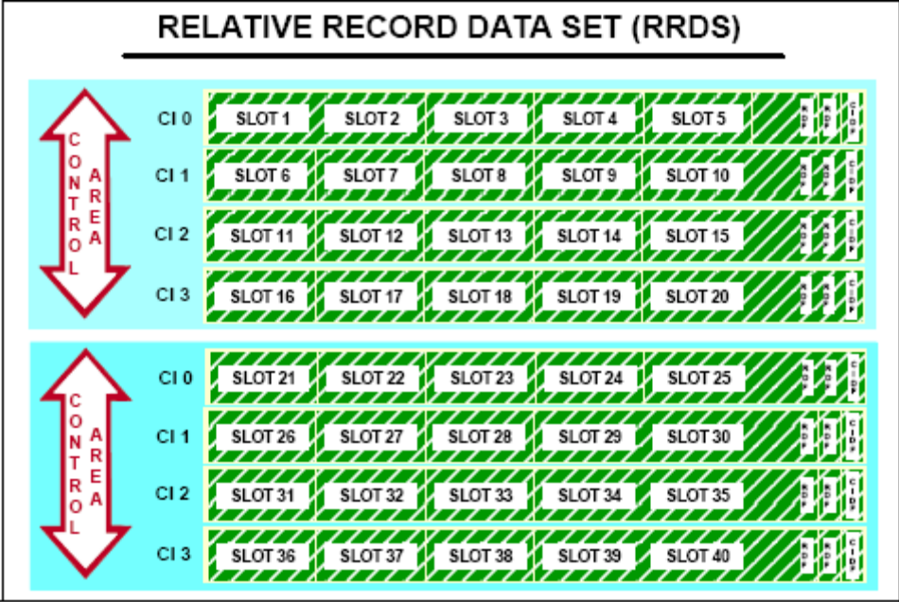

Typical RRDS processing

The application program inputs the RRN of the target record and VSAM is able to find its location (using CCHHR format) quickly using a formula that takes into consideration the geometry of the DASD device. The relative record number is always used as a search argument.

An RRDS can be processed sequentially, directly or skip-sequentially.

- RRDS sequential access is treated the same way as ESDS sequential access. However, empty slots are automatically skipped by VSAM.

- An RRDS can be processed directly by supplying the relative record number as a key. VSAM calculates the RBA and accesses the appropriate record or slot through CCHHR. RRDS direct address processing by supplying the RBA is not supported.

- Skip-sequential access is treated like an RRDS direct processing request, but the position is maintained. After that, records must are processed in ascending relative record number sequence.

You specify the RRDS organization using the IDCAMS DEFINE command with the NUMBERED option.

JCL to Create RRDS

//CRTRRDS JOB A123,SUNIL,CLASS=A,MSGCLASS=T,PRTY=1,MSGLEVEL=(1,1),
// NOTIFY=CSNEW85,TIME=1
//STEP EXEC PGM=IDCAMS
//SYSPRINT DD SYSOUT=*
//SYSOUT DD SYSOUT=*
//SYSIN DD *
DEFINE CLUSTER -
(NAME(CSNEW85.VSAM.RRDS) -
TRACKS(5,3) -
CISZ(512) -
RECORDSIZE(80,80) -
NUMBERED) -
DATA -
(NAME(CSNEW85.RRDS.DATA))
/*
//

KEY SEQUENCED DATA SET (KSDS)

A KSDS VSAM data set contains records in order by a key field and can be accessed by the key or by a relative byte address. The key contains a unique value, such as an employee number or part number.

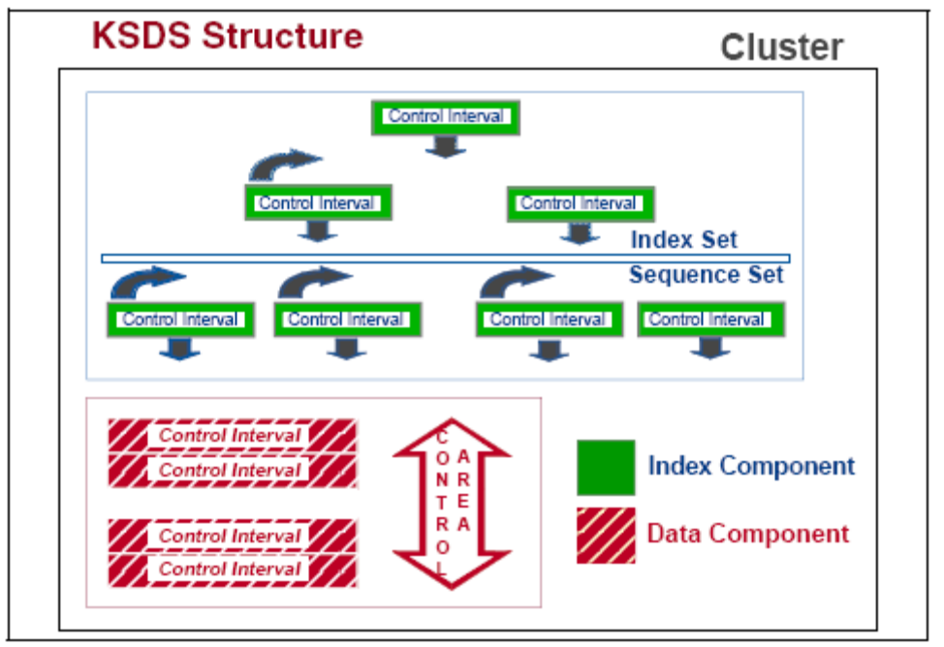

In a KSDS organization, records are initially loaded in the data component in ascending collating sequence by key. The key contains a unique value that determines that record's collating position in the data set.

In VSAM KSDS, if a search argument of a logical record is its key field, then:

- In all logical records, the key length must be the same. The length of the key must be from one byte to 255 bytes.

- In all logical records the key offset (in relation to the logical record beginning) must be the same.

- The value of the key field cannot be duplicated among the logical records, it must be unique.

- After it is specified, the value of the key cannot be altered, however the entire record can be deleted.

- In a spanned record, this field must be located totally in the first control interval.

Logical records in a KSDS organization can be fixed or variable length records.

When a new record is added to the data component, it is inserted logically in its collating sequence by key.

JCL to Create KSDS

//CRTKSDS JOB A123,SUNIL,CLASS=A,MSGCLASS=T,PRTY=1,MSGLEVEL=(1,1),
// NOTIFY=USERID,TIME=1
//STEP EXEC PGM=IDCAMS
//SYSPRINT DD SYSOUT=*
//SYSOUT DD SYSOUT=*
//SYSIN DD *
DEFINE CLUSTER -
(NAME(CSNEW85.VSAM.KSDS8) -
TRACKS(5,3) -
CISZ(512) -
RECORDSIZE(80,80) -
FREESPACE(20,20) -
KEY(3,0) -
INDEXED) -
DATA -
(NAME(CSNEW85.KSDS8.DATA))-
INDEX(NAME(CSNEW85.VSAM.INDEX))
/*
//

DEFINE PATH

The DEFINE PATH command defines a path directly over a base cluster or over an alternate index and its related base cluster. The syntax of the DEFINE PATH Command is:

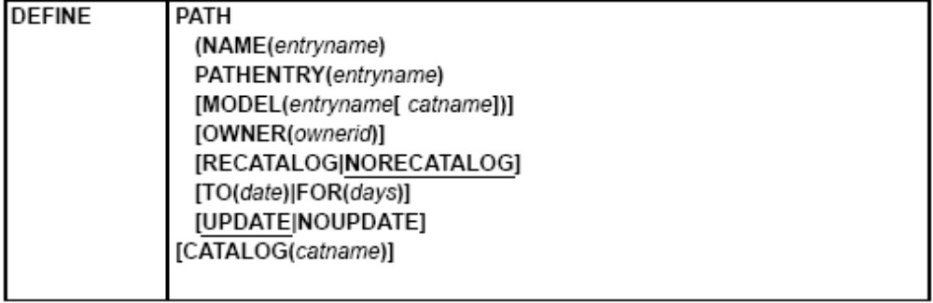

DEFINE can be abbreviated: DEF

Example 1: Define a Path

In this example, a path is defined. Previous examples illustrate the definition of the path’s alternate index, EXAMPLE.AIX, and the alternate index’s base cluster, EXAMPLE.KSDS2. The alternate index, path, and base cluster are defined in the same catalog, USERCAT.

//DEFPATH JOB ...
//STEP1 EXEC PGM=IDCAMS
//SYSPRINT DD SYSOUT=A
//SYSIN DD *
DEFINE PATH -
(NAME(EXAMPLE.PATH) -
PATHENTRY(EXAMPLE.AIX) -
CATALOG(USERCAT)
/*

Example 2: Define a Path (Recatalog) in a Catalog

In this example, a path previously defined and found damaged is redefined. The cluster and path are defined in the same catalog, USERCAT4.

//DEFPATHF JOB ...
//STEP1 EXEC PGM=IDCAMS
//SYSPRINT DD SYSOUT=A
//SYSIN DD *
DEFINE PATH -
(NAME(EXAMPLE1.PATH) -
PATHENTRY(EXAMPLE1.KSDS01) -
RECATALOG) -
CATALOG(USERCAT4)
/*

BLDINDEX

The BLDINDEX command builds alternate indexes for existing data sets. The syntax of the BLDINDEX command is:

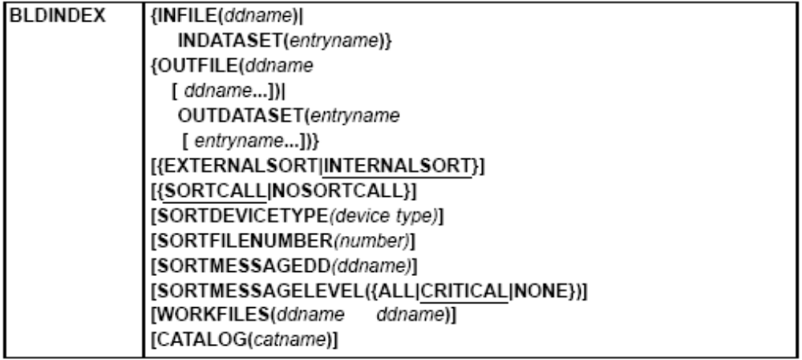

BLDINDEX can be abbreviated: BIX

Requirement: If you use BLDINDEX and intend to use the default sort product (DFSORT™ or equivalent), you must ensure that IDCAMS is called in problem state.

JCL to Build Index

Example 1: Build an Alternate-Index over a Key Sequenced Data Set (KSDS)

This example builds an alternate index over a previously defined base cluster, EXAMPLE. KSDS2. Data records are already loaded into the base cluster. The alternate index, its path, and its base cluster are all defined in the same catalog, USERCAT.

//BUILDAIX JOB ...
//BASEDD DD DSNAME=EXAMPLE.KSDS2,DISP=OLD
//AIXDD DD DSNAME=EXAMPLE.AIX,DISP=OLD
//IDCUT1 DD DSNAME=SORT.WORK.ONE,DISP=OLD,AMP='AMORG',
// VOL=SER=VSER01,UNIT=DISK
//IDCUT2 DD DSNAME=SORT.WORK.TWO,DISP=OLD,AMP='AMORG',
// VOL=SER=VSER01,UNIT=DISK
//SYSPRINT DD SYSOUT=A
//SYSIN DD *
BLDINDEX INFILE(BASEDD) -
OUTFILE(AIXDD) -
NOSORTCALL -
CATALOG(USERCAT)
/*

Example 2: Build an Alternate-Index over a Key Sequenced Data Set (KSDS) Using DFSORT

This example, using DFSORT, builds an alternate index over a previously defined base cluster, EXAMPLE.KSDS2. Data records are already loaded into the base cluster. The alternate index, its path, and its base cluster are all defined in the same catalog, USERCAT.

//BUILDAIX JOB ...
//BASEDD DD DSNAME=EXAMPLE.KSDS2,DISP=OLD
//AIXDD DD DSNAME=EXAMPLE.AIX,DISP=OLD
//SYSPRINT DD SYSOUT=A
//SYSIN DD *
BLDINDEX INFILE(BASEDD) -
OUTFILE(AIXDD/AIXUPPW) -
SORTCALL -
SORTMESSAGELEVEL(ALL)
/*

DEFINE ALTERNATE INDEX

The DEFINE ALTERNATEINDEX command defines an alternate index. Use it to show attributes for the alternate index as a whole and for the components of the alternate index. The syntax of the DEFINE ALTERNATIVEINDEX command is:

DEFINE ALTERNATEINDEX (parameters) -
[DATA(parameters)] -
[INDEX(parameters)] -
[CATALOG(subparameters)]

DEFINE can be abbreviated: DEF

Restriction: If IMBED, KEYRANGE, ORDERED, or REPLICATE is specified, it is ignored.

Example 1: Define an Alternate Index Using SMS Data Class Specification

In this example, an SMS-managed alternate index is defined. Because a data class is specified and no overriding attributes are explicitly specified, this define will be unsuccessful if SMS is inactive.

//DEFAIX JOB ...
//STEP1 EXEC PGM=IDCAMS
//SYSPRINT DD SYSOUT=A
//SYSIN DD *
DEFINE ALTERNATEINDEX -
(NAME(EXMP1.AIX) -
RELATE(EXAMPLE.SMS1) -
DATACLAS(VSALLOC) -
NONUNIQUEKEY -
UPGRADE)
/*

Example 2: Define an SMS Managed Alternate Index

In this example, an SMS-managed alternate index is defined. Data class is not used, and explicitly defined attributes override any attributes in the default data class.

//DEFAIX JOB ...
//STEP1 EXEC PGM=IDCAMS
//SYSPRINT DD SYSOUT=A
//SYSIN DD *
DEFINE ALTERNATEINDEX -
(NAME(EXMP2.AIX) -
RELATE(EXAMPLE.SMS2) -
KEYS(3 0) -
RECORDSIZE(40 50) -
KILOBYTES(1600 200) -
NONUNIQUEKEY -
UPGRADE)
/*

Example 3: Define an Alternate Index

In this example, an alternate index is defined. An example for DEFINE CLUSTER illustrates the definition of the alternate index base cluster, EXAMPLE.KSDS2. A subsequent example illustrates the definition of a path, EXAMPLE.PATH, that lets you process the base cluster’s data records using the alternate key to locate them. The alternate index, path, and base cluster are defined in the same catalog, USERCAT.

//DEFAIX1 JOB ...
//STEP1 EXEC PGM=IDCAMS
//SYSPRINT DD SYSOUT=A
//SYSIN DD *
DEFINE ALTERNATEINDEX -
(NAME(EXAMPLE.AIX) -
RELATE(EXAMPLE.KSDS2) -
KEYS(3 0) -
RECORDSIZE(40 50) -
VOLUMES(VSER01) -
CYLINDERS(3 1) -
NONUNIQUEKEY -
UPGRADE) -
CATALOG(USERCAT)
/*

Example 4: Define an Alternate Index with RECATALOG

In this example, an alternate index is redefined into an integrated catalog facility catalog.

//DEFAIXR JOB ...
//STEP1 EXEC PGM=IDCAMS
//SYSPRINT DD SYSOUT=A
//SYSIN DD *
DEFINE ALTERNATEINDEX -
(NAME(DEFAIXR.AIX01) -
RELATE(DEFKSDS.KSDS03) –
CYLINDERS(2 1) -
VOLUMES(333001) -
RECATALOG) -
CATALOG(USERCAT4)
/*

REPRO

The REPRO command performs the following functions:

- Copies VSAM and non-VSAM data sets
- Copies catalogs
- Copies or merges tape volume catalogs
- Splits integrated catalog facility catalog entries between two catalogs
- Splits entries from an integrated catalog facility master catalog into another integrated catalog
facility catalog
- Merges integrated catalog facility catalog entries into another integrated catalog facility user
catalog.

Example 1: Copy Records into a Key Sequenced Data Set

In this example, records from an indexed sequential data set, ISAMDSET, are copied into key-sequenced VSAM cluster, RPR.EXAMPLE.KSDS1.

//REPRO1 JOB ...
//STEP1 EXEC PGM=IDCAMS
//INDSET1 DD DSNAME=ISAMDSET,DISP=OLD,
// DCB=(DSORG=IS,BUFNO=6)
//SYSPRINT DD SYSOUT=A
//SYSIN DD *
REPRO -
INFILE(INDSET1) -
OUTDATASET(RPR.EXAMPLE.KSDS1)
/*

The syntax of the REPRO command is:
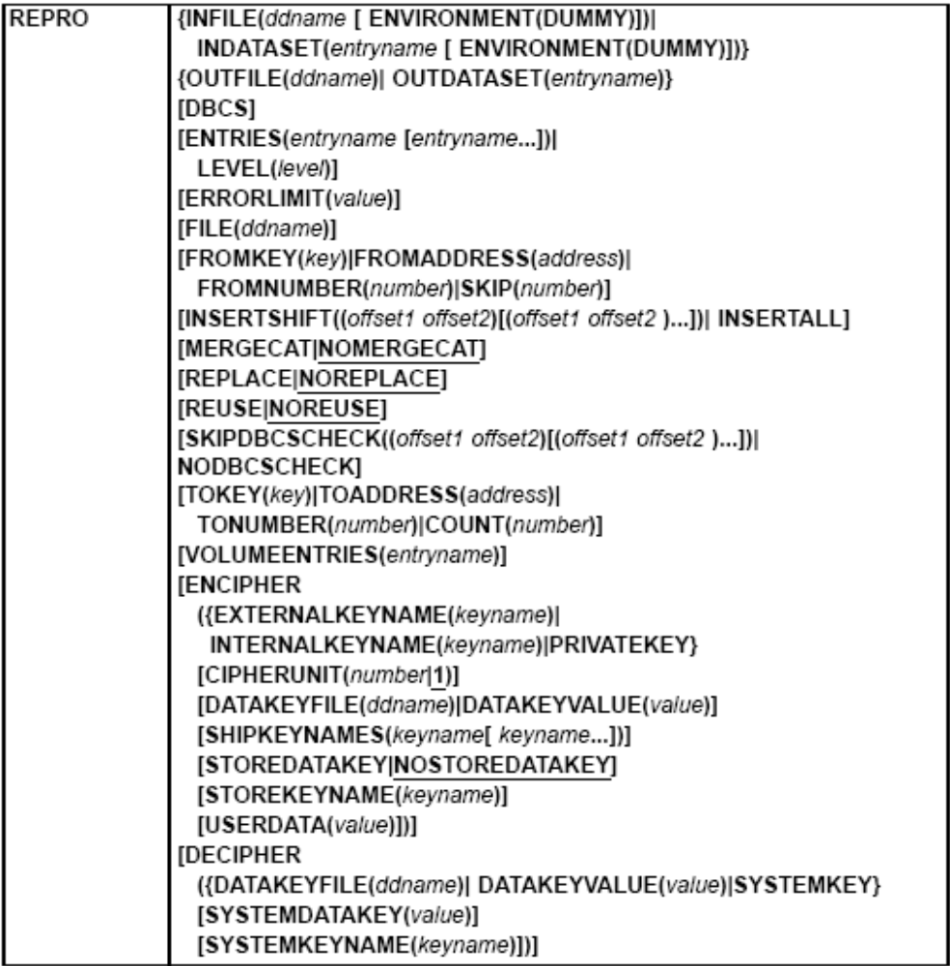

Example 2: Merge an Integrated Catalog Facility User Catalog into Another Integrated Catalog Facility User Catalog.

This example shows how integrated catalog facility user catalog entries are merged into another integrated catalog facility user catalog. This function effectively combines entries from two catalogs into one catalog.

//MERGE6 JOB ...
//STEP1 EXEC PGM=IDCAMS
//DD1 DD VOL=SER=VSER01,UNIT=DISK,DISP=OLD
// DD VOL=SER=VSER02,UNIT=DISK,DISP=OLD
// DD VOL=SER=VSER03,UNIT=DISK,DISP=OLD
//SYSPRINT DD SYSOUT=A
//SYSIN DD *
REPRO -
INDATASET(USERCAT4) –
OUTDATASET(USERCAT5) -
MERGECAT -
FILE(DD1)
/*

DEFINING A CATALOG

Defining a master catalog or user catalog is basically the same. Use the access method services command DEFINE USERCATALOG ICFCATALOG to define the basic catalog structure of an
ICF catalog. Using this command you cannot specify whether you want to create a user or a
master catalog.

JCL to Define a Catalog

//DEFCATLG JOB ,,CLASS=M,
// MSGLEVEL=(1,1),NOTIFY=USERID,TIME=(1)
//EXSTEP EXEC PGM=IDCAMS
//SYSPRINT DD SYSOUT=*
//SYSIN DD *
DEFINE USERCATALOG -
(NAME(CSNEW85.KISH85) -
CYLINDER(45 15) -
VOLUME(SMS004) -
ICFCATALOG -
FREESPACE(10 10) -
STRNO(3) -
IMBED -
REPLICATE) -
DATA( CONTROLINTERVALSIZE(4096) -
BUFND(4) )-
INDEX( BUFNI(4) )
/*
//

DEFINING ALIASES

In order to use a catalog, the system must be able to determine which data sets should be defined in that catalog. The simplest way to accomplish this is to define aliases in the master
catalog for the user catalog. Before defining an alias, carefully consider the effect the new
alias has on old data sets. A poorly chosen alias could make some data sets inaccessible.

You can define aliases for the user catalog in the same job in which you define the catalog by
including DEFINE ALIAS commands after the DEFINE USERCATALOG command. You can use
conditional operators to ensure the aliases are only defined if the catalog is successfully defined. After the catalog is defined, you can add new aliases or delete old aliases.

Catalog aliases are defined only in the master catalog, which contains an entry for the user
catalog. The number of aliases a catalog can have is limited by the maximum record size for
the master catalog.

You cannot define an alias if a data set cataloged in the master catalog has the same
high-level qualifier as the alias. The DEFINE ALIAS command fails with a "Duplicate data set
name” error.

JCL to Define Alias

//DEFALIAS JOB ,,CLASS=M,USER=DAVIN3,
// MSGLEVEL=(1,1),NOTIFY=USERID,TIME=(1)
//IDCAMS EXEC PGM=IDCAMS
//SYSPRINT DD SYSOUT=*
//SYSIN DD *
// DEFINE ALIAS(NAME(MUKESH1) RELATE(USERCAT.CUST))
/*
//

DEFINING A BCS WITH A MODEL

When you define a BCS or VVDS, you can use an existing BCS or VVDS as a model for the new one. The attributes of the existing data set are copied to the newly defined data set unless you explicitly specify a different value for an attribute. You can override any of a model's attributes.

If you do not want to change or add any attributes, you need only supply the entry name of the
object being defined and the MODEL parameter. When you define a BCS, you must also specify the volume and space information for the BCS.

JCL to create Model Catalog

//MODELCAT JOB ,,CLASS=M,
// MSGLEVEL=(1,1),NOTIFY=USERID,TIME=(1)
//STEP1 EXEC PGM=IDCAMS
//SYSPRINT DD SYSOUT=*
//SYSIN DD *
DEFINE USERCATALOG -
(NAME(CSNEW85.KIS85) -
MODEL(CSNEW85.KISH85) -
VOLUME(SMS003) -
CYLINDER(2 4))
/*
//

LISTCAT

- List all ALIAS entries in the master catalog:

LISTCAT ALIAS CAT(master.catalog.name)

This command provides a list of all aliases that are currently defined in your master catalog. If you need information only about one specific alias, use the keyword ENTRY(aliasname) and specify ALL to get detailed information.

JCL to ListCat Alias

//LSTALIAS JOB ,,CLASS=M,
// MSGLEVEL=(1,1),NOTIFY=USERID,TIME=(1)
//STEP1 EXEC PGM=IDCAMS
//SYSPRINT DD SYSOUT=*
//SYSIN DD *
LISTCAT ALIAS CAT(CSNEW85.KIS85)
/*
//

- List a user catalog connector in the master catalog:

LISTCAT ENT(user.catalog.name) ALL

You can use this command to display the volser and the alias associations of a user catalog as it is defined in the master catalog.

- List the catalog’s self describing record:

LISTCAT ENT(user.catalog.name) CAT(user.catalog.name) ALL

This gives you detailed information about a user catalog, like attributes, statistics, extent information, and more. Because the self describing record is in the user catalog, you need to specify the name of the user catalog in the CAT statement. If you don’t use the CAT keyword, only the user catalog connector information from the master catalog is listed.

JCL to ListCat all Entries

//LISTENT JOB ,,CLASS=M,
// MSGLEVEL=(1,1),NOTIFY=USERID,TIME=(1)
//STEP1 EXEC PGM=IDCAMS
//SYSPRINT DD SYSOUT=*
//SYSIN DD *
LISTCAT ALL ENTRIES(CSNEW85.KIS85)
/*
//

JCL to Print VVDS

//PRNTVVDS JOB ,,CLASS=M,
// MSGLEVEL=(1,1),NOTIFY=USERID,TIME=(1)
//STEPRUN EXEC PGM=IDCAMS
//SYSPRINT DD SYSOUT=A
//VVDS DD DSN=SYS1.VVDS.VSMS001,DISP=SHR,UNIT=3390,
// VOL=SER=SMS001,AMP=AMORG
//SYSIN DD *
PRINT INFILE(VVDS) COUNT(1) CHAR
/*
//

MERGING THE TWO CATALOGS

Use the following steps to merge two integrated catalog facility catalogs:

1. Use ALTER LOCK to lock both catalogs.

2. Use LISTCAT to list the aliases for the catalog you intend to delete after the merger:

//JOB ...
//S1 EXEC PGM=IDCAMS
//SYSPRINT DD SYSOUT=*
//DD1 DD DSN=listcat.output,DISP=(NEW,CATLG),
// SPACE=(TRK,(10,10)),
// DCB=(RECFM=VBA,LRECL=125,BLKSIZE=629)
//SYSIN DD *
LISTC ENT(catalog.name) ALL -
OUTFILE(DD1)
/*
//

- Use EXAMINE and DIAGNOSE to ensure that the catalogs are error-free. Fix any errors
Indicated.

- Use REPRO MERGECAT without specifying the ENTRIES or LEVEL parameter. The
OUTDATASET parameter specifies the catalog that you are keeping after the two catalogs
are merged. Here is an example:

//MERGE6 JOB ...
//STEP1 EXEC PGM=IDCAMS
//DD1 DD VOL=SER=VSER01,UNIT=DISK,DISP=OLD
// DD VOL=SER=VSER02,UNIT=DISK,DISP=OLD
// DD VOL=SER=VSER03,UNIT=DISK,DISP=OLD
//SYSPRINT DD SYSOUT=A
//SYSIN DD *
REPRO -
INDATASET(USERCAT4) -
OUTDATASET(USERCAT5) -
MERGECAT -
FILE(DD1)
/*
//

- Use the listing created in step 2 to create a sequence of DELETE ALIAS and DEFINE ALIAS
commands to delete the aliases of the obsolete catalog, and to redefine the aliases as aliases
of the catalog you are keeping.

The DELETE ALIAS/DEFINE ALIAS sequence must be run on each system that shares the
changed catalogs and uses a different master catalog.

6. Use DELETE USERCATALOG to delete the obsolete catalog. Specify RECOVERY on the
DELETE command.

- If your catalog is shared, run the EXPORT DISCONNECT command on each shared system to remove unwanted user catalog connector entries. If your catalog is shared, run the
EXPORT DISCONNECT command on each shared system to remove unwanted user catalog
connector entries.

- Use ALTER UNLOCK to unlock the remaining catalog.

You can also merge entries from one tape volume catalog to another using REPRO MERGECAT. REPRO retrieves tape library or tape volume entries and redefines them in a target tape volume catalog. In this case, VOLUMEENTRIES needs to be used to correctly filter the appropriate entries. The LEVEL parameter is not allowed when merging tape volume catalogs.

SPLITTING A CATALOG

To split a catalog or move a group of entries, use the access method services REPRO MERGECAT command. Use the following steps to split a catalog or to move a group of entries:

1. Use ALTER LOCK to lock the catalog. If you are moving entries to an existing catalog, lock it
as well.

2. If you are splitting a catalog, define a new catalog with DEFINE USERCATALOG LOCK .

3. Use LISTCAT to obtain a listing of the catalog aliases you are moving to the new catalog.
Use the OUTFILE parameter to define a data set to contain the output listing.

4. Use EXAMINE and DIAGNOSE to ensure that the catalogs are error-free. Fix any errors
indicated.

5. Use REPRO MERGECAT to split the catalog or move the group of entries. When splitting a
catalog, the OUTDATASET parameter specifies the catalog created in step 2. When moving a
group of entries, the OUTDATASET parameter specifies the catalog which is to receive the
entries.

Use the ENTRIES or LEVEL parameters to specify which catalog entries are to be removed
from the source catalog and placed in the catalog specified in OUTDATASET.

In the following example all entries that match the generic name VSAMDATA.* are moved from
catalog USERCAT4 to USERCAT5.

//MERGE76 JOB ...
//STEP1 EXEC PGM=IDCAMS
//DD1 DD VOL=SER=VSER01,UNIT=DISK,DISP=OLD
// DD VOL=SER=VSER02,UNIT=DISK,DISP=OLD
// DD VOL=SER=VSER03,UNIT=DISK,DISP=OLD
//SYSPRINT DD SYSOUT=A
//SYSIN DD *
REPRO -
INDATASET(USERCAT4) -
OUTDATASET(USERCAT5) -
ENTRIES(VSAMDATA.*) -
MERGECAT -
FILE(DD1)
/*
//

6. Use the listing created in step 3 to create a sequence of DELETE ALIAS and DEFINE ALIAS
commands for each alias. These commands delete the alias from the original catalog, and
redefine them as aliases for the catalog which now contains entries belonging to that alias
name.

The DELETE ALIAS/DEFINE ALIAS sequence must be run on each system that shares the
changed catalogs and uses a different master catalog.

- Unlock both catalogs using ALTER UNLOCK.

DEFINE DATA SETS

There are many ways to define a data set, for example using IDCAMS DEFINE CLUSTER to create a VSAM data set or using a JCL DD statement to define a non-VSAM data set. If you
define a VSAM data set or SMS-managed non-VSAM data set, an entry in the BCS, in the
VTOC, and in the VVDS is created.

DELETE DATA SETS

If there is no damage to the BCS, VVDS, or VTOC, you can easily delete a data set—for example, by running an IDCAMS DELETE job, by using a JCL DD statement, or by issuing the
command DELETE in ISPF 3.4 in front of the data set name. This will delete the entries for the
data set in the BCS, VTOC, and VVDS. By doing that, the reserved space for this data set on
the volume is released. The data set itself is not overwritten until the freed space is reused by
another data set. You can use the parameter ERASE for an IDCAMS DELETE if you want the
data set to be overwritten with binary zeros for security reasons.

DELETE ALIASES

To simply delete an alias, use the IDCAMS DELETE ALIAS command, specifying the alias you
are deleting.

To delete all the aliases for a catalog, use EXPORT DISCONNECT to disconnect the catalog. The aliases are deleted when the catalog is disconnected. When you again connect the catalog
(using IMPORT CONNECT) the aliases remain deleted.

DELETE THE CATALOG ENTRY

To only delete a catalog entry you can use the DELETE NOSCRATCH command; the VVDS and
VTOC entries are not deleted. The entry deleted can be reinstated with the DEFINE RECATALOG command as shown below

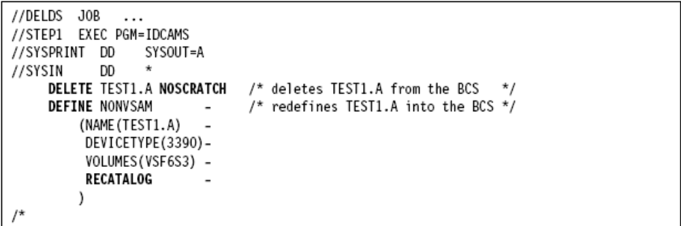

DELETE VVR or NVR RECORDS

When the catalog entry is missing, and the data set remains on the DASD, you can use the DELETE VVR for VSAM data sets and DELETE NVR for non-VSAM SMS-managed data sets to
remove its entry from the VVDS. You can only use these commands if there is no entry in the
BCS for the data set.

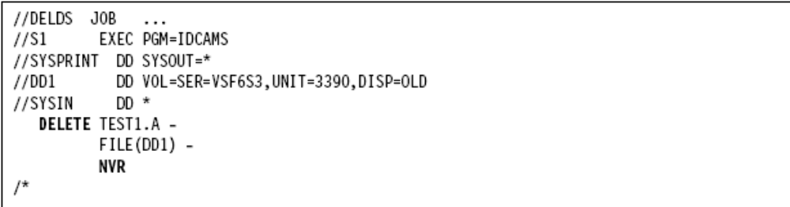
DELETE GENERATION DATA GROUPS

In this example, a generation data group (GDG) base catalog entry is deleted from the catalog. The generation data sets associated with GDGBASE remain unaffected in the VTOC.

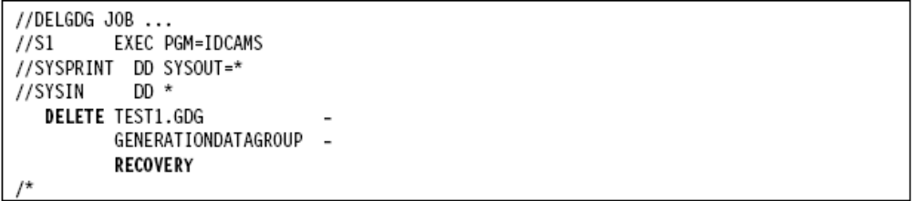

The DELETE command with keyword RECOVERY removes the GDG base catalog entry from the catalog.

DELETE AN ICF

When deleting an ICF, you must take care to specify whether you want to delete only the catalog, or if you want to delete all associated data. The following examples show how to delete a catalog.

- Delete with recovery

Below, a user catalog is deleted in preparation for replacing it with an imported backup copy. The VVDS and VTOC entries for objects defined in the catalog are not deleted and the data sets are not scratched, as shown in the JCL.

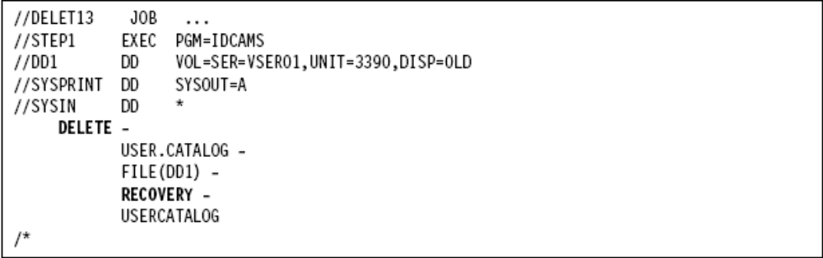

RECOVERY specifies that only the catalog data set is deleted, without deleting the objects defined in the catalog.

- Delete an empty user catalog

Below, a user catalog is deleted. A user catalog can be deleted when it is empty; that is, when there are no objects cataloged in it other than the catalog's volume. If the catalog is not empty, it cannot be deleted unless the FORCE parameter is specified.
