CONSOLE COMMAND’S

Changing Console Characteristics:
1. Changing the Authorization of a Console:
You change the authorization of consoles by The VARY CN, AUTH= command defines which system command groups may be entered through the consoles specified on the AUTH= keyword. To assign master level authority to a console named REMOTE, Enter:
VARY CN (REMOTE), AUTH=MASTER
2. Changing the Master Console In a System or Sysplex:

You assign the master console by: VARY device, MSTCONS
To reassign the console named CON31E as a console with master console authority, enter:
VARY CON31E, MSTCO

DEFINING ROUTING CODES FOR A CONSOLE:
1 Master console action
2 Master console information
3 Tape pool
4 Direct access pool
5 Tape library
6 Disk library
7 Unit record pool
8 Teleprocessing control
9 System security
10 System error/maintenance/system programmer
Information
11 Programmer information
12 Emulators
13-20 Reserved for customer use
21-28 Reserved for subsystem use
29-40 Reserved for IBM
41 Information about JES3 job status
42 General information about JES2 or JES3
43-64 Reserved for JES2 or JES3
65-96 Messages associated with particular processors
Messages associated with particular devices

CONTROLLING THE FORMAT OF MESSAGES:
CONTROL S, MFORM= (J,T,S),L=2
ACTIVATING WTO AND WTOR INSTALLATION EXIT ROUTINES:
CONTROL M, UEXIT=N
DEFINING PFKS USING THE CONTROL COMMAND
CONTROL N, PFK= (5, CMD='D U,L=9A'),CON=N
CONTROL N, PFK= (5,CMD='D U,L=9A'),CON=Y
CHANGING OUT OF LINE DISPLAY AREA SPECIFICATIONS:
K A[,03[,09]...][,L={Console name }]
|, NONE {name} |, REF
CONTROLLING DISPLAYS IN AREAS:
K D [,N[,HOLD] ] ,F,H,U}[,L={a, cca name-a}]
, PFK
REMOVING INFORMATION FROM THE SCREEN:
K E[,nn ] ,nn,nn
,SEG ,N
,PFK ,D[,L={a }] {cc } {cca }
{name } {name-a}
CHANGING OR DISPLAYING MESSAGE DELETION AND FORMAT SPECIFICATIONS:
K S[,REF ]
[, CON= {Y|N}][, SEG=nn][, DEL= {Y|N|R|RD|W}]
[, RNUM=nn][, RTME=nnn][, MFORM= (option [, option [, L= {cc|name}]
CHANGING THE OPERATING MODE OF A CONSOLE:
K V[,REF ][,L={cc }]
| {name}
|,USE={FC|SD|MS}[,CMDSYS={sysname|*}]

DISPLAYING SYSTEM ACTIVITY:
D A- Display a
To display detailed information about all active units of work, enter:
D A, L
To display detailed information about active jobs, enter:
D J, L
To display more detailed information about active jobs, enter:
D J, A
To display detailed information about any active time-sharing user with the name arich, enter:
D TS, arich
DISPLAYING PAGE AND SWAP DATA SET INFORMATION:
D ASM - Display asm
To display detailed information about the master scheduler address space, enter:
D A,*MASTER*
To display detailed information about all initiator address spaces beginning with INIT, enter:
D A,INIT*
To display detailed information about any active time-sharing user with the name LIST, enter:
D TS,(LIST)
To display detailed information about all active jobs, started tasks, time-sharing users, or address spaces with the name beginning with D96,enter:
D A,D96*
DISPLAYING CONSOLE STATUS INFORMATION :
D CONSOLE - Display consoles
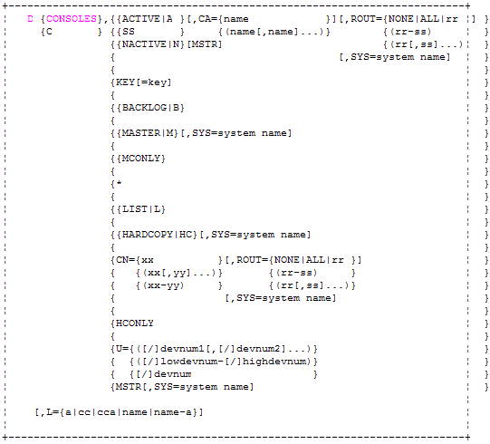
CHANGING OR DISPLAYING THE NUMBER OF ALLOWED WTO AND WTOR MESSAGE BUFFERS:
K M[,REF|[,MLIM=nnnn][,RLIM=mmmm]]
INCREASING THE MAXIMUM NUMBER OF REPLY IDS:
K M[,RMAX=nnnn ] ,REF
RESPONDING TO AN INACTIVE CONSOLE:
If an MCS console appears inactive, check the system response by requesting a display of the time:
D T - DISPLAY T
RECOVERING LOST MESSAGES:
To recover lost messages, use the
CONTROL Q
Displaying Console Status Information
The DISPLAY command to display the Status of all consoles or specified consoles In the Sysplex.
D C, L
Displaying Commands Defined for PFKs
The DISPLAY PFK command to display the PFK definitions in effect for a specified Console, the PFK definitions in a specified PFK table or the PFK tables that are Available.
D PFK
Changing Out Of Line Display Area Specifications
The CONTROL A command to change, Remove, or examine out of line display area specifications for any MCS console in the system. CHANGING OUT OF LINE DISPLAY AREA SPECIFICATIONS
K A
Deleting Retained Action Messages
The CONTROL C command to delete the outstanding action messages that the Action message retention facility (AMRF) has retained.
K C
HALTING THE PRINTING OR THE DISPLAY OF A STATUS DISPLAY
Use the CONTROL C,D command to halt the Printing or display of the status.
K C,D
Controlling Displays in Areas
The CONTROL D command to control Displays, message numbering, and the PFK Display line.
K D
REMOVING INFORMATION FROM THE SCREEN.
The CONTROL E command to remove Various types of messages from the screen Or to cause message numbers to be Deleted,
K E
ACTIVATING, DEACTIVATING, OR DISPLAYING THE STATUS OF THE ACTION MESSAGE RETENTION FACILITY.
The CONTROL M, AMRF command to change or display the status of the action message retention facility. You can enter the command from the master console, or from a console with master authority. M Indicates message processing by the message Retention facility.
K M,AMRF
Changing or Displaying the Number of Allowed WTL SYSLOG Buffers
The CONTROL M,LOGLIM command to change or display the number of allowed WTL (write-to-log) SYSLOG buffers. You can enter the command from consoles with master authority.
K M,LOGLIM
Changing or Displaying the Number of Allowed WTO and WTOR Message Buffers
The CONTROL M,MLIM command to change or display the number of allowed WTO (write-to-operator) or WTOR (write-to-operator-with-reply) message buffers. You can enter the command from consoles with master authority.
K M,MLIM
Changing the Time the System Waits for ROUTE Command Responses
The CONTROL M,ROUTTIME command to display or change the maximum amount of time the ROUTE *ALL or ROUTE system groupname command waits for a response from each system in the sysplex before aggregating the responses. ROUTTIME applies to any ROUTE command with the *ALL or system group name operand when issued from any system in a sysplex.
K M,ROUTTIME
Increasing the Maximum Number of Reply IDs
The CONTROL M,RMAX command to display or dynamically increase the maximum number of reply IDs.increase the maximum number of reply IDs.
K M RMAX
Changing or Displaying the Status of WTO Installation Exit IEAVMXIT
The CONTROL M,UEXIT command to change or Display the status of the WTO installation exit IEAVMXIT. This exit receives control when the System issues a WTO message unless your Installation names another WTO installation exit Routine for the message.
K M,UEXIT
Changing a PFK Definition
The CONTROL N,PFK command to change the Definition of a PFK on a particular console or to Assign a PFK table to a particular console. A PFK command that you assign to a PFK by using the CONTROL N, PFK command is not associated with the PFK when you bring the console Online again.
K N,PFK

Rerouting Message Queues
Route a console's messages to another console or To the system log. It affects only messages currently On the console's queue. Subsequent messages are Queued as usual. Route a console's messages to Another console or to the system log.
K Q
Changing or Displaying Message Deletion and Format Specifications
The CONTROL S command to change console specifications or to display the console Specifications currently in effect. Any changes you Make with the CONTROL S command do not exist When you IPL the system the next time.
K S
Changing or Displaying Time Intervals for Dynamic Displays
The CONTROL T command to change the time Interval or to see the current time interval used for Updating dynamic displays on a console.
K T
Changing the Operating Mode of a Console
The CONTROL V,USE command to change the Operating mode of a console.
K V,USE
Selecting the Message Levels for a Console
The CONTROL V,LEVEL command to specify the Message levels for messages that are to be Displayed at a console.
K V,LEVEL

