FLIM Analysis Template

Sevde Coban

2025-04-09

# Purpose

FLIM collects photon excitation information from cell images to examine metabolic changes within biologic samples. This information is Fourier transformed to collect two parameters: S-coordinate and G-coordinate. These parameters are used to calculate fraction bound (fB), which is the fraction of bound to unbound NADH within the cells we’re looking at. Fraction bound can tell you if the cells are using more glycolysis (more free NADH) or oxidative phosphorylation (more NADH is bound to an enzyme).

The purpose of this analysis is to compare the differences in fraction bound (fB) between STA treated and untreated samples.

# Z’ Factors for Fraction Bound and G-Coordinates

Here are the Z’ factors for fB and G-Coordinate across the 3 experiments. Raw values are calculated using all individual measurements for each sample. Mean values first average indiividual measurements within each Sample_ID then calculates Z’ factors using the averaged values. This minimizes intra-sample variability.

Z’ Factor per Run (fB)

| Experiment | z_prime_factor |
| --- | --- |
| EITM-USC_run1 | -0.1959437 |
| EITM-USC_run2 | -19.6521376 |
| EITM-USC_run3 | 0.0248862 |

Z’ Factor per Run (Average fB)

| Experiment | z_prime_factor |
| --- | --- |
| EITM-USC_run1 | 0.5402899 |
| EITM-USC_run2 | -2.2092288 |
| EITM-USC_run3 | 0.8344722 |

Z’ Factor per Run (G)

| Experiment | z_prime_factor |
| --- | --- |
| EITM-USC_run1 | 0.1179575 |
| EITM-USC_run2 | -19.7009225 |
| EITM-USC_run3 | 0.1939339 |

Z’ Factor per Run (Average G)

| Experiment | z_prime_factor |
| --- | --- |
| EITM-USC_run1 | 0.6898841 |
| EITM-USC_run2 | -4.4975397 |
| EITM-USC_run3 | 0.8750364 |

# Scatterplot of S- & G- Coordinates of STA Treatments

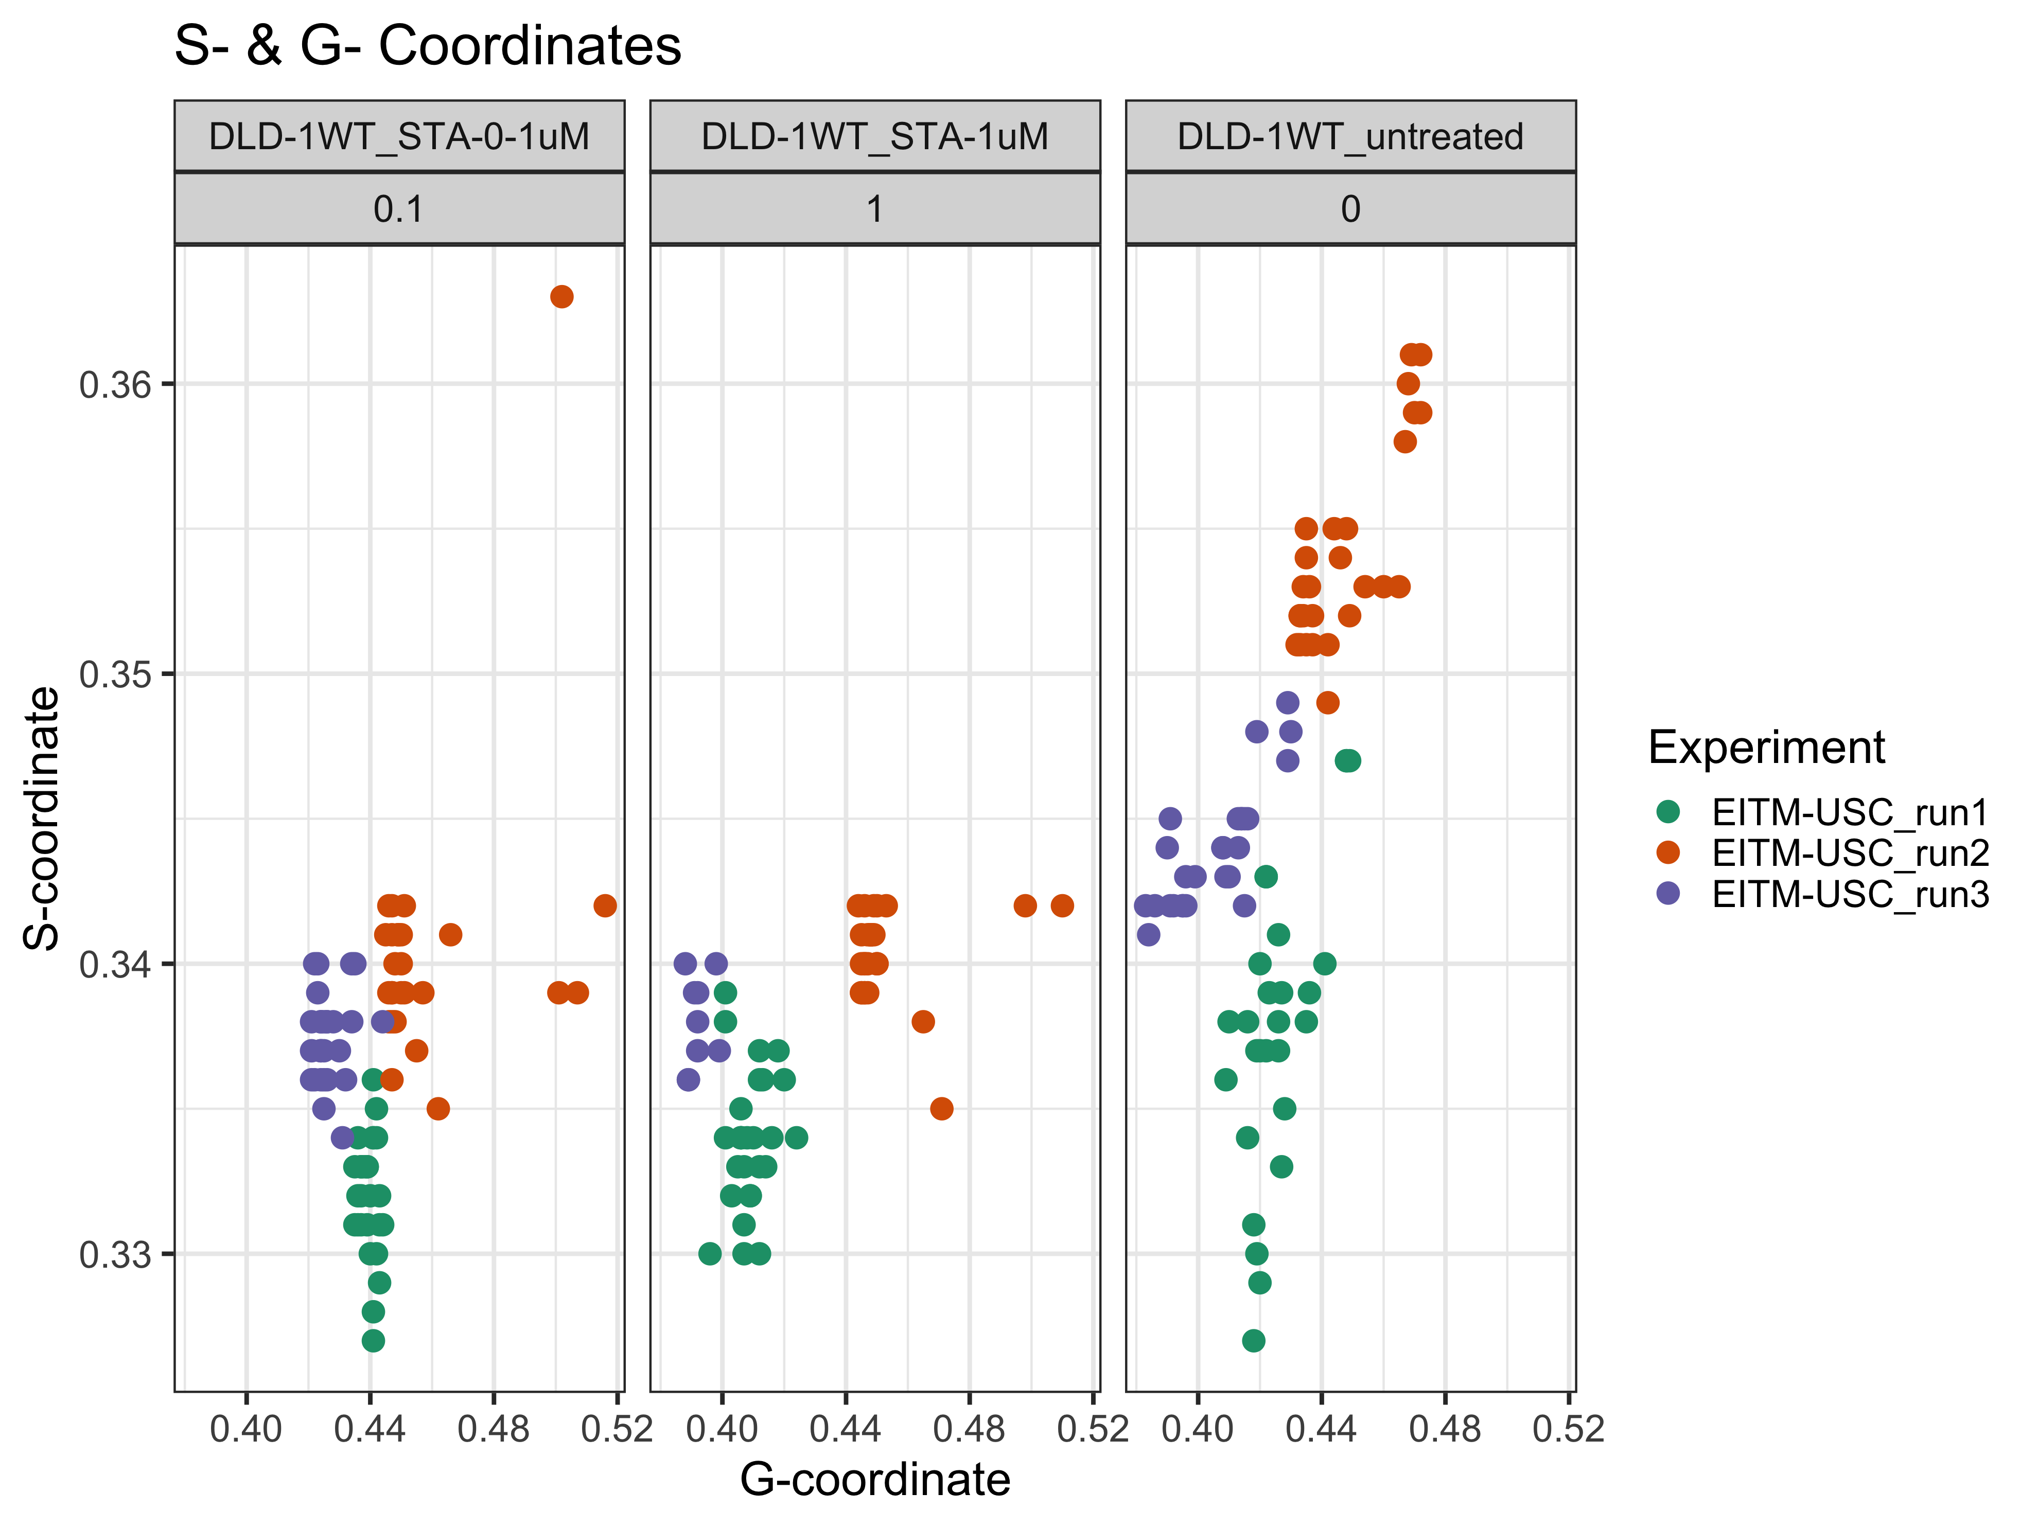

# Mixed Effects Models (Fraction Bound)

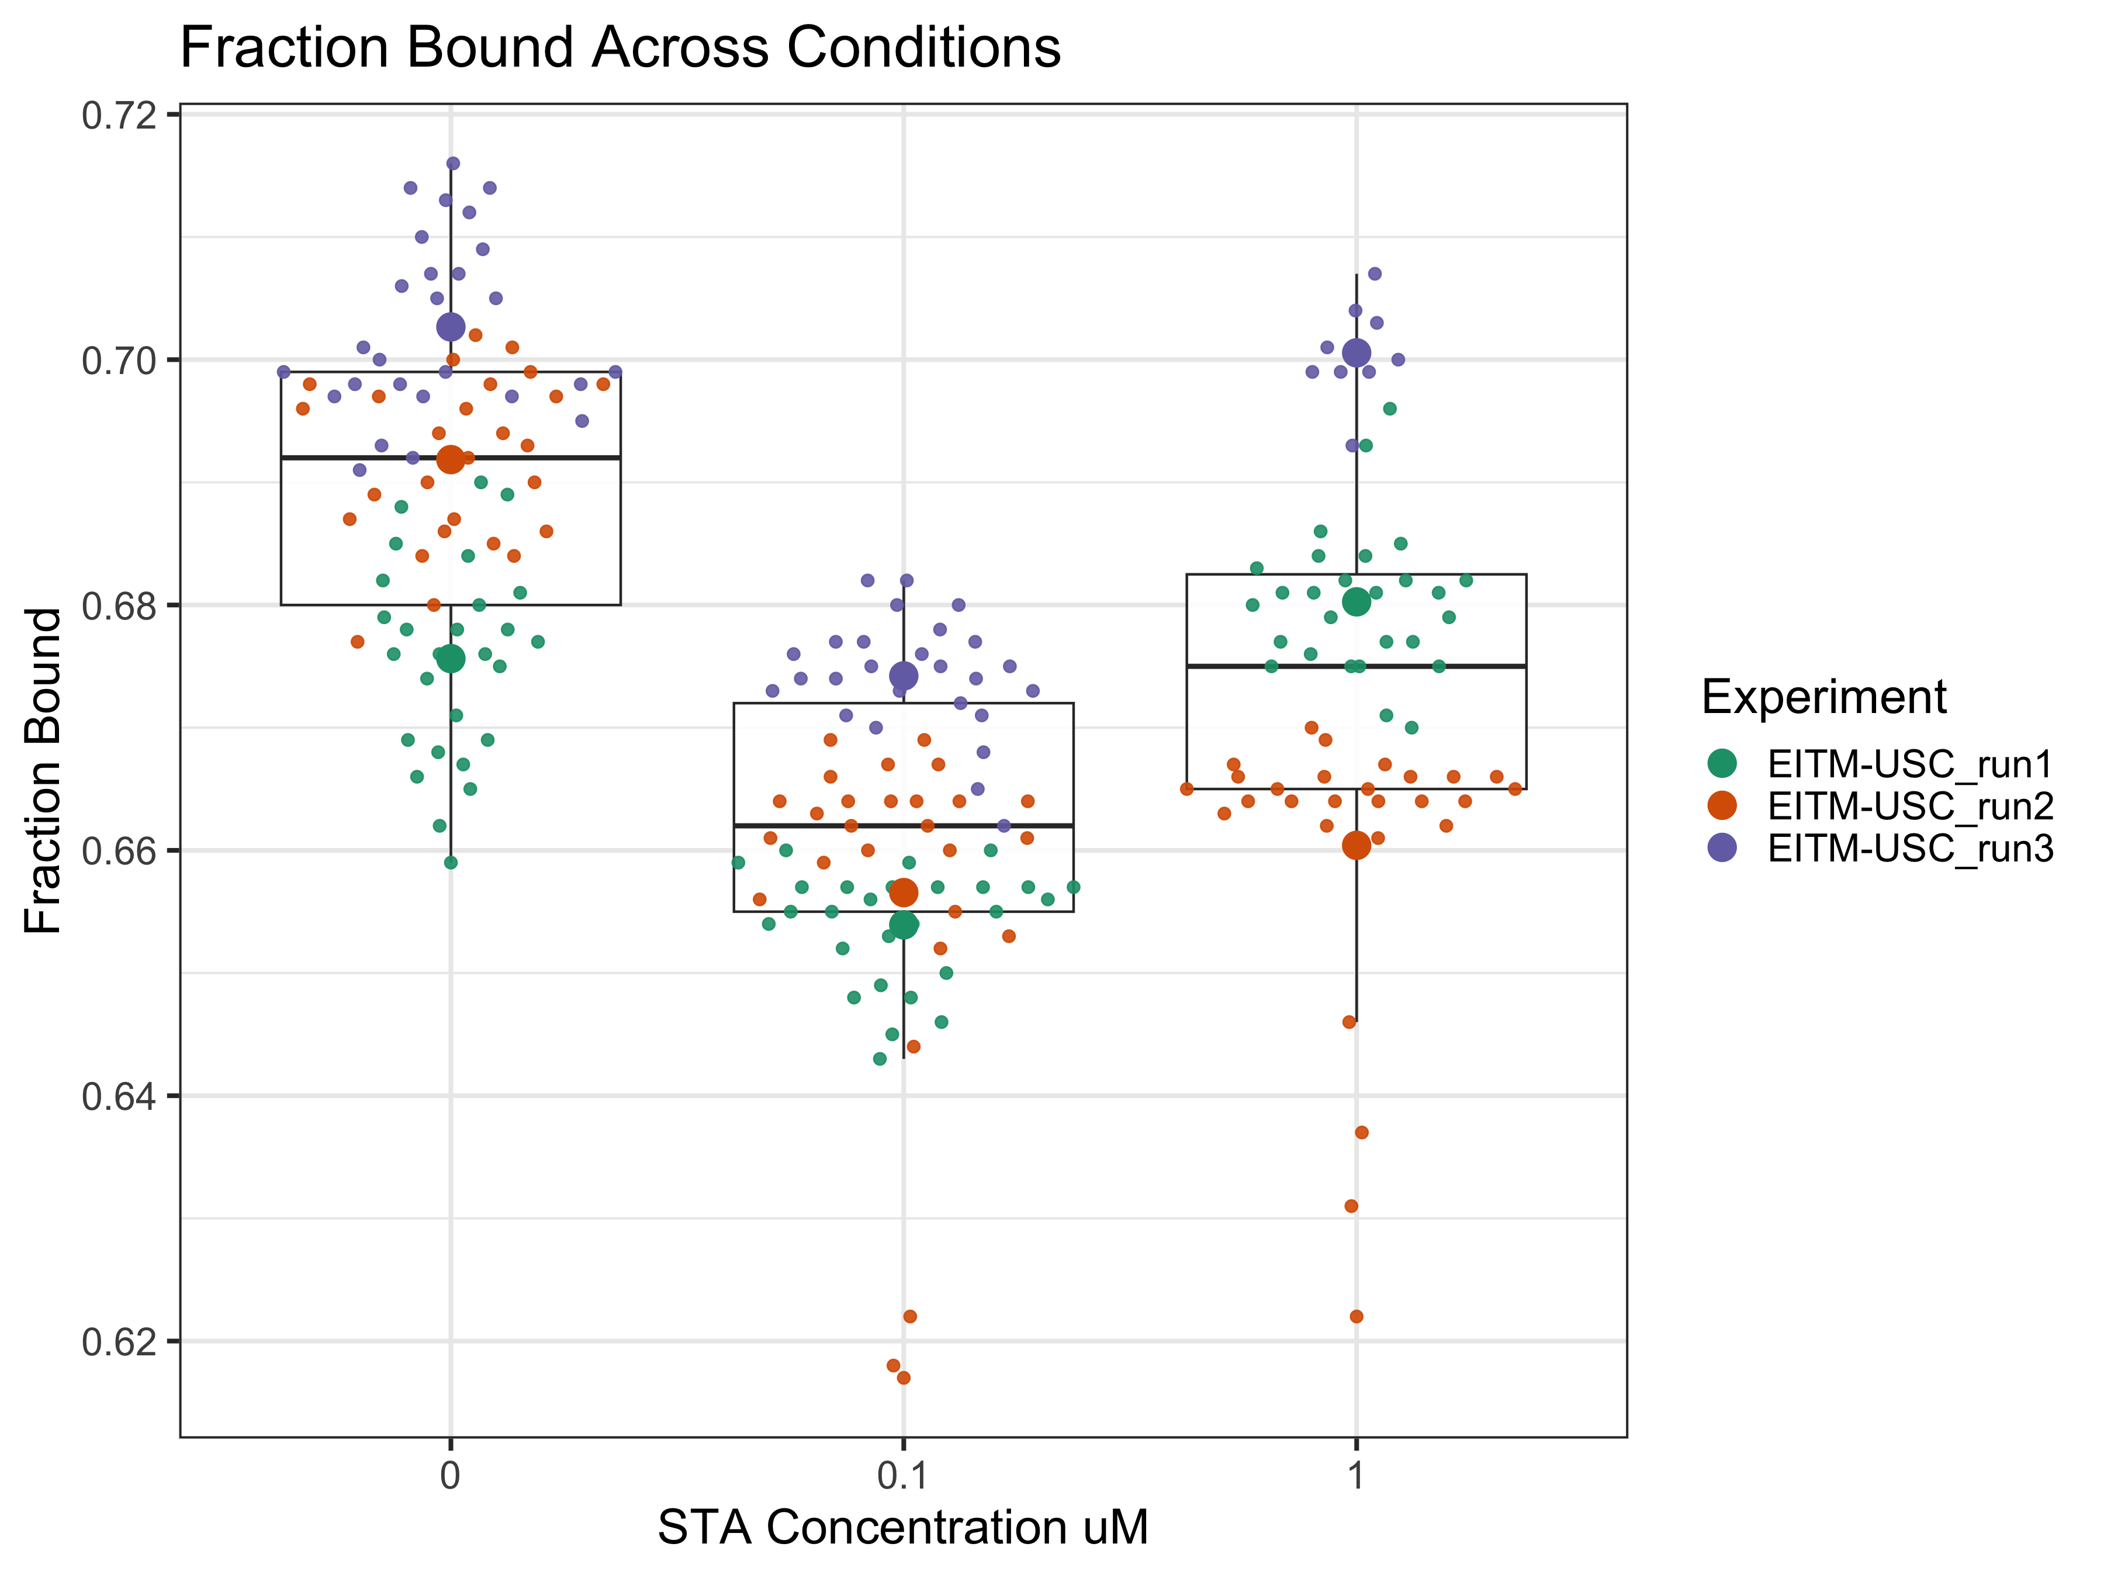 The goal of this experiment is to compare fraction bound (fB) across varying concentrations of STA treatment. Each boxplot displays the distribution of fB for a specific concentration, and each point is color-coded by experimental run. You can see that the data tends to cluster by run rather than purely by treatment. The data points from run 3 consistently appear higher across all conditions. This suggests that a substantial percentage of the variation in fB is attributable to differences between experiment runs, rather than just treatment effects. This is not suprising because FLIM is a variable assay and there can be fluctuations between runs resulting in variations in the data.

To account for this, we use a mixed-effects model, with STA concentration as a fixed effects and experiment (run) as a random effect in order to isolate the effect of STA treatment on fB.

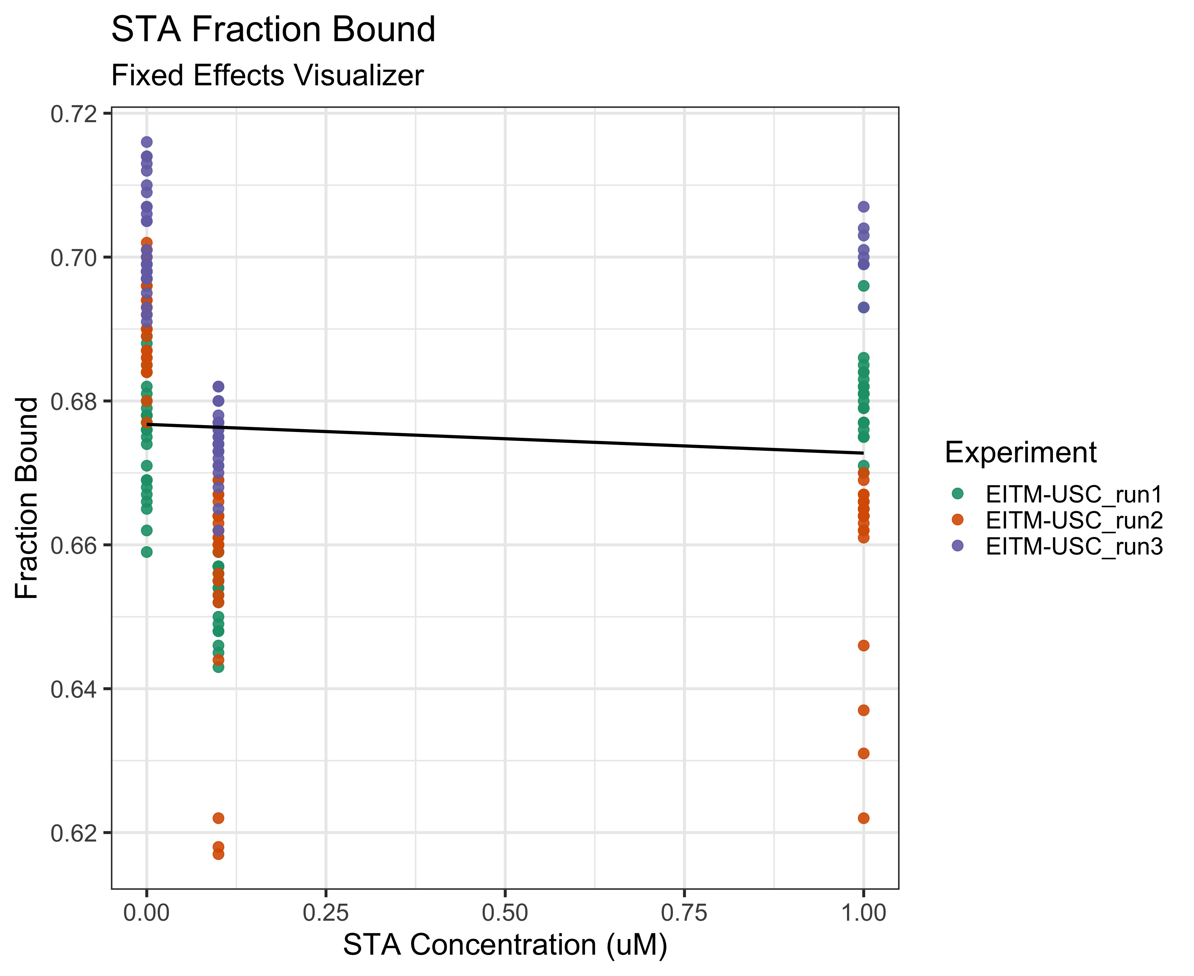

This is a fixed linear model that only considers concentration and not experiment in the model. Just looking at concentration, we observe that fB slightly decreases as STA concentration increases.

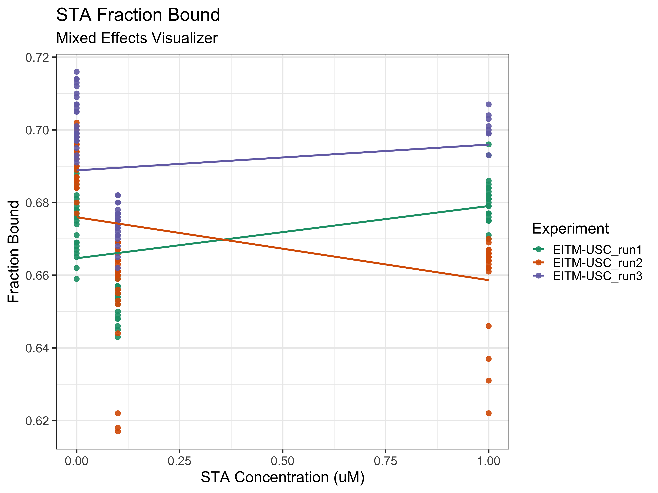

The mixed effect model shows us that the overall results are being skewed by outliers from run 2. While run 1 and run 3 show a consistent trend in how fraction bound responds to STA concentration, increasing fB as concentration increases, run 2 deviates from that pattern and decreases fB as concentration increases. This skews the results we see in the fixed effects model. By including experiment as a random effect, the model helps correct for the variability across runs and displays the true relationship between STA and fB.

## Predictors Estimates CI p  
## 1 (Intercept) 0.68 0.66 – 0.69 <0.001  
## 2 Concentration -0.00 -0.01 – 0.01 0.981  
## 3 Random Effects   
## 4 σ2 0.00   
## 5 τ00Experiment 0.00   
## 6 ICC 0.34   
## 7 N Experiment 3   
## 8 Observations 225   
## 9 Marginal R2 / Conditional R2 0.000 / 0.336

This mixed effects model assesses the effect of STA concentration on fraction bound, while accounting for experiment variation with Experiment as a random effect. The estimate column contains the average difference in Fraction Bound from the intercept produced each unit of concentration.

The fixed effect estimate for concentration is 0.00, and a p-value of 0.981, suggesting that concentration does not have a statistically significant effect on fraction bound.

The intercept estimate is 0.68, which represents the average fraction bound with concentration is 0.

The ICC is 0.34, which means that 34% of the variation in fB can be attributed to differences between the runs.

For the random effects, the marginal R squared only considers the variance of fixed effects. The conditional R squared takes in both the fixed effects and the random effects. The marginal R squared is 0.00, suggesting that none of the differences in fB can be explained by just concentration. The conditional R squared is 0.336, which means that when experiment is accounted for as a random effect, 33.6% of the variation is explained.