FLIM Analysis Template

Sevde Coban

2024-11-13

# Purpose

FLIM collects photon excitation information from cell images to examine metabolic changes within biologic samples. This information is Fourier transformed to collect two parameters: S-coordinate and G-coordinate. These parameters are used to calculate fraction bound (fB), which is the fraction of bound to unbound NADH within the cells we’re looking at. Fraction bound can tell you if the cells are using more glycolysis (more free NADH) or oxidative phosphorylation (more NADH is bound to an enzyme).

The purpose of this analysis is to compare the differences in fraction bound (fB) between conditions between the treatments DMSO and Osimertinib.

# Z’ Factor and % Cell Viability for Fraction Bound and G-Coordinates

Fraction Bound Z’factor and %CV

| plate_id | z_prime_factor | percent_cv |
| --- | --- | --- |
| UP01 | -0.8313833 | 13.81436 |

Mean Fraction Bound Z’factor and %CV

| plate_id | z_prime_factor | percent_cv |
| --- | --- | --- |
| UP01 | -0.8137432 | 13.78173 |

G-Coordinate Z’factor and %CV

| plate_id | z_prime_factor | percent_cv |
| --- | --- | --- |
| UP01 | -0.247461 | 6.888528 |

Mean G-Coordinate Z’factor and %CV

| plate_id | z_prime_factor | percent_cv |
| --- | --- | --- |
| UP01 | -0.2259419 | 6.868782 |

# Scatterplot of S- & G- Coordinates of Treatments DMSO, Osimertinib, and Temsirolimus

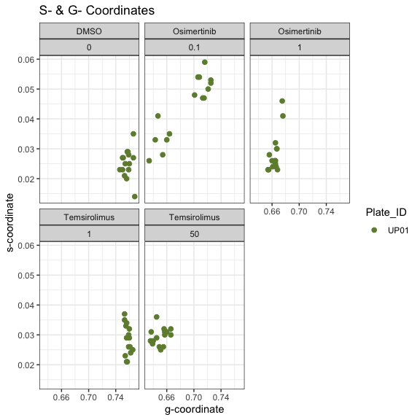

# Mixed Effects Models

## DMSO

## Linear mixed model fit by REML ['lmerMod']  
## Formula: f_b ~ concentration + (1 | plate_id)  
## Data: dmso_df  
##   
## REML criterion at convergence: -70.9  
##   
## Scaled residuals:   
## Min 1Q Median 3Q Max   
## -3.05750 -0.20095 0.06086 0.48915 1.83996   
##   
## Random effects:  
## Groups Name Variance Std.Dev.  
## plate_id (Intercept) 33.591052 5.7958   
## Residual 0.004692 0.0685   
## Number of obs: 45, groups: plate_id, 3  
##   
## Fixed effects:  
## Estimate Std. Error t value  
## (Intercept) 3.7913376 3.3462115 1.133  
## concentration -0.0005081 0.0003369 -1.508  
##   
## Correlation of Fixed Effects:  
## (Intr)  
## concentratn -0.001

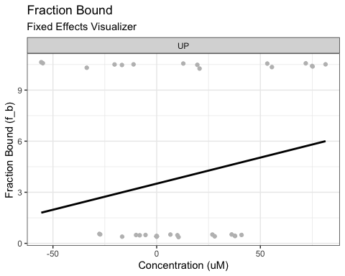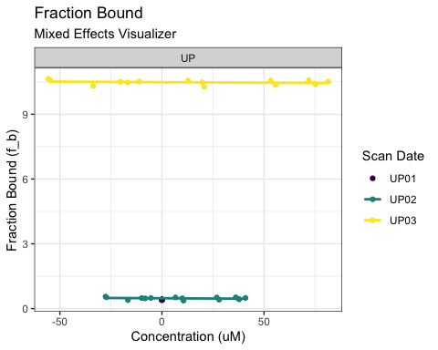

## Osimertinib

## Linear mixed model fit by REML ['lmerMod']  
## Formula: f_b ~ concentration + (1 | plate_id)  
## Data: dmso_df  
##   
## REML criterion at convergence: -70.9  
##   
## Scaled residuals:   
## Min 1Q Median 3Q Max   
## -3.05750 -0.20095 0.06086 0.48915 1.83996   
##   
## Random effects:  
## Groups Name Variance Std.Dev.  
## plate_id (Intercept) 33.591052 5.7958   
## Residual 0.004692 0.0685   
## Number of obs: 45, groups: plate_id, 3  
##   
## Fixed effects:  
## Estimate Std. Error t value  
## (Intercept) 3.7913376 3.3462115 1.133  
## concentration -0.0005081 0.0003369 -1.508  
##   
## Correlation of Fixed Effects:  
## (Intr)  
## concentratn -0.001

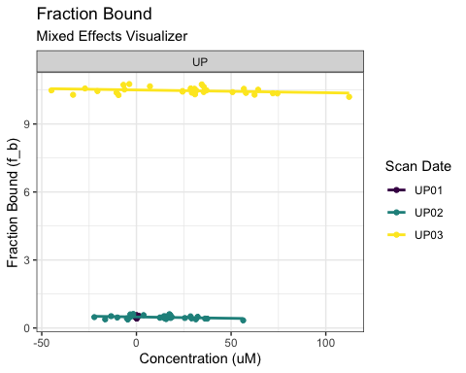 ## Temsirolimus

## Linear mixed model fit by REML ['lmerMod']  
## Formula: f_b ~ concentration + (1 | plate_id)  
## Data: dmso_df  
##   
## REML criterion at convergence: -70.9  
##   
## Scaled residuals:   
## Min 1Q Median 3Q Max   
## -3.05750 -0.20095 0.06086 0.48915 1.83996   
##   
## Random effects:  
## Groups Name Variance Std.Dev.  
## plate_id (Intercept) 33.591052 5.7958   
## Residual 0.004692 0.0685   
## Number of obs: 45, groups: plate_id, 3  
##   
## Fixed effects:  
## Estimate Std. Error t value  
## (Intercept) 3.7913376 3.3462115 1.133  
## concentration -0.0005081 0.0003369 -1.508  
##   
## Correlation of Fixed Effects:  
## (Intr)  
## concentratn -0.001

