MAP-8 Case Study: Multidimensional Analysis of Empathy (IRI Replication)

1. Methodological Foundations
This study applies the MAP-8 framework to explore empathy constructs using three complementary methods: Confirmatory Factor Analysis (CFA) for linear structures, Fuzzy-Set Qualitative Comparative Analysis (fsQCA) for configurational causality, and Hierarchical Clustering for latent profile identification.

2. Data Preparation and Quality Control
Raw cases: 2322
Cases after QC (AC2/AC3): 1322
Cases after MD outliers removal: 1262
Dropped as potentially random: 60

3. Psychometric Validation
Factorability check: KMO = 0.891.

Table 1. Reliability Metrics (Cronbach's Alpha)
Construct | Alpha (α)
FS | 0.707
PT | 0.706
EC | 0.659
PD | 0.748

4. Confirmatory Factor Analysis Results

Table 2. Standardized Factor Loadings
Latent | Item | Estimate | p-value
FS | FS1 | 1.000 | Fixed
FS | FS5 | 1.602 | < 0.001
FS | FS7 | -0.006 | 0.922
FS | FS12 | 0.421 | < 0.001
FS | FS16 | 1.691 | < 0.001
FS | FS23 | 1.716 | < 0.001
FS | FS26 | 1.590 | < 0.001
PT | PT3 | 1.000 | Fixed
PT | PT8 | 2.022 | < 0.001
PT | PT11 | 2.750 | < 0.001
PT | PT15 | 0.727 | < 0.001
PT | PT21 | 2.350 | < 0.001
PT | PT25 | 2.375 | < 0.001
PT | PT28 | 2.479 | < 0.001
EC | EC2 | 1.000 | Fixed
EC | EC4 | 0.175 | < 0.001
EC | EC9 | 0.874 | < 0.001
EC | EC14 | 0.302 | < 0.001
EC | EC18 | 0.126 | 0.010
EC | EC20 | 1.317 | < 0.001
EC | EC22 | 1.447 | < 0.001
PD | PD6 | 1.000 | Fixed
PD | PD10 | 0.891 | < 0.001
PD | PD13 | 0.370 | < 0.001
PD | PD17 | 1.104 | < 0.001
PD | PD19 | 0.195 | < 0.001
PD | PD24 | 0.908 | < 0.001
PD | PD27 | 0.653 | < 0.001

5. Heterogeneity and Empathy Profiles
Hierarchical clustering identified homogeneous subgroups based on empathy dimensions.
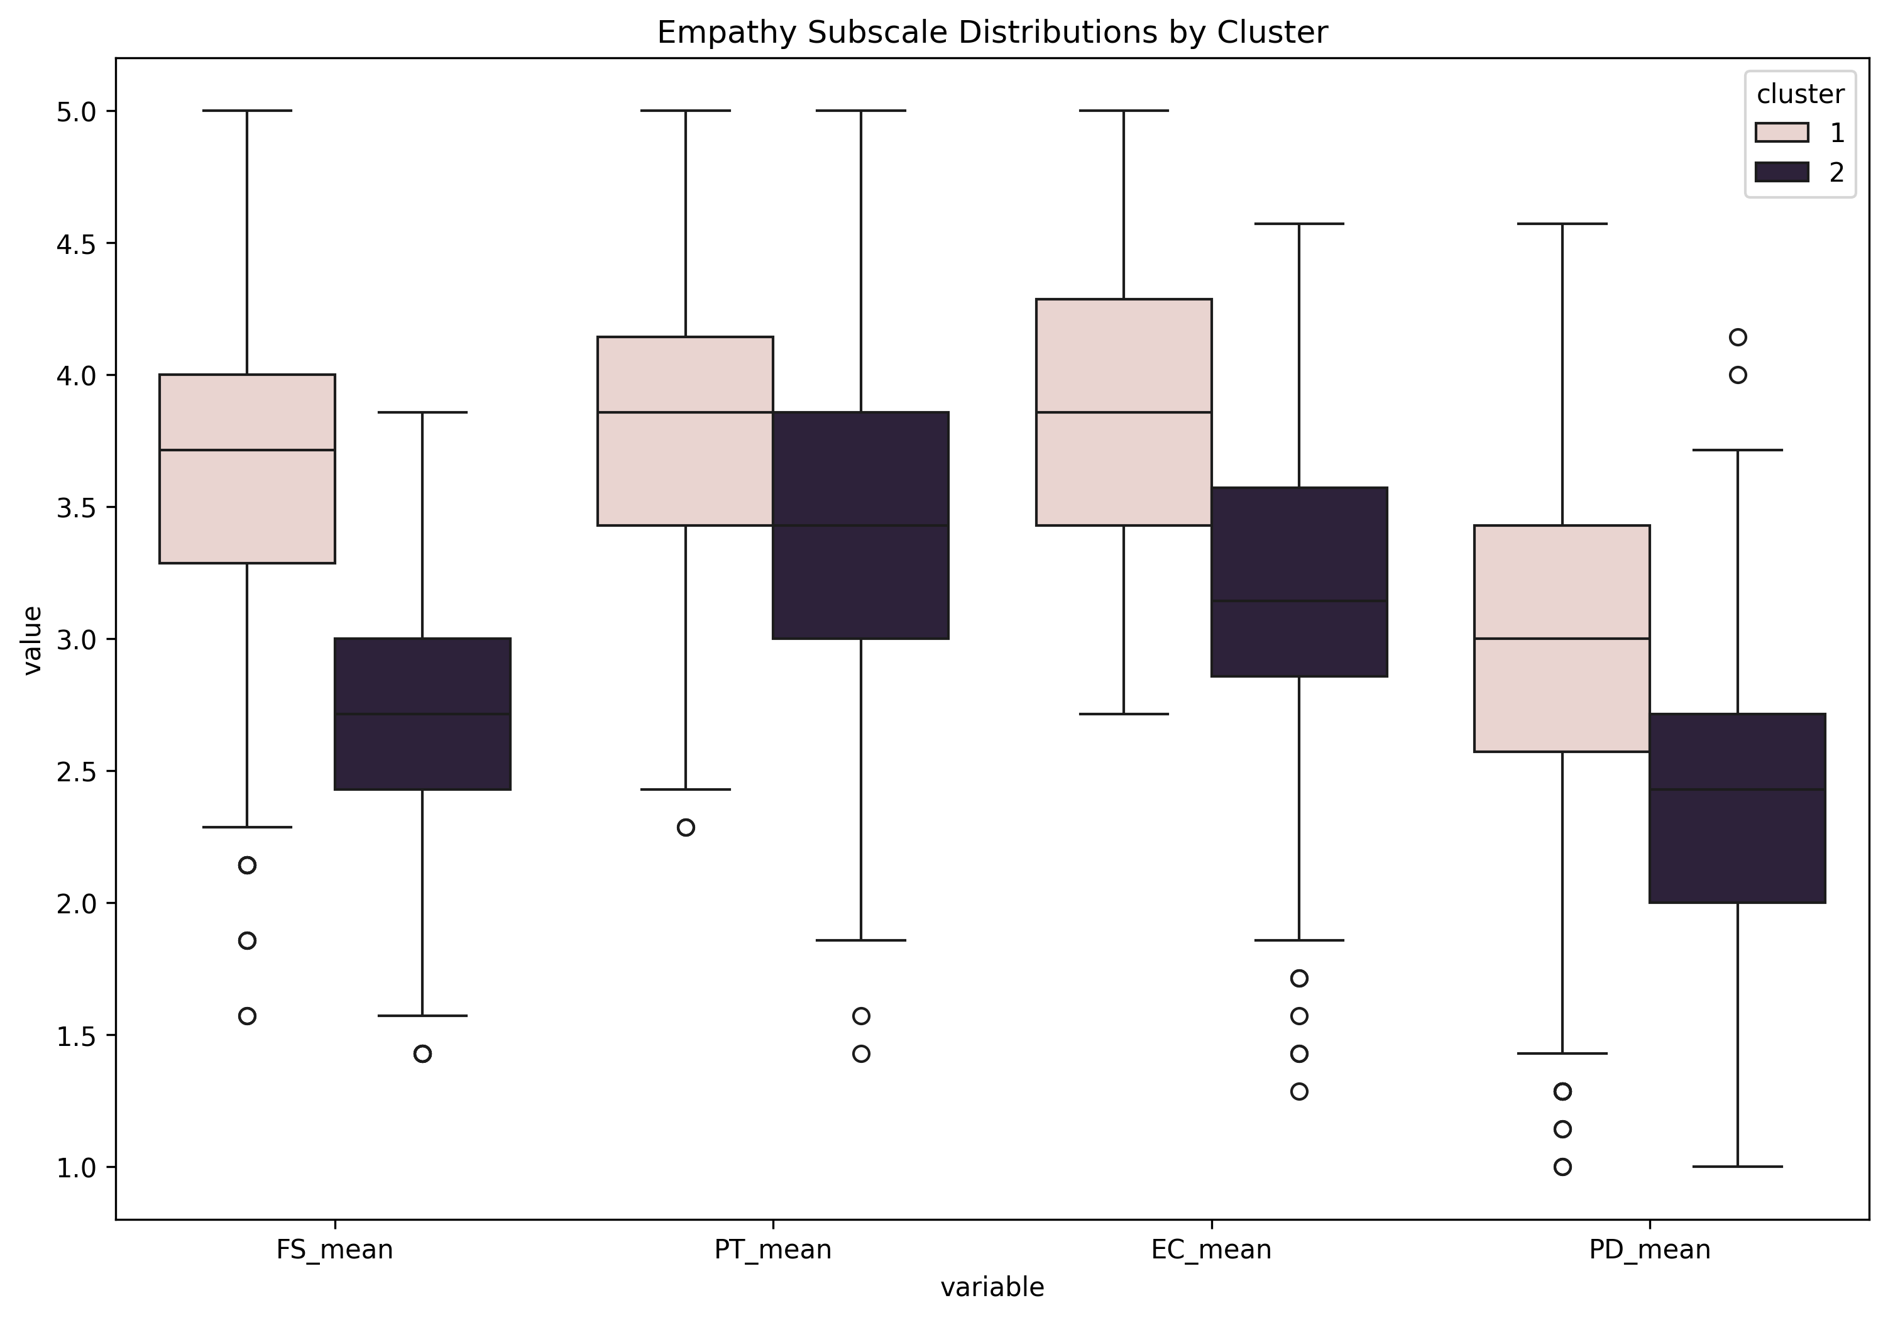
Figure 1. Comparison of IRI subscale distributions across identified clusters.

6. Configurational Pathways (fsQCA)

Table 3. Parsimonious Solution for High Total Empathy
(With Remainders) ---
M1: fs_f + ec_f + pt_f*pd_f -> iri_total_f
inclS PRI covS covU
----------------------------------------
1 fs_f 0.833 0.718 0.855 0.070
2 ec_f 0.851 0.744 0.873 0.059
3 pt_f*pd_f 0.935 0.864 0.611 0.007
----------------------------------------
M1 0.761 0.625 0.987

