MAP-8 Empathy Research: Psychometric and Configurational Analysis Results

1. Reliability and Inter-scale Correlations
The internal consistency of the IRI scales was evaluated using Cronbach's Alpha. Preliminary EFA checks (KMO and Bartlett) confirmed the suitability of the data.
- --- Scale: FS (Cronbach's Alpha: 0.701) ---
- --- Scale: PT (Cronbach's Alpha: 0.693) ---
- --- Scale: EC (Cronbach's Alpha: 0.662) ---
- --- Scale: PD (Cronbach's Alpha: 0.741) ---

Factor Correlations
Dimension | FS_mean | PT_mean | EC_mean | PD_mean
FS_mean | 1.000 | 0.517 | 0.581 | 0.585
PT_mean | 0.517 | 1.000 | 0.513 | 0.484
EC_mean | 0.581 | 0.513 | 1.000 | 0.688
PD_mean | 0.585 | 0.484 | 0.688 | 1.000

2. Confirmatory Factor Analysis (CFA)
A CFA was performed to validate the multidimensional structure of the IRI.

Table: Latent Factor Loadings
Latent | Item | Estimate | p-value
FS | FS1 | 1.000 | -
FS | FS5 | 1.333 | < 0.001
FS | FS7_rev | -0.321 | < 0.001
FS | FS12_rev | -0.509 | < 0.001
FS | FS16 | 1.364 | < 0.001
FS | FS23 | 1.390 | < 0.001
FS | FS26 | 1.271 | < 0.001
PT | PT3_rev | 1.000 | -
PT | PT8 | -1.595 | < 0.001
PT | PT11 | -2.107 | < 0.001
PT | PT15_rev | 0.633 | < 0.001
PT | PT21 | -1.952 | < 0.001
PT | PT25 | -1.894 | < 0.001
PT | PT28 | -1.822 | < 0.001
EC | EC2 | 1.000 | -
EC | EC4_rev | -0.414 | < 0.001
EC | EC9 | 0.981 | < 0.001
EC | EC14_rev | -0.499 | < 0.001
EC | EC18_rev | -0.326 | < 0.001
EC | EC20 | 1.127 | < 0.001
EC | EC22 | 1.209 | < 0.001
PD | PD6 | 1.000 | -
PD | PD10 | 0.981 | < 0.001
PD | PD13_rev | -0.472 | < 0.001
PD | PD17 | 1.074 | < 0.001
PD | PD19_rev | -0.321 | < 0.001
PD | PD24 | 0.898 | < 0.001
PD | PD27 | 0.737 | < 0.001

3. Empathy Profiles (Hierarchical Clustering)
Using Ward's method, latent profiles were identified based on subscale means.
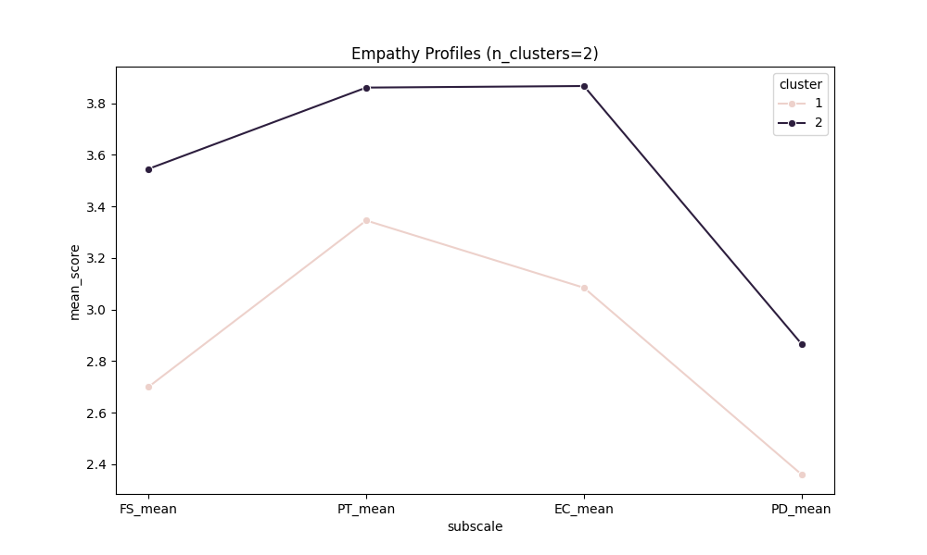
Figure 1. Empathy profiles identified via Hierarchical Clustering.

4. Configurational Analysis (fsQCA)
The fsQCA analysis reveals pathways leading to high total empathy.

