Results Section - FlexSim Validation with 24h Served-Only Cohort

1. Data and Matching Rule
Run folder: C:\Users\LEONA\Documents\GitHub\MOFGPM\results\run_20260228_091617
GA source subfolder: combinatorics
FlexSim sheet used: Raw Data
24h horizon used: 1440.00 minutes
Matching rule: for each FlexSim staffing row (Doctor, Nurse, Assistant, Specialist), select the GA row with feasible=True, then max lambda, then min wait.

2. Cohort Reconciliation
GA all-finished metrics are not directly comparable to FlexSim 24h outputs.
Validation is performed on the served within 24h cohort to align denominators and avoid the Dylan vs Laura discrepancy.
Served_24h for GA is defined at patient level as last_end <= 1440 (or T_MAX_DAY from settings). GA waiting on this cohort is computed using first wait plus inter-activity waiting gaps.
Patients with missing first_wait in triage file (filled with 0 for reconstruction): 0
Capacity/horizon mismatch threshold used: |served_gap_pct| > 20.0%

3. KPI Definition and Figure Encoding
KPI in this validation refers to the aggregate waiting/attention metric computed only on the served-within-24h cohort. For FlexSim, FS_mean is the average across 10 replications and FS_ci95 is computed as 1.96*FS_std/sqrt(10).
For GA, GA_scaled_total_24h = GA_avg_wait_per_served * FlexSim Patient, which aligns the GA numerator with the FlexSim served denominator.
Figure 1 left panel: each dot is one staffing scenario; blue means no capacity/horizon mismatch, red means mismatch, and larger dots indicate more served patients in FlexSim.
Figure 1 right panel: the line and error bars show decile-averaged ratio GA_scaled_total_24h / FS_mean (+/-95% CI across scenarios), and shaded bars show mismatch rate by decile.
Figure 2 is an aggregated summary (overall levels and ratio distribution by mismatch group), while Figures 3 and 4 summarize per-patient KPI and served-rate levels.

4. Key Summary
Matched scenarios: 144
Average GA total patients (all-finished cohort): 35.00
Average GA served within 24h: 12.77
Average FlexSim served within 24h (Patient): 17.29
Capacity/horizon mismatch flags: 113
Scenarios with |z|<2: 0.7%

5. Tables
Scenario | Doctor | Nurse | Assistant | Specialist | sample_id | N_total_ga | N_served_24h_ga | GA_served_rate | Patient | FS_served_rate | served_gap_patients | served_gap_pct | capacity_horizon_mismatch
Scenario 1 | 1 | 1 | 1 | 1 | 1 | 35 | 1 | 0.0417 | 7.0000 | 0.2917 | -6.0000 | -85.7143 | True
Scenario 2 | 1 | 1 | 2 | 1 | 4 | 35 | 3 | 0.1250 | 7.0000 | 0.2917 | -4.0000 | -57.1429 | True
Scenario 3 | 1 | 2 | 1 | 1 | 7 | 35 | 3 | 0.1250 | 7.0000 | 0.2917 | -4.0000 | -57.1429 | True
Scenario 4 | 1 | 2 | 2 | 1 | 10 | 35 | 2 | 0.0833 | 7.0000 | 0.2917 | -5.0000 | -71.4286 | True
Scenario 5 | 1 | 3 | 1 | 1 | 13 | 35 | 1 | 0.0417 | 7.2000 | 0.3000 | -6.2000 | -86.1111 | True
Scenario 6 | 1 | 3 | 2 | 1 | 16 | 35 | 0 | 0.0000 | 7.2000 | 0.3000 | -7.2000 | -100.0000 | True
Scenario 7 | 1 | 4 | 1 | 1 | 19 | 35 | 2 | 0.0833 | 7.2000 | 0.3000 | -5.2000 | -72.2222 | True
Scenario 8 | 1 | 4 | 2 | 1 | 22 | 35 | 4 | 0.1667 | 7.2000 | 0.3000 | -3.2000 | -44.4444 | True
Scenario 9 | 1 | 1 | 1 | 2 | 2 | 35 | 2 | 0.0833 | 7.2000 | 0.3000 | -5.2000 | -72.2222 | True
Scenario 10 | 1 | 1 | 2 | 2 | 5 | 35 | 2 | 0.0833 | 7.2000 | 0.3000 | -5.2000 | -72.2222 | True
Scenario 11 | 1 | 2 | 1 | 2 | 8 | 35 | 2 | 0.0833 | 7.2000 | 0.3000 | -5.2000 | -72.2222 | True
Scenario 12 | 1 | 2 | 2 | 2 | 11 | 35 | 1 | 0.0417 | 7.2000 | 0.3000 | -6.2000 | -86.1111 | True
Scenario 13 | 1 | 3 | 1 | 2 | 14 | 35 | 2 | 0.0833 | 7.2000 | 0.3000 | -5.2000 | -72.2222 | True
Scenario 14 | 1 | 3 | 2 | 2 | 17 | 35 | 4 | 0.1667 | 7.2000 | 0.3000 | -3.2000 | -44.4444 | True
Scenario 15 | 1 | 4 | 1 | 2 | 20 | 35 | 1 | 0.0417 | 7.2000 | 0.3000 | -6.2000 | -86.1111 | True
Scenario 16 | 1 | 4 | 2 | 2 | 23 | 35 | 2 | 0.0833 | 7.2000 | 0.3000 | -5.2000 | -72.2222 | True
Scenario 17 | 1 | 1 | 1 | 3 | 3 | 35 | 0 | 0.0000 | 7.2000 | 0.3000 | -7.2000 | -100.0000 | True
Scenario 18 | 1 | 1 | 2 | 3 | 6 | 35 | 3 | 0.1250 | 7.2000 | 0.3000 | -4.2000 | -58.3333 | True
Scenario 19 | 1 | 2 | 1 | 3 | 9 | 35 | 3 | 0.1250 | 7.2000 | 0.3000 | -4.2000 | -58.3333 | True
Scenario 20 | 1 | 2 | 2 | 3 | 12 | 35 | 3 | 0.1250 | 7.2000 | 0.3000 | -4.2000 | -58.3333 | True
Table 1. Cohort and capacity reconciliation (full table in CSV).
Scenario | Doctor | Nurse | Assistant | Specialist | FS_mean | FS_std | FS_ci95 | FS_avg_wait_per_served | GA_total_wait_all_finished | GA_avg_wait_all_finished | GA_total_wait_served_24h | GA_avg_wait_per_served | GA_scaled_total_24h | abs_diff_per_patient | pct_diff_per_patient | abs_diff_total_24h | pct_diff_total_24h
Scenario 1 | 1 | 1 | 1 | 1 | 1378.8176 | 45.8531 | 28.4201 | 196.9739 | 91558.1849 | 2615.9481 | 236.2482 | 236.2482 | 1653.7372 | 39.2742 | 19.9388 | 274.9196 | 19.9388
Scenario 2 | 1 | 1 | 2 | 1 | 1378.8176 | 45.8531 | 28.4201 | 196.9739 | 71081.4284 | 2030.8980 | 546.4549 | 182.1516 | 1275.0614 | 14.8223 | -7.5250 | 103.7562 | -7.5250
Scenario 3 | 1 | 2 | 1 | 1 | 1370.7415 | 68.3655 | 42.3734 | 195.8202 | 82737.6072 | 2363.9316 | 1923.0303 | 641.0101 | 4487.0707 | 445.1899 | 227.3462 | 3116.3292 | 227.3462
Scenario 4 | 1 | 2 | 2 | 1 | 1369.2997 | 67.3091 | 41.7186 | 195.6142 | 79706.4509 | 2277.3272 | 382.6794 | 191.3397 | 1339.3780 | 4.2745 | -2.1852 | 29.9217 | -2.1852
Scenario 5 | 1 | 3 | 1 | 1 | 1386.2597 | 55.8228 | 34.5993 | 192.5361 | 87890.6420 | 2511.1612 | 312.2448 | 312.2448 | 2248.1622 | 119.7087 | 62.1747 | 861.9025 | 62.1747
Scenario 6 | 1 | 3 | 2 | 1 | 1385.2277 | 55.1810 | 34.2016 | 192.3927 | 89137.1039 | 2546.7744 | 0.0000 | - | - | - | - | - | -
Scenario 7 | 1 | 4 | 1 | 1 | 1386.2597 | 55.8228 | 34.5993 | 192.5361 | 77896.1903 | 2225.6054 | 1257.2812 | 628.6406 | 4526.2122 | 436.1045 | 226.5053 | 3139.9525 | 226.5053
Scenario 8 | 1 | 4 | 2 | 1 | 1385.2277 | 55.1810 | 34.2016 | 192.3927 | 70034.9850 | 2000.9996 | 2373.6093 | 593.4023 | 4272.4968 | 401.0096 | 208.4328 | 2887.2691 | 208.4328
Scenario 9 | 1 | 1 | 1 | 2 | 1369.1237 | 55.3532 | 34.3083 | 190.1561 | 79363.3119 | 2267.5232 | 1094.2869 | 547.1434 | 3939.4328 | 356.9874 | 187.7339 | 2570.3091 | 187.7339
Scenario 10 | 1 | 1 | 2 | 2 | 1369.1237 | 55.3532 | 34.3083 | 190.1561 | 80847.6035 | 2309.9315 | 796.7837 | 398.3919 | 2868.4214 | 208.2358 | 109.5078 | 1499.2977 | 109.5078
Scenario 11 | 1 | 2 | 1 | 2 | 1356.8818 | 73.3025 | 45.4333 | 188.4558 | 82876.9317 | 2367.9123 | 965.2277 | 482.6138 | 3474.8196 | 294.1580 | 156.0886 | 2117.9378 | 156.0886
Scenario 12 | 1 | 2 | 2 | 2 | 1356.8818 | 73.3025 | 45.4333 | 188.4558 | 71557.5245 | 2044.5007 | 224.0351 | 224.0351 | 1613.0530 | 35.5793 | 18.8794 | 256.1712 | 18.8794
Scenario 13 | 1 | 3 | 1 | 2 | 1353.9890 | 59.0992 | 36.6301 | 188.0540 | 73847.7974 | 2109.9371 | 426.3356 | 213.1678 | 1534.8083 | 25.1138 | 13.3546 | 180.8193 | 13.3546
Scenario 14 | 1 | 3 | 2 | 2 | 1353.9890 | 59.0992 | 36.6301 | 188.0540 | 74625.9136 | 2132.1690 | 2341.8788 | 585.4697 | 4215.3818 | 397.4157 | 211.3306 | 2861.3928 | 211.3306
Scenario 15 | 1 | 4 | 1 | 2 | 1353.9890 | 59.0992 | 36.6301 | 188.0540 | 82898.9653 | 2368.5419 | 695.3898 | 695.3898 | 5006.8068 | 507.3358 | 269.7819 | 3652.8178 | 269.7819
Scenario 16 | 1 | 4 | 2 | 2 | 1353.9890 | 59.0992 | 36.6301 | 188.0540 | 83187.0873 | 2376.7739 | 418.4303 | 209.2151 | 1506.3489 | 21.1611 | 11.2527 | 152.3599 | 11.2527
Scenario 17 | 1 | 1 | 1 | 3 | 1364.7797 | 48.0110 | 29.7575 | 189.5527 | 90674.9526 | 2590.7129 | 0.0000 | - | - | - | - | - | -
Scenario 18 | 1 | 1 | 2 | 3 | 1364.7797 | 48.0110 | 29.7575 | 189.5527 | 78391.7833 | 2239.7652 | 1401.3618 | 467.1206 | 3363.2682 | 277.5679 | 146.4331 | 1998.4885 | 146.4331
Scenario 19 | 1 | 2 | 1 | 3 | 1356.8818 | 73.3025 | 45.4333 | 188.4558 | 80481.3378 | 2299.4668 | 1992.1648 | 664.0549 | 4781.1954 | 475.5991 | 252.3664 | 3424.3137 | 252.3664
Scenario 20 | 1 | 2 | 2 | 3 | 1356.8818 | 73.3025 | 45.4333 | 188.4558 | 80109.3311 | 2288.8380 | 1152.1316 | 384.0439 | 2765.1158 | 195.5881 | 103.7846 | 1408.2340 | 103.7846
Table 2. Served-only KPI comparison (full table in CSV).
Scenario | Doctor | Nurse | Assistant | Specialist | GA_scaled_total_24h | FS_mean | FS_std | z_score | z_interpretation
Scenario 1 | 1 | 1 | 1 | 1 | 1653.7372 | 1378.8176 | 45.8531 | 5.9957 | Material gap (|z|>=2)
Scenario 2 | 1 | 1 | 2 | 1 | 1275.0614 | 1378.8176 | 45.8531 | -2.2628 | Material gap (|z|>=2)
Scenario 3 | 1 | 2 | 1 | 1 | 4487.0707 | 1370.7415 | 68.3655 | 45.5833 | Material gap (|z|>=2)
Scenario 4 | 1 | 2 | 2 | 1 | 1339.3780 | 1369.2997 | 67.3091 | -0.4445 | Consistent (|z|<2)
Scenario 5 | 1 | 3 | 1 | 1 | 2248.1622 | 1386.2597 | 55.8228 | 15.4400 | Material gap (|z|>=2)
Scenario 6 | 1 | 3 | 2 | 1 | - | 1385.2277 | 55.1810 | - | Unverified (FS_std=0)
Scenario 7 | 1 | 4 | 1 | 1 | 4526.2122 | 1386.2597 | 55.8228 | 56.2486 | Material gap (|z|>=2)
Scenario 8 | 1 | 4 | 2 | 1 | 4272.4968 | 1385.2277 | 55.1810 | 52.3236 | Material gap (|z|>=2)
Scenario 9 | 1 | 1 | 1 | 2 | 3939.4328 | 1369.1237 | 55.3532 | 46.4347 | Material gap (|z|>=2)
Scenario 10 | 1 | 1 | 2 | 2 | 2868.4214 | 1369.1237 | 55.3532 | 27.0860 | Material gap (|z|>=2)
Scenario 11 | 1 | 2 | 1 | 2 | 3474.8196 | 1356.8818 | 73.3025 | 28.8931 | Material gap (|z|>=2)
Scenario 12 | 1 | 2 | 2 | 2 | 1613.0530 | 1356.8818 | 73.3025 | 3.4947 | Material gap (|z|>=2)
Scenario 13 | 1 | 3 | 1 | 2 | 1534.8083 | 1353.9890 | 59.0992 | 3.0596 | Material gap (|z|>=2)
Scenario 14 | 1 | 3 | 2 | 2 | 4215.3818 | 1353.9890 | 59.0992 | 48.4168 | Material gap (|z|>=2)
Scenario 15 | 1 | 4 | 1 | 2 | 5006.8068 | 1353.9890 | 59.0992 | 61.8082 | Material gap (|z|>=2)
Scenario 16 | 1 | 4 | 2 | 2 | 1506.3489 | 1353.9890 | 59.0992 | 2.5780 | Material gap (|z|>=2)
Scenario 17 | 1 | 1 | 1 | 3 | - | 1364.7797 | 48.0110 | - | Unverified (FS_std=0)
Scenario 18 | 1 | 1 | 2 | 3 | 3363.2682 | 1364.7797 | 48.0110 | 41.6256 | Material gap (|z|>=2)
Scenario 19 | 1 | 2 | 1 | 3 | 4781.1954 | 1356.8818 | 73.3025 | 46.7148 | Material gap (|z|>=2)
Scenario 20 | 1 | 2 | 2 | 3 | 2765.1158 | 1356.8818 | 73.3025 | 19.2113 | Material gap (|z|>=2)
Table 3. Statistical check with z-score interpretation (full table in CSV).

6. Figures and Alt Text
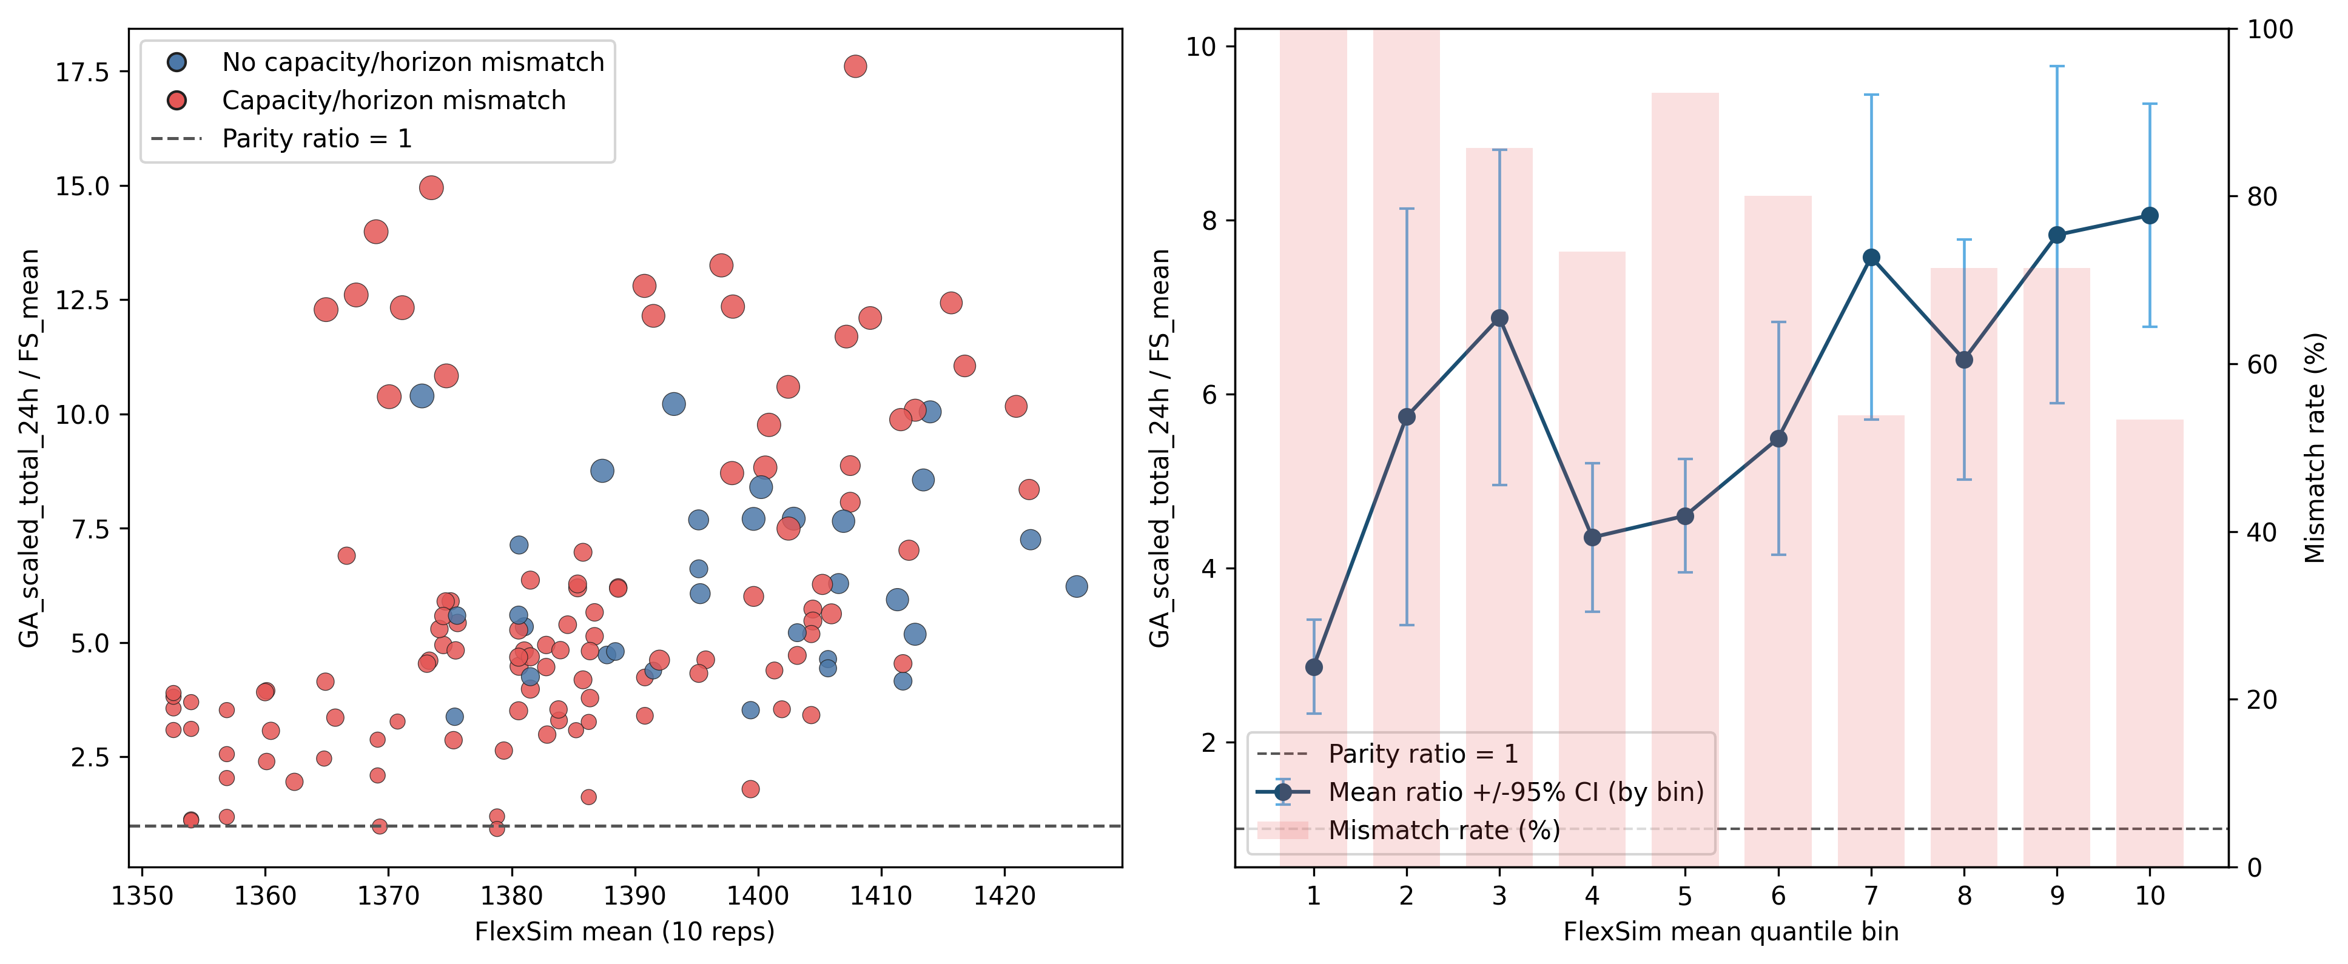
Figure 1. Aggregated ratio view of GA_scaled_total_24h versus FlexSim mean (10 replications).
Alt text: Left panel shows scenario-level ratio values with blue points for non-mismatch and red points for capacity-horizon mismatch; point size reflects FlexSim served patients. Right panel shows decile-averaged ratio with 95% confidence intervals and mismatch-rate bars.
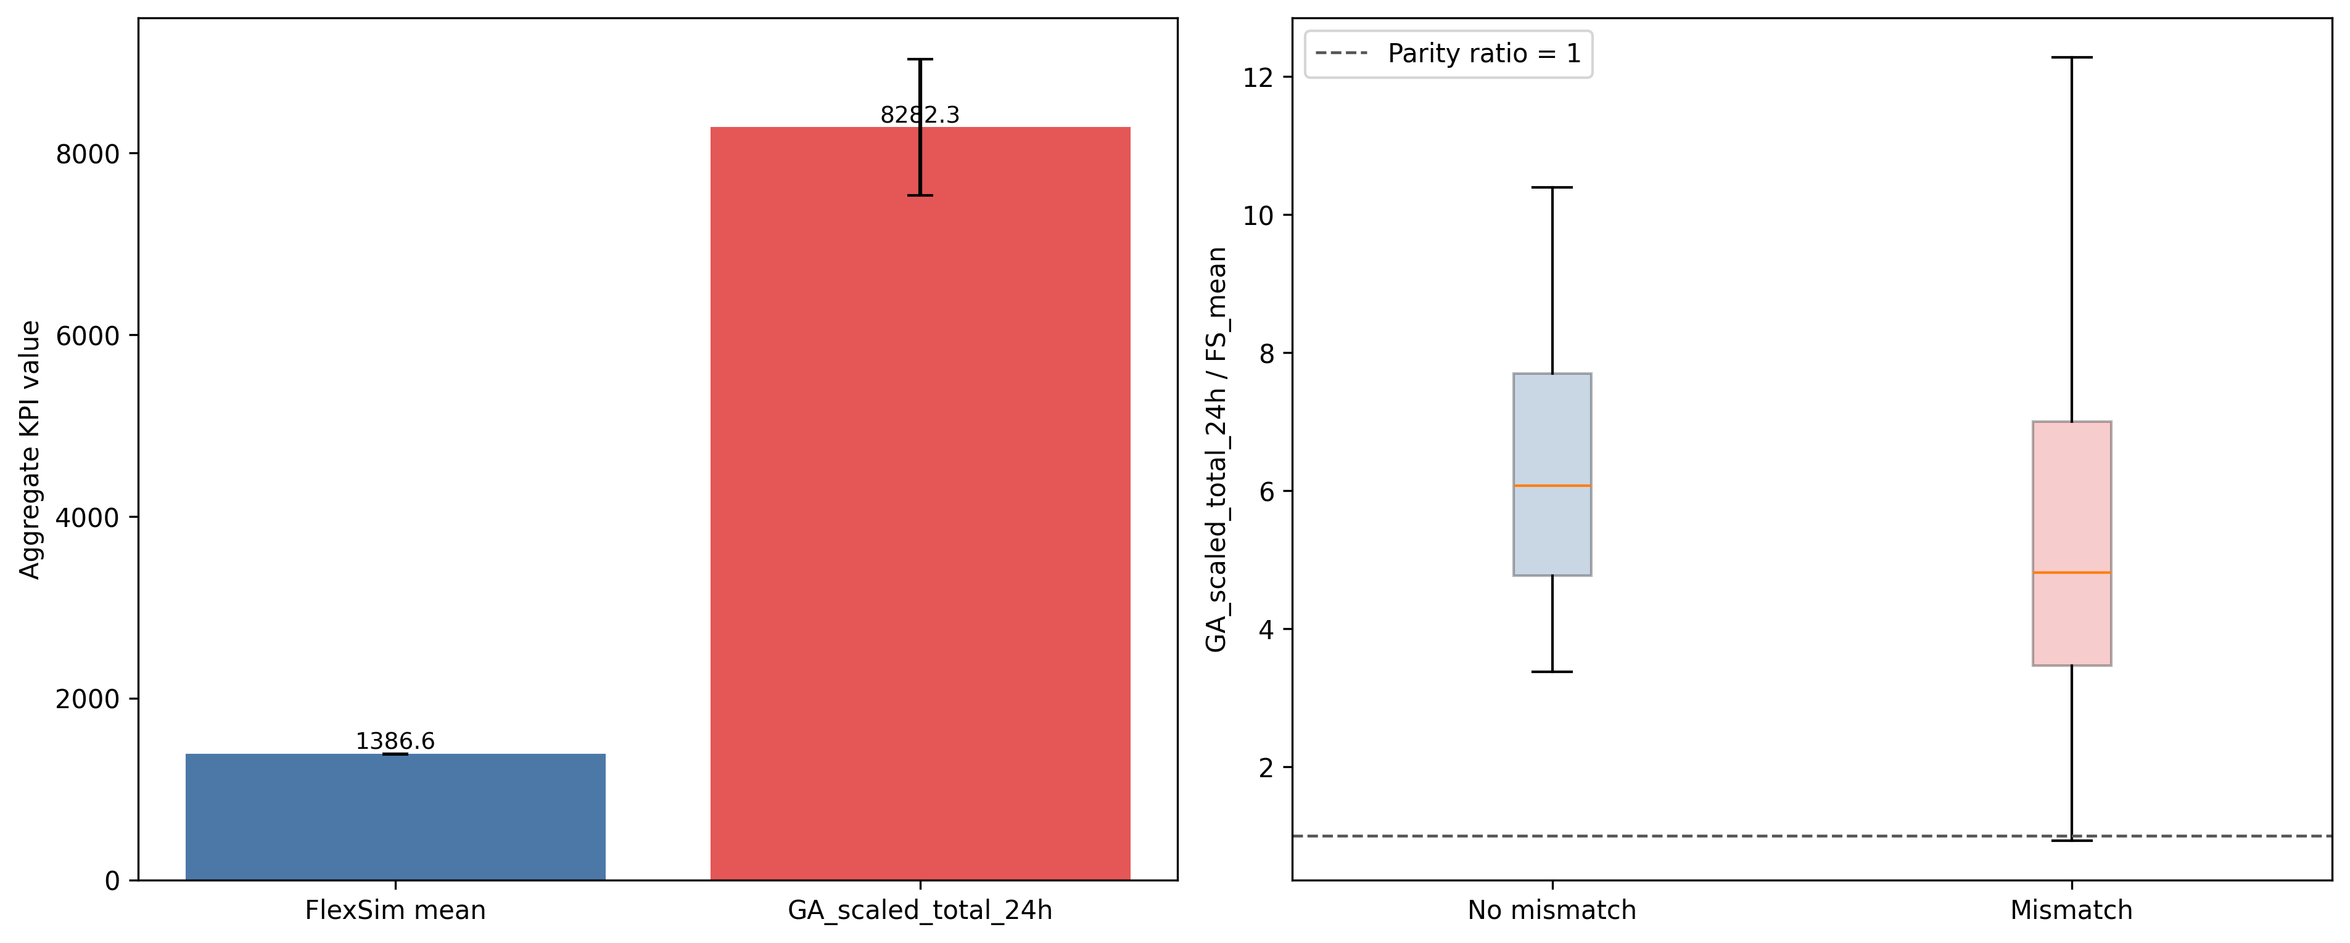
Figure 2. Aggregated KPI summary: overall levels and ratio distribution.
Alt text: Left panel compares overall mean aggregate KPI for FlexSim and GA scaled 24-hour values with confidence intervals. Right panel shows the distribution of ratio GA_scaled_total_24h divided by FlexSim mean for mismatch and non-mismatch groups, with parity at 1.
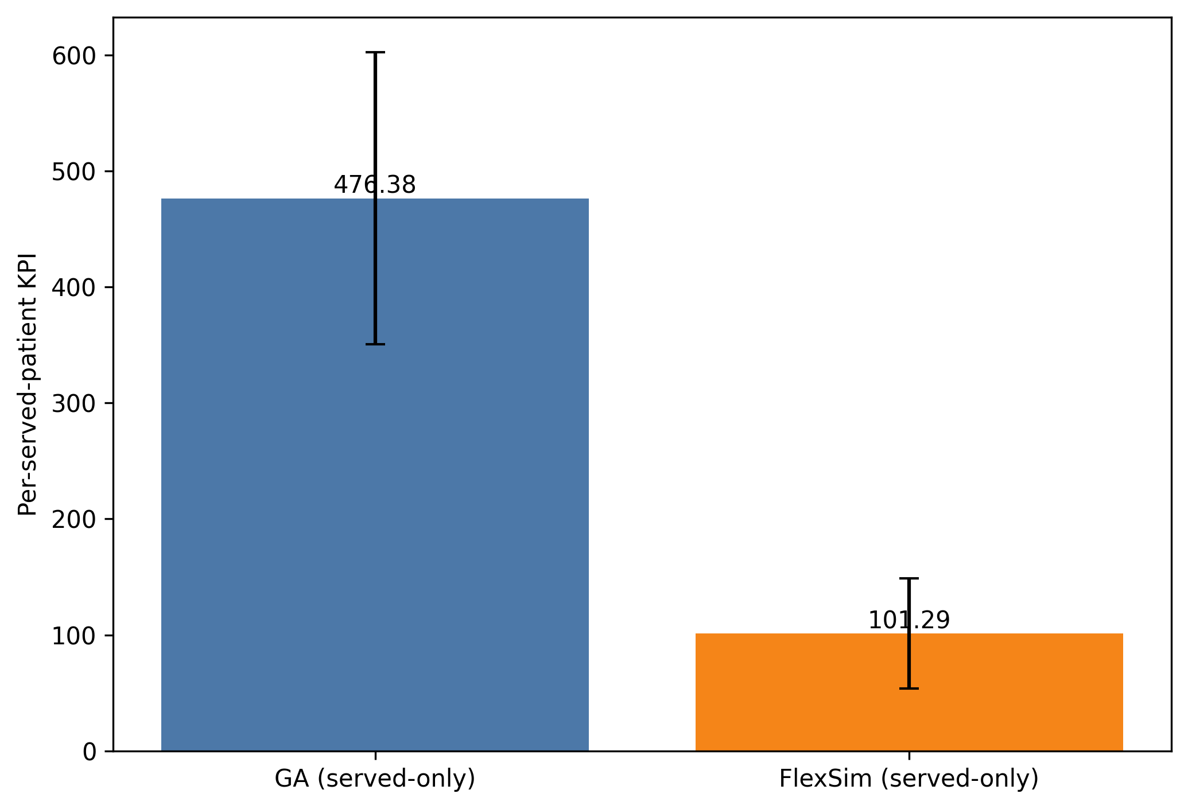
Figure 3. Mean per-served-patient KPI (GA vs FlexSim).
Alt text: Two-bar chart comparing mean served-only per-patient KPI for GA and FlexSim, with error bars showing scenario variability.
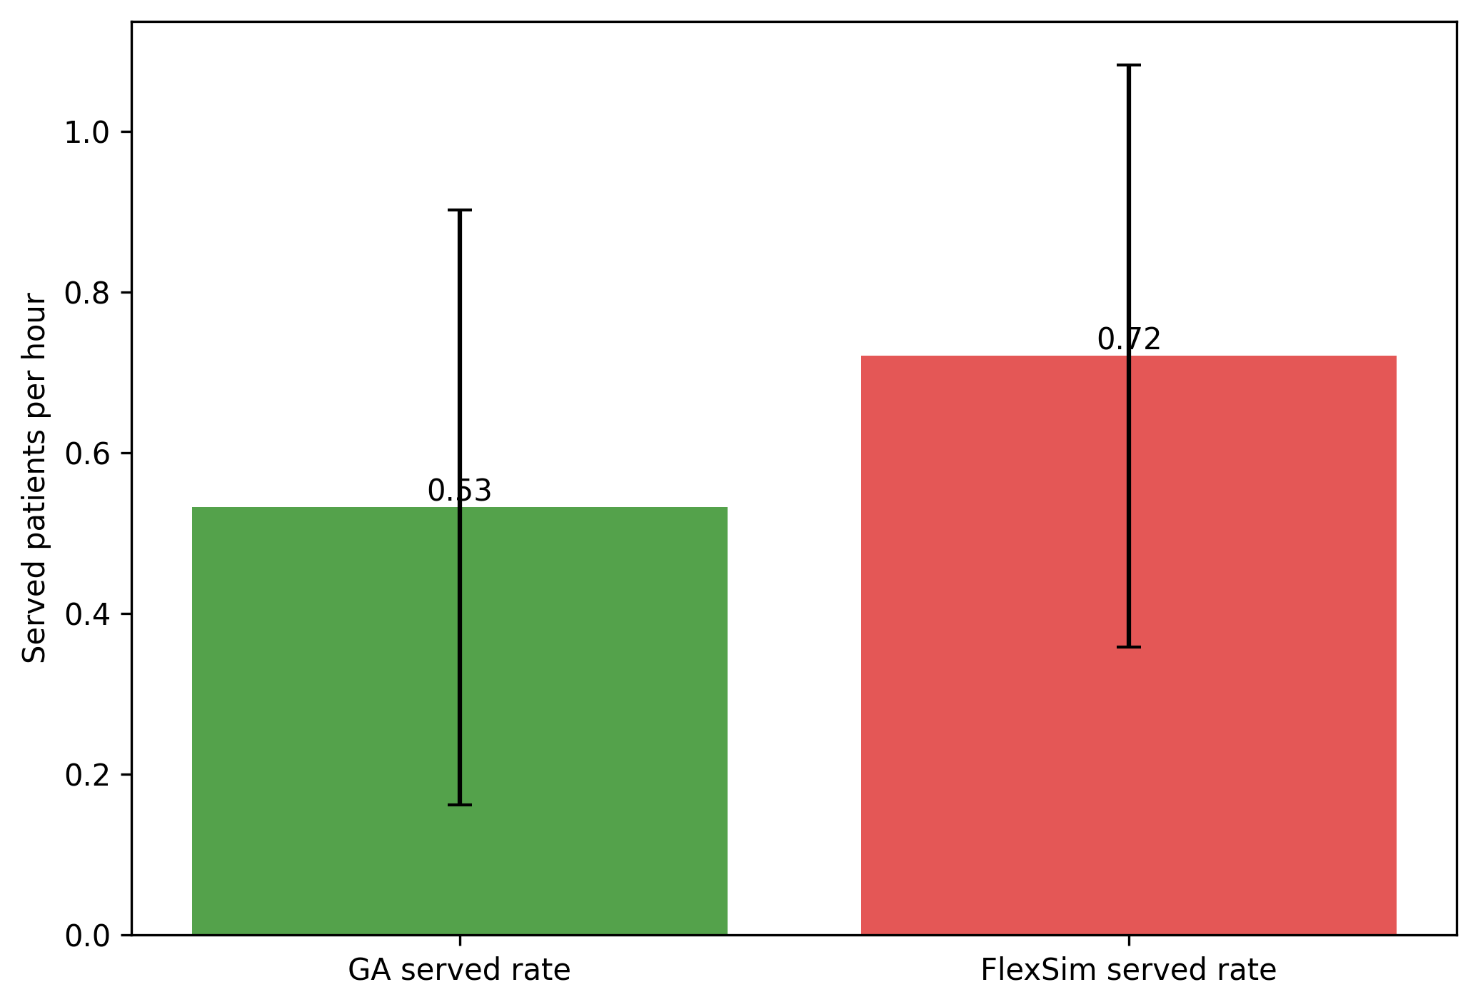
Figure 4. Mean served rate per hour (GA vs FlexSim).
Alt text: Two-bar chart comparing average served patients per hour in GA and FlexSim under the 24-hour served-only cohort definition.

Appendix A. Scenario-Level Detail
Detailed scenario-level comparison is moved to the appendix to keep the main section aggregated and easier to interpret.
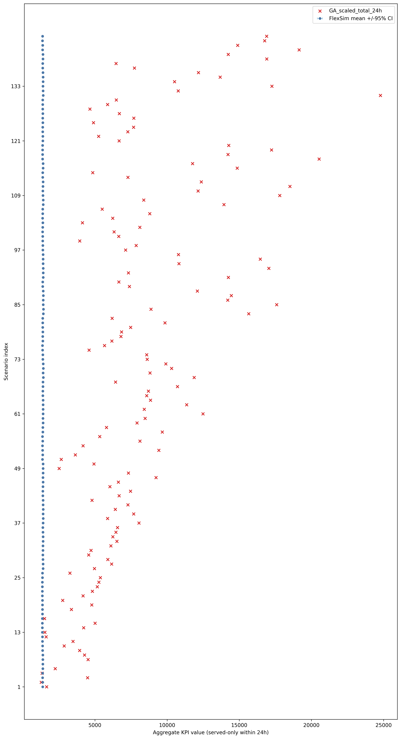
Appendix Figure A1. Scenario-level FlexSim mean +/-95% CI with GA scaled 24h points.
Alt text: Detailed scenario-by-scenario chart where each row shows FlexSim mean with confidence interval and a GA scaled 24-hour marker.

