Results - Baseline-Anchored Feasibility and Tradeoff Analysis (MOFGPM)
This Results section is structured to match the baseline-anchored decision gap described in the Introduction. We first report baseline performance, then diagnose feasibility boundaries under uncertainty, and finally map the cost-service tradeoff using MOFGPM outcomes (mu_Cost, mu_Wait, and lambda).

1. Inputs and Evaluation Definitions
Baseline staffing configuration (reference case):
Doctor=3, Nurse=3, Assistant=6, Specialist=1
MOFGPM goal and tolerance parameters:
G_cost=650.0, C_max=22750.0, G_wait=50.0, W_max=200000.0
Waiting metric used: Total accumulated waiting time across all patients and activities (minutes).
Feasibility rule: Feasible if triage early-care standards are satisfied and both memberships are positive (mu_Cost>0, mu_Wait>0).

2. Baseline Case Results
A unique baseline row could not be identified from the provided results table. If you want an explicit baseline subsection, store the baseline staffing vector in the results DataFrame.

3. Feasibility Under Uncertainty Scenarios
This section integrates merged outputs across 1 run batches and 1 operational scenario groups.
Table 1 summarizes feasibility rates and best-achieved balanced satisfaction by analysis group.
Operational scenario | Runs | Feasible (%) | Min feasible W_max | Best lambda | Best Cost | Best Wait | Binding
MODE=combinatorics|FZ=expected|P=36|T=1440.0|NS=25|GW=50.0|MW=200000.0 | 144 | 62.5 | 200000.00 | 0.939 | 2000.00 | 12045.05 | Cost
Table 1. Scenario-level feasibility and best MOFGPM outcomes.

4. Cross-Scenario Integrated Diagnostics
Operational scenario | Samples | Feasible (%) | Median lambda (feasible) | P90 lambda (feasible) | Mean cost | Mean wait
MODE=combinatorics|FZ=expected|P=36|T=1440.0|NS=25|GW=50.0|MW=200000.0 | 144 | 62.5 | 0.855 | 0.924 | 1625.00 | 44333.54
Table 2. Integrated performance diagnostics across scenario groups.

5. Cost-Service Tradeoff Map (MOFGPM Interpretation)
scenario_key | wmax | Doctor | Nurse | Assistant | Specialist | cost | wait | mu_cost | mu_wait | lambda
MODE=combinatorics|FZ=expected|P=36|T=1440.0|NS=25|GW=50.0|MW=200000.0 | 200000.00 | 4 | 2 | 2 | 3 | 2000.00 | 12045.05 | 0.939 | 0.940 | 0.939
MODE=combinatorics|FZ=expected|P=36|T=1440.0|NS=25|GW=50.0|MW=200000.0 | 200000.00 | 5 | 1 | 2 | 3 | 2100.00 | 12768.37 | 0.934 | 0.936 | 0.934
MODE=combinatorics|FZ=expected|P=36|T=1440.0|NS=25|GW=50.0|MW=200000.0 | 200000.00 | 4 | 4 | 2 | 3 | 2200.00 | 13448.73 | 0.930 | 0.933 | 0.930
MODE=combinatorics|FZ=expected|P=36|T=1440.0|NS=25|GW=50.0|MW=200000.0 | 200000.00 | 5 | 2 | 2 | 3 | 2200.00 | 14069.64 | 0.930 | 0.930 | 0.930
MODE=combinatorics|FZ=expected|P=36|T=1440.0|NS=25|GW=50.0|MW=200000.0 | 200000.00 | 4 | 3 | 2 | 3 | 2100.00 | 14483.36 | 0.934 | 0.928 | 0.928
MODE=combinatorics|FZ=expected|P=36|T=1440.0|NS=25|GW=50.0|MW=200000.0 | 200000.00 | 5 | 2 | 2 | 2 | 1900.00 | 14536.54 | 0.943 | 0.928 | 0.928
MODE=combinatorics|FZ=expected|P=36|T=1440.0|NS=25|GW=50.0|MW=200000.0 | 200000.00 | 5 | 3 | 2 | 3 | 2300.00 | 14952.97 | 0.925 | 0.925 | 0.925
MODE=combinatorics|FZ=expected|P=36|T=1440.0|NS=25|GW=50.0|MW=200000.0 | 200000.00 | 3 | 3 | 2 | 3 | 1900.00 | 15240.76 | 0.943 | 0.924 | 0.924
MODE=combinatorics|FZ=expected|P=36|T=1440.0|NS=25|GW=50.0|MW=200000.0 | 200000.00 | 3 | 2 | 2 | 3 | 1800.00 | 15254.63 | 0.948 | 0.924 | 0.924
MODE=combinatorics|FZ=expected|P=36|T=1440.0|NS=25|GW=50.0|MW=200000.0 | 200000.00 | 6 | 1 | 2 | 3 | 2300.00 | 15290.32 | 0.925 | 0.924 | 0.924
Table 3. Top feasible solutions (ranked by lambda, then cost and wait).

6. Feasibility Boundary Diagnostics
Operational scenario | Min feasible W_max
MODE=combinatorics|FZ=expected|P=36|T=1440.0|NS=25|GW=50.0|MW=200000.0 | 200000.00
Table 4. Minimum feasible W_max by scenario group.

7. Figures
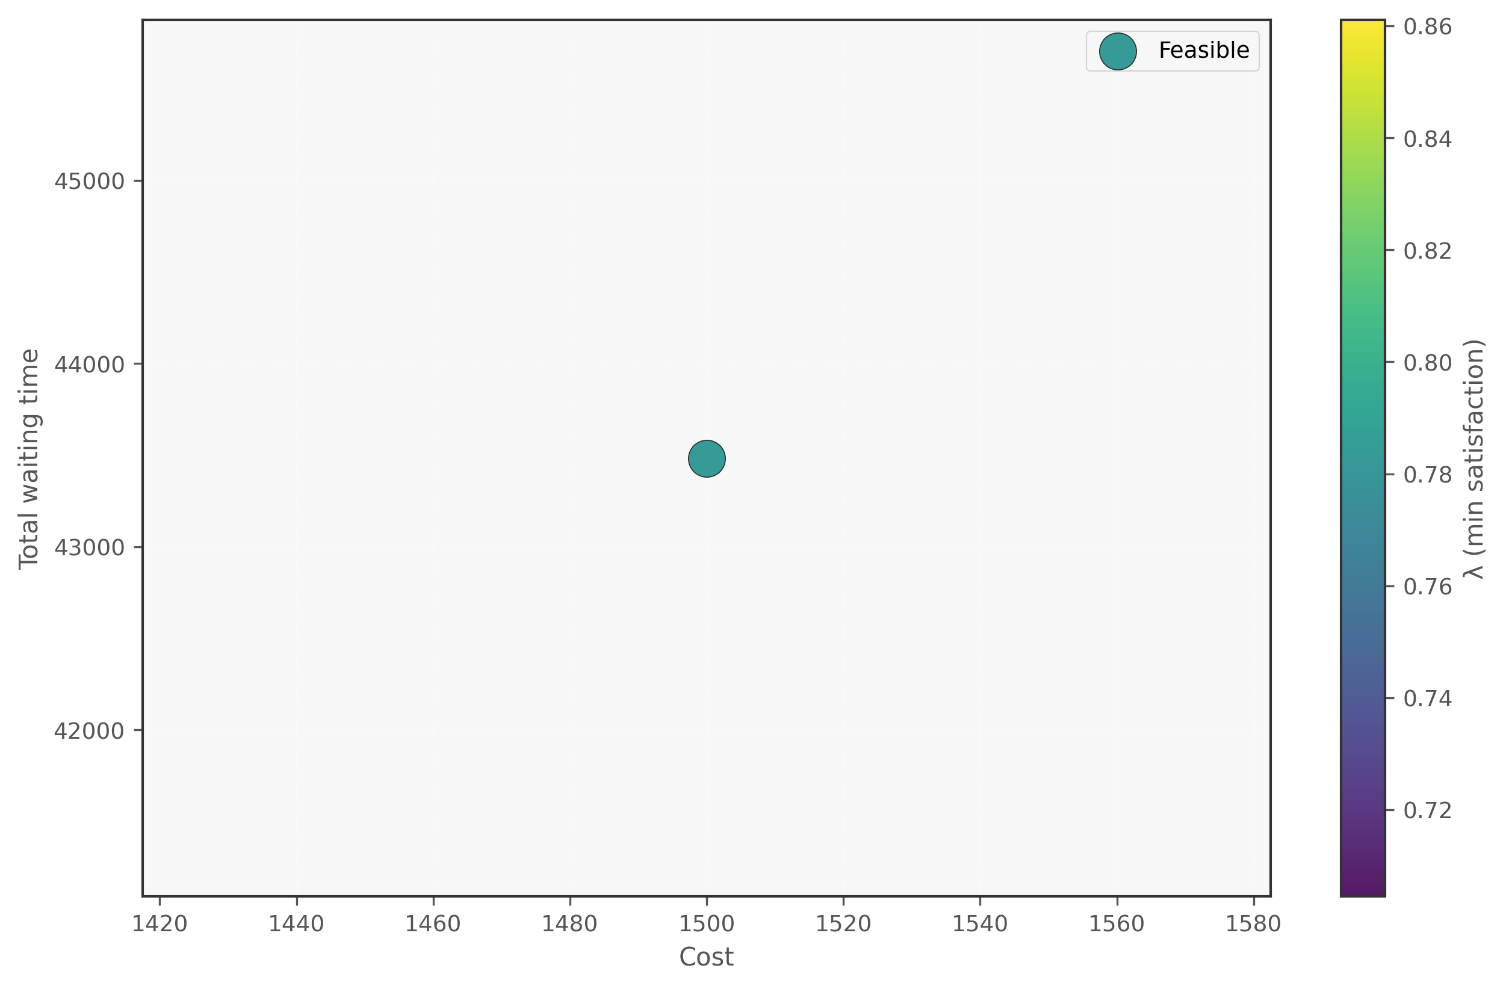
Figure 1. Cost-Wait scatter (lambda encoding) - Fixed
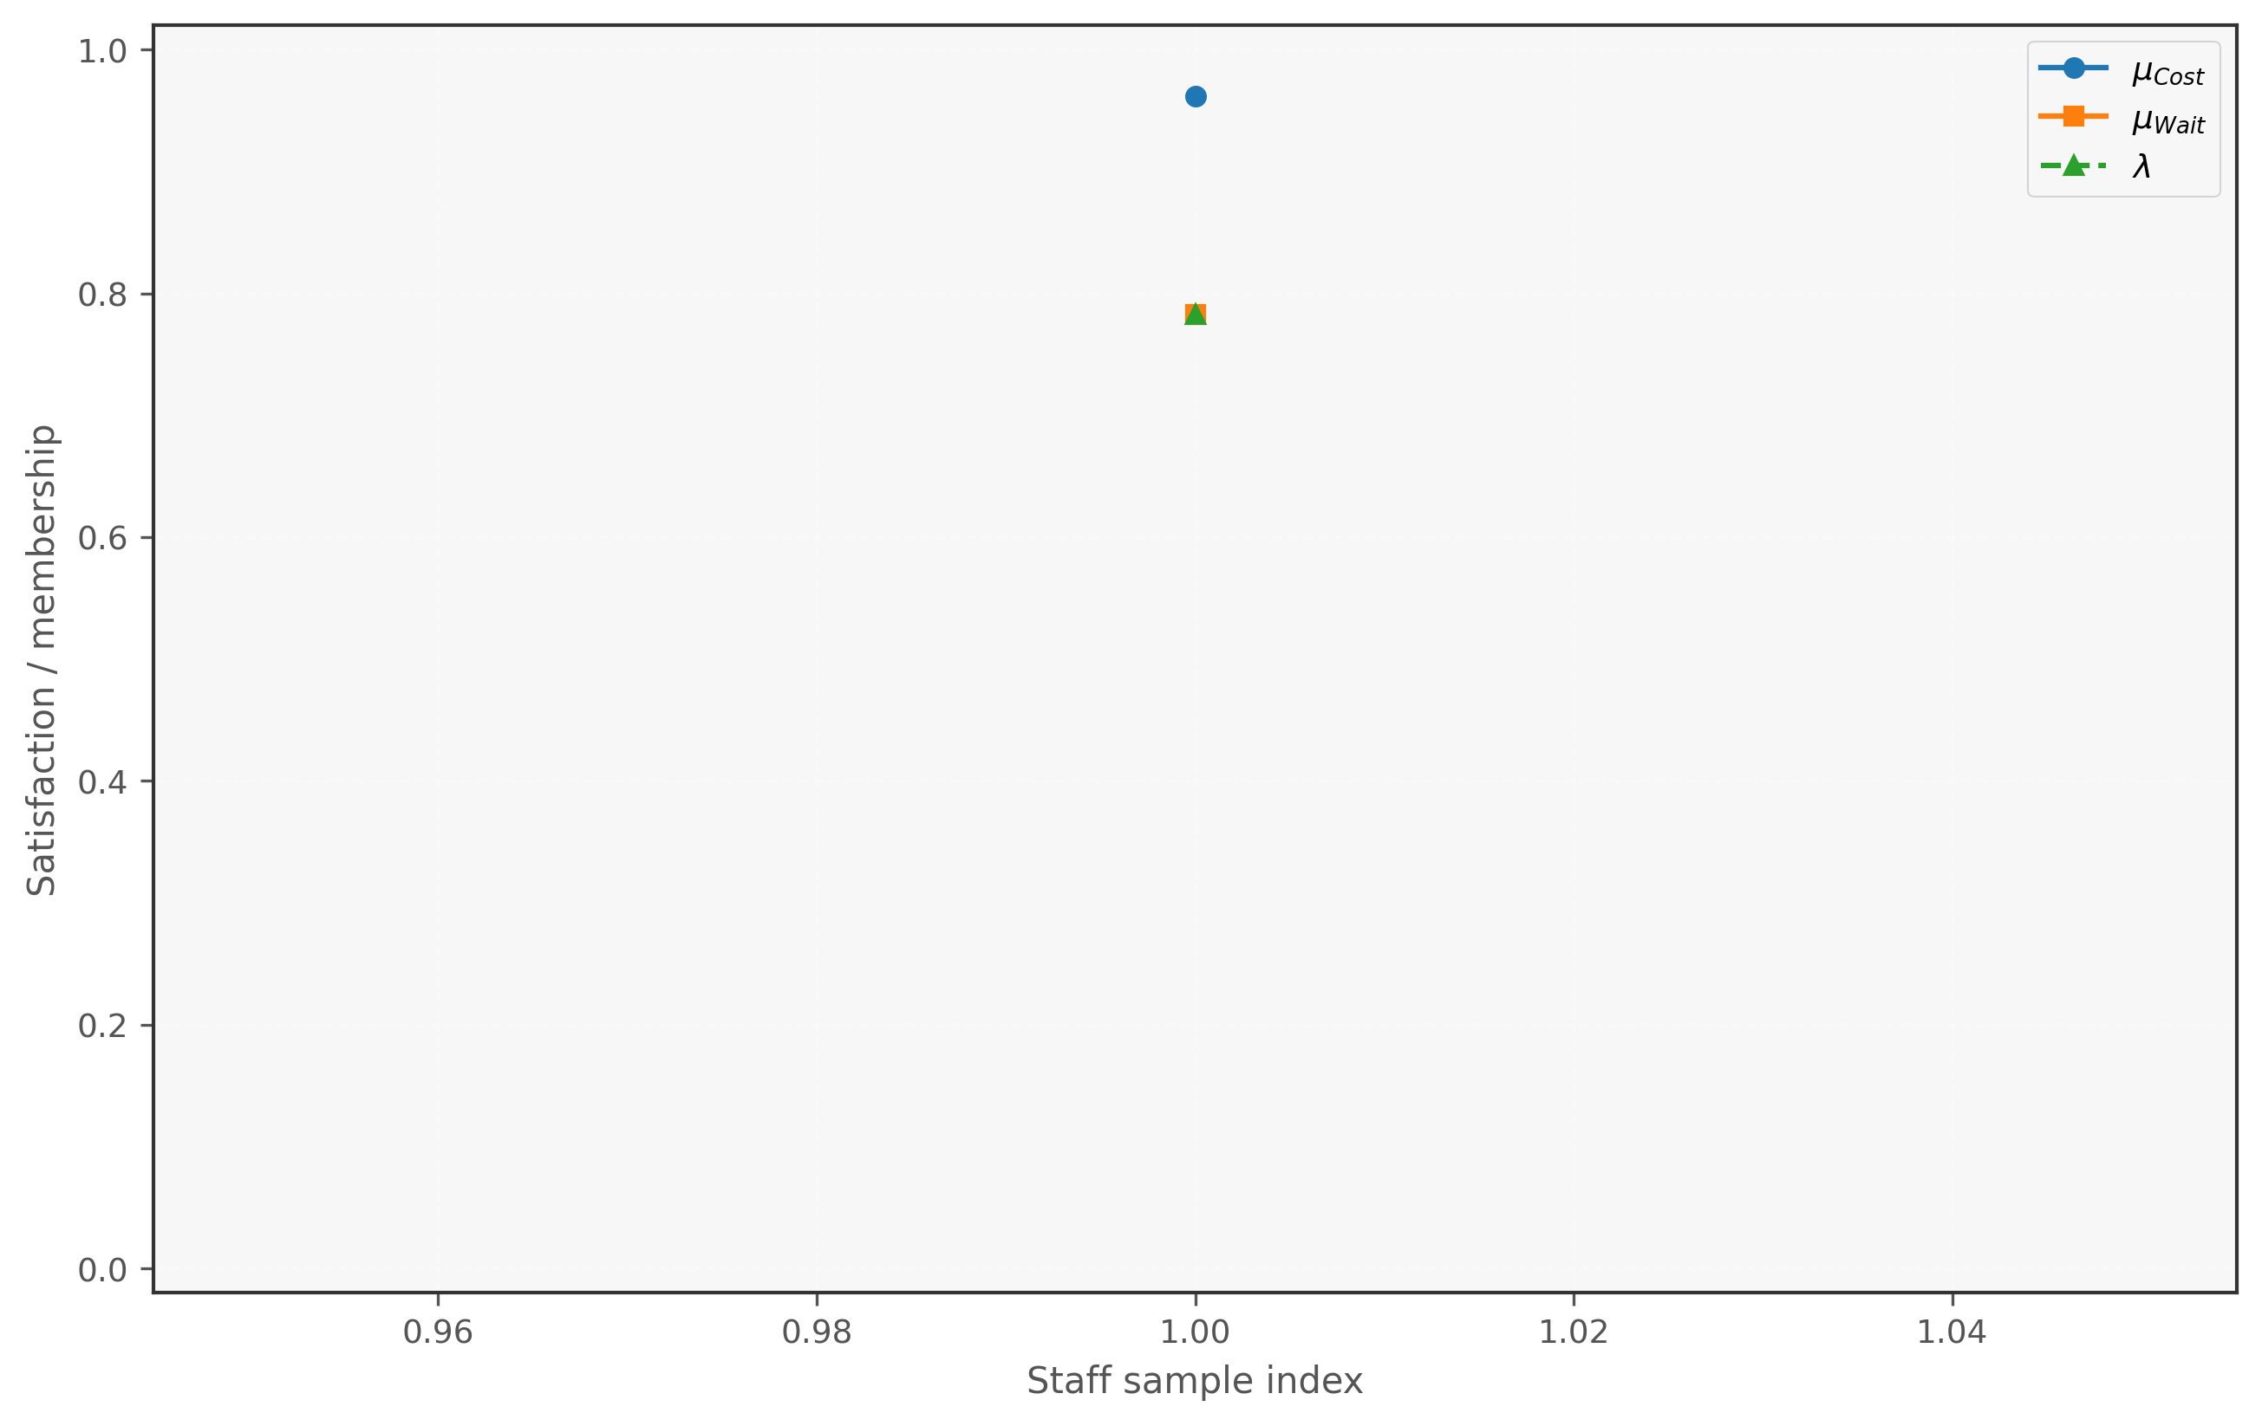
Figure 2. Membership decomposition - Fixed
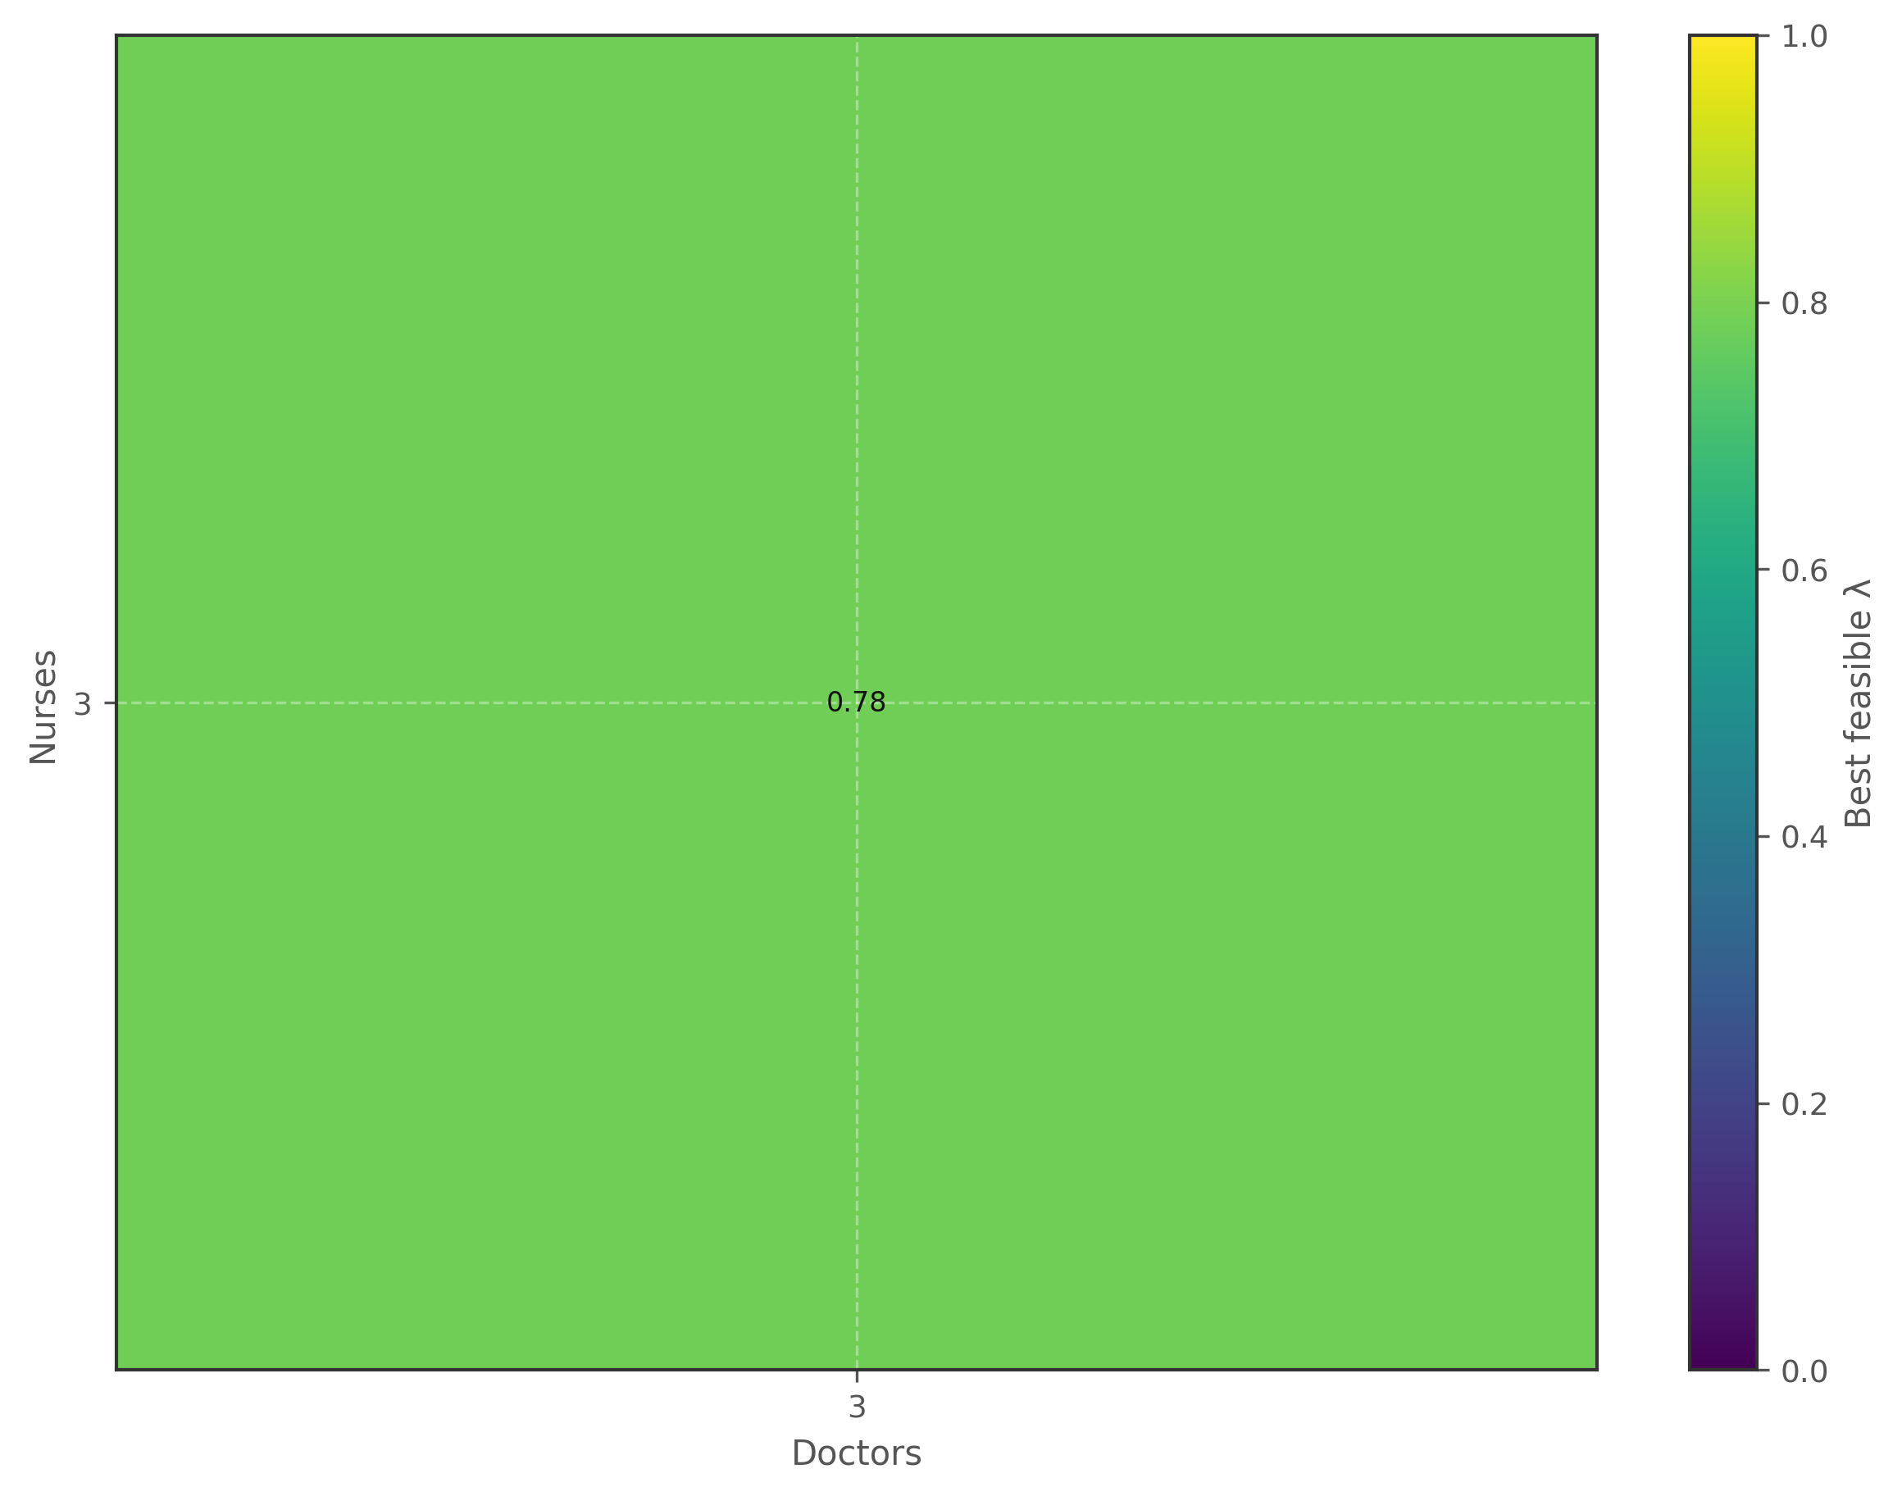
Figure 3. Feasibility heatmap (Doctor x Nurse) - Fixed
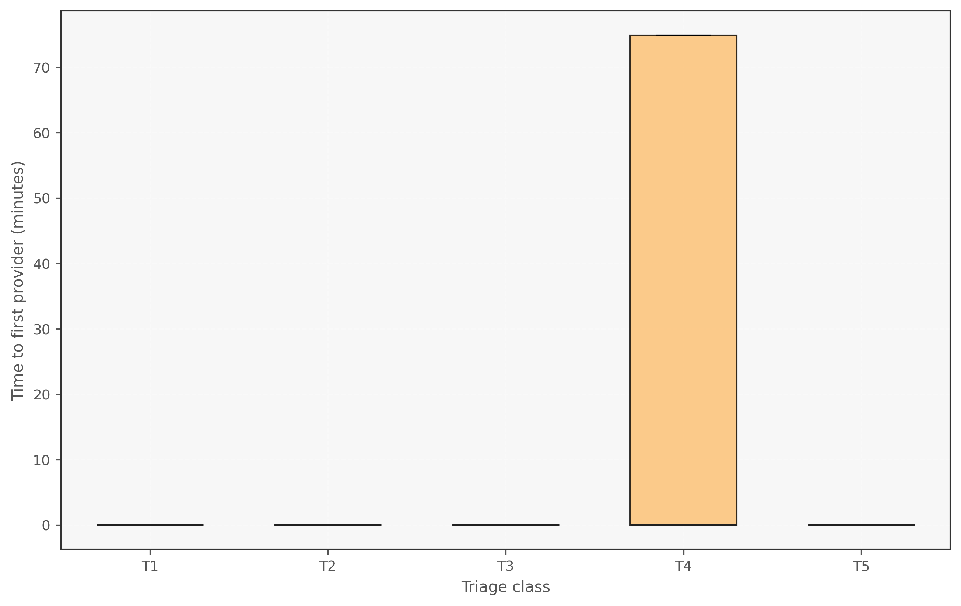
Figure 4. Triage first-wait boxplot - Fixed
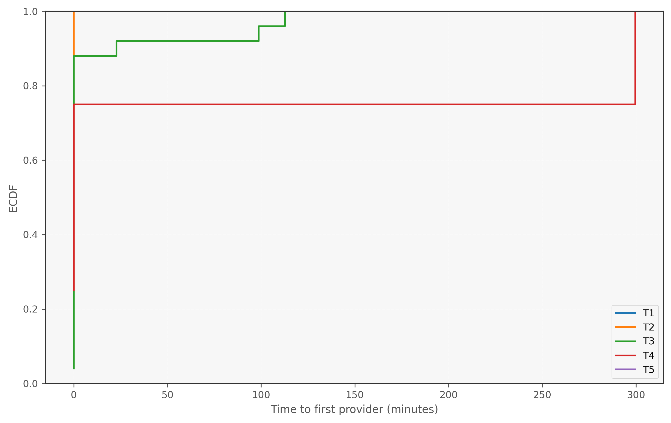
Figure 5. Triage first-wait ECDF - Fixed
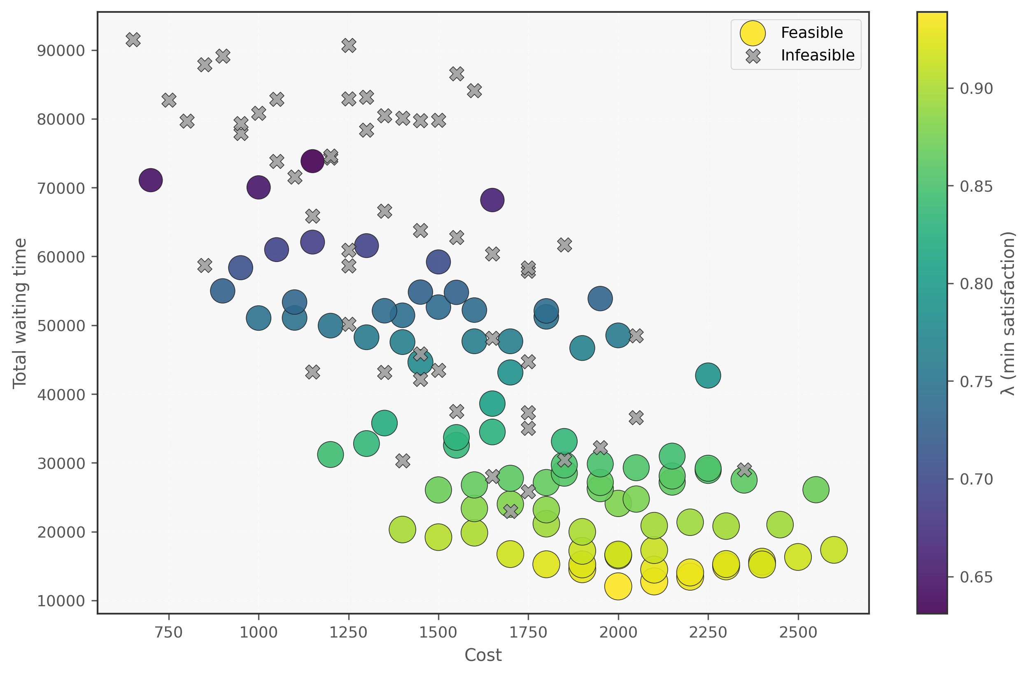
Figure 6. Cost-Wait scatter (lambda encoding) - Combinatorics
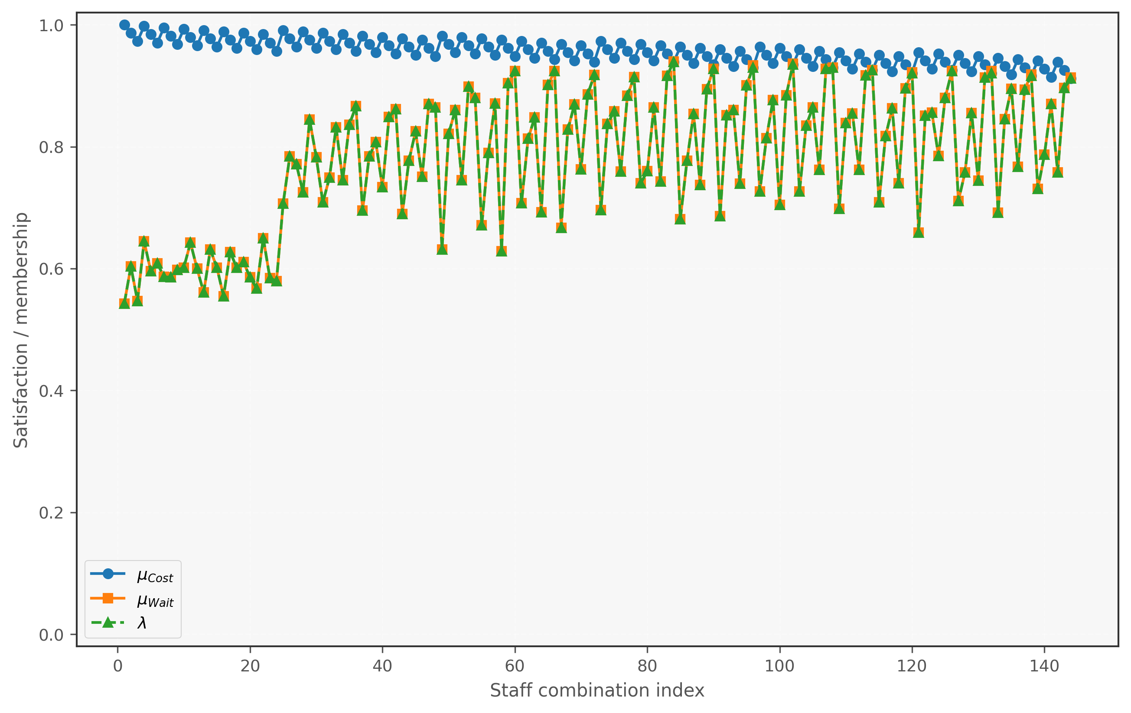
Figure 7. Membership decomposition - Combinatorics
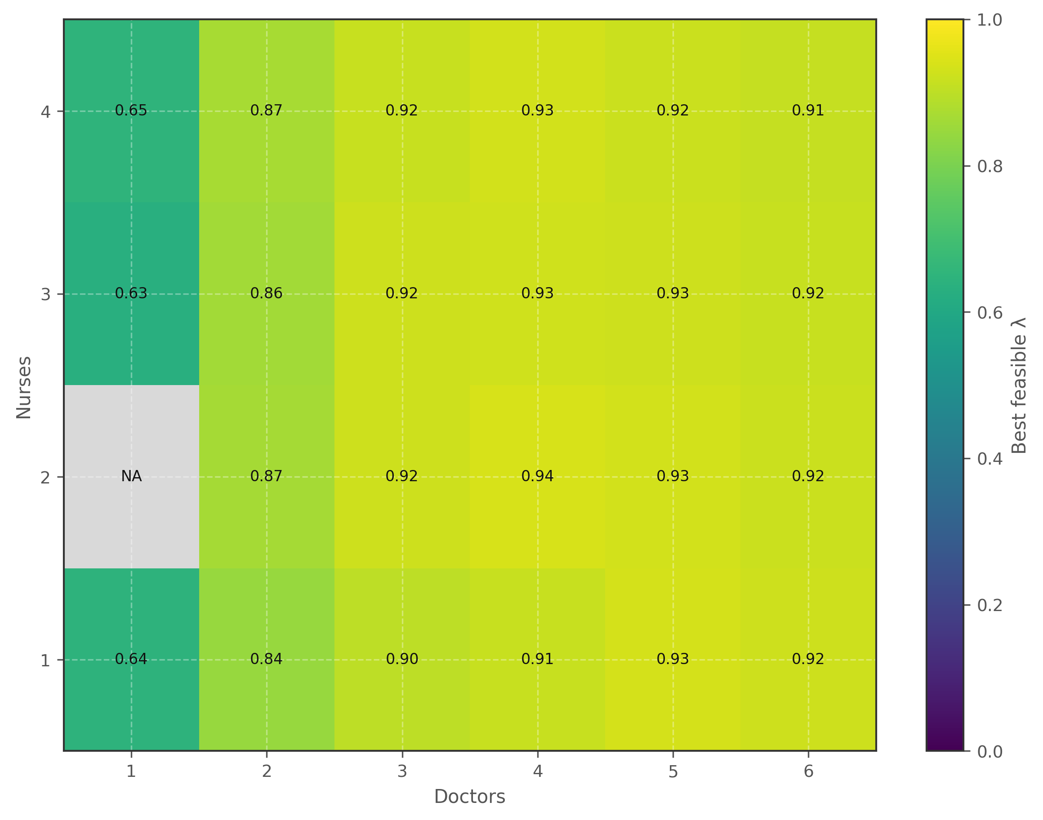
Figure 8. Feasibility heatmap (Doctor x Nurse) - Combinatorics
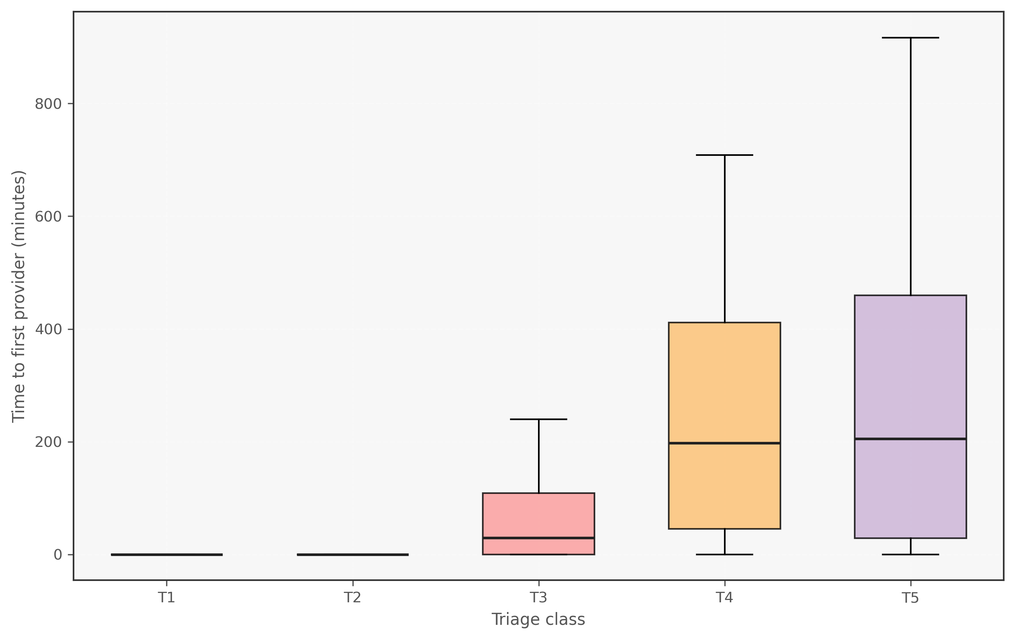
Figure 9. Triage first-wait boxplot - Combinatorics
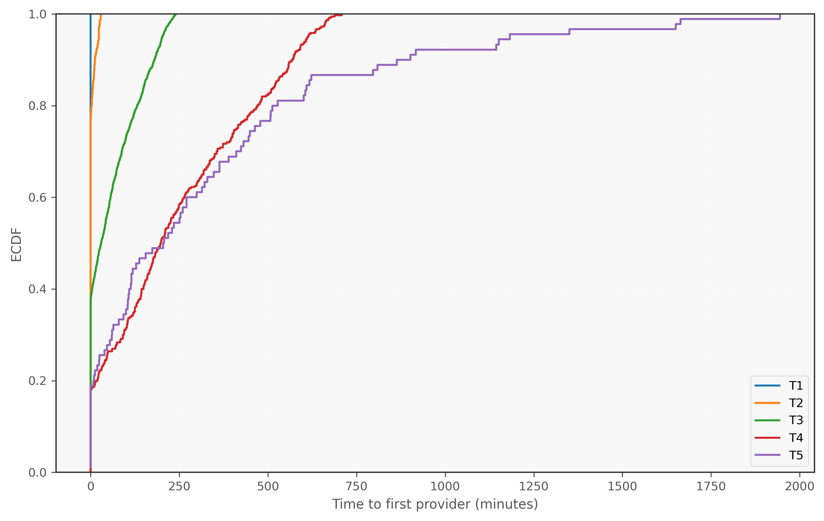
Figure 10. Triage first-wait ECDF - Combinatorics
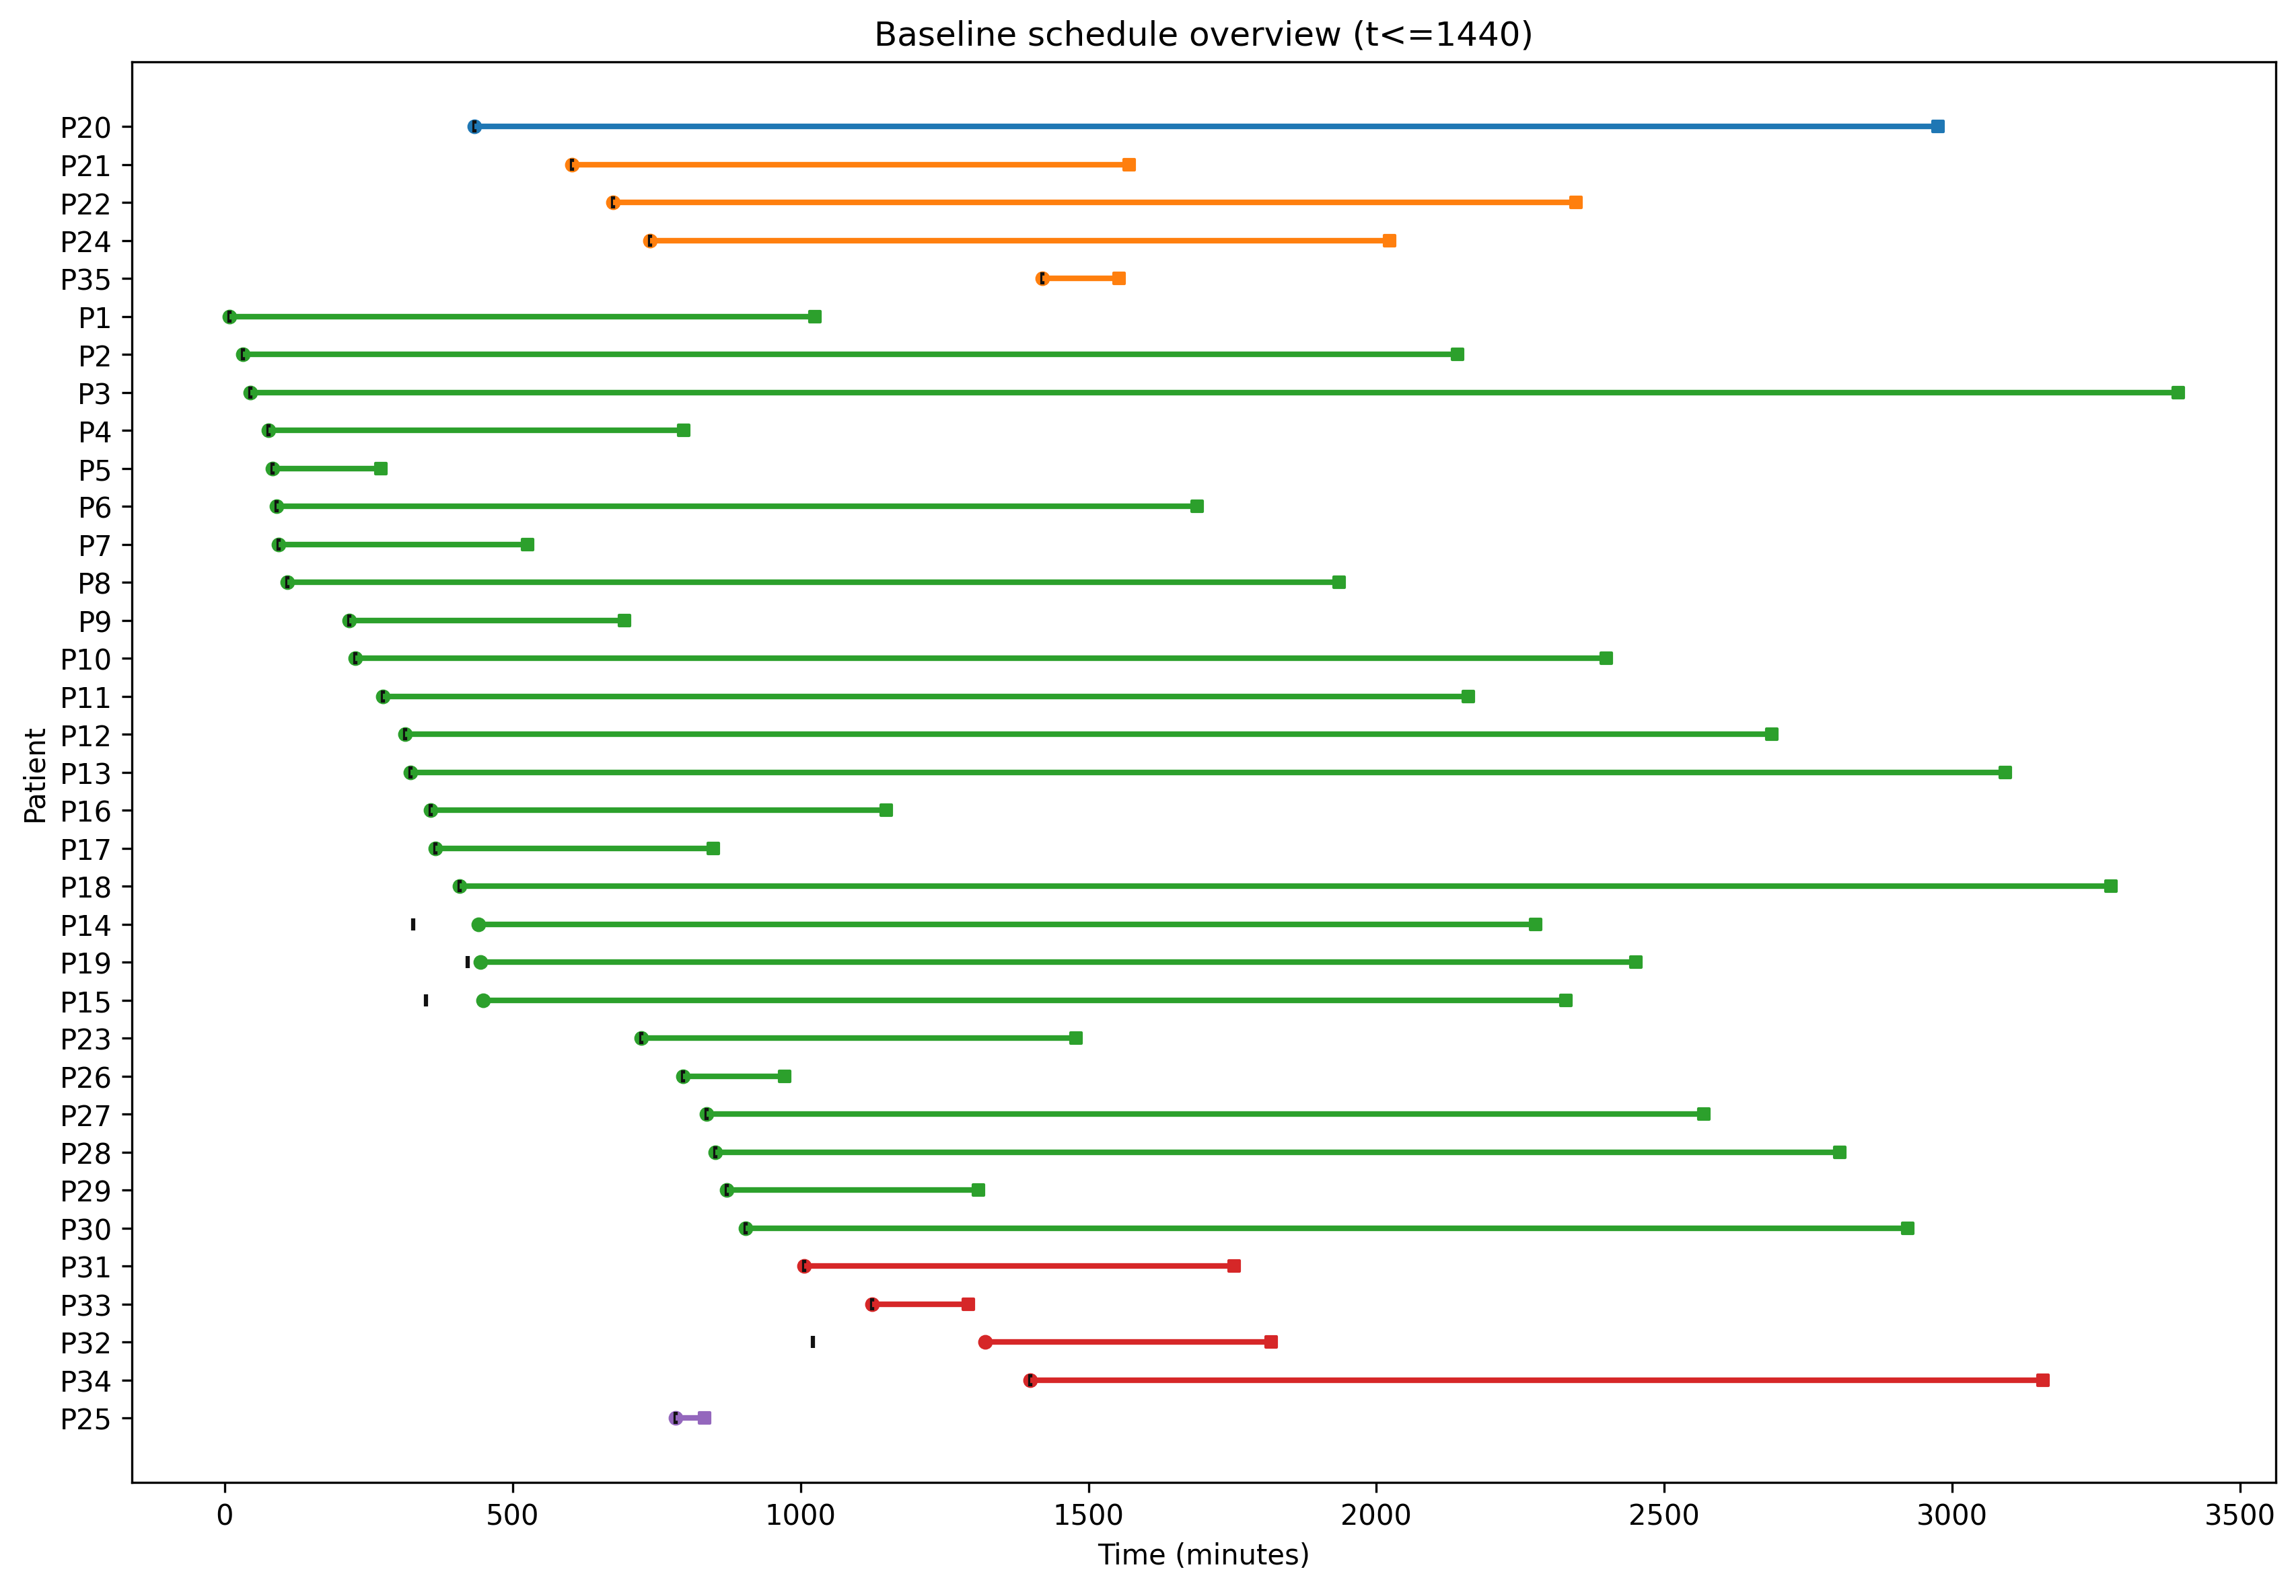
Figure 11. Baseline schedule overview (t<=1440)
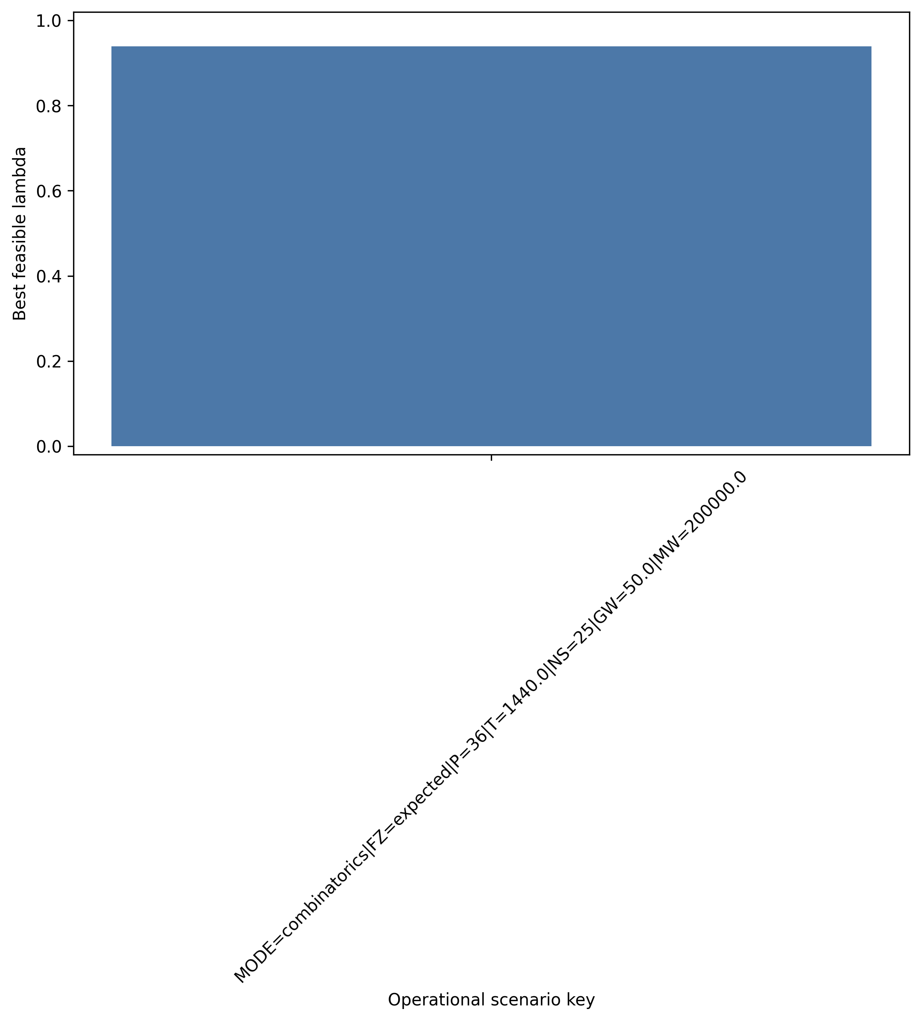
Figure 12. Best lambda by operational scenario key
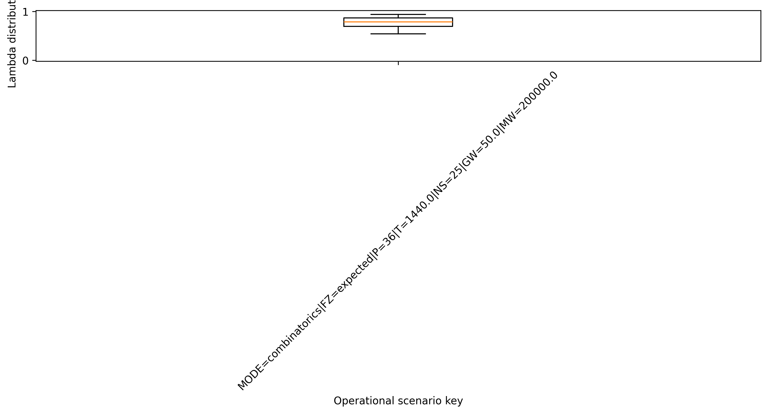
Figure 13. Lambda distribution by operational scenario key
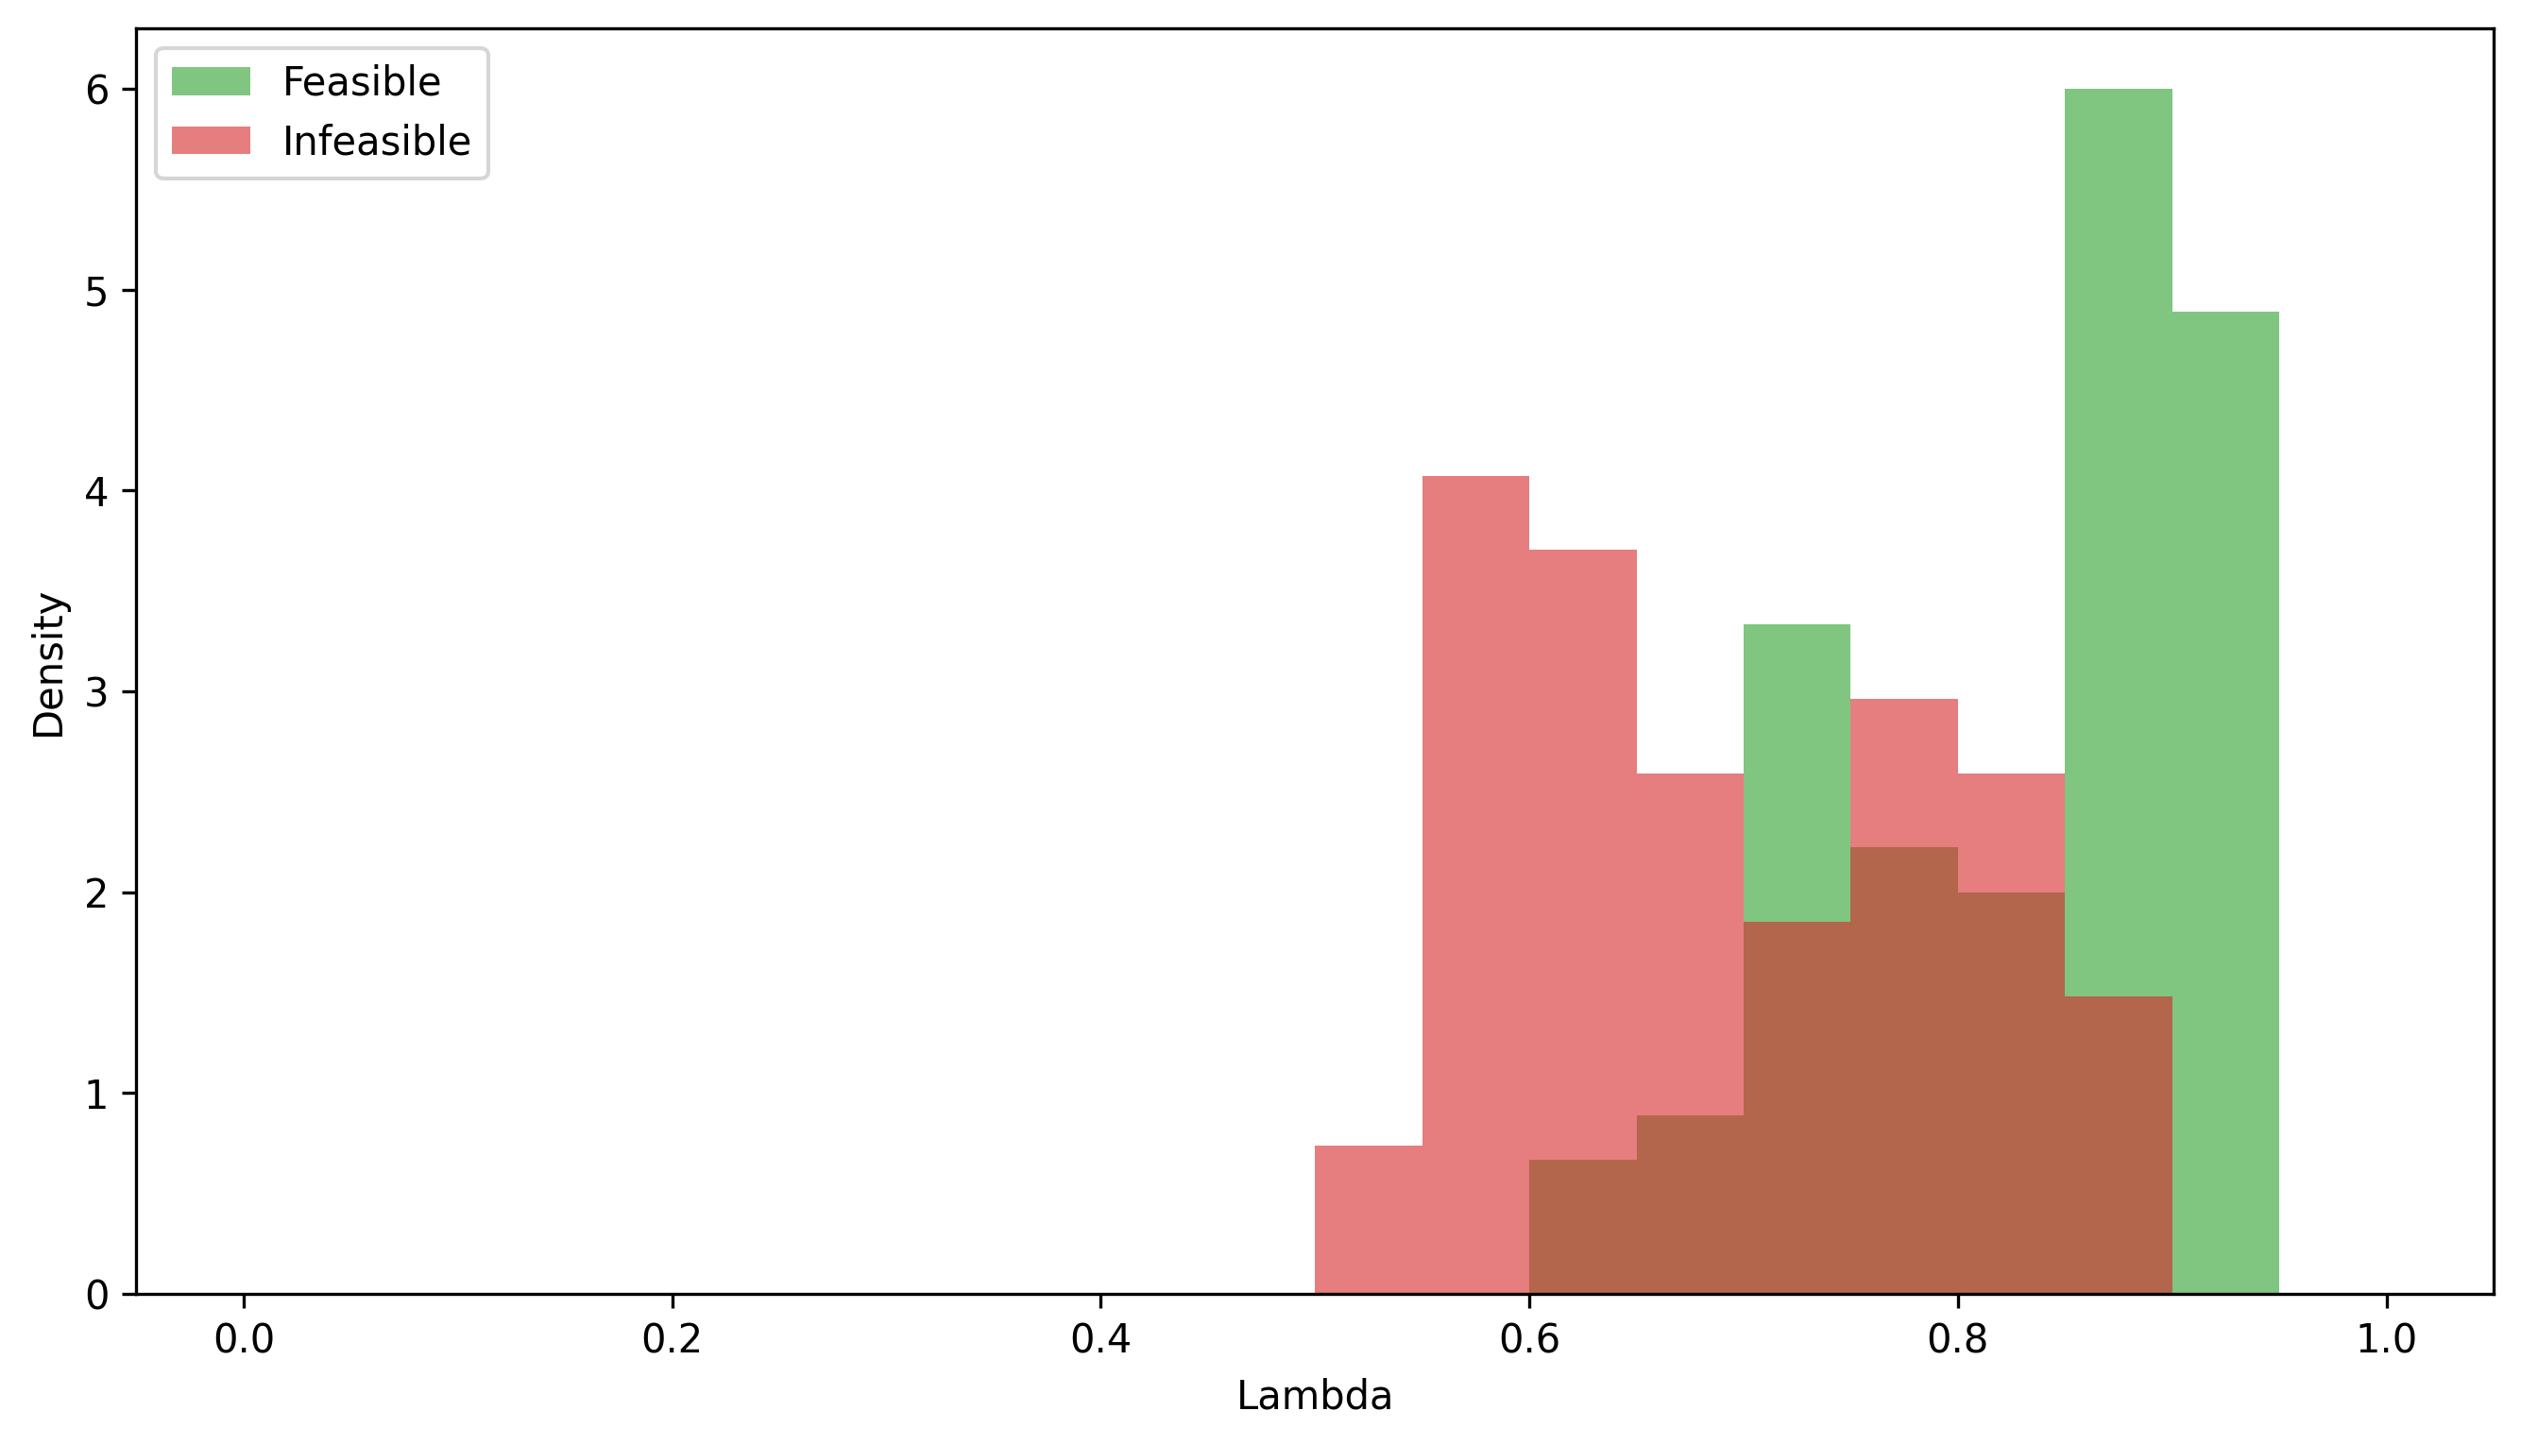
Figure 14. Lambda density (feasible vs infeasible)
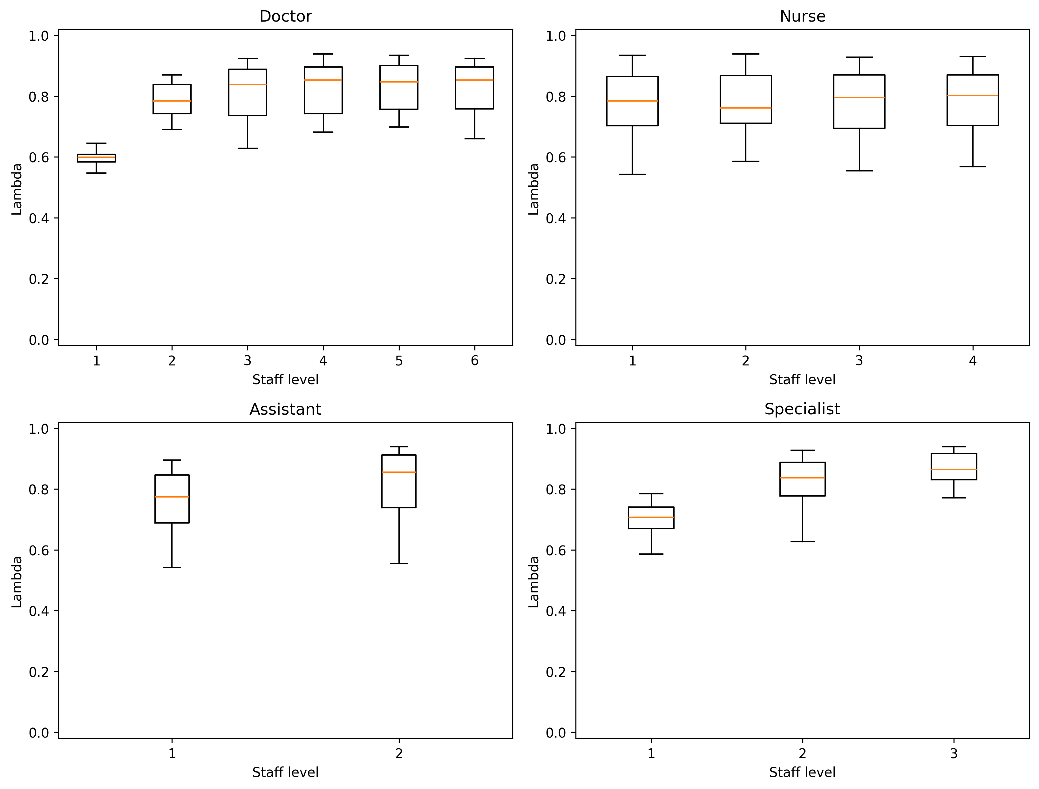
Figure 15. Lambda vs resource levels
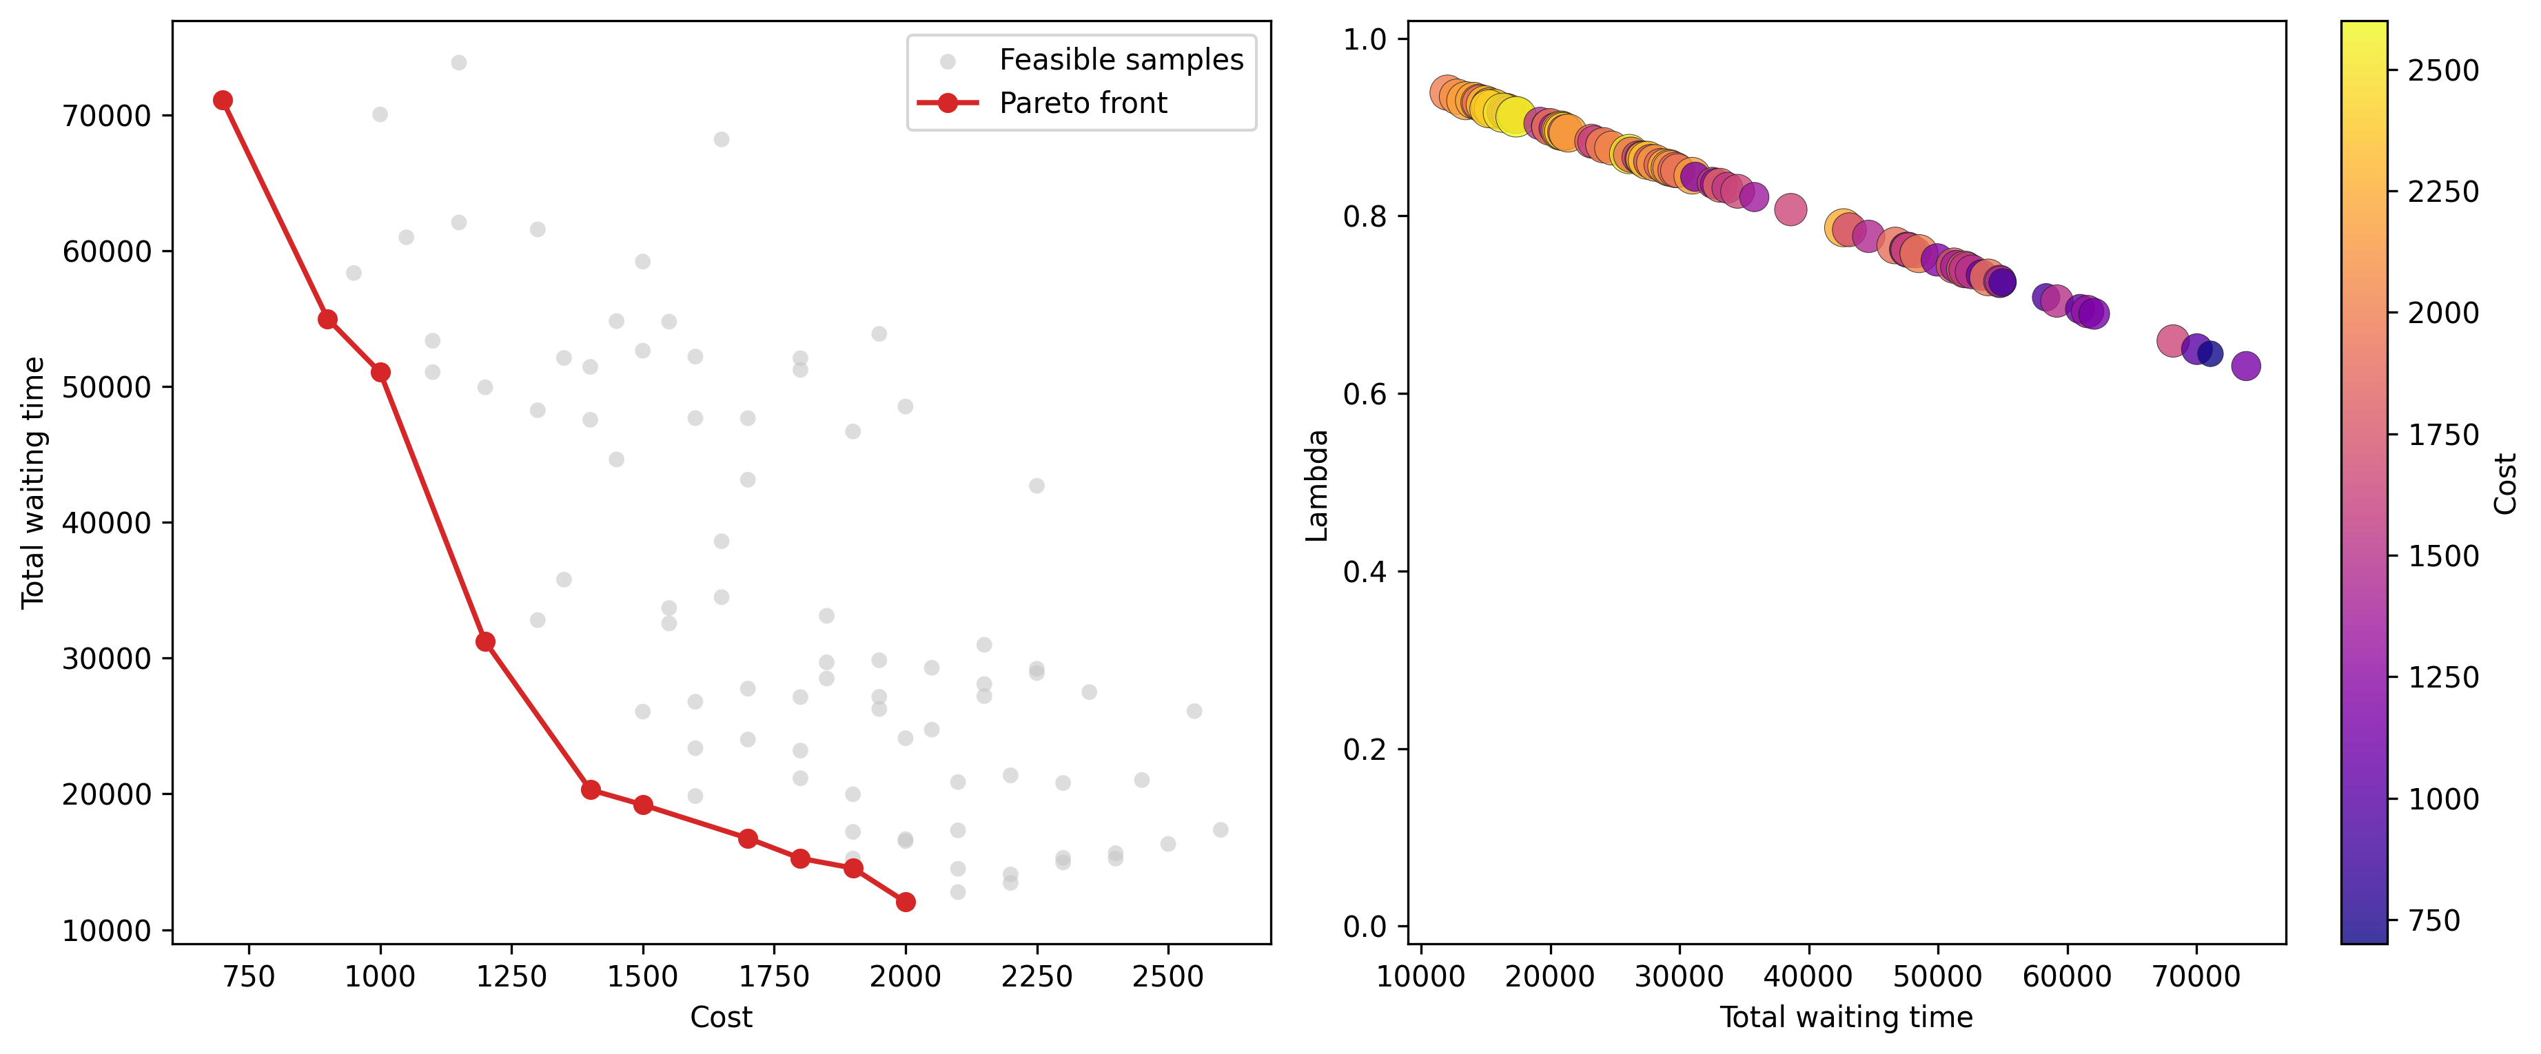
Figure 16. Operational Pareto overview
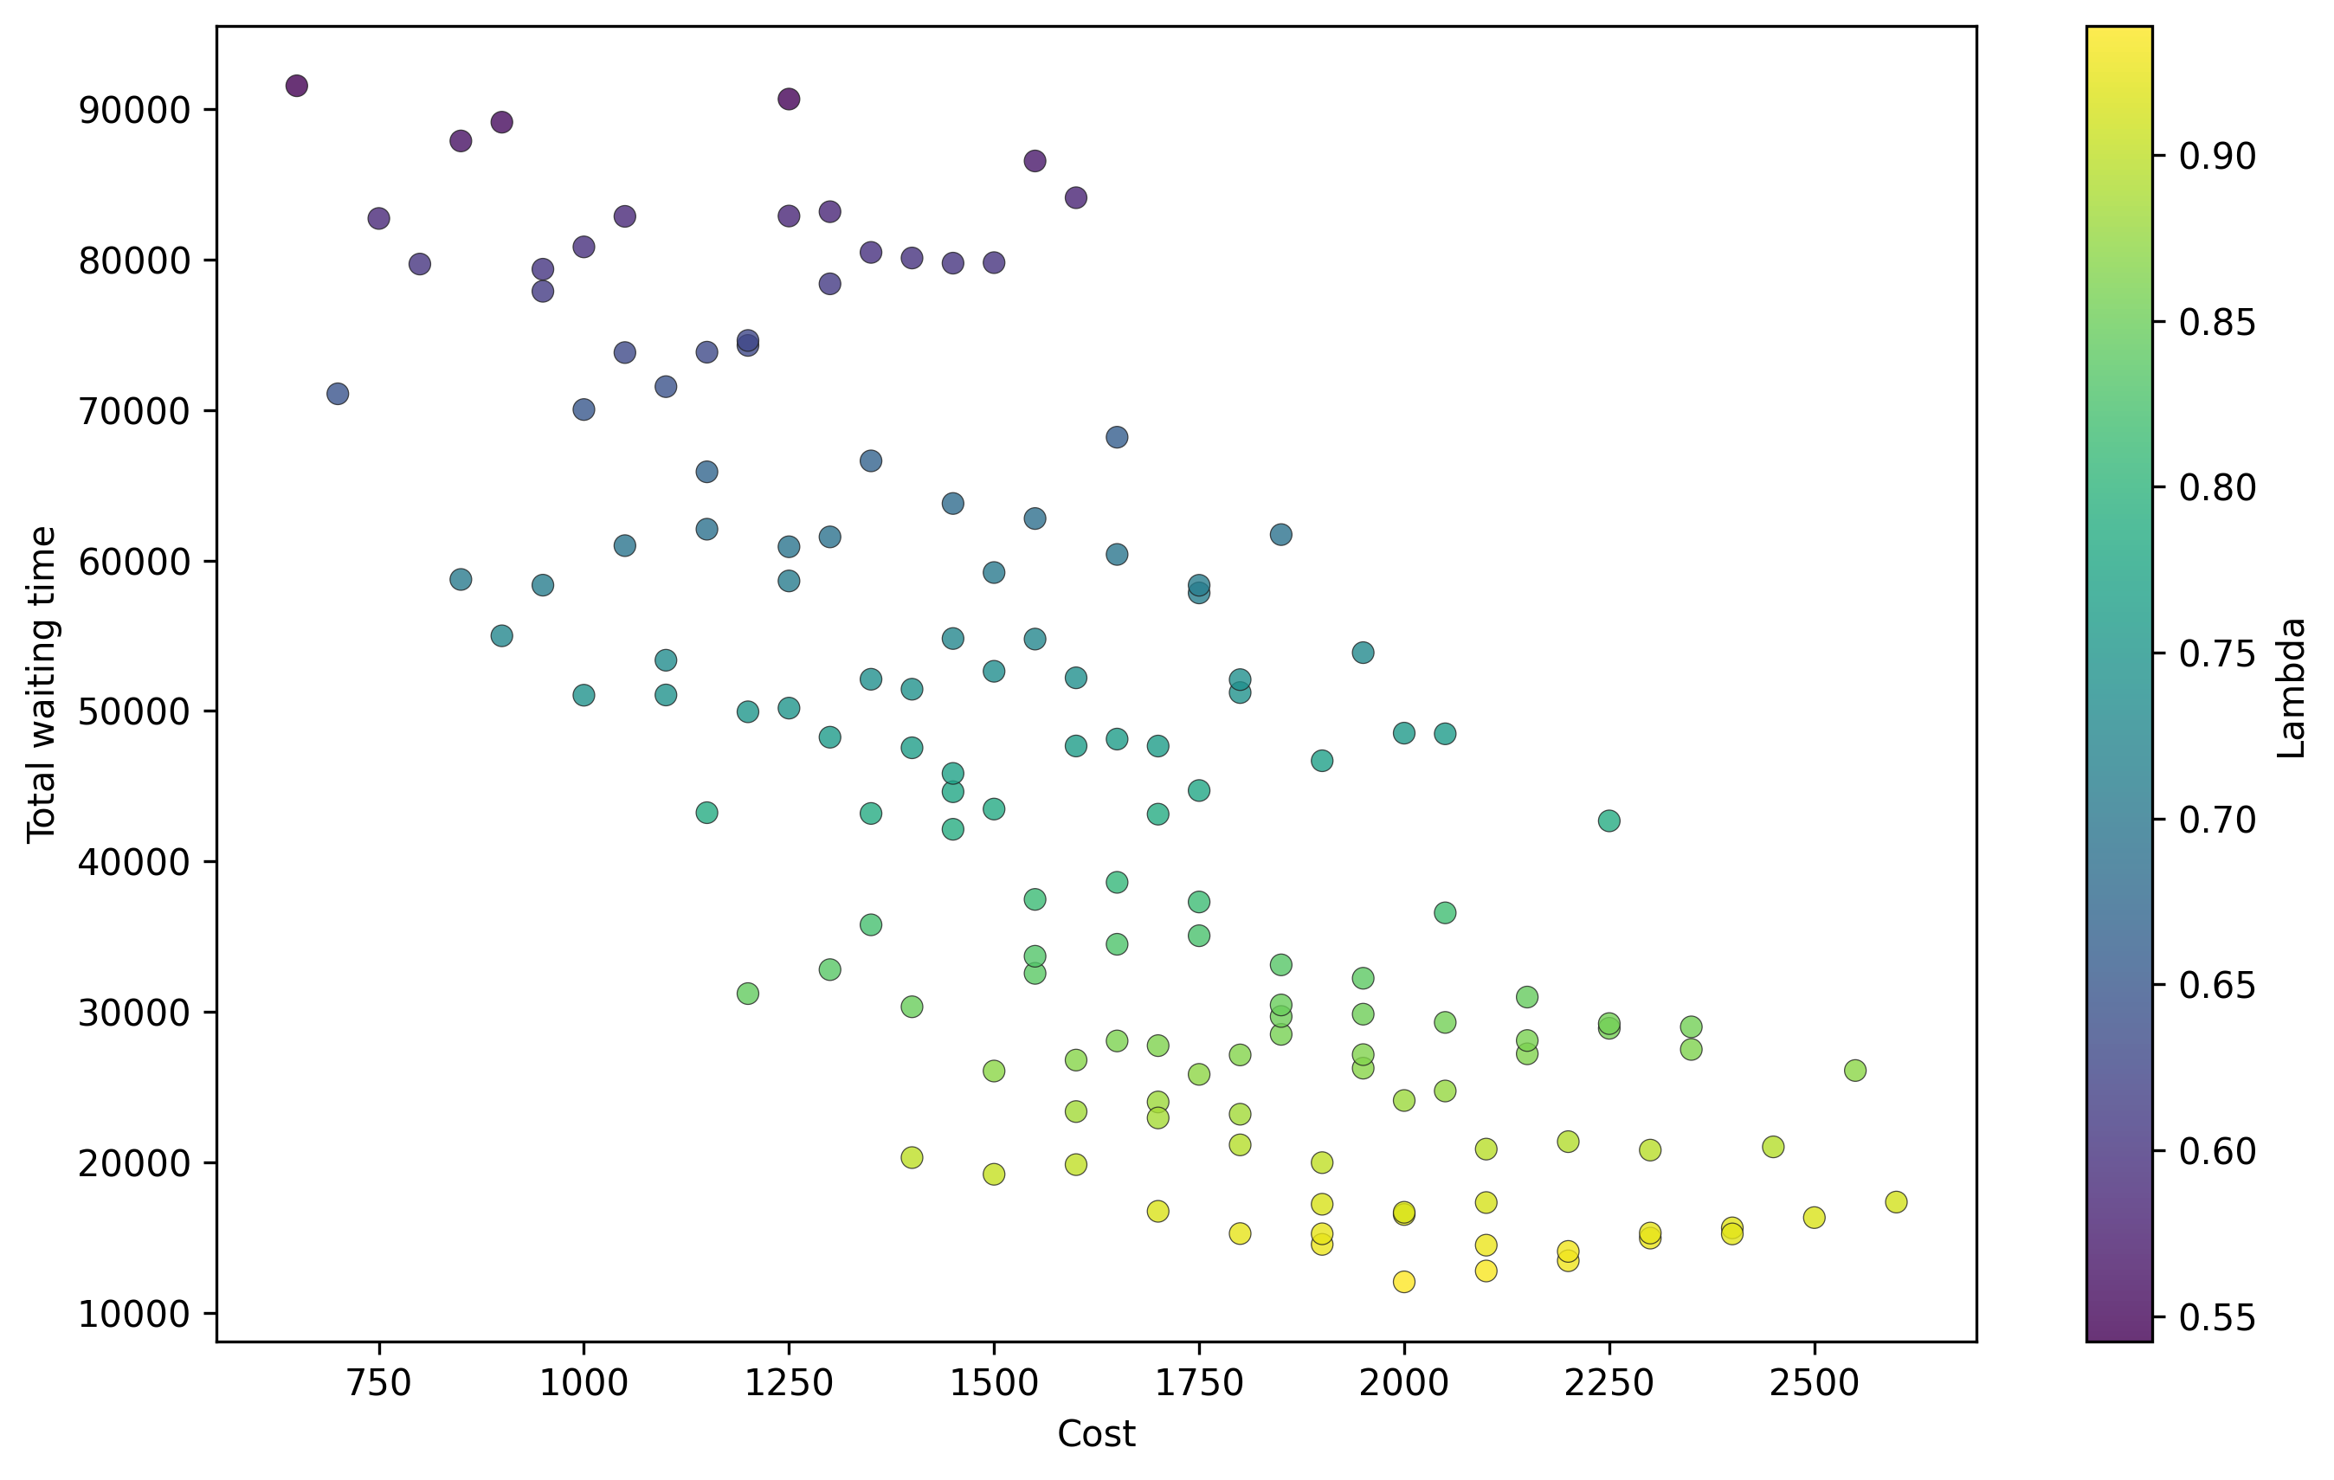
Figure 17. Cost-Wait scatter (all merged runs)
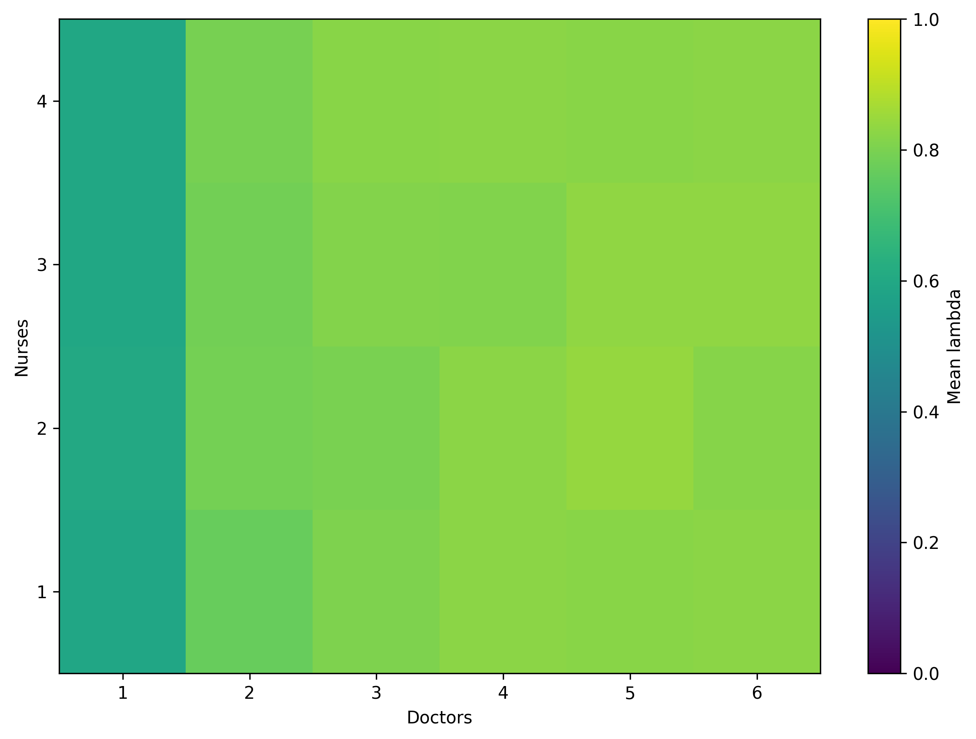
Figure 18. Mean lambda heatmap (Doctor x Nurse)
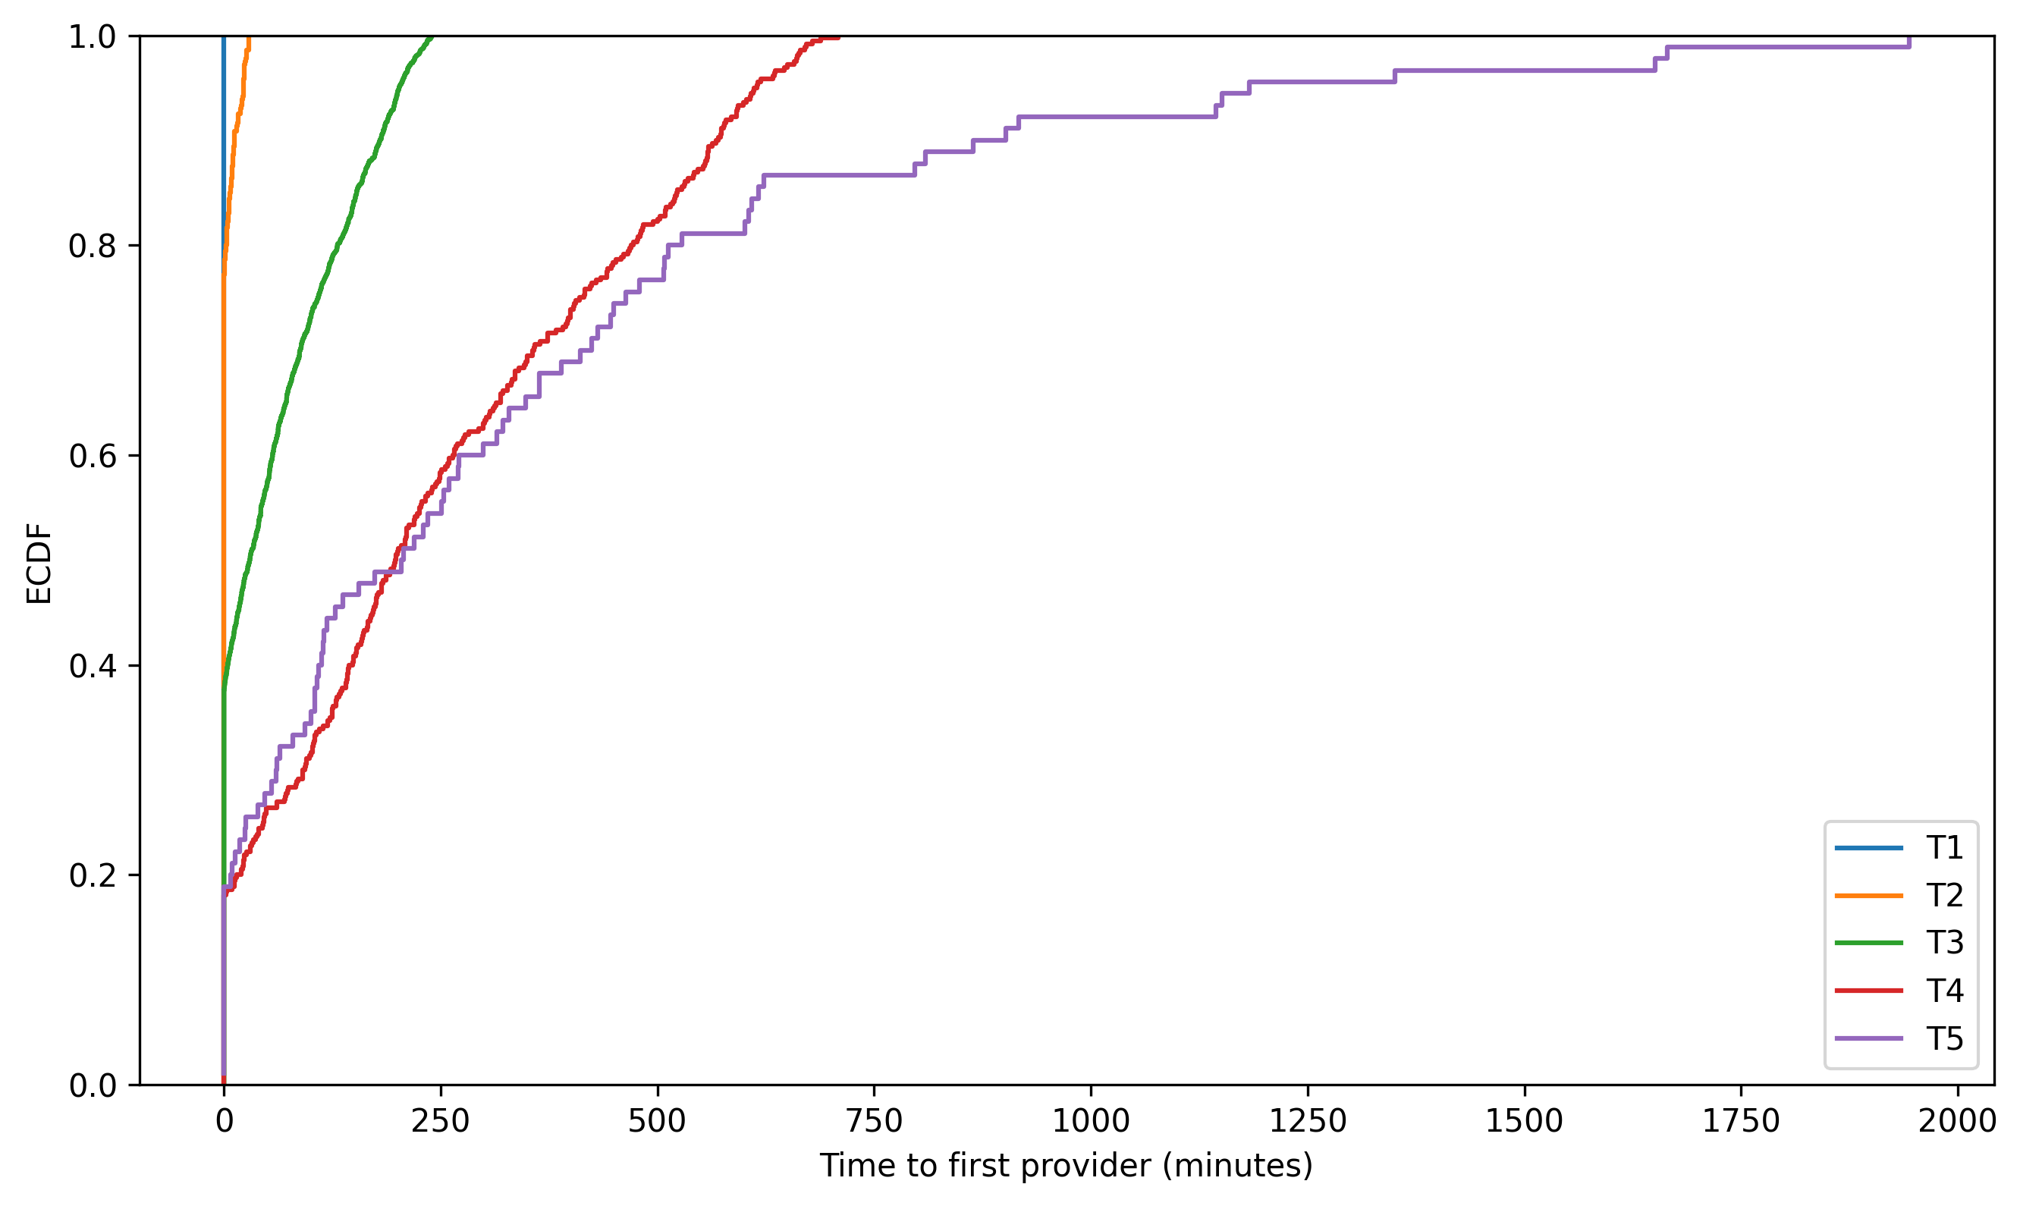
Figure 19. Triage first-wait ECDF (merged)

8. Summary
Results are presented as baseline performance plus integrated feasibility and tradeoff diagnostics. Merged exploration outputs (random sampling and combinatorics) identify robust feasible regions, likely binding objectives, and the cost associated with service improvements.

