Results Section - External Validation with FlexSim
This section operationalizes methodology subsection 8.1 (external validation with FlexSim) using only existing results artifacts. No new optimization or simulation runs were generated. Comparability is built through per-patient and baseline-index transformations.
Source run folder: C:\Users\LEONA\Documents\GitHub\MOFGPM\results\run_20260228_091617
MOFGPM patient count used for normalization: 36

1. Data Matching and Transformation
Scenario matching is performed by staffing tuple (Doctor, Nurse, Assistant, Specialist). MOFGPM and FlexSim are compared on transformed metrics: (i) per-patient values, and (ii) baseline-index values.
metric | value
MOFGPM combinatorics scenarios | 144
FlexSim scenarios | 144
Matched scenarios (shared staffing tuples) | 144
FlexSim replications per scenario | 10
Table 1. Data coverage and scenario matching summary.

2. Baseline-Anchored Comparison Logic
A model baseline run exists in fixed mode and is included for interpretation, but it can be outside the shared combinatorics design space.
The configured baseline staffing is outside the shared scenario space. A nearest shared proxy baseline is used for cross-model normalization.
baseline_item | in_shared_space | model_wait_per_patient | flexsim_mean_per_patient | notes
Configured baseline target (3, 3, 6, 1) | False | - | - | Reference target from methodology/fixed settings
Fixed-mode MOFGPM baseline run | False | 1207.8608 | - | Observed baseline run from fixed/results.csv
Shared reference used (3, 3, 2, 1) | True | 1710.2309 | 107.9732 | Nearest shared proxy baseline (normalized distance=4.000)
Table 2. Baseline and proxy-baseline elements used in validation.

3. Statistical Validation Tests
Primary validity checks include Pearson/Spearman/Kendall correlations, baseline-index error metrics, and direction-of-improvement agreement.
test | statistic | p_value | notes
Per-patient correlation | 0.8670 | 0.0000
Per-patient rank correlation | 0.8585 | 0.0000
Baseline-index correlation | 0.8670 | 0.0000
Baseline-index rank correlation | 0.8585 | 0.0000
Rank concordance (Kendall tau) | 0.6591 | 0.0000
Lambda vs FlexSim per-patient (Spearman) | -0.8578 | 0.0000
Linear fit (per-patient): slope | 0.0664 | 0.0000 | R2=0.7517
Baseline-index MAPE (%) | 28.7570 | - | Lower is better
Baseline-index MAE | 0.2574 | - | Lower is better
Baseline-index RMSE | 0.3095 | - | Lower is better
Scenarios within +/-0.10 baseline-index gap (%) | 22.9167 | - | Higher is better
Wilcoxon signed-rank on baseline-index gap | 881.0000 | 0.0000 | H0: median gap = 0
Improvement-direction agreement (%) | 87.5000 | -
Cohen kappa (improvement direction) | 0.6795 | -
Table 3. Statistical validation tests between MOFGPM and FlexSim.

4. Scenario-Level Agreement Diagnostics
Largest disagreements identify staffing combinations where model assumptions and FlexSim behavior diverge most.
Doctor | Nurse | Assistant | Specialist | model_wait_per_patient | flexsim_mean_per_patient | model_baseline_index | flexsim_baseline_index | baseline_index_gap | baseline_index_gap_abs | model_lambda
1.0000 | 1.0000 | 2.0000 | 1.0000 | 1974.4841 | 196.9739 | 1.1545 | 1.8243 | -0.6698 | 0.6698 | 0.6448
5.0000 | 1.0000 | 2.0000 | 3.0000 | 354.6770 | 93.2815 | 0.2074 | 0.8639 | -0.6565 | 0.6565 | 0.9344
1.0000 | 4.0000 | 2.0000 | 1.0000 | 1945.4163 | 192.3927 | 1.1375 | 1.7819 | -0.6443 | 0.6443 | 0.6500
6.0000 | 1.0000 | 2.0000 | 3.0000 | 424.7312 | 93.2815 | 0.2483 | 0.8639 | -0.6156 | 0.6156 | 0.9238
4.0000 | 1.0000 | 2.0000 | 3.0000 | 477.9437 | 93.3125 | 0.2795 | 0.8642 | -0.5848 | 0.5848 | 0.9142
1.0000 | 2.0000 | 2.0000 | 2.0000 | 1987.7090 | 188.4558 | 1.1622 | 1.7454 | -0.5831 | 0.5831 | 0.6424
3.0000 | 1.0000 | 2.0000 | 2.0000 | 564.0710 | 96.2355 | 0.3298 | 0.8913 | -0.5615 | 0.5615 | 0.8987
2.0000 | 1.0000 | 2.0000 | 2.0000 | 866.8987 | 115.2194 | 0.5069 | 1.0671 | -0.5602 | 0.5602 | 0.8442
1.0000 | 3.0000 | 1.0000 | 2.0000 | 2051.3277 | 188.0540 | 1.1994 | 1.7417 | -0.5422 | 0.5422 | 0.6309
1.0000 | 3.0000 | 2.0000 | 2.0000 | 2072.9420 | 188.0540 | 1.2121 | 1.7417 | -0.5296 | 0.5296 | 0.6270
1.0000 | 4.0000 | 1.0000 | 1.0000 | 2163.7831 | 192.5361 | 1.2652 | 1.7832 | -0.5180 | 0.5180 | 0.6107
1.0000 | 2.0000 | 2.0000 | 1.0000 | 2214.0681 | 195.6142 | 1.2946 | 1.8117 | -0.5171 | 0.5171 | 0.6016
3.0000 | 1.0000 | 2.0000 | 3.0000 | 666.7790 | 96.2051 | 0.3899 | 0.8910 | -0.5011 | 0.5011 | 0.8802
2.0000 | 2.0000 | 2.0000 | 3.0000 | 744.1266 | 100.3295 | 0.4351 | 0.9292 | -0.4941 | 0.4941 | 0.8663
5.0000 | 1.0000 | 2.0000 | 2.0000 | 644.1828 | 93.3459 | 0.3767 | 0.8645 | -0.4879 | 0.4879 | 0.8843
Table 4. Top disagreement scenarios (highest absolute baseline-index gap).
Strongest agreements identify where both models produce similar relative performance patterns.
Doctor | Nurse | Assistant | Specialist | model_wait_per_patient | flexsim_mean_per_patient | model_baseline_index | flexsim_baseline_index | baseline_index_gap | baseline_index_gap_abs | model_lambda
3.0000 | 3.0000 | 2.0000 | 1.0000 | 1710.2309 | 107.9732 | 1.0000 | 1.0000 | 0.0000 | 0.0000 | 0.6923
4.0000 | 4.0000 | 1.0000 | 2.0000 | 824.6386 | 52.6279 | 0.4822 | 0.4874 | -0.0052 | 0.0052 | 0.8518
5.0000 | 2.0000 | 1.0000 | 3.0000 | 755.6936 | 46.7483 | 0.4419 | 0.4330 | 0.0089 | 0.0089 | 0.8642
5.0000 | 1.0000 | 2.0000 | 1.0000 | 1644.4283 | 105.0554 | 0.9615 | 0.9730 | -0.0115 | 0.0115 | 0.7042
5.0000 | 3.0000 | 1.0000 | 1.0000 | 1677.8619 | 107.2902 | 0.9811 | 0.9937 | -0.0126 | 0.0126 | 0.6982
6.0000 | 3.0000 | 1.0000 | 3.0000 | 583.8819 | 38.4550 | 0.3414 | 0.3562 | -0.0147 | 0.0147 | 0.8951
4.0000 | 1.0000 | 1.0000 | 1.0000 | 1692.0415 | 105.2008 | 0.9894 | 0.9743 | 0.0150 | 0.0150 | 0.6956
6.0000 | 3.0000 | 1.0000 | 1.0000 | 1714.4978 | 106.4465 | 1.0025 | 0.9859 | 0.0166 | 0.0166 | 0.6916
4.0000 | 4.0000 | 1.0000 | 3.0000 | 780.2392 | 46.9058 | 0.4562 | 0.4344 | 0.0218 | 0.0218 | 0.8598
4.0000 | 4.0000 | 1.0000 | 1.0000 | 1744.1678 | 106.3696 | 1.0198 | 0.9851 | 0.0347 | 0.0347 | 0.6862
4.0000 | 2.0000 | 1.0000 | 3.0000 | 754.1966 | 51.5604 | 0.4410 | 0.4775 | -0.0365 | 0.0365 | 0.8645
3.0000 | 3.0000 | 1.0000 | 2.0000 | 1040.8314 | 69.6775 | 0.6086 | 0.6453 | -0.0367 | 0.0367 | 0.8129
5.0000 | 4.0000 | 1.0000 | 1.0000 | 1620.8824 | 106.3758 | 0.9478 | 0.9852 | -0.0374 | 0.0374 | 0.7084
4.0000 | 3.0000 | 1.0000 | 3.0000 | 813.6701 | 47.2854 | 0.4758 | 0.4379 | 0.0378 | 0.0378 | 0.8538
6.0000 | 2.0000 | 1.0000 | 1.0000 | 1606.8067 | 105.7028 | 0.9395 | 0.9790 | -0.0394 | 0.0394 | 0.7110
Table 5. Top agreement scenarios (lowest absolute baseline-index gap).

5. Figures and Alt Text
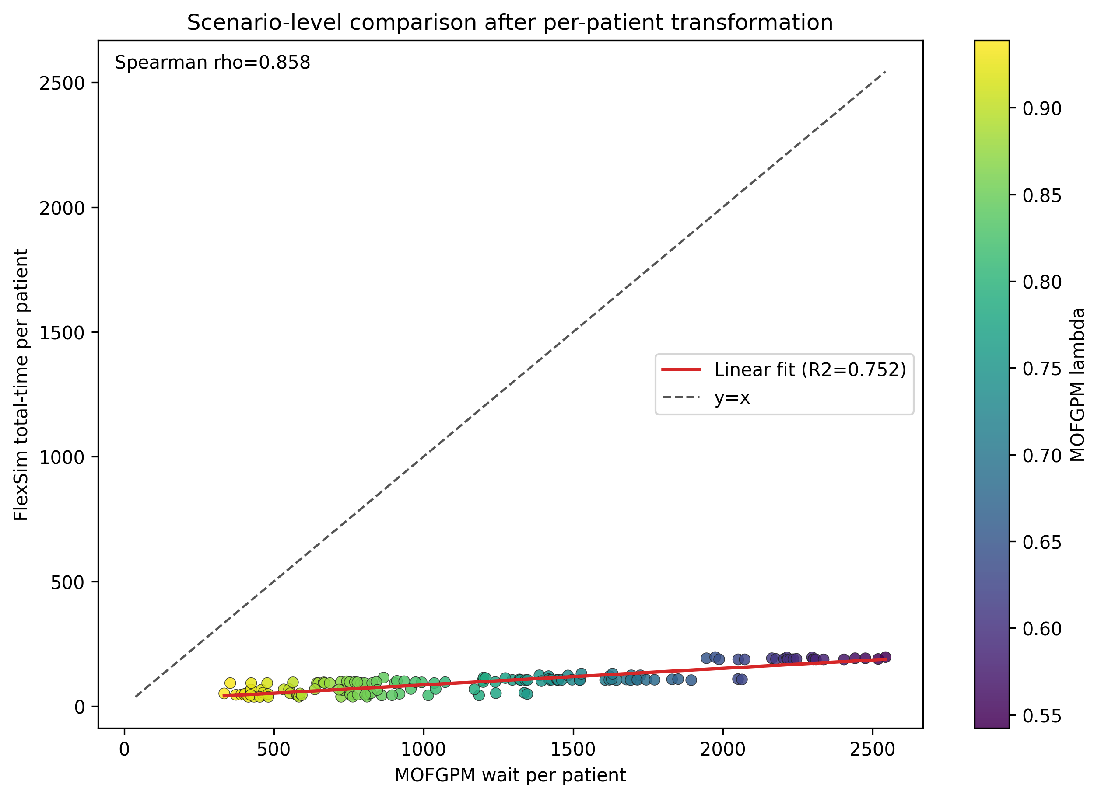
Figure 1. MOFGPM vs FlexSim per-patient metric (lambda color encoding).
Alt text: Scatter of 144 matched staffing scenarios comparing MOFGPM and FlexSim per-patient values, with a positive trend, regression line, and y equals x reference.
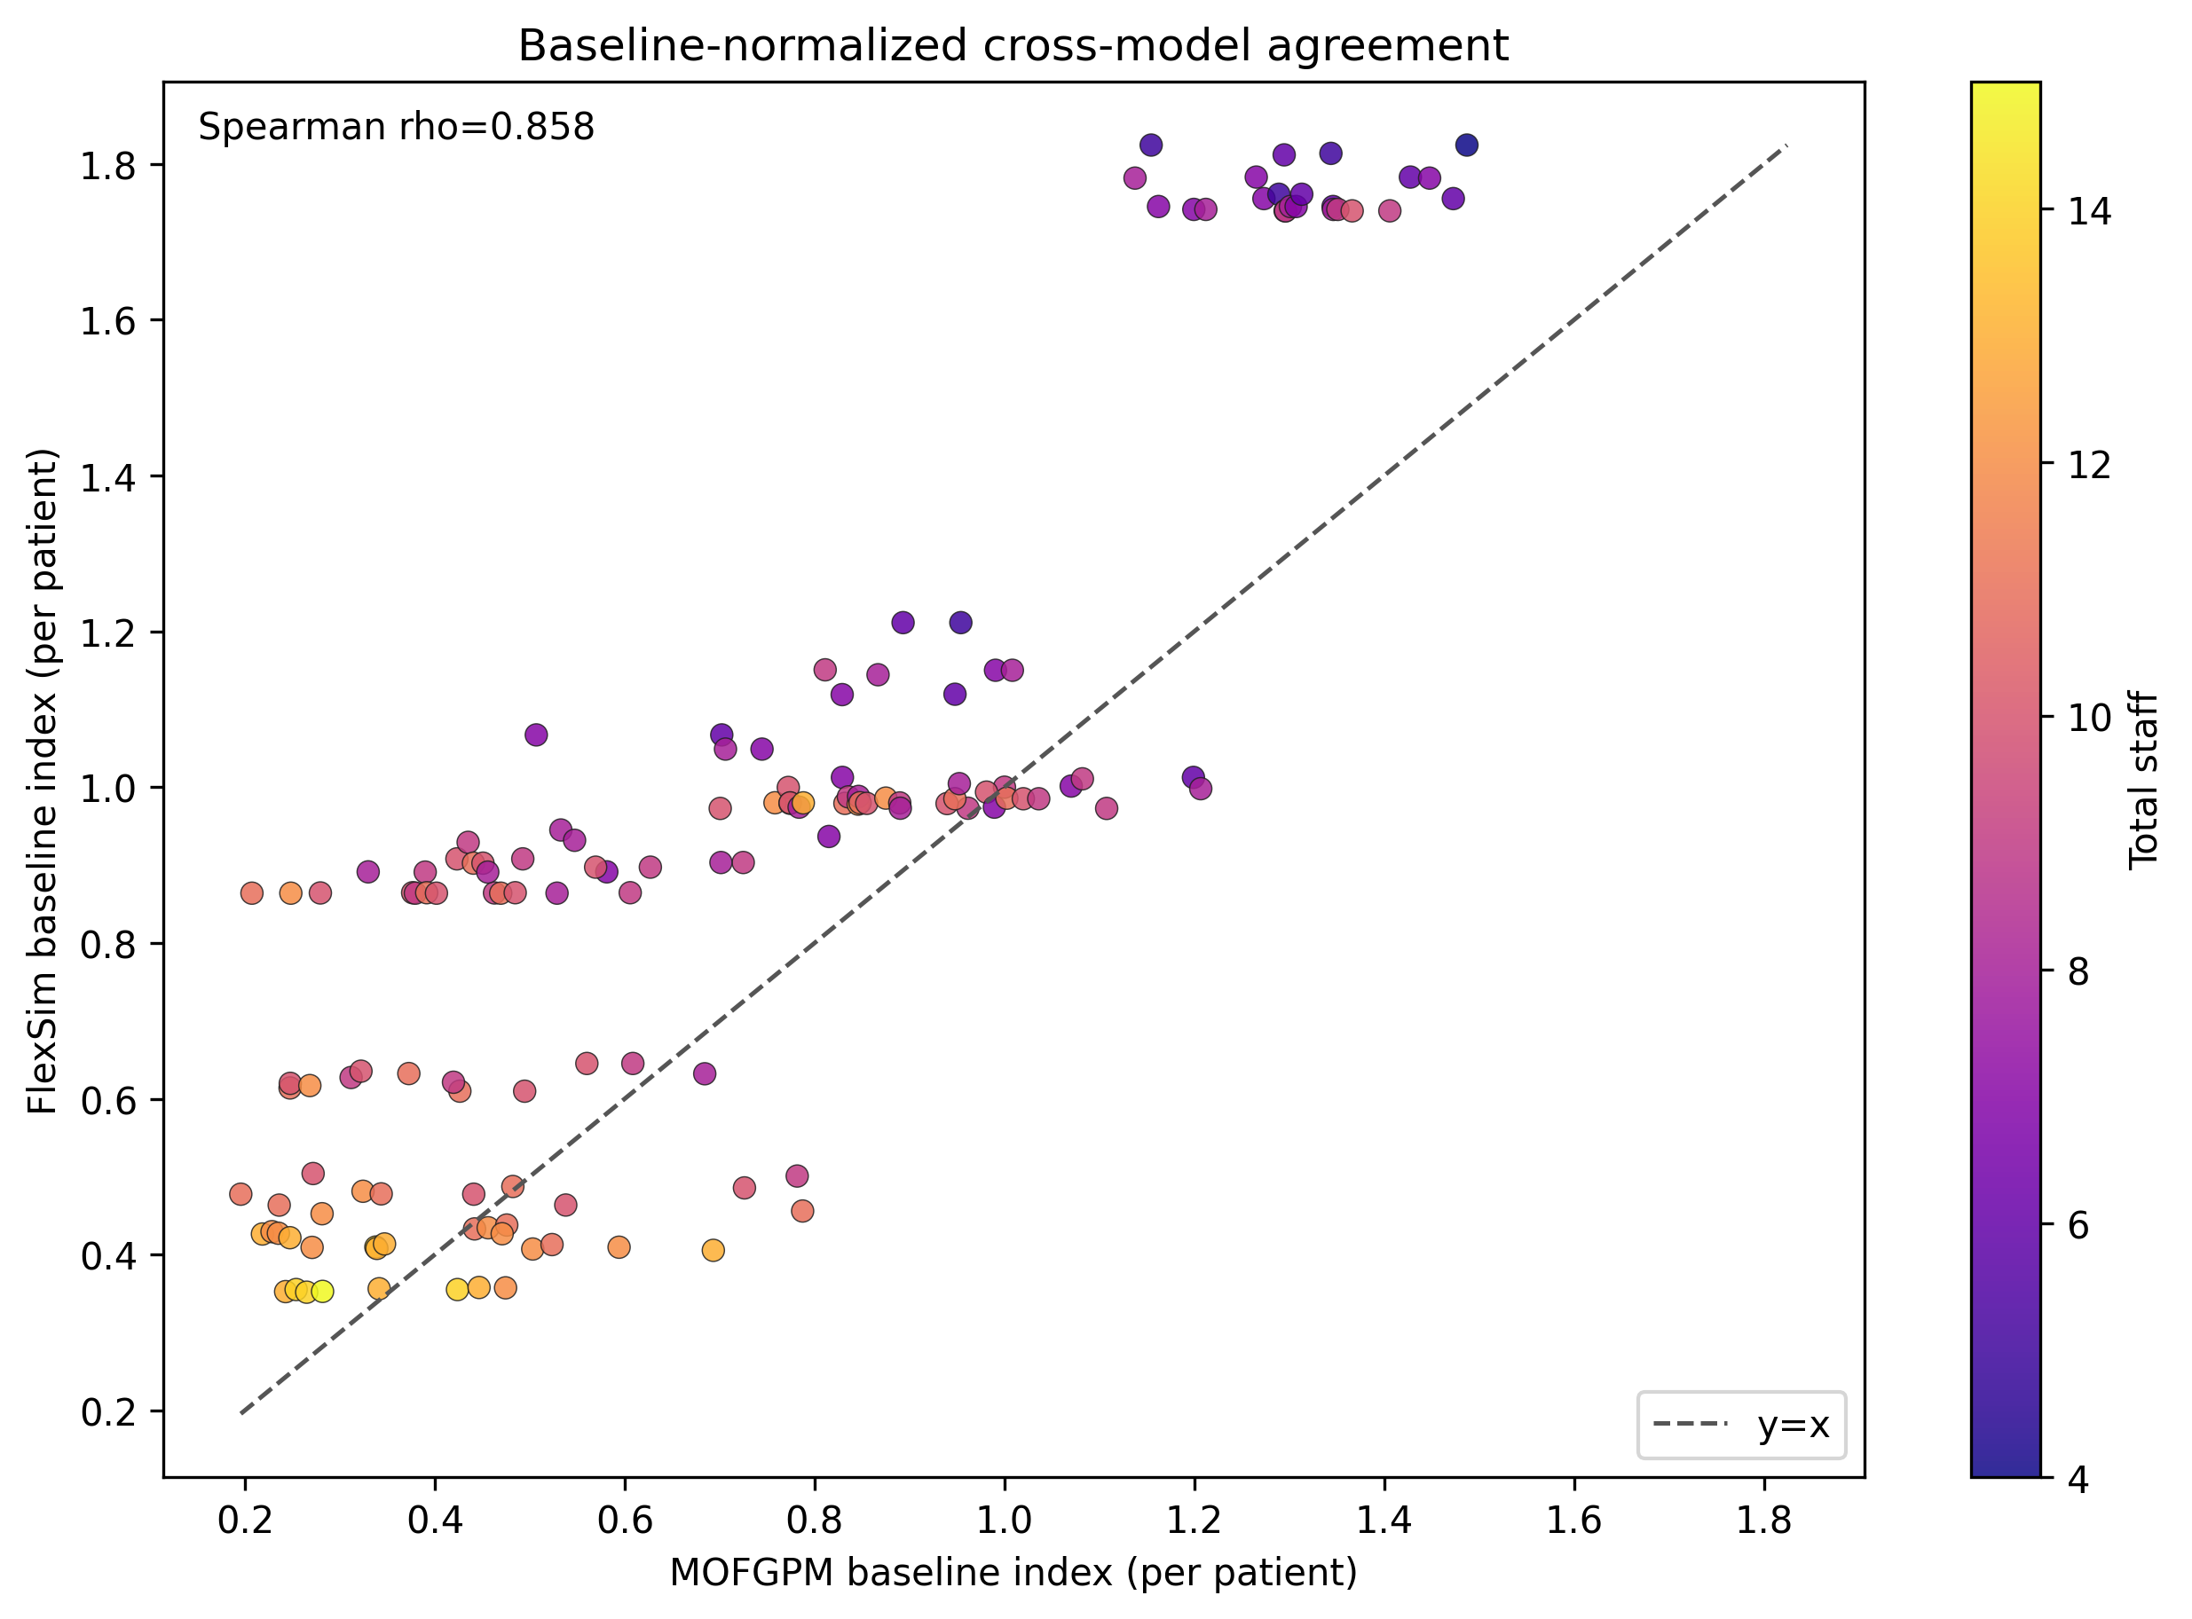
Figure 2. Baseline-index comparison (per-patient transformed values).
Alt text: Scatter of baseline-normalized per-patient performance for MOFGPM and FlexSim, colored by total staff, with y equals x line and positive rank alignment.
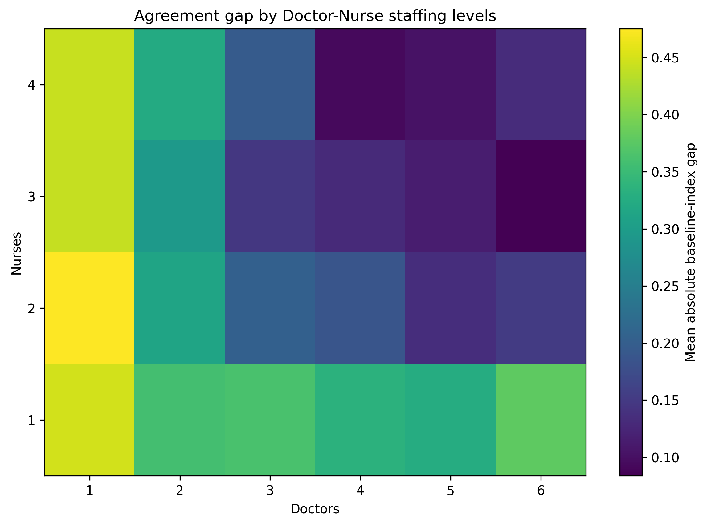
Figure 3. Mean absolute agreement gap by Doctor-Nurse levels.
Alt text: Heatmap showing where model-to-FlexSim normalized gap is smaller or larger across doctor and nurse staffing combinations.
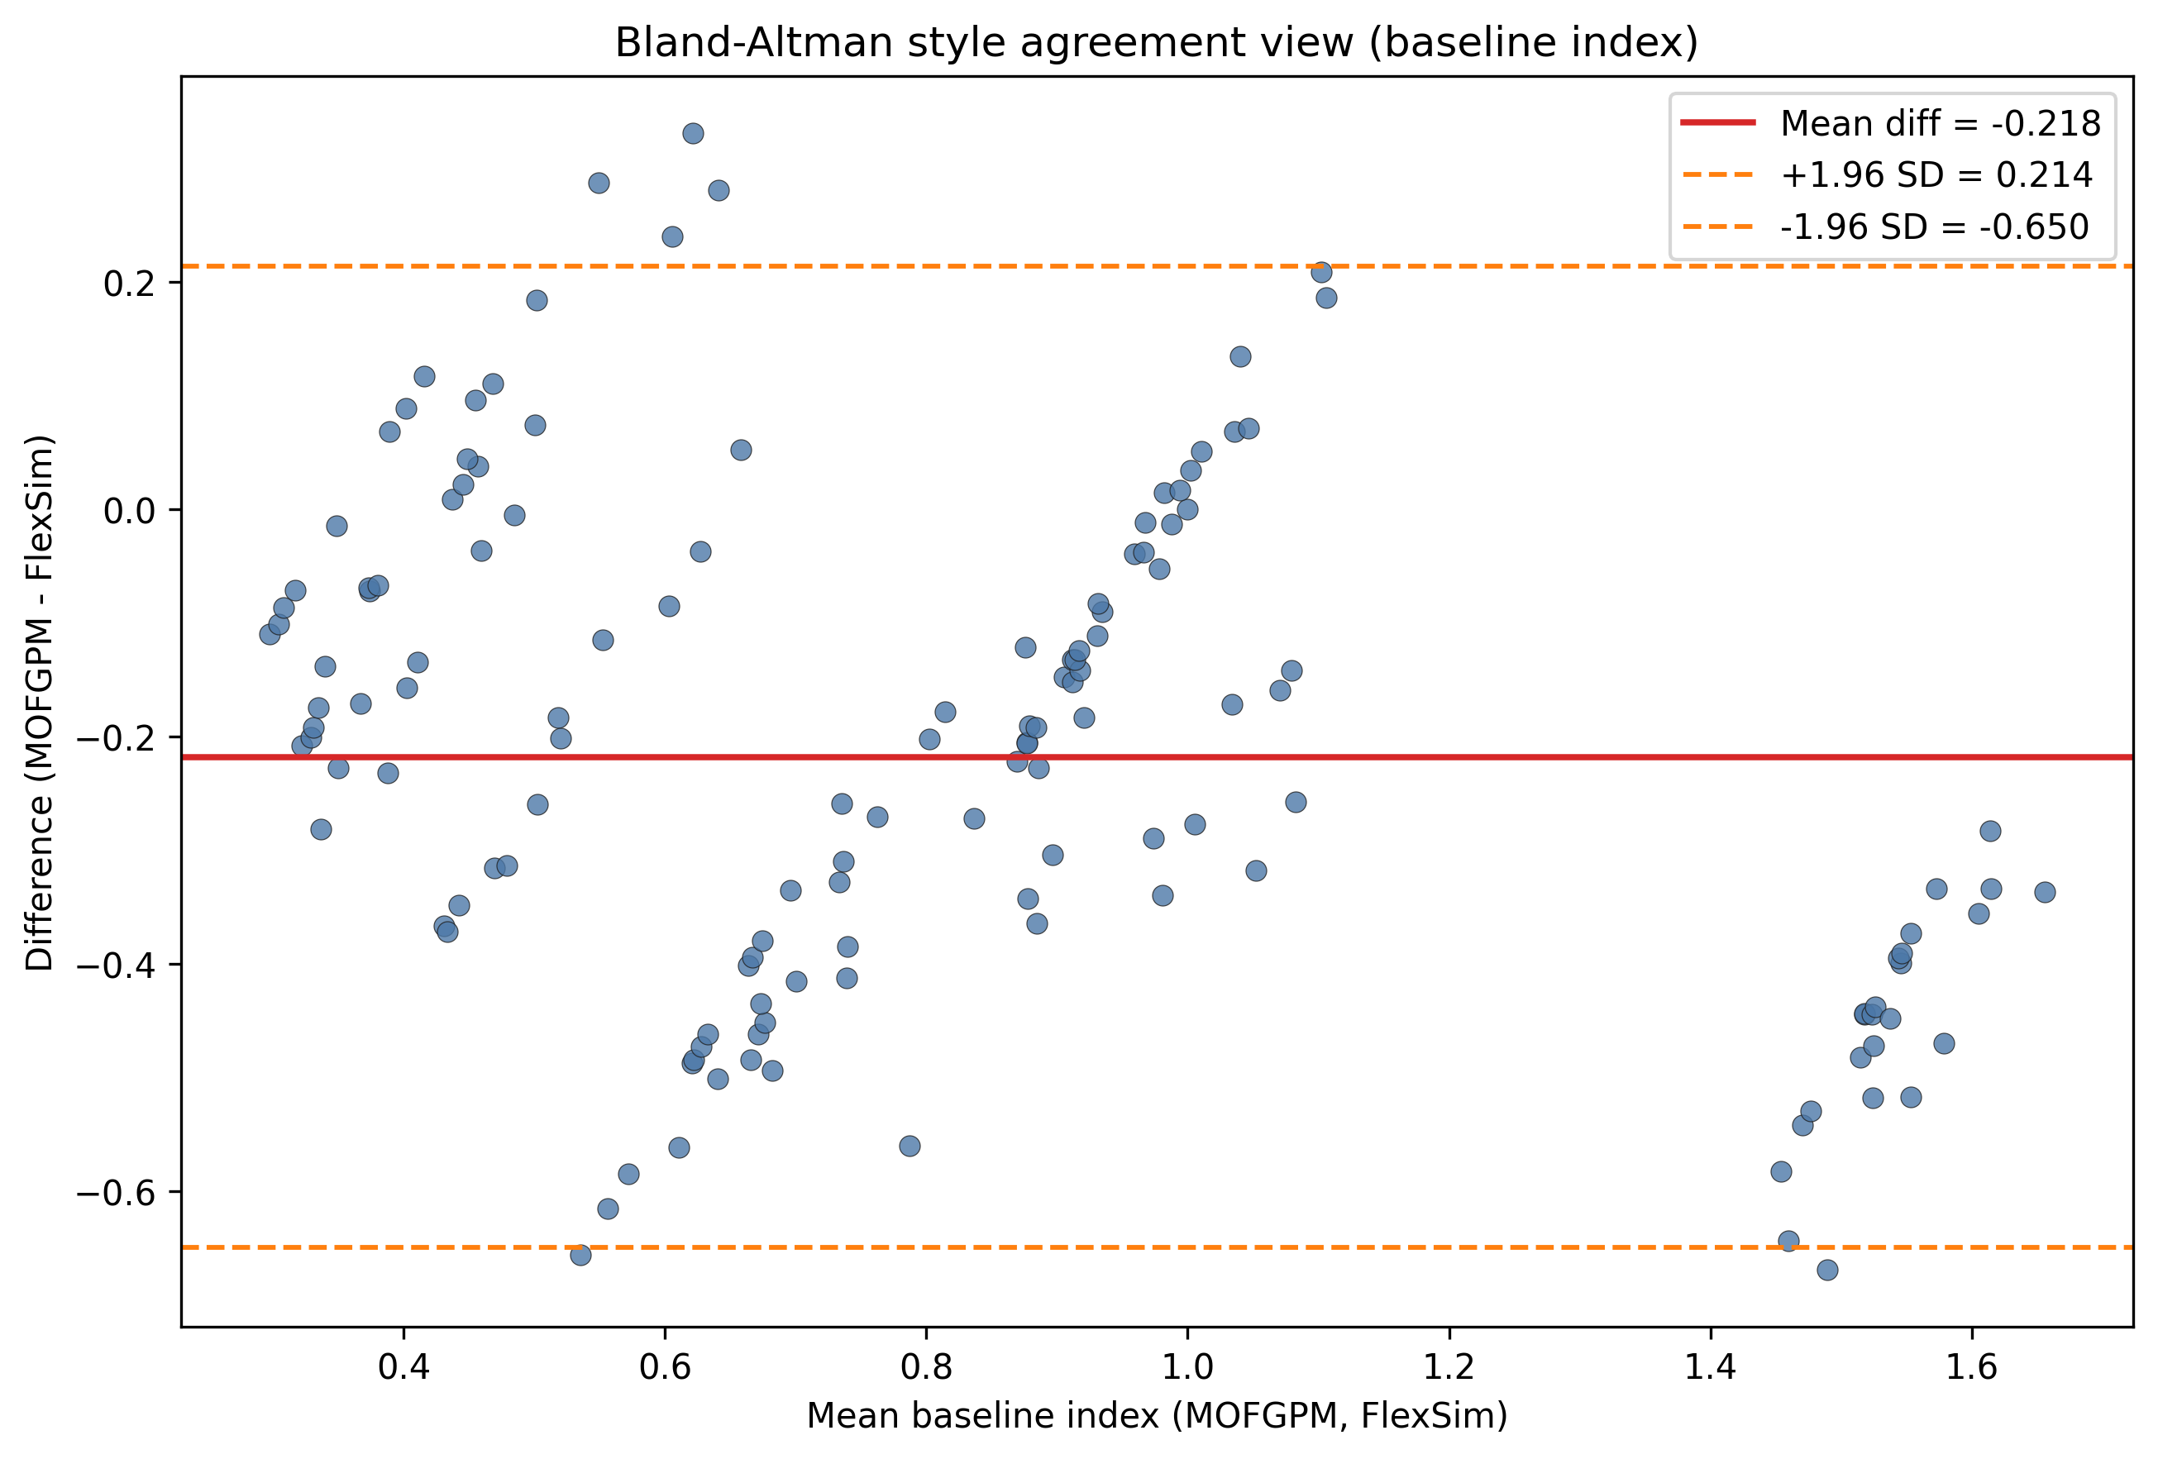
Figure 4. Bland-Altman agreement plot for baseline-index metrics.
Alt text: Agreement plot with baseline-index mean on x-axis and MOFGPM minus FlexSim difference on y-axis, including mean bias and limits of agreement lines.

6. Validation Interpretation
Per-patient rank correlation indicates monotonic alignment between MOFGPM and FlexSim (Spearman rho=0.858). This supports external validity of staffing tradeoff trends under the chosen transformation.
Because scales differ across engines, managerial interpretation should prioritize rank stability and baseline-index agreement rather than raw totals alone.

