Unified Results Section - Baseline, Sensitivity, and FlexSim Validation

1. Methodology-Aligned Sequence
Run folder: C:\Users\LEONA\Documents\GitHub\MOFGPM\results\run_20260228_091617
Results are ordered to match the proposed methodology: (i) baseline scheduling feasibility diagnosis, (ii) sensitivity analysis with patient throughput by staffing combinations, and (iii) external validation with FlexSim.

2. Baseline Case (24h Scheduling Feasibility)
Target patients in 24h: 36; GA generated patients: 35; served within 24h: 11.
Maximum completion time reached 3393.01 minutes (horizon=1440).
Baseline interpretation: NOT feasible for the 24h target; backlog remains beyond one day.
sample_id | Doctor | Nurse | Assistant | Specialist | target_patients_24h | generated_patients_ga | served_24h_ga | served_24h_rate | served_share_generated_pct | served_share_target_pct | backlog_vs_generated | backlog_vs_target | completion_time_max_min | horizon_min | schedule_feasible_24h_target | missing_first_wait_rows | ga_wait_all_finished | ga_lambda_fixed_row | ga_feasible_fixed_row
1 | 3 | 3 | 6 | 1 | 36 | 35 | 11 | 0.4583 | 31.4286 | 30.5556 | 24 | 25 | 3393.0096 | 1440.0000 | False | 0 | 43482.9871 | 0.7828 | True
Table B1. Baseline feasibility metrics for fixed staffing.
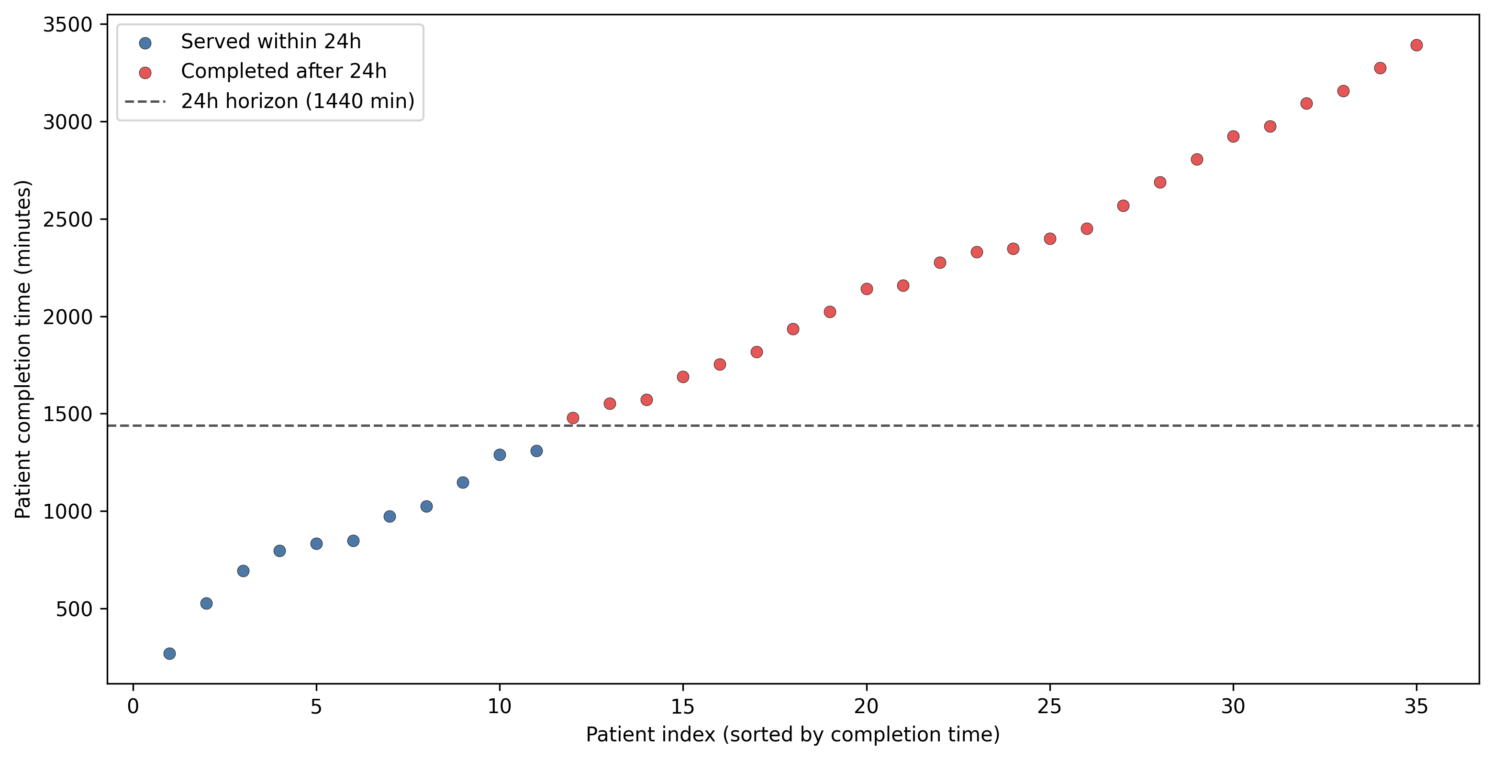
Figure B1. Baseline completion profile under fixed staffing.
Alt text: Scatter plot of patient completion times in the fixed baseline case, showing which patients finish within 24 hours and which spill beyond the daily horizon.

3. Sensitivity Analysis on Patient Throughput
Sensitivity analysis evaluates average attended patients/day under staffing combinations. Heatmaps are organized by Assistant and Specialist, with Doctor and Nurse axes inside each panel.
Doctor | Nurse | Assistant | Specialist | N_served_24h_ga | GA_served_rate | Patient | FS_served_rate | served_gap_patients | capacity_horizon_mismatch | GA_lambda
4 | 4 | 2 | 3 | 31 | 1.2917 | 30.4000 | 1.2667 | 0.6000 | False | 0.9299
6 | 1 | 2 | 3 | 31 | 1.2917 | 14.8000 | 0.6167 | 16.2000 | True | 0.9238
6 | 2 | 2 | 3 | 31 | 1.2917 | 30.6000 | 1.2750 | 0.4000 | False | 0.9208
5 | 2 | 2 | 3 | 30 | 1.2500 | 30.2000 | 1.2583 | -0.2000 | False | 0.9299
5 | 1 | 2 | 3 | 29 | 1.2083 | 14.8000 | 0.6167 | 14.2000 | True | 0.9344
5 | 4 | 2 | 3 | 29 | 1.2083 | 35.8000 | 1.4917 | -6.8000 | False | 0.9208
3 | 4 | 2 | 3 | 29 | 1.2083 | 21.2000 | 0.8833 | 7.8000 | True | 0.9176
4 | 1 | 2 | 3 | 29 | 1.2083 | 14.8000 | 0.6167 | 14.2000 | True | 0.9142
4 | 3 | 2 | 3 | 28 | 1.1667 | 30.4000 | 1.2667 | -2.4000 | False | 0.9278
3 | 3 | 2 | 3 | 28 | 1.1667 | 21.2000 | 0.8833 | 6.8000 | True | 0.9240
5 | 3 | 2 | 2 | 28 | 1.1667 | 31.4000 | 1.3083 | -3.4000 | False | 0.9169
4 | 2 | 2 | 3 | 27 | 1.1250 | 27.4000 | 1.1417 | -0.4000 | False | 0.9389
5 | 2 | 2 | 2 | 27 | 1.1250 | 28.2000 | 1.1750 | -1.2000 | False | 0.9275
5 | 3 | 2 | 3 | 27 | 1.1250 | 36.0000 | 1.5000 | -9.0000 | True | 0.9253
6 | 3 | 2 | 3 | 27 | 1.1250 | 36.2000 | 1.5083 | -9.2000 | True | 0.9163
Table S1. Top staffing combinations by GA served-within-24h count.
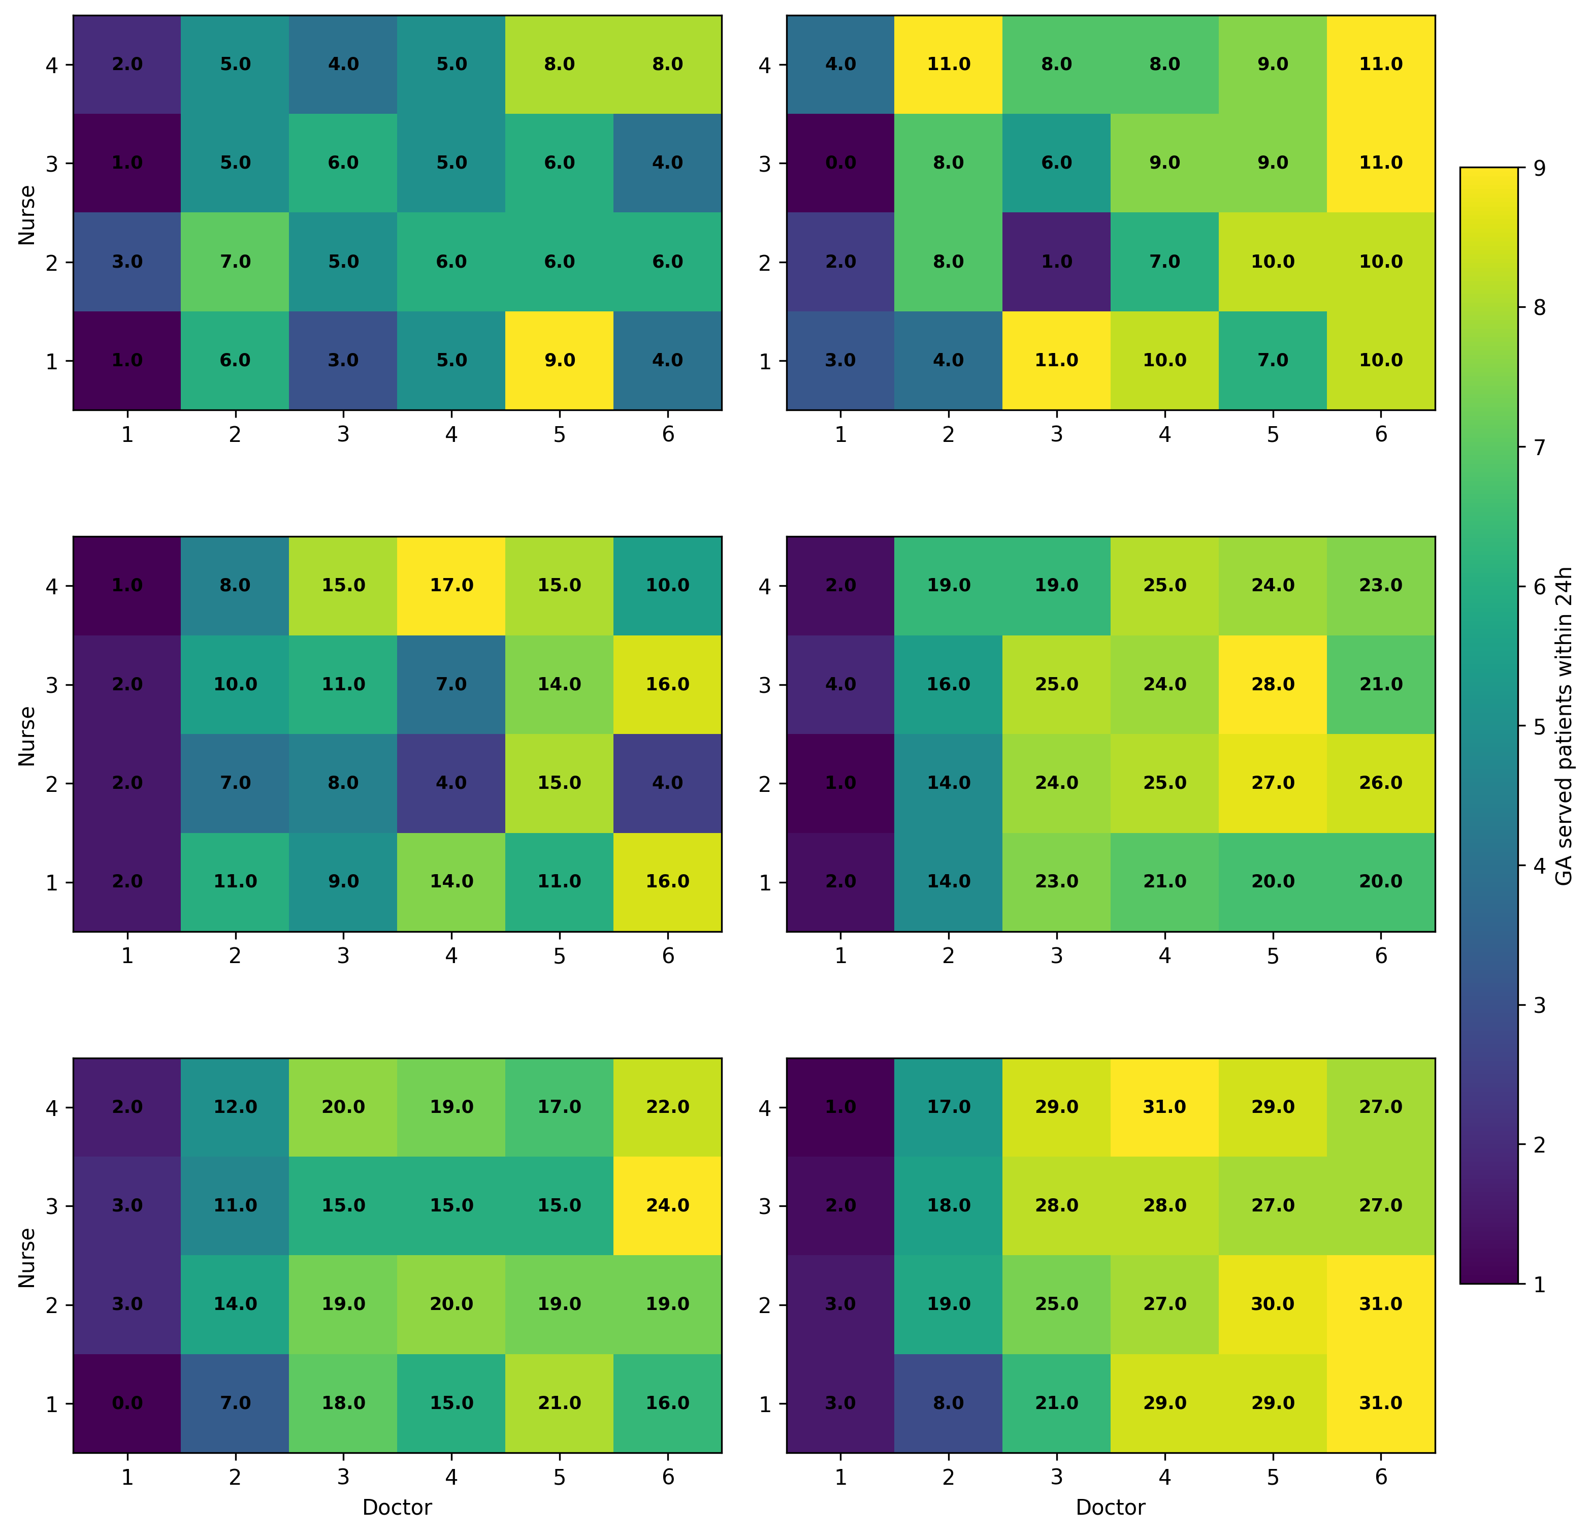
Figure S1. GA served patients within 24h by staffing combination
Alt text: Heatmap grid by Assistant and Specialist levels; each panel shows Doctor versus Nurse combinations with annotated values for ga served patients within 24h.
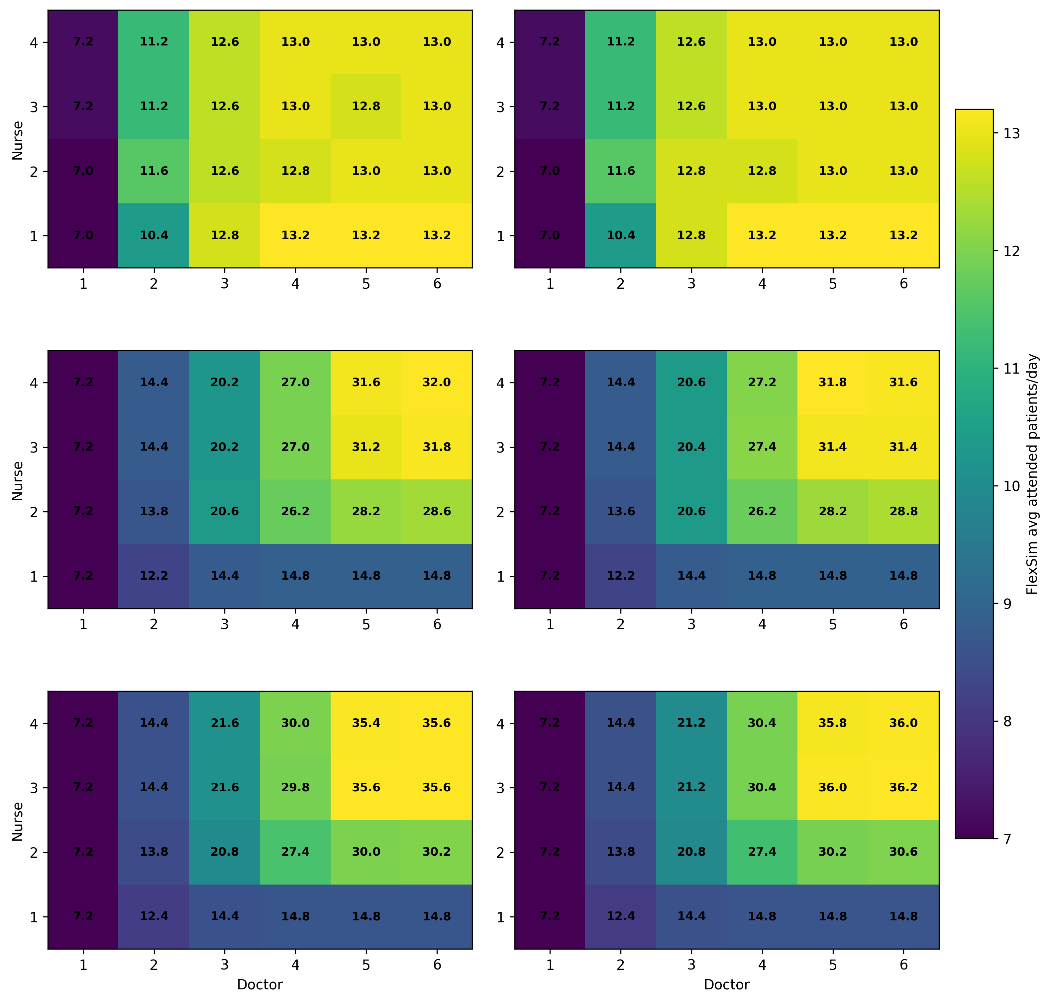
Figure S2. FlexSim average attended patients/day by staffing combination
Alt text: Heatmap grid by Assistant and Specialist levels; each panel shows Doctor versus Nurse combinations with annotated values for flexsim avg attended patients/day.
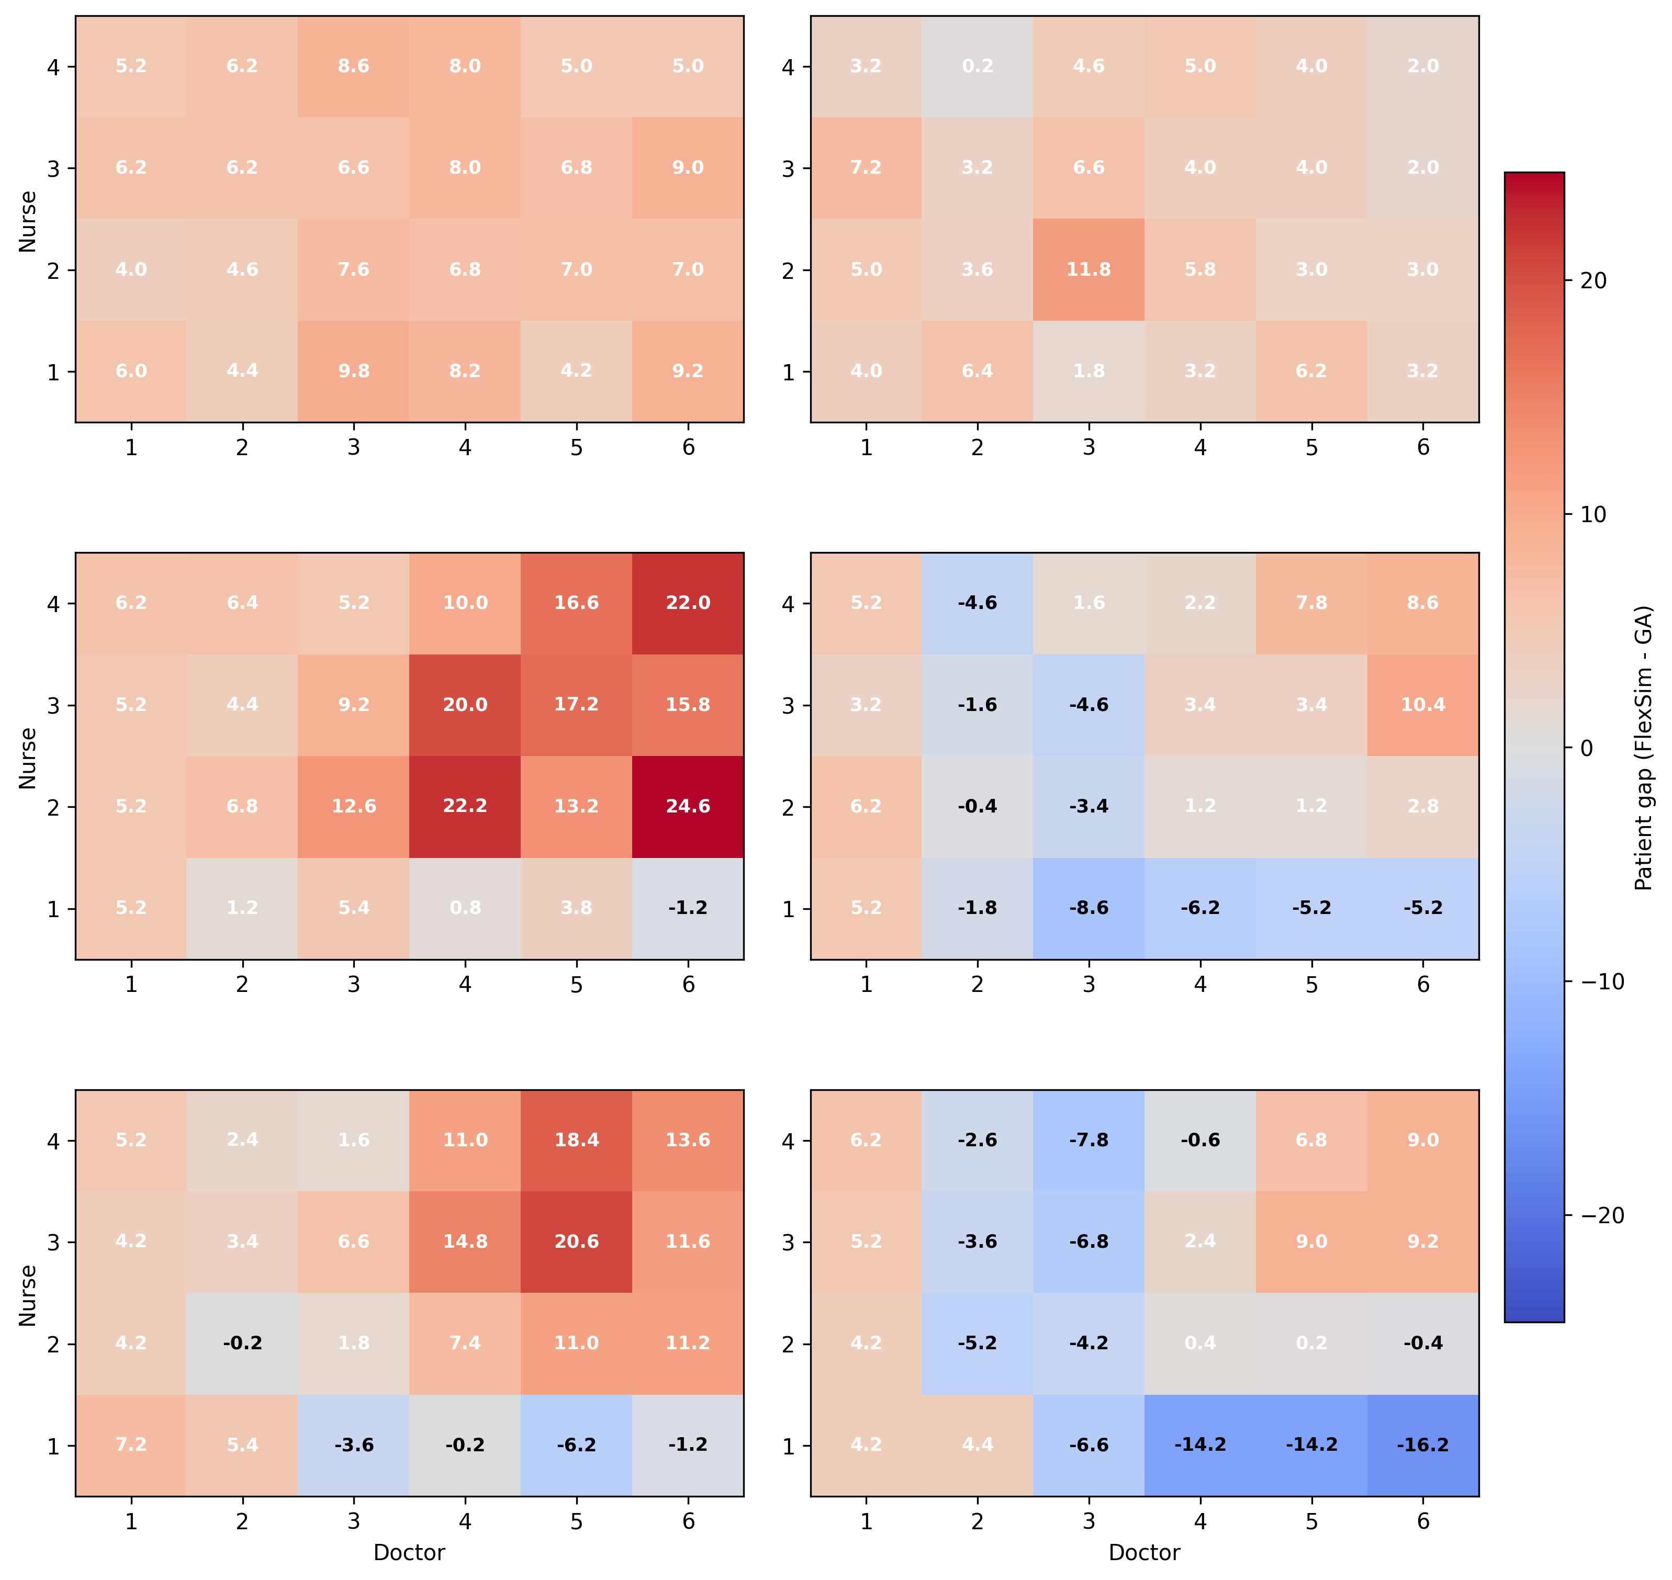
Figure S3. Gap in attended patients/day (FlexSim - GA served_24h)
Alt text: Heatmap grid by Assistant and Specialist levels; each panel shows Doctor versus Nurse combinations with annotated values for patient gap (flexsim - ga).

4. External Validation with FlexSim
Comparability is enforced on the served-within-24h cohort. KPI definition: aggregate waiting/attention metric for served patients only.
FlexSim KPI uses FS_mean (10-replication average). GA KPI is scaled as GA_scaled_total_24h = GA_avg_wait_per_served * FlexSim Patient.
Scenario | Doctor | Nurse | Assistant | Specialist | sample_id | N_total_ga | N_served_24h_ga | GA_served_rate | Patient | FS_served_rate | served_gap_patients | served_gap_pct | capacity_horizon_mismatch
Scenario 1 | 1 | 1 | 1 | 1 | 1 | 35 | 1 | 0.0417 | 7.0000 | 0.2917 | -6.0000 | -85.7143 | True
Scenario 2 | 1 | 1 | 2 | 1 | 4 | 35 | 3 | 0.1250 | 7.0000 | 0.2917 | -4.0000 | -57.1429 | True
Scenario 3 | 1 | 2 | 1 | 1 | 7 | 35 | 3 | 0.1250 | 7.0000 | 0.2917 | -4.0000 | -57.1429 | True
Scenario 4 | 1 | 2 | 2 | 1 | 10 | 35 | 2 | 0.0833 | 7.0000 | 0.2917 | -5.0000 | -71.4286 | True
Scenario 5 | 1 | 3 | 1 | 1 | 13 | 35 | 1 | 0.0417 | 7.2000 | 0.3000 | -6.2000 | -86.1111 | True
Scenario 6 | 1 | 3 | 2 | 1 | 16 | 35 | 0 | 0.0000 | 7.2000 | 0.3000 | -7.2000 | -100.0000 | True
Scenario 7 | 1 | 4 | 1 | 1 | 19 | 35 | 2 | 0.0833 | 7.2000 | 0.3000 | -5.2000 | -72.2222 | True
Scenario 8 | 1 | 4 | 2 | 1 | 22 | 35 | 4 | 0.1667 | 7.2000 | 0.3000 | -3.2000 | -44.4444 | True
Scenario 9 | 1 | 1 | 1 | 2 | 2 | 35 | 2 | 0.0833 | 7.2000 | 0.3000 | -5.2000 | -72.2222 | True
Scenario 10 | 1 | 1 | 2 | 2 | 5 | 35 | 2 | 0.0833 | 7.2000 | 0.3000 | -5.2000 | -72.2222 | True
Scenario 11 | 1 | 2 | 1 | 2 | 8 | 35 | 2 | 0.0833 | 7.2000 | 0.3000 | -5.2000 | -72.2222 | True
Scenario 12 | 1 | 2 | 2 | 2 | 11 | 35 | 1 | 0.0417 | 7.2000 | 0.3000 | -6.2000 | -86.1111 | True
Scenario 13 | 1 | 3 | 1 | 2 | 14 | 35 | 2 | 0.0833 | 7.2000 | 0.3000 | -5.2000 | -72.2222 | True
Scenario 14 | 1 | 3 | 2 | 2 | 17 | 35 | 4 | 0.1667 | 7.2000 | 0.3000 | -3.2000 | -44.4444 | True
Scenario 15 | 1 | 4 | 1 | 2 | 20 | 35 | 1 | 0.0417 | 7.2000 | 0.3000 | -6.2000 | -86.1111 | True
Scenario 16 | 1 | 4 | 2 | 2 | 23 | 35 | 2 | 0.0833 | 7.2000 | 0.3000 | -5.2000 | -72.2222 | True
Scenario 17 | 1 | 1 | 1 | 3 | 3 | 35 | 0 | 0.0000 | 7.2000 | 0.3000 | -7.2000 | -100.0000 | True
Scenario 18 | 1 | 1 | 2 | 3 | 6 | 35 | 3 | 0.1250 | 7.2000 | 0.3000 | -4.2000 | -58.3333 | True
Scenario 19 | 1 | 2 | 1 | 3 | 9 | 35 | 3 | 0.1250 | 7.2000 | 0.3000 | -4.2000 | -58.3333 | True
Scenario 20 | 1 | 2 | 2 | 3 | 12 | 35 | 3 | 0.1250 | 7.2000 | 0.3000 | -4.2000 | -58.3333 | True
Table V1. Cohort and capacity reconciliation.
Scenario | Doctor | Nurse | Assistant | Specialist | FS_mean | FS_std | FS_ci95 | FS_avg_wait_per_served | GA_total_wait_all_finished | GA_avg_wait_all_finished | GA_total_wait_served_24h | GA_avg_wait_per_served | GA_scaled_total_24h | abs_diff_per_patient | pct_diff_per_patient | abs_diff_total_24h | pct_diff_total_24h
Scenario 1 | 1 | 1 | 1 | 1 | 1378.8176 | 45.8531 | 28.4201 | 196.9739 | 91558.1849 | 2615.9481 | 236.2482 | 236.2482 | 1653.7372 | 39.2742 | 19.9388 | 274.9196 | 19.9388
Scenario 2 | 1 | 1 | 2 | 1 | 1378.8176 | 45.8531 | 28.4201 | 196.9739 | 71081.4284 | 2030.8980 | 546.4549 | 182.1516 | 1275.0614 | 14.8223 | -7.5250 | 103.7562 | -7.5250
Scenario 3 | 1 | 2 | 1 | 1 | 1370.7415 | 68.3655 | 42.3734 | 195.8202 | 82737.6072 | 2363.9316 | 1923.0303 | 641.0101 | 4487.0707 | 445.1899 | 227.3462 | 3116.3292 | 227.3462
Scenario 4 | 1 | 2 | 2 | 1 | 1369.2997 | 67.3091 | 41.7186 | 195.6142 | 79706.4509 | 2277.3272 | 382.6794 | 191.3397 | 1339.3780 | 4.2745 | -2.1852 | 29.9217 | -2.1852
Scenario 5 | 1 | 3 | 1 | 1 | 1386.2597 | 55.8228 | 34.5993 | 192.5361 | 87890.6420 | 2511.1612 | 312.2448 | 312.2448 | 2248.1622 | 119.7087 | 62.1747 | 861.9025 | 62.1747
Scenario 6 | 1 | 3 | 2 | 1 | 1385.2277 | 55.1810 | 34.2016 | 192.3927 | 89137.1039 | 2546.7744 | 0.0000 | - | - | - | - | - | -
Scenario 7 | 1 | 4 | 1 | 1 | 1386.2597 | 55.8228 | 34.5993 | 192.5361 | 77896.1903 | 2225.6054 | 1257.2812 | 628.6406 | 4526.2122 | 436.1045 | 226.5053 | 3139.9525 | 226.5053
Scenario 8 | 1 | 4 | 2 | 1 | 1385.2277 | 55.1810 | 34.2016 | 192.3927 | 70034.9850 | 2000.9996 | 2373.6093 | 593.4023 | 4272.4968 | 401.0096 | 208.4328 | 2887.2691 | 208.4328
Scenario 9 | 1 | 1 | 1 | 2 | 1369.1237 | 55.3532 | 34.3083 | 190.1561 | 79363.3119 | 2267.5232 | 1094.2869 | 547.1434 | 3939.4328 | 356.9874 | 187.7339 | 2570.3091 | 187.7339
Scenario 10 | 1 | 1 | 2 | 2 | 1369.1237 | 55.3532 | 34.3083 | 190.1561 | 80847.6035 | 2309.9315 | 796.7837 | 398.3919 | 2868.4214 | 208.2358 | 109.5078 | 1499.2977 | 109.5078
Scenario 11 | 1 | 2 | 1 | 2 | 1356.8818 | 73.3025 | 45.4333 | 188.4558 | 82876.9317 | 2367.9123 | 965.2277 | 482.6138 | 3474.8196 | 294.1580 | 156.0886 | 2117.9378 | 156.0886
Scenario 12 | 1 | 2 | 2 | 2 | 1356.8818 | 73.3025 | 45.4333 | 188.4558 | 71557.5245 | 2044.5007 | 224.0351 | 224.0351 | 1613.0530 | 35.5793 | 18.8794 | 256.1712 | 18.8794
Scenario 13 | 1 | 3 | 1 | 2 | 1353.9890 | 59.0992 | 36.6301 | 188.0540 | 73847.7974 | 2109.9371 | 426.3356 | 213.1678 | 1534.8083 | 25.1138 | 13.3546 | 180.8193 | 13.3546
Scenario 14 | 1 | 3 | 2 | 2 | 1353.9890 | 59.0992 | 36.6301 | 188.0540 | 74625.9136 | 2132.1690 | 2341.8788 | 585.4697 | 4215.3818 | 397.4157 | 211.3306 | 2861.3928 | 211.3306
Scenario 15 | 1 | 4 | 1 | 2 | 1353.9890 | 59.0992 | 36.6301 | 188.0540 | 82898.9653 | 2368.5419 | 695.3898 | 695.3898 | 5006.8068 | 507.3358 | 269.7819 | 3652.8178 | 269.7819
Scenario 16 | 1 | 4 | 2 | 2 | 1353.9890 | 59.0992 | 36.6301 | 188.0540 | 83187.0873 | 2376.7739 | 418.4303 | 209.2151 | 1506.3489 | 21.1611 | 11.2527 | 152.3599 | 11.2527
Scenario 17 | 1 | 1 | 1 | 3 | 1364.7797 | 48.0110 | 29.7575 | 189.5527 | 90674.9526 | 2590.7129 | 0.0000 | - | - | - | - | - | -
Scenario 18 | 1 | 1 | 2 | 3 | 1364.7797 | 48.0110 | 29.7575 | 189.5527 | 78391.7833 | 2239.7652 | 1401.3618 | 467.1206 | 3363.2682 | 277.5679 | 146.4331 | 1998.4885 | 146.4331
Scenario 19 | 1 | 2 | 1 | 3 | 1356.8818 | 73.3025 | 45.4333 | 188.4558 | 80481.3378 | 2299.4668 | 1992.1648 | 664.0549 | 4781.1954 | 475.5991 | 252.3664 | 3424.3137 | 252.3664
Scenario 20 | 1 | 2 | 2 | 3 | 1356.8818 | 73.3025 | 45.4333 | 188.4558 | 80109.3311 | 2288.8380 | 1152.1316 | 384.0439 | 2765.1158 | 195.5881 | 103.7846 | 1408.2340 | 103.7846
Table V2. Served-only KPI comparison.
Scenario | Doctor | Nurse | Assistant | Specialist | GA_scaled_total_24h | FS_mean | FS_std | z_score | z_interpretation
Scenario 1 | 1 | 1 | 1 | 1 | 1653.7372 | 1378.8176 | 45.8531 | 5.9957 | Material gap (|z|>=2)
Scenario 2 | 1 | 1 | 2 | 1 | 1275.0614 | 1378.8176 | 45.8531 | -2.2628 | Material gap (|z|>=2)
Scenario 3 | 1 | 2 | 1 | 1 | 4487.0707 | 1370.7415 | 68.3655 | 45.5833 | Material gap (|z|>=2)
Scenario 4 | 1 | 2 | 2 | 1 | 1339.3780 | 1369.2997 | 67.3091 | -0.4445 | Consistent (|z|<2)
Scenario 5 | 1 | 3 | 1 | 1 | 2248.1622 | 1386.2597 | 55.8228 | 15.4400 | Material gap (|z|>=2)
Scenario 6 | 1 | 3 | 2 | 1 | - | 1385.2277 | 55.1810 | - | Unverified (FS_std=0)
Scenario 7 | 1 | 4 | 1 | 1 | 4526.2122 | 1386.2597 | 55.8228 | 56.2486 | Material gap (|z|>=2)
Scenario 8 | 1 | 4 | 2 | 1 | 4272.4968 | 1385.2277 | 55.1810 | 52.3236 | Material gap (|z|>=2)
Scenario 9 | 1 | 1 | 1 | 2 | 3939.4328 | 1369.1237 | 55.3532 | 46.4347 | Material gap (|z|>=2)
Scenario 10 | 1 | 1 | 2 | 2 | 2868.4214 | 1369.1237 | 55.3532 | 27.0860 | Material gap (|z|>=2)
Scenario 11 | 1 | 2 | 1 | 2 | 3474.8196 | 1356.8818 | 73.3025 | 28.8931 | Material gap (|z|>=2)
Scenario 12 | 1 | 2 | 2 | 2 | 1613.0530 | 1356.8818 | 73.3025 | 3.4947 | Material gap (|z|>=2)
Scenario 13 | 1 | 3 | 1 | 2 | 1534.8083 | 1353.9890 | 59.0992 | 3.0596 | Material gap (|z|>=2)
Scenario 14 | 1 | 3 | 2 | 2 | 4215.3818 | 1353.9890 | 59.0992 | 48.4168 | Material gap (|z|>=2)
Scenario 15 | 1 | 4 | 1 | 2 | 5006.8068 | 1353.9890 | 59.0992 | 61.8082 | Material gap (|z|>=2)
Scenario 16 | 1 | 4 | 2 | 2 | 1506.3489 | 1353.9890 | 59.0992 | 2.5780 | Material gap (|z|>=2)
Scenario 17 | 1 | 1 | 1 | 3 | - | 1364.7797 | 48.0110 | - | Unverified (FS_std=0)
Scenario 18 | 1 | 1 | 2 | 3 | 3363.2682 | 1364.7797 | 48.0110 | 41.6256 | Material gap (|z|>=2)
Scenario 19 | 1 | 2 | 1 | 3 | 4781.1954 | 1356.8818 | 73.3025 | 46.7148 | Material gap (|z|>=2)
Scenario 20 | 1 | 2 | 2 | 3 | 2765.1158 | 1356.8818 | 73.3025 | 19.2113 | Material gap (|z|>=2)
Table V3. Statistical check (z-score based).
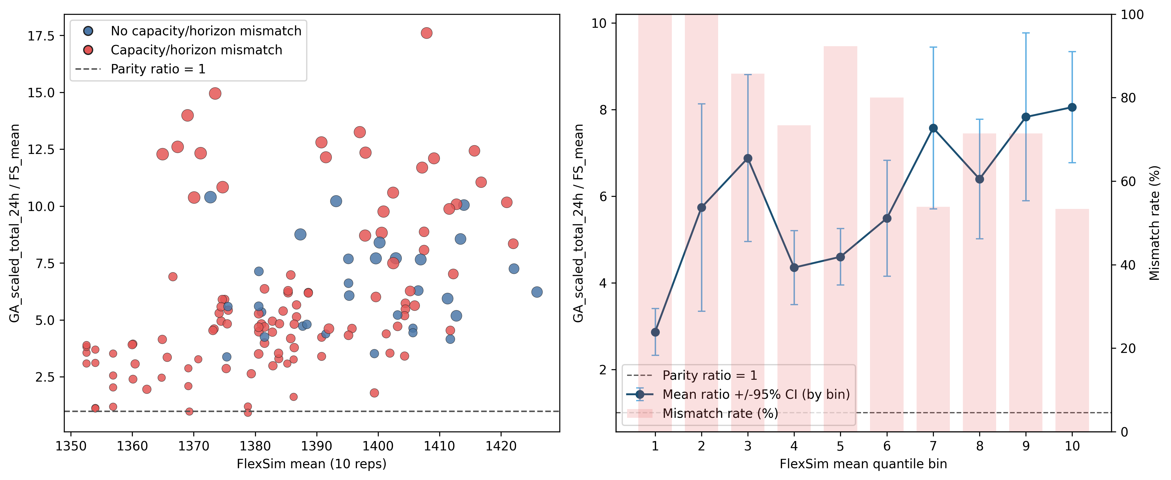
Figure 1. Aggregated ratio view of GA_scaled_total_24h versus FlexSim mean (10 replications).
Alt text: Left panel shows scenario-level ratio values with blue points for non-mismatch and red points for capacity-horizon mismatch; point size reflects FlexSim served patients. Right panel shows decile-averaged ratio with 95% confidence intervals and mismatch-rate bars.
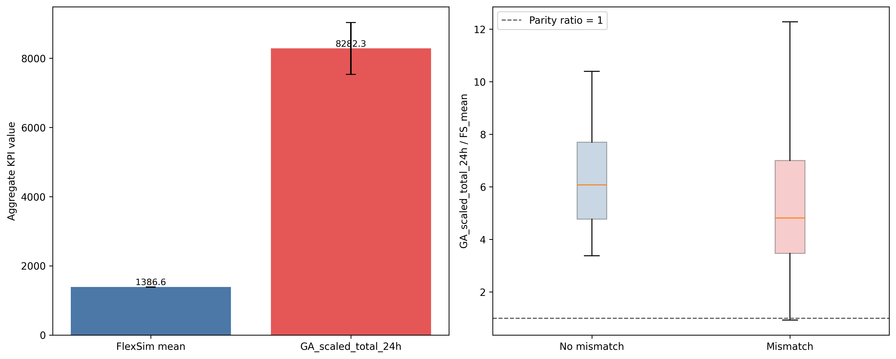
Figure 2. Aggregated KPI summary: overall levels and ratio distribution.
Alt text: Left panel compares overall mean aggregate KPI for FlexSim and GA scaled 24-hour values with confidence intervals. Right panel shows the distribution of ratio GA_scaled_total_24h divided by FlexSim mean for mismatch and non-mismatch groups, with parity at 1.
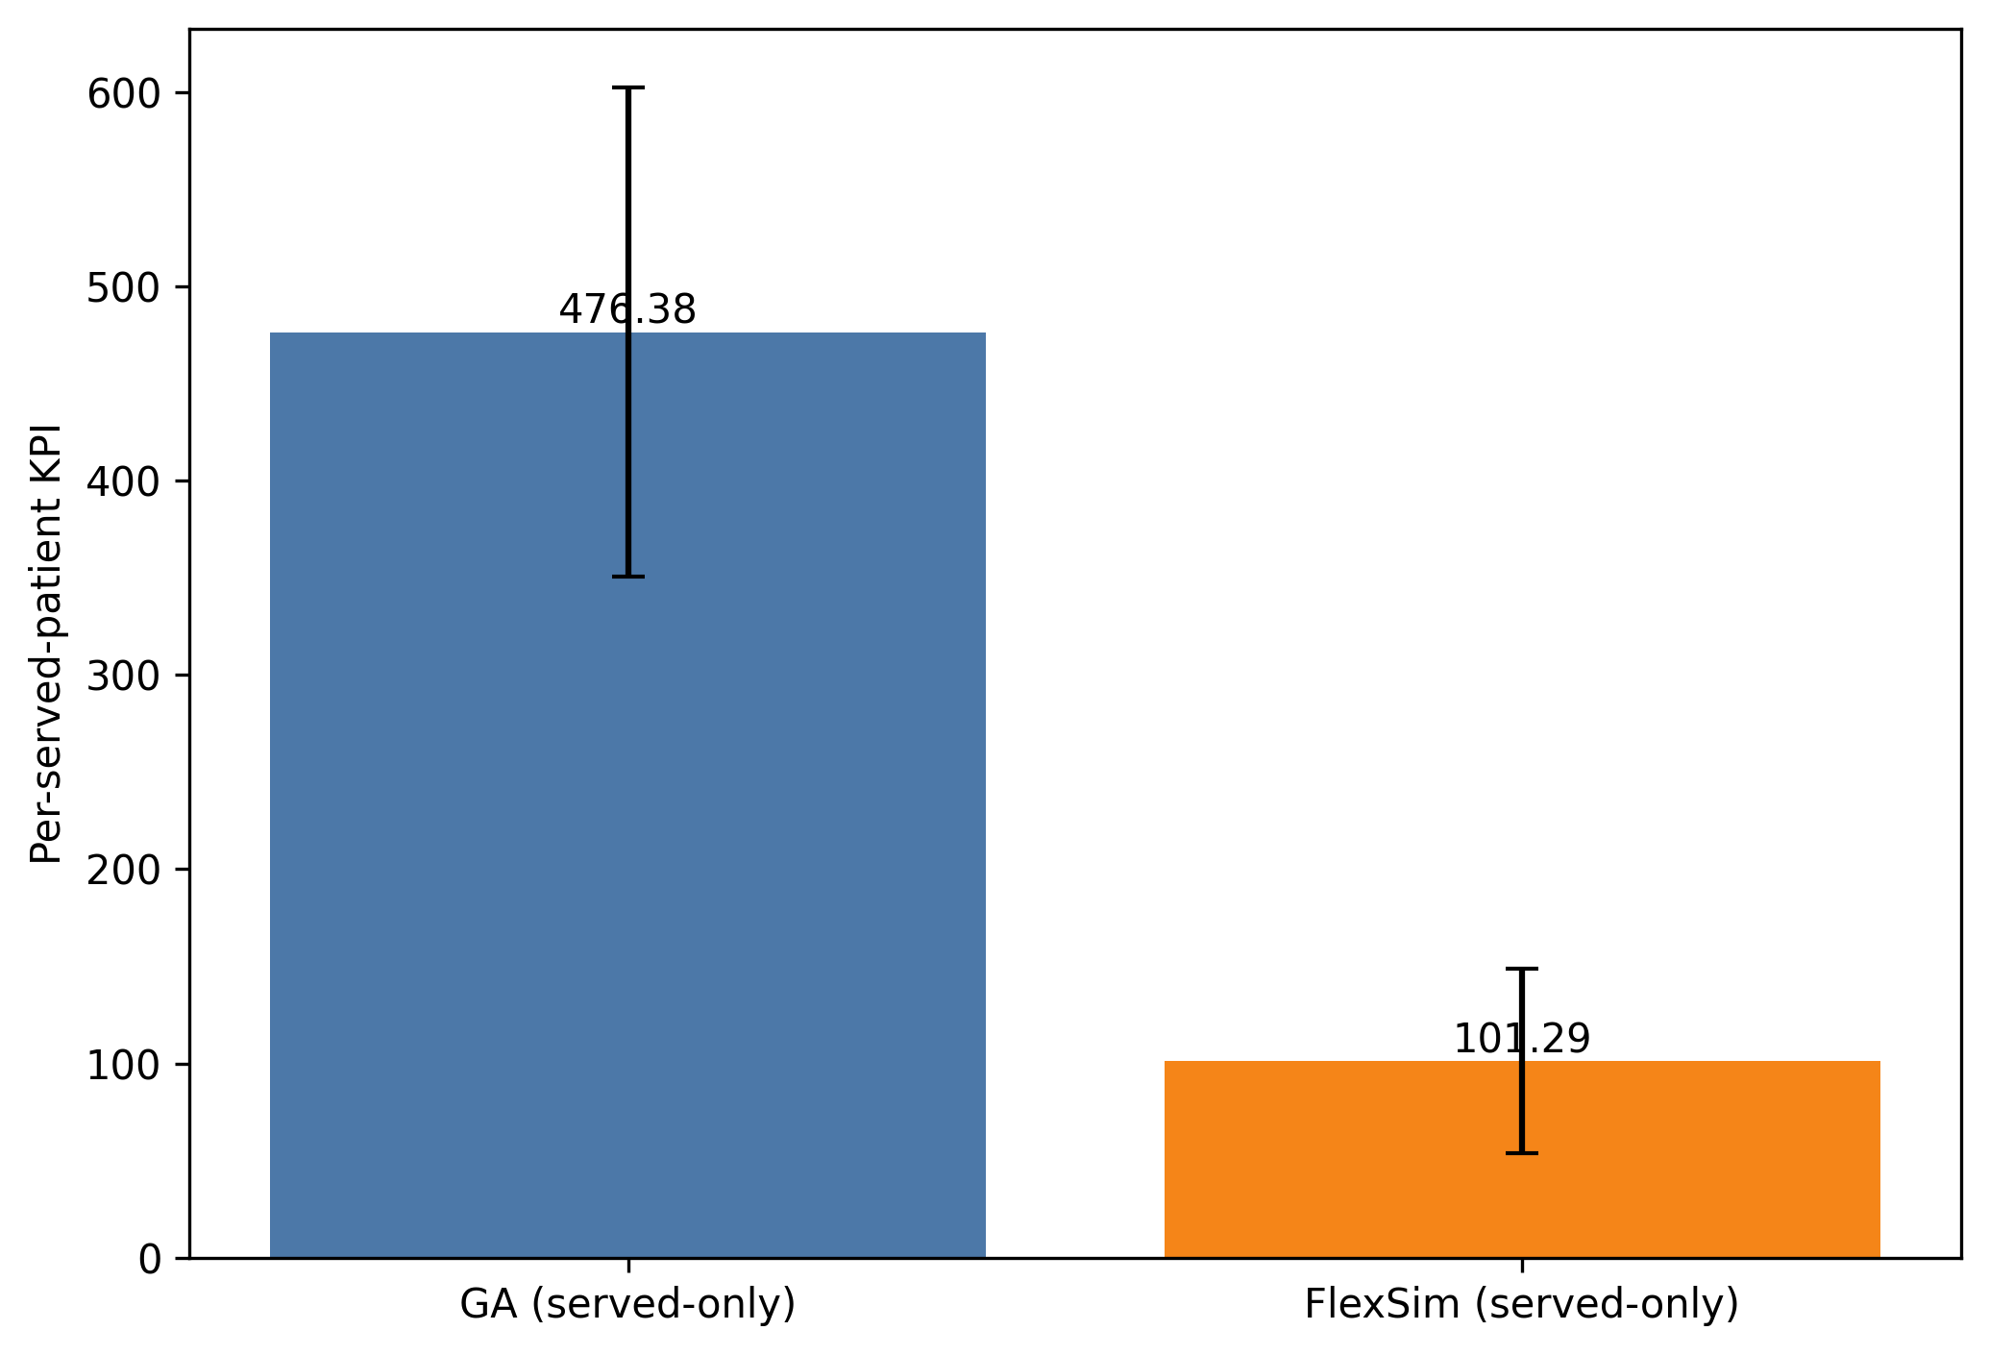
Figure 3. Mean per-served-patient KPI (GA vs FlexSim).
Alt text: Two-bar chart comparing mean served-only per-patient KPI for GA and FlexSim, with error bars showing scenario variability.
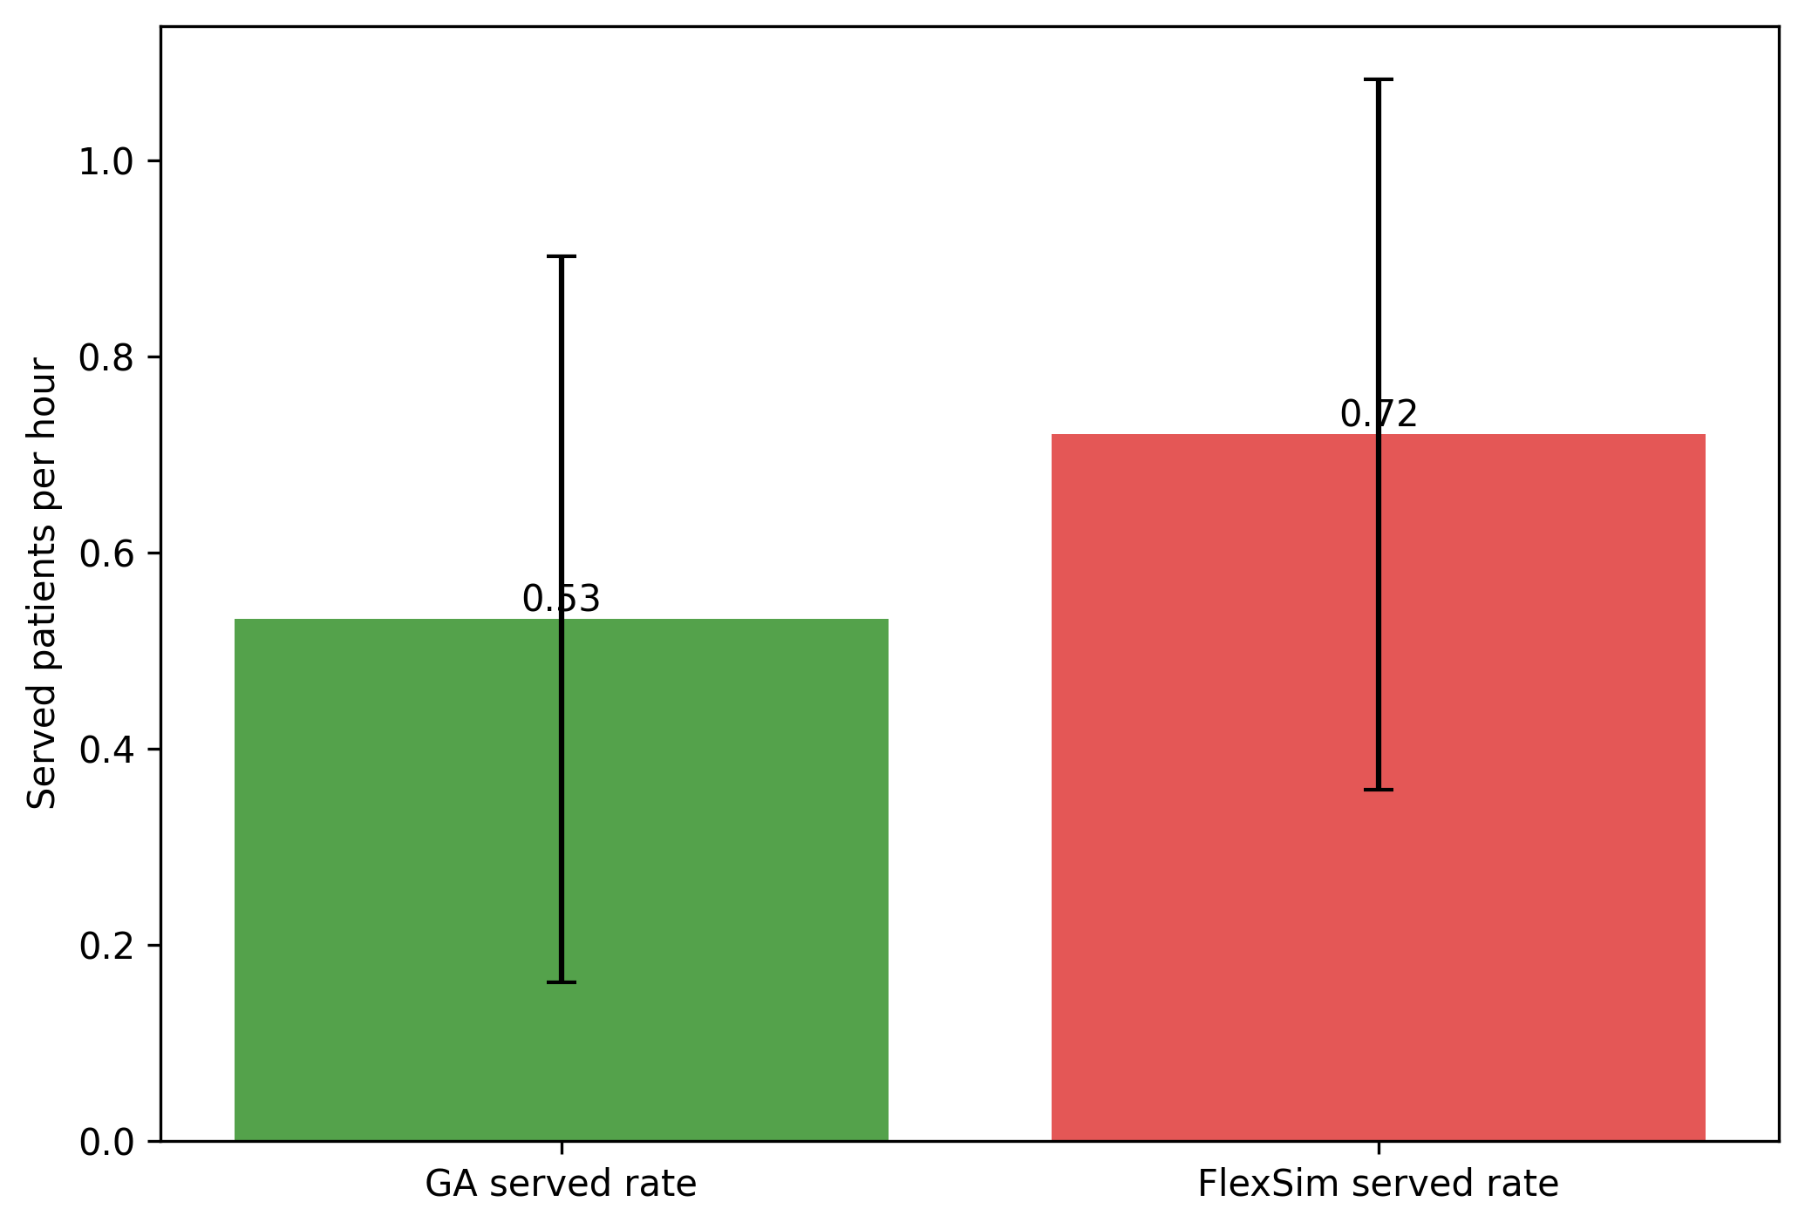
Figure 4. Mean served rate per hour (GA vs FlexSim).
Alt text: Two-bar chart comparing average served patients per hour in GA and FlexSim under the 24-hour served-only cohort definition.

Appendix A. Detailed Scenario-Level Validation
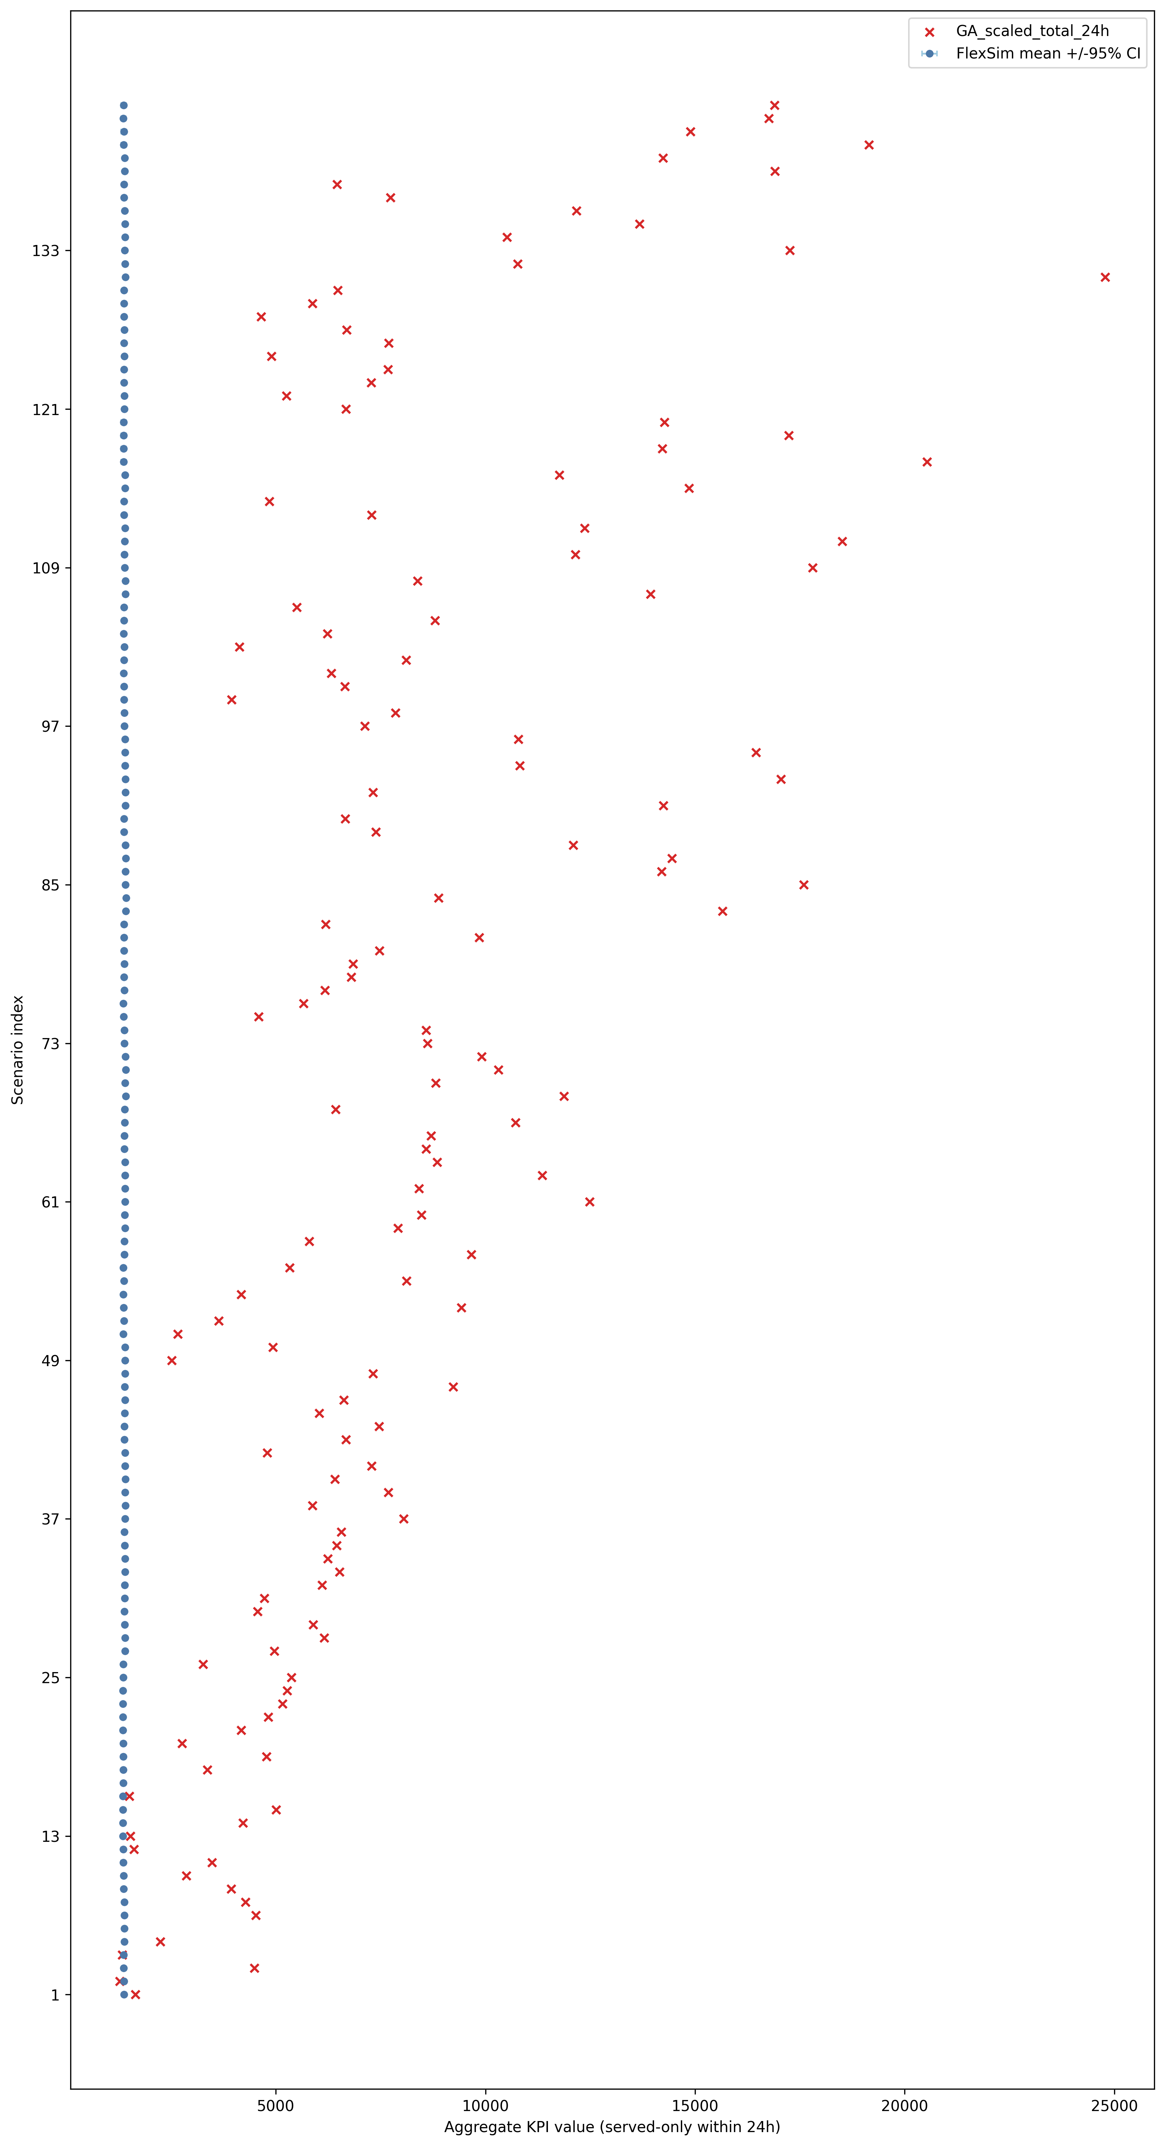
Appendix Figure A1. Scenario-level FlexSim mean +/-95% CI with GA scaled 24h points.
Alt text: Detailed scenario-by-scenario chart where each row shows FlexSim mean with confidence interval and a GA scaled 24-hour marker.

