Results - Baseline-Anchored Feasibility and Tradeoff Analysis (MOFGPM)
This Results section is structured to match the baseline-anchored decision gap described in the Introduction. We first report baseline performance, then diagnose feasibility boundaries under uncertainty, and finally map the cost-service tradeoff using MOFGPM outcomes (mu_Cost, mu_Wait, and lambda).

1. Inputs and Evaluation Definitions
Baseline staffing configuration (reference case):
Doctor=3, Nurse=3, Assistant=6, Specialist=1
MOFGPM goal and tolerance parameters:
G_cost=650.0, C_max=22750.0, G_wait=50.0, W_max=200000.0
Waiting metric used: Total accumulated waiting time across all patients and activities (minutes).
Feasibility rule: Feasible if triage early-care standards are satisfied and both memberships are positive (mu_Cost>0, mu_Wait>0).

2. Baseline Case Results
A unique baseline row could not be identified from the provided results table. If you want an explicit baseline subsection, store the baseline staffing vector in the results DataFrame.

3. Feasibility Under Uncertainty Scenarios
This section integrates merged outputs across 6 run batches and 1 operational scenario groups.
Table 1 summarizes feasibility rates and best-achieved balanced satisfaction by analysis group.
Operational scenario | Runs | Feasible (%) | Min feasible W_max | Best lambda | Best Cost | Best Wait | Binding
FZ=expected|P=36|T=1440.0|NS=25|GW=50.0|MW=200000.0 | 25 | 48.0 | 200000.00 | 0.894 | 2750.00 | 21226.84 | Wait
Table 1. Scenario-level feasibility and best MOFGPM outcomes.

4. Cross-Scenario Integrated Diagnostics
Operational scenario | Samples | Feasible (%) | Median lambda (feasible) | P90 lambda (feasible) | Mean cost | Mean wait
FZ=expected|P=36|T=1440.0|NS=25|GW=50.0|MW=200000.0 | 25 | 48.0 | 0.877 | 0.893 | 1488.00 | inf
Table 2. Integrated performance diagnostics across scenario groups.

5. Cost-Service Tradeoff Map (MOFGPM Interpretation)
scenario_key | wmax | Doctor | Nurse | Assistant | Specialist | cost | wait | mu_cost | mu_wait | lambda
FZ=expected|P=36|T=1440.0|NS=25|GW=50.0|MW=200000.0 | 200000.00 | 6 | 8 | 9 | 1 | 2750.00 | 21226.84 | 0.905 | 0.894 | 0.894
FZ=expected|P=36|T=1440.0|NS=25|GW=50.0|MW=200000.0 | 200000.00 | 6 | 8 | 9 | 1 | 2750.00 | 21226.84 | 0.905 | 0.894 | 0.894
FZ=expected|P=36|T=1440.0|NS=25|GW=50.0|MW=200000.0 | 200000.00 | 3 | 1 | 1 | 2 | 1350.00 | 22841.19 | 0.968 | 0.886 | 0.886
FZ=expected|P=36|T=1440.0|NS=25|GW=50.0|MW=200000.0 | 200000.00 | 3 | 1 | 1 | 2 | 1350.00 | 22841.19 | 0.968 | 0.886 | 0.886
FZ=expected|P=36|T=1440.0|NS=25|GW=50.0|MW=200000.0 | 200000.00 | 2 | 3 | 8 | 2 | 1700.00 | 23949.51 | 0.952 | 0.880 | 0.880
FZ=expected|P=36|T=1440.0|NS=25|GW=50.0|MW=200000.0 | 200000.00 | 3 | 1 | 9 | 1 | 1450.00 | 24644.15 | 0.964 | 0.877 | 0.877
FZ=expected|P=36|T=1440.0|NS=25|GW=50.0|MW=200000.0 | 200000.00 | 3 | 1 | 9 | 1 | 1450.00 | 24644.15 | 0.964 | 0.877 | 0.877
FZ=expected|P=36|T=1440.0|NS=25|GW=50.0|MW=200000.0 | 200000.00 | 1 | 1 | 2 | 1 | 700.00 | 40914.44 | 0.998 | 0.796 | 0.796
FZ=expected|P=36|T=1440.0|NS=25|GW=50.0|MW=200000.0 | 200000.00 | 1 | 1 | 2 | 1 | 700.00 | 40914.44 | 0.998 | 0.796 | 0.796
FZ=expected|P=36|T=1440.0|NS=25|GW=50.0|MW=200000.0 | 200000.00 | 1 | 5 | 2 | 1 | 1100.00 | 42728.68 | 0.980 | 0.787 | 0.787
Table 3. Top feasible solutions (ranked by lambda, then cost and wait).

6. Feasibility Boundary Diagnostics
Operational scenario | Min feasible W_max
FZ=expected|P=36|T=1440.0|NS=25|GW=50.0|MW=200000.0 | 200000.00
Table 4. Minimum feasible W_max by scenario group.

7. Figures
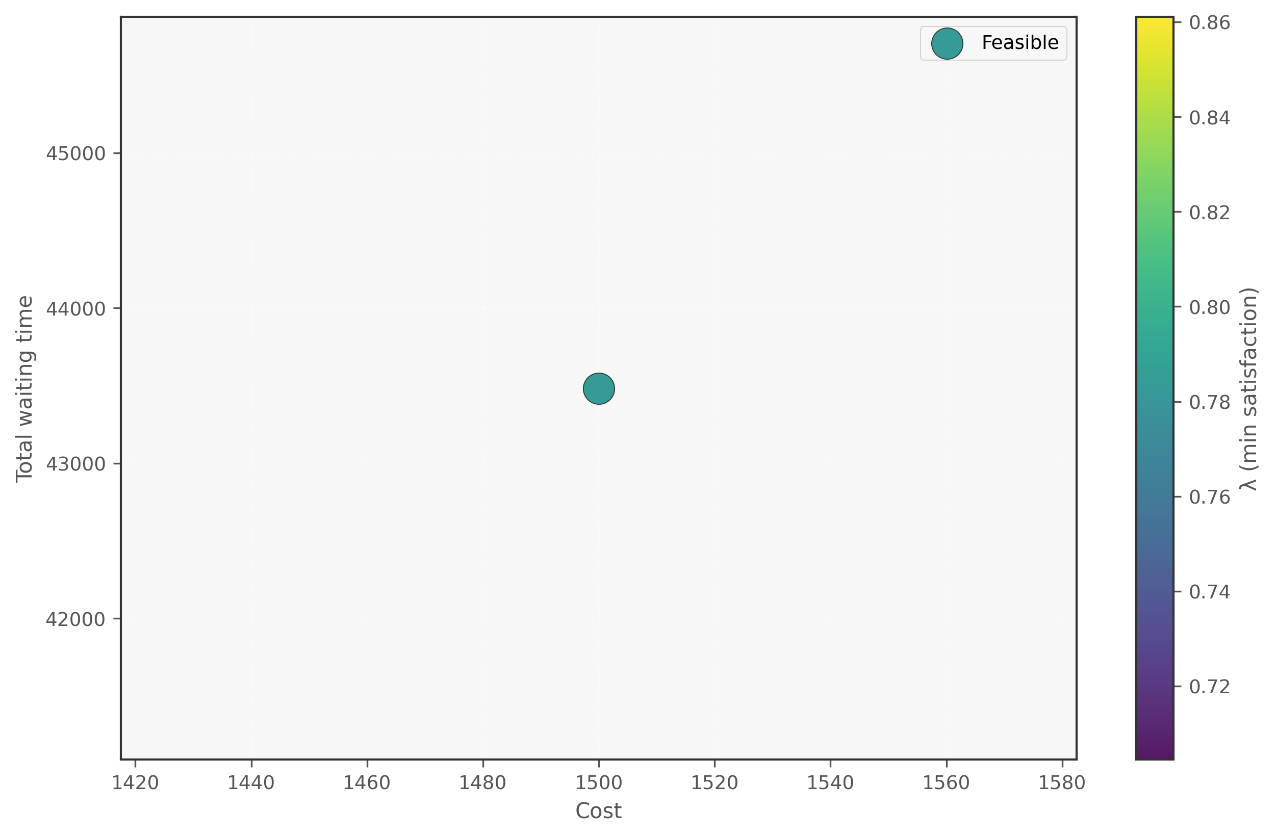
Figure 1. Cost-Wait scatter (lambda encoding) - Fixed
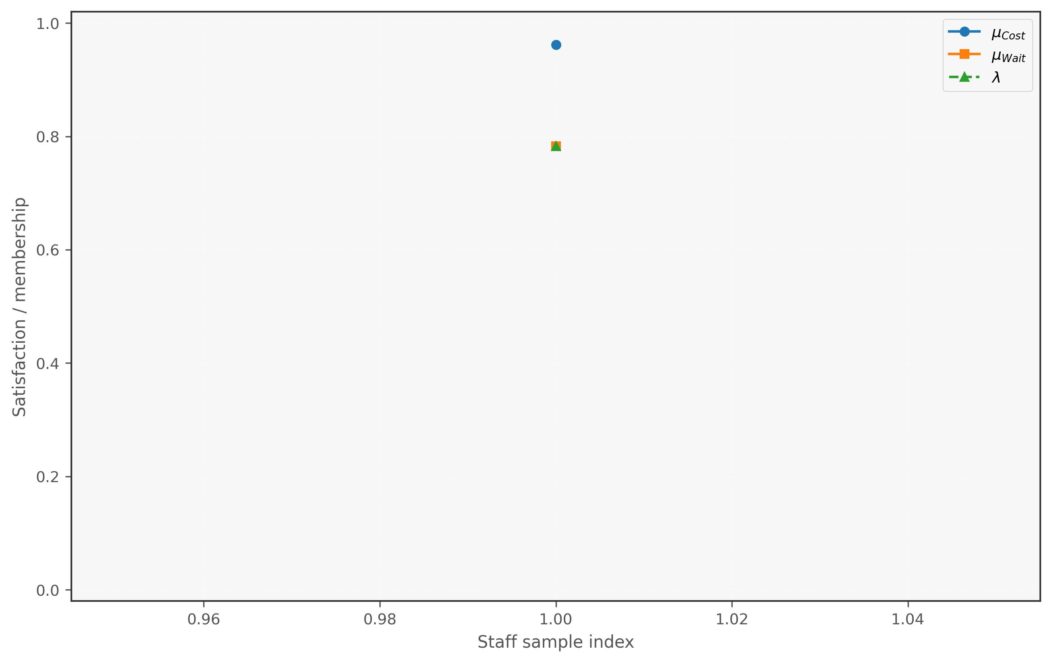
Figure 2. Membership decomposition - Fixed
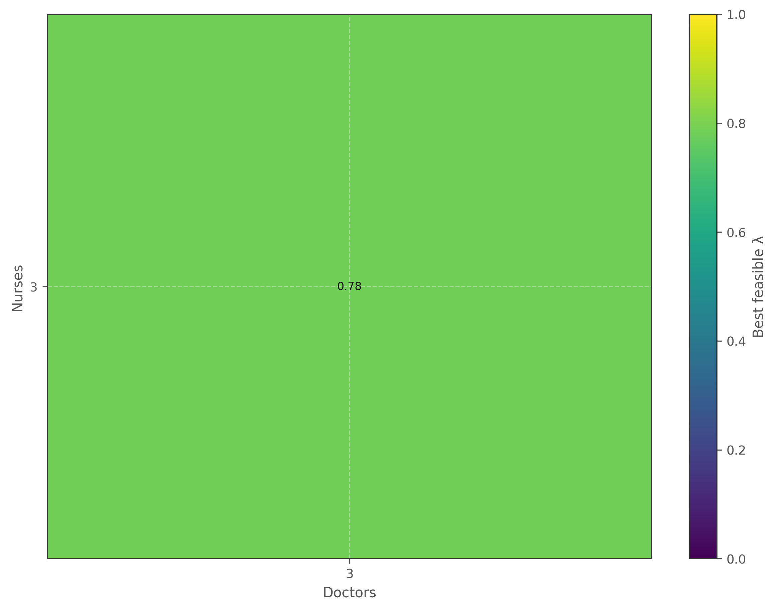
Figure 3. Feasibility heatmap (Doctor x Nurse) - Fixed
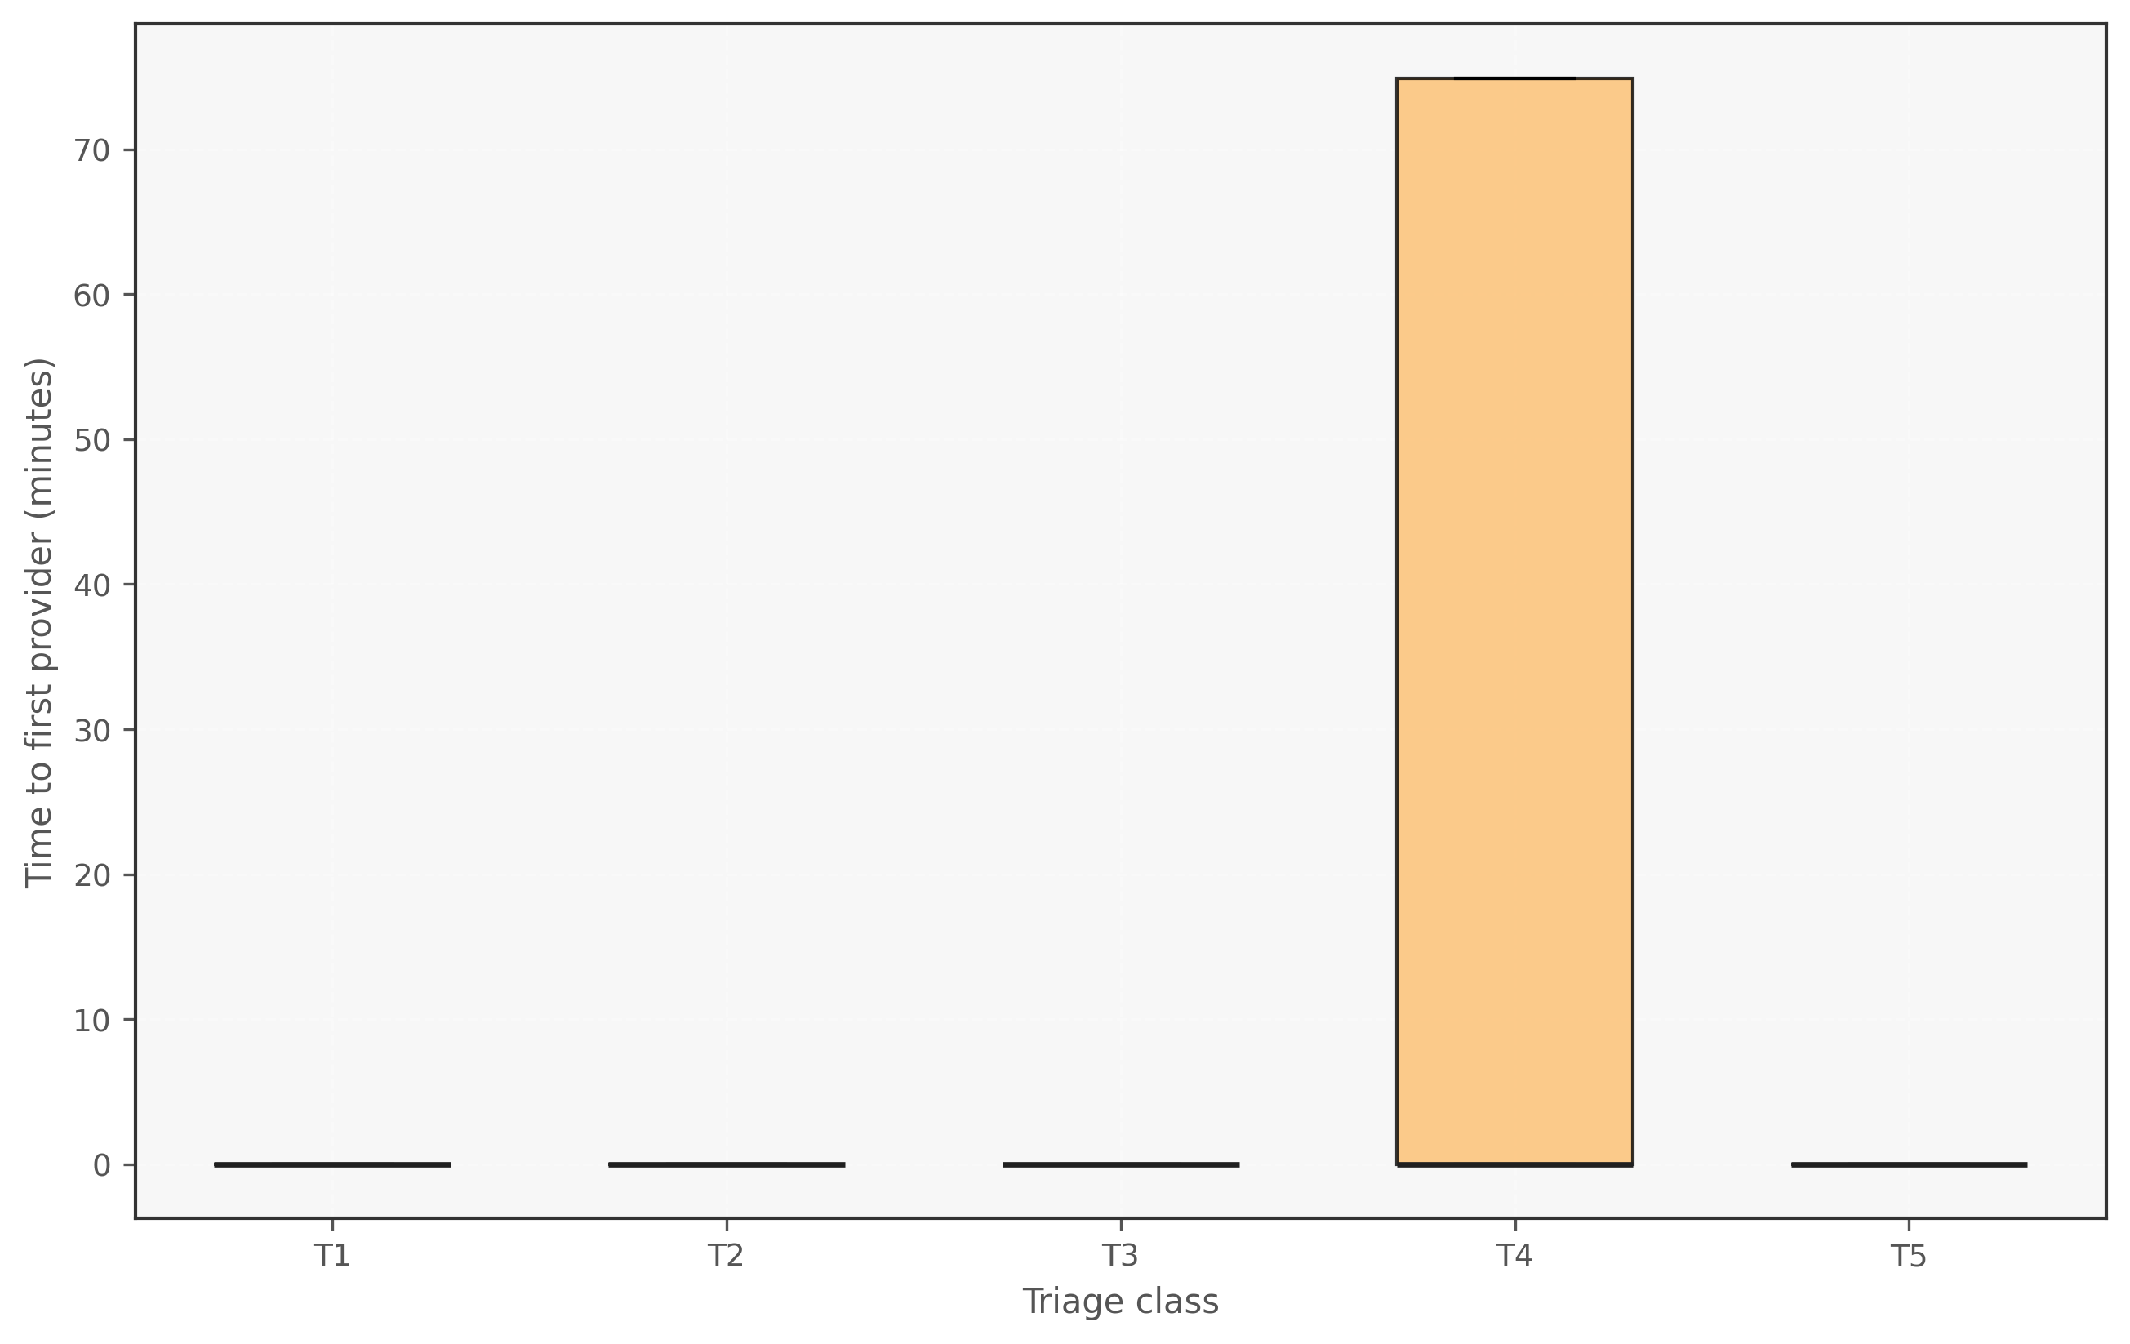
Figure 4. Triage first-wait boxplot - Fixed
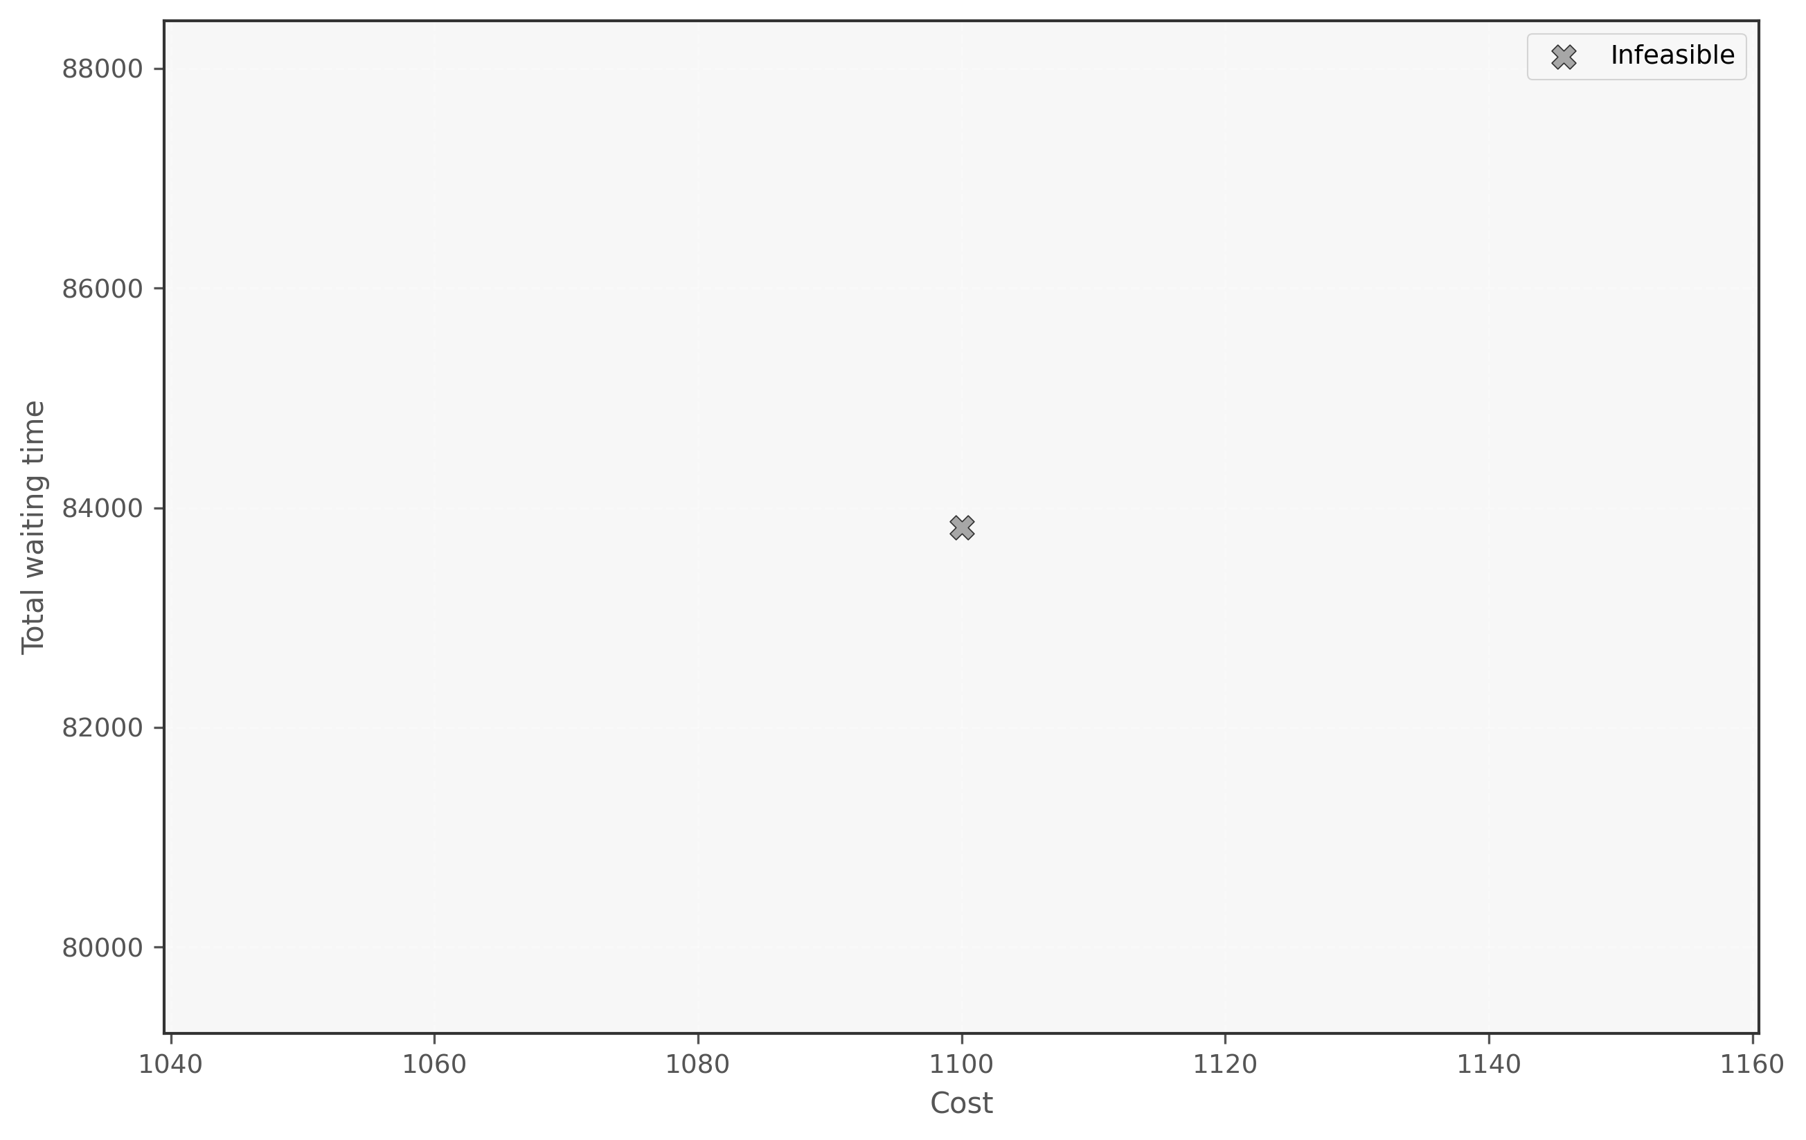
Figure 5. Cost-Wait scatter (lambda encoding) - Sensitivity
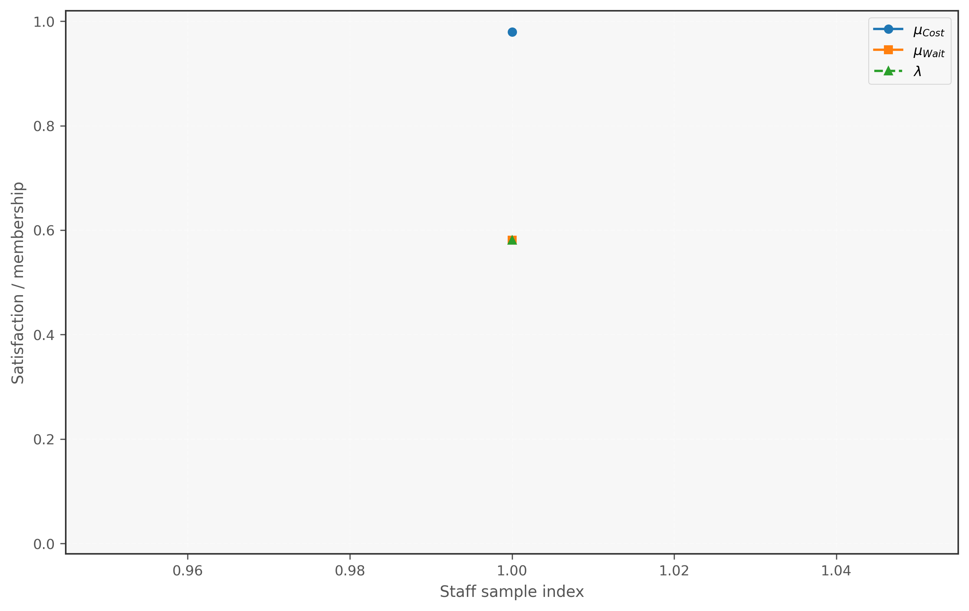
Figure 6. Membership decomposition - Sensitivity
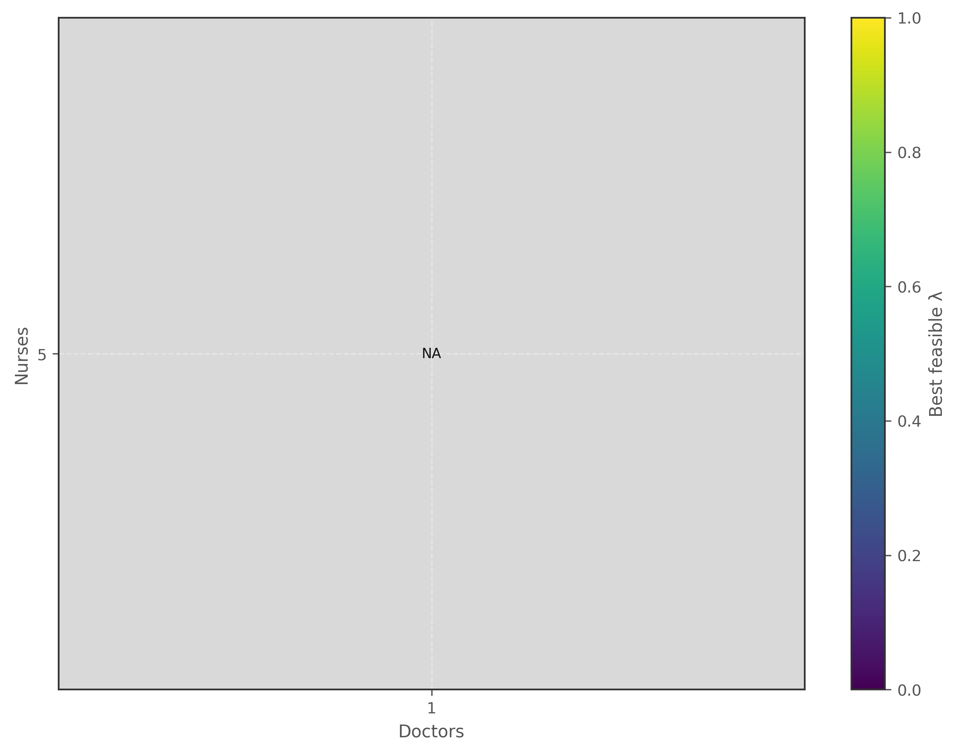
Figure 7. Feasibility heatmap (Doctor x Nurse) - Sensitivity
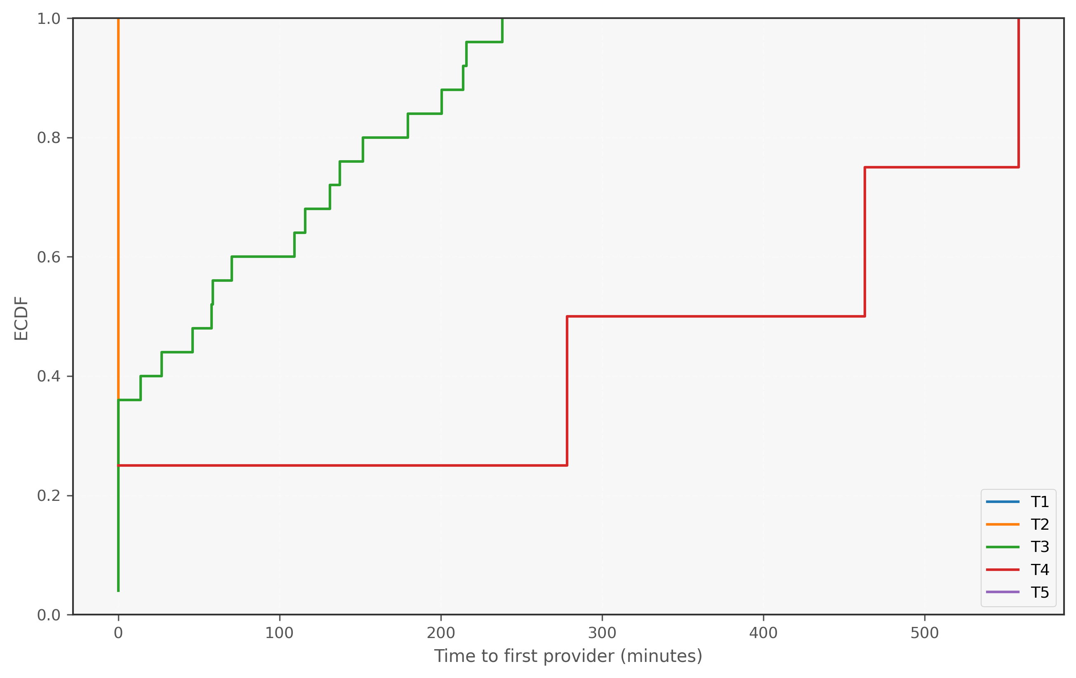
Figure 8. Triage first-wait ECDF - Sensitivity
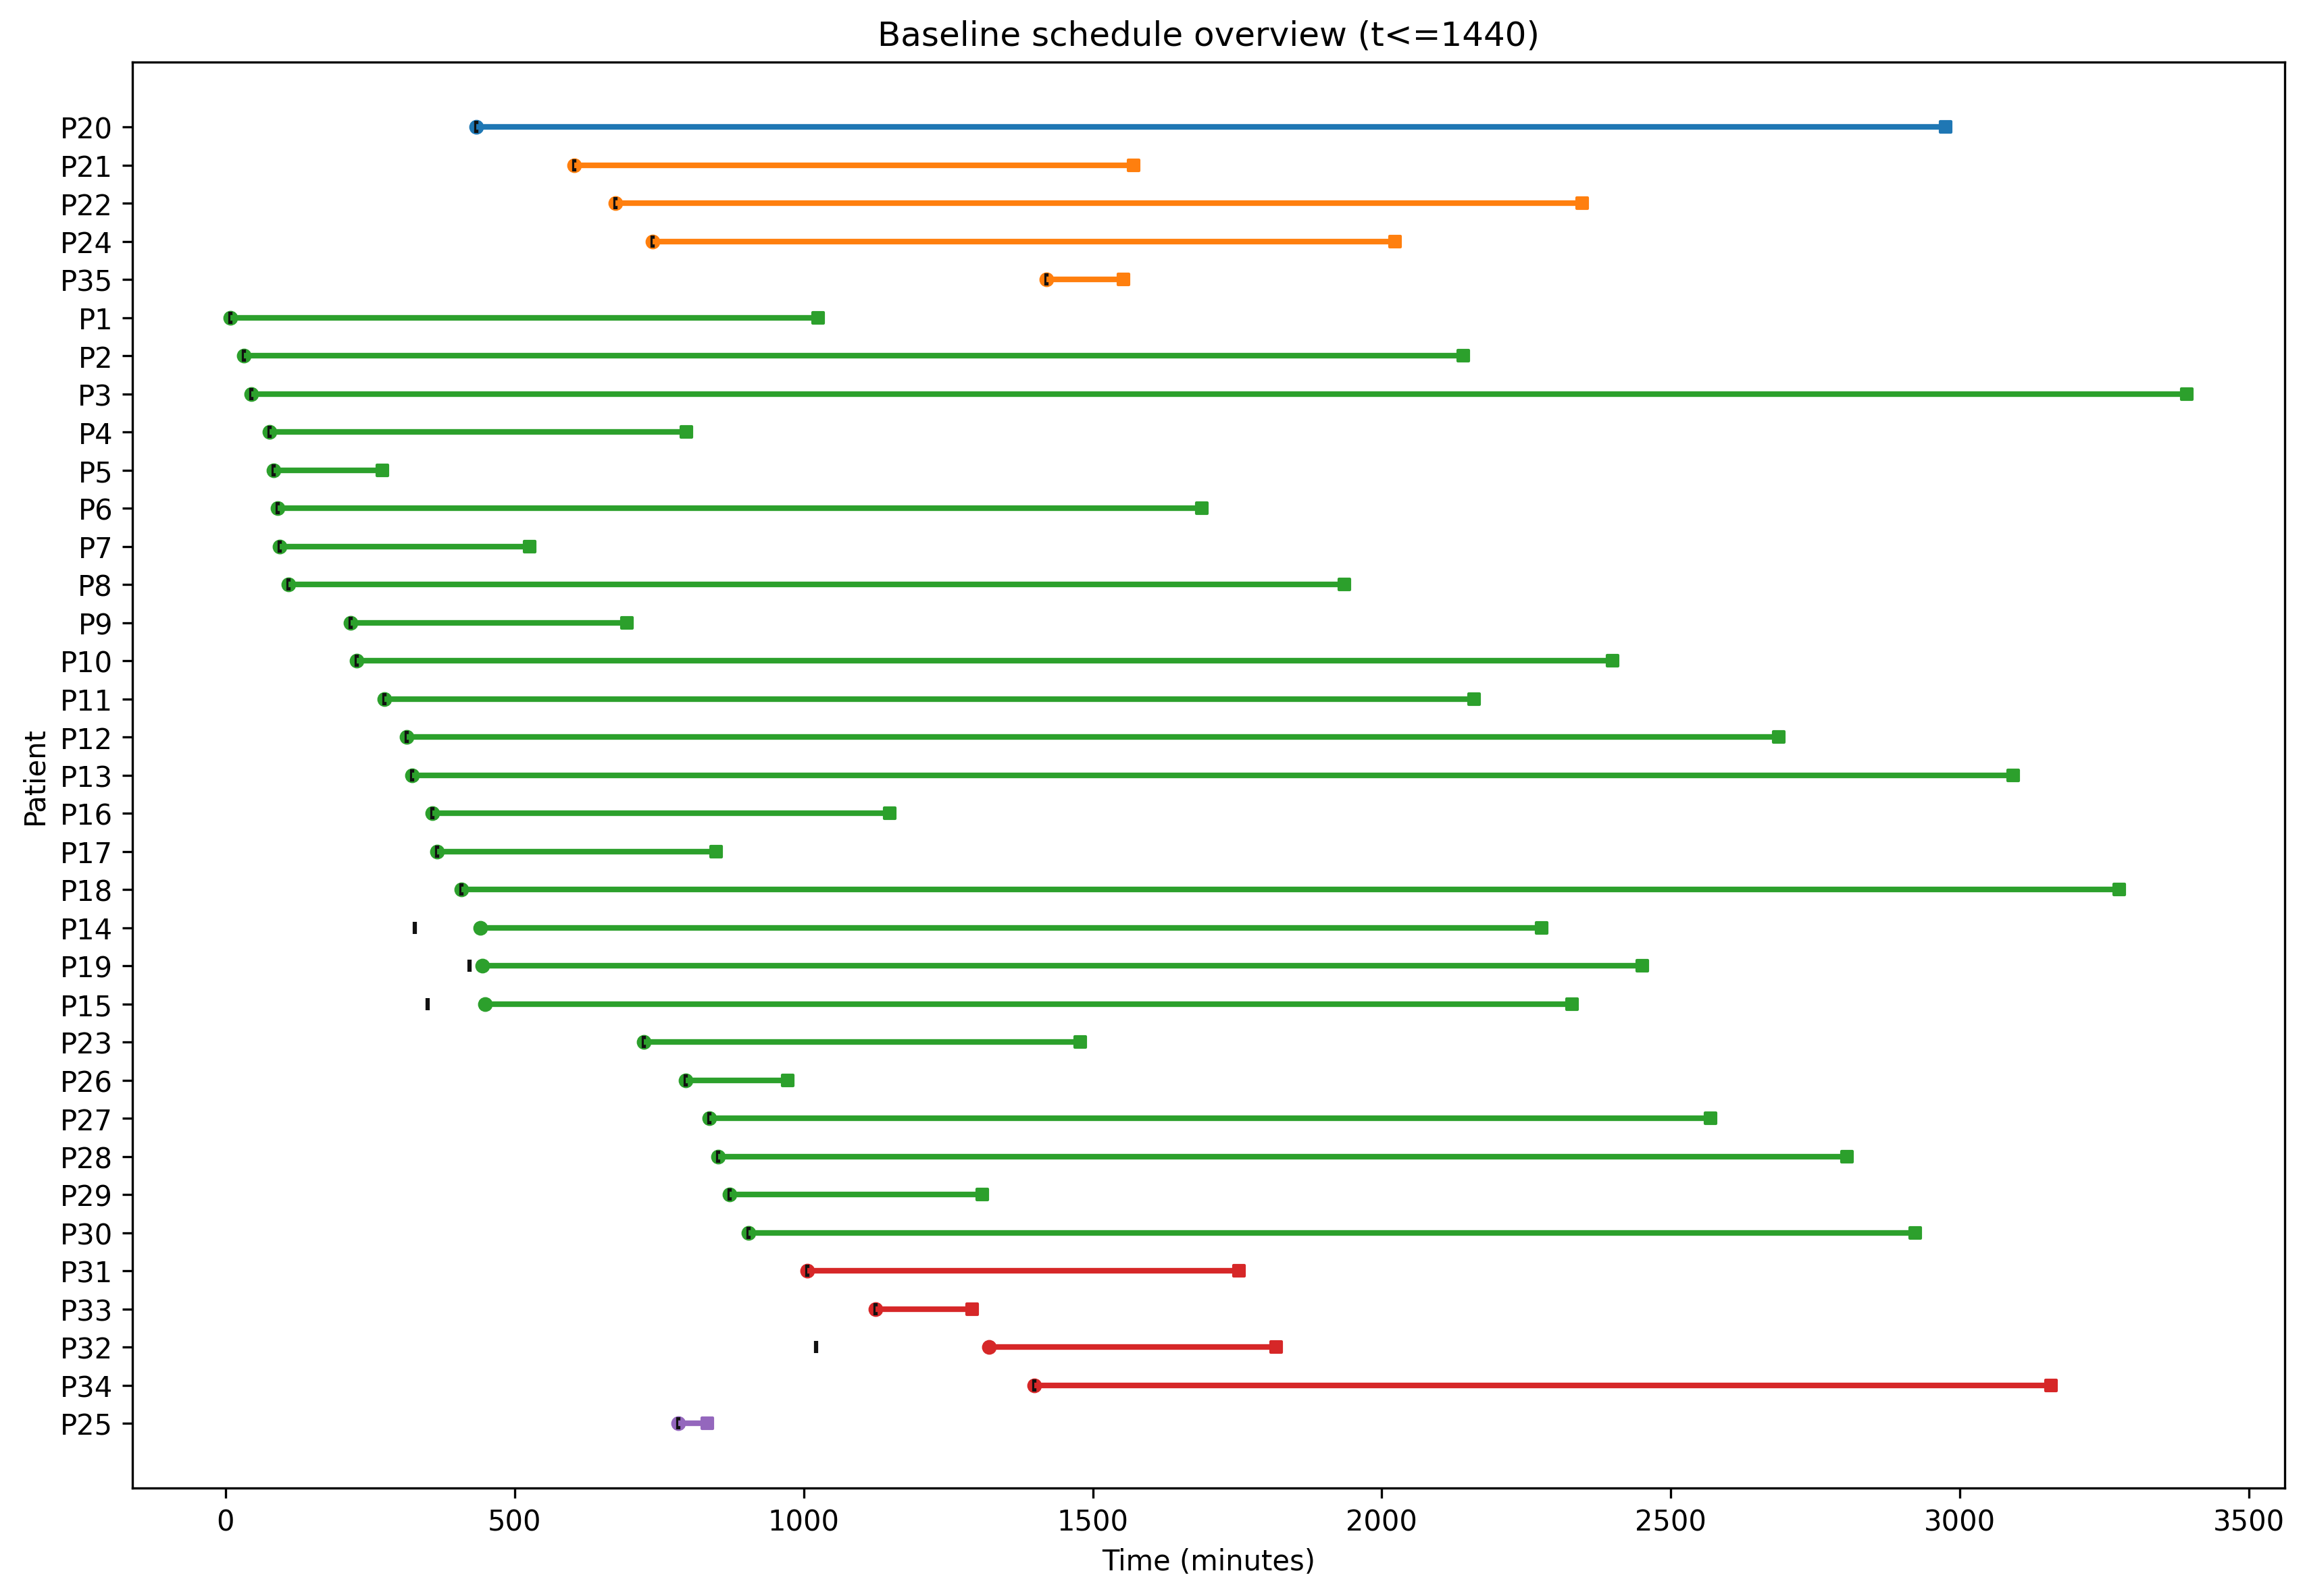
Figure 9. Baseline schedule overview (t<=1440)
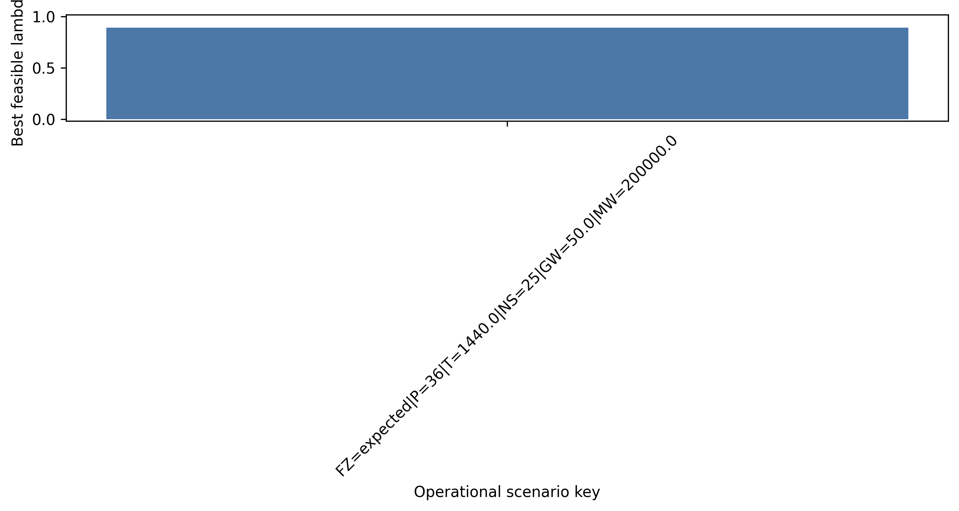
Figure 10. Best lambda by operational scenario key
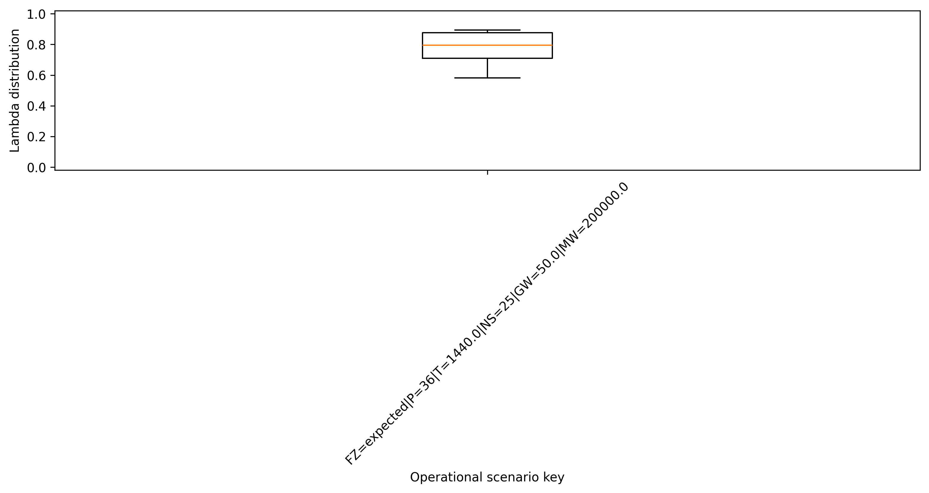
Figure 11. Lambda distribution by operational scenario key
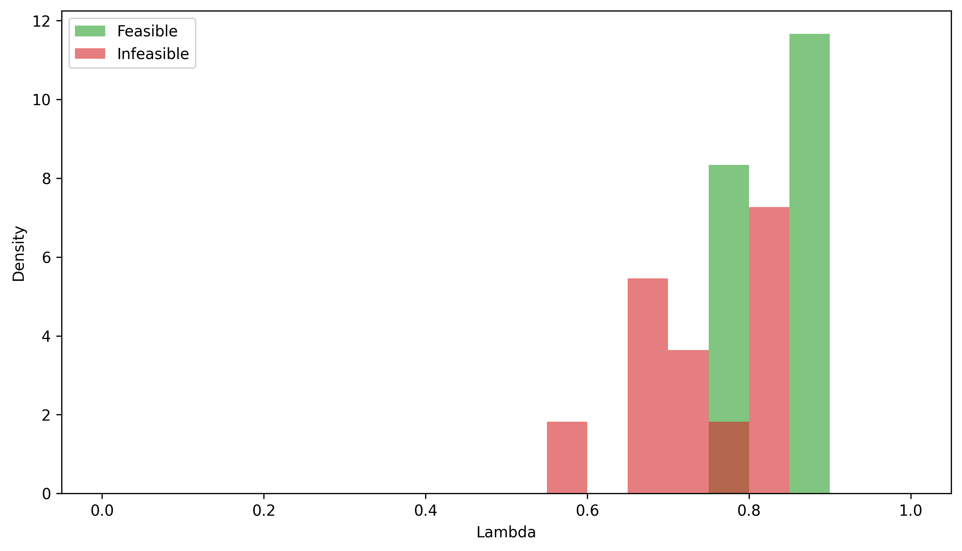
Figure 12. Lambda density (feasible vs infeasible)
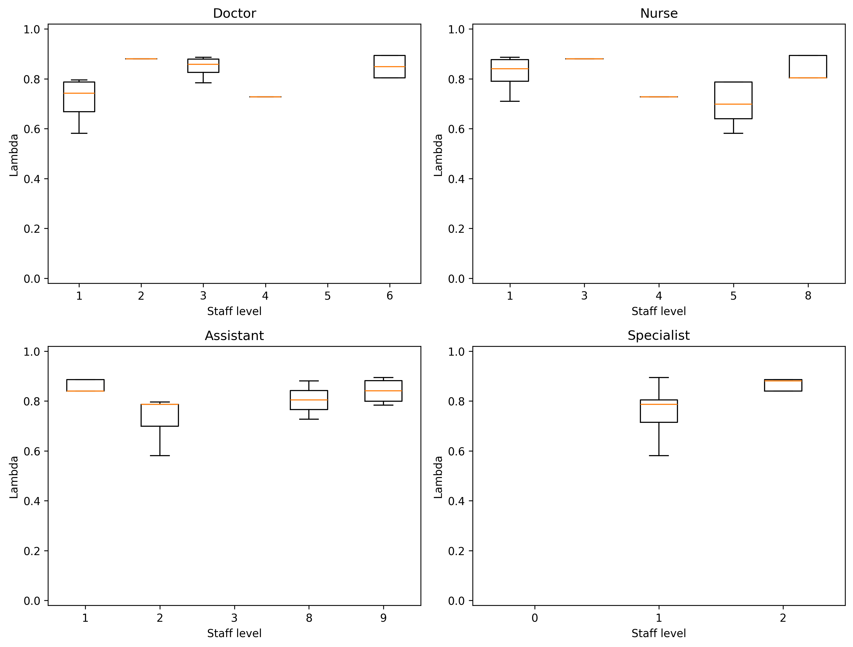
Figure 13. Lambda vs resource levels
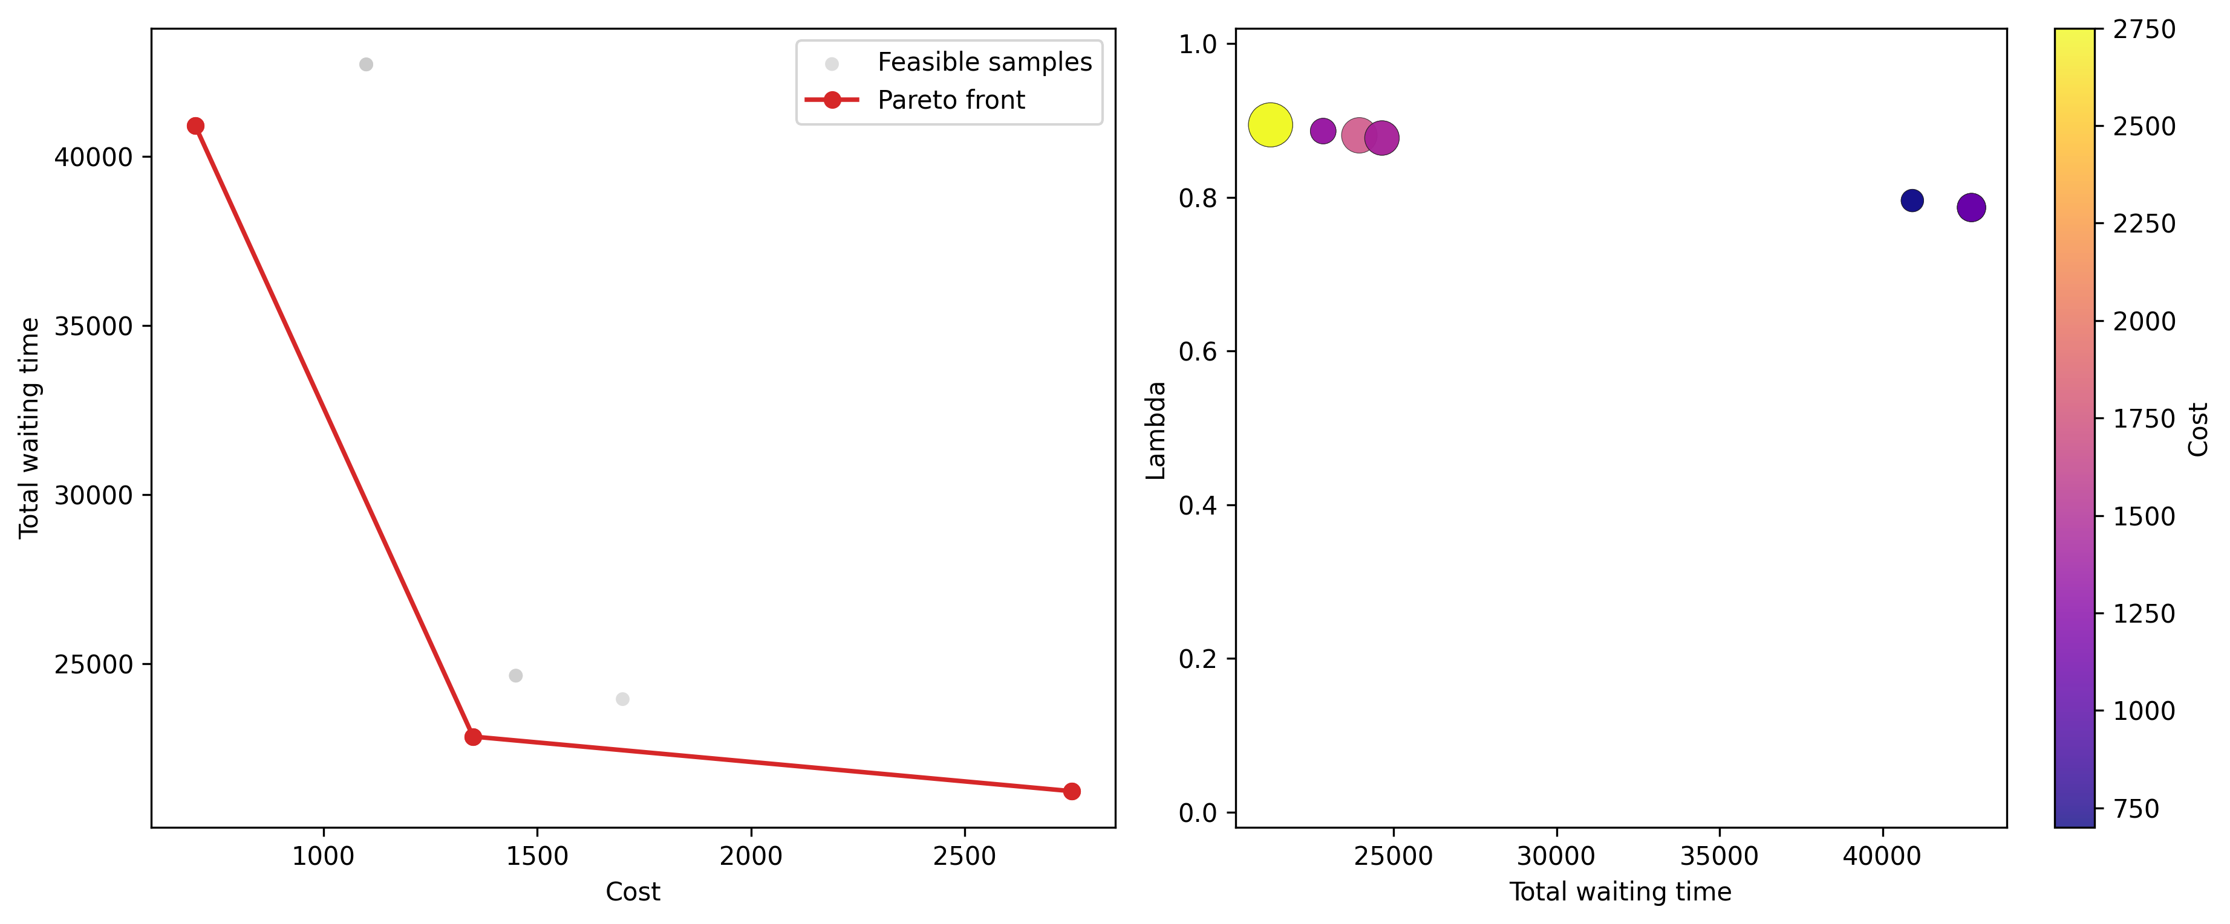
Figure 14. Operational Pareto overview
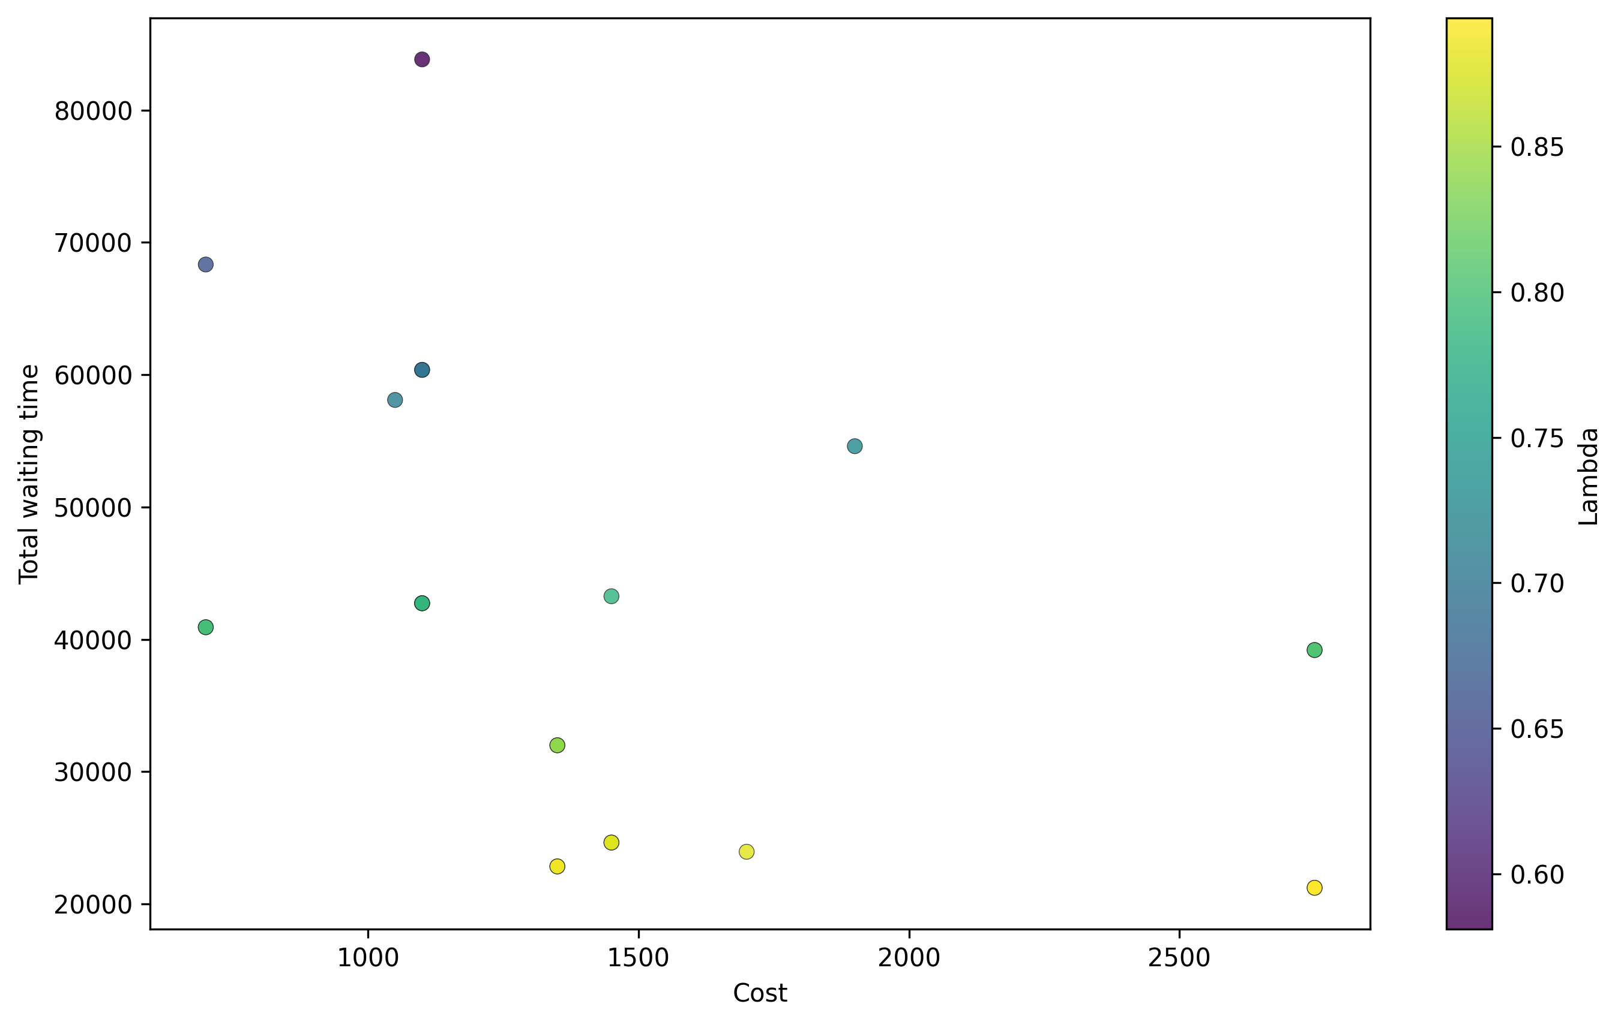
Figure 15. Cost-Wait scatter (all merged runs)
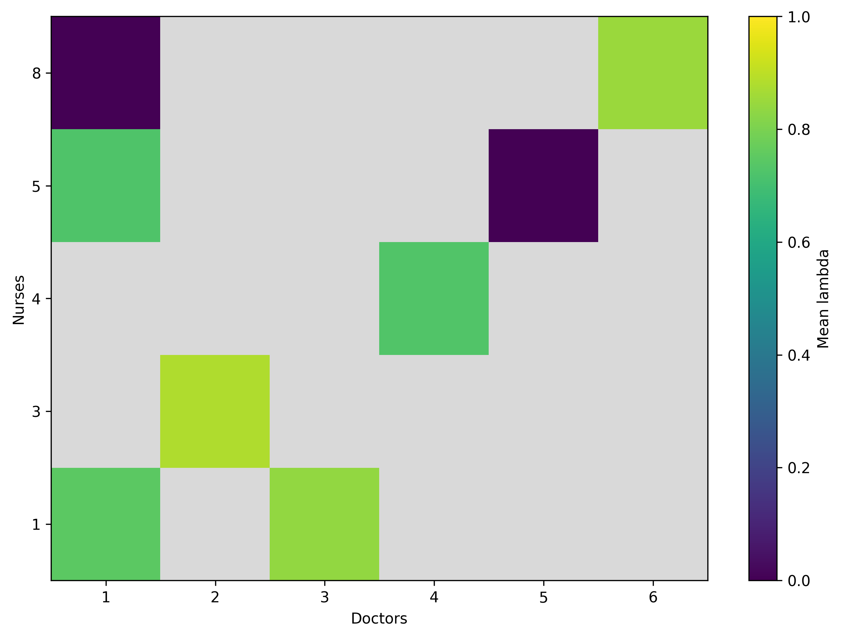
Figure 16. Mean lambda heatmap (Doctor x Nurse)
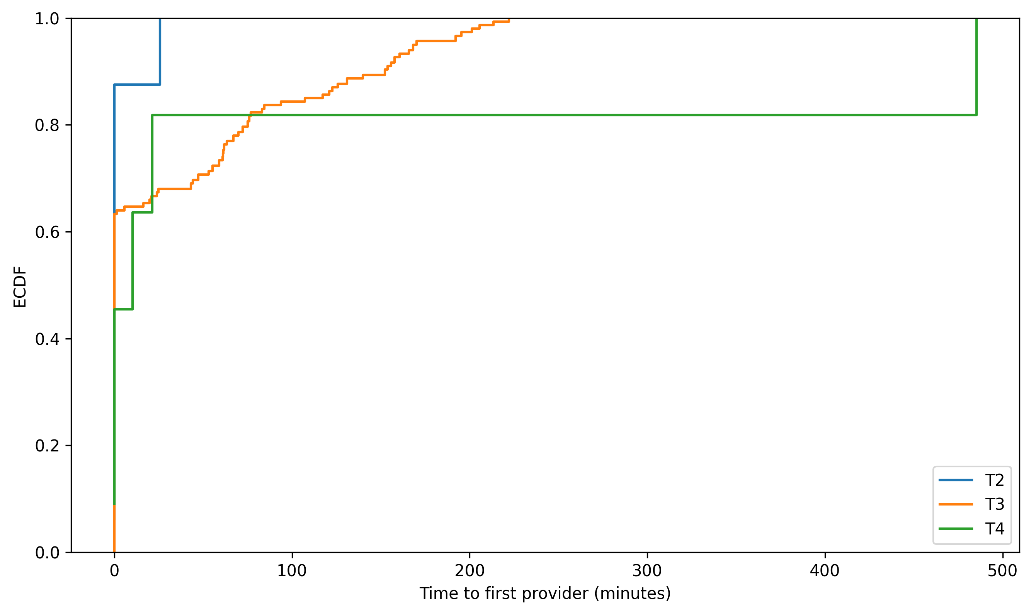
Figure 17. Triage first-wait ECDF (merged)

8. Summary
Results are presented as baseline performance plus integrated feasibility and tradeoff diagnostics. Merged sensitivity outputs identify robust feasible regions, likely binding objectives, and the cost associated with service improvements.

