Results - Baseline-Anchored Feasibility and Tradeoff Analysis (MOFGPM)
This Results section is structured to match the baseline-anchored decision gap described in the Introduction. We first report baseline performance, then diagnose feasibility boundaries under uncertainty, and finally map the cost-service tradeoff using MOFGPM outcomes (mu_Cost, mu_Wait, and lambda).

1. Inputs and Evaluation Definitions
Baseline staffing configuration (reference case):
Doctor=3, Nurse=3, Assistant=6, Specialist=1
MOFGPM goal and tolerance parameters:
G_cost=650.0, C_max=22750.0, G_wait=50.0, W_max=200000.0
Waiting metric used: Total accumulated waiting time across all patients and activities (minutes).
Feasibility rule: Feasible if triage early-care standards are satisfied and both memberships are positive (mu_Cost>0, mu_Wait>0).

2. Baseline Case Results
Under baseline staffing, the system is Infeasible. Cost=1500.00, Wait=47628.87, mu_Cost=0.962, mu_Wait=0.762, lambda=0.762.
The binding objective at baseline is Wait.

3. Feasibility Under Uncertainty Scenarios
Table 1 summarizes feasibility rates and best-achieved balanced satisfaction by uncertainty scenario.
Scenario | Runs | Feasible (%) | Min feasible W_max | Best lambda | Best Cost | Best Wait | Binding
expected | 4 | 0.0 | - | - | - | - | -
Table 1. Scenario-level feasibility and best MOFGPM outcomes.

4. Cost-Service Tradeoff Map (MOFGPM Interpretation)
No feasible solutions were found in the provided results.

5. Feasibility Boundary Diagnostics
Scenario | Min feasible W_max
expected | -
Table 3. Minimum feasible W_max by scenario.

6. Figures
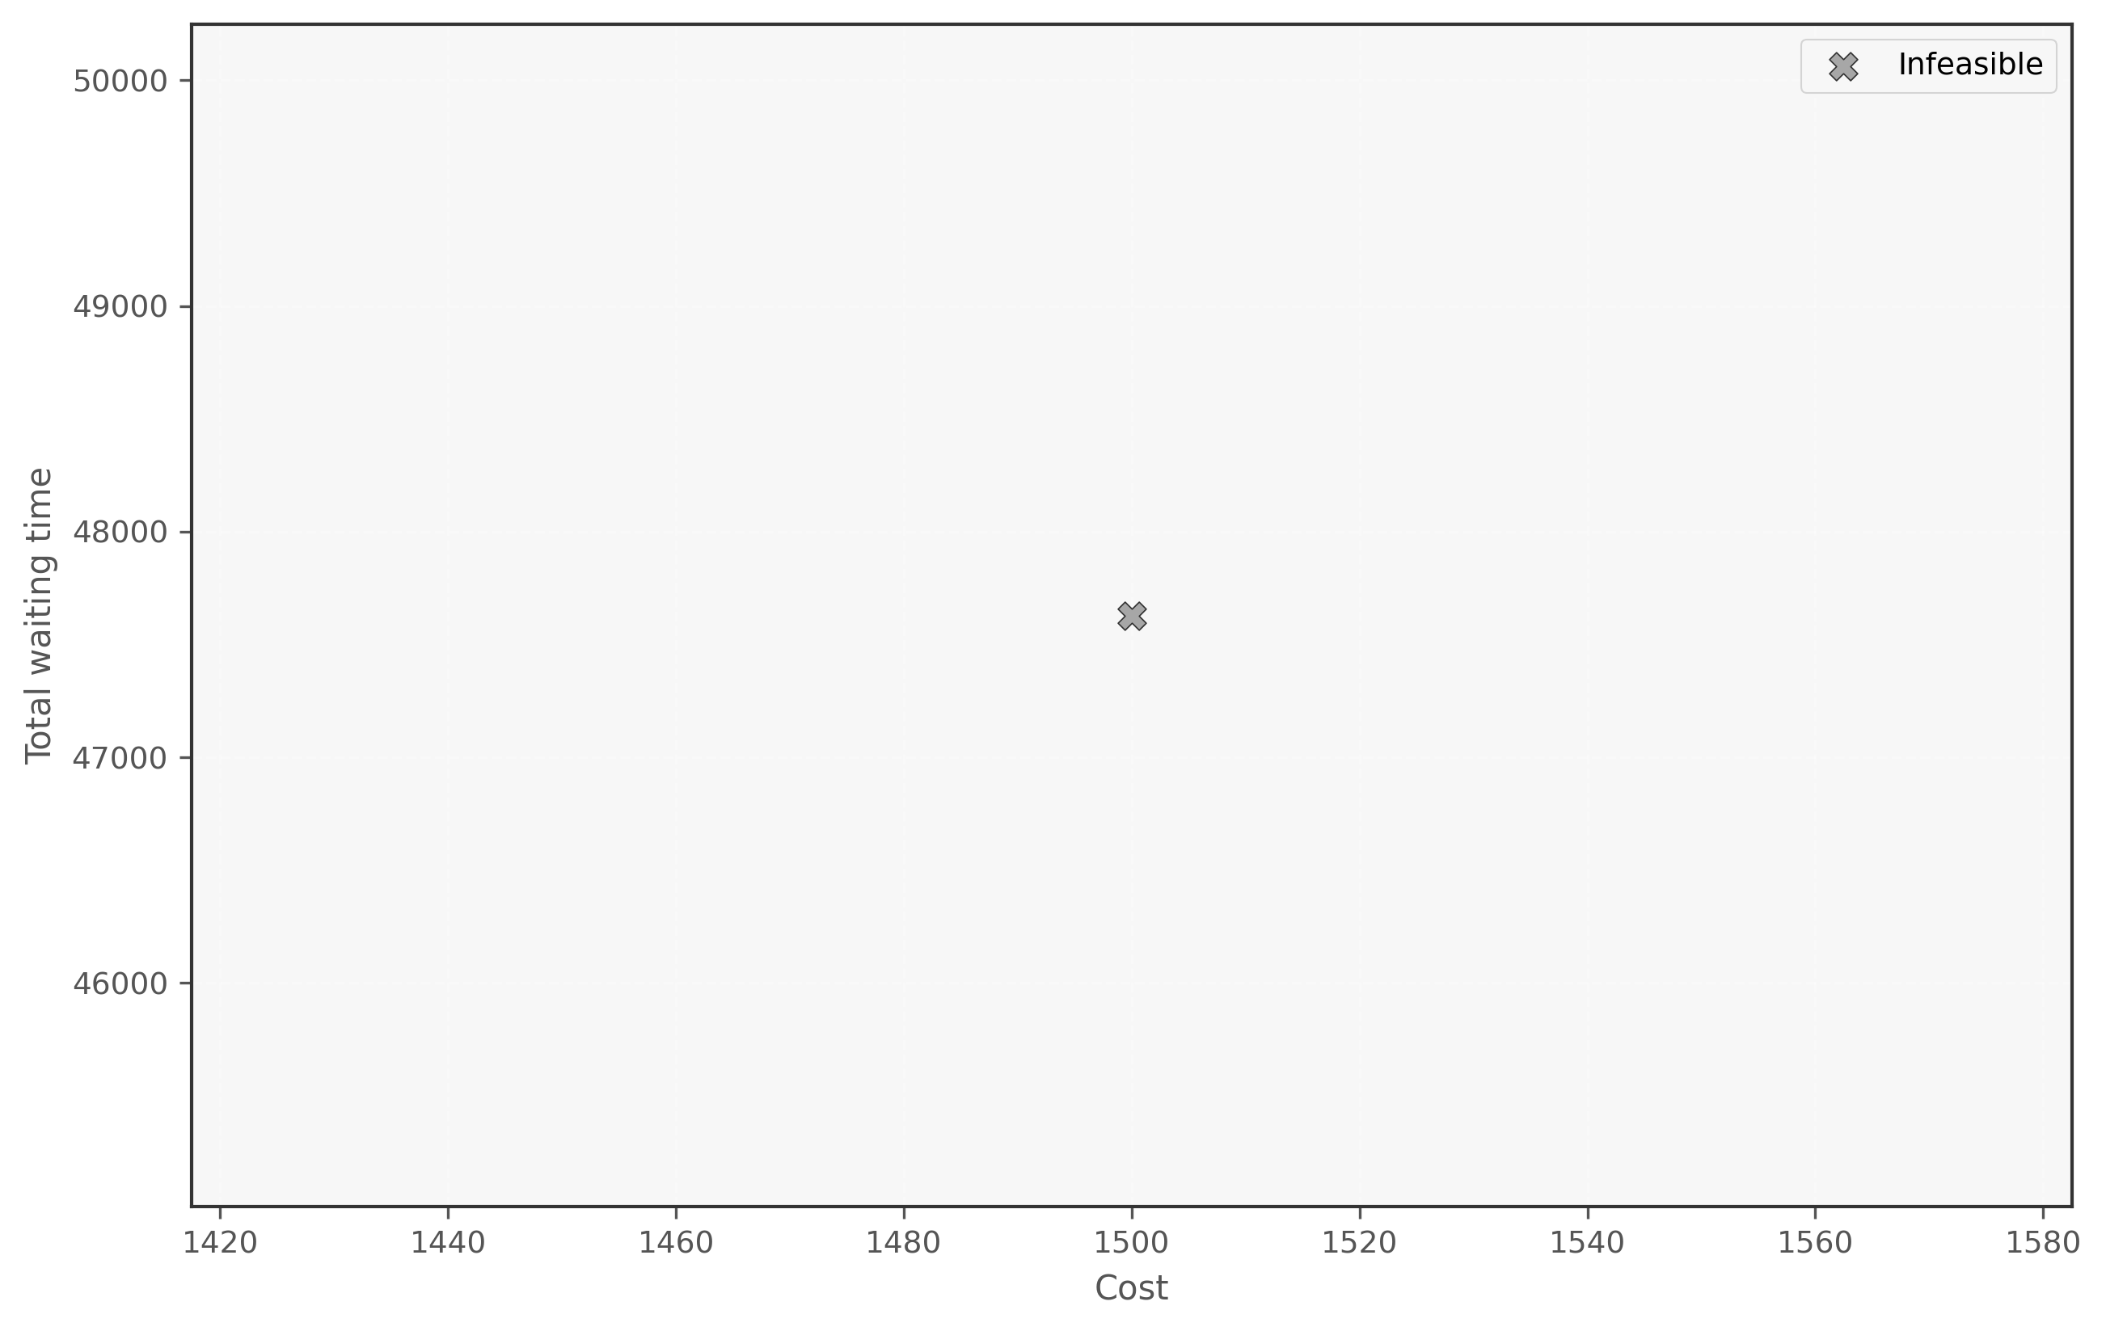
Figure 1. Cost-Wait scatter (lambda encoding) - Fixed
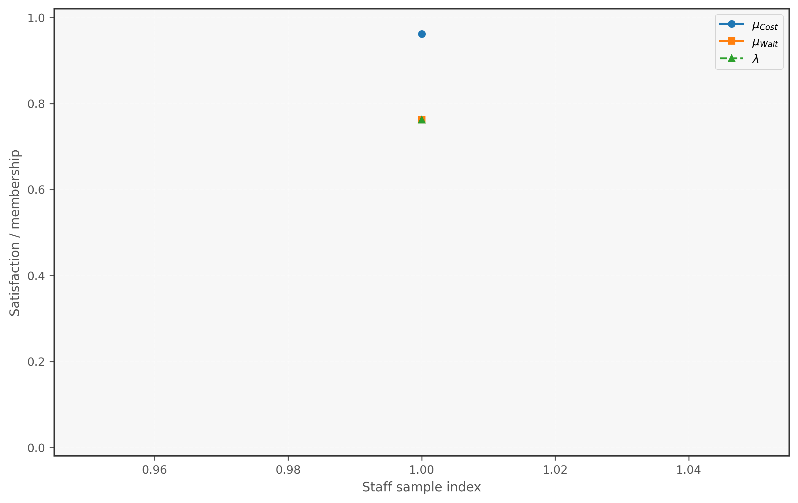
Figure 2. Membership decomposition - Fixed
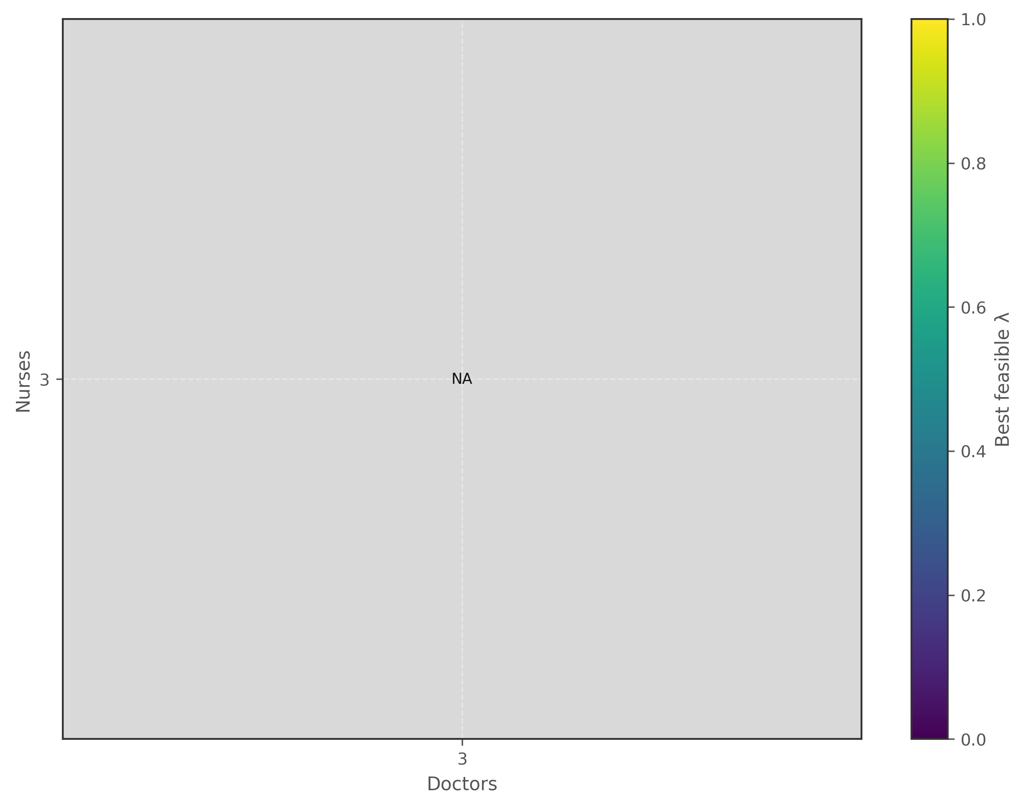
Figure 3. Feasibility heatmap (Doctor x Nurse) - Fixed
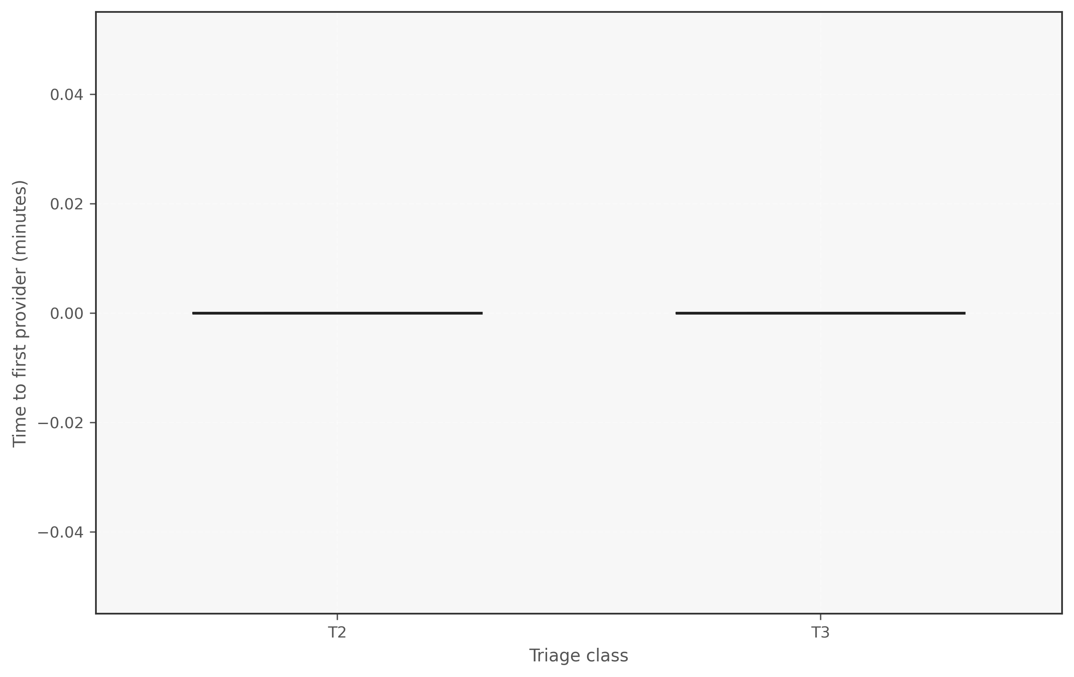
Figure 4. Triage first-wait boxplot - Fixed
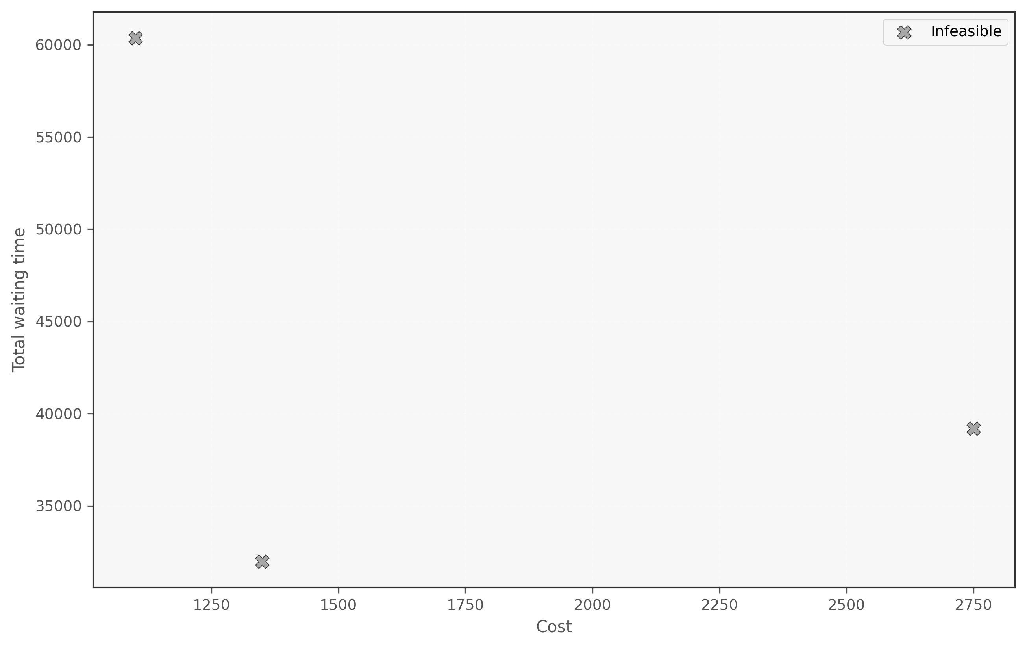
Figure 5. Cost-Wait scatter (lambda encoding) - Sensitivity
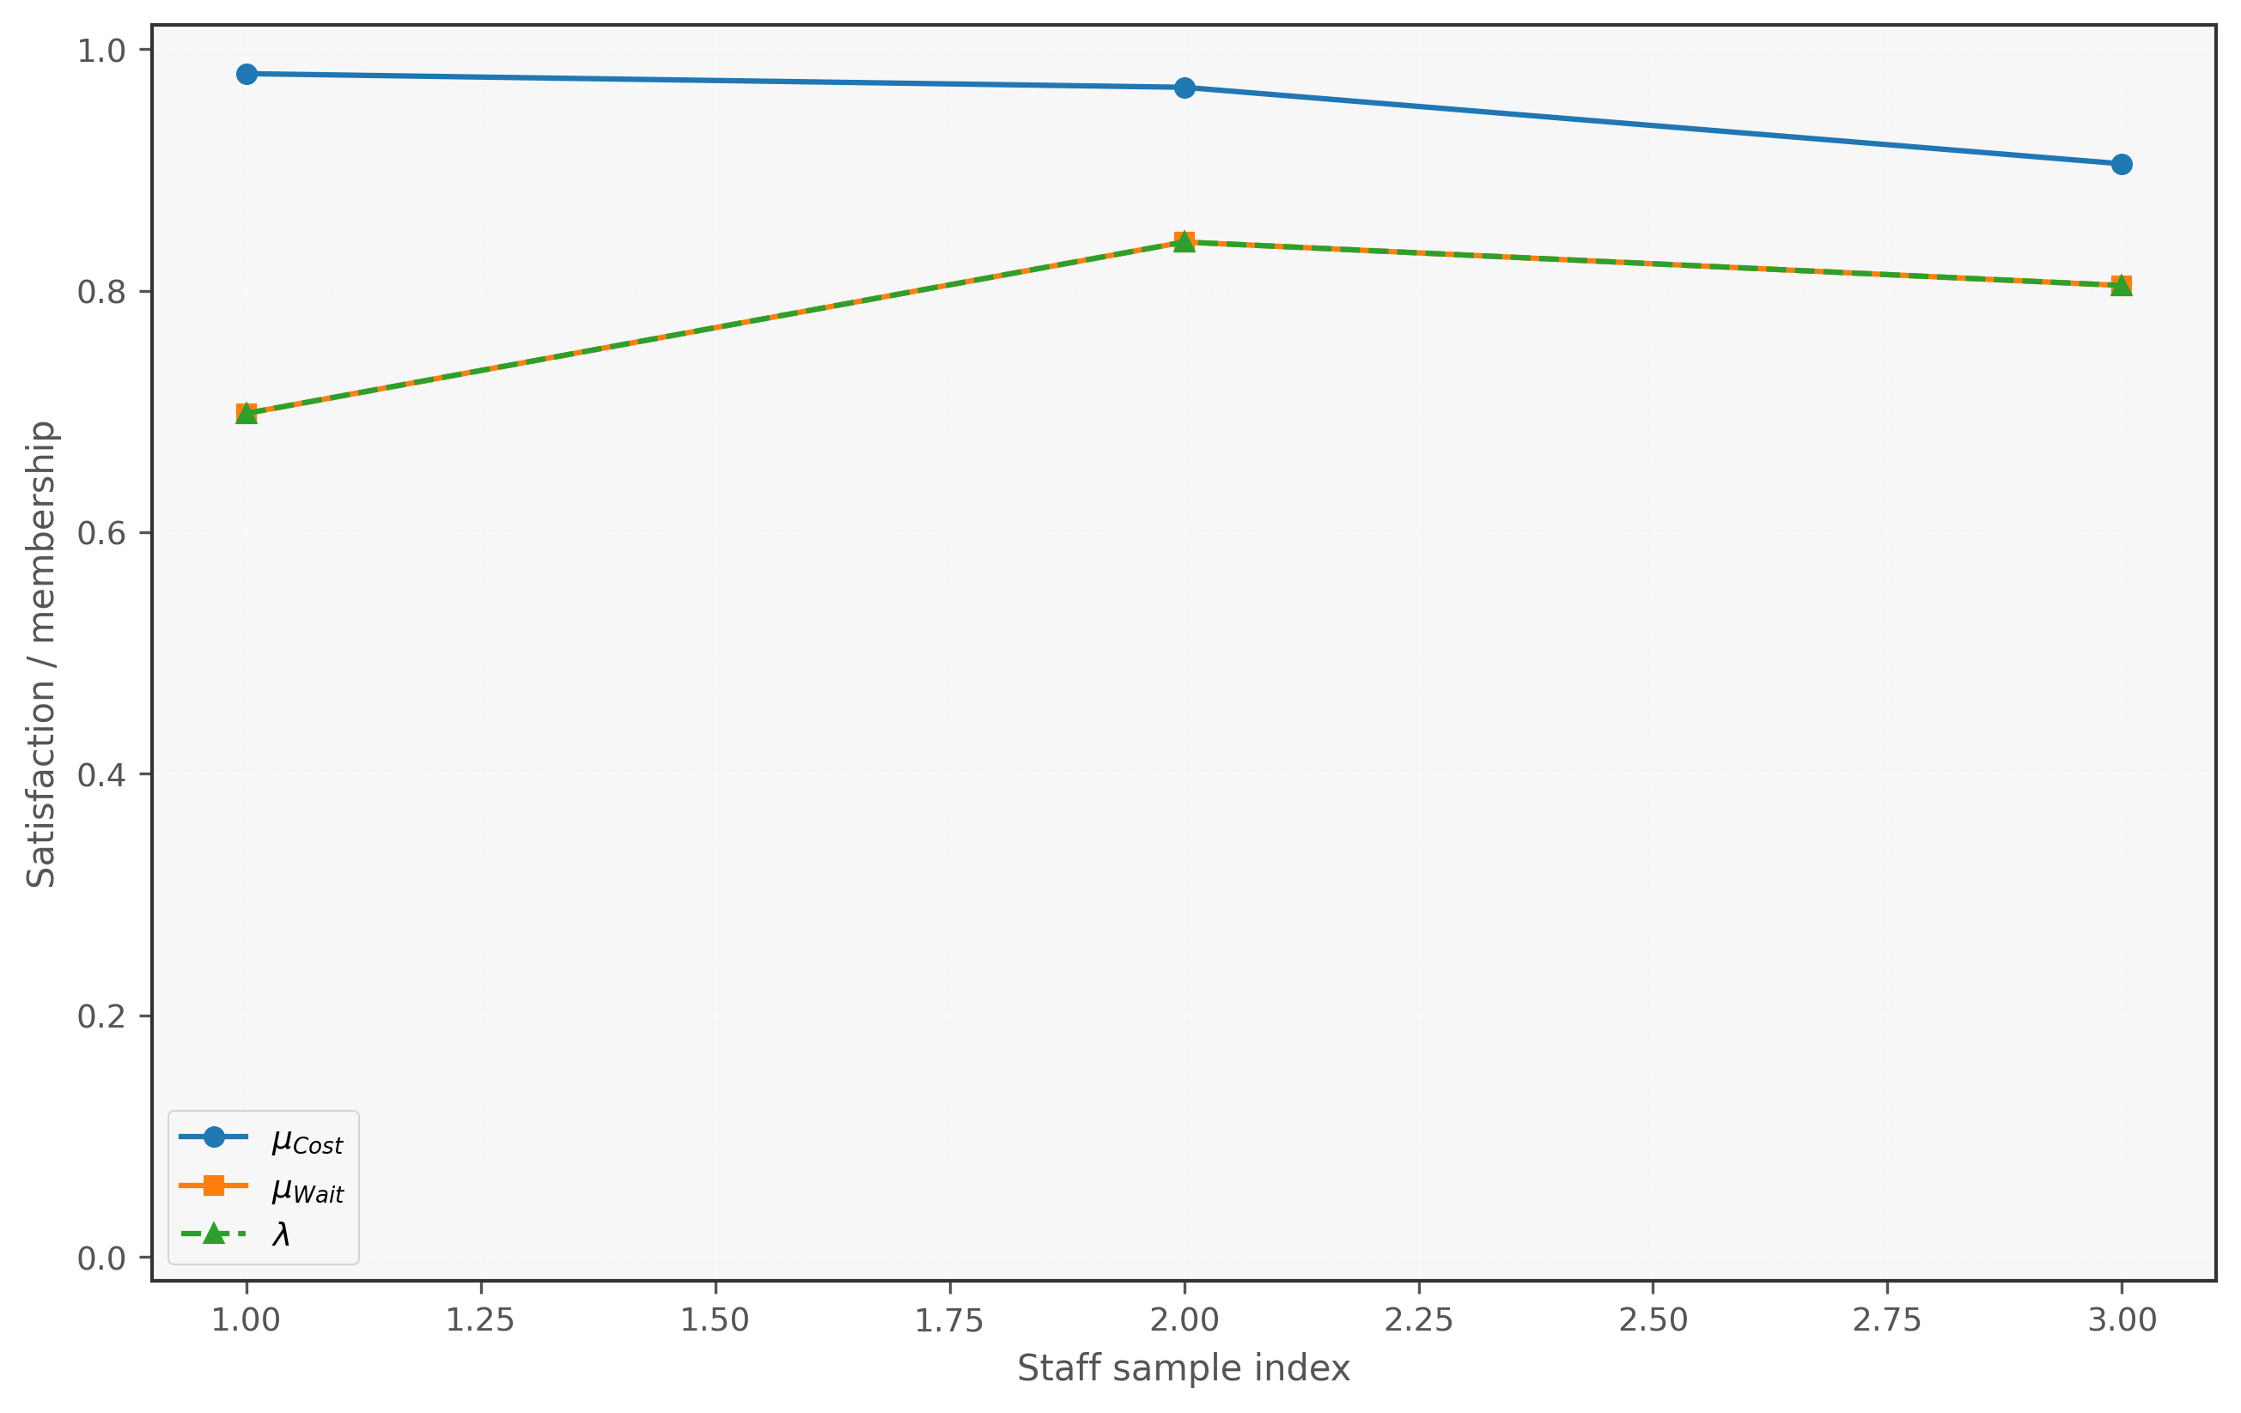
Figure 6. Membership decomposition - Sensitivity
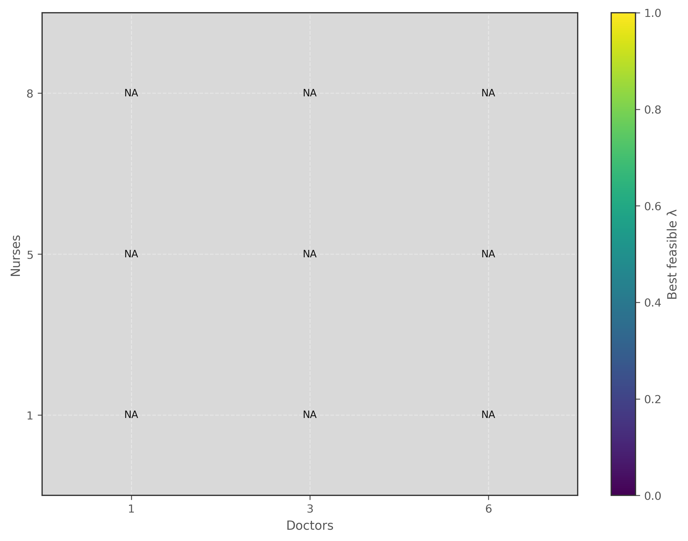
Figure 7. Feasibility heatmap (Doctor x Nurse) - Sensitivity
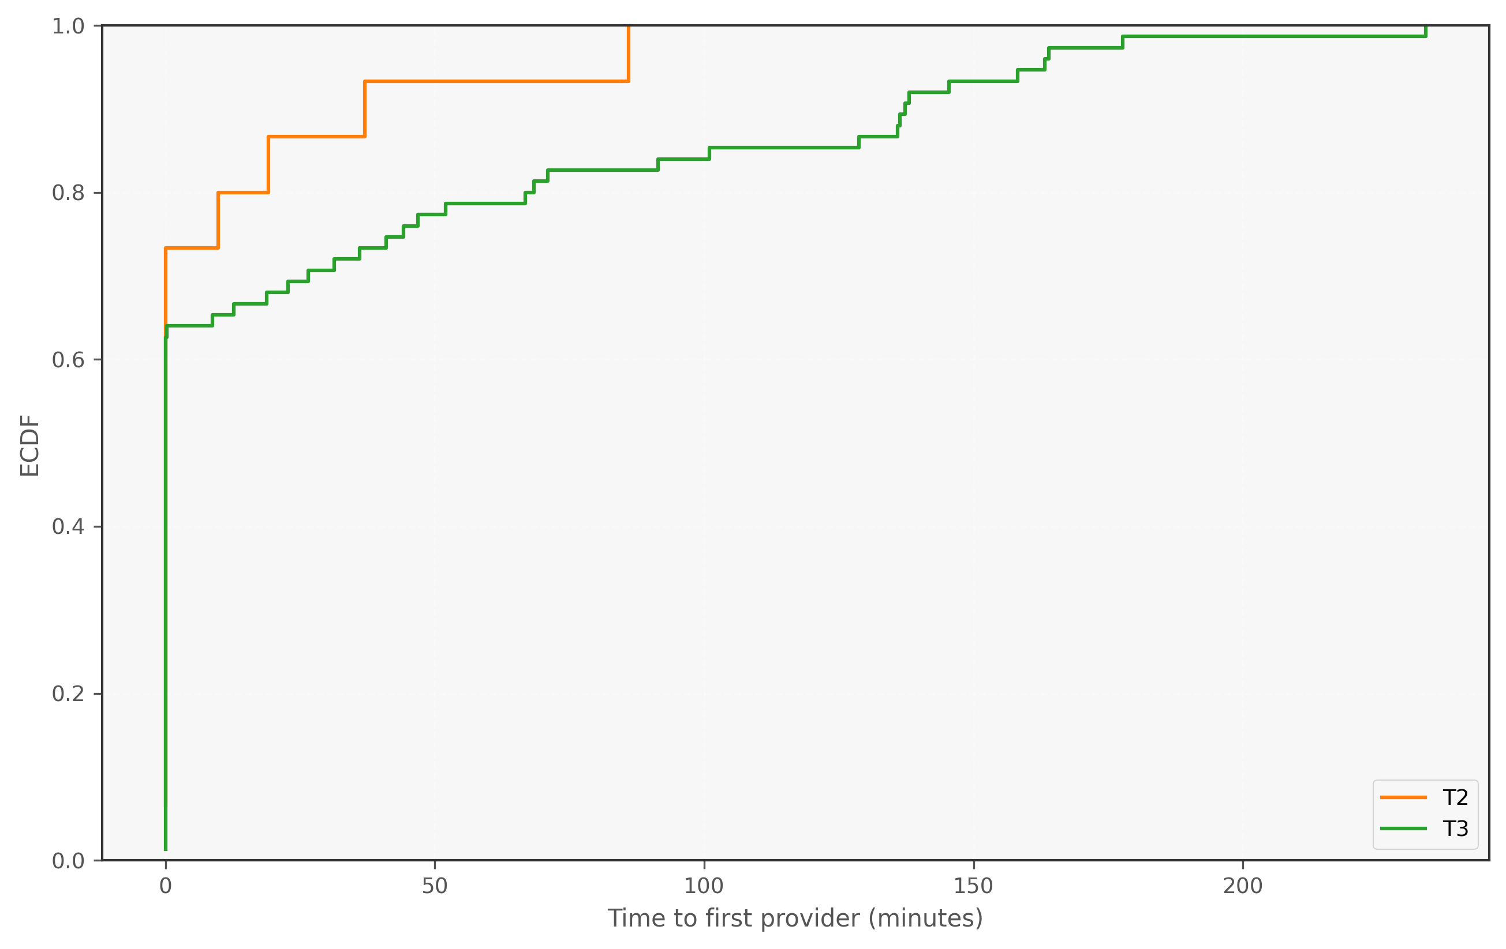
Figure 8. Triage first-wait ECDF - Sensitivity

7. Summary
Results are presented as baseline performance plus a feasibility and tradeoff map. Sensitivity outputs identify what is feasible, what binds first, and what cost is associated with service improvements.

