Results - Baseline-Anchored Feasibility and Tradeoff Analysis (MOFGPM)
This Results section is structured to match the baseline-anchored decision gap described in the Introduction. We first report baseline performance, then diagnose feasibility boundaries under uncertainty, and finally map the cost-service tradeoff using MOFGPM outcomes (mu_Cost, mu_Wait, and lambda).

1. Inputs and Evaluation Definitions
Baseline staffing configuration (reference case):
Doctor=3, Nurse=3, Assistant=6, Specialist=1
MOFGPM goal and tolerance parameters:
G_cost=650.0, C_max=22750.0, G_wait=50.0, W_max=200000.0
Waiting metric used: Total accumulated waiting time across all patients and activities (minutes).
Feasibility rule: Feasible if triage early-care standards are satisfied and both memberships are positive (mu_Cost>0, mu_Wait>0).

2. Baseline Case Results
Under baseline staffing, the system is Feasible. Cost=1500.00, Wait=24644.41, mu_Cost=0.962, mu_Wait=0.877, lambda=0.877.
The binding objective at baseline is Wait.

3. Feasibility Under Uncertainty Scenarios
Table 1 summarizes feasibility rates and best-achieved balanced satisfaction by uncertainty scenario.
Scenario | Runs | Feasible (%) | Min feasible W_max | Best lambda | Best Cost | Best Wait | Binding
expected | 6 | 100.0 | 200000.00 | 0.894 | 2750.00 | 21226.84 | Wait
Table 1. Scenario-level feasibility and best MOFGPM outcomes.

4. Cost-Service Tradeoff Map (MOFGPM Interpretation)
scenario | wmax | Doctor | Nurse | Assistant | Specialist | cost | wait | mu_cost | mu_wait | lambda
expected | 200000.00 | 6 | 8 | 9 | 1 | 2750.00 | 21226.84 | 0.905 | 0.894 | 0.894
expected | 200000.00 | 3 | 1 | 1 | 2 | 1350.00 | 22841.19 | 0.968 | 0.886 | 0.886
expected | 200000.00 | 3 | 1 | 9 | 1 | 1450.00 | 24644.15 | 0.964 | 0.877 | 0.877
expected | 200000.00 | 3 | 3 | 6 | 1 | 1500.00 | 24644.41 | 0.962 | 0.877 | 0.877
expected | 200000.00 | 1 | 1 | 2 | 1 | 700.00 | 40914.44 | 0.998 | 0.796 | 0.796
expected | 200000.00 | 1 | 5 | 2 | 1 | 1100.00 | 42728.68 | 0.980 | 0.787 | 0.787
Table 2. Top feasible solutions (ranked by lambda, then cost and wait).

5. Feasibility Boundary Diagnostics
Scenario | Min feasible W_max
expected | 200000.00
Table 3. Minimum feasible W_max by scenario.

6. Figures
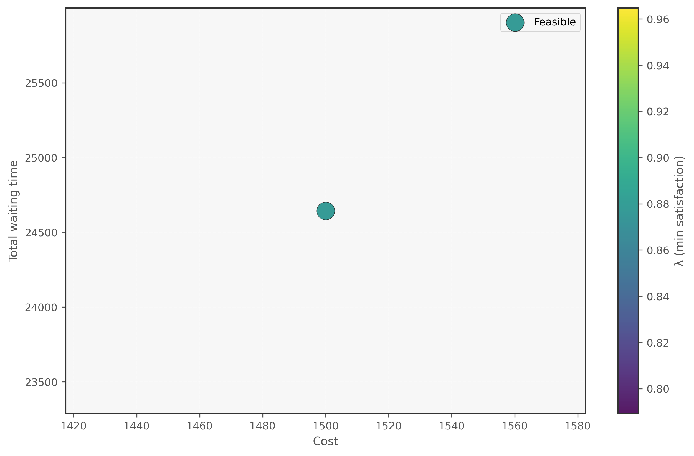
Figure 1. Cost-Wait scatter (lambda encoding) - Fixed
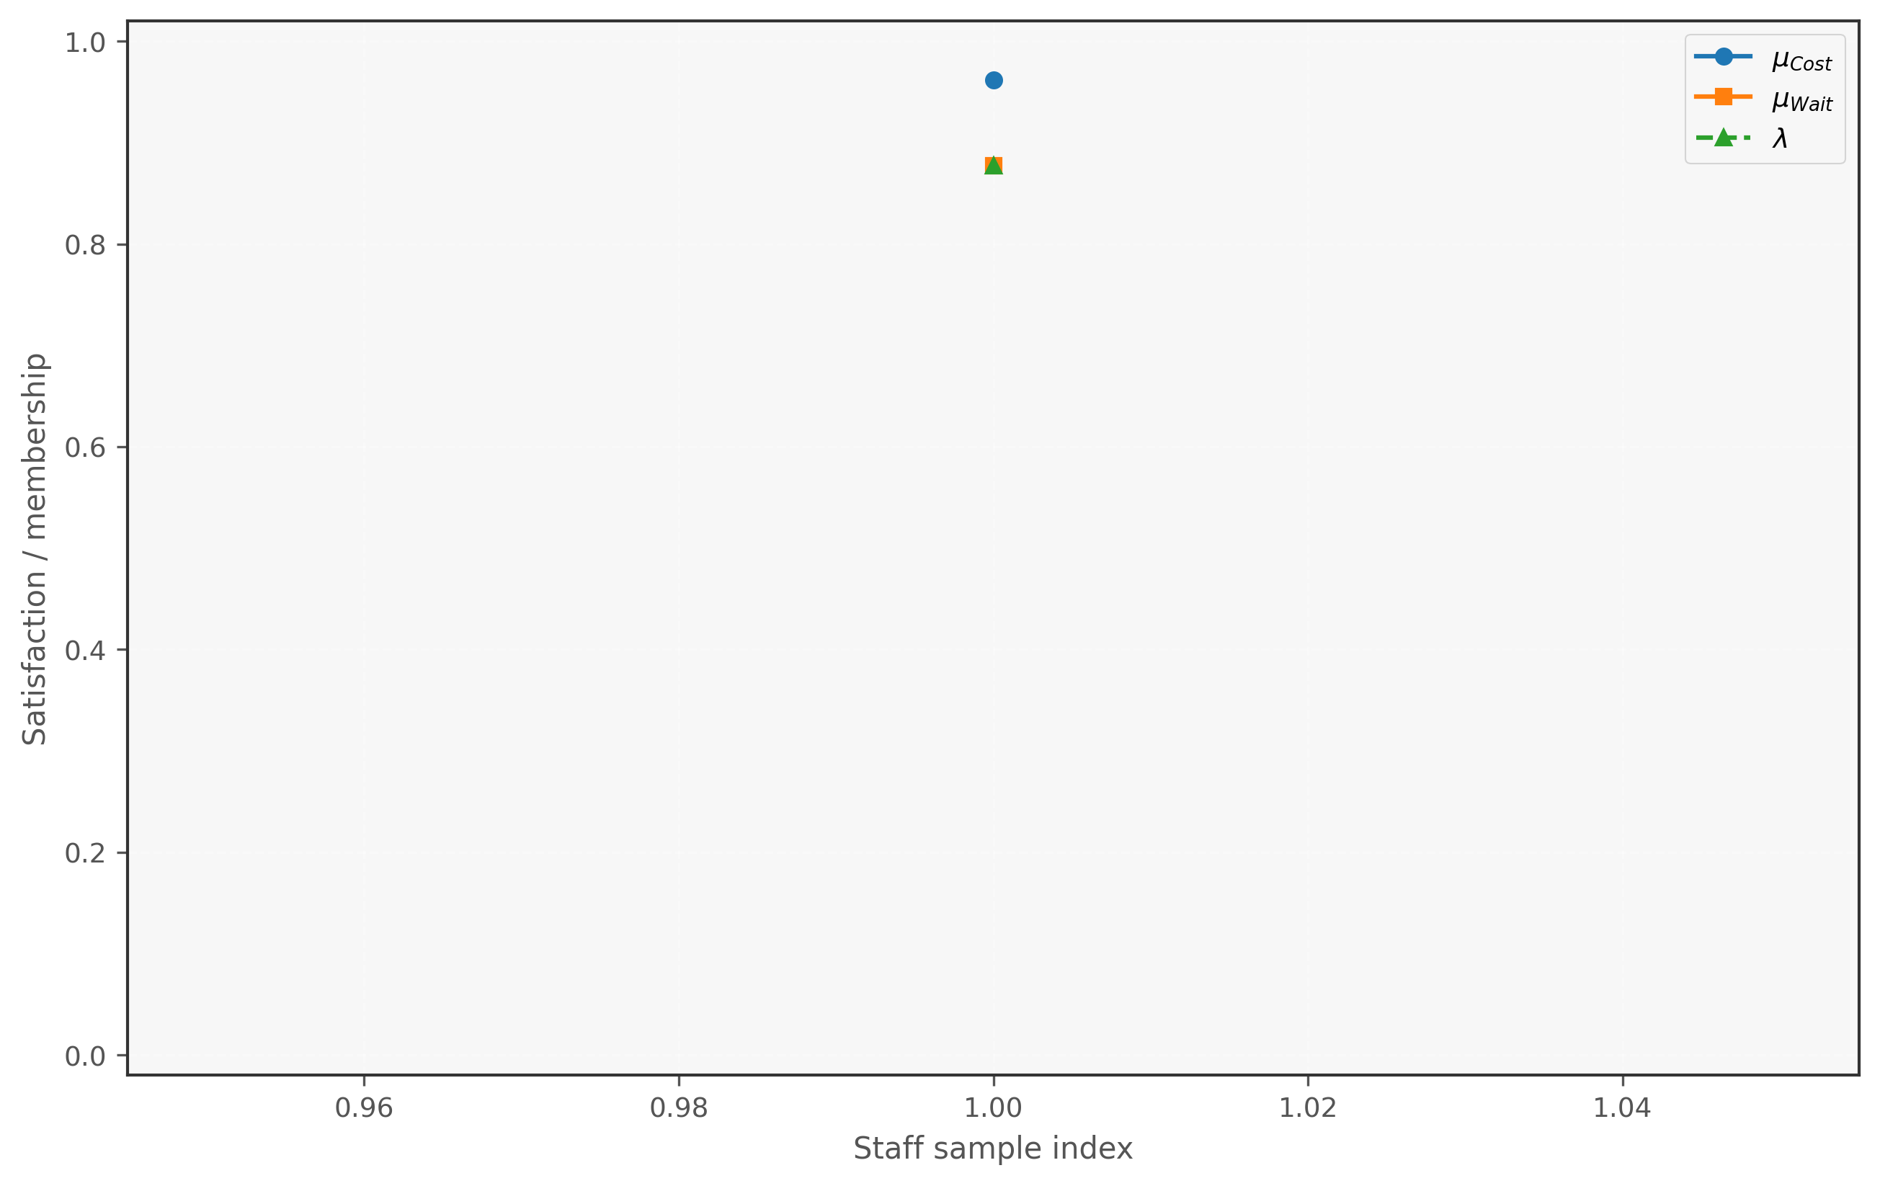
Figure 2. Membership decomposition - Fixed
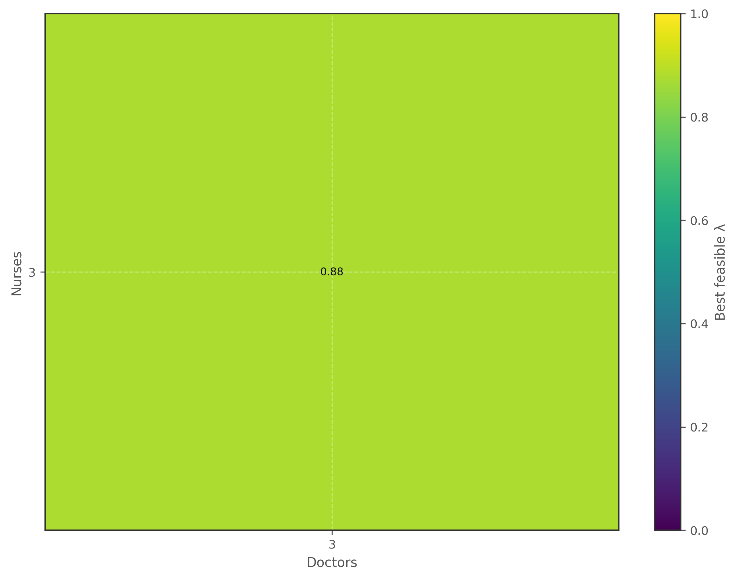
Figure 3. Feasibility heatmap (Doctor x Nurse) - Fixed
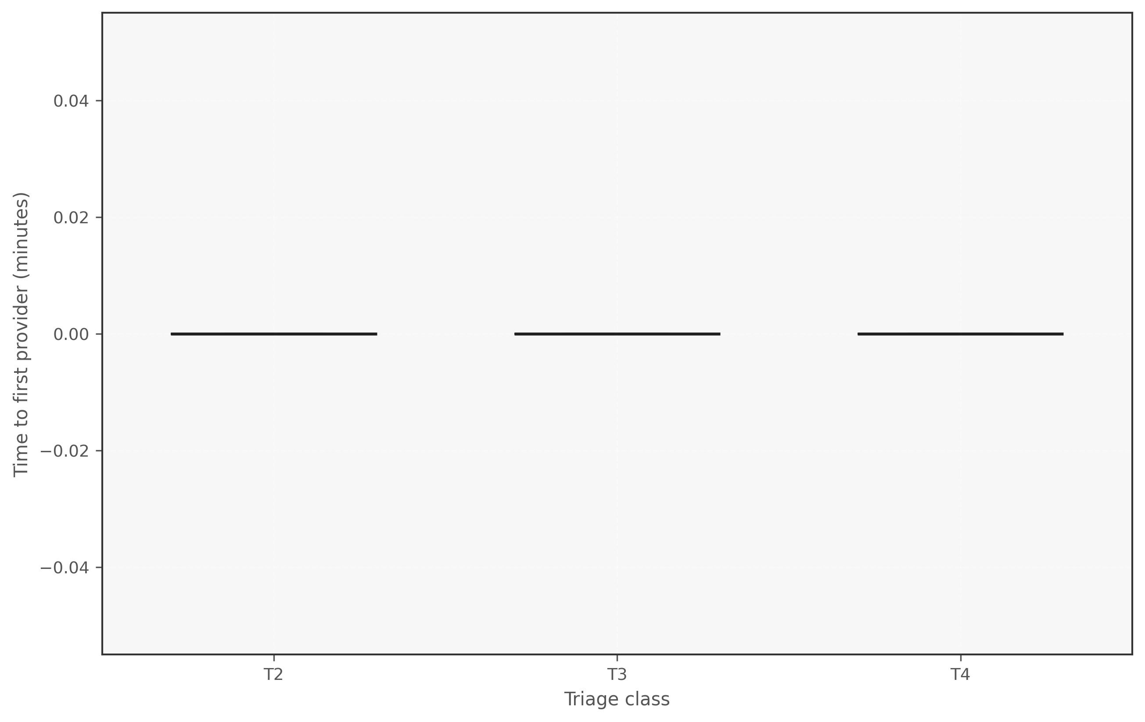
Figure 4. Triage first-wait boxplot - Fixed
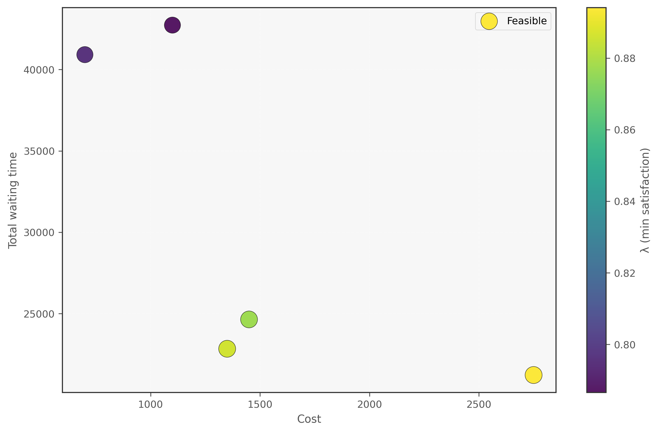
Figure 5. Cost-Wait scatter (lambda encoding) - Sensitivity
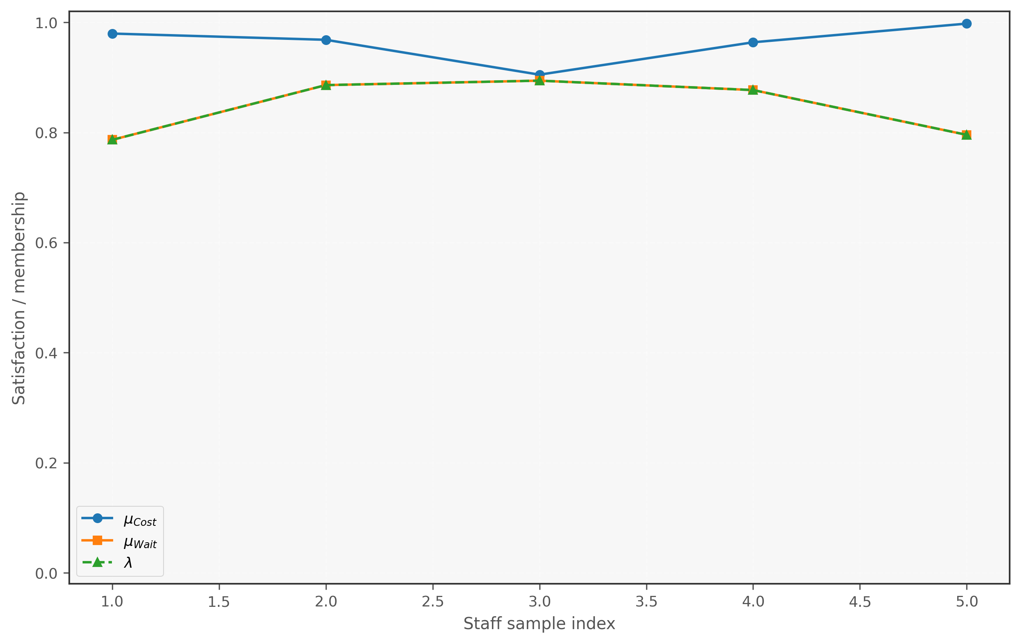
Figure 6. Membership decomposition - Sensitivity
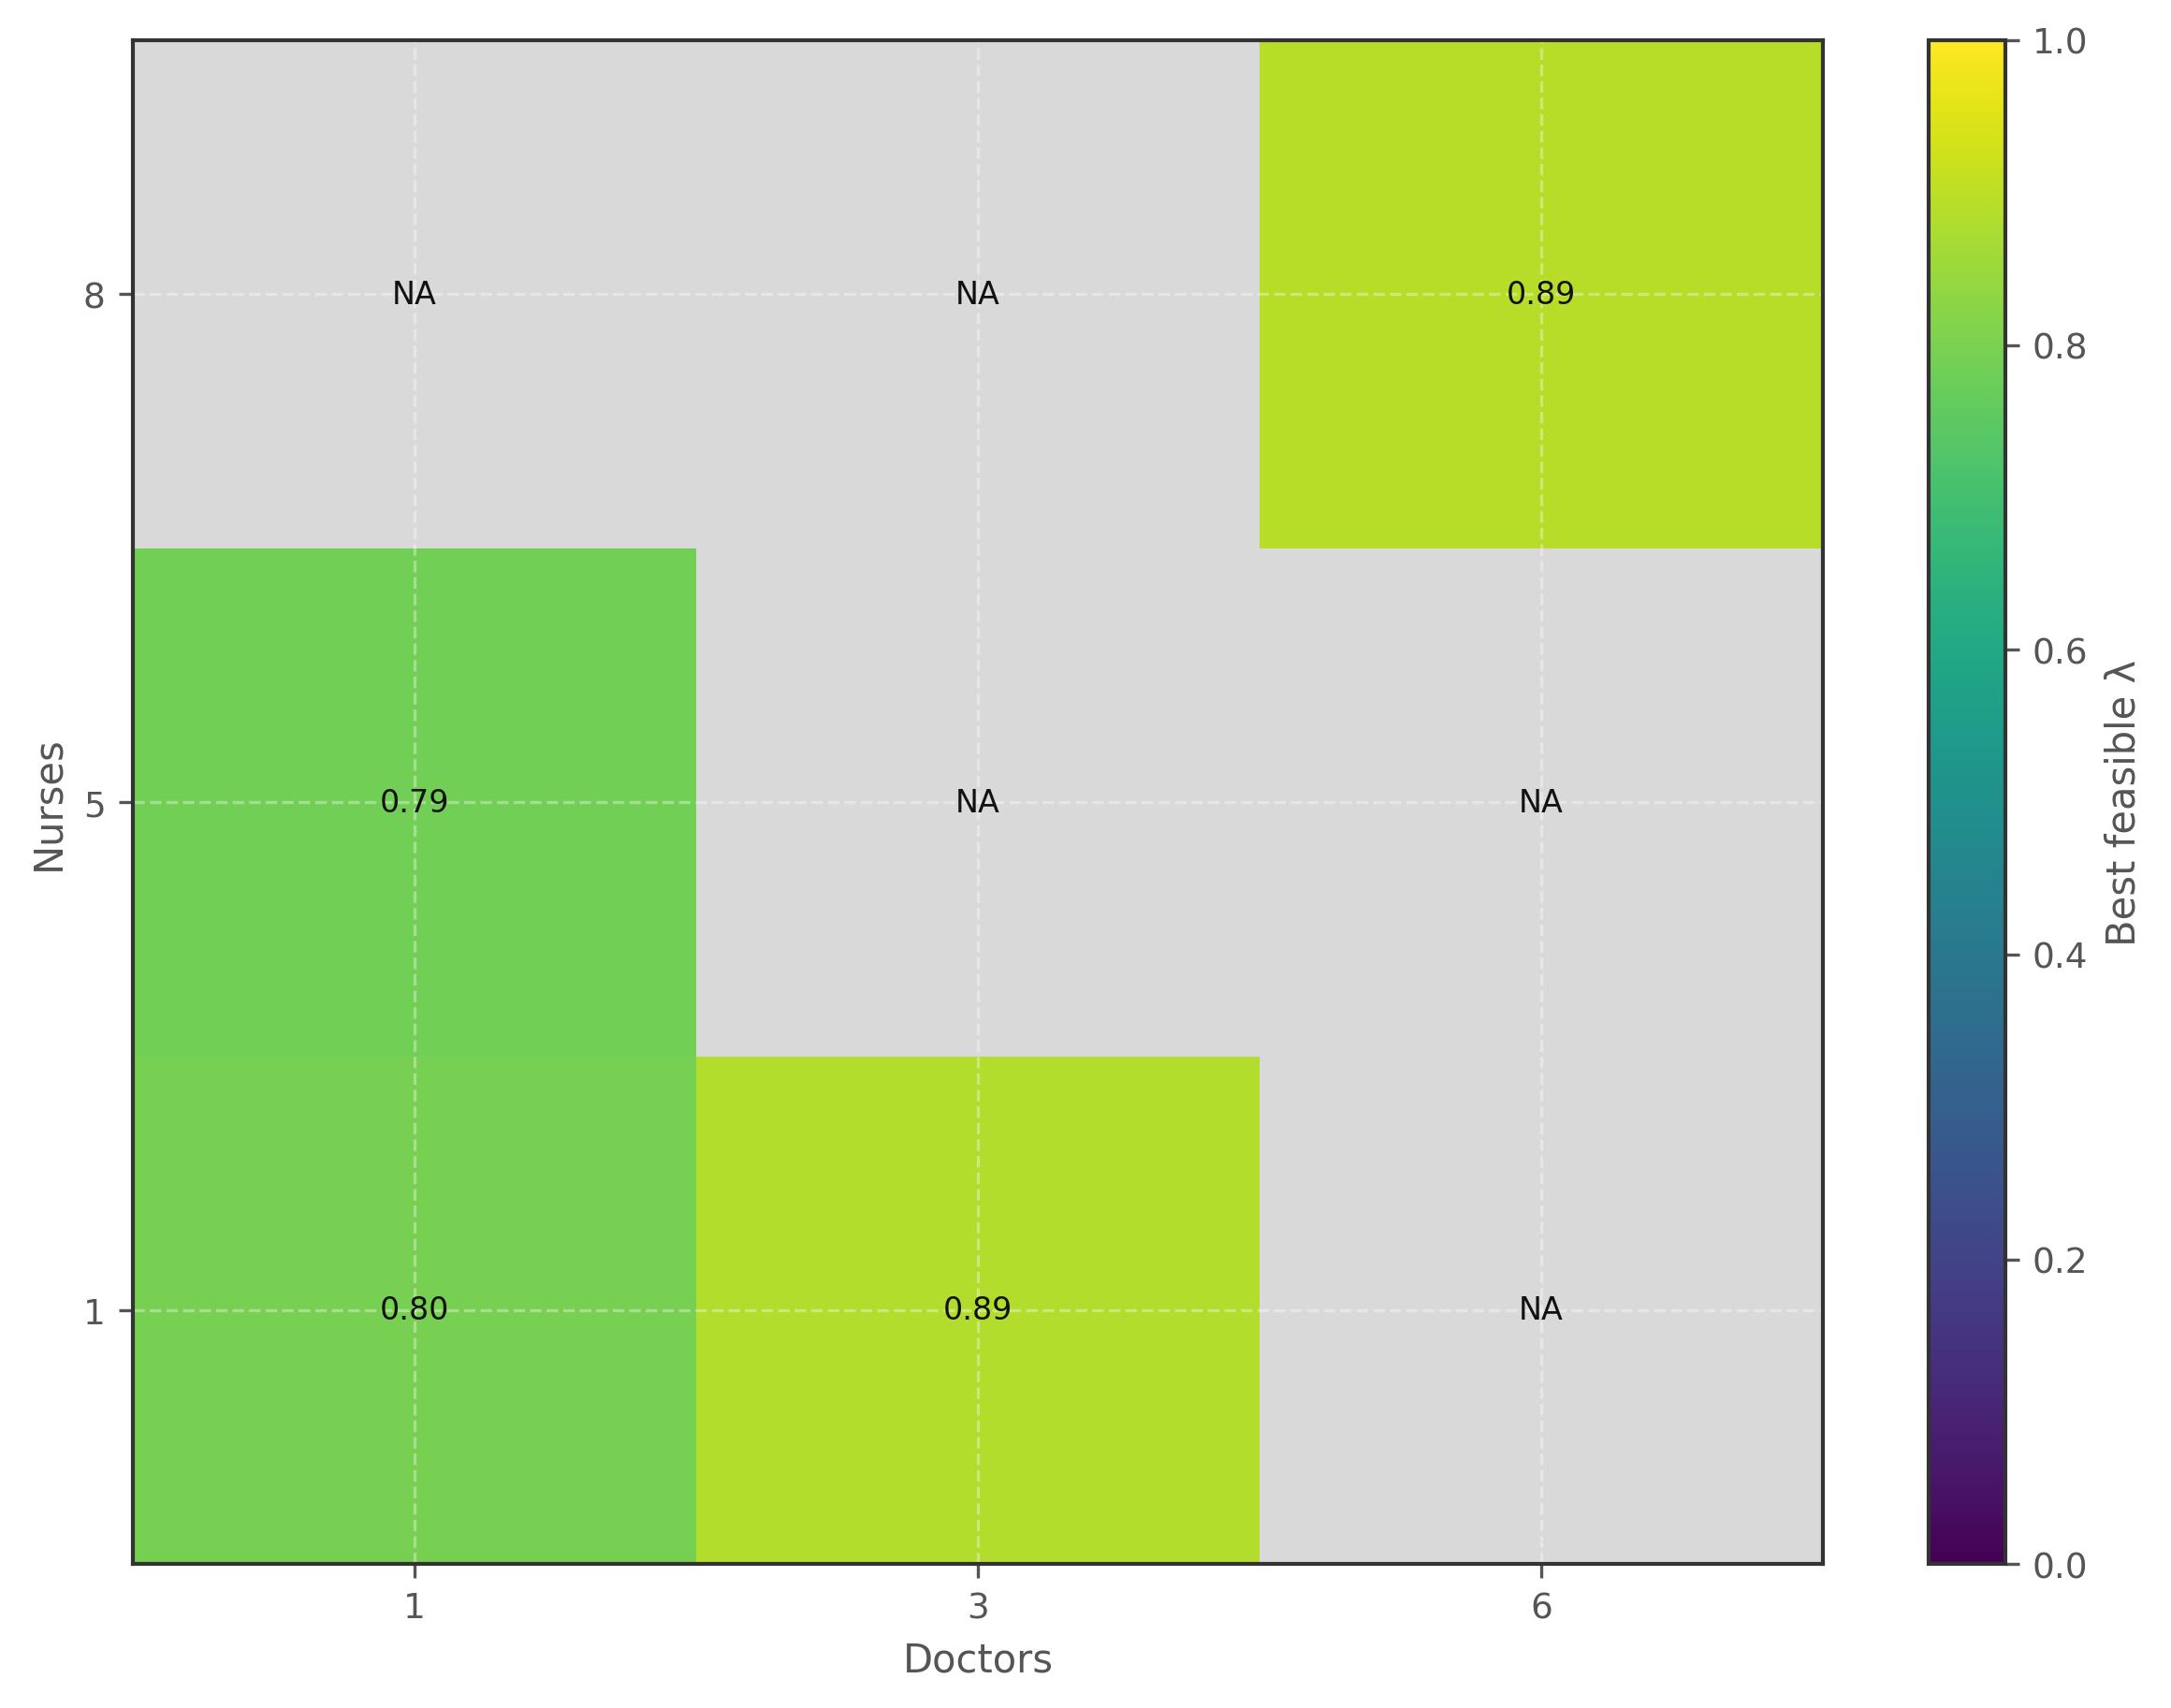
Figure 7. Feasibility heatmap (Doctor x Nurse) - Sensitivity
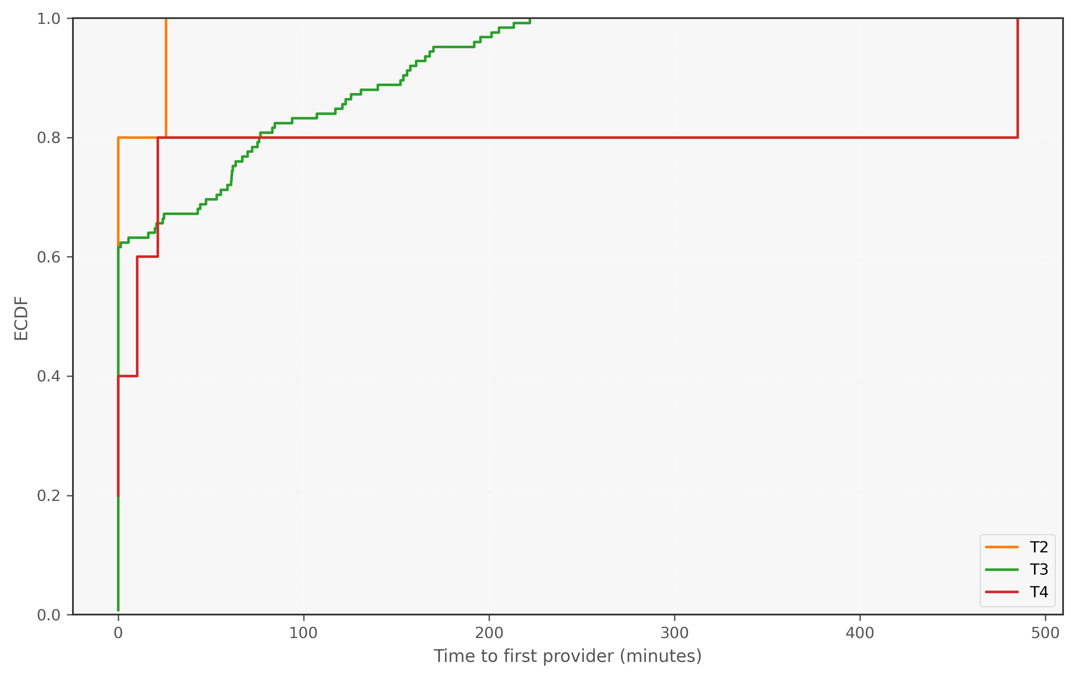
Figure 8. Triage first-wait ECDF - Sensitivity

7. Summary
Results are presented as baseline performance plus a feasibility and tradeoff map. Sensitivity outputs identify what is feasible, what binds first, and what cost is associated with service improvements.

