Working Paper Report of Moral Judgement under Two-sided Tobit Models
By Leonardo H. Talero-Sarmiento Date: 2026-04-18 21:09:45
This run uses Version 2.0/consolidado_ALL_2026_04_09_LONG.xlsx as the only analytical source and preserves each imported row as one real judgement observation. The production estimator is a two-sided Tobit fitted with survival::survreg, using bilateral censoring at -9 and 9, participant-cluster robust standard errors through cluster = id, and factor(session) in every active formula.

Understanding the modeling strategy
The purpose of the pipeline is to explain how participants assign moral judgement to a focal negotiator within a structured experimental setting. The objective is not limited to describing average responses. Rather, the pipeline is designed to estimate how judgement changes as a function of empathy, group alignment, negotiation decisions, and role-specific relational structure. The outcome of interest is judgement, interpreted as the participant’s moral evaluation of the target negotiator. Because each participant contributes repeated evaluations across scenarios and targets, the modeling strategy must satisfy three conditions simultaneously: it must preserve one row per real observation, respect the bounded structure of the outcome, and account for within-participant dependence. For these reasons, the production workflow uses a two-sided Tobit model with participant-cluster robust inference and session adjustment.
The need for a Tobit specification follows directly from the nature of the dependent variable. judgement is continuous in interpretation but bounded in measurement. Values at the extremes are therefore not ordinary unrestricted observations; they are limits imposed by the response scale. A standard linear model assumes an outcome that can vary freely over the real line, which is inappropriate when responses accumulate at lower and upper boundaries. The Tobit framework addresses this by assuming an underlying latent moral evaluation, denoted here by y_i^*, that is only observed through a bounded realized score:
$$y_{i}^{*}=X_{i}β+ε_{i}$$
and
$$judgement_{i}=max(−9,min(9,y_{i}^{*})).$$
Under this specification, the model jointly represents three kinds of outcomes: interior continuous values, lower-bound pile-up, and upper-bound pile-up. In this context, censoring does not mean that data are missing. It means that the observed score is recorded at the measurement boundary whenever the latent evaluation would extend beyond the scale. The Tobit model is therefore not a technical convenience but a direct response to the design of the judgement variable itself.
A second methodological challenge arises from the repeated-measures structure of the experiment. Each participant contributes multiple rows, so the observations are not independent. Ignoring this dependence would tend to underestimate standard errors and overstate statistical significance. The current pipeline addresses this issue through participant-cluster robust standard errors using id as the clustering variable. Session is also incorporated because different experimental sessions may vary in context, timing, or implementation details. This is handled through factor(session), which absorbs systematic session-level shifts. In the active production branch, session is therefore modeled as a fixed-effect adjustment rather than as a random session intercept. The implemented estimator is best described as a two-sided Tobit with participant-cluster robust inference and session fixed effects.
The predictors are organized into theoretically meaningful blocks. The first block contains empathy dimensions, represented by iri_fs, iri_ec, iri_pt, and iri_pd, and provides the basis for H1. The second block captures role-specific ingroup/outgroup structure and underlies H2. The third block incorporates negotiation decisions through decision_target, decision_other, and their interaction, forming the core of H4. Finally, all models include sociodemographic controls such as age, SES, sex, and player faculty. This structure allows the pipeline to evaluate distinct explanatory mechanisms while preserving a coherent hypothesis architecture.
Interactions are especially important in this design because additive effects alone are unlikely to capture the logic of the experiment. In H3, empathy-by-group interactions test whether the effect of empathy depends on social alignment. In H4 and H5, the interaction between decision_target and decision_other evaluates whether the moral meaning of one negotiator’s decision depends on the counterpart’s decision. These interaction terms are theoretically motivated and reflect the fact that moral evaluation is shaped not only by isolated attributes but also by combinations of dispositions, relationships, and actions.
The distinction between victim and bystander roles is central to the entire modeling strategy. Victim models focus on victim-negotiator alignment and therefore operate with a more direct relational structure. Bystander models, by contrast, require a broader map that includes bystander-victim, bystander-negotiator, and victim-negotiator relations. Because these mechanisms differ substantively, the victim and bystander specifications cannot be treated as interchangeable. Role-specific models are therefore necessary both statistically and theoretically.
The five hypothesis families follow naturally from this structure. H1 models judgement as a function of empathy and controls. H2 focuses on role-specific group alignment. H3 combines empathy and group structure with theoretically motivated interactions. H4 models judgement as a function of decision_target, decision_other, and their interaction. H5 integrates all previous components into a single specification. This progression allows the analysis to move from simpler explanations toward a more comprehensive account of moral judgement.
A key principle of the workflow is that one row remains one real target-judgement observation. The pipeline does not duplicate rows into separate pseudo-observations for negotiators, because doing so would artificially inflate the sample size and distort inference. Instead, the relational context involving N1, N2, victim, and bystander is reconstructed within each existing row. This preserves the integrity of the long-format design while maintaining the proper unit of analysis.
Taken together, the current production strategy has several strengths. It respects the bounded structure of the outcome, preserves the long-format observational design, adjusts inference for repeated observations, controls for session-level heterogeneity, separates victim and bystander mechanisms, and maps directly onto the theoretical architecture of H1 through H5. At the same time, its limitations must also be recognized. The estimator is not a full mixed-effects Tobit with random participant and session intercepts. In addition, sparse role-specific cells may still produce rank-deficient contrasts in interaction-heavy models. For that reason, interpretation should rely on the full combination of coefficient tables and model-implied figures rather than on isolated p-values.
Overall, the current production pipeline is statistically and conceptually aligned with the experiment. It treats bounded continuous moral judgement with a two-sided Tobit model, handles repeated observations through participant-cluster robust inference, adjusts session heterogeneity through fixed effects, and preserves role-specific relational theory within model specification. This makes the present workflow a defensible production framework, while also leaving a clear path for future multilevel Tobit extensions.

Dataset and sample description
The report uses the consolidated long experimental dataset as the single analytical source. Each participant contributes 20 judgement rows in principle: ten scenarios multiplied by two target-negotiator evaluations. Each imported row remains one real judgement observation on the target negotiator, enriched with relational context for N1, N2, victim, and bystander without duplicating rows. Double counting is prevented because N1 and N2 are reconstructed as contextual attributes inside each existing row rather than by expanding the file into duplicated negotiator-specific observations. Victim and bystander analyses are estimated separately so that relational coding follows the role-specific logic of the experiment.
The authoritative interpretation is that each player observes ten scenarios and evaluates two negotiators, so the longitudinal file should contain 20 judgement rows per participant. The clustering diagnostic below is consistent with that design.
Table 1. Participant summary
metric | value
participants | 243.000
sessions | 16.000
mean_age | 20.086
women_share | 0.426
engineering_share | 0.568
Table 2. Judgement summary
sample | rows | participants | mean_judgement | sd_judgement
All | 4860 | 243 | 1.623 | 6.674
Victim | 2430 | 243 | 1.504 | 6.842
Bystander | 2430 | 243 | 1.741 | 6.500

Datacard and symbol dictionary
Table 3. Datacard symbol dictionary
symbol | definition
judgement | Observed moral judgement on the bounded scale from -9 to 9.
y* | Latent judgement tendency underlying the censored Tobit observation.
iri_fs / iri_ec / iri_pt / iri_pd | IRI empathy dimensions: fantasy, empathic concern, perspective taking, and personal distress.
decision_target | Indicator for whether the target negotiator accepted the harmful deal; judgement is directed toward this actor.
decision_other | Indicator for whether the other negotiator accepted the harmful deal and may shift judgement of the target through the joint outcome context.
victim_N1_group / victim_N2_group | Victim-specific relations to negotiator 1 and negotiator 2, with ingroup defined by faculty coincidence including control-control matches.
bystander_victim_group / bystander_N1_group / bystander_N2_group | Bystander-side relational factors for the victim and both negotiators, again using faculty coincidence as ingroup.
N1_N2_same_faculty | Context term indicating whether N1 and N2 share faculty membership.
factor(session) | Session fixed effects included directly in every fitted formula.
cluster = id | Participant-level clustering used for robust standard errors and repeated-measures adjustment.
Log(scale) | Estimated Tobit log-scale parameter summarizing latent residual dispersion.
Table 4. Observation audit
checkpoint | value
base_excel_rows | 4860
processed_import_rows | 4860
processed_judgment_rows | 4860
unique_source_row_numbers | 4860
duplicated_source_row_numbers | 0

Predictor glossary and abbreviation note
Table 5. Predictor glossary
predictor | compact_label | meaning
iri_fs | FS | Fantasy empathy dimension.
iri_ec | EC | Empathic concern empathy dimension.
iri_pt | PT | Perspective-taking empathy dimension.
iri_pd | PD | Personal-distress empathy dimension.
victim_N1_groupingroup | V-N1 In | Victim and N1 are from the same faculty, relative to the ingroup baseline.
victim_N1_groupoutgroup | V-N1 Out | Victim and N1 are from different faculties, relative to the ingroup baseline.
victim_N2_groupingroup | V-N2 In | Victim and N2 are from the same faculty, relative to the ingroup baseline.
victim_N2_groupoutgroup | V-N2 Out | Victim and N2 are from different faculties, relative to the ingroup baseline.
bystander_victim_groupoutgroup | B-V Out | Bystander and victim are from different faculties, relative to ingroup.
bystander_N1_groupingroup | B-N1 In | Bystander and N1 are from the same faculty, relative to the ingroup baseline.
bystander_N1_groupoutgroup | B-N1 Out | Bystander and N1 are from different faculties, relative to the ingroup baseline.
bystander_N2_groupingroup | B-N2 In | Bystander and N2 are from the same faculty, relative to the ingroup baseline.
bystander_N2_groupoutgroup | B-N2 Out | Bystander and N2 are from different faculties, relative to the ingroup baseline.
N1_N2_same_facultysame | SameFac | N1 and N2 share faculty, relative to different-faculty context.
iri_fs:victim_N1_groupoutgroup | FS x V-N1 Out | Fantasy slope difference when victim-N1 is outgroup rather than ingroup.
iri_ec:victim_N2_groupoutgroup | EC x V-N2 Out | Empathic-concern slope difference when victim-N2 is outgroup rather than ingroup.
iri_pt:bystander_victim_groupoutgroup | PT x B-V Out | Perspective-taking slope difference when the bystander-victim relation is outgroup rather than ingroup.
iri_pd:bystander_N1_groupoutgroup | PD x B-N1 Out | Personal-distress slope difference when the bystander-N1 relation is outgroup rather than ingroup.
decision_target | Target Acc | Target negotiator accepted the harmful deal.
decision_other | Other Acc | Other negotiator accepted the harmful deal.
decision_target:decision_other | Target x Other | Joint decision effect when both negotiator decisions are considered together.
faculty_player_factorEngineering | Eng part. | Participant belongs to Engineering, relative to Humanities.
sex_female | Woman | Participant is a woman.
age | Age | Participant age.
ses | SES | Participant socioeconomic status.
The report keeps compact predictor references in figure captions and narratives, but the glossary above remains the authoritative mapping back to the current pipeline variables.

Interaction interpretation rules
- When an interaction is statistically relevant, the main effects should be read as the baseline component of the relationship rather than the whole substantive story.
- Continuous-by-factor interactions indicate that the empathy slope changes across relational conditions.
- Factor-by-factor interactions indicate that the joint context differs from what would be expected by adding the two main contrasts independently.
- The target-by-other decision interaction indicates that the moral meaning of one negotiator’s choice depends on what the counterpart did.
- Session effects are adjustment terms only and are not interpreted as substantive experimental mechanisms.

H1-H5 hypotheses with role-specific equation summaries
Table 6. H1-H5 role-specific formulas and theoretical focus
hypothesis | role | formula_rhs | theoretical_focus
H1 | Victim | iri_fs + iri_ec + iri_pt + iri_pd + age + ses + sex_female + faculty_player_factor + factor(session) | Empathy dimensions only, always adjusted by sociodemographics.
H1 | Bystander | iri_fs + iri_ec + iri_pt + iri_pd + age + ses + sex_female + faculty_player_factor + factor(session) | Empathy dimensions only, always adjusted by sociodemographics.
H2 | Victim | victim_N1_group + victim_N2_group + victim_N1_group:victim_N2_group + N1_N2_same_faculty + age + ses + sex_female + faculty_player_factor + factor(session) | Victim-side ingroup/outgroup structure with the allowed N1 x N2 relational interaction.
H2 | Bystander | bystander_victim_group + bystander_N1_group + bystander_N2_group + victim_N1_group + victim_N2_group + bystander_N1_group:bystander_N2_group + victim_N1_group:victim_N2_group + N1_N2_same_faculty + age + ses + sex_female + faculty_player_factor + factor(session) | Bystander-side relational structure with explicit bystander-victim, bystander-negotiator, victim-negotiator, and N1/N2 context terms.
H3 | Victim | iri_fs + iri_ec + iri_pt + iri_pd + victim_N1_group + victim_N2_group + victim_N1_group:victim_N2_group + N1_N2_same_faculty + iri_fs:victim_N1_group + iri_fs:victim_N2_group + iri_ec:victim_N1_group + iri_ec:victim_N2_group + iri_pt:victim_N1_group + iri_pt:victim_N2_group + iri_pd:victim_N1_group + iri_pd:victim_N2_group + age + ses + sex_female + faculty_player_factor + factor(session) | Empathy plus victim-side relational structure, including empathy x victim-N1 and empathy x victim-N2 interactions because empathy may depend on negotiator closeness.
H3 | Bystander | iri_fs + iri_ec + iri_pt + iri_pd + bystander_victim_group + bystander_N1_group + bystander_N2_group + victim_N1_group + victim_N2_group + bystander_N1_group:bystander_N2_group + victim_N1_group:victim_N2_group + N1_N2_same_faculty + iri_fs:bystander_victim_group + iri_fs:bystander_N1_group + iri_fs:bystander_N2_group + iri_ec:bystander_victim_group + iri_ec:bystander_N1_group + iri_ec:bystander_N2_group + iri_pt:bystander_victim_group + iri_pt:bystander_N1_group + iri_pt:bystander_N2_group + iri_pd:bystander_victim_group + iri_pd:bystander_N1_group + iri_pd:bystander_N2_group + age + ses + sex_female + faculty_player_factor + factor(session) | Empathy plus bystander-side relational structure, including empathy x bystander-victim and empathy x bystander-negotiator interactions because empathy may depend on group closeness in the bystander role.
H4 | Victim | decision_target * decision_other + age + ses + sex_female + faculty_player_factor + factor(session) | Target and other negotiator decisions with their interaction, plus sociodemographics.
H4 | Bystander | decision_target * decision_other + age + ses + sex_female + faculty_player_factor + factor(session) | Target and other negotiator decisions with their interaction, plus sociodemographics.
H5 | Victim | iri_fs + iri_ec + iri_pt + iri_pd + victim_N1_group + victim_N2_group + victim_N1_group:victim_N2_group + N1_N2_same_faculty + iri_fs:victim_N1_group + iri_fs:victim_N2_group + iri_ec:victim_N1_group + iri_ec:victim_N2_group + iri_pt:victim_N1_group + iri_pt:victim_N2_group + iri_pd:victim_N1_group + iri_pd:victim_N2_group + decision_target * decision_other + age + ses + sex_female + faculty_player_factor + factor(session) | Integrated model with empathy, victim-side relations, empathy x group interactions, decisions, and the victim-side relational interaction.
H5 | Bystander | iri_fs + iri_ec + iri_pt + iri_pd + bystander_victim_group + bystander_N1_group + bystander_N2_group + victim_N1_group + victim_N2_group + bystander_N1_group:bystander_N2_group + victim_N1_group:victim_N2_group + N1_N2_same_faculty + iri_fs:bystander_victim_group + iri_fs:bystander_N1_group + iri_fs:bystander_N2_group + iri_ec:bystander_victim_group + iri_ec:bystander_N1_group + iri_ec:bystander_N2_group + iri_pt:bystander_victim_group + iri_pt:bystander_N1_group + iri_pt:bystander_N2_group + iri_pd:bystander_victim_group + iri_pd:bystander_N1_group + iri_pd:bystander_N2_group + decision_target * decision_other + age + ses + sex_female + faculty_player_factor + factor(session) | Integrated model with empathy, bystander-side relations, empathy x group interactions, decisions, and the role-specific relational interactions.
Any earlier repository note that described negotiator code 0 as a hidden label or that narrowed H3 to additive effects only should now be treated as outdated. The active formulas below are the authoritative specification.

H1
Victim: iri_fs + iri_ec + iri_pt + iri_pd + age + ses + sex_female + faculty_player_factor + factor(session)
Bystander: iri_fs + iri_ec + iri_pt + iri_pd + age + ses + sex_female + faculty_player_factor + factor(session)

H2
Victim: victim_N1_group + victim_N2_group + victim_N1_group:victim_N2_group + N1_N2_same_faculty + age + ses + sex_female + faculty_player_factor + factor(session)
Bystander: bystander_victim_group + bystander_N1_group + bystander_N2_group + victim_N1_group + victim_N2_group + bystander_N1_group:bystander_N2_group + victim_N1_group:victim_N2_group + N1_N2_same_faculty + age + ses + sex_female + faculty_player_factor + factor(session)

H3
Victim: iri_fs + iri_ec + iri_pt + iri_pd + victim_N1_group + victim_N2_group + victim_N1_group:victim_N2_group + N1_N2_same_faculty + iri_fs:victim_N1_group + iri_fs:victim_N2_group + iri_ec:victim_N1_group + iri_ec:victim_N2_group + iri_pt:victim_N1_group + iri_pt:victim_N2_group + iri_pd:victim_N1_group + iri_pd:victim_N2_group + age + ses + sex_female + faculty_player_factor + factor(session)
Bystander: iri_fs + iri_ec + iri_pt + iri_pd + bystander_victim_group + bystander_N1_group + bystander_N2_group + victim_N1_group + victim_N2_group + bystander_N1_group:bystander_N2_group + victim_N1_group:victim_N2_group + N1_N2_same_faculty + iri_fs:bystander_victim_group + iri_fs:bystander_N1_group + iri_fs:bystander_N2_group + iri_ec:bystander_victim_group + iri_ec:bystander_N1_group + iri_ec:bystander_N2_group + iri_pt:bystander_victim_group + iri_pt:bystander_N1_group + iri_pt:bystander_N2_group + iri_pd:bystander_victim_group + iri_pd:bystander_N1_group + iri_pd:bystander_N2_group + age + ses + sex_female + faculty_player_factor + factor(session)

H4
Victim: decision_target * decision_other + age + ses + sex_female + faculty_player_factor + factor(session)
Bystander: decision_target * decision_other + age + ses + sex_female + faculty_player_factor + factor(session)

H5
Victim: iri_fs + iri_ec + iri_pt + iri_pd + victim_N1_group + victim_N2_group + victim_N1_group:victim_N2_group + N1_N2_same_faculty + iri_fs:victim_N1_group + iri_fs:victim_N2_group + iri_ec:victim_N1_group + iri_ec:victim_N2_group + iri_pt:victim_N1_group + iri_pt:victim_N2_group + iri_pd:victim_N1_group + iri_pd:victim_N2_group + decision_target * decision_other + age + ses + sex_female + faculty_player_factor + factor(session)
Bystander: iri_fs + iri_ec + iri_pt + iri_pd + bystander_victim_group + bystander_N1_group + bystander_N2_group + victim_N1_group + victim_N2_group + bystander_N1_group:bystander_N2_group + victim_N1_group:victim_N2_group + N1_N2_same_faculty + iri_fs:bystander_victim_group + iri_fs:bystander_N1_group + iri_fs:bystander_N2_group + iri_ec:bystander_victim_group + iri_ec:bystander_N1_group + iri_ec:bystander_N2_group + iri_pt:bystander_victim_group + iri_pt:bystander_N1_group + iri_pt:bystander_N2_group + iri_pd:bystander_victim_group + iri_pd:bystander_N1_group + iri_pd:bystander_N2_group + decision_target * decision_other + age + ses + sex_female + faculty_player_factor + factor(session)

Mathematical foundations
The primary estimator is a two-sided Tobit fitted with survival::survreg.
$$y_{i}=max(−9,min(9,y_{i}^{*}))$$
$$y_{i}^{*}=β_{0}+X_{i}β+δ_{session(i)}+ε_{i}$$
where factor(session) supplies session fixed effects and cluster-robust standard errors are computed at the participant level through cluster = id with robust = TRUE. This report therefore treats session as an implemented fixed-effect adjustment, not as a random intercept.
In this production branch, factor(session) is reported instead of (1|session) because the fitted estimator is a two-sided Tobit with session fixed effects and participant-cluster robust standard errors. The report does not claim a random session intercept that was not actually estimated.

Dependence and effective sample size diagnostic
The following clustering diagnostic is descriptive. It summarizes within-participant dependence in the observed data and should not be read as evidence that the fitted estimator included participant random intercepts.
Table 7. Descriptive clustering diagnostic
metric | value
participants | 243.000
observations | 4860.000
average_observations_per_id | 20.000
icc_descriptive | 0.134
design_effect | 3.537
effective_sample_size | 1373.909
Because the target of inference is repeated judgement within participant, the effective-sample-size table is a descriptive clustering diagnostic only; it does not replace the model-based dependence adjustment through cluster = id and factor(session).

Descriptive statistics and figures
Table 8. Decision summary by role
role_label | decision_pattern | n | mean_judgement
bystander | both_accept | 604 | -2.785
victim | both_accept | 610 | -3.167
bystander | both_reject | 690 | 7.086
victim | both_reject | 662 | 7.062
bystander | target_accept_other_reject | 568 | -3.155
victim | target_accept_other_reject | 579 | -3.803
bystander | target_reject_other_accept | 568 | 4.958
victim | target_reject_other_accept | 579 | 5.378
Table 9. Role-specific ingroup/outgroup summary
variable | level | n
victim_N1_group | ingroup | 1682
victim_N1_group | outgroup | 3178
victim_N2_group | ingroup | 1578
victim_N2_group | outgroup | 3282
bystander_victim_group | ingroup | 1212
bystander_victim_group | outgroup | 1218
bystander_N1_group | ingroup | 812
bystander_N1_group | outgroup | 1618
bystander_N2_group | ingroup | 798
bystander_N2_group | outgroup | 1632
N1_N2_same_faculty | different | 3276
N1_N2_same_faculty | same | 1584
Table 10. Participant-level empathy and mean judgement correlation matrix
term | iri_fs | iri_ec | iri_pt | iri_pd | judgement
iri_fs | 1.000 | 0.409 | 0.154 | 0.282 | 0.051
iri_ec | 0.409 | 1.000 | 0.482 | 0.219 | -0.017
iri_pt | 0.154 | 0.482 | 1.000 | -0.177 | 0.111
iri_pd | 0.282 | 0.219 | -0.177 | 1.000 | -0.046
judgement | 0.051 | -0.017 | 0.111 | -0.046 | 1.000
The group summary and the formulas above use role-specific ingroup/outgroup coding. Ingroup is defined by faculty coincidence, including control with control, while outgroup means non-matching faculties.
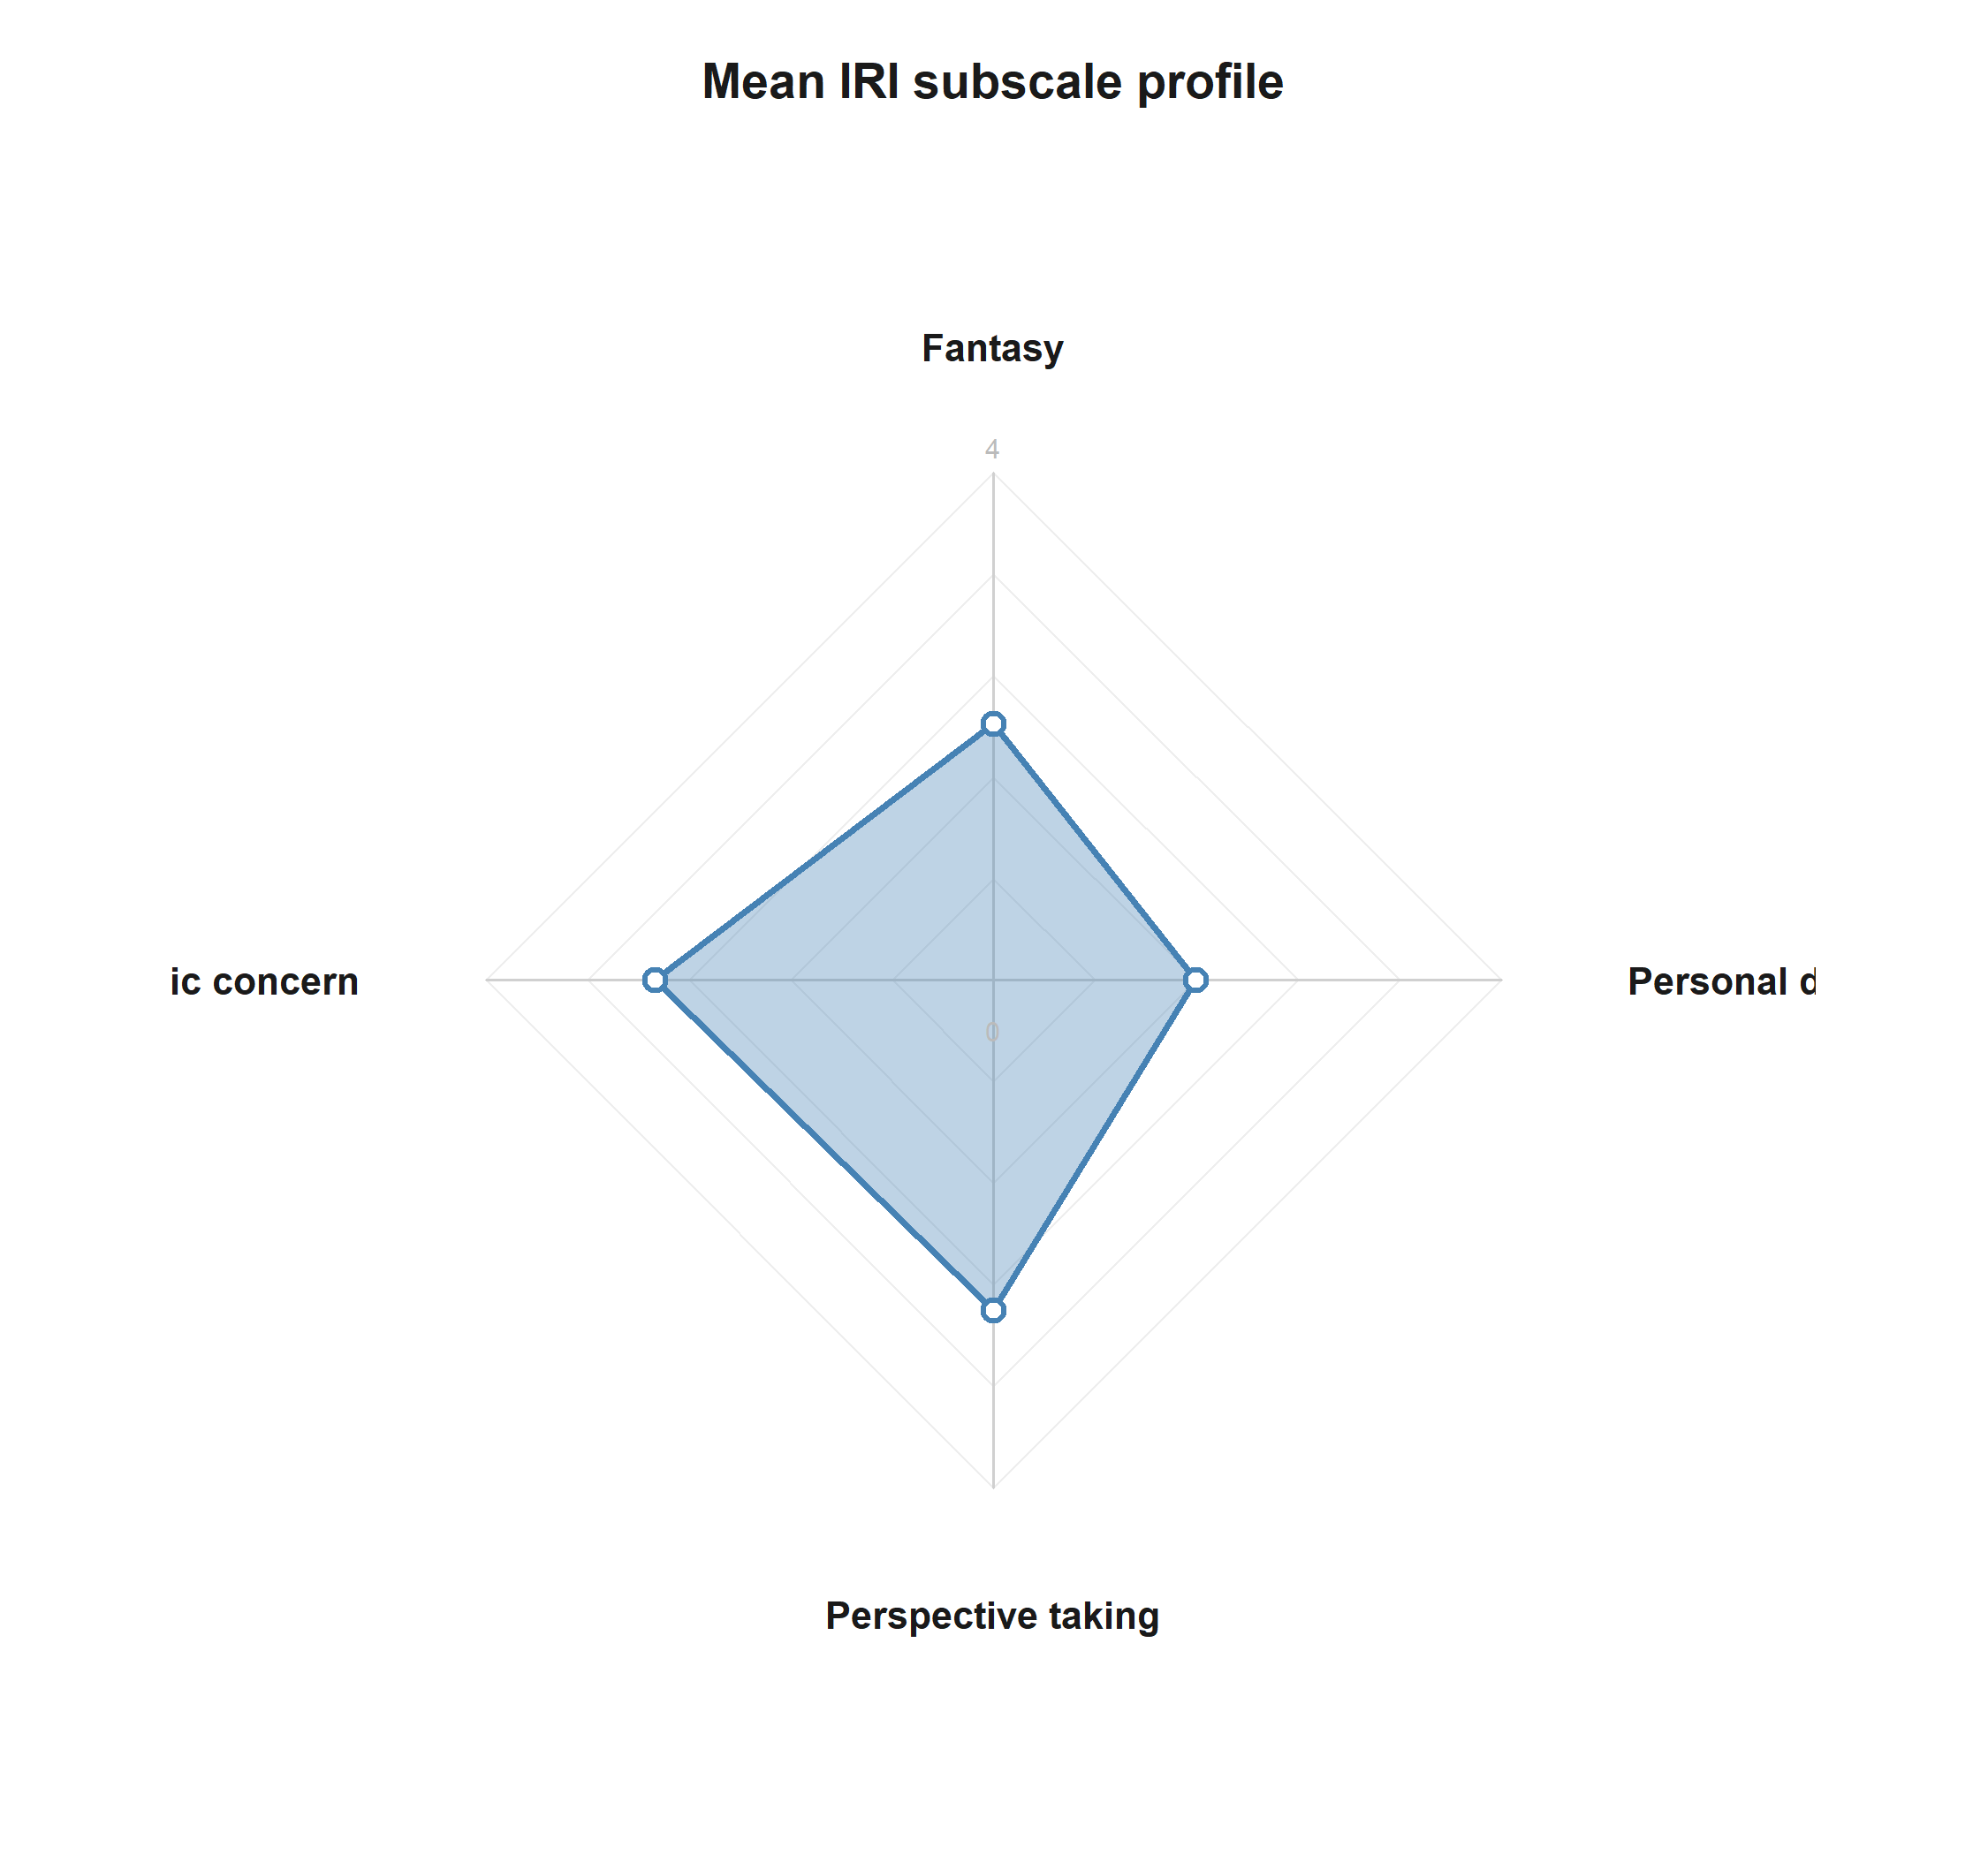
Mean IRI subscale profile across participants.
This figure summarizes the central empathy profile of the sample before conditioning on hypothesis-specific models.
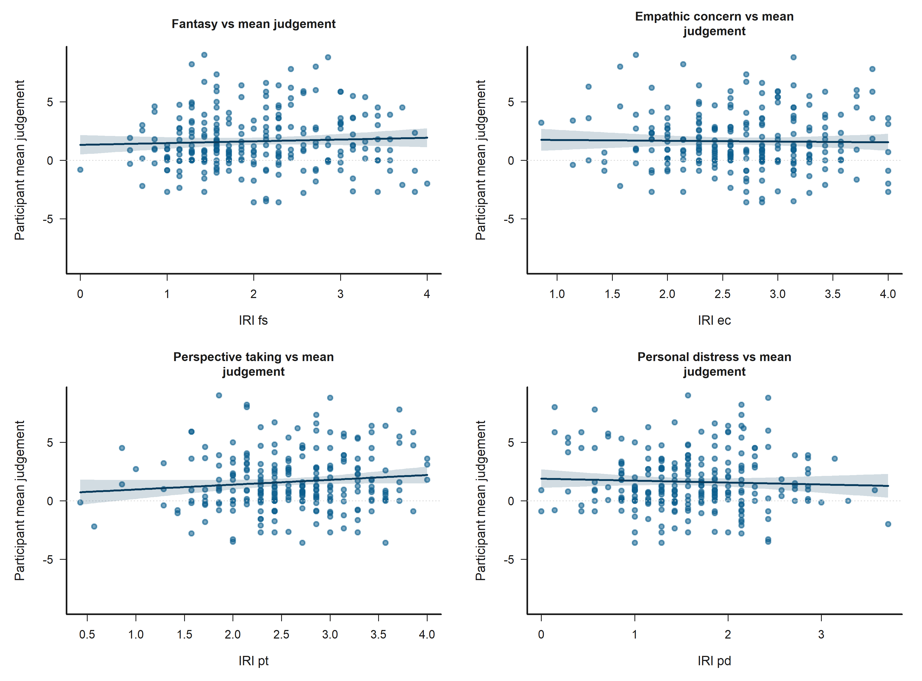
Participant-level bivariate scatters of IRI subscales against mean judgement.
These scatterplots show the participant-level descriptive relationship between empathy dimensions and average judgement.
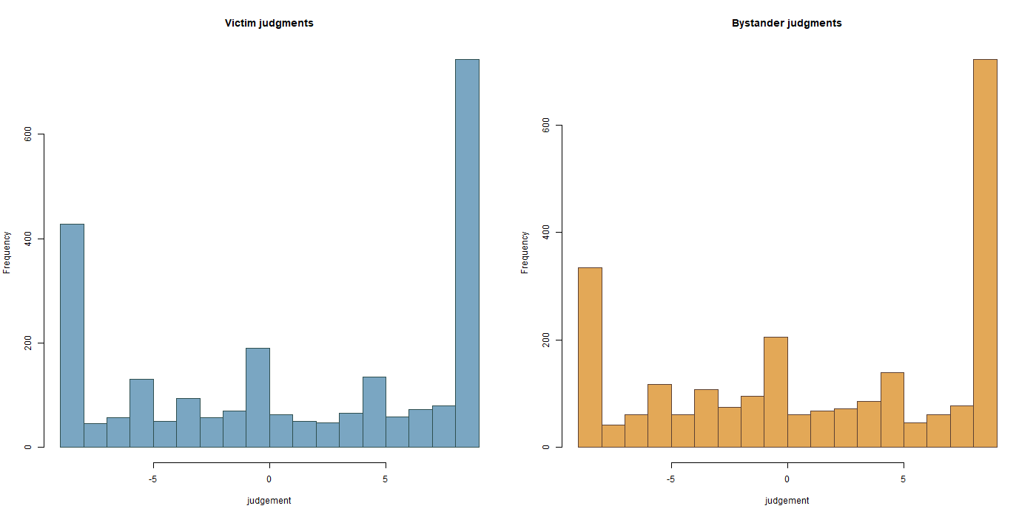
Observed judgement distributions split by role.
This figure shows the raw shape of the bounded judgement outcome in the victim and bystander subsets.
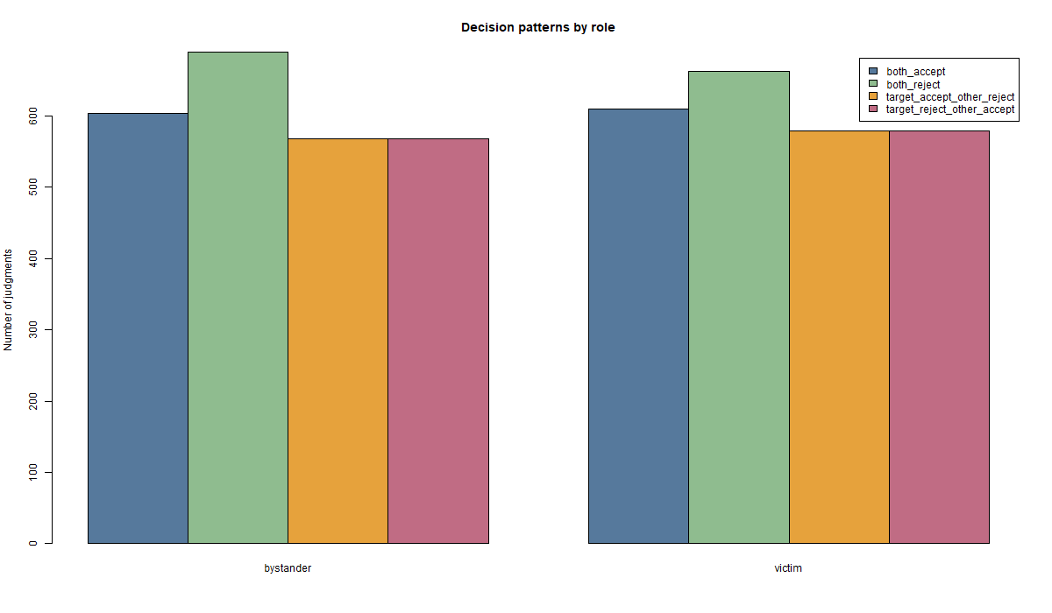
Observed decision patterns by role.
This figure summarizes how the four joint decision contexts are distributed across roles.

Estimator fit summary
Bystander models use 2,420 observations from 243 participants. Victim models use 2,420 observations from 243 participants.
All production models use the estimator configuration shown below.
Table 11. Estimator configuration
Estimator | Session handling | Dependence
Two-sided Tobit | factor_session_fixed_effect | cluster_robust_id

Model-level fit and censoring summary

Bystander models
Table 12. Bystander model fit and censoring summary
H | L. cens. | U. cens. | AIC | BIC | Sigma
H1 | 300 | 723 | 12558.800 | 12703.600 | 10.264
H2 | 300 | 723 | 12557.400 | 12725.400 | 10.242
H3 | 300 | 723 | 12569.200 | 12829.800 | 10.193
H4 | 300 | 723 | 11060.300 | 11199.300 | 6.917
H5 | 300 | 723 | 11080.200 | 11358.200 | 6.876

Victim models
Table 13. Victim model fit and censoring summary
H | L. cens. | U. cens. | AIC | BIC | Sigma
H1 | 377 | 744 | 12280.600 | 12425.300 | 11.564
H2 | 377 | 744 | 12297.600 | 12442.400 | 11.607
H3 | 377 | 744 | 12296.000 | 12510.300 | 11.541
H4 | 377 | 744 | 10747.900 | 10886.900 | 7.626
H5 | 377 | 744 | 10749.300 | 10980.900 | 7.570

Hypothesis significance summary by role

Victim
Table 14. Victim focal support terms (p < 0.10)
hypothesis | role | support
H1 | Victim | Empathy: Perspective taking**
H2 | Victim | None below p < 0.10
H3 | Victim | Empathy: Fantasy*; Empathy: Perspective taking+
H4 | Victim | Target accepted; Other negotiator accepted; Target accepted x Other accepted***
H5 | Victim | Empathy: Fantasy; Victim-N2 outgroup vs ingroup+; Target accepted; Other negotiator accepted; Empathy: Fantasy x Victim-N1 outgroup vs ingroup+; Target accepted x Other accepted**

Bystander
Table 15. Bystander focal support terms (p < 0.10)
hypothesis | role | support
H1 | Bystander | None below p < 0.10
H2 | Bystander | Bystander-N2 outgroup vs ingroup+; Victim-N1 outgroup vs ingroup+; Victim-N2 outgroup vs ingroup+; Bystander-N1 outgroup vs ingroup x Bystander-N2 outgroup vs ingroup+; Victim-N1 outgroup vs ingroup x Victim-N2 outgroup vs ingroup+
H3 | Bystander | Empathy: Empathic concern+; Empathy: Personal distress+; Victim-N1 outgroup vs ingroup+; Victim-N2 outgroup vs ingroup+; Bystander-N1 outgroup vs ingroup x Bystander-N2 outgroup vs ingroup+; Victim-N1 outgroup vs ingroup x Victim-N2 outgroup vs ingroup+; Empathy: Fantasy x Bystander-victim outgroup vs ingroup+; Empathy: Personal distress x Bystander-victim outgroup vs ingroup*
H4 | Bystander | Target accepted; Other negotiator accepted; Target accepted x Other accepted***
H5 | Bystander | Victim-N1 outgroup vs ingroup; Victim-N2 outgroup vs ingroup; Target accepted; Other negotiator accepted; Victim-N1 outgroup vs ingroup x Victim-N2 outgroup vs ingroup; Empathy: Fantasy x Bystander-victim outgroup vs ingroup; Target accepted x Other accepted***

Significance-driven figures

H1 Victim: Empathy: Perspective taking
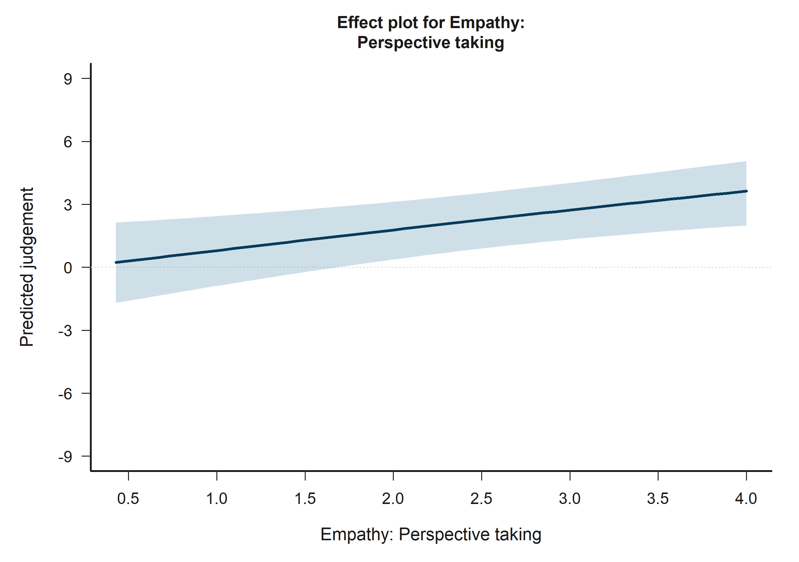
H1 Victim: model-implied predictions for Empathy: Perspective taking.
Across the displayed contrast, the model implies higher predicted judgement toward the right-hand side of the plot.

H2 Bystander: Bystander-N2 outgroup vs ingroup
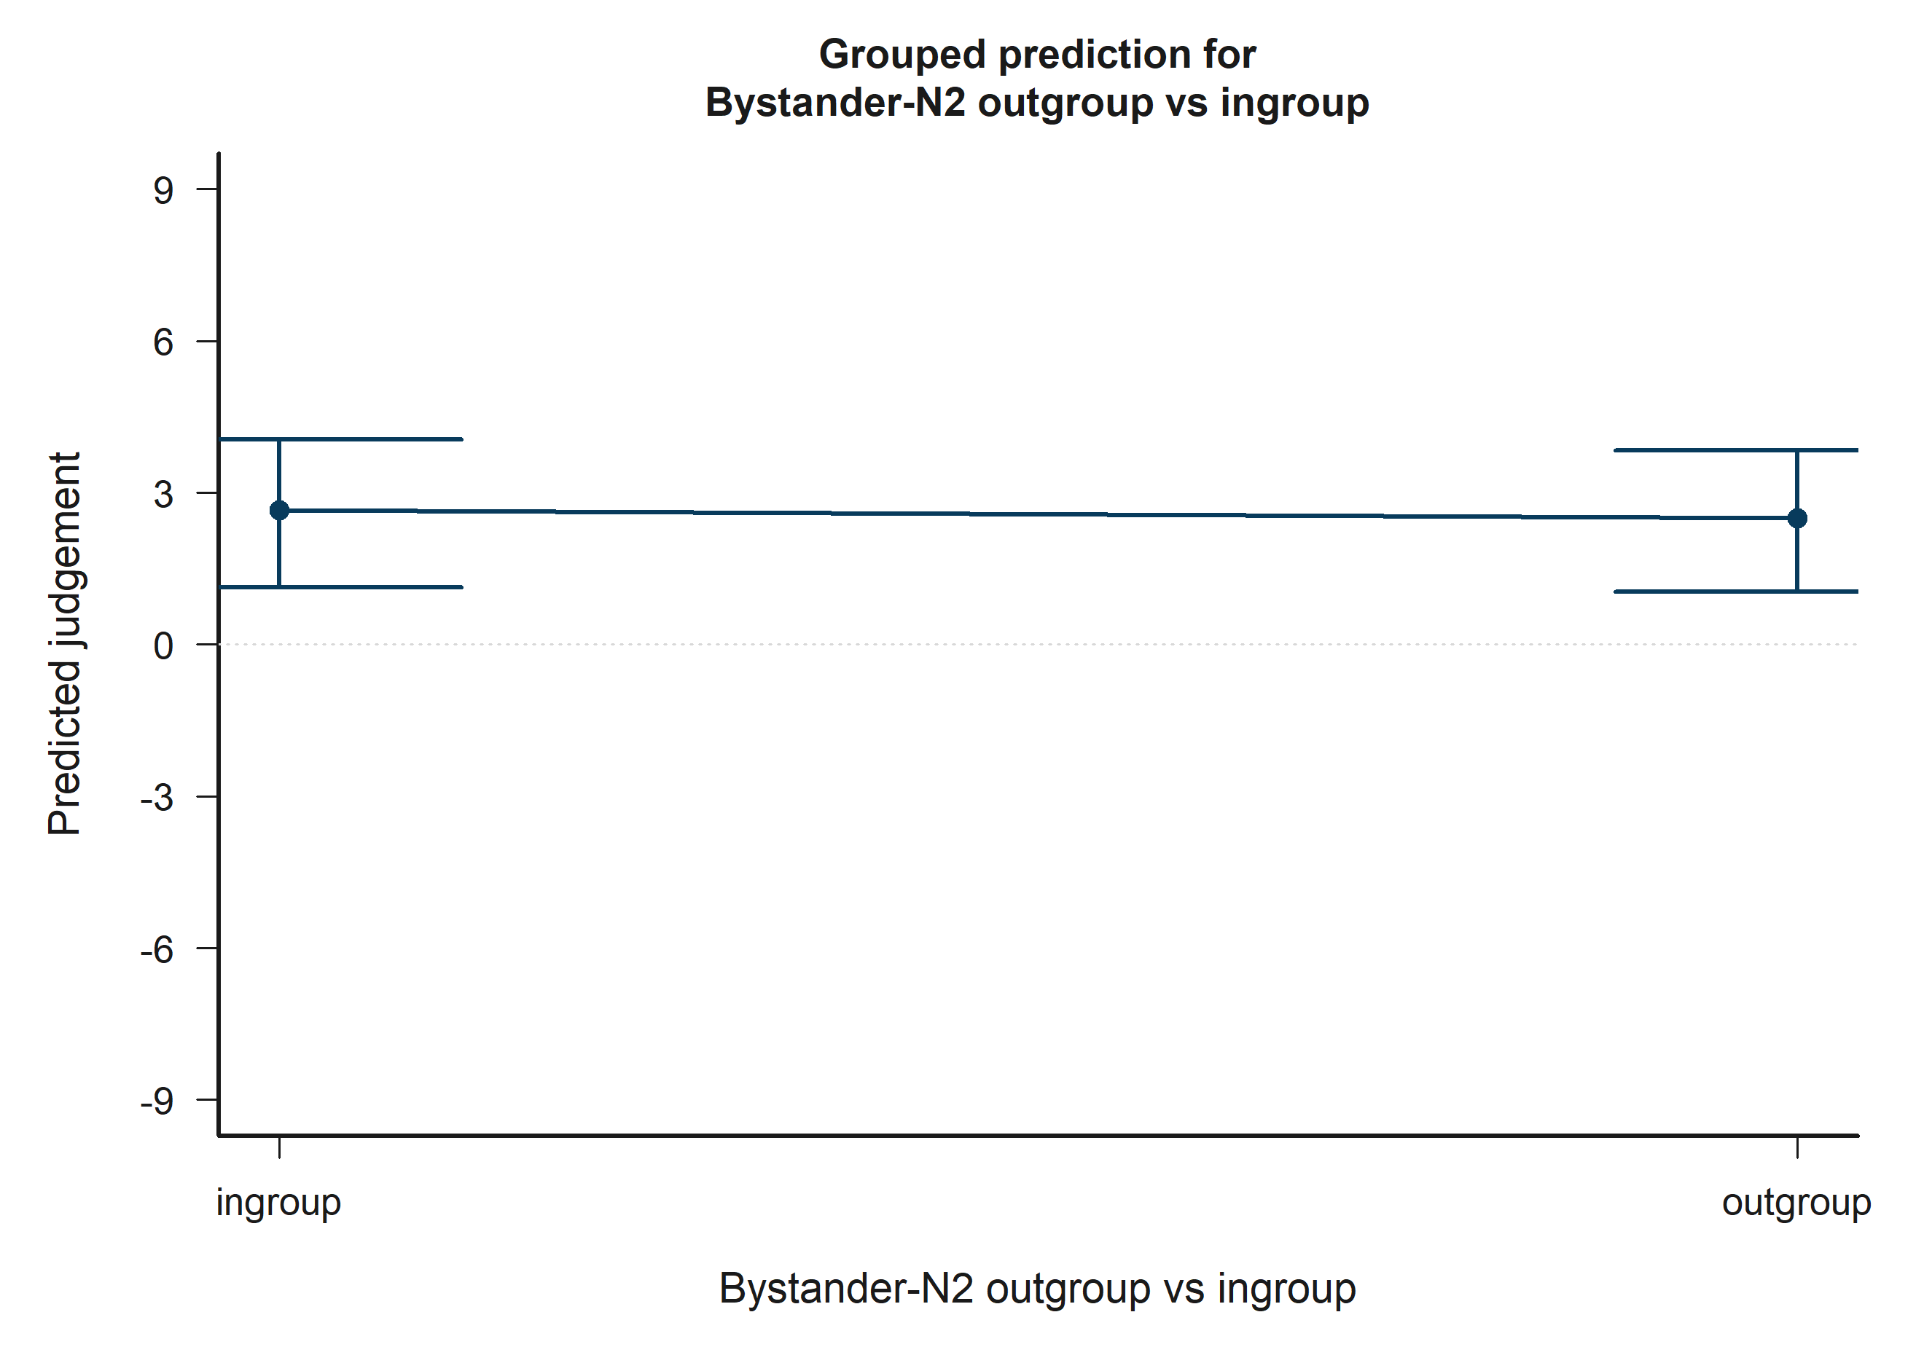
H2 Bystander: model-implied predictions for Bystander-N2 outgroup vs ingroup.
Across the displayed contrast, the model implies lower predicted judgement toward the right-hand side of the plot.

H2 Bystander: Victim-N1 outgroup vs ingroup
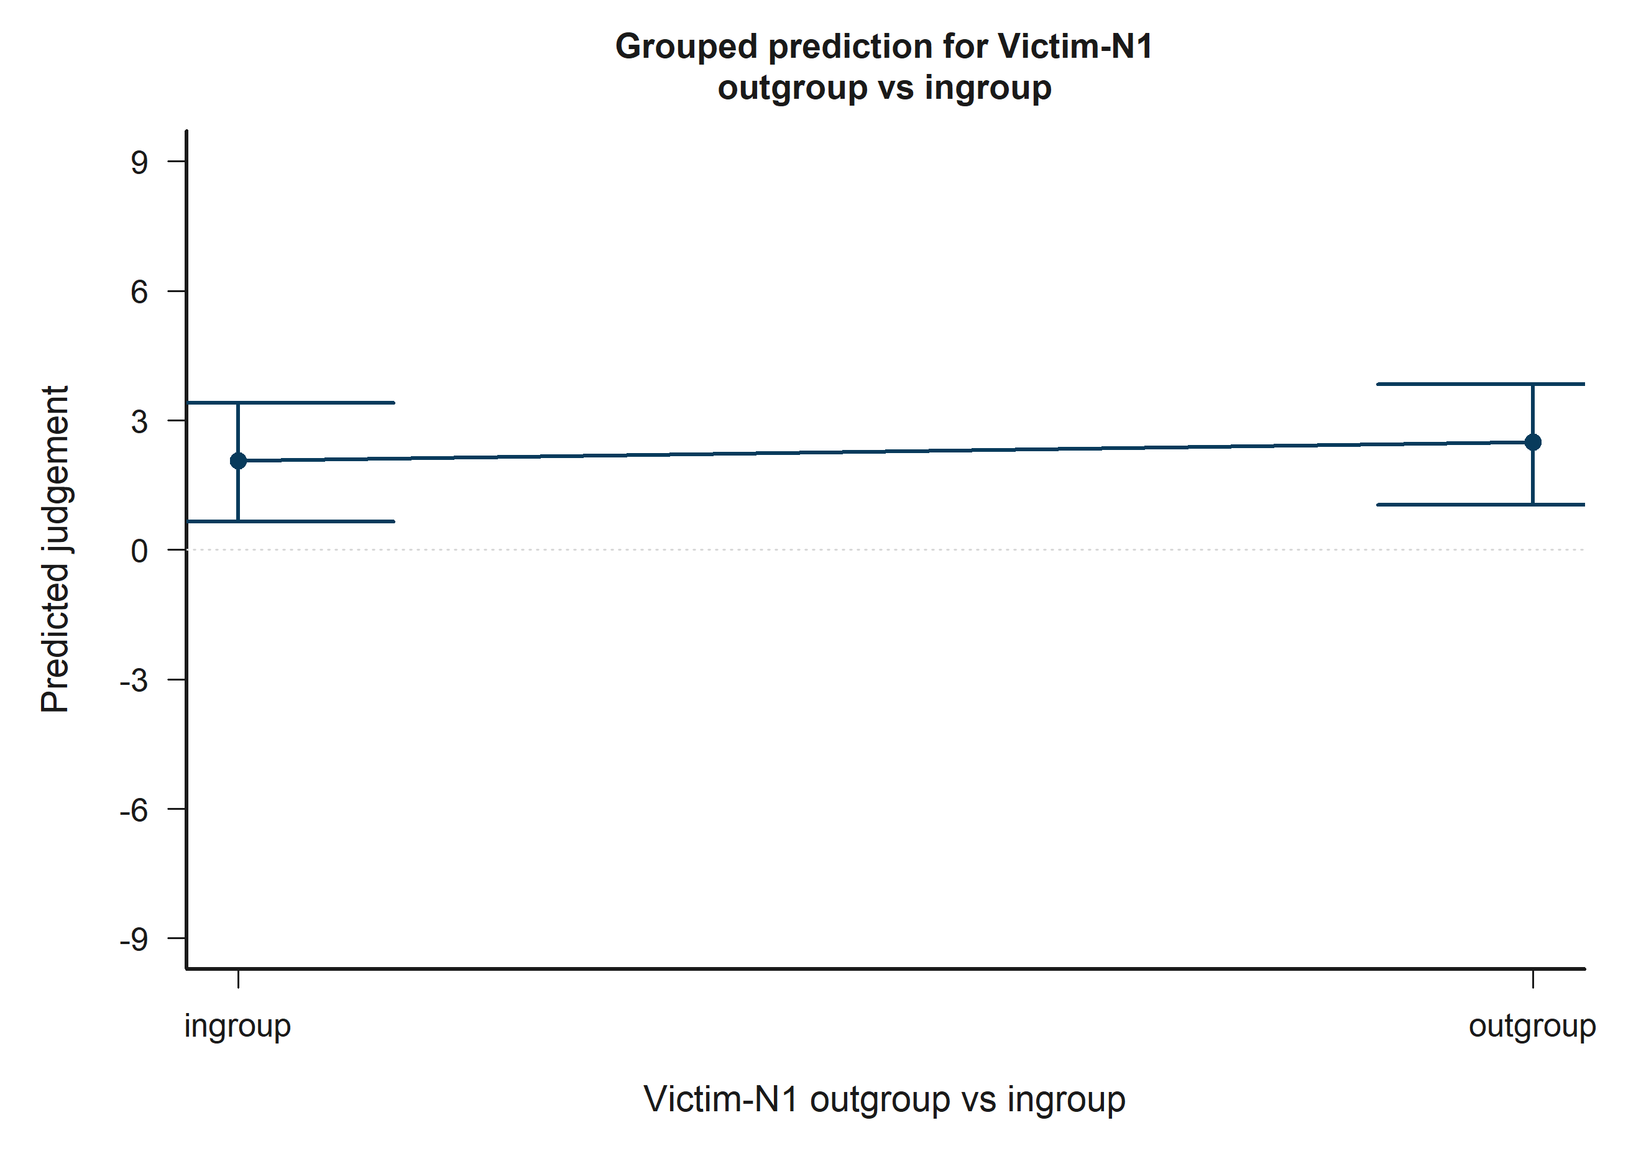
H2 Bystander: model-implied predictions for Victim-N1 outgroup vs ingroup.
Across the displayed contrast, the model implies higher predicted judgement toward the right-hand side of the plot.

H2 Bystander: Victim-N2 outgroup vs ingroup
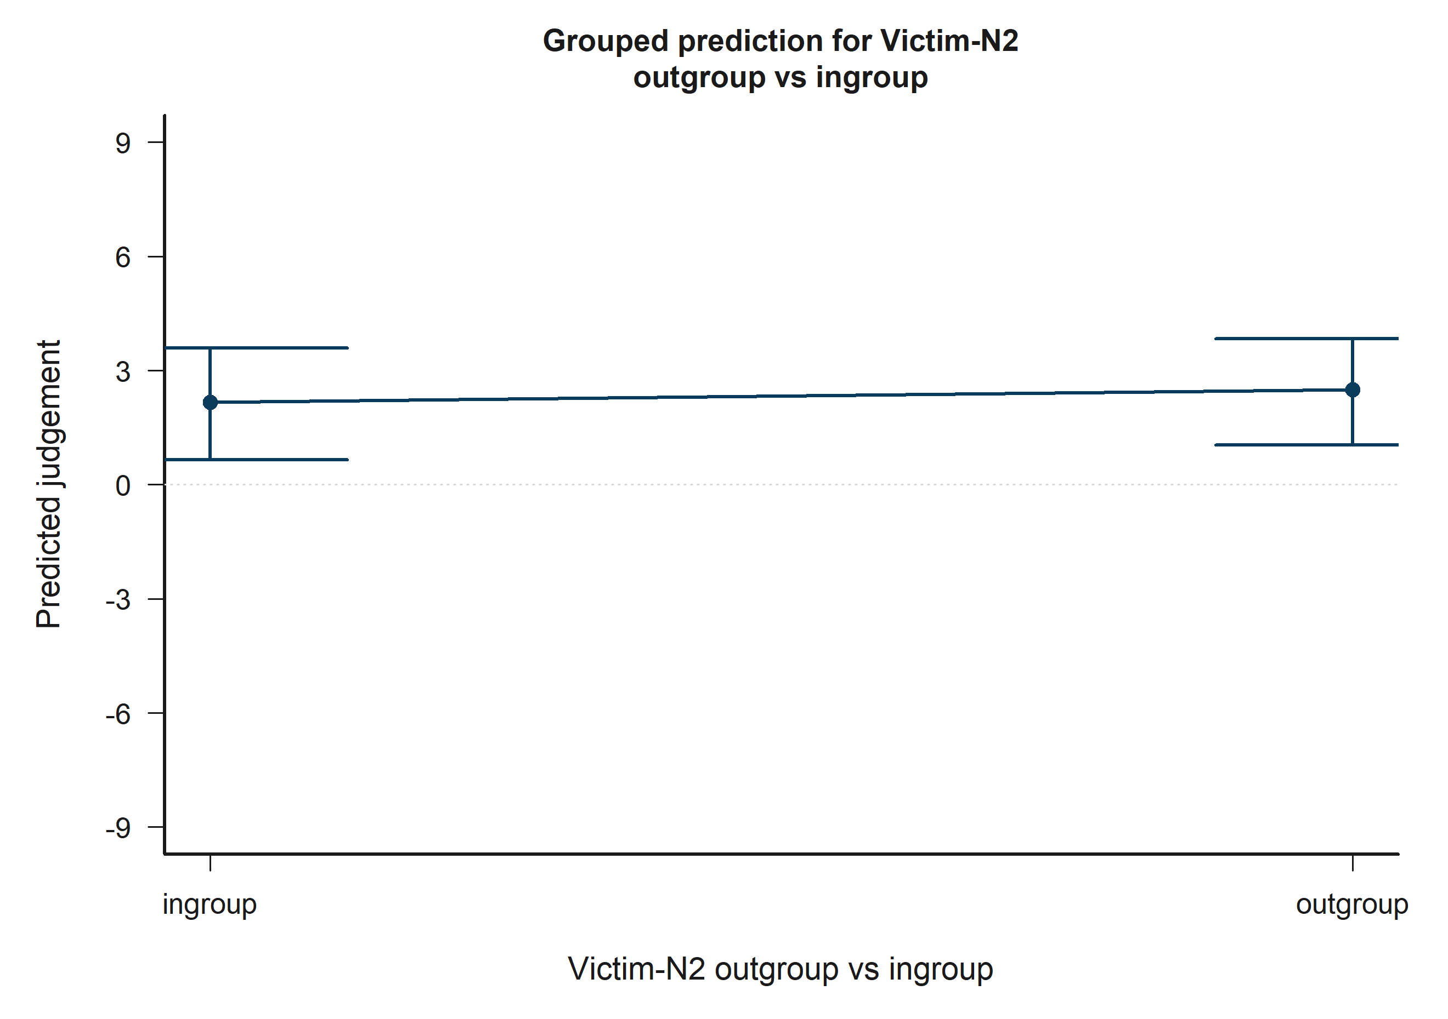
H2 Bystander: model-implied predictions for Victim-N2 outgroup vs ingroup.
Across the displayed contrast, the model implies higher predicted judgement toward the right-hand side of the plot.

H2 Bystander: Bystander-N1 outgroup vs ingroup x Bystander-N2 outgroup vs ingroup
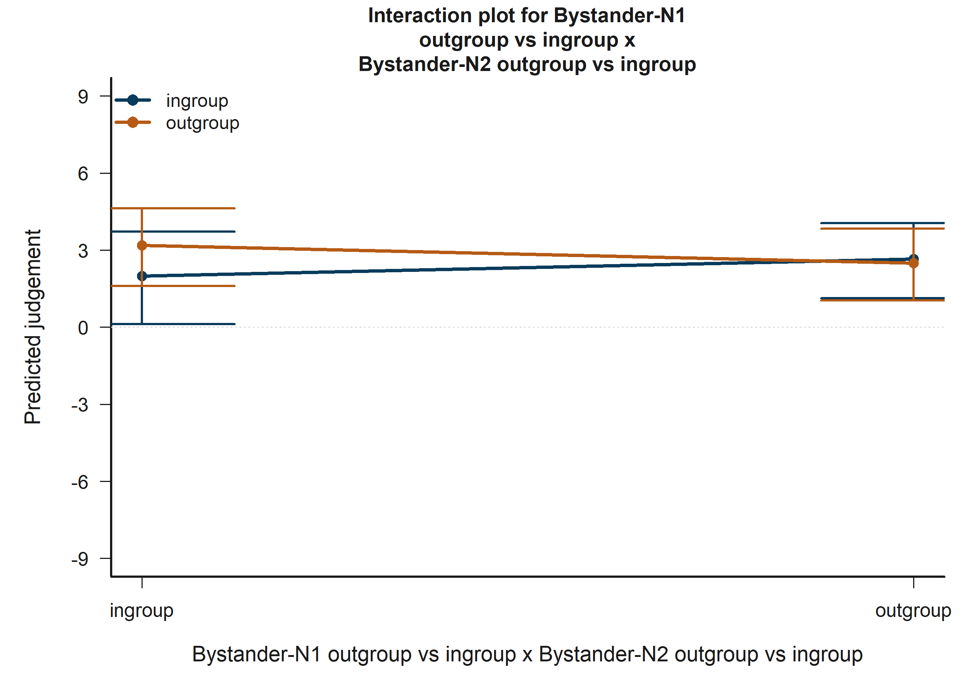
H2 Bystander: model-implied predictions for Bystander-N1 outgroup vs ingroup x Bystander-N2 outgroup vs ingroup.
The plotted lines summarize how the fitted predicted judgement changes across the focal term while holding the remaining covariates at their reference profile.

H2 Bystander: Victim-N1 outgroup vs ingroup x Victim-N2 outgroup vs ingroup
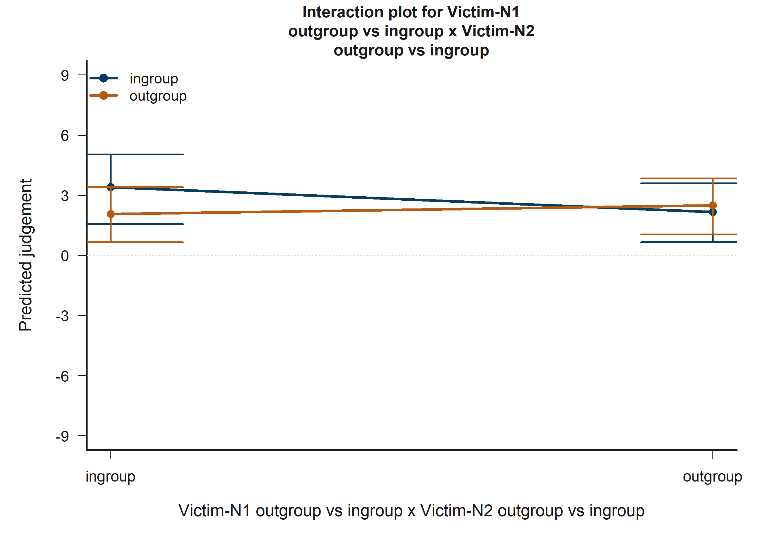
H2 Bystander: model-implied predictions for Victim-N1 outgroup vs ingroup x Victim-N2 outgroup vs ingroup.
The plotted lines summarize how the fitted predicted judgement changes across the focal term while holding the remaining covariates at their reference profile.

H3 Victim: Empathy: Fantasy
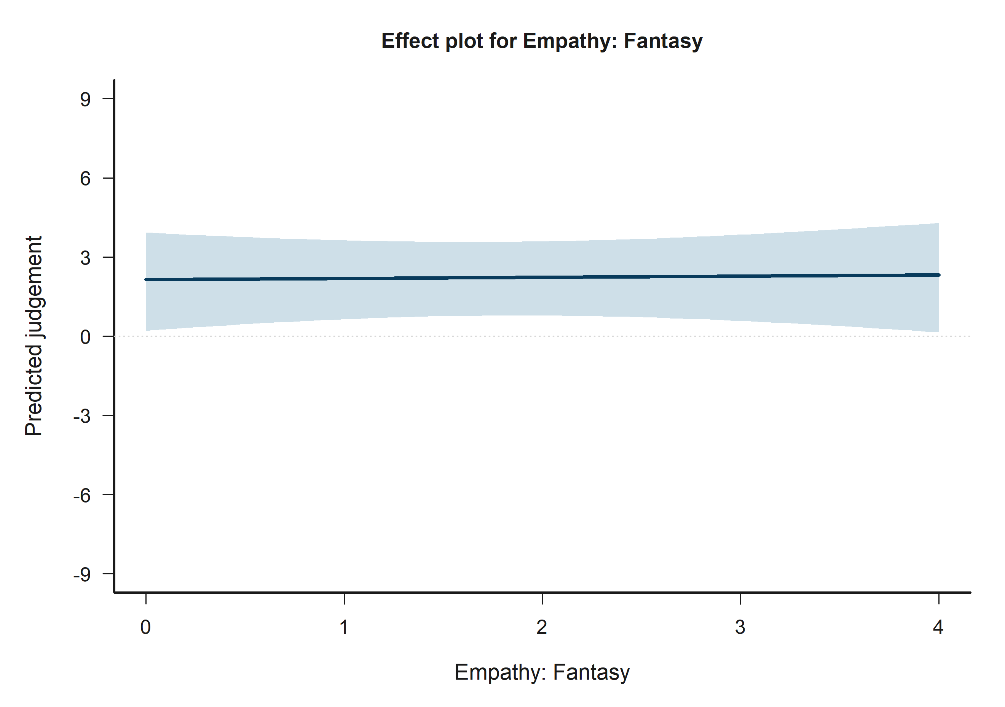
H3 Victim: model-implied predictions for Empathy: Fantasy.
Across the displayed contrast, the model implies higher predicted judgement toward the right-hand side of the plot.

H3 Victim: Empathy: Perspective taking
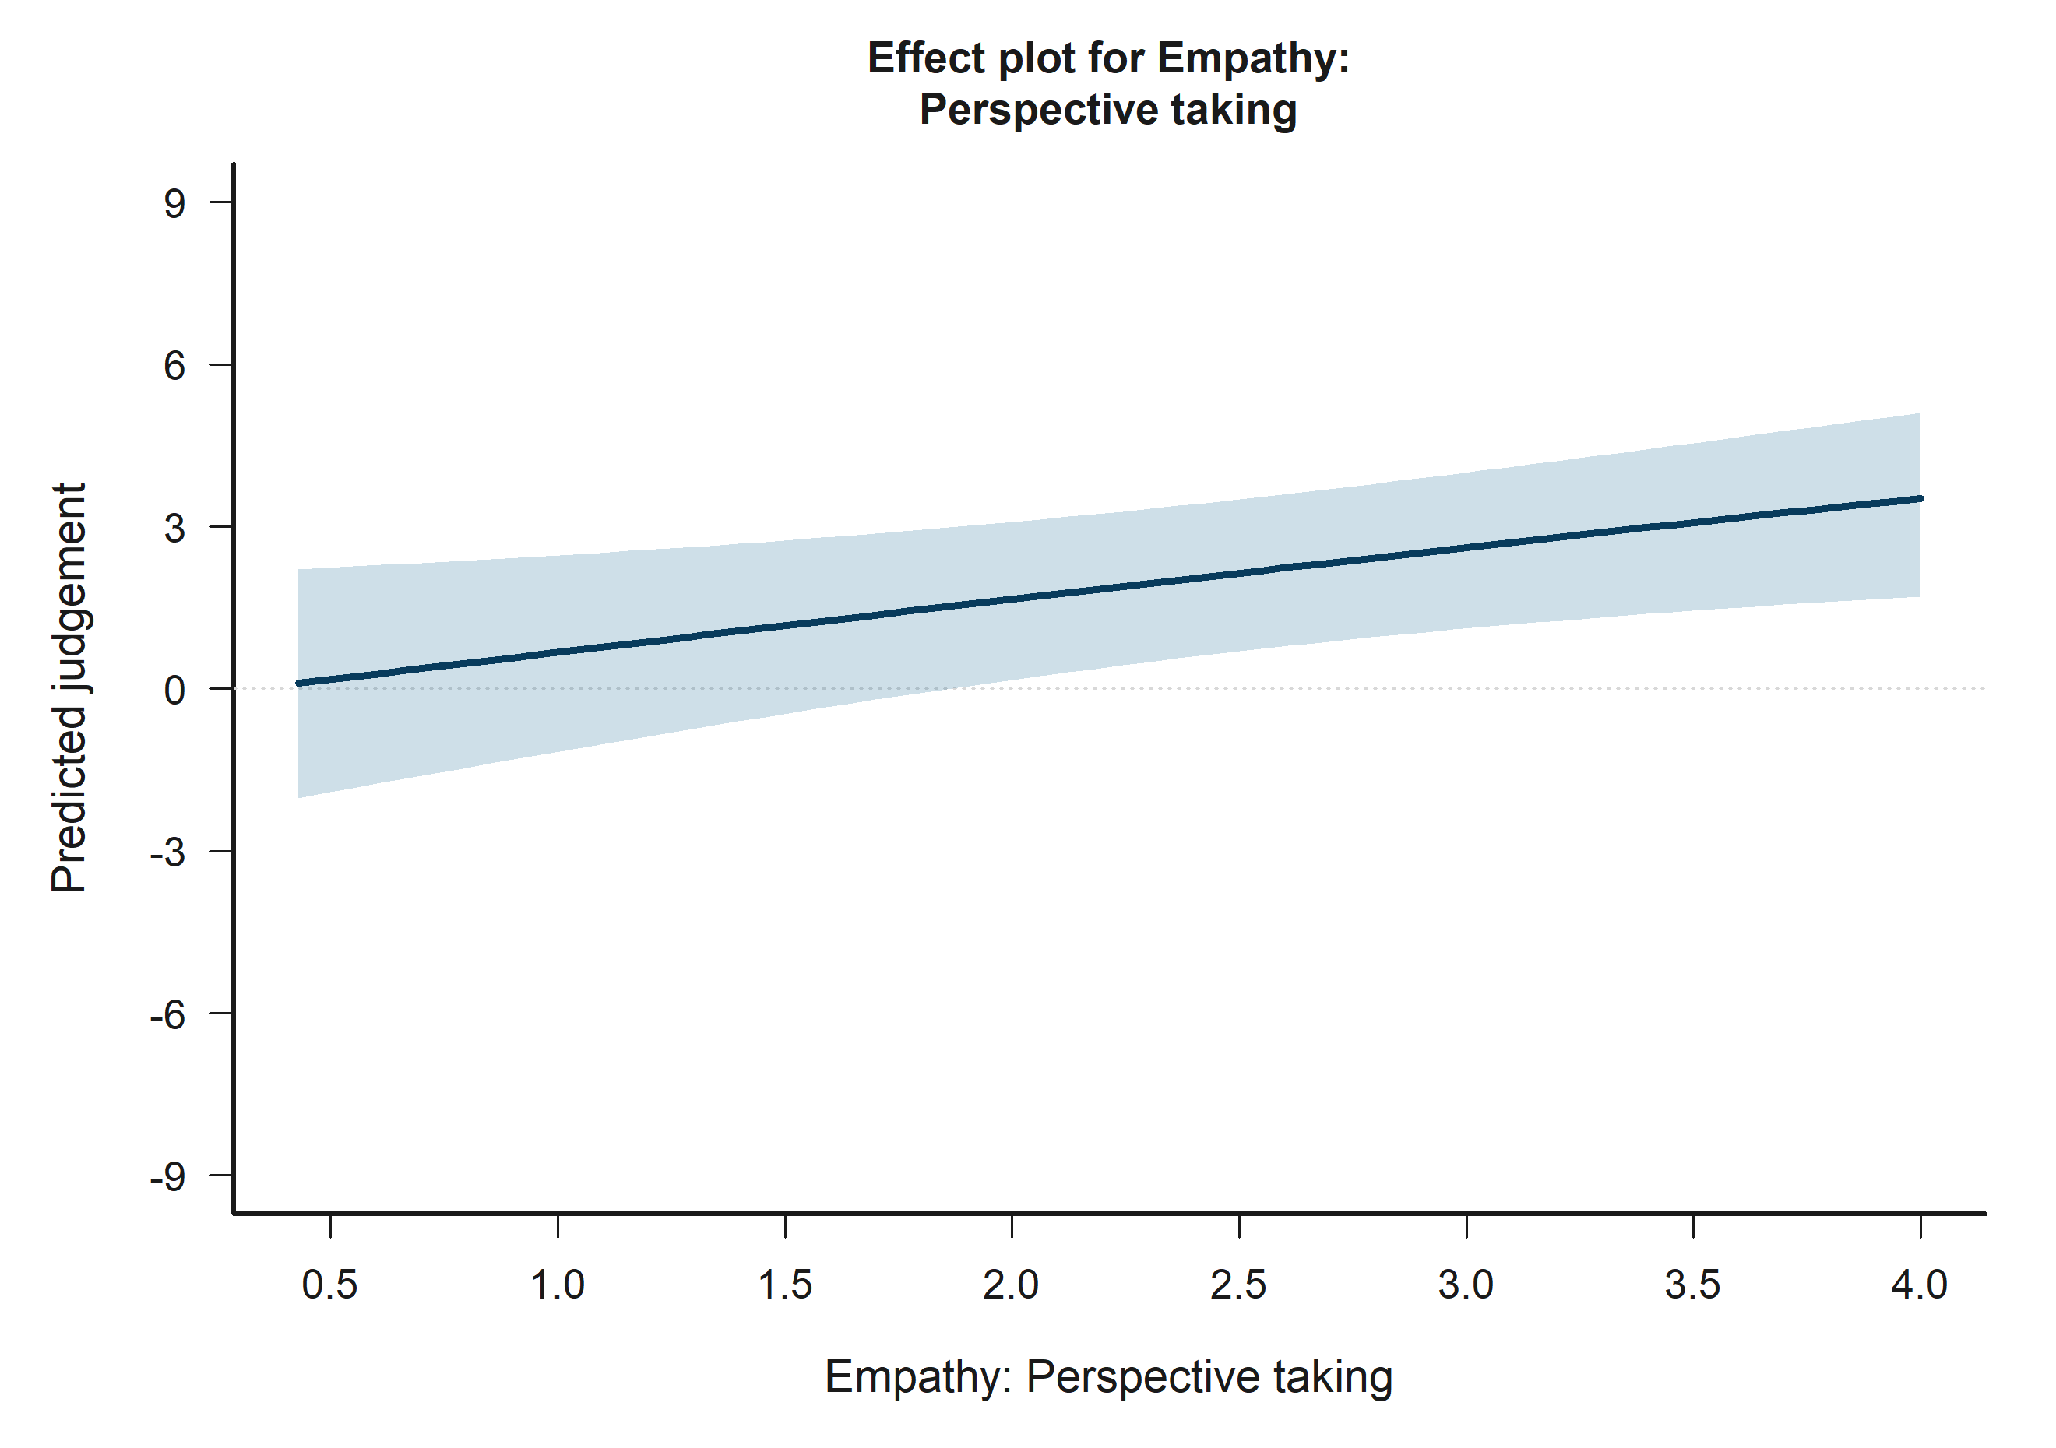
H3 Victim: model-implied predictions for Empathy: Perspective taking.
Across the displayed contrast, the model implies higher predicted judgement toward the right-hand side of the plot.

H3 Bystander: Empathy: Empathic concern
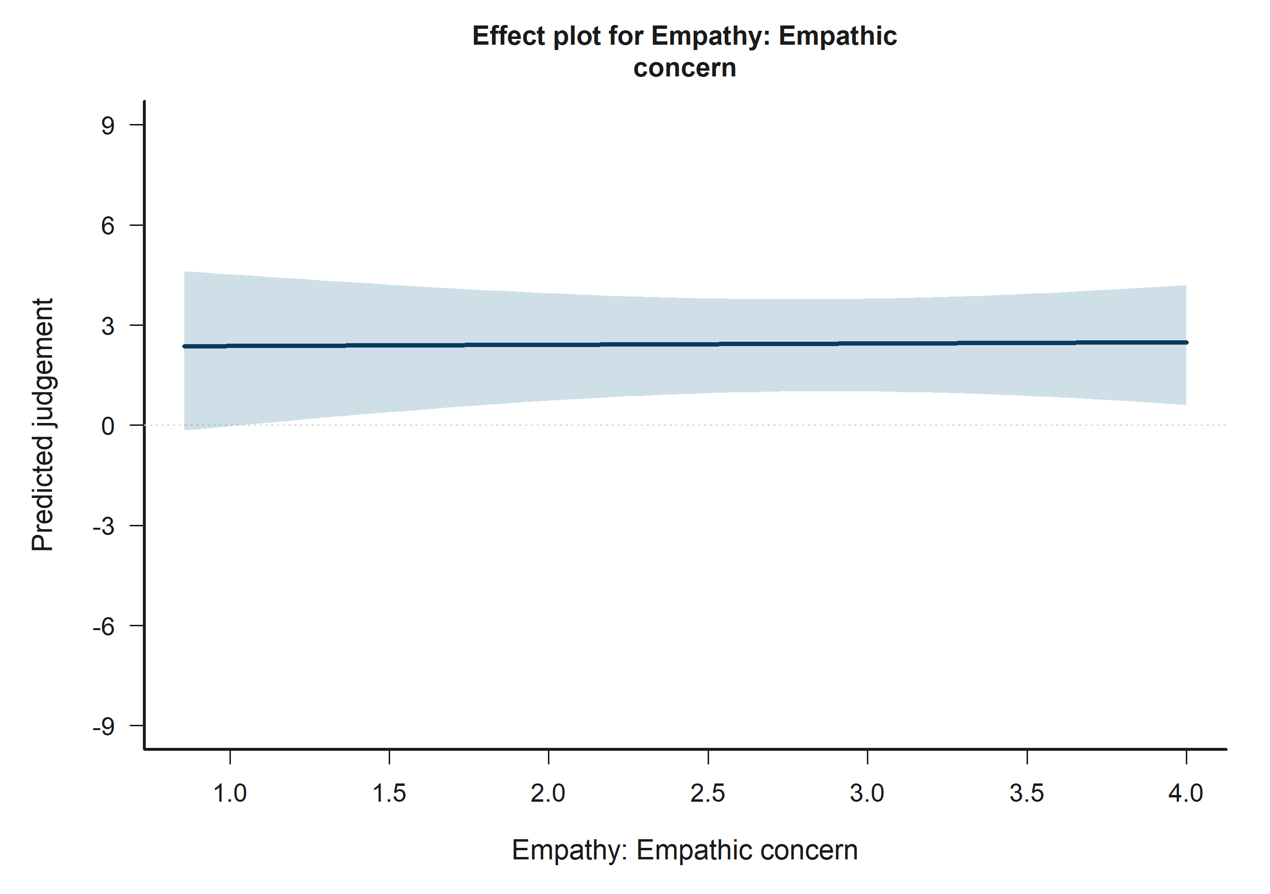
H3 Bystander: model-implied predictions for Empathy: Empathic concern.
Across the displayed contrast, the model implies higher predicted judgement toward the right-hand side of the plot.

H3 Bystander: Empathy: Personal distress
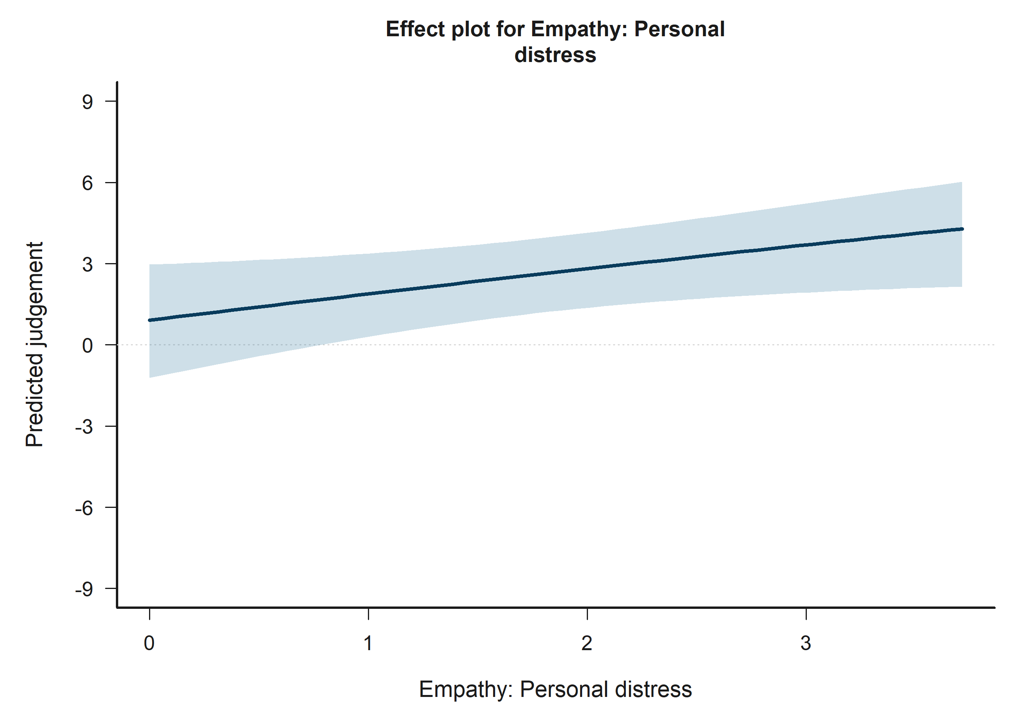
H3 Bystander: model-implied predictions for Empathy: Personal distress.
Across the displayed contrast, the model implies higher predicted judgement toward the right-hand side of the plot.

H3 Bystander: Victim-N1 outgroup vs ingroup
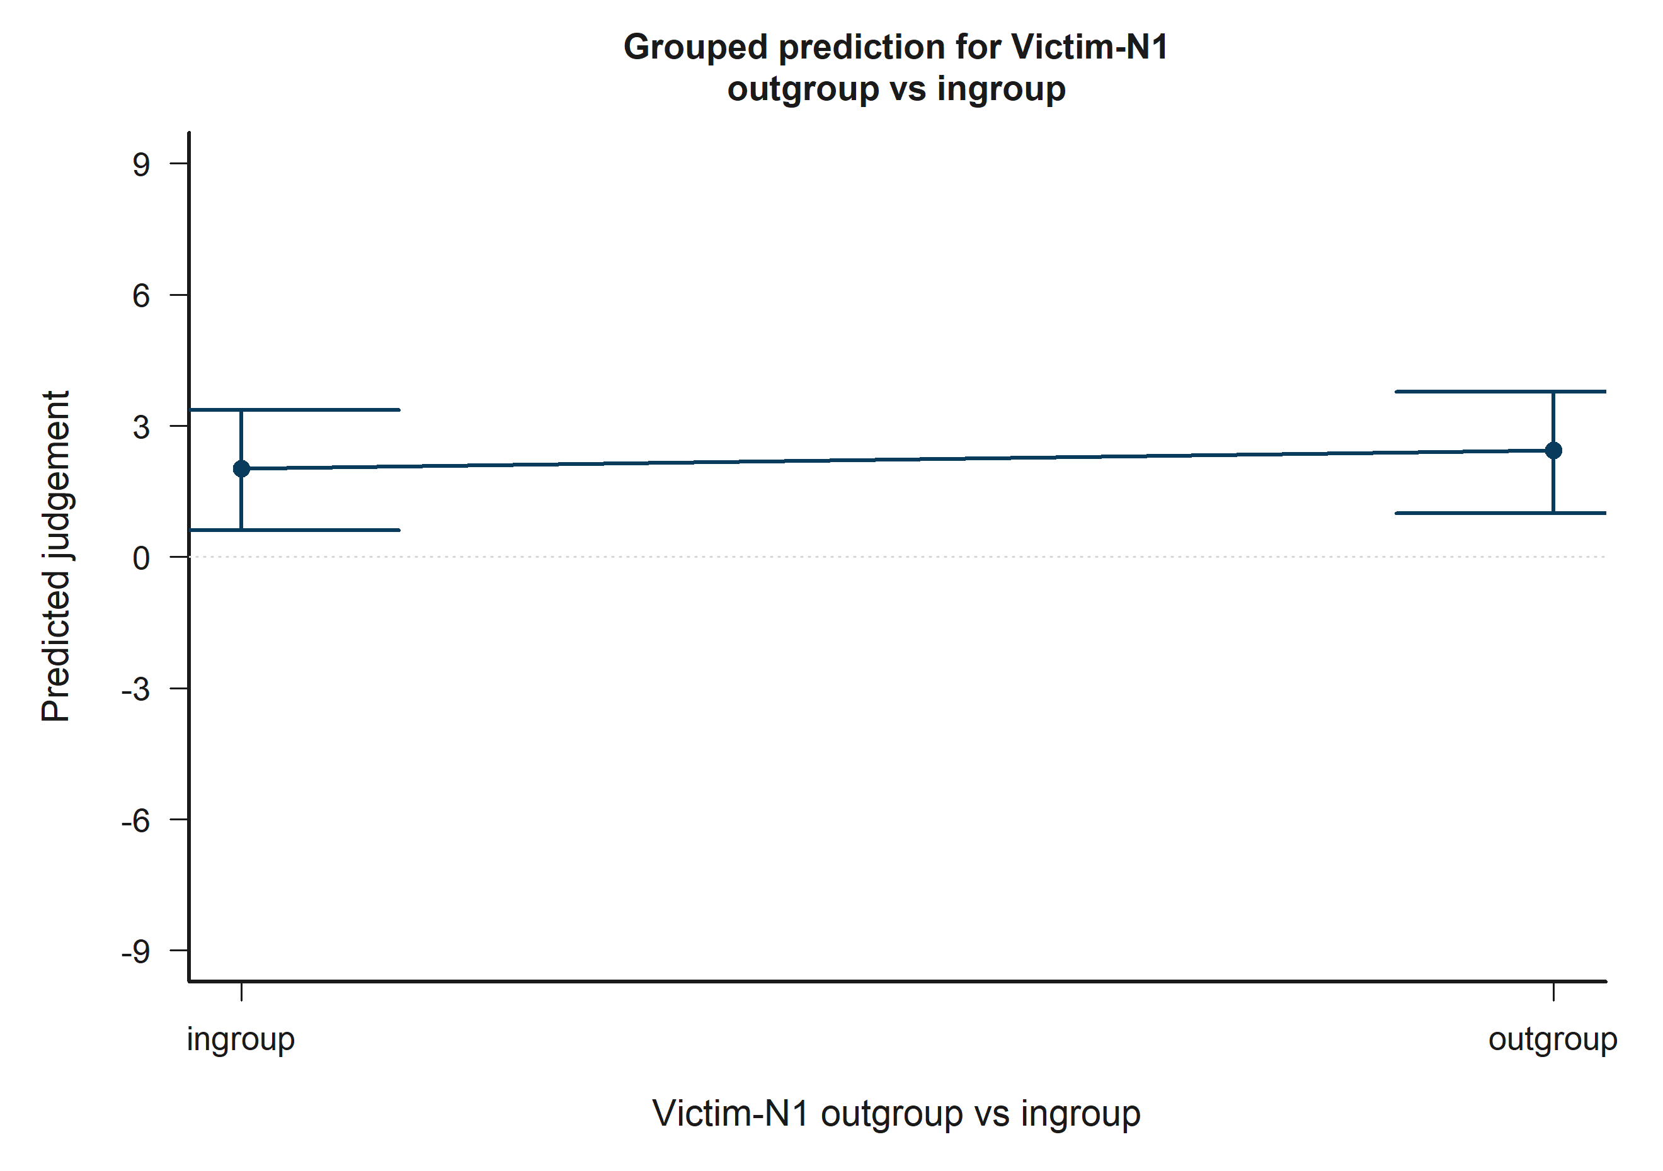
H3 Bystander: model-implied predictions for Victim-N1 outgroup vs ingroup.
Across the displayed contrast, the model implies higher predicted judgement toward the right-hand side of the plot.

H3 Bystander: Victim-N2 outgroup vs ingroup
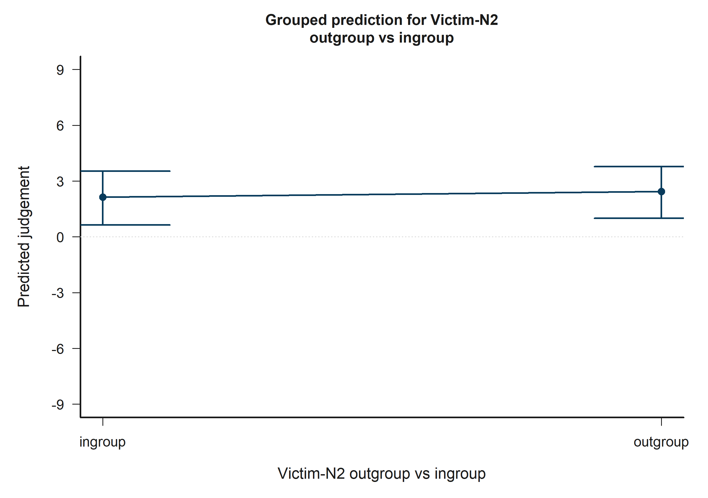
H3 Bystander: model-implied predictions for Victim-N2 outgroup vs ingroup.
Across the displayed contrast, the model implies higher predicted judgement toward the right-hand side of the plot.

H3 Bystander: Bystander-N1 outgroup vs ingroup x Bystander-N2 outgroup vs ingroup
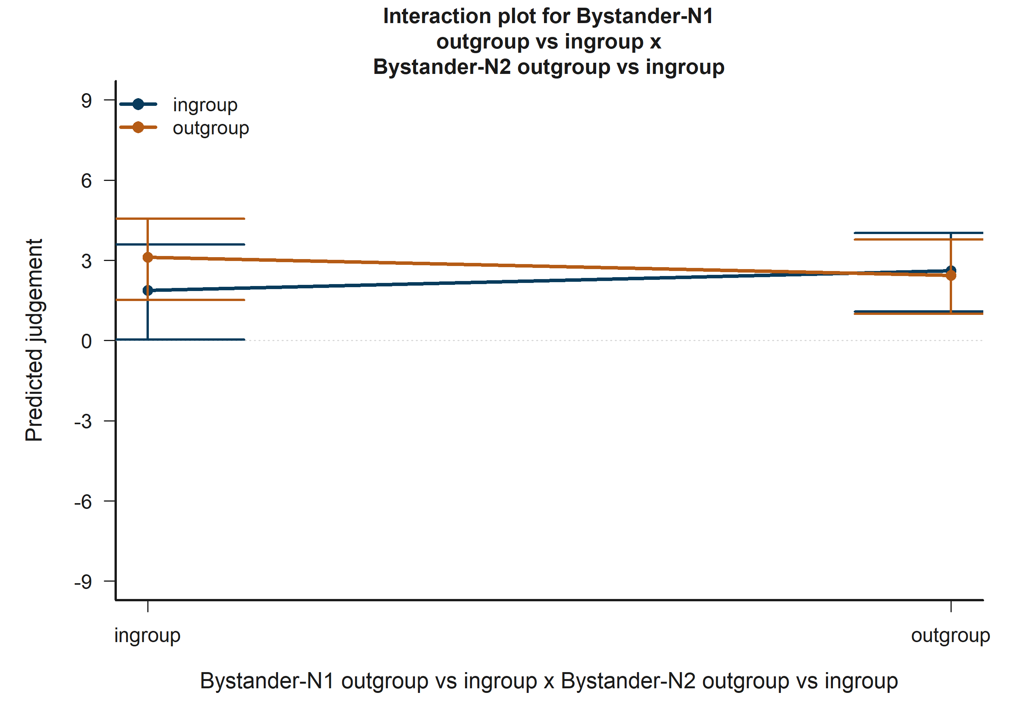
H3 Bystander: model-implied predictions for Bystander-N1 outgroup vs ingroup x Bystander-N2 outgroup vs ingroup.
The plotted lines summarize how the fitted predicted judgement changes across the focal term while holding the remaining covariates at their reference profile.

H3 Bystander: Victim-N1 outgroup vs ingroup x Victim-N2 outgroup vs ingroup
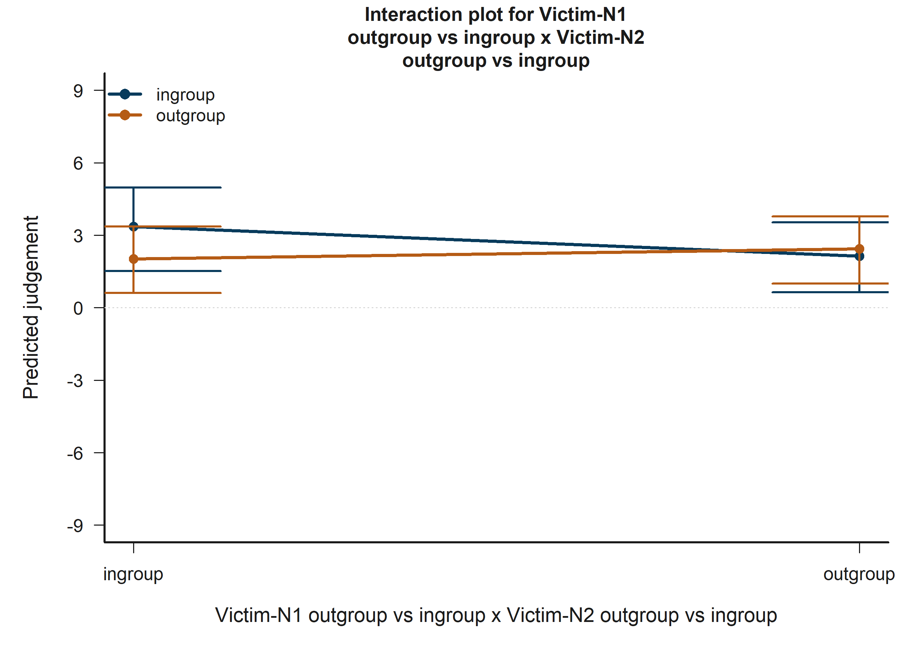
H3 Bystander: model-implied predictions for Victim-N1 outgroup vs ingroup x Victim-N2 outgroup vs ingroup.
The plotted lines summarize how the fitted predicted judgement changes across the focal term while holding the remaining covariates at their reference profile.

H3 Bystander: Empathy: Fantasy x Bystander-victim outgroup vs ingroup
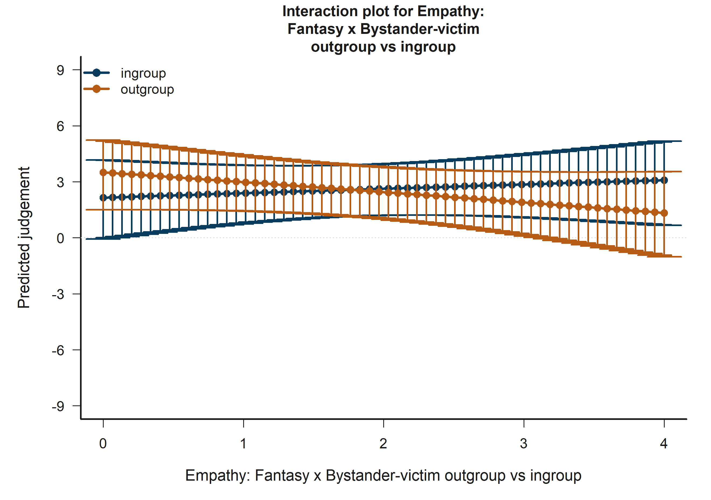
H3 Bystander: model-implied predictions for Empathy: Fantasy x Bystander-victim outgroup vs ingroup.
The plotted lines summarize how the fitted predicted judgement changes across the focal term while holding the remaining covariates at their reference profile.

H3 Bystander: Empathy: Personal distress x Bystander-victim outgroup vs ingroup
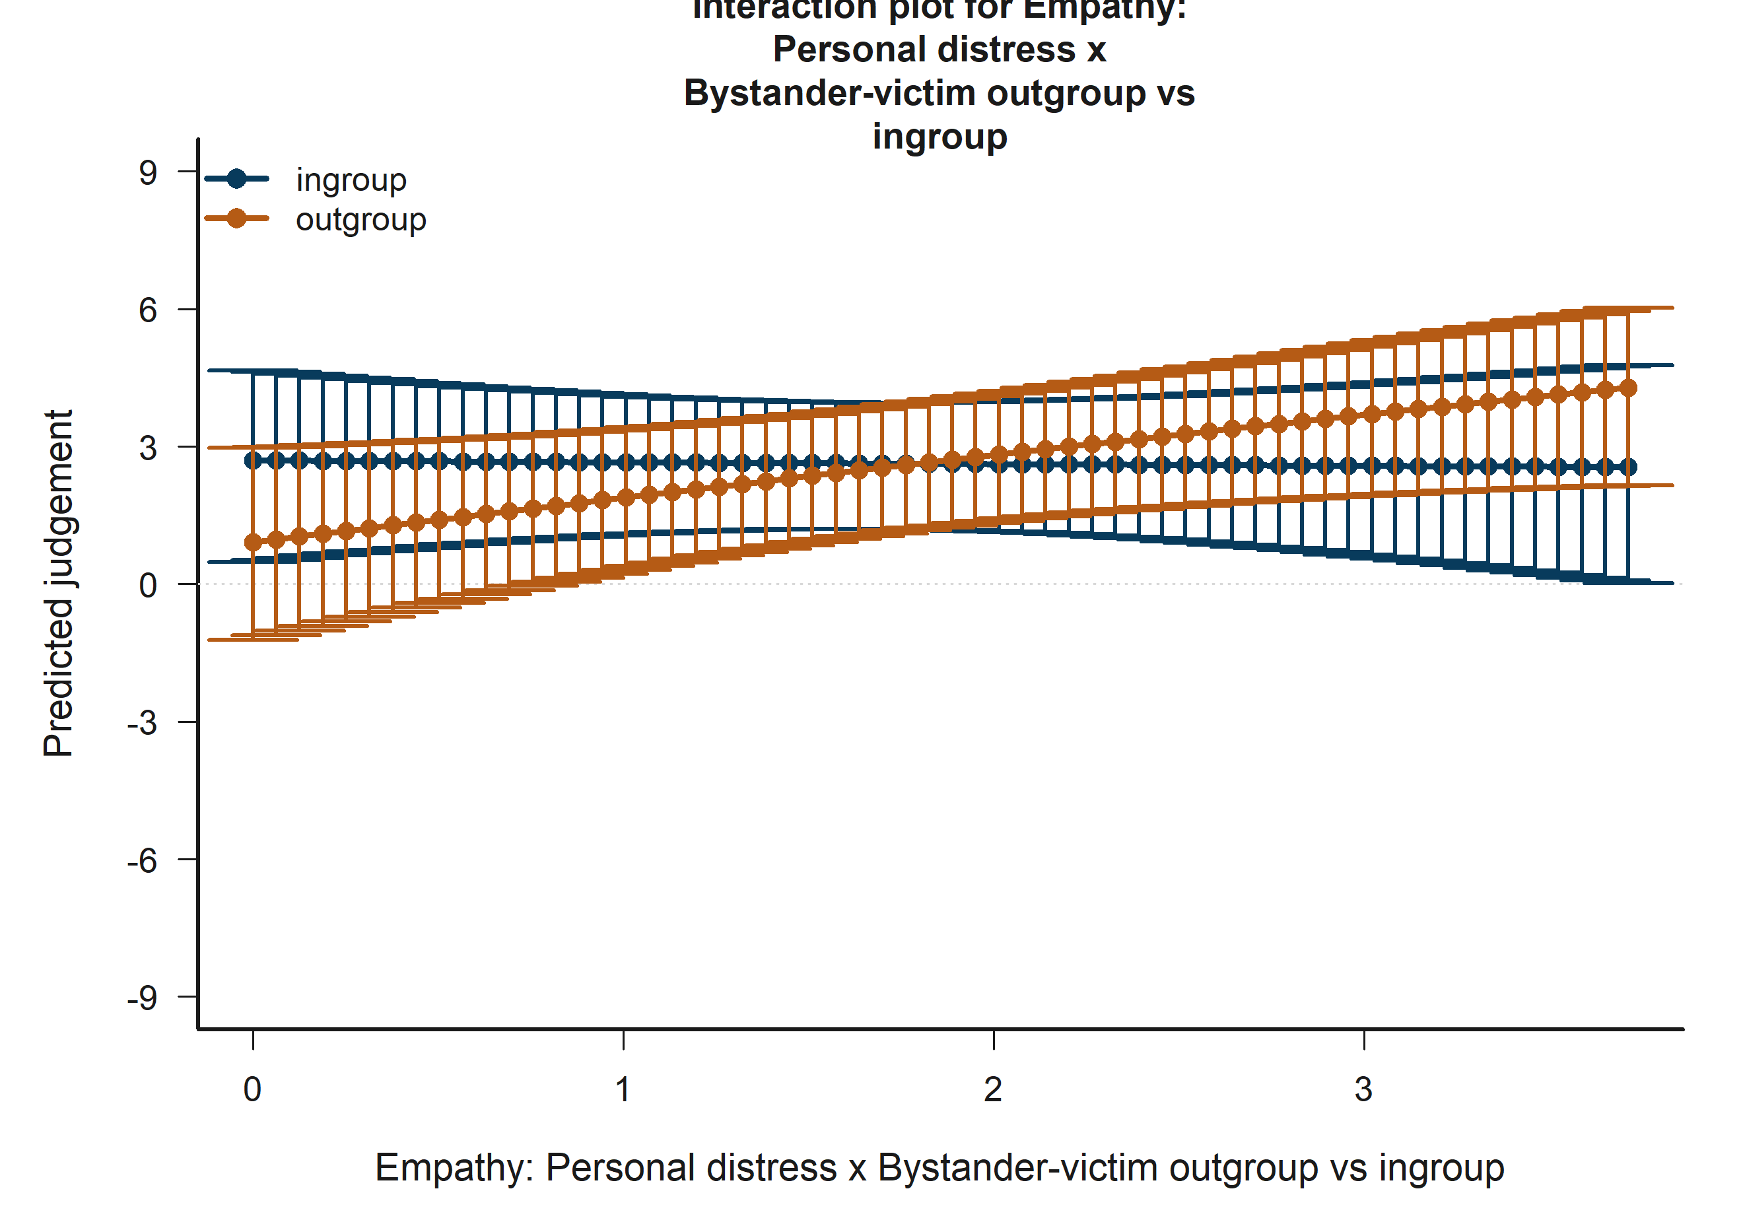
H3 Bystander: model-implied predictions for Empathy: Personal distress x Bystander-victim outgroup vs ingroup.
The plotted lines summarize how the fitted predicted judgement changes across the focal term while holding the remaining covariates at their reference profile.

H4 Victim: Target accepted
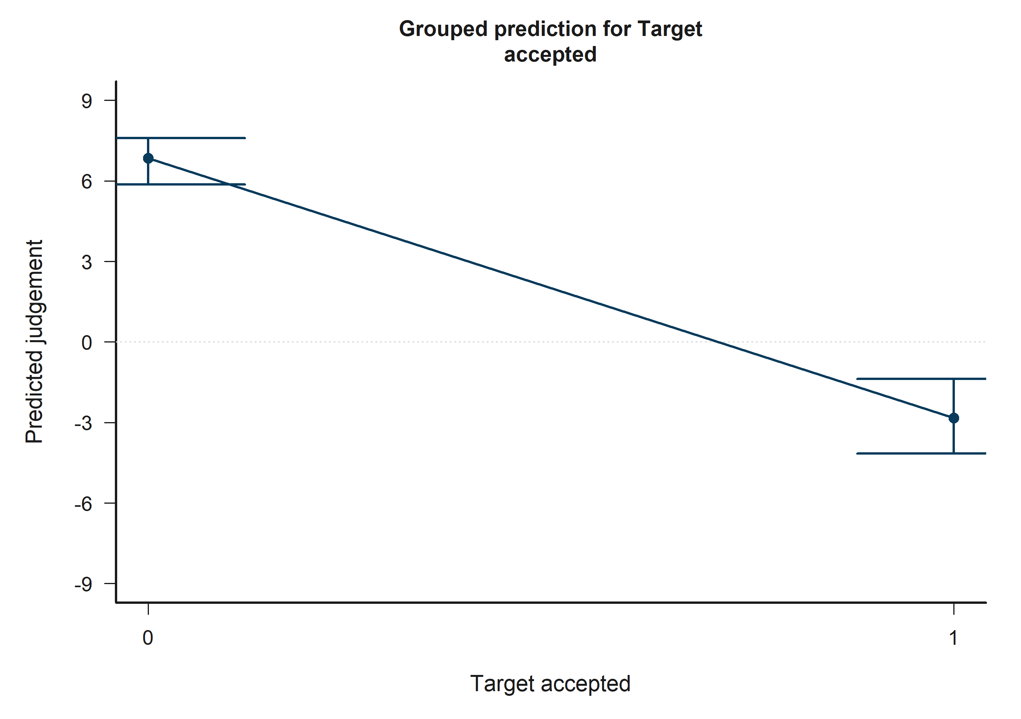
H4 Victim: model-implied predictions for Target accepted.
Across the displayed contrast, the model implies lower predicted judgement toward the right-hand side of the plot.

H4 Victim: Other negotiator accepted
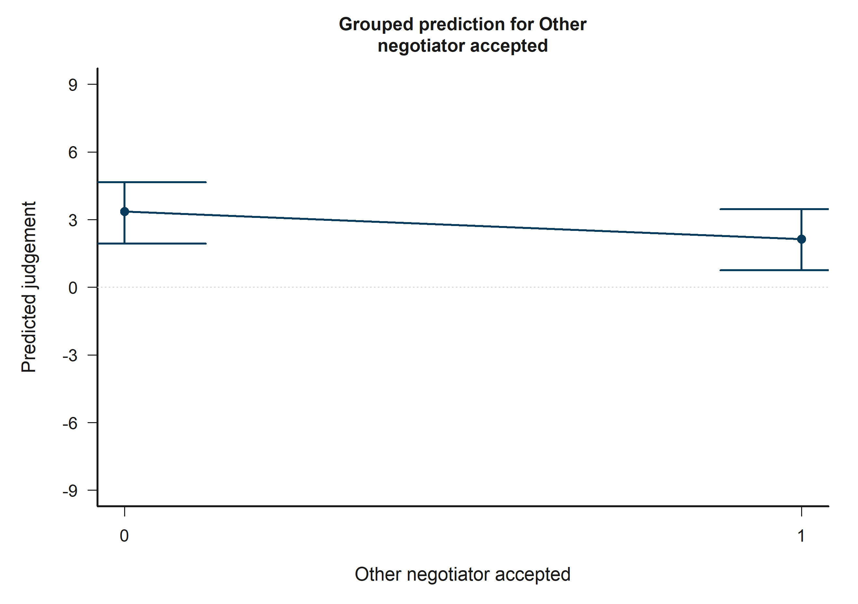
H4 Victim: model-implied predictions for Other negotiator accepted.
Across the displayed contrast, the model implies lower predicted judgement toward the right-hand side of the plot.

H4 Victim: Target accepted x Other accepted
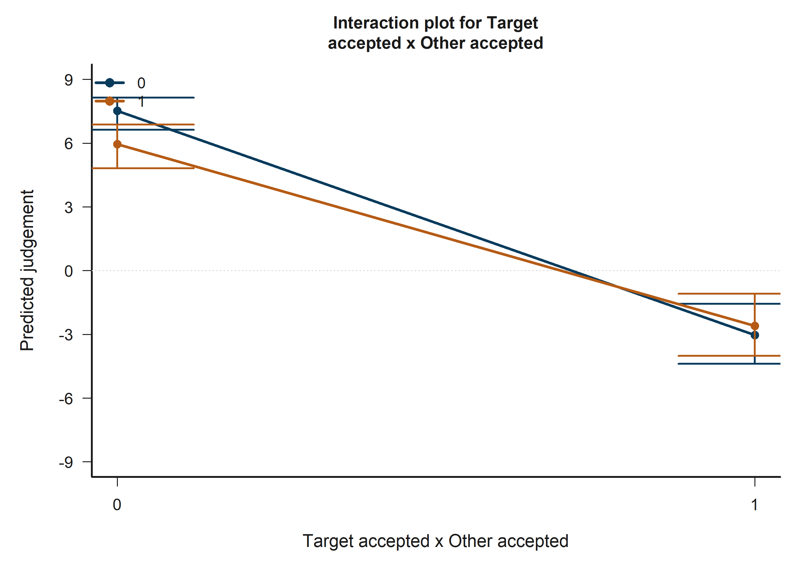
H4 Victim: model-implied predictions for Target accepted x Other accepted.
The plotted lines summarize how the fitted predicted judgement changes across the focal term while holding the remaining covariates at their reference profile.

H4 Bystander: Target accepted
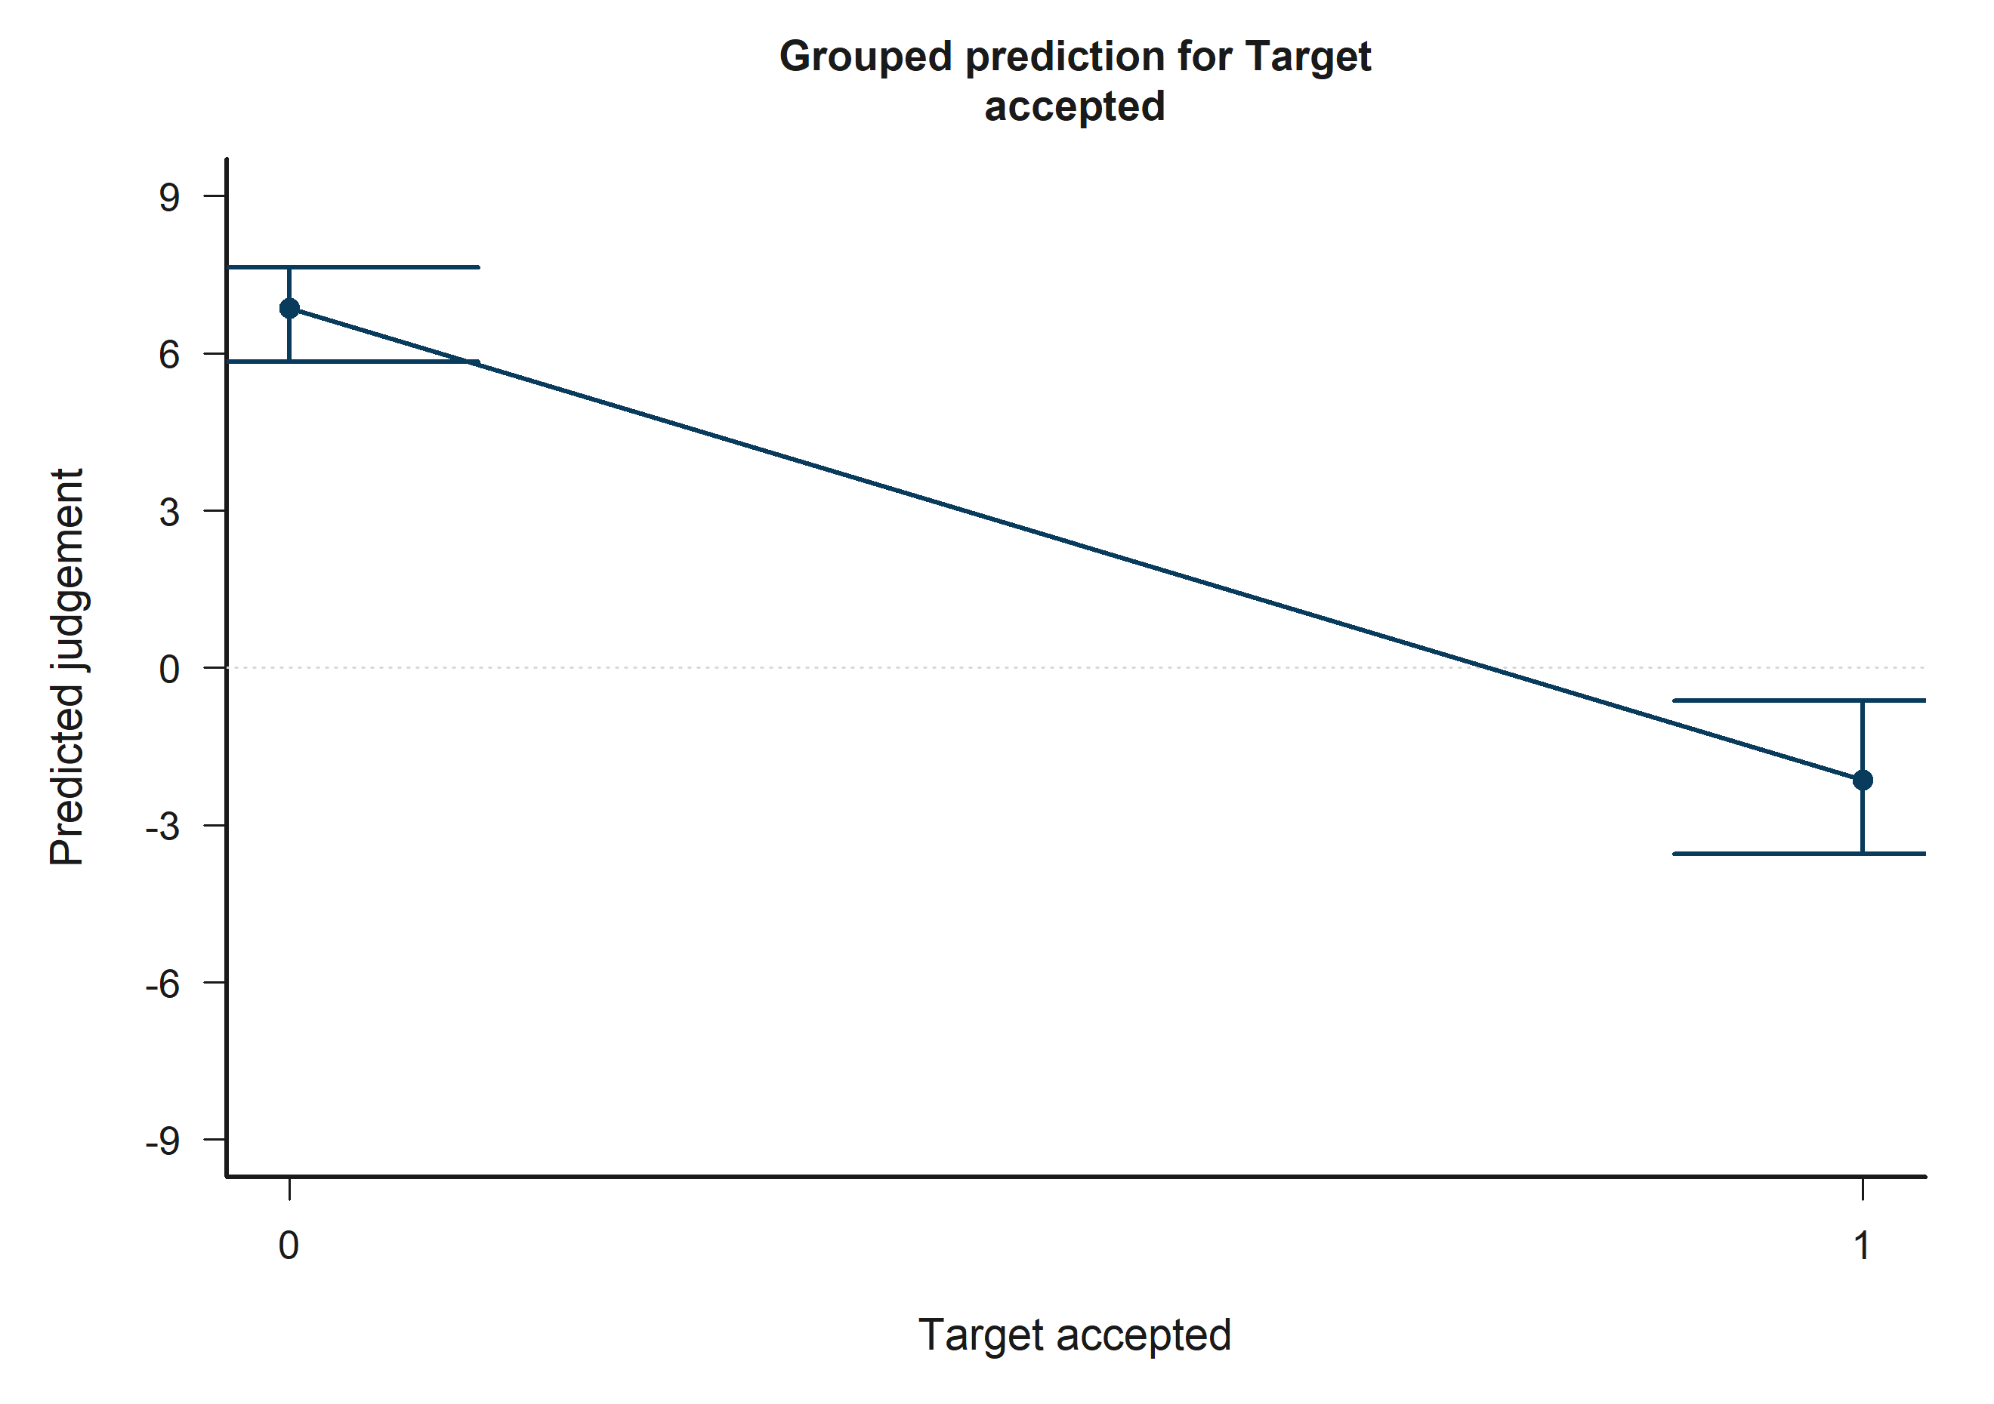
H4 Bystander: model-implied predictions for Target accepted.
Across the displayed contrast, the model implies lower predicted judgement toward the right-hand side of the plot.

H4 Bystander: Other negotiator accepted
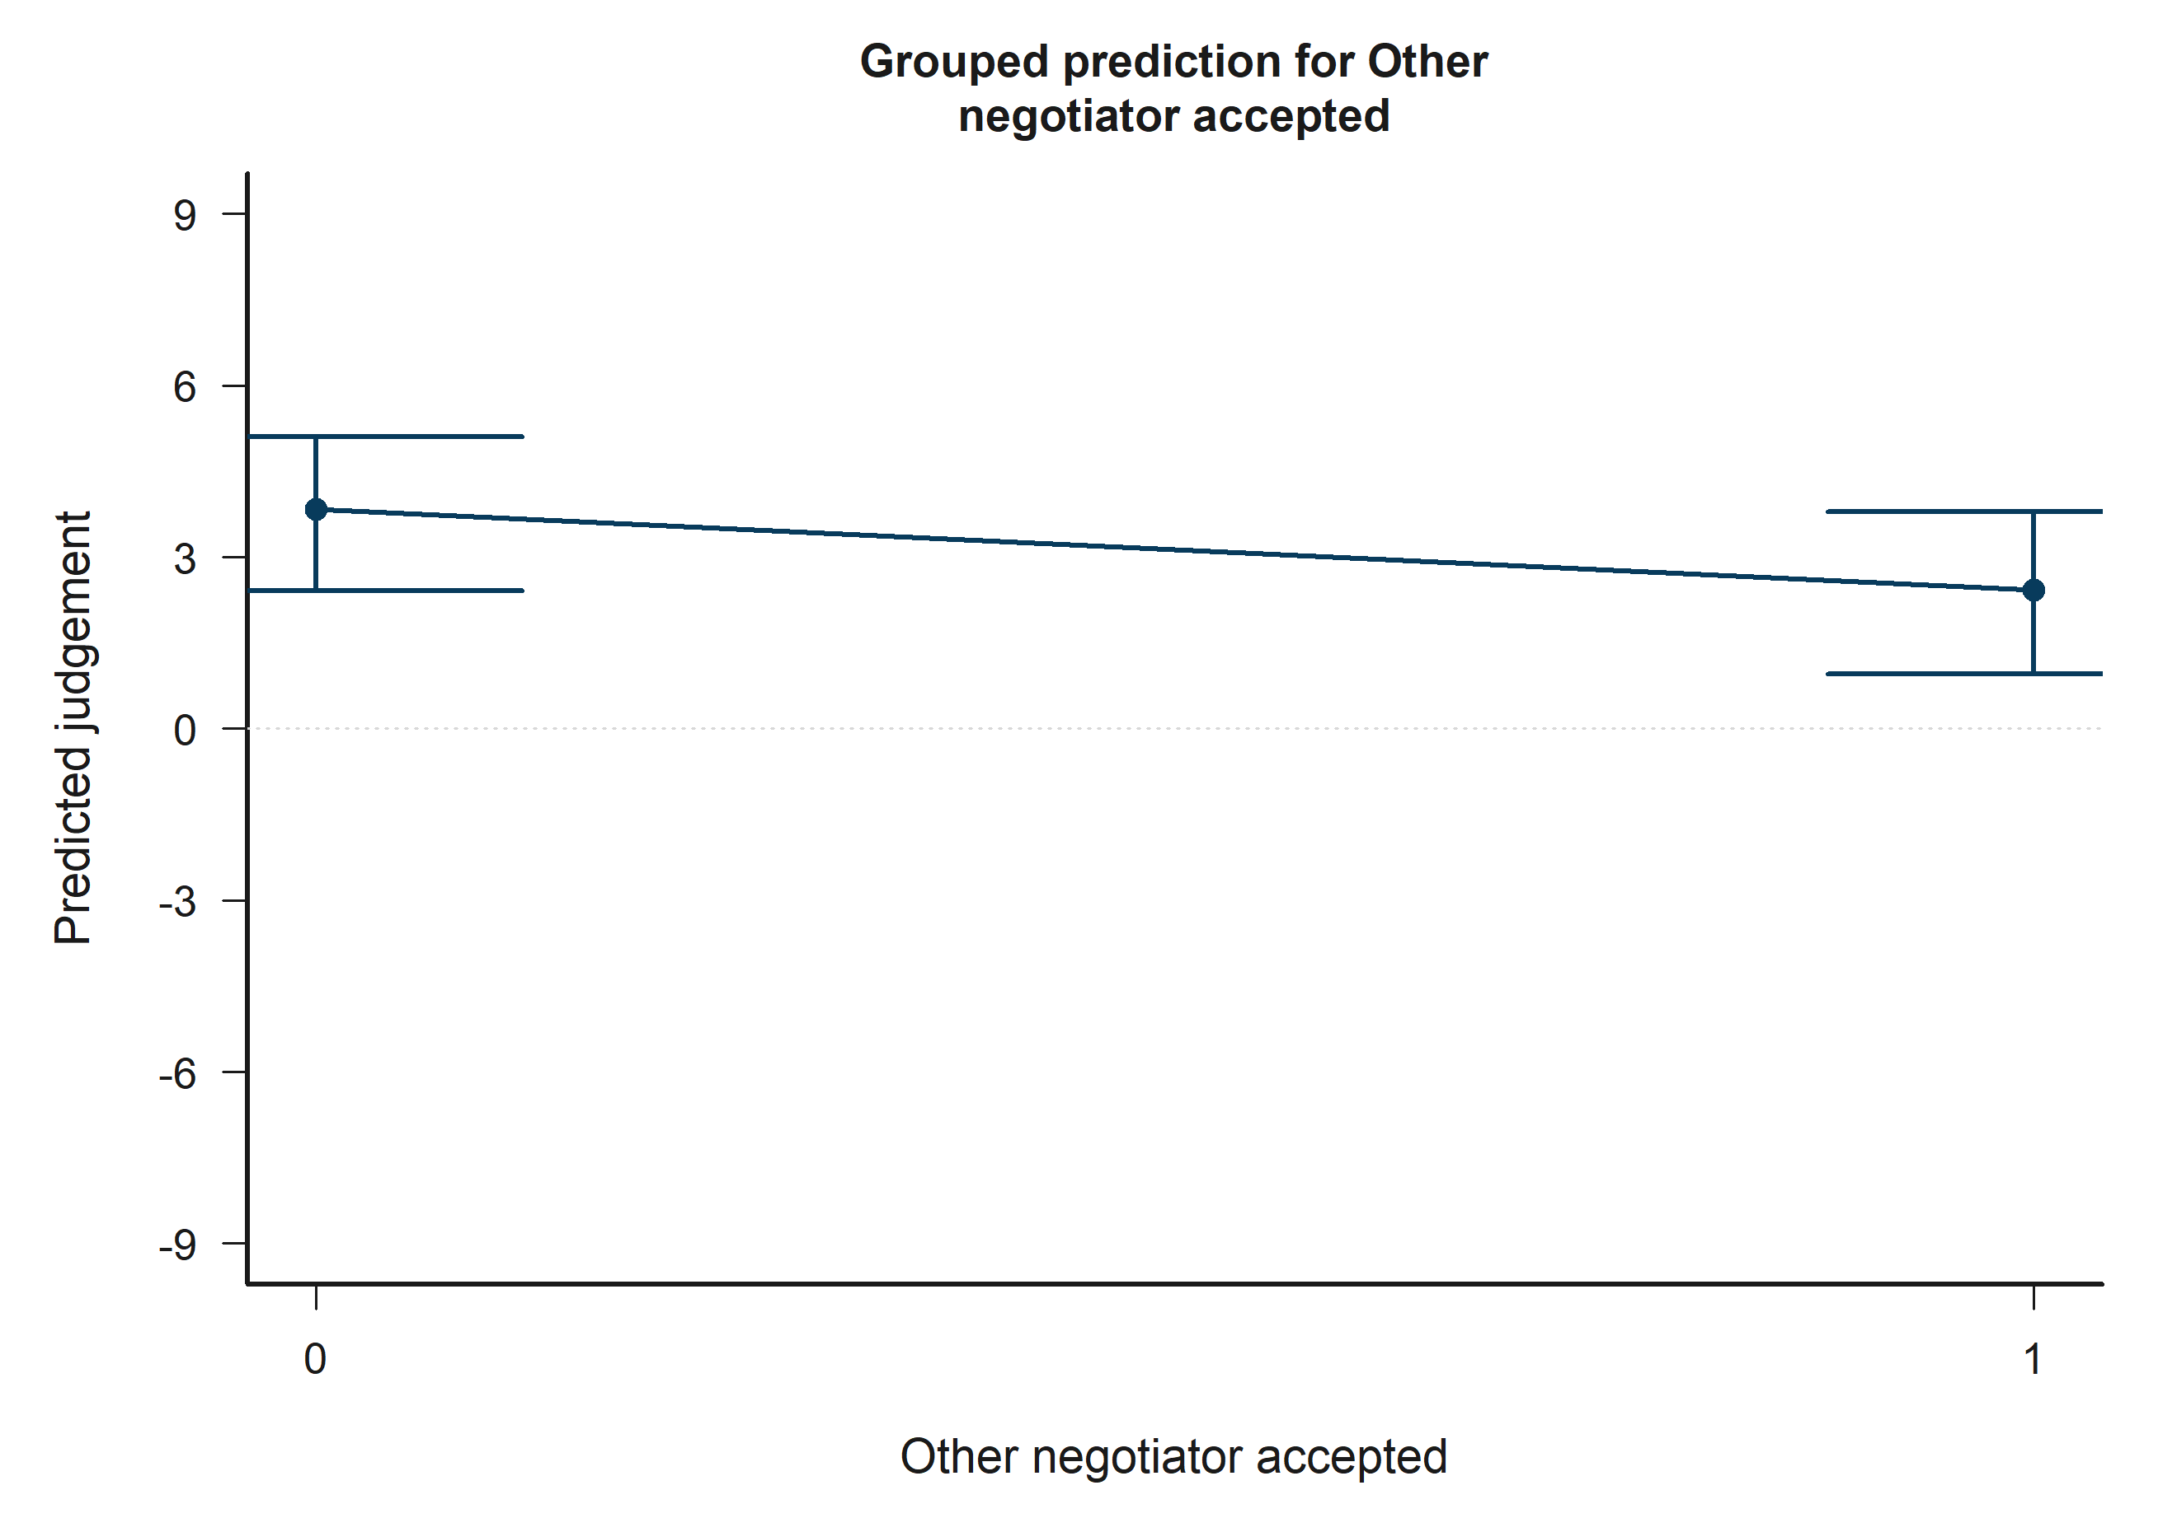
H4 Bystander: model-implied predictions for Other negotiator accepted.
Across the displayed contrast, the model implies lower predicted judgement toward the right-hand side of the plot.

H4 Bystander: Target accepted x Other accepted
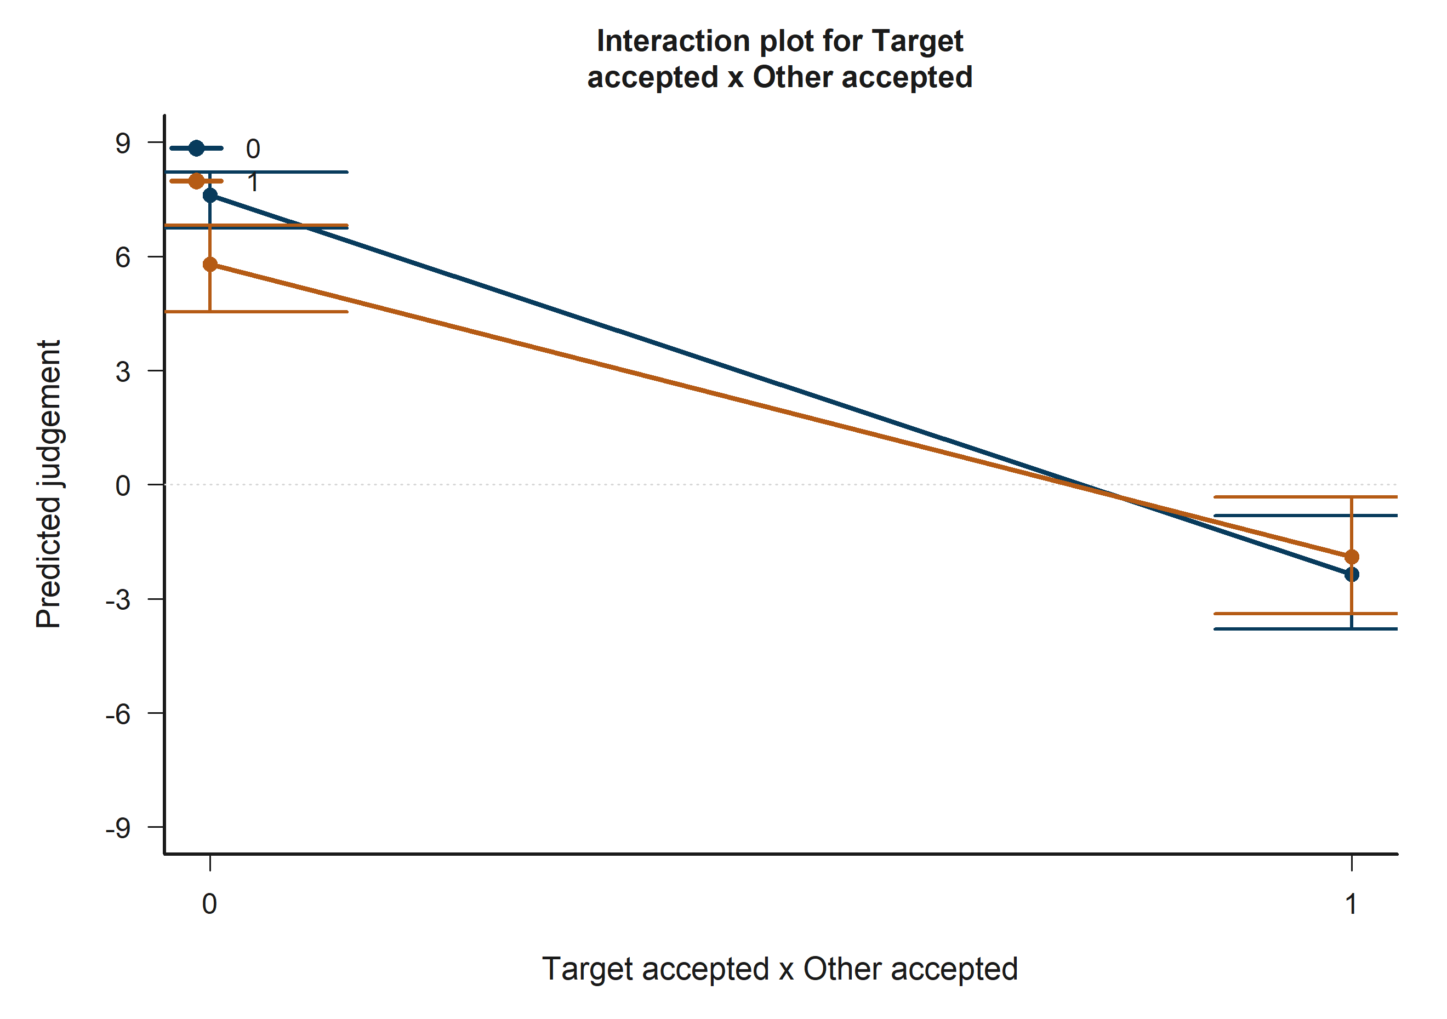
H4 Bystander: model-implied predictions for Target accepted x Other accepted.
The plotted lines summarize how the fitted predicted judgement changes across the focal term while holding the remaining covariates at their reference profile.

H5 Victim: Empathy: Fantasy
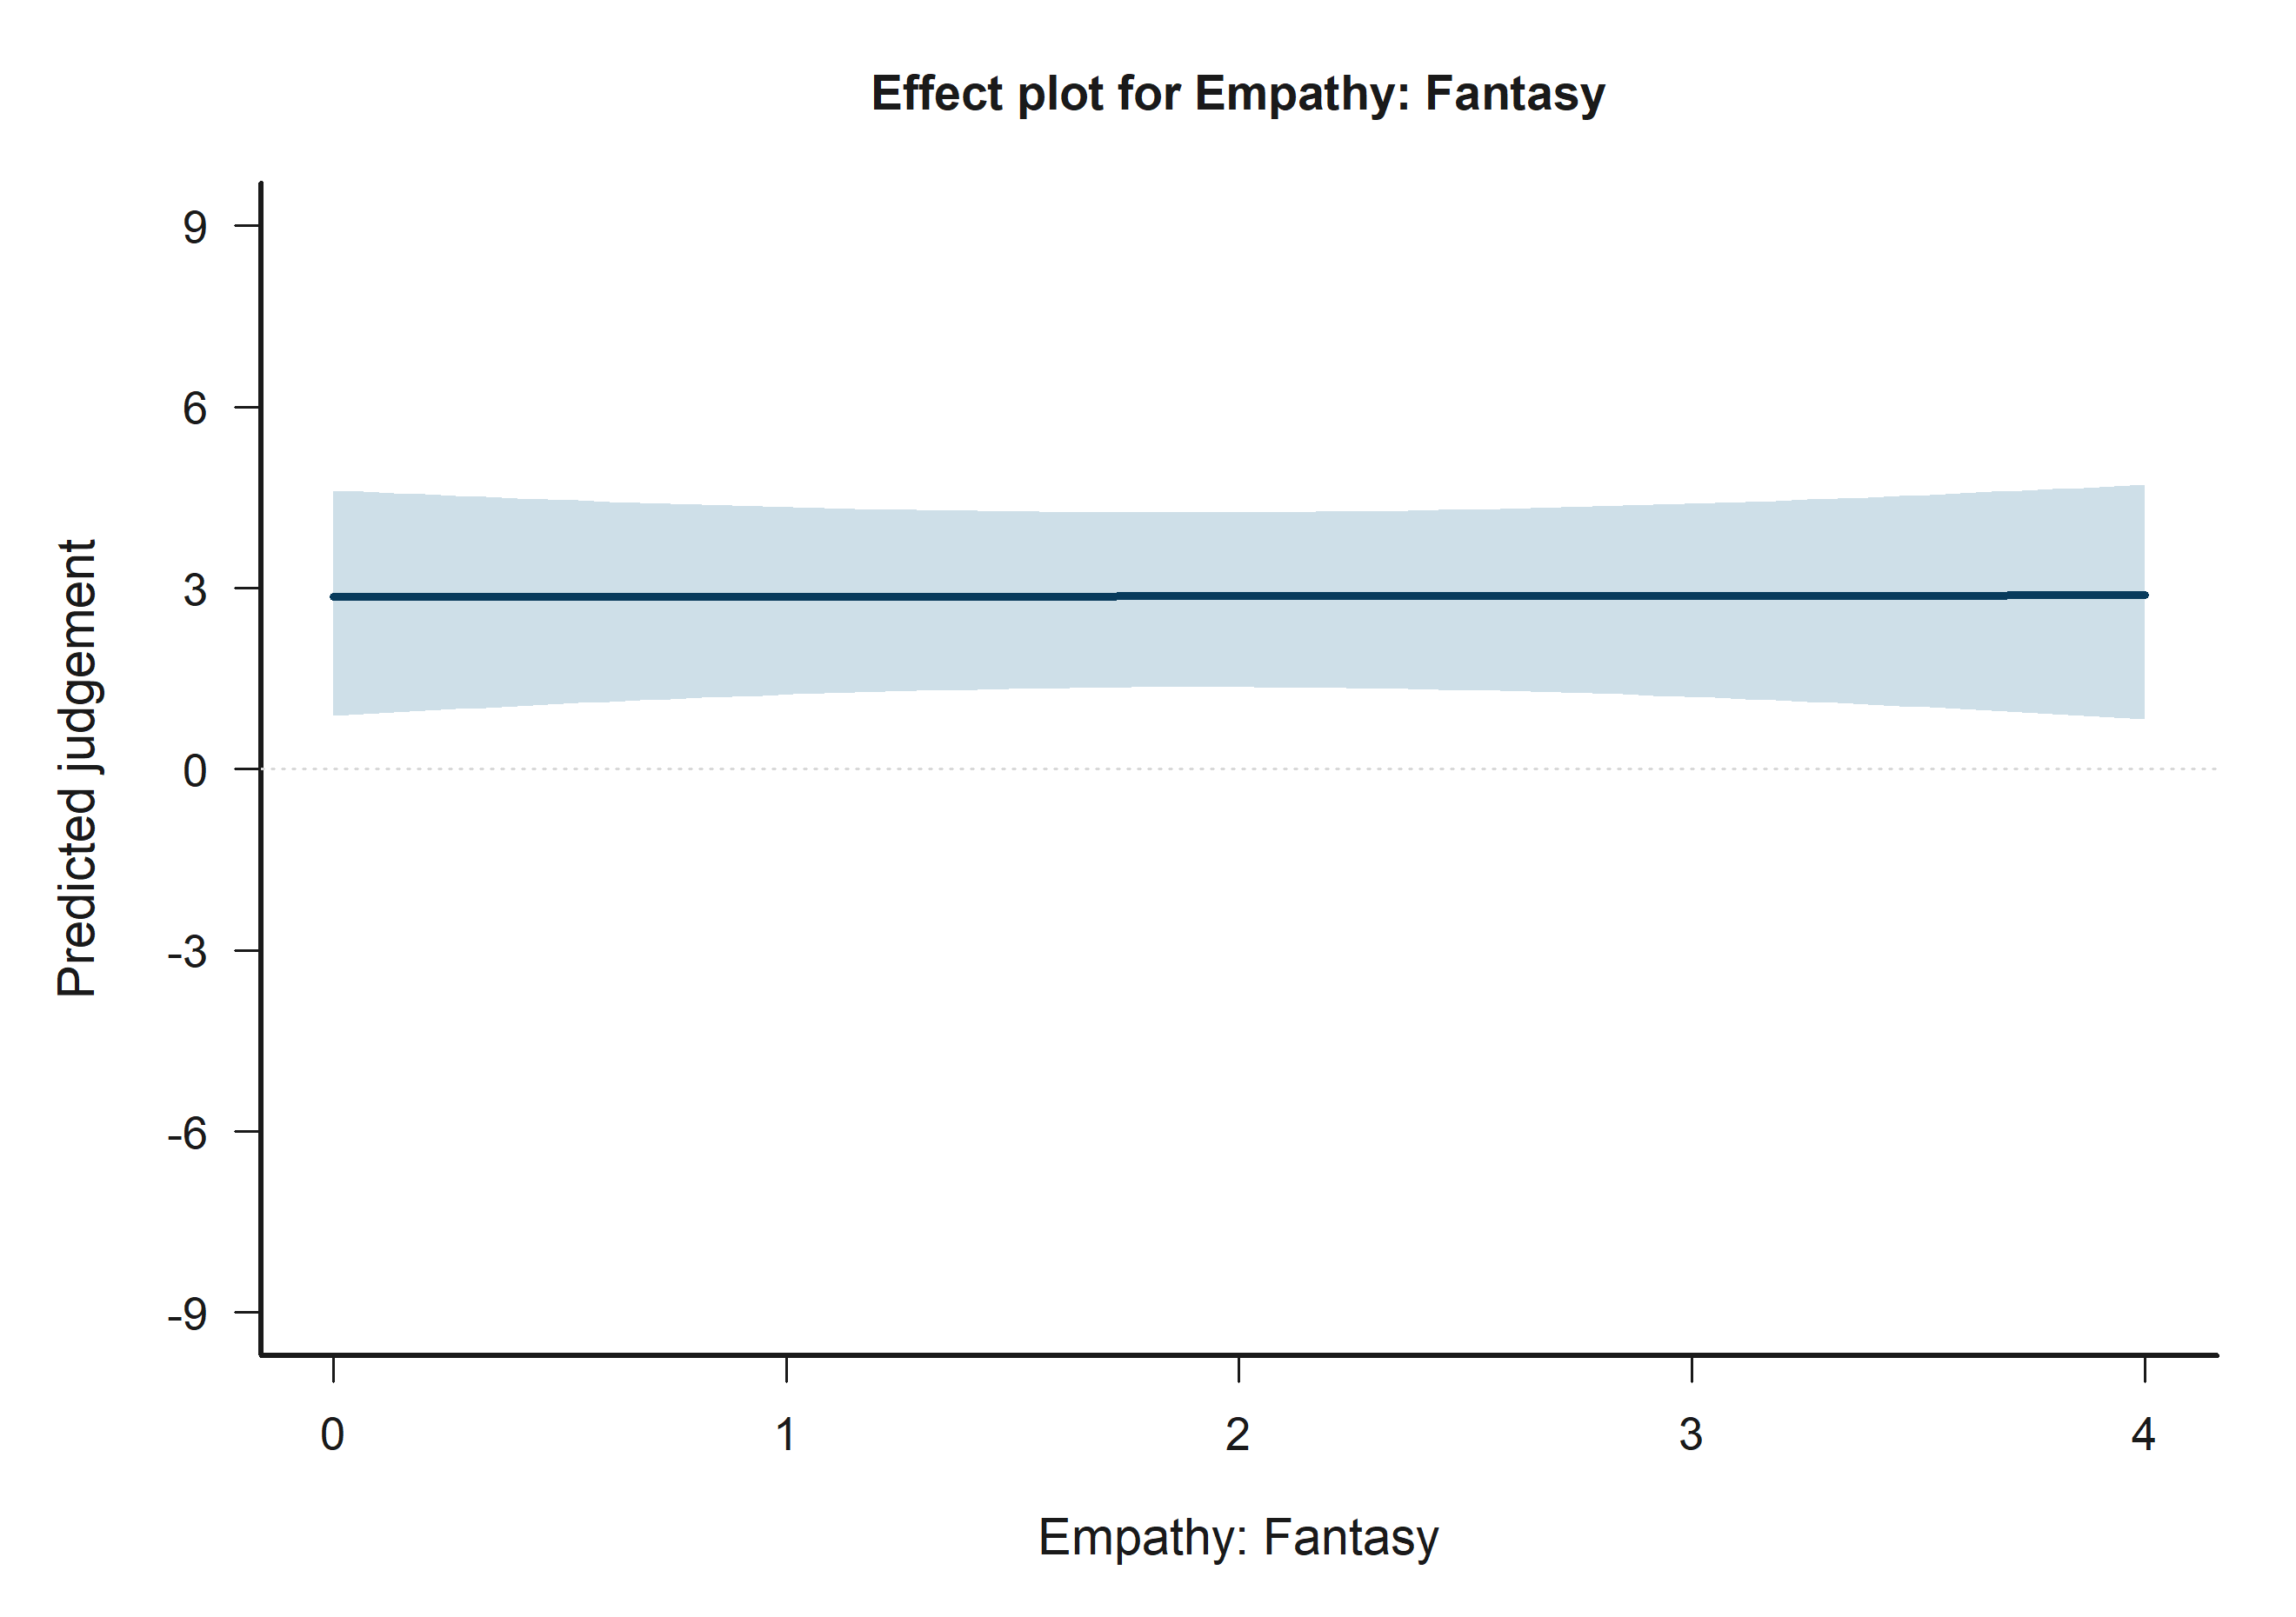
H5 Victim: model-implied predictions for Empathy: Fantasy.
Across the displayed contrast, the model implies higher predicted judgement toward the right-hand side of the plot.

H5 Victim: Victim-N2 outgroup vs ingroup
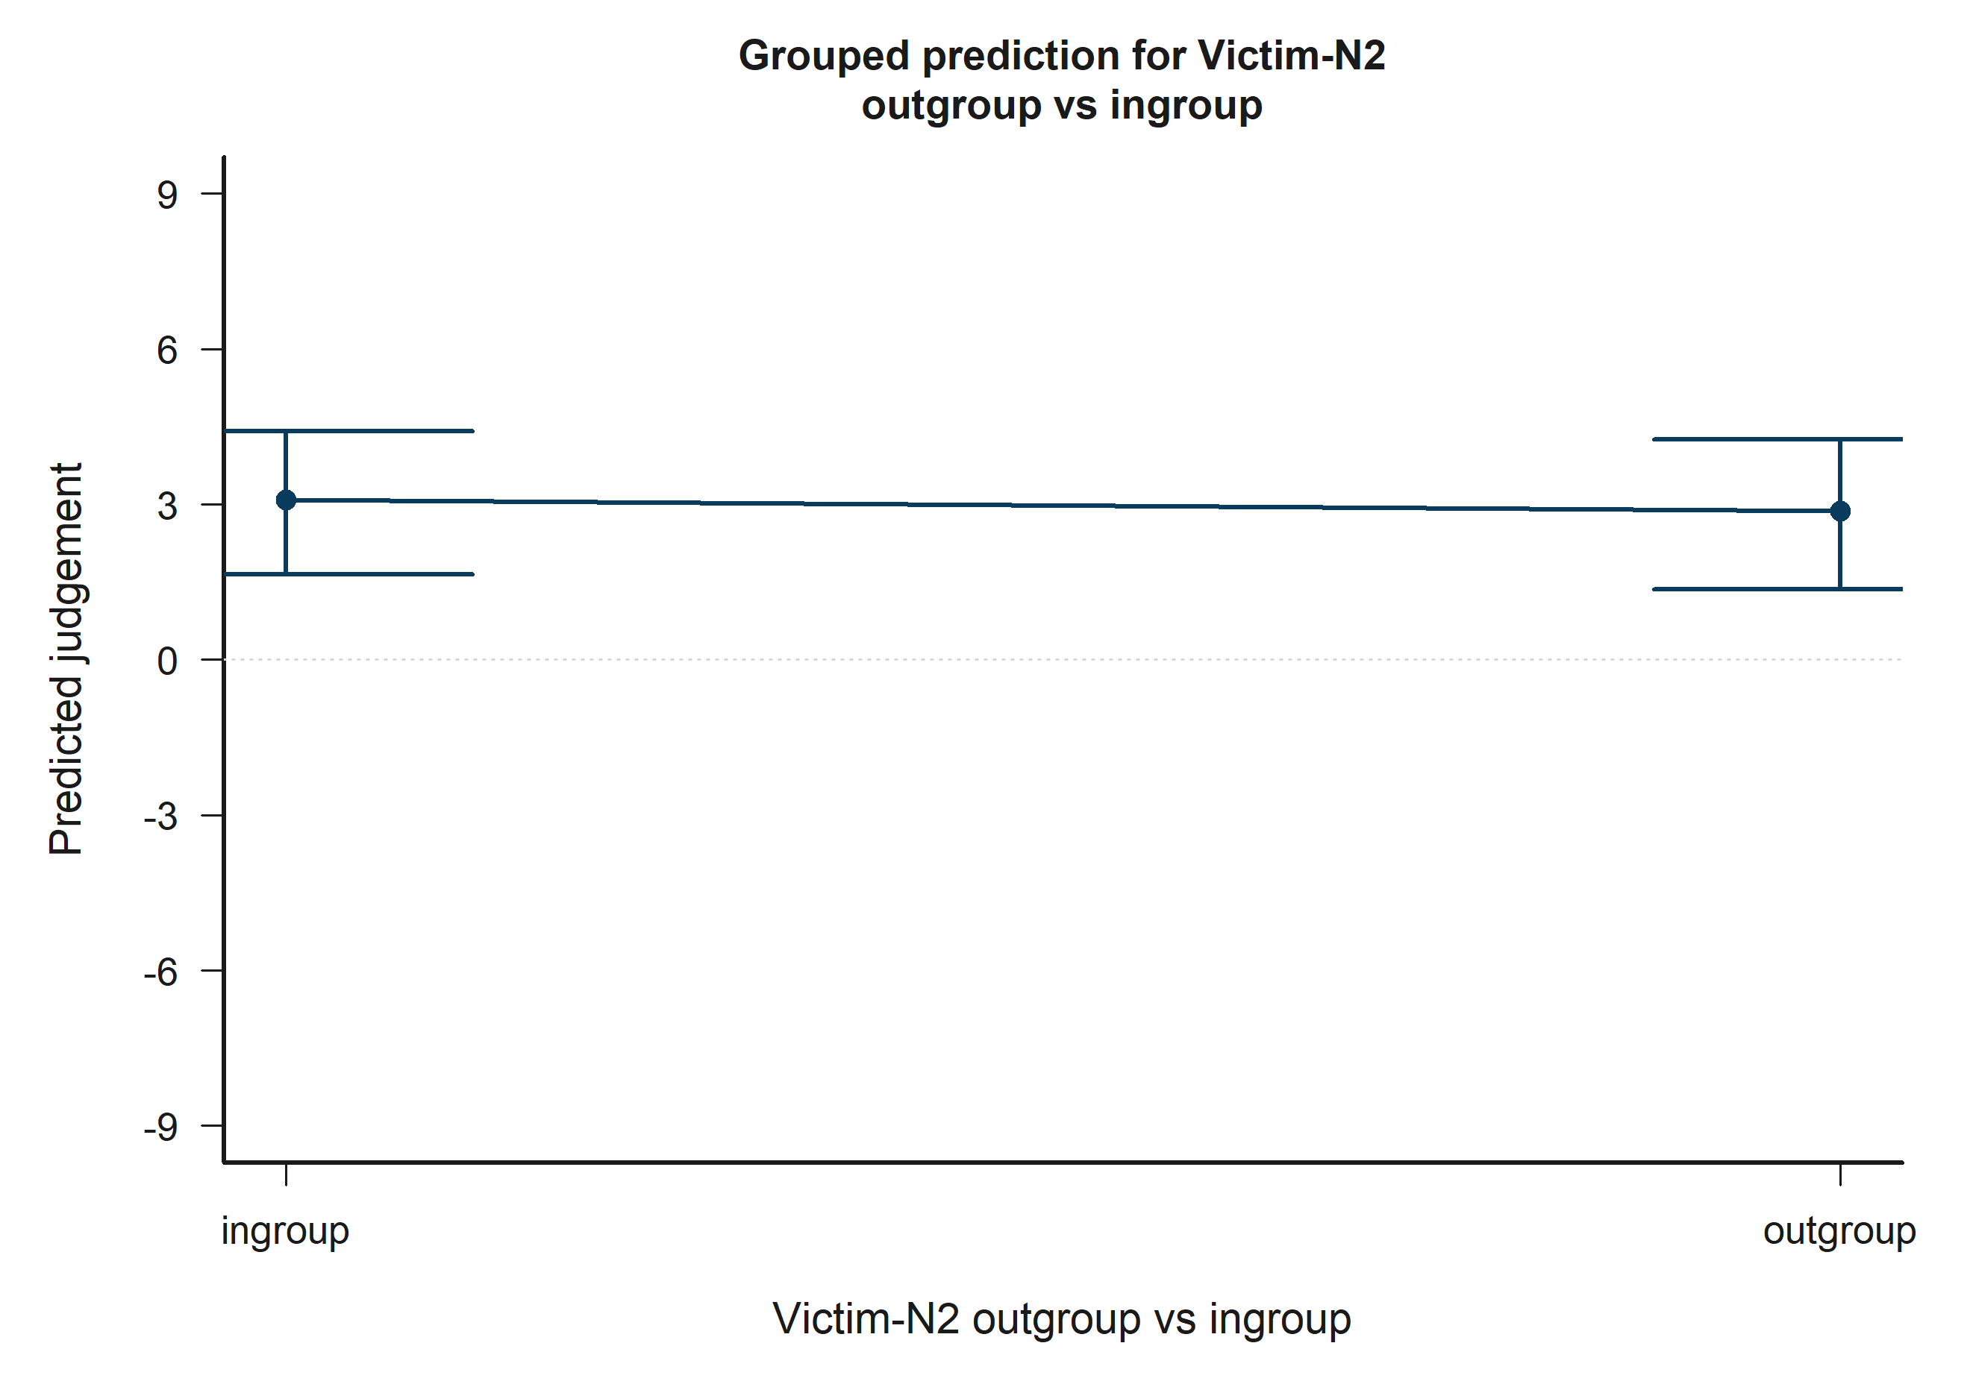
H5 Victim: model-implied predictions for Victim-N2 outgroup vs ingroup.
Across the displayed contrast, the model implies lower predicted judgement toward the right-hand side of the plot.

H5 Victim: Target accepted
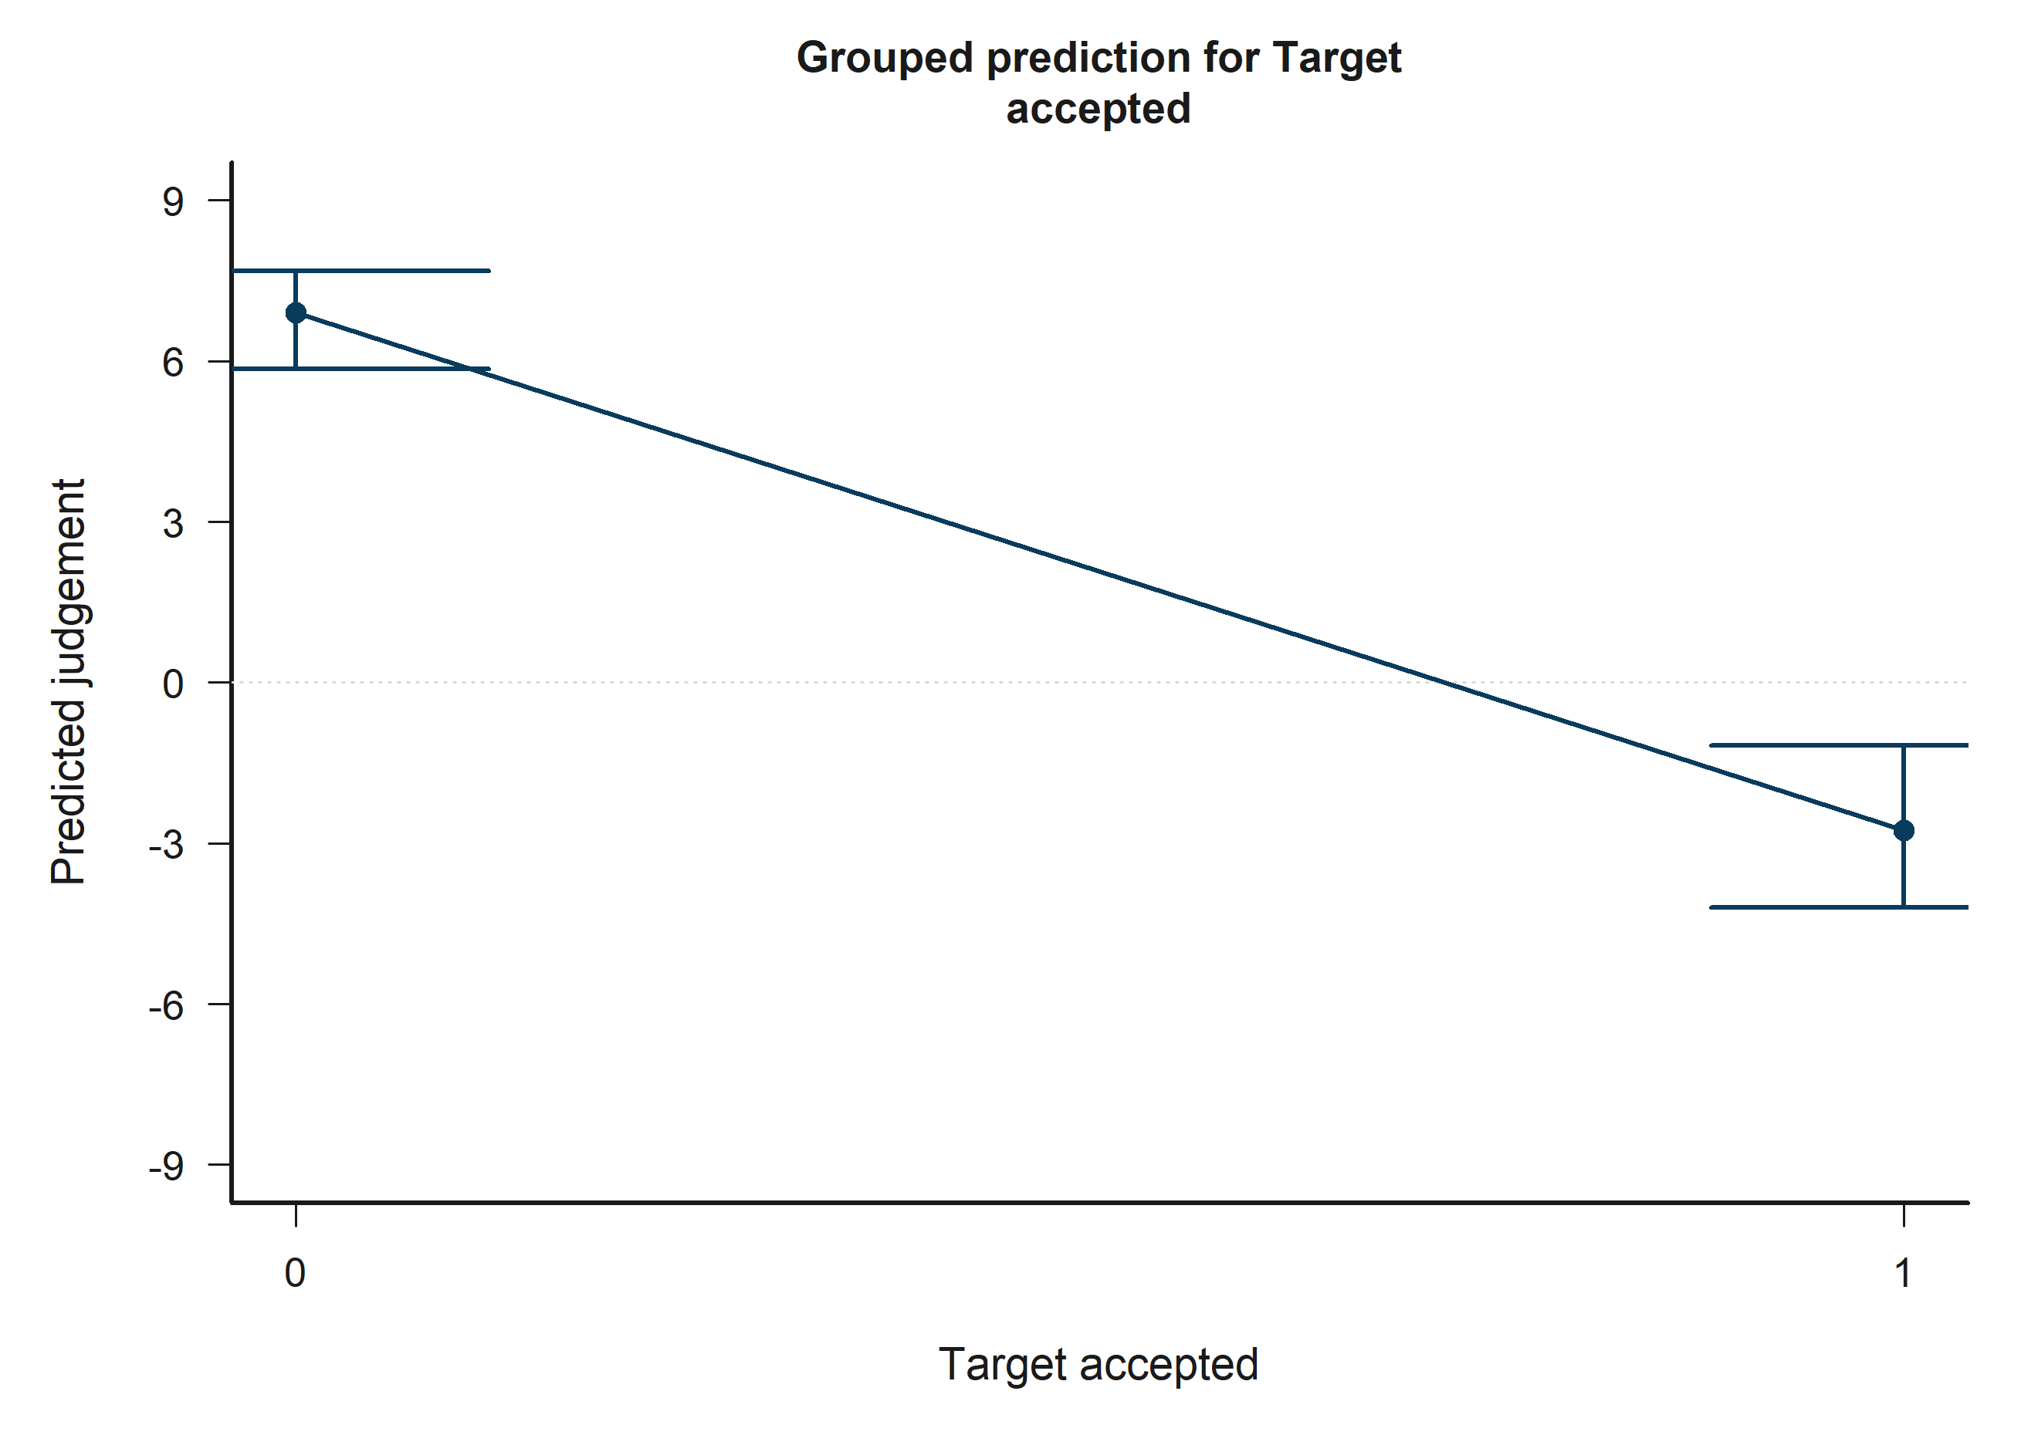
H5 Victim: model-implied predictions for Target accepted.
Across the displayed contrast, the model implies lower predicted judgement toward the right-hand side of the plot.

H5 Victim: Other negotiator accepted
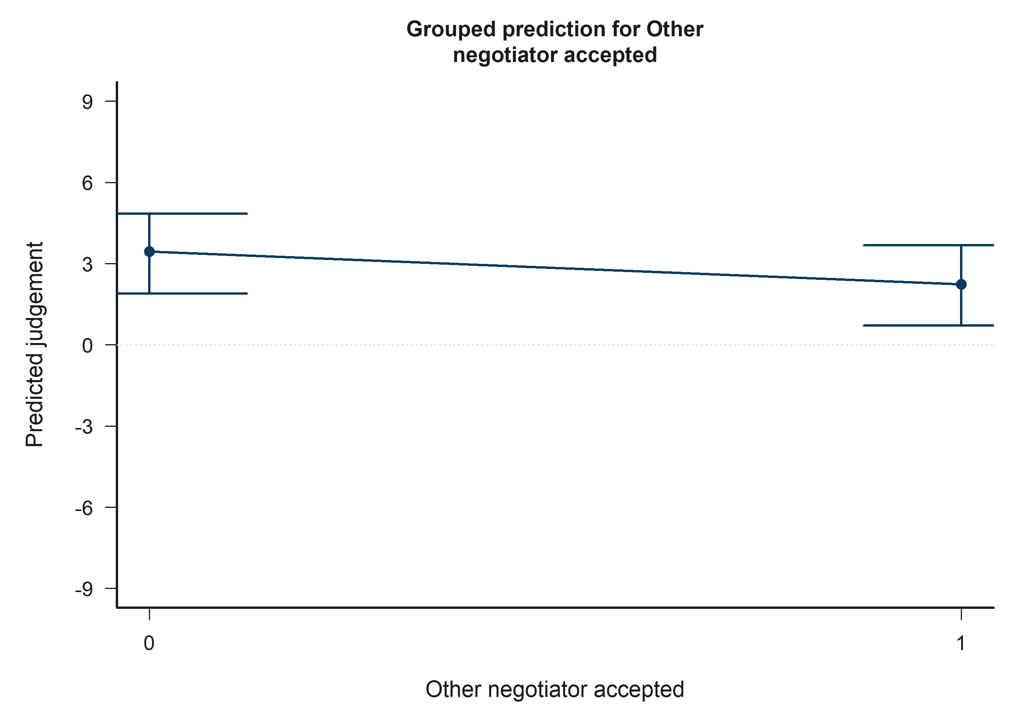
H5 Victim: model-implied predictions for Other negotiator accepted.
Across the displayed contrast, the model implies lower predicted judgement toward the right-hand side of the plot.

H5 Victim: Empathy: Fantasy x Victim-N1 outgroup vs ingroup
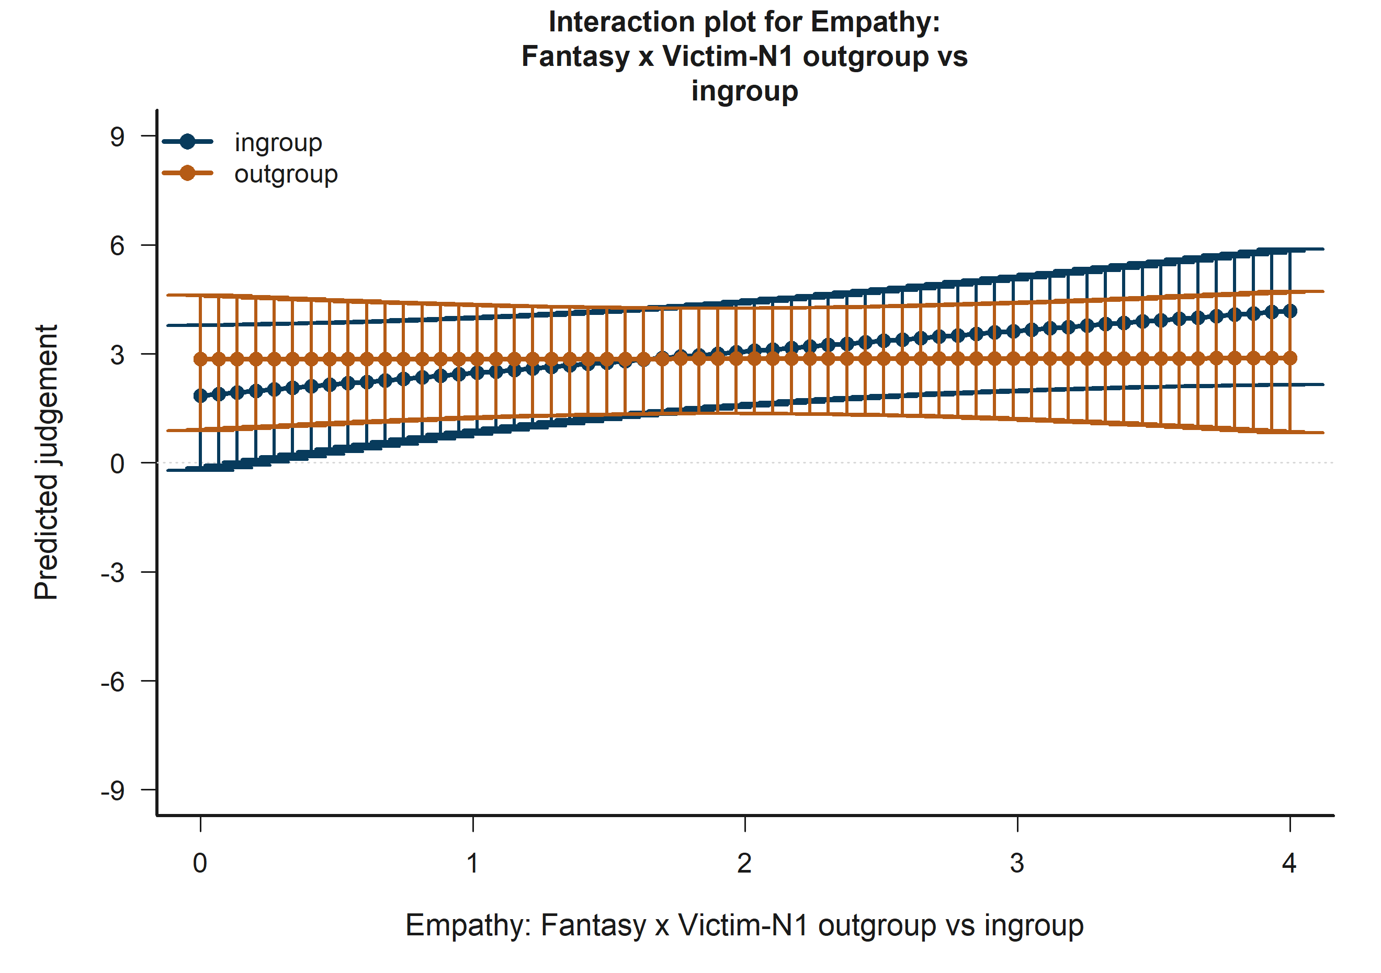
H5 Victim: model-implied predictions for Empathy: Fantasy x Victim-N1 outgroup vs ingroup.
The plotted lines summarize how the fitted predicted judgement changes across the focal term while holding the remaining covariates at their reference profile.

H5 Victim: Target accepted x Other accepted
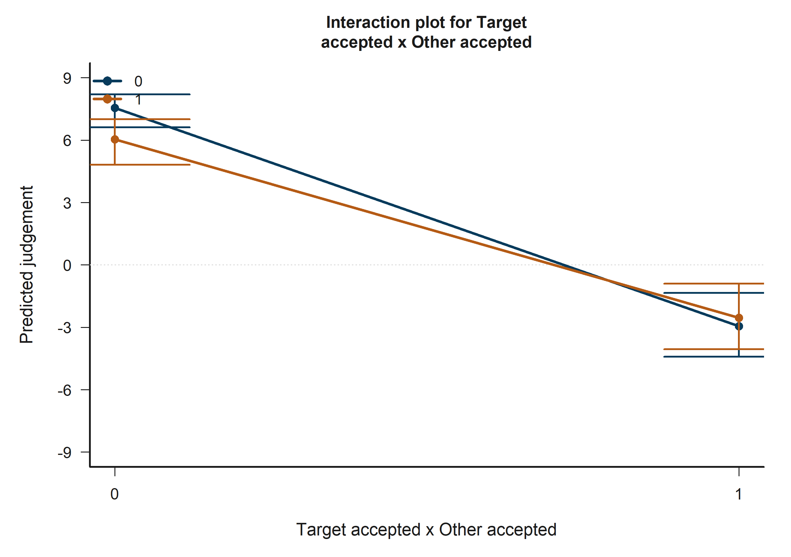
H5 Victim: model-implied predictions for Target accepted x Other accepted.
The plotted lines summarize how the fitted predicted judgement changes across the focal term while holding the remaining covariates at their reference profile.

H5 Bystander: Victim-N1 outgroup vs ingroup
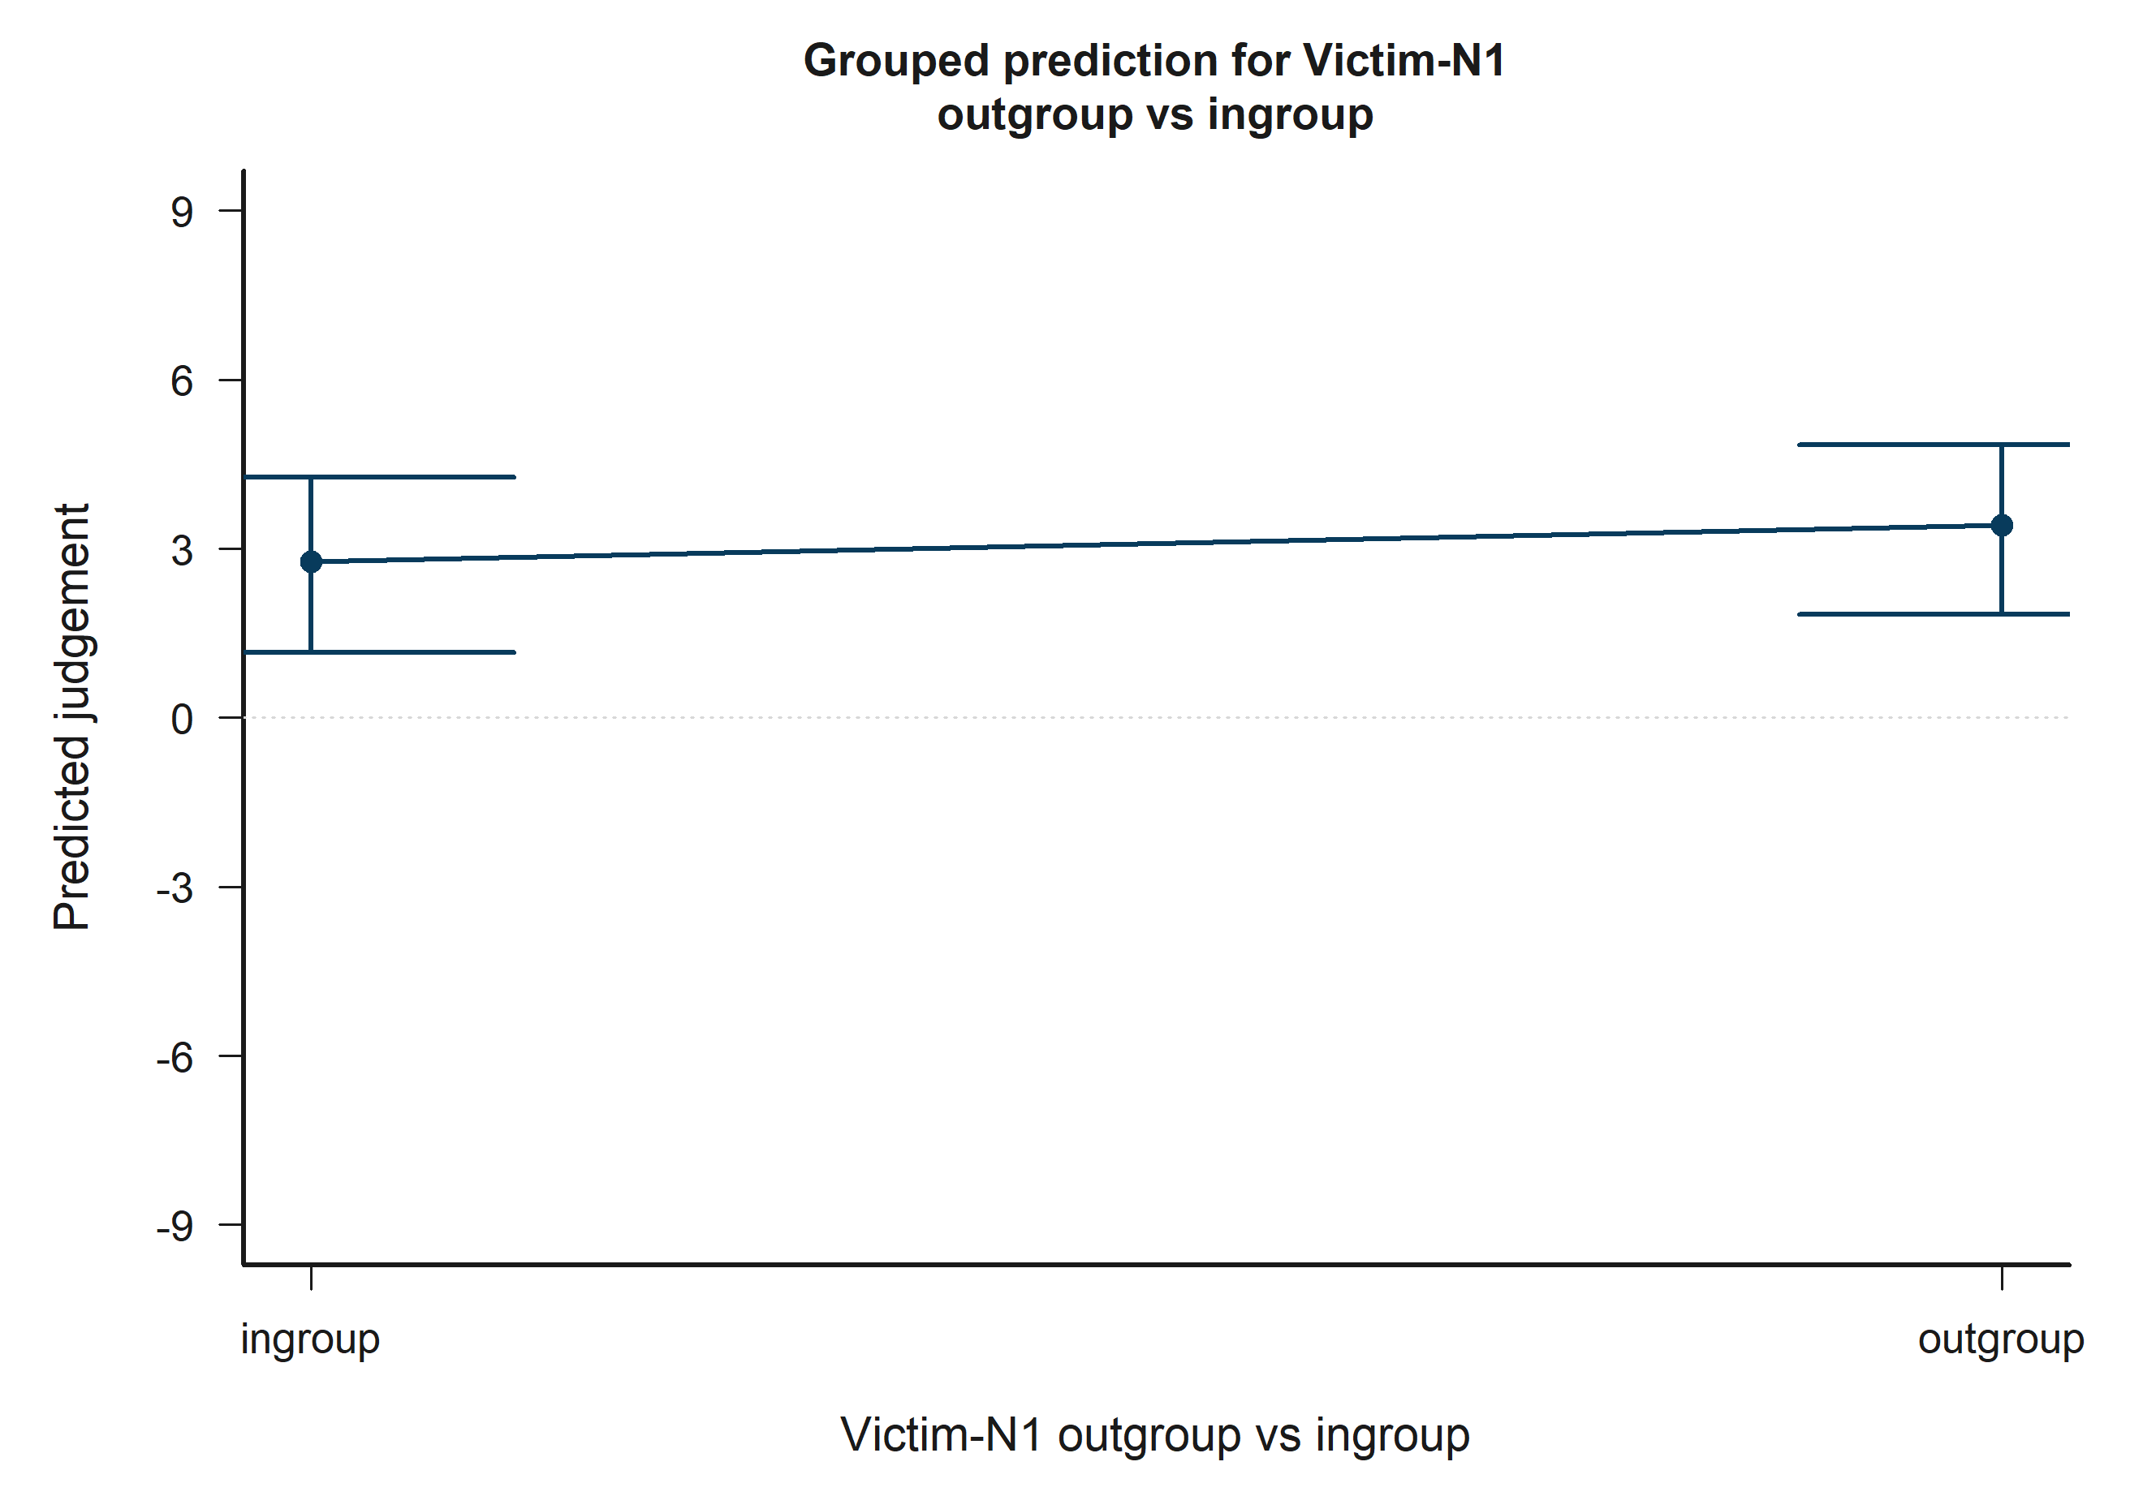
H5 Bystander: model-implied predictions for Victim-N1 outgroup vs ingroup.
Across the displayed contrast, the model implies higher predicted judgement toward the right-hand side of the plot.

H5 Bystander: Victim-N2 outgroup vs ingroup
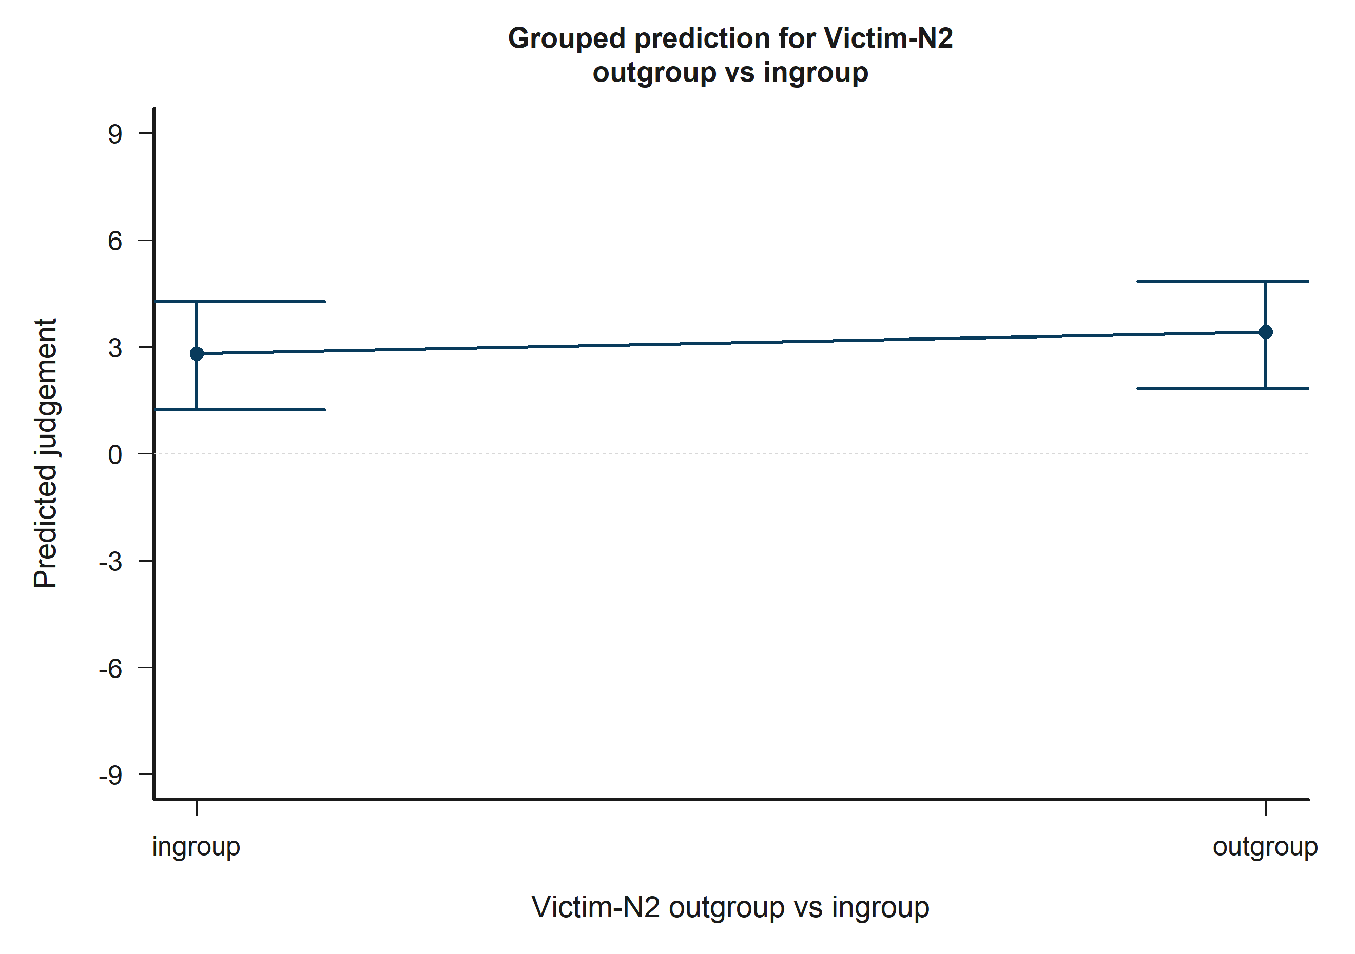
H5 Bystander: model-implied predictions for Victim-N2 outgroup vs ingroup.
Across the displayed contrast, the model implies higher predicted judgement toward the right-hand side of the plot.

H5 Bystander: Target accepted
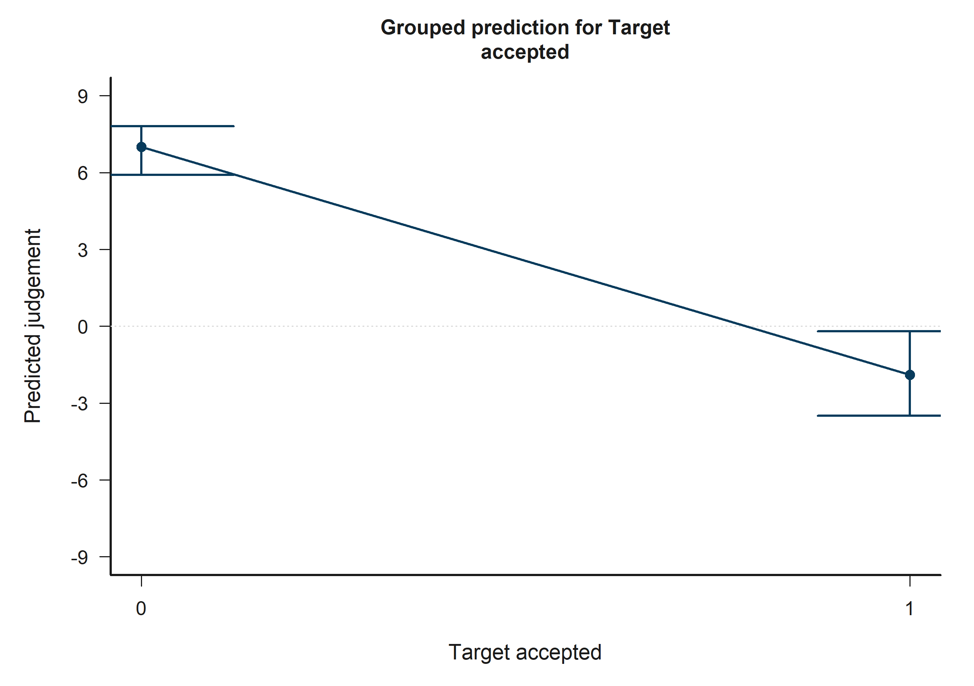
H5 Bystander: model-implied predictions for Target accepted.
Across the displayed contrast, the model implies lower predicted judgement toward the right-hand side of the plot.

H5 Bystander: Other negotiator accepted
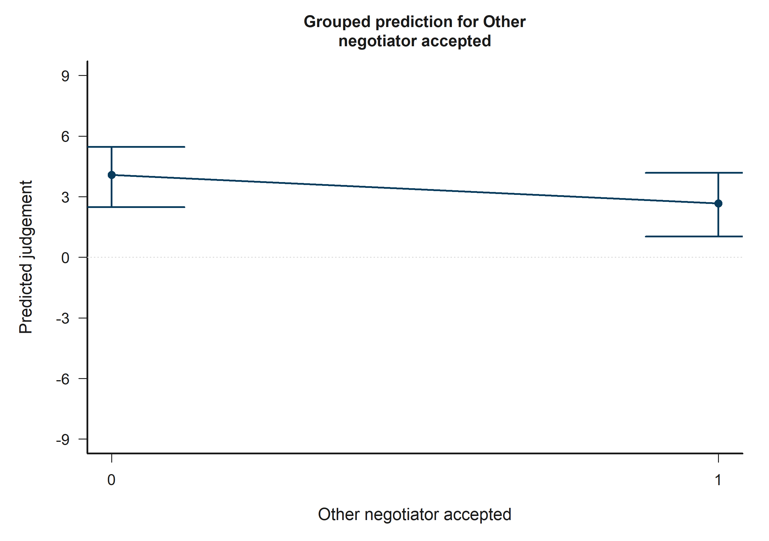
H5 Bystander: model-implied predictions for Other negotiator accepted.
Across the displayed contrast, the model implies lower predicted judgement toward the right-hand side of the plot.

H5 Bystander: Victim-N1 outgroup vs ingroup x Victim-N2 outgroup vs ingroup
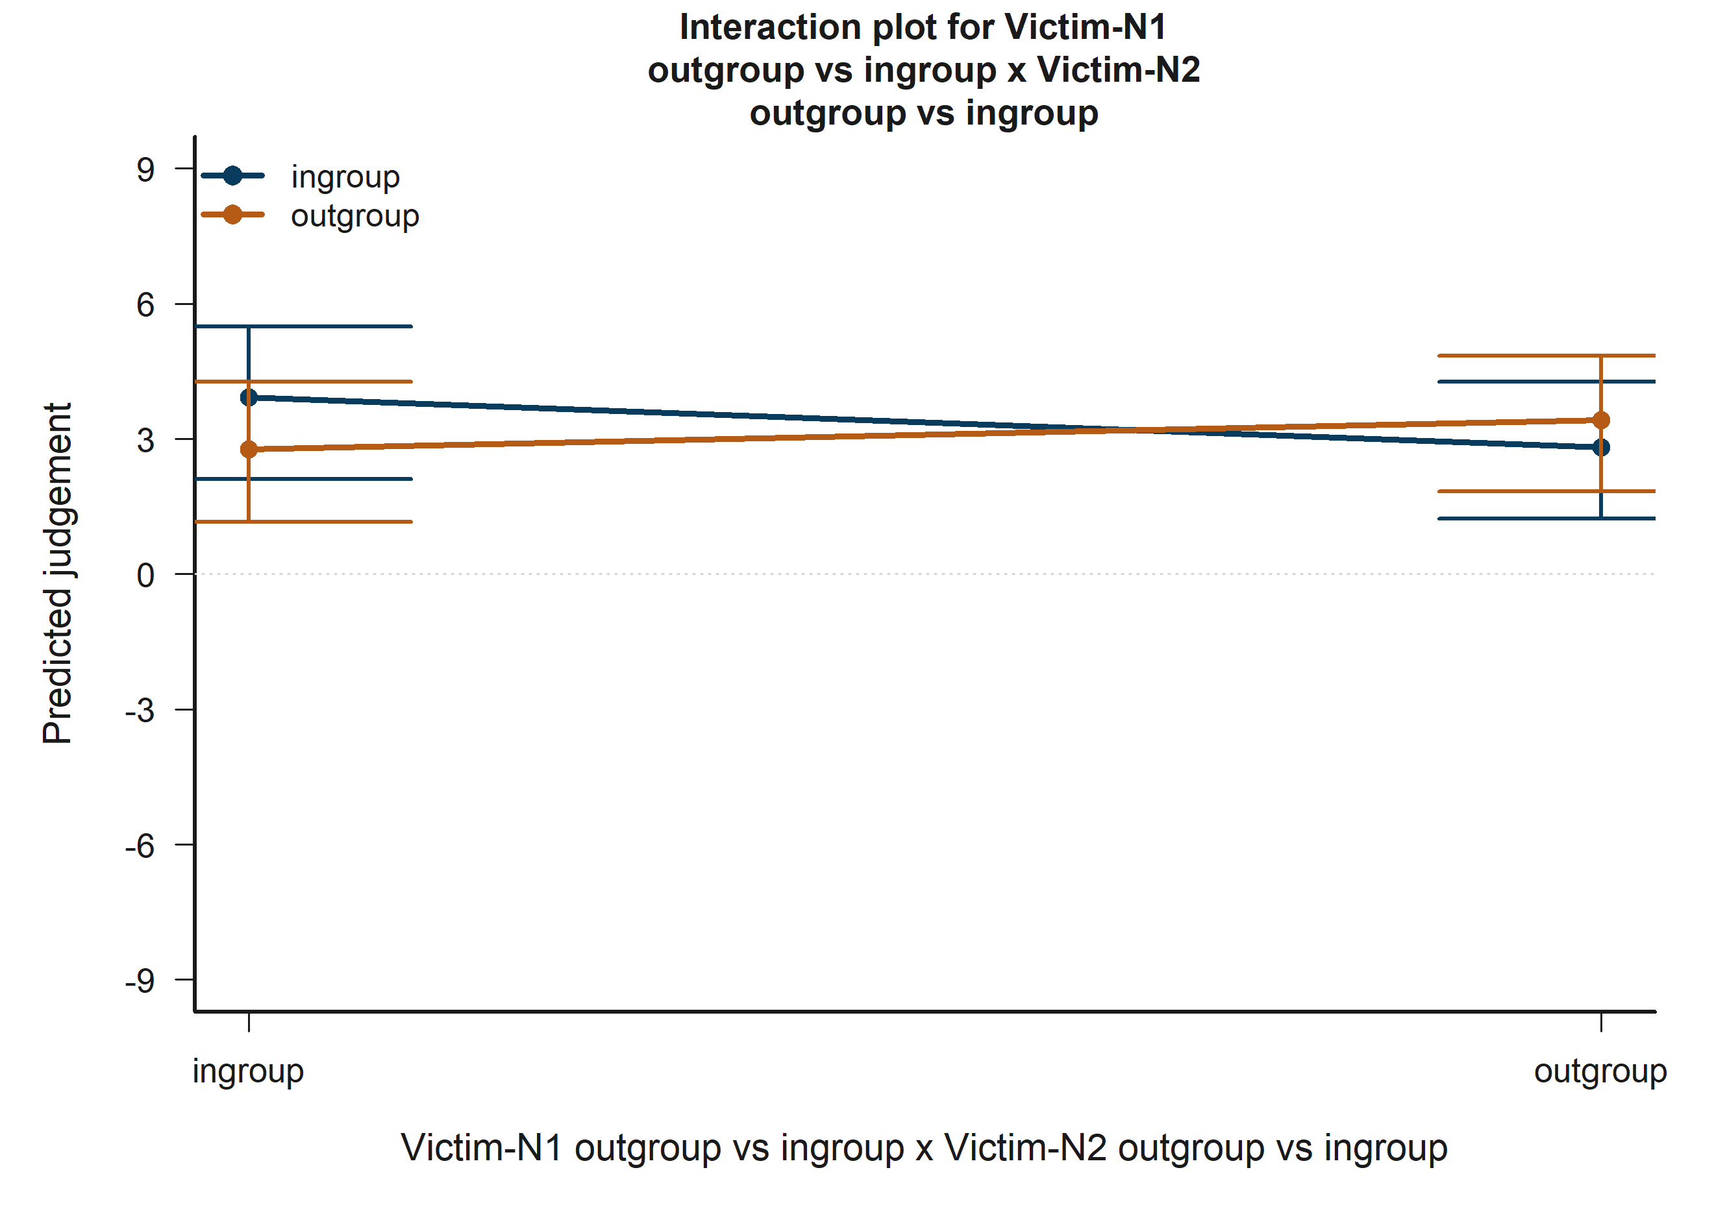
H5 Bystander: model-implied predictions for Victim-N1 outgroup vs ingroup x Victim-N2 outgroup vs ingroup.
The plotted lines summarize how the fitted predicted judgement changes across the focal term while holding the remaining covariates at their reference profile.

H5 Bystander: Empathy: Fantasy x Bystander-victim outgroup vs ingroup
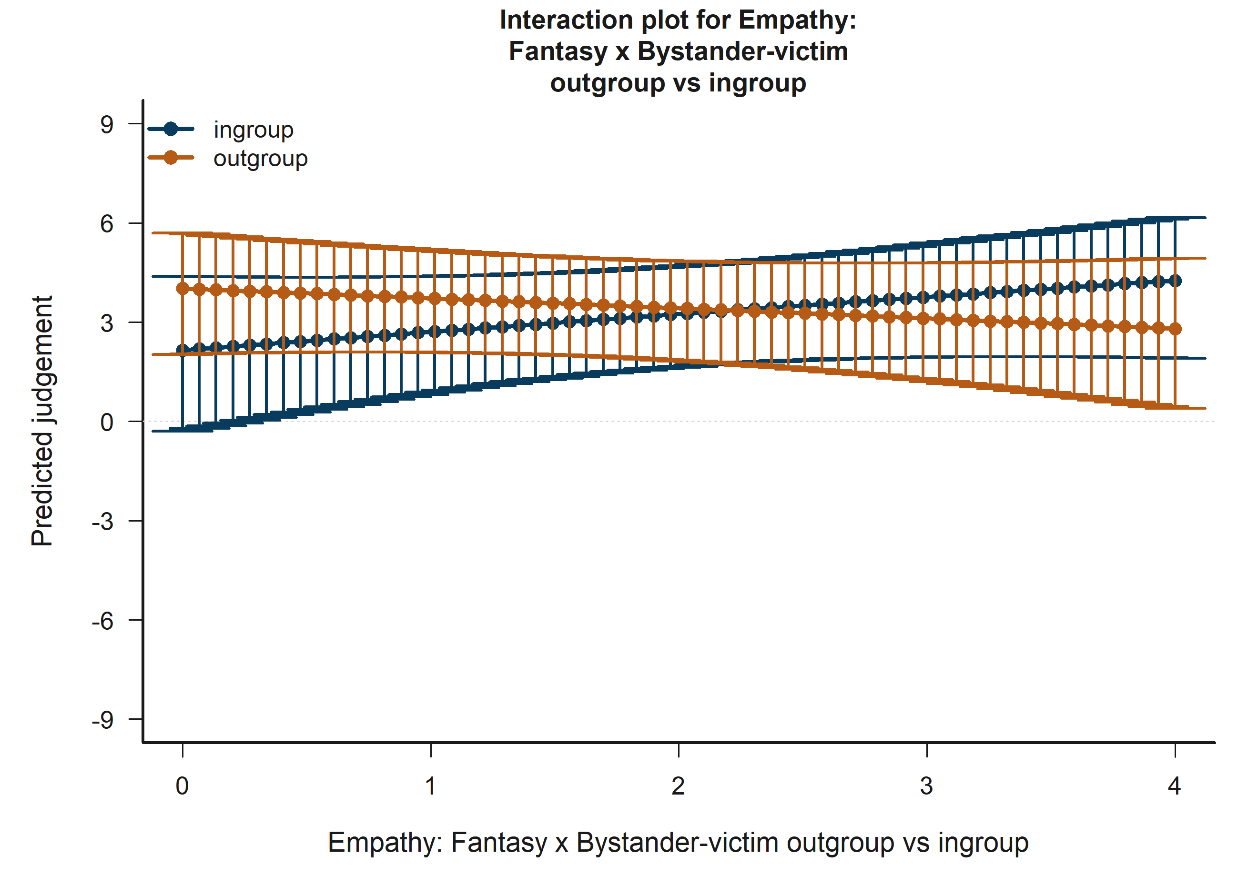
H5 Bystander: model-implied predictions for Empathy: Fantasy x Bystander-victim outgroup vs ingroup.
The plotted lines summarize how the fitted predicted judgement changes across the focal term while holding the remaining covariates at their reference profile.

H5 Bystander: Target accepted x Other accepted
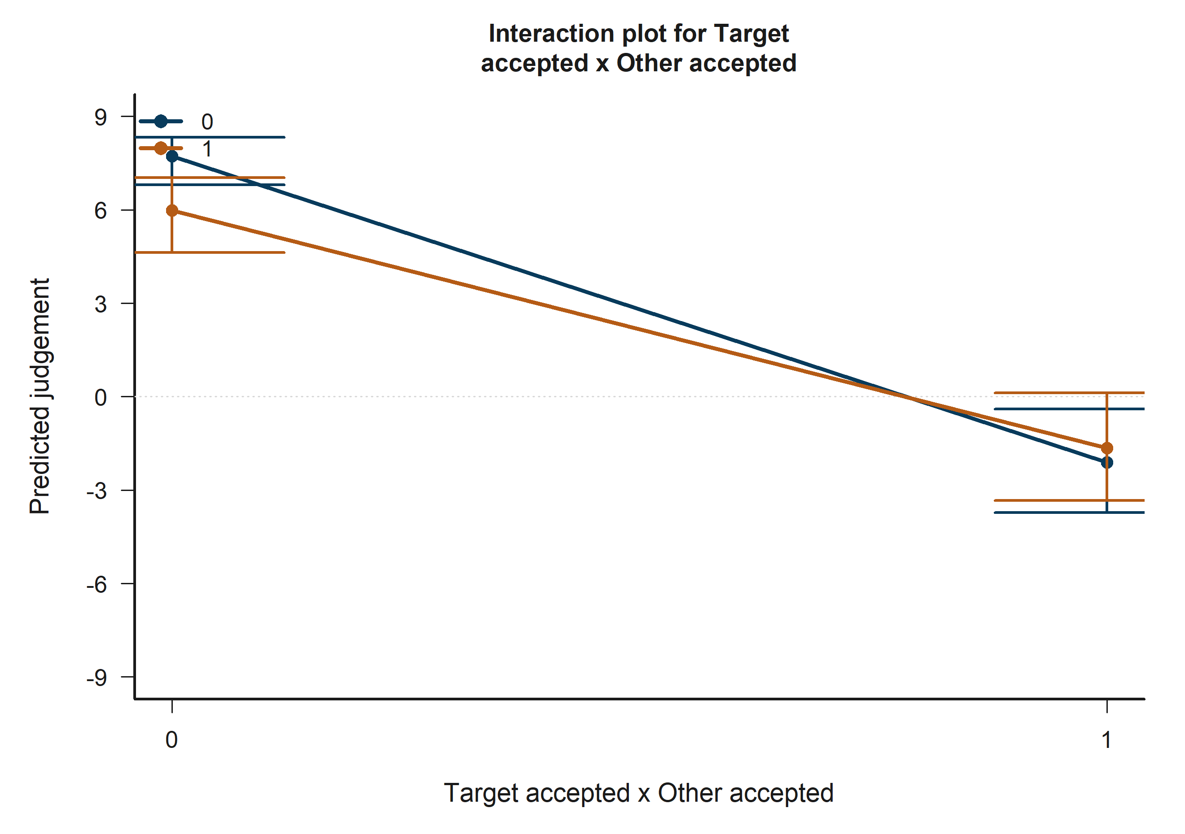
H5 Bystander: model-implied predictions for Target accepted x Other accepted.
The plotted lines summarize how the fitted predicted judgement changes across the focal term while holding the remaining covariates at their reference profile.

Full coefficient tables and interpretation summary

H1 Victim coefficient table
Table 16. H1 Victim coefficient estimates
term_label | estimate | std_error | conf_low | conf_high | p_value_display
Intercept | -0.874 | 3.297 | -7.337 | 5.589 | 0.791
Empathy: Fantasy | 0.644 | 0.524 | -0.383 | 1.672 | 0.219
Empathy: Empathic concern | -0.850 | 0.751 | -2.322 | 0.623 | 0.258
Empathy: Perspective taking | 1.773 | 0.614 | 0.570 | 2.975 | 0.004**
Empathy: Personal distress | 0.035 | 0.588 | -1.117 | 1.188 | 0.952
Age | -0.025 | 0.133 | -0.285 | 0.235 | 0.850
Socioeconomic status | 0.451 | 0.344 | -0.224 | 1.126 | 0.190
Woman participant | 0.211 | 0.812 | -1.380 | 1.803 | 0.795
Participant faculty: Engineering vs Humanities | 1.352 | 0.803 | -0.222 | 2.925 | 0.092+
Tobit log-scale | 2.448 | 0.057 | 2.336 | 2.560 | <0.001***
The H1 Victim model shows focal evidence for one hypothesis terms. Empathy: Perspective taking is associated with higher predicted judgement (estimate = 1.77, p = 0.004**). Session dummies remain in the fitted estimator for adjustment but are intentionally omitted from the substantive narrative.

H1 Bystander coefficient table
Table 17. H1 Bystander coefficient estimates
term_label | estimate | std_error | conf_low | conf_high | p_value_display
Intercept | -3.438 | 3.171 | -9.654 | 2.777 | 0.278
Empathy: Fantasy | 0.111 | 0.446 | -0.763 | 0.984 | 0.804
Empathy: Empathic concern | -0.859 | 0.638 | -2.110 | 0.391 | 0.178
Empathy: Perspective taking | 0.573 | 0.560 | -0.524 | 1.671 | 0.306
Empathy: Personal distress | 0.167 | 0.561 | -0.934 | 1.267 | 0.766
Age | 0.361 | 0.103 | 0.160 | 0.563 | <0.001***
Socioeconomic status | 0.491 | 0.299 | -0.096 | 1.078 | 0.101
Woman participant | -0.810 | 0.704 | -2.190 | 0.569 | 0.250
Participant faculty: Engineering vs Humanities | 1.005 | 0.626 | -0.222 | 2.232 | 0.109
Tobit log-scale | 2.329 | 0.057 | 2.217 | 2.440 | <0.001***
In the H1 Bystander model, no focal hypothesis term reached p < 0.10. The report therefore retains the coefficient table for auditability but does not attach a significance-driven substantive interpretation beyond the descriptive prediction plots.

H2 Victim coefficient table
Table 18. H2 Victim coefficient estimates
term_label | estimate | std_error | conf_low | conf_high | p_value_display
Intercept | 2.846 | 3.504 | -4.023 | 9.715 | 0.417
Victim-N1 outgroup vs ingroup | -0.232 | 1.364 | -2.905 | 2.441 | 0.865
Victim-N2 outgroup vs ingroup | -0.424 | 1.310 | -2.992 | 2.144 | 0.746
N1/N2 same faculty vs different | 0.359 | 0.849 | -1.305 | 2.023 | 0.672
Age | -0.020 | 0.133 | -0.281 | 0.241 | 0.881
Socioeconomic status | 0.525 | 0.358 | -0.176 | 1.227 | 0.142
Woman participant | 0.327 | 0.764 | -1.171 | 1.824 | 0.669
Participant faculty: Engineering vs Humanities | 1.526 | 0.817 | -0.076 | 3.128 | 0.062+
Victim-N1 outgroup vs ingroup x Victim-N2 outgroup vs ingroup | 0.133 | 1.792 | -3.379 | 3.646 | 0.941
Tobit log-scale | 2.452 | 0.057 | 2.340 | 2.563 | <0.001***
In the H2 Victim model, no focal hypothesis term reached p < 0.10. The report therefore retains the coefficient table for auditability but does not attach a significance-driven substantive interpretation beyond the descriptive prediction plots.

H2 Bystander coefficient table
Table 19. H2 Bystander coefficient estimates
term_label | estimate | std_error | conf_low | conf_high | p_value_display
Intercept | -2.381 | 3.001 | -8.263 | 3.501 | 0.428
Bystander-victim outgroup vs ingroup | -0.315 | 0.495 | -1.285 | 0.656 | 0.525
Bystander-N1 outgroup vs ingroup | 1.132 | 1.078 | -0.980 | 3.245 | 0.294
Bystander-N2 outgroup vs ingroup | 2.085 | 1.120 | -0.110 | 4.280 | 0.063+
Victim-N1 outgroup vs ingroup | -2.168 | 1.227 | -4.573 | 0.237 | 0.077+
Victim-N2 outgroup vs ingroup | -2.331 | 1.214 | -4.710 | 0.049 | 0.055+
N1/N2 same faculty vs different | 0.786 | 0.831 | -0.844 | 2.416 | 0.344
Age | 0.325 | 0.101 | 0.126 | 0.524 | 0.001**
Socioeconomic status | 0.466 | 0.299 | -0.120 | 1.052 | 0.119
Woman participant | -0.902 | 0.661 | -2.198 | 0.394 | 0.173
Participant faculty: Engineering vs Humanities | 1.064 | 0.646 | -0.202 | 2.331 | 0.099+
Bystander-N1 outgroup vs ingroup x Bystander-N2 outgroup vs ingroup | -2.359 | 1.401 | -5.104 | 0.386 | 0.092+
Victim-N1 outgroup vs ingroup x Victim-N2 outgroup vs ingroup | 2.884 | 1.578 | -0.210 | 5.977 | 0.068+
Tobit log-scale | 2.326 | 0.057 | 2.215 | 2.438 | <0.001***
The H2 Bystander model shows focal evidence for 5 hypothesis terms. Victim-N2 outgroup vs ingroup is associated with lower predicted judgement (estimate = -2.33, p = 0.055+). Bystander-N2 outgroup vs ingroup is associated with higher predicted judgement (estimate = 2.08, p = 0.063+). Victim-N1 outgroup vs ingroup x Victim-N2 outgroup vs ingroup is associated with higher predicted judgement (estimate = 2.88, p = 0.068+). Session dummies remain in the fitted estimator for adjustment but are intentionally omitted from the substantive narrative.

H3 Victim coefficient table
Table 20. H3 Victim coefficient estimates
term_label | estimate | std_error | conf_low | conf_high | p_value_display
Intercept | -4.295 | 4.224 | -12.574 | 3.984 | 0.309
Empathy: Fantasy | 2.044 | 0.859 | 0.360 | 3.727 | 0.017*
Empathy: Empathic concern | -0.137 | 1.104 | -2.302 | 2.027 | 0.901
Empathy: Perspective taking | 1.678 | 0.980 | -0.242 | 3.598 | 0.087+
Empathy: Personal distress | -0.416 | 1.038 | -2.451 | 1.619 | 0.689
Victim-N1 outgroup vs ingroup | 1.415 | 2.894 | -4.257 | 7.087 | 0.625
Victim-N2 outgroup vs ingroup | 2.983 | 3.200 | -3.288 | 9.255 | 0.351
N1/N2 same faculty vs different | 0.297 | 0.845 | -1.360 | 1.954 | 0.725
Age | -0.025 | 0.132 | -0.284 | 0.235 | 0.853
Socioeconomic status | 0.472 | 0.344 | -0.203 | 1.146 | 0.171
Woman participant | 0.248 | 0.817 | -1.352 | 1.849 | 0.761
Participant faculty: Engineering vs Humanities | 1.519 | 0.812 | -0.073 | 3.110 | 0.061+
Victim-N1 outgroup vs ingroup x Victim-N2 outgroup vs ingroup | 0.328 | 1.780 | -3.161 | 3.816 | 0.854
Empathy: Fantasy x Victim-N1 outgroup vs ingroup | -0.829 | 0.752 | -2.302 | 0.644 | 0.270
Empathy: Fantasy x Victim-N2 outgroup vs ingroup | -1.132 | 0.883 | -2.863 | 0.599 | 0.200
Empathy: Empathic concern x Victim-N1 outgroup vs ingroup | 0.380 | 1.113 | -1.802 | 2.562 | 0.733
Empathy: Empathic concern x Victim-N2 outgroup vs ingroup | -1.357 | 1.116 | -3.544 | 0.831 | 0.224
Empathy: Perspective taking x Victim-N1 outgroup vs ingroup | -0.388 | 1.042 | -2.430 | 1.653 | 0.709
Empathy: Perspective taking x Victim-N2 outgroup vs ingroup | 0.482 | 1.152 | -1.777 | 2.740 | 0.676
Empathy: Personal distress x Victim-N1 outgroup vs ingroup | -0.049 | 0.958 | -1.926 | 1.828 | 0.959
Empathy: Personal distress x Victim-N2 outgroup vs ingroup | 0.573 | 0.928 | -1.245 | 2.391 | 0.537
Tobit log-scale | 2.446 | 0.057 | 2.334 | 2.558 | <0.001***
The H3 Victim model shows focal evidence for 2 hypothesis terms. Empathy: Fantasy is associated with higher predicted judgement (estimate = 2.04, p = 0.017*). Empathy: Perspective taking is associated with higher predicted judgement (estimate = 1.68, p = 0.087+). Session dummies remain in the fitted estimator for adjustment but are intentionally omitted from the substantive narrative.

H3 Bystander coefficient table
Table 21. H3 Bystander coefficient estimates
term_label | estimate | std_error | conf_low | conf_high | p_value_display
Intercept | 2.237 | 4.049 | -5.698 | 10.173 | 0.581
Empathy: Fantasy | 1.337 | 0.928 | -0.482 | 3.155 | 0.150
Empathy: Empathic concern | -2.025 | 1.209 | -4.395 | 0.344 | 0.094+
Empathy: Perspective taking | 0.002 | 1.030 | -2.017 | 2.022 | 0.998
Empathy: Personal distress | -1.516 | 0.910 | -3.300 | 0.269 | 0.096+
Bystander-victim outgroup vs ingroup | -3.515 | 2.601 | -8.612 | 1.583 | 0.177
Bystander-N1 outgroup vs ingroup | -1.442 | 2.871 | -7.070 | 4.185 | 0.615
Bystander-N2 outgroup vs ingroup | -0.129 | 2.740 | -5.499 | 5.241 | 0.963
Victim-N1 outgroup vs ingroup | -2.124 | 1.215 | -4.505 | 0.256 | 0.080+
Victim-N2 outgroup vs ingroup | -2.317 | 1.216 | -4.701 | 0.066 | 0.057+
N1/N2 same faculty vs different | 0.826 | 0.820 | -0.781 | 2.434 | 0.314
Age | 0.353 | 0.103 | 0.152 | 0.554 | <0.001***
Socioeconomic status | 0.418 | 0.295 | -0.160 | 0.996 | 0.157
Woman participant | -0.791 | 0.696 | -2.155 | 0.574 | 0.256
Participant faculty: Engineering vs Humanities | 0.868 | 0.625 | -0.357 | 2.093 | 0.165
Bystander-N1 outgroup vs ingroup x Bystander-N2 outgroup vs ingroup | -2.421 | 1.405 | -5.174 | 0.331 | 0.085+
Victim-N1 outgroup vs ingroup x Victim-N2 outgroup vs ingroup | 2.833 | 1.574 | -0.252 | 5.918 | 0.072+
Empathy: Fantasy x Bystander-victim outgroup vs ingroup | -1.335 | 0.759 | -2.823 | 0.152 | 0.078+
Empathy: Fantasy x Bystander-N1 outgroup vs ingroup | -0.947 | 0.780 | -2.476 | 0.582 | 0.225
Empathy: Fantasy x Bystander-N2 outgroup vs ingroup | 0.016 | 0.856 | -1.663 | 1.694 | 0.985
Empathy: Empathic concern x Bystander-victim outgroup vs ingroup | 1.081 | 1.084 | -1.043 | 3.206 | 0.318
Empathy: Empathic concern x Bystander-N1 outgroup vs ingroup | 1.081 | 1.022 | -0.922 | 3.085 | 0.290
Empathy: Empathic concern x Bystander-N2 outgroup vs ingroup | -0.073 | 1.135 | -2.298 | 2.152 | 0.949
Empathy: Perspective taking x Bystander-victim outgroup vs ingroup | 0.142 | 0.900 | -1.623 | 1.906 | 0.875
Empathy: Perspective taking x Bystander-N1 outgroup vs ingroup | 0.355 | 1.034 | -1.672 | 2.381 | 0.732
Empathy: Perspective taking x Bystander-N2 outgroup vs ingroup | 0.348 | 0.960 | -1.534 | 2.230 | 0.717
Empathy: Personal distress x Bystander-victim outgroup vs ingroup | 1.647 | 0.770 | 0.138 | 3.155 | 0.032*
Empathy: Personal distress x Bystander-N1 outgroup vs ingroup | 0.501 | 0.827 | -1.120 | 2.122 | 0.545
Empathy: Personal distress x Bystander-N2 outgroup vs ingroup | 0.948 | 0.788 | -0.597 | 2.493 | 0.229
Tobit log-scale | 2.322 | 0.057 | 2.210 | 2.433 | <0.001***
The H3 Bystander model shows focal evidence for 8 hypothesis terms. Empathy: Personal distress x Bystander-victim outgroup vs ingroup is associated with higher predicted judgement (estimate = 1.65, p = 0.032*). Victim-N2 outgroup vs ingroup is associated with lower predicted judgement (estimate = -2.32, p = 0.057+). Victim-N1 outgroup vs ingroup x Victim-N2 outgroup vs ingroup is associated with higher predicted judgement (estimate = 2.83, p = 0.072+). Session dummies remain in the fitted estimator for adjustment but are intentionally omitted from the substantive narrative.

H4 Victim coefficient table
Table 22. H4 Victim coefficient estimates
term_label | estimate | std_error | conf_low | conf_high | p_value_display
Intercept | 9.771 | 2.575 | 4.723 | 14.819 | <0.001***
Target accepted | -16.984 | 1.072 | -19.086 | -14.882 | <0.001***
Other negotiator accepted | -3.951 | 0.705 | -5.332 | -2.570 | <0.001***
Age | 0.042 | 0.102 | -0.158 | 0.242 | 0.681
Socioeconomic status | 0.284 | 0.273 | -0.251 | 0.819 | 0.298
Woman participant | 0.464 | 0.548 | -0.611 | 1.539 | 0.398
Participant faculty: Engineering vs Humanities | 1.364 | 0.595 | 0.197 | 2.531 | 0.022*
Target accepted x Other accepted | 4.558 | 0.772 | 3.044 | 6.071 | <0.001***
Tobit log-scale | 2.032 | 0.051 | 1.932 | 2.132 | <0.001***
The H4 Victim model shows focal evidence for 3 hypothesis terms. Target accepted is associated with lower predicted judgement (estimate = -16.98, p = <0.001). Target accepted x Other accepted is associated with higher predicted judgement (estimate = 4.56, p = <0.001). Other negotiator accepted is associated with lower predicted judgement (estimate = -3.95, p = <0.001***). Session dummies remain in the fitted estimator for adjustment but are intentionally omitted from the substantive narrative.

H4 Bystander coefficient table
Table 23. H4 Bystander coefficient estimates
term_label | estimate | std_error | conf_low | conf_high | p_value_display
Intercept | 7.699 | 2.718 | 2.371 | 13.026 | 0.005**
Target accepted | -15.354 | 0.967 | -17.249 | -13.459 | <0.001***
Other negotiator accepted | -4.262 | 0.662 | -5.559 | -2.965 | <0.001***
Age | 0.164 | 0.094 | -0.020 | 0.349 | 0.081+
Socioeconomic status | 0.206 | 0.246 | -0.276 | 0.689 | 0.402
Woman participant | 0.098 | 0.543 | -0.967 | 1.164 | 0.856
Participant faculty: Engineering vs Humanities | 1.174 | 0.515 | 0.165 | 2.183 | 0.023*
Target accepted x Other accepted | 4.849 | 0.769 | 3.342 | 6.357 | <0.001***
Tobit log-scale | 1.934 | 0.050 | 1.835 | 2.033 | <0.001***
The H4 Bystander model shows focal evidence for 3 hypothesis terms. Target accepted is associated with lower predicted judgement (estimate = -15.35, p = <0.001). Other negotiator accepted is associated with lower predicted judgement (estimate = -4.26, p = <0.001). Target accepted x Other accepted is associated with higher predicted judgement (estimate = 4.85, p = <0.001***). Session dummies remain in the fitted estimator for adjustment but are intentionally omitted from the substantive narrative.

H5 Victim coefficient table
Table 24. H5 Victim coefficient estimates
term_label | estimate | std_error | conf_low | conf_high | p_value_display
Intercept | 4.069 | 3.411 | -2.617 | 10.755 | 0.233
Empathy: Fantasy | 1.469 | 0.656 | 0.184 | 2.755 | 0.025*
Empathy: Empathic concern | 0.420 | 0.899 | -1.342 | 2.183 | 0.640
Empathy: Perspective taking | 1.168 | 0.766 | -0.334 | 2.670 | 0.127
Empathy: Personal distress | -0.316 | 0.716 | -1.719 | 1.087 | 0.659
Victim-N1 outgroup vs ingroup | 1.766 | 1.806 | -1.774 | 5.305 | 0.328
Victim-N2 outgroup vs ingroup | 4.155 | 2.198 | -0.153 | 8.462 | 0.059+
N1/N2 same faculty vs different | -0.299 | 0.574 | -1.424 | 0.826 | 0.603
Target accepted | -16.910 | 1.071 | -19.010 | -14.810 | <0.001***
Other negotiator accepted | -3.881 | 0.699 | -5.251 | -2.512 | <0.001***
Age | 0.016 | 0.100 | -0.180 | 0.212 | 0.870
Socioeconomic status | 0.219 | 0.267 | -0.305 | 0.743 | 0.412
Woman participant | 0.444 | 0.572 | -0.677 | 1.564 | 0.438
Participant faculty: Engineering vs Humanities | 1.495 | 0.610 | 0.299 | 2.690 | 0.014*
Victim-N1 outgroup vs ingroup x Victim-N2 outgroup vs ingroup | -0.161 | 1.217 | -2.547 | 2.224 | 0.894
Empathy: Fantasy x Victim-N1 outgroup vs ingroup | -0.826 | 0.468 | -1.744 | 0.091 | 0.077+
Empathy: Fantasy x Victim-N2 outgroup vs ingroup | -0.632 | 0.578 | -1.764 | 0.500 | 0.274
Empathy: Empathic concern x Victim-N1 outgroup vs ingroup | -0.045 | 0.684 | -1.386 | 1.296 | 0.948
Empathy: Empathic concern x Victim-N2 outgroup vs ingroup | -0.784 | 0.849 | -2.447 | 0.879 | 0.356
Empathy: Perspective taking x Victim-N1 outgroup vs ingroup | -0.058 | 0.596 | -1.227 | 1.111 | 0.922
Empathy: Perspective taking x Victim-N2 outgroup vs ingroup | -0.276 | 0.742 | -1.731 | 1.179 | 0.710
Empathy: Personal distress x Victim-N1 outgroup vs ingroup | 0.026 | 0.572 | -1.095 | 1.147 | 0.964
Empathy: Personal distress x Victim-N2 outgroup vs ingroup | -0.139 | 0.541 | -1.199 | 0.921 | 0.797
Target accepted x Other accepted | 4.445 | 0.762 | 2.950 | 5.939 | <0.001***
Tobit log-scale | 2.024 | 0.051 | 1.924 | 2.124 | <0.001***
The H5 Victim model shows focal evidence for 6 hypothesis terms. Target accepted is associated with lower predicted judgement (estimate = -16.91, p = <0.001). Target accepted x Other accepted is associated with higher predicted judgement (estimate = 4.44, p = <0.001). Other negotiator accepted is associated with lower predicted judgement (estimate = -3.88, p = <0.001***). Session dummies remain in the fitted estimator for adjustment but are intentionally omitted from the substantive narrative.

H5 Bystander coefficient table
Table 25. H5 Bystander coefficient estimates
term_label | estimate | std_error | conf_low | conf_high | p_value_display
Intercept | 10.158 | 3.366 | 3.561 | 16.756 | 0.003**
Empathy: Fantasy | 0.737 | 0.674 | -0.583 | 2.058 | 0.274
Empathy: Empathic concern | -0.705 | 0.860 | -2.391 | 0.981 | 0.412
Empathy: Perspective taking | -0.680 | 0.731 | -2.112 | 0.753 | 0.352
Empathy: Personal distress | -0.178 | 0.699 | -1.549 | 1.192 | 0.799
Bystander-victim outgroup vs ingroup | -1.983 | 1.951 | -5.807 | 1.840 | 0.309
Bystander-N1 outgroup vs ingroup | -0.272 | 1.921 | -4.037 | 3.494 | 0.887
Bystander-N2 outgroup vs ingroup | -1.351 | 1.831 | -4.939 | 2.237 | 0.461
Victim-N1 outgroup vs ingroup | -1.543 | 0.774 | -3.061 | -0.026 | 0.046*
Victim-N2 outgroup vs ingroup | -1.589 | 0.759 | -3.076 | -0.103 | 0.036*
N1/N2 same faculty vs different | -0.105 | 0.564 | -1.210 | 1.001 | 0.853
Target accepted | -15.384 | 0.962 | -17.270 | -13.498 | <0.001***
Other negotiator accepted | -4.305 | 0.665 | -5.609 | -3.001 | <0.001***
Age | 0.184 | 0.097 | -0.006 | 0.375 | 0.058+
Socioeconomic status | 0.168 | 0.248 | -0.317 | 0.654 | 0.497
Woman participant | 0.040 | 0.557 | -1.051 | 1.132 | 0.942
Participant faculty: Engineering vs Humanities | 1.064 | 0.516 | 0.053 | 2.075 | 0.039*
Bystander-N1 outgroup vs ingroup x Bystander-N2 outgroup vs ingroup | -1.307 | 1.011 | -3.289 | 0.675 | 0.196
Victim-N1 outgroup vs ingroup x Victim-N2 outgroup vs ingroup | 2.410 | 1.069 | 0.315 | 4.505 | 0.024*
Empathy: Fantasy x Bystander-victim outgroup vs ingroup | -1.143 | 0.507 | -2.137 | -0.149 | 0.024*
Empathy: Fantasy x Bystander-N1 outgroup vs ingroup | 0.119 | 0.515 | -0.890 | 1.127 | 0.818
Empathy: Fantasy x Bystander-N2 outgroup vs ingroup | -0.133 | 0.580 | -1.270 | 1.004 | 0.818
Empathy: Empathic concern x Bystander-victim outgroup vs ingroup | 0.698 | 0.812 | -0.894 | 2.289 | 0.390
Empathy: Empathic concern x Bystander-N1 outgroup vs ingroup | -0.033 | 0.666 | -1.338 | 1.272 | 0.960
Empathy: Empathic concern x Bystander-N2 outgroup vs ingroup | -0.162 | 0.786 | -1.703 | 1.378 | 0.836
Empathy: Perspective taking x Bystander-victim outgroup vs ingroup | 0.649 | 0.618 | -0.561 | 1.860 | 0.293
Empathy: Perspective taking x Bystander-N1 outgroup vs ingroup | 0.542 | 0.662 | -0.756 | 1.840 | 0.413
Empathy: Perspective taking x Bystander-N2 outgroup vs ingroup | 0.714 | 0.682 | -0.624 | 2.051 | 0.296
Empathy: Personal distress x Bystander-victim outgroup vs ingroup | 0.605 | 0.608 | -0.588 | 1.798 | 0.320
Empathy: Personal distress x Bystander-N1 outgroup vs ingroup | -0.191 | 0.567 | -1.302 | 0.919 | 0.736
Empathy: Personal distress x Bystander-N2 outgroup vs ingroup | 0.626 | 0.541 | -0.434 | 1.685 | 0.247
Target accepted x Other accepted | 4.891 | 0.791 | 3.340 | 6.442 | <0.001***
Tobit log-scale | 1.928 | 0.050 | 1.830 | 2.026 | <0.001***
The H5 Bystander model shows focal evidence for 7 hypothesis terms. Target accepted is associated with lower predicted judgement (estimate = -15.38, p = <0.001). Other negotiator accepted is associated with lower predicted judgement (estimate = -4.31, p = <0.001). Target accepted x Other accepted is associated with higher predicted judgement (estimate = 4.89, p = <0.001***). Session dummies remain in the fitted estimator for adjustment but are intentionally omitted from the substantive narrative.

Compliance checklist
Table 26. Pipeline compliance checklist
criterion | status | evidence
a) uses judgement | YES | All formulas model judgement directly.
b) repeated structure by id | YES | All fitted Tobit models use participant-cluster robust standard errors through cluster = id.
c) session grouping | YES | The active Tobit branch uses factor(session) in every formula and documents that choice explicitly instead of claiming a random session intercept.
d) no double count introduced by the pipeline | YES | Imported rows = 4860; final analytical rows = 4860; duplicated source row numbers introduced by the pipeline = 0.
e) victim and bystander treated differently | YES | Role-specific formulas are estimated separately and H2/H3/H5 use different relational blocks for victim and bystander.
f) decision_target and decision_other included where required | YES | H4 and H5 both include decision_target, decision_other, and their interaction.
g) sociodemographics included in every hypothesis model | YES | Every H1-H5 formula retains age, ses, sex_female, and faculty_player_factor.

Corrections relative to outdated notes
The current production branch supersedes earlier notes that treated the negotiator 0 code as control_hidden, narrowed H3 to additive-only empathy terms, or implied that the main estimator used (1|session). The repository now documents the implemented estimator and the authoritative role-specific design directly.

Limitations
The production branch does not fit a full multilevel Tobit with explicit random participant and session intercepts inside the same estimator. Sparse relational cells can produce rank-deficient design matrices, so some interaction contrasts are dropped automatically and reported as such. The dynamic figures visualize model-implied predictions from the saved primary Tobit fits and should be interpreted jointly with the coefficient tables rather than as standalone causal effects.

Discussion
The empathy results speak to a mechanism in which moral judgement is not only a response to outcomes but also to dispositional social sensitivity. When empathy slopes vary across ingroup and outgroup relations, the findings support the original theoretical expectation that empathic orientation is filtered through perceived social closeness rather than operating as a uniform moral amplifier.
The ingroup/outgroup results matter because the experiment embeds judgement in a relational structure with two negotiators and role-dependent social ties. Victim and bystander models are therefore not interchangeable. In the victim role, the central question is how the judged negotiator and the counterpart relate to the harmed person. In the bystander role, the participant is socially external to the harm event, so judgement can depend on a broader map that includes bystander-victim, bystander-negotiator, and victim-negotiator alignments.
The decision terms sharpen the moral interpretation of the target-focused outcome. decision_target captures what the judged negotiator did, decision_other captures the counterpart’s choice, and their interaction tests whether the meaning of one decision changes when the other negotiator accepts or rejects. This is substantively important because moral evaluations of the target can respond both to individual action and to the joint negotiation outcome.
Practically, the results speak to negotiation ethics and third-party evaluation. If moral judgement shifts with empathy, faculty closeness, and joint decision patterns, then perceived fairness in harmful negotiations is shaped by both dispositional and relational context. That has implications for how observers assign blame, excuse strategic behavior, or infer responsibility from coordinated action.
Methodologically, the active estimator is a two-sided Tobit with participant-cluster robust standard errors and session fixed effects. This is an honest production choice for a bounded repeated-measures outcome because it preserves the Tobit structure for judgement, adjusts within-participant dependence through clustering by id, and controls for session-level shifts through factor(session). At the same time, it is not equivalent to a fully mixed Tobit with random participant and session intercepts, so dependence is handled through robust inference plus fixed-effects adjustment rather than a full hierarchical likelihood.
The main limitations follow directly from that estimator choice and from the sparsity of some relational cells. The production branch does not estimate a full mixed Tobit, some interaction contrasts may be dropped in rank-deficient subsets, and any substantive reading should remain tied to the coefficient tables and model-implied figures rather than to isolated p-values. Future work should compare these production estimates against stable multilevel censored models, test alternative role-specific interaction sets, and examine whether the same theoretical patterns replicate under additional institutional or cultural contexts.

Final audit note
The project now faithfully reflects the authoritative design in its production branch: judgement is the outcome, the long file remains the single source, one row remains one real observation, role-specific group definitions are used, decision_target and decision_other are modeled where required, and repeated measurements are handled through participant-cluster robust inference with factor(session).
No rank-deficiency warning remained in the saved fit summary for this run.
Estimator limitation: the production estimator is still a two-sided Tobit with factor(session) and participant-cluster robust standard errors by id, not a full mixed-effects Tobit with random participant and session intercepts.

Conclusion
The active workflow now reproduces a scientific dynamic report structure while remaining faithful to the implemented estimator: two-sided Tobit, factor(session), participant-cluster robust inference by id, no row duplication, and full H1-H5 coverage across victim and bystander specifications.

