Table of Contents

Tobit Regression Pipeline Report
Generated on 2026-03-14 22:24 -05.

Inputs
- Dataset: data_final_FLORIDA.xlsx
- Codebook: datacard.md
- Hypotheses source: hypotheses.md

Analysis Design
- Unit of analysis: negotiator-level judgments (two judgments per stage, ten stages per participant).
- Primary outcome: the raw bounded judgment score judgement, observed from -9 (acted very badly) to 9 (acted very well).
- Primary sample: participants passing both attention checks and with a non-missing empathy composite.
- Main hypothesis models are estimated on harmful decisions only (decision_accept = 1).
- The main Tobit specification uses survival::survreg() with participant-clustered robust standard errors and censoring at -9 and 9.
- H2a is operationalized as same_group_harm = 1 when the negotiator and victim share the same labeled faculty.
- H2b and H3 are operationalized relative to the evaluator: perp_outgroup = 1 when the negotiator belongs to the participant’s outgroup.

Word-Friendly Equations
Observed outcome definition for Word: y_ij = -9 if y*_ij <= -9 y_ij = y*_ij if -9 < y*_ij < 9 y_ij = 9 if y*_ij >= 9
Main harmful-decision model for Word: y*_ij = beta0 + beta1IRI_i + beta2OutgroupPerp_ij + beta3ControlPerp_ij + beta4VictimOutgroup_ij + beta5(IRI_iOutgroupPerp_ij) + beta6(IRI_iControlPerp_ij) + gamma’*X_ij + e_ij
Same-group-harm model for Word: y*_ij = alpha0 + alpha1IRI_i + alpha2SameGroupHarm_ij + alpha3OutgroupPerp_ij + alpha4VictimOutgroup_ij + delta’*X_ij + u_ij
Where: IRI_i = standardized empathy composite OutgroupPerp_ij = 1 if the negotiator belongs to the evaluator’s outgroup ControlPerp_ij = 1 if the negotiator’s faculty label is hidden VictimOutgroup_ij = 1 if the victim belongs to the evaluator’s outgroup SameGroupHarm_ij = 1 if negotiator and victim share the same labeled faculty X_ij = observer role, participant faculty, sex, age, socioeconomic status, stage indicators, and negotiator-slot indicator

Sample Overview
The workbook contains 63 participants, of whom 58 passed both attention checks. The primary analysis retains 58 participants and 1160 negotiator-level judgments. The Tobit hypothesis models focus on 569 harmful decisions in which a negotiator accepted the payoff-increasing but victim-harming deal.
Metric | Value
Participants in workbook | 63.00
Participants passing both attention checks | 58.00
Participants in primary analysis | 58.00
Mean age (analysis sample) | 20.29
SD age (analysis sample) | 4.88
Women in analysis sample | 27.00
Men in analysis sample | 31.00
Humanities in analysis sample | 27.00
Engineering in analysis sample | 31.00
Victim-first treatment in analysis sample | 29.00
Observer-first treatment in analysis sample | 29.00

Empathy Scale Summary
Scale | Items | Mean | SD | Min | Max | Alpha
IRI total | 28 | 2.196 | 0.448 | 1.036 | 3.250 | 0.767
Fantasy | 7 | 2.111 | 0.723 | 0.286 | 4.000 | 0.644
Empathic concern | 8 | 2.222 | 0.485 | 1.125 | 3.125 | 0.299
Perspective taking | 7 | 2.488 | 0.665 | 0.571 | 3.714 | 0.597
Personal distress | 6 | 1.918 | 0.635 | 0.000 | 3.000 | 0.521

Package Availability
The local environment only has survival installed. AER, VGAM, and censReg are included as recommended alternatives in the documentation, but the fitted model below uses survival::survreg() because it supports clustered robust inference cleanly in this project.
Package | Available
survival | TRUE
AER | FALSE
VGAM | FALSE
censReg | FALSE

Assumptions and Sample Size
The Tobit model is appropriate here because the observed dependent variable is bounded at -9 and 9 and the sample includes observations piled up at both limits. In the harmful-decision sample there are 569 negotiator-level observations from 58 participants. The observed censoring shares are 29.9% at the lower bound and 4.7% at the upper bound. Substantive interpretation assumes a latent continuous evaluation process, approximately normal model errors, and correct specification of the linear predictor. Inference is clustered by participant to address repeated judgments within persons, but the estimates should still be read cautiously because the participant count is modest.

Descriptive Patterns
The observed Tobit outcome is the raw moral-judgment score from -9 to 9, where lower values indicate harsher condemnation. Descriptively, accepted harmful deals receive much lower ratings than rejected deals (mean judgment -3.19 versus 6.21 ). Within the harmful-decision sample, same-faculty harm averages -3.55 judgment points compared with -2.91 for cross-faculty harm. Outgroup perpetrators average -3.12 judgment points versus -3.34 for labeled ingroup perpetrators.
Metric | Value
Negotiator-level judgments in analysis sample | 1160.000
Harmful decisions in primary model sample | 569.000
Acceptance rate in analysis sample | 0.491
Mean raw judgment for rejected decisions | 6.212
Mean raw judgment for accepted decisions | -3.192
Left-censored share at -9 in accepted sample | 0.299
Right-censored share at 9 in accepted sample | 0.047

negotiator_alignment | role | Observations | MeanJudgement | SDJudgement | SEJudgement | Lower95 | Upper95
ingroup | victim | 95 | -3.979 | 4.842 | 0.497 | -4.953 | -3.005
outgroup | victim | 97 | -3.289 | 5.278 | 0.536 | -4.339 | -2.238
control | victim | 104 | -3.740 | 5.593 | 0.548 | -4.815 | -2.665
ingroup | observer | 92 | -2.685 | 5.056 | 0.527 | -3.718 | -1.652
outgroup | observer | 80 | -2.913 | 5.406 | 0.604 | -4.097 | -1.728
control | observer | 101 | -2.475 | 5.723 | 0.569 | -3.591 | -1.359

Figures
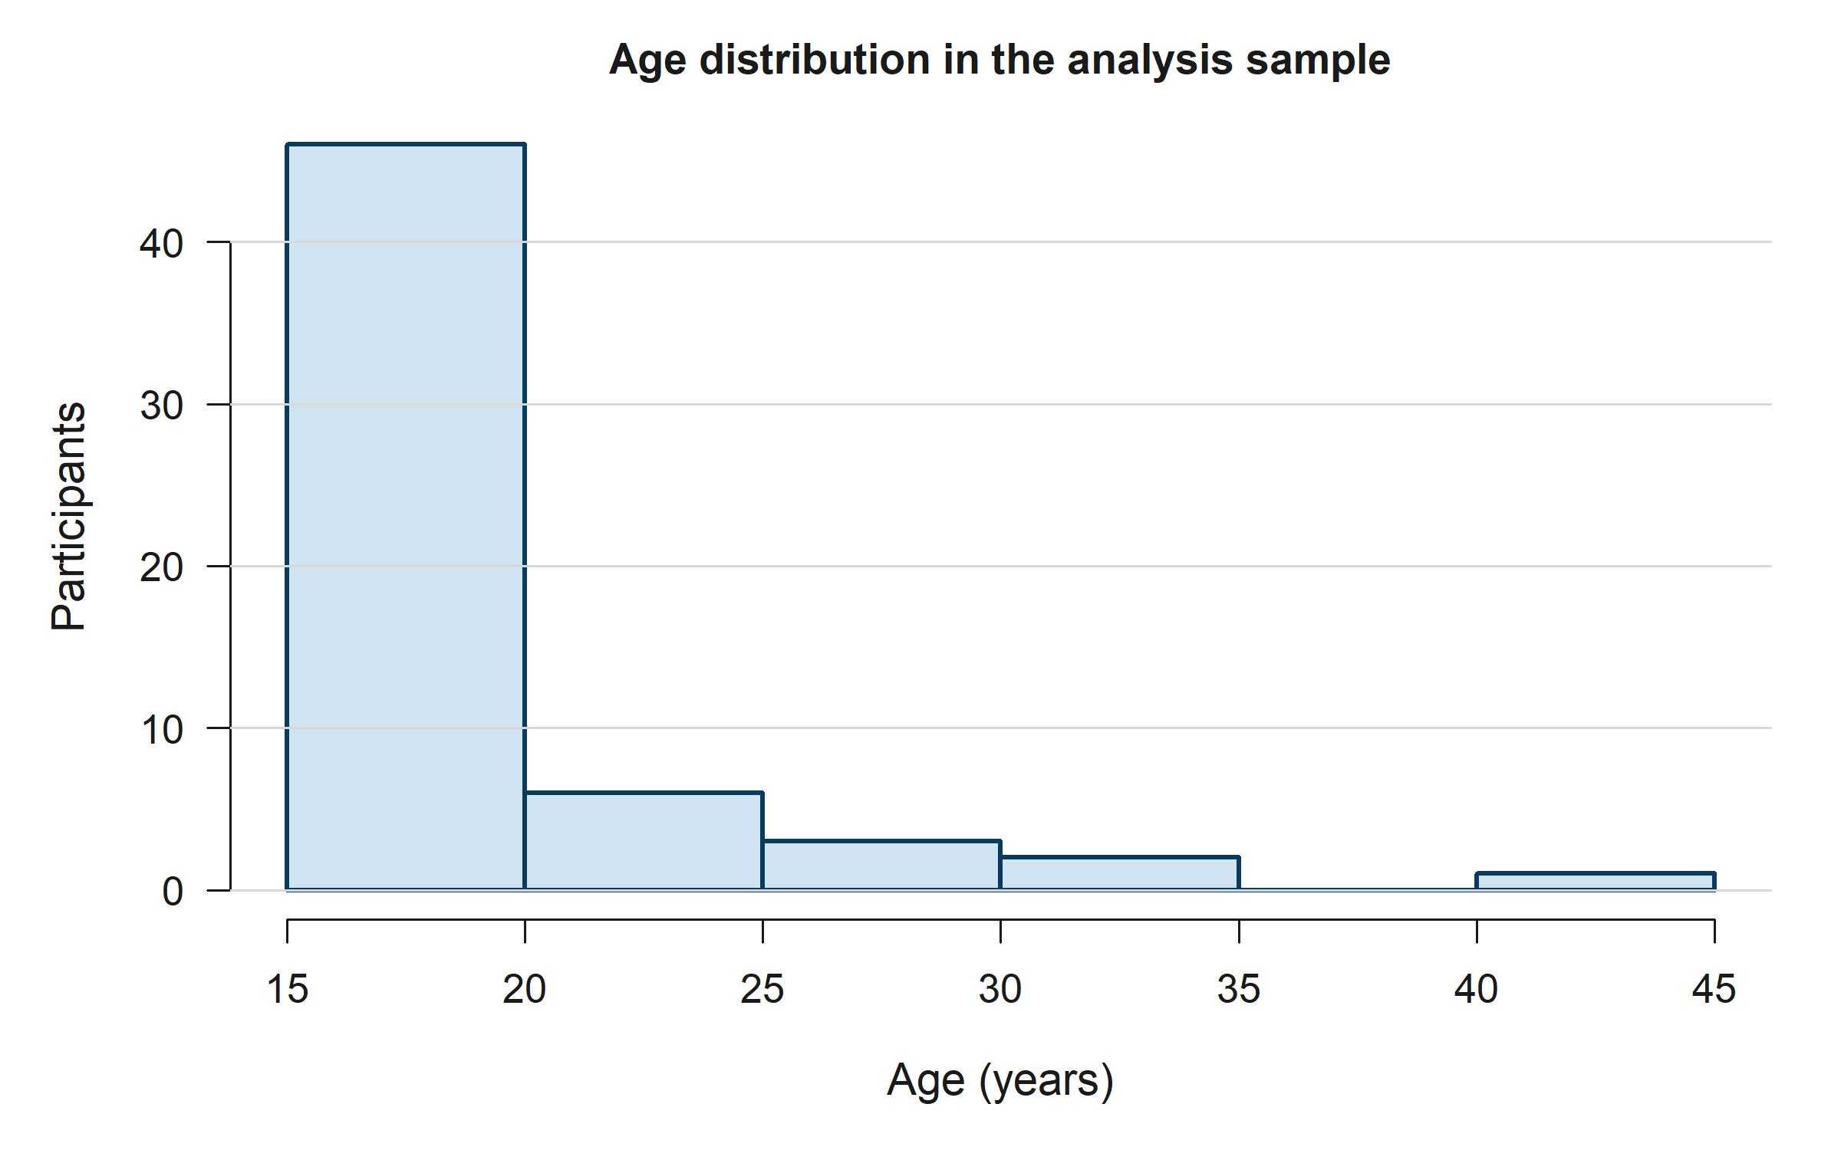
Age distribution
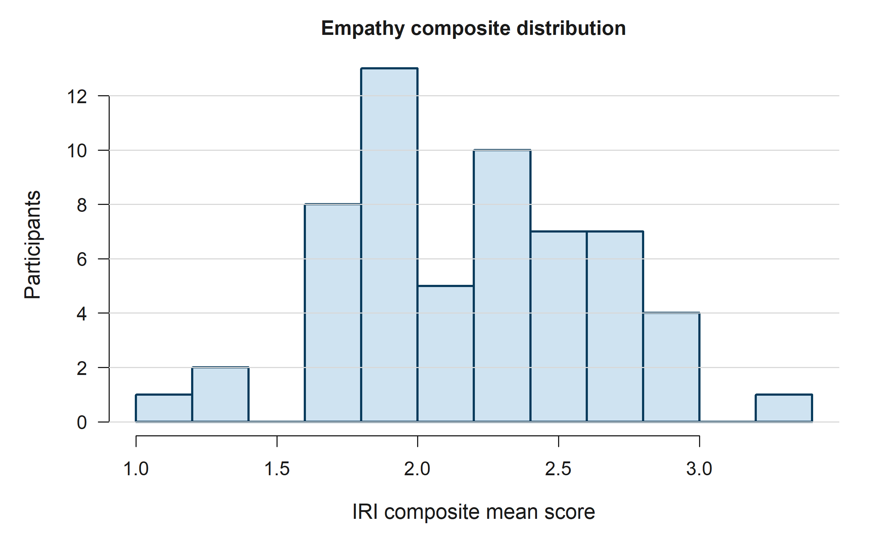
Empathy composite distribution
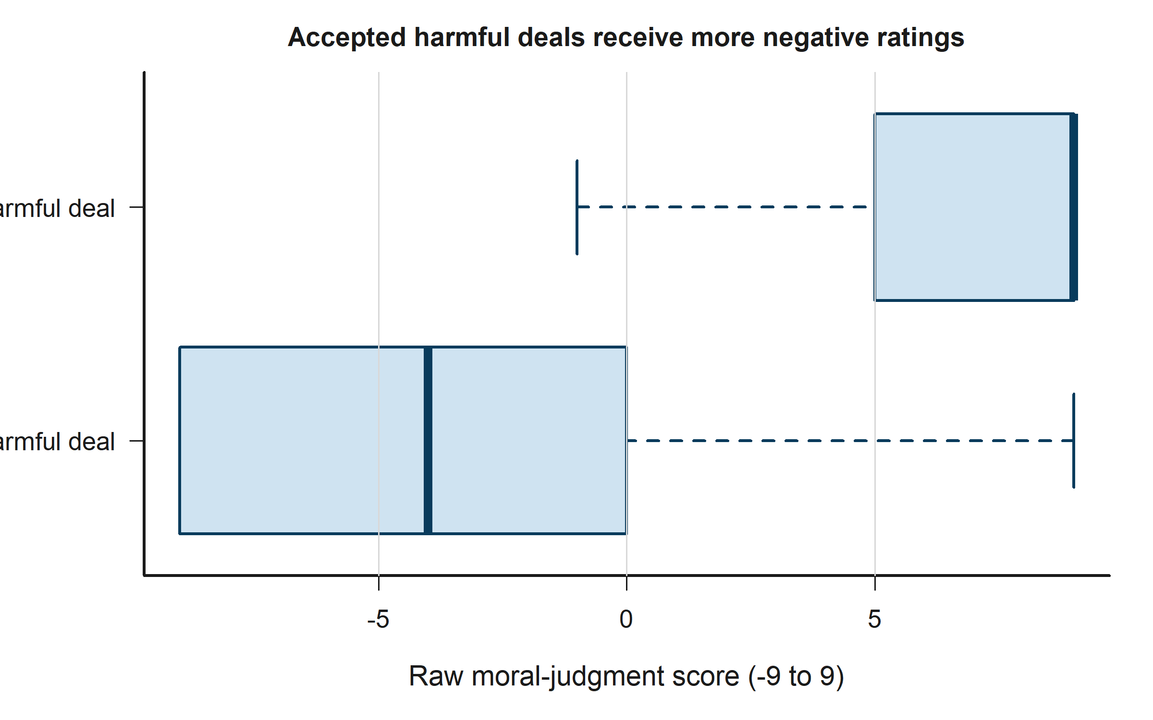
Judgment by decision
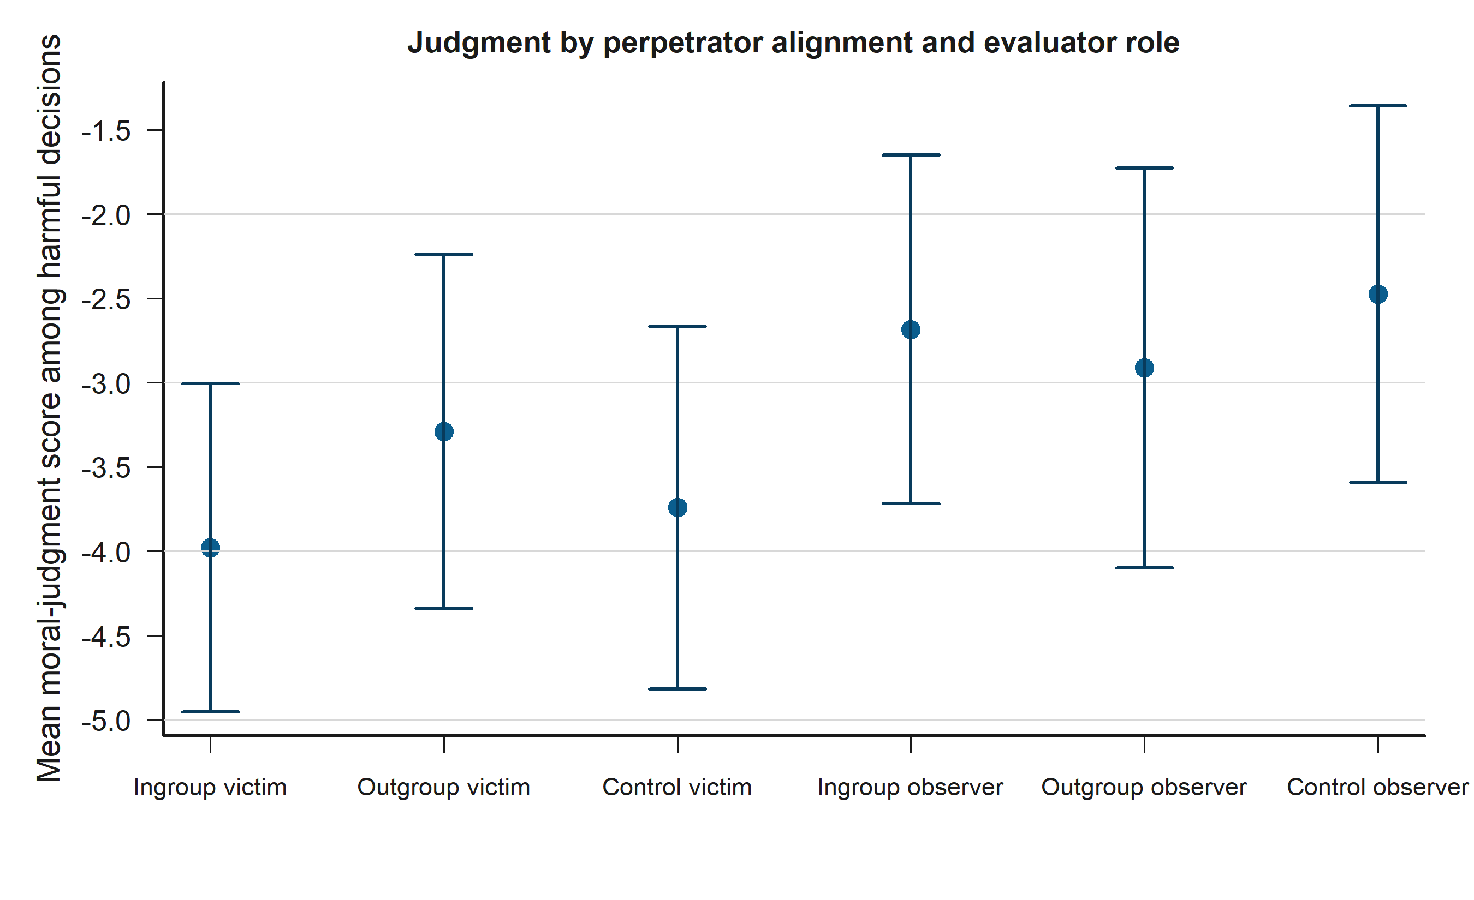
Harmful decisions by group

Tobit Models
In the main harmful-decision Tobit model, higher empathy is associated with harsher judgments (b = -0.79, 95% CI [-2.86, 1.29], p = 0.457; not statistically distinguishable from zero). Outgroup perpetrators receive more favorable judgments than ingroup perpetrators (b = 0.08, 95% CI [-1.27, 1.44], p = 0.906; not statistically distinguishable from zero). The empathy slope becomes more negative in outgroup cases than ingroup cases (b = -0.45, 95% CI [-2.06, 1.16], p = 0.583; not statistically distinguishable from zero). In the same-faculty harm model, same-faculty harm is associated with harsher condemnation (b = -1.34, 95% CI [-2.88, 0.19], p = 0.087; not statistically distinguishable from zero).

Main Harmful-Decision Tobit
Term | Estimate | RobustSE | CI_Low | CI_High | PValue
Intercept | 0.508 | 5.090 | -9.468 | 10.484 | 0.921
Empathy composite (z) | -0.788 | 1.059 | -2.864 | 1.288 | 0.457
Outgroup perpetrator (ref = ingroup) | 0.082 | 0.691 | -1.272 | 1.436 | 0.906
Control label hidden (ref = ingroup) | 0.139 | 0.807 | -1.443 | 1.721 | 0.863
Victim outgroup (ref = ingroup) | -2.417 | 1.233 | -4.834 | -0.000 | 0.050
Observer role (ref = victim) | 2.890 | 1.394 | 0.158 | 5.622 | 0.038
Engineering participant (ref = humanities) | -1.279 | 1.801 | -4.808 | 2.251 | 0.478
Man (ref = woman) | -1.821 | 1.761 | -5.273 | 1.631 | 0.301
Age | -0.089 | 0.218 | -0.516 | 0.338 | 0.683
Socioeconomic status | -0.435 | 0.760 | -1.923 | 1.054 | 0.567
Stage 2 (ref = stage 1) | 0.769 | 1.056 | -1.301 | 2.840 | 0.466
Stage 3 (ref = stage 1) | -1.132 | 1.450 | -3.973 | 1.710 | 0.435
Stage 4 (ref = stage 1) | -2.214 | 1.528 | -5.208 | 0.781 | 0.147
Stage 5 (ref = stage 1) | -1.788 | 1.250 | -4.238 | 0.662 | 0.153
Stage 6 (ref = stage 1) | -0.749 | 1.348 | -3.391 | 1.893 | 0.578
Stage 7 (ref = stage 1) | -1.454 | 1.237 | -3.878 | 0.970 | 0.240
Stage 8 (ref = stage 1) | -3.178 | 1.407 | -5.936 | -0.421 | 0.024
Stage 9 (ref = stage 1) | -2.733 | 1.358 | -5.394 | -0.071 | 0.044
Stage 10 (ref = stage 1) | -1.122 | 1.359 | -3.787 | 1.542 | 0.409
Negotiator 2 (ref = negotiator 1) | 0.002 | 0.485 | -0.948 | 0.953 | 0.996
Empathy x outgroup perpetrator | -0.450 | 0.821 | -2.059 | 1.159 | 0.583
Empathy x control label hidden | -0.450 | 0.733 | -1.887 | 0.987 | 0.539

Same-Faculty Harm Tobit
Term | Estimate | RobustSE | CI_Low | CI_High | PValue
Intercept | 4.054 | 5.531 | -6.788 | 14.895 | 0.464
Empathy composite (z) | -0.873 | 0.953 | -2.740 | 0.994 | 0.359
Negotiator and victim share faculty | -1.341 | 0.783 | -2.876 | 0.194 | 0.087
Outgroup perpetrator (ref = ingroup) | -0.578 | 0.721 | -1.991 | 0.835 | 0.423
Victim outgroup (ref = ingroup) | -1.847 | 1.534 | -4.854 | 1.160 | 0.229
Observer role (ref = victim) | 2.294 | 1.520 | -0.685 | 5.272 | 0.131
Engineering participant (ref = humanities) | -1.755 | 1.764 | -5.211 | 1.702 | 0.320
Man (ref = woman) | -1.175 | 1.774 | -4.652 | 2.302 | 0.508
Age | -0.213 | 0.227 | -0.659 | 0.233 | 0.349
Socioeconomic status | -0.303 | 0.735 | -1.743 | 1.137 | 0.680
Stage 2 (ref = stage 1) | -0.630 | 1.527 | -3.623 | 2.363 | 0.680
Stage 3 (ref = stage 1) | -0.843 | 1.536 | -3.855 | 2.168 | 0.583
Stage 4 (ref = stage 1) | -3.761 | 1.511 | -6.722 | -0.800 | 0.013
Stage 5 (ref = stage 1) | -1.283 | 1.822 | -4.853 | 2.288 | 0.481
Stage 6 (ref = stage 1) | -0.760 | 1.393 | -3.490 | 1.970 | 0.585
Stage 7 (ref = stage 1) | -2.578 | 1.478 | -5.475 | 0.319 | 0.081
Stage 8 (ref = stage 1) | -2.125 | 1.470 | -5.005 | 0.756 | 0.148
Stage 9 (ref = stage 1) | -1.470 | 1.362 | -4.139 | 1.199 | 0.280
Stage 10 (ref = stage 1) | -1.463 | 1.611 | -4.622 | 1.695 | 0.364
Negotiator 2 (ref = negotiator 1) | -0.147 | 0.576 | -1.277 | 0.982 | 0.798

Model Fit Summary
Model | Observations | Participants | LowerBoundCensored | UpperBoundCensored | LogLik | AIC | PseudoR2
Main harmful-decision Tobit | 569 | 58 | 170 | 27 | -1458.903 | 2963.805 | 0.014
Same-faculty harm Tobit | 364 | 58 | 103 | 13 | -941.867 | 1925.733 | 0.013
Full-sample Tobit | 1160 | 58 | 182 | 332 | -2627.999 | 5303.998 | 0.117

Hypothesis Validation
Decision rule: reject H0 when p < 0.05; otherwise fail to reject H0. For the research hypothesis, ‘Support HA’ means the coefficient is statistically detectable and points in the theorized direction.
H1: Fail to reject H0; Insufficient evidence for HA. H1 is inconclusive: fail to reject the null. The coefficient direction is negative but the estimate is not statistically distinguishable from zero. H2a: Fail to reject H0; Insufficient evidence for HA. H2a is inconclusive: fail to reject the null. The coefficient direction is negative but the estimate is not statistically distinguishable from zero. H2b: Fail to reject H0; Insufficient evidence for HA. H2b is inconclusive: fail to reject the null. The coefficient direction is positive but the estimate is not statistically distinguishable from zero. H3: Fail to reject H0; Insufficient evidence for HA. H3 is inconclusive: fail to reject the null. The coefficient direction is negative but the estimate is not statistically distinguishable from zero.
Hypothesis | Description | ModelTerm | Estimate | CI95 | PValue | Verdict | NullDecision | ResearchDecision | Interpretation
H1 | Higher empathy predicts lower moral-judgment scores for harmful decisions. | Empathy composite (z) | -0.788 | [-2.86, 1.29] | 0.457 | Inconclusive | Fail to reject H0 | Insufficient evidence for HA | H1 is inconclusive: fail to reject the null. The coefficient direction is negative but the estimate is not statistically distinguishable from zero.
H2a | Same-faculty harm receives lower moral-judgment scores than cross-faculty harm. | Negotiator and victim share faculty | -1.341 | [-2.88, 0.19] | 0.087 | Inconclusive | Fail to reject H0 | Insufficient evidence for HA | H2a is inconclusive: fail to reject the null. The coefficient direction is negative but the estimate is not statistically distinguishable from zero.
H2b | Outgroup perpetrators receive lower moral-judgment scores than ingroup perpetrators. | Outgroup perpetrator (ref = ingroup) | 0.082 | [-1.27, 1.44] | 0.906 | Inconclusive | Fail to reject H0 | Insufficient evidence for HA | H2b is inconclusive: fail to reject the null. The coefficient direction is positive but the estimate is not statistically distinguishable from zero.
H3 | Empathy becomes more negative in outgroup than ingroup cases. | Empathy x outgroup perpetrator | -0.450 | [-2.06, 1.16] | 0.583 | Inconclusive | Fail to reject H0 | Insufficient evidence for HA | H3 is inconclusive: fail to reject the null. The coefficient direction is negative but the estimate is not statistically distinguishable from zero.

Output Inventory
- outputs/data/ contains participant-level and long-format analysis datasets.
- outputs/tables/ contains all summary and hypothesis tables in CSV format.
- outputs/models/ contains fitted Tobit models (.rds) plus coefficient and fit-stat CSV files.
- outputs/figures/ contains 300 dpi minimalist figures using a high-contrast blue palette suitable for low-vision reading.
- outputs/report/ contains the Markdown report, Word report, LaTeX article, PDF article, and session information.

