Scientific Analysis of Moral Judgments with Tobit and Cluster-Aware Non-Parametric Robustness Checks

Dataset Description
The empirical foundation of this project rests on two primary experimental datasets: FLORIDA and BUC. The sample consists of students from the Bucaramanga Campus. These datasets capture incentivized moral judgments from distinct socio-economic contexts. Participants were presented with standardized negotiation scenarios where a negotiator’s decision resulted in varying degrees of payoff for themselves, their own group, and a victim group. Under Option 2: judgment-level relational modeling , each judgment is treated as relational and linked both to a descriptive victim x negotiator scenario shorthand and to hypothesis-specific predictors for judged negotiator status, decision outcome, and additional relational controls.

Option 2 Relational Case Configuration
Option 2 replaces isolated ingroup/outgroup indicators with explicit judgment-level relational variables built from the paired-group structure of each judgment. The analytic hypothesis models decompose that structure into the judged negotiator’s relational status, decision outcome (Accept/Reject), their interaction, and additional relational controls for the counterpart negotiator and, in observer rows, victim alignment. All hypothesis sections are now interpreted through negotiator-level relational predictors rather than descriptive case labels.

Hypothesis Significance Summary
Only hypothesis-relevant predictors with p < 0.10 are shown below. Symbols follow the rule + for p < 0.10, * for p < 0.05, ** for p < 0.01, and *** for p < 0.001. If bootstrap is disabled for a run, too few non-parametric bootstrap refits succeed, or the non-parametric fit does not converge, the non-parametric column reports that status explicitly. Dynamic figures are generated only for predictors that appear here with at least one significance symbol. | Hypothesis | Tobit support | Non-parametric support | | — | — | — | | H1 | Empathy: Empathic concern; Empathy: Perspective taking | None | | H2 | None | None | | H3 | Personal distress x judged negotiator outgroup**; Empathic concern x judged negotiator outgroup* | None |

Significance-Driven Figures
Only hypothesis-relevant predictors that reach at least p < .10 are visualized automatically. These figures rely on the saved Tobit and clustered non-parametric fits, and id remains only an inference-level clustering unit.

H1: Empathy under relational controls
Empathy: Empathic concern is statistically significant in the Tobit model (*, p = 0.023). The figure below shows that across the observed range, higher Empathy: Empathic concern corresponds to lower predicted latent judgment.
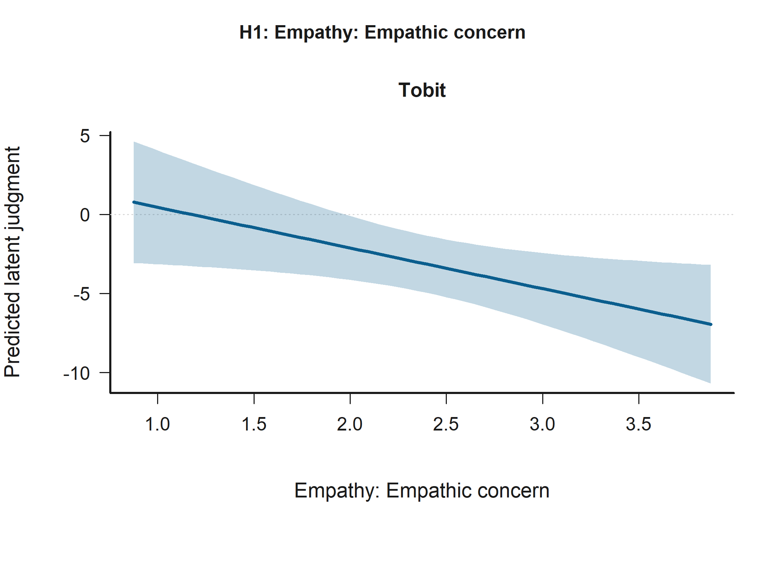
Effect Plot for Empathy: Empathic concern in H1: Empathy under relational controls. Support comes from the Tobit model (*, p = 0.023). The panels show predicted latent judgments with 95% confidence intervals.
Empathy: Perspective taking is statistically significant in the Tobit model (*, p = 0.045). The figure below shows that across the observed range, higher Empathy: Perspective taking corresponds to higher predicted latent judgment.
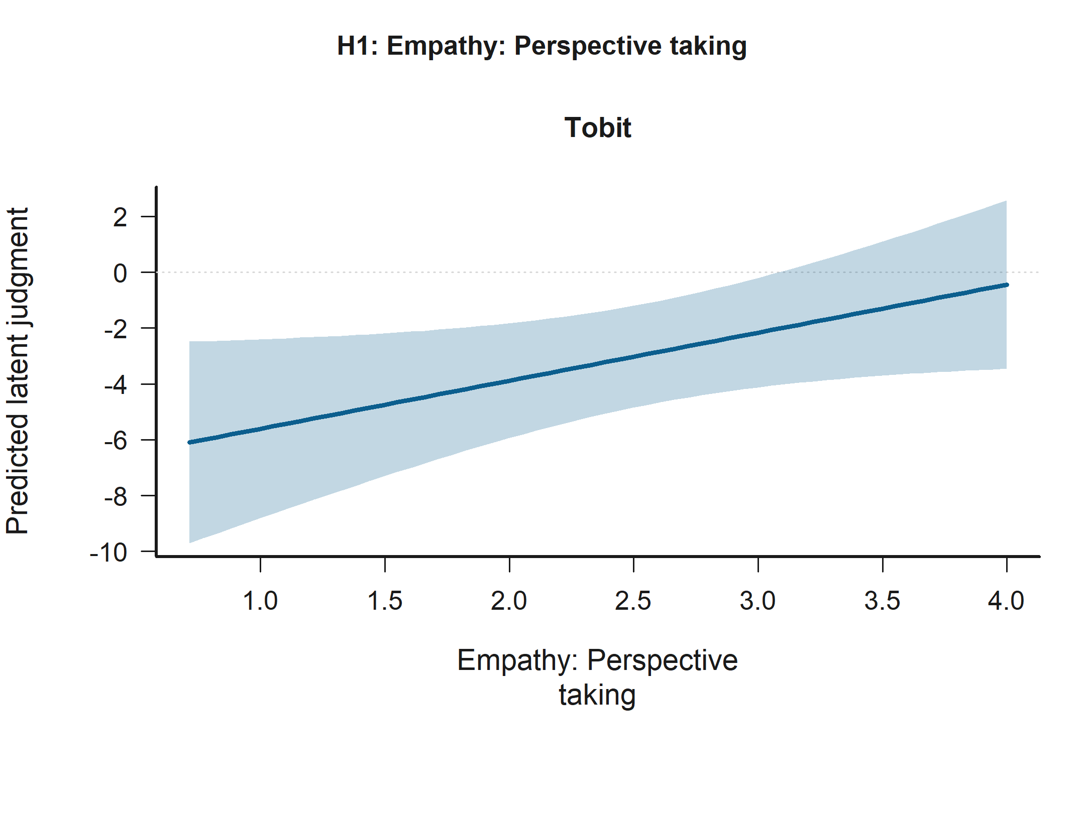
Effect Plot for Empathy: Perspective taking in H1: Empathy under relational controls. Support comes from the Tobit model (*, p = 0.045). The panels show predicted latent judgments with 95% confidence intervals.

H3: Empathy x judged-status moderation
Personal distress x judged negotiator outgroup is statistically significant in the Tobit model (**, p = 0.002). The figure below shows that the predicted relationship rises most sharply for Empathy: Personal distress when the condition is Judged negotiator outgroup.
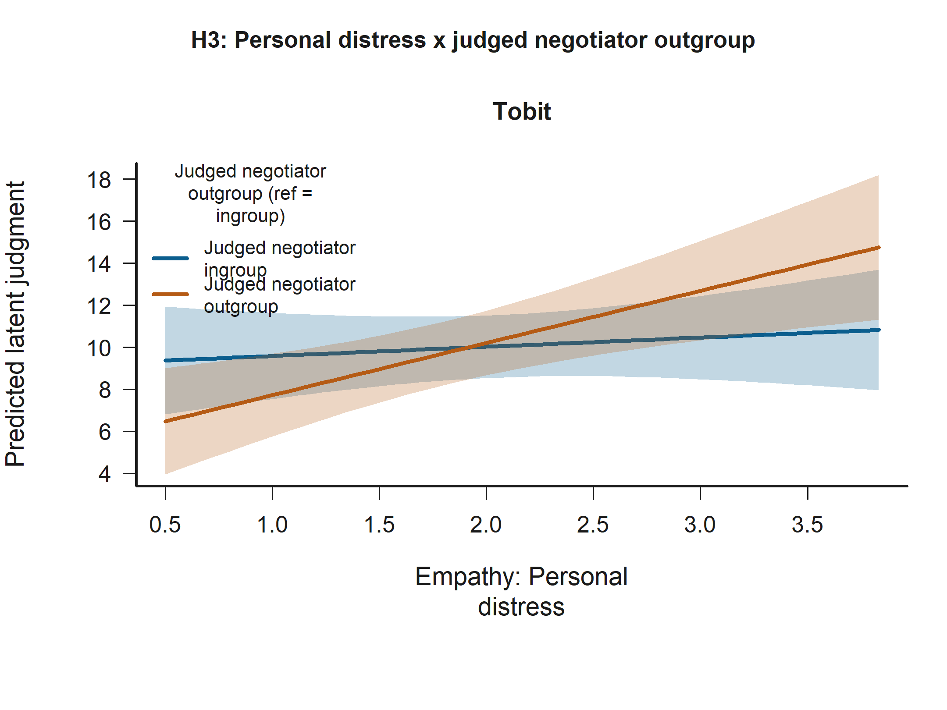
Interaction Plot for Personal distress x judged negotiator outgroup in H3: Empathy x judged-status moderation. Support comes from the Tobit model (**, p = 0.002). The panels show predicted latent judgments with 95% confidence intervals.
Empathic concern x judged negotiator outgroup is statistically significant in the Tobit model (*, p = 0.025). The figure below shows that the predicted relationship falls most sharply for Empathy: Empathic concern when the condition is Judged negotiator outgroup.
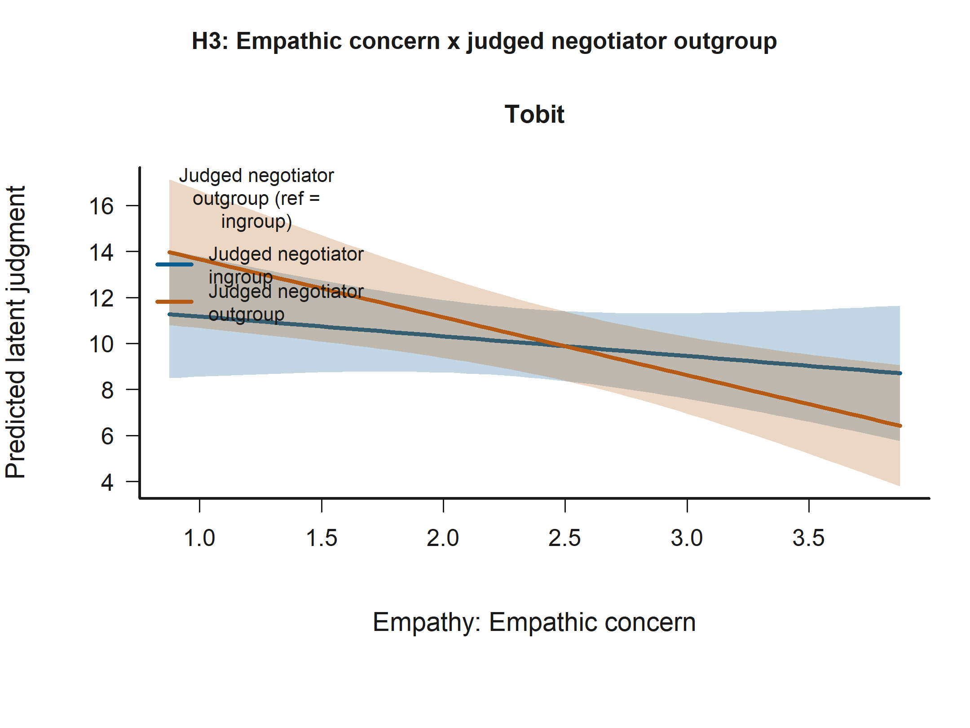
Interaction Plot for Empathic concern x judged negotiator outgroup in H3: Empathy x judged-status moderation. Support comes from the Tobit model (*, p = 0.025). The panels show predicted latent judgments with 95% confidence intervals.

All Significant Predictors (p < .10)
The following figures extend beyond the hypothesis-target terms and visualize every predictor that reaches p < .10 in the available H1-H3 Tobit or clustered non-parametric models. This includes significant controls such as age when they clear the threshold.

Accepted-decision sample
Observer role (ref = victim) is statistically significant in: - H1: Empathy under relational controls Model B (Tobit) - H1: Empathy under relational controls Model A (Tobit) The figure below shows that predicted latent judgment is higher for Observer role than for Victim role.
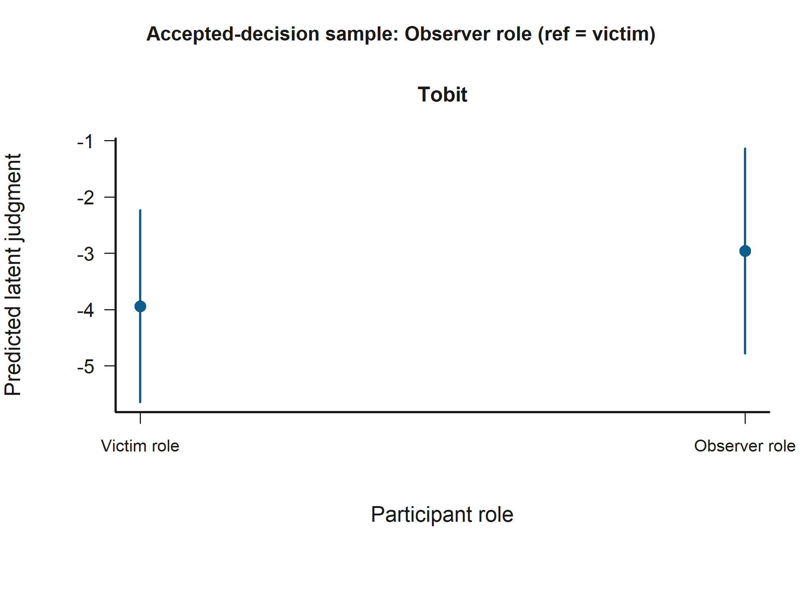
Grouped Prediction Plot for Observer role (ref = victim) in the Accepted-decision sample. Statistically significant support appears in H1: Empathy under relational controls Model B (Tobit) and H1: Empathy under relational controls Model A (Tobit). The panels show predicted latent judgments with 95% confidence intervals.
Empathy: Empathic concern is statistically significant in: - H1: Empathy under relational controls Model B (Tobit) The figure below shows that across the observed range, higher Empathy: Empathic concern corresponds to lower predicted latent judgment.
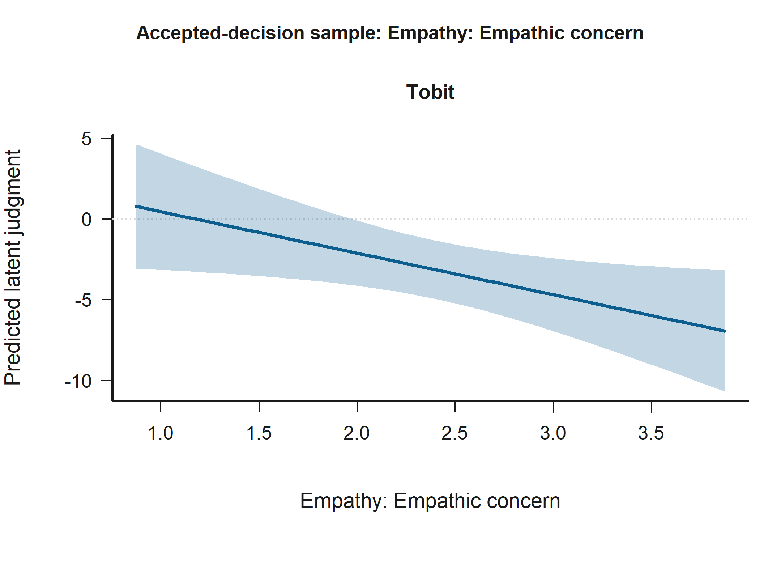
Effect Plot for Empathy: Empathic concern in the Accepted-decision sample. Statistically significant support appears in H1: Empathy under relational controls Model B (Tobit). The panels show predicted latent judgments with 95% confidence intervals.
Age is statistically significant in: - H1: Empathy under relational controls Model A (Tobit) - H1: Empathy under relational controls Model B (Tobit) The figure below shows that across the observed range, higher Age corresponds to higher predicted latent judgment.
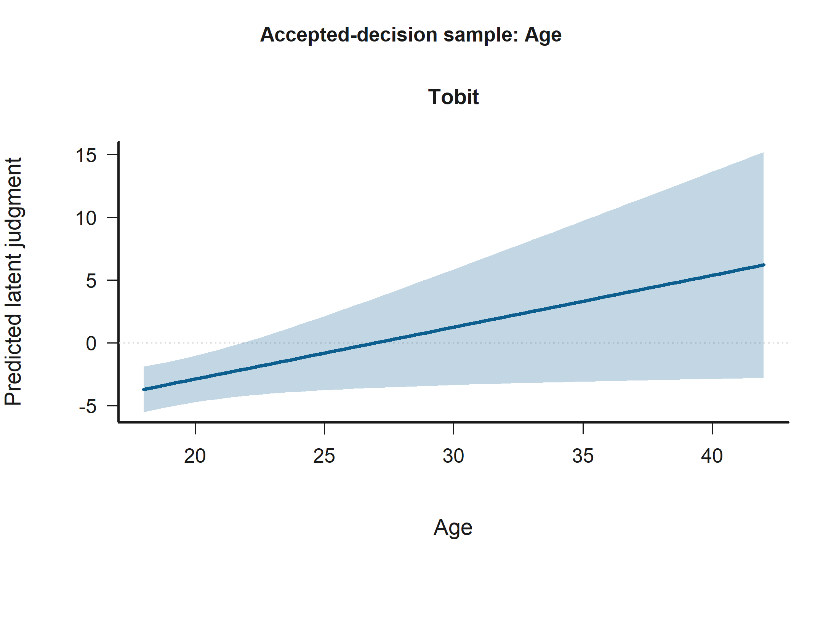
Effect Plot for Age in the Accepted-decision sample. Statistically significant support appears in H1: Empathy under relational controls Model A (Tobit) and H1: Empathy under relational controls Model B (Tobit). The panels show predicted latent judgments with 95% confidence intervals.
Empathy: Perspective taking is statistically significant in: - H1: Empathy under relational controls Model B (Tobit) The figure below shows that across the observed range, higher Empathy: Perspective taking corresponds to higher predicted latent judgment.
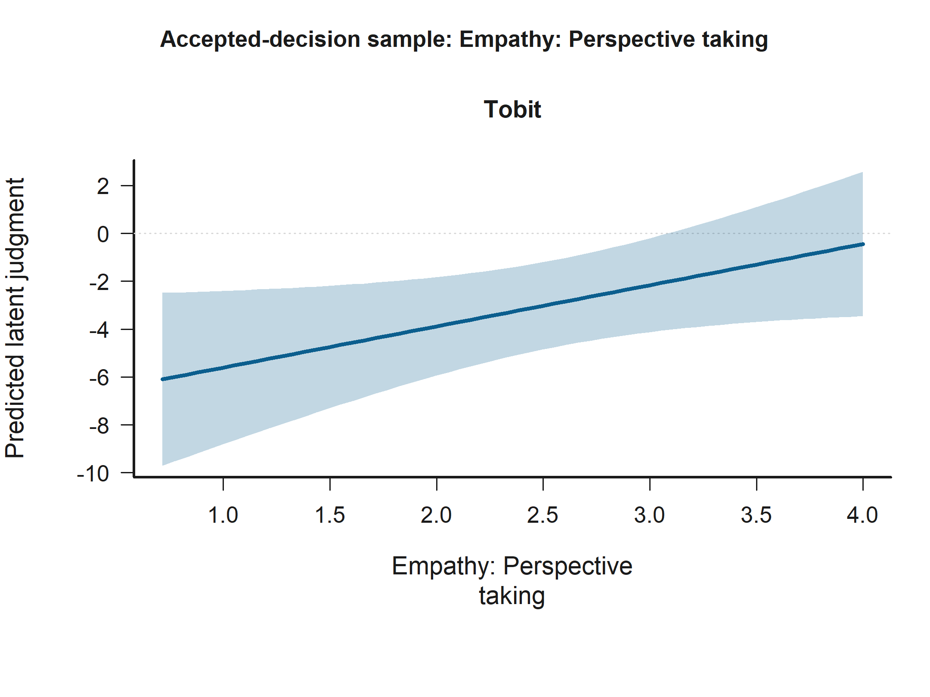
Effect Plot for Empathy: Perspective taking in the Accepted-decision sample. Statistically significant support appears in H1: Empathy under relational controls Model B (Tobit). The panels show predicted latent judgments with 95% confidence intervals.
Engineering participant (ref = humanities) is statistically significant in: - H1: Empathy under relational controls Model A (Tobit) - H1: Empathy under relational controls Model B (Tobit) The figure below shows that predicted latent judgment is higher for Engineering participant than for Humanities participant.
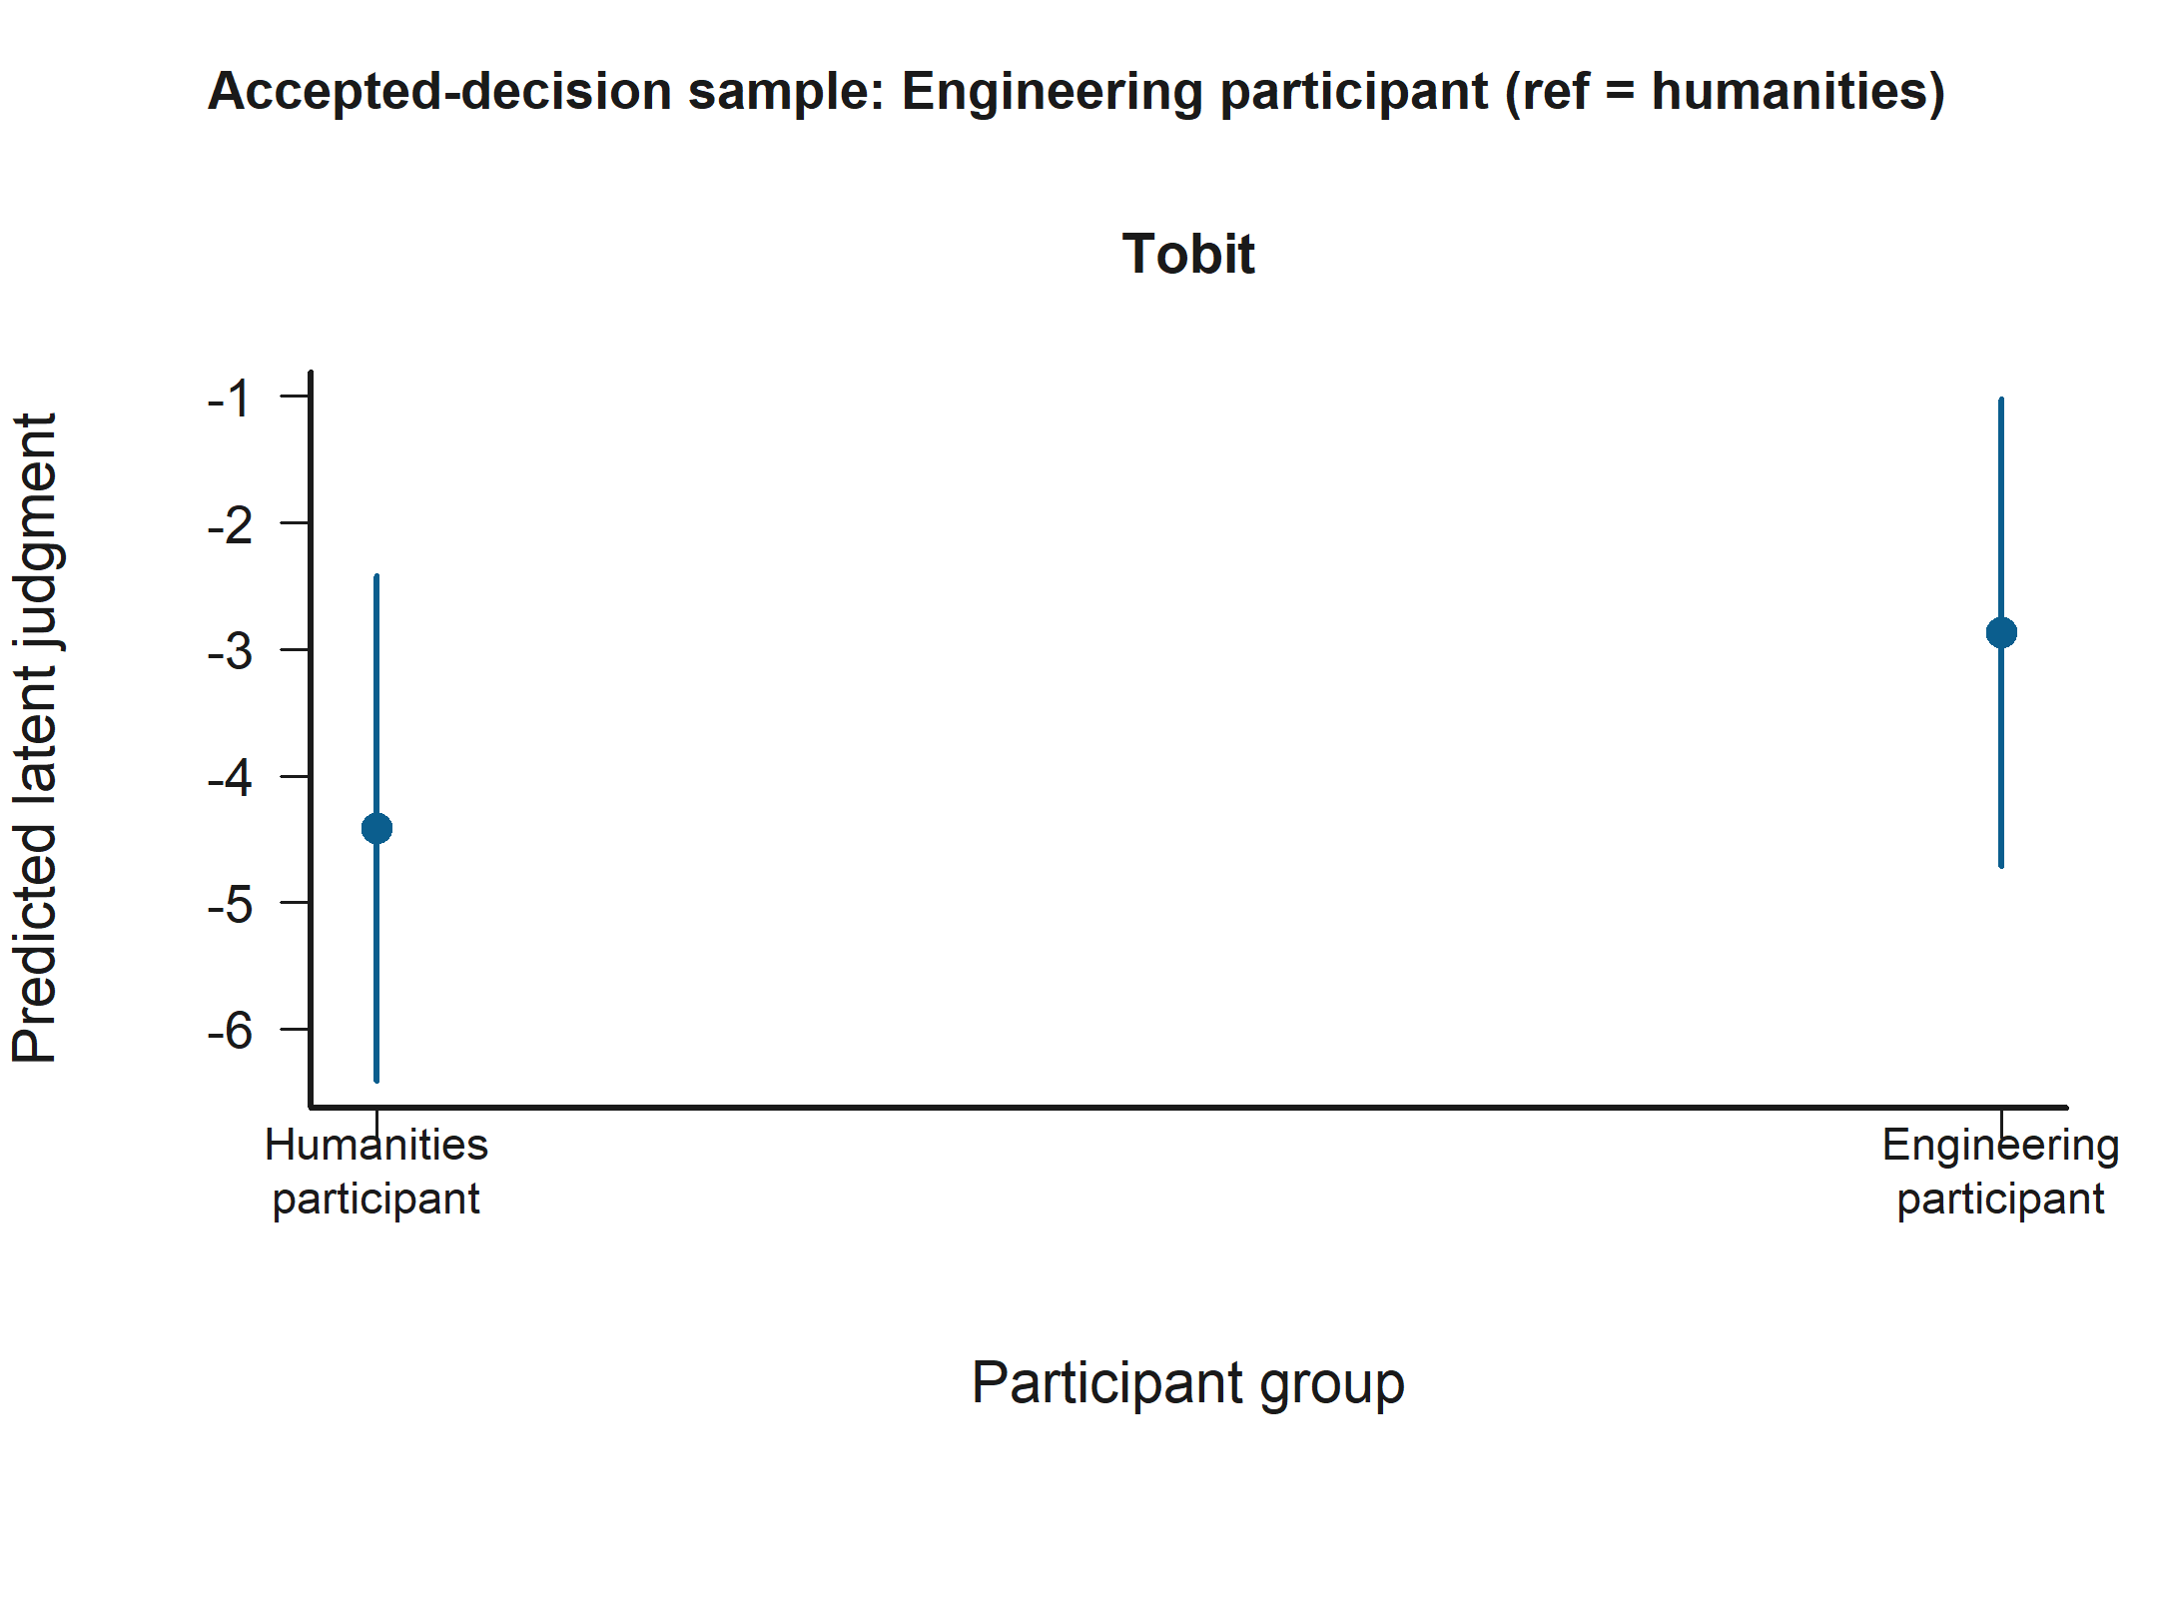
Grouped Prediction Plot for Engineering participant (ref = humanities) in the Accepted-decision sample. Statistically significant support appears in H1: Empathy under relational controls Model A (Tobit) and H1: Empathy under relational controls Model B (Tobit). The panels show predicted latent judgments with 95% confidence intervals.

Betrayal sample
Negotiator accepted harmful deal is statistically significant in: - H2: Judged-status x decision contrasts Model A (Tobit) - H2: Judged-status x decision contrasts Model B (Tobit) The figure below shows that predicted latent judgment is lower for Accept harmful deal than for Reject harmful deal.
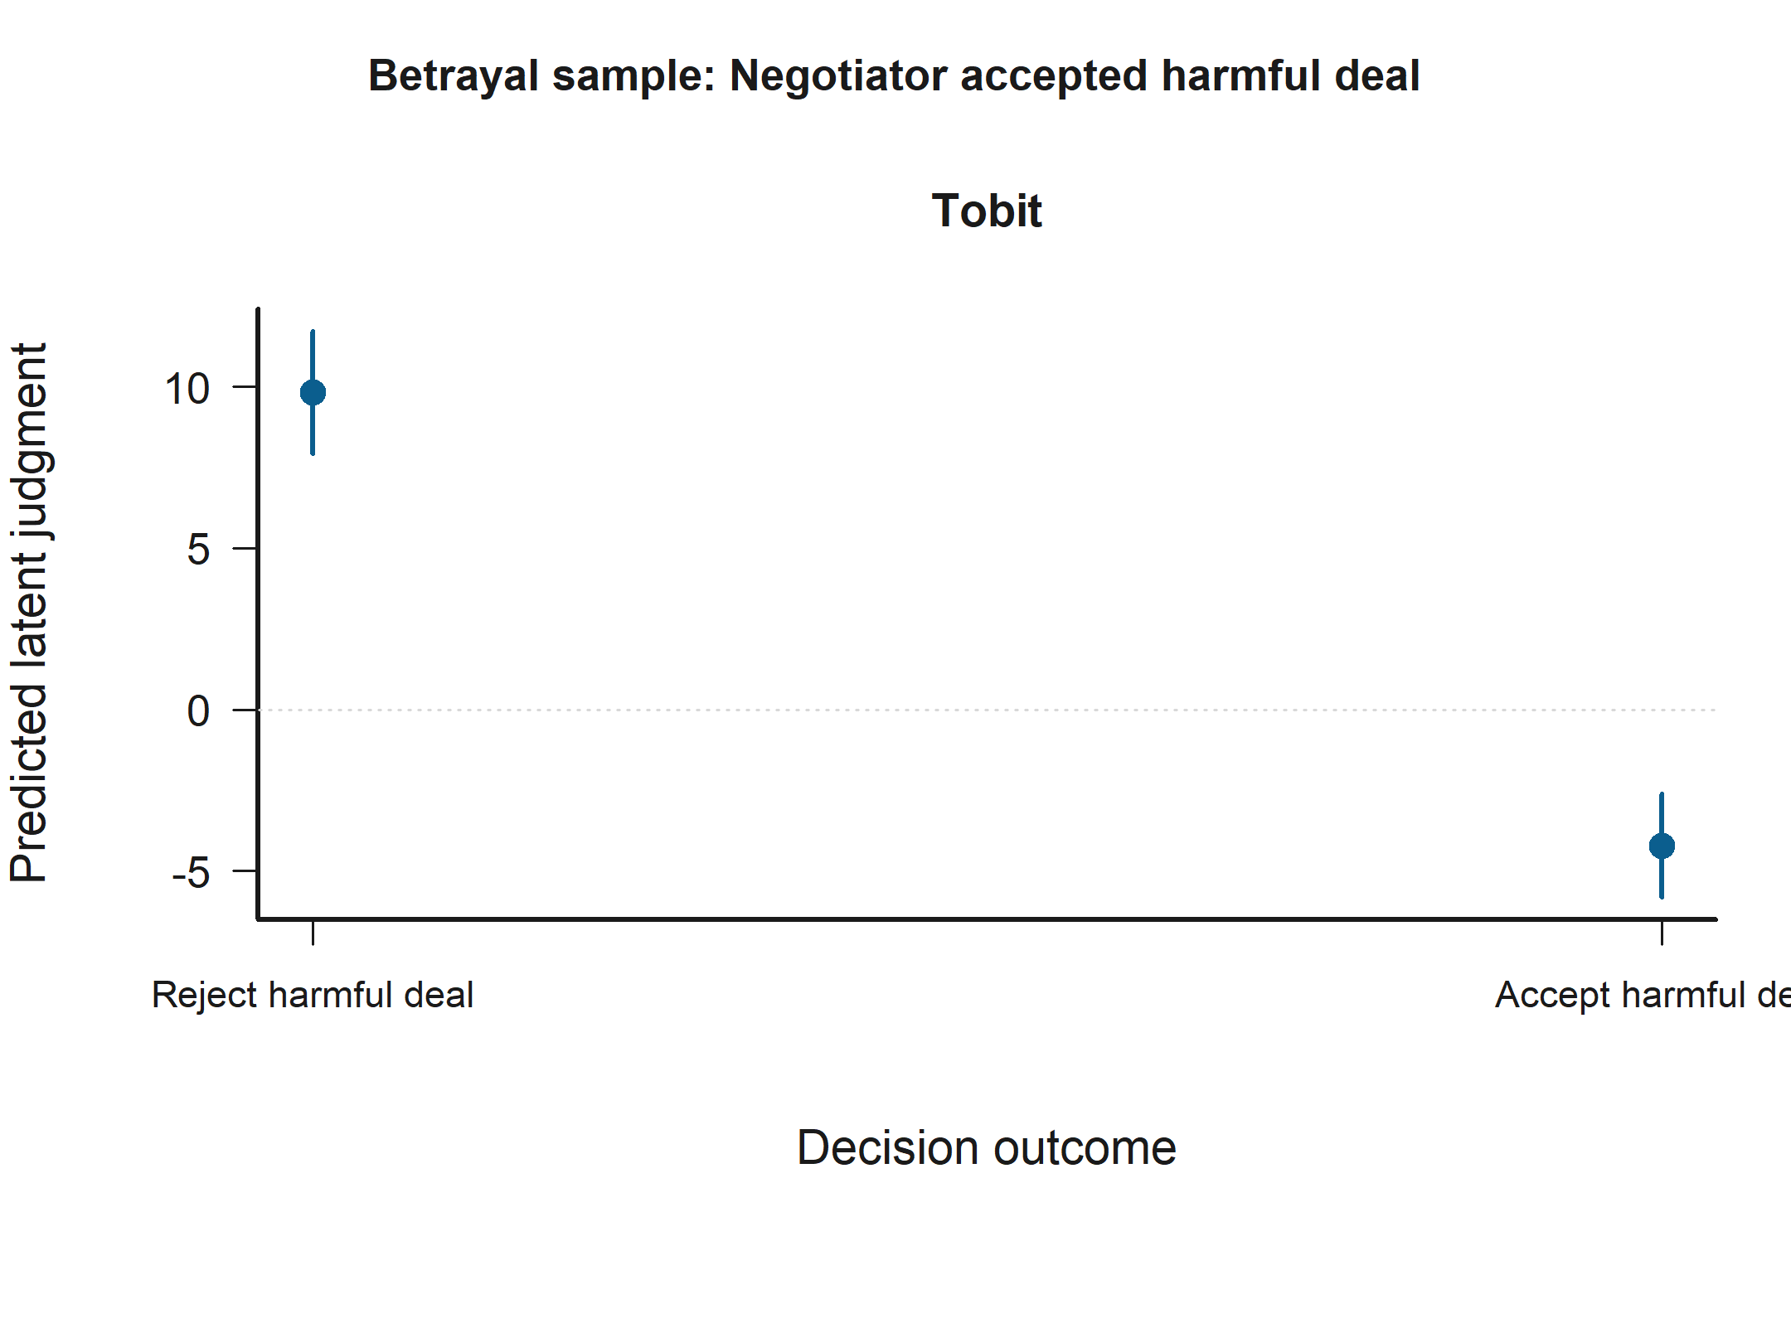
Grouped Prediction Plot for Negotiator accepted harmful deal in the Betrayal sample. Statistically significant support appears in H2: Judged-status x decision contrasts Model A (Tobit) and H2: Judged-status x decision contrasts Model B (Tobit). The panels show predicted latent judgments with 95% confidence intervals.
Empathy: Perspective taking is statistically significant in: - H2: Judged-status x decision contrasts Model B (Tobit) The figure below shows that across the observed range, higher Empathy: Perspective taking corresponds to higher predicted latent judgment.
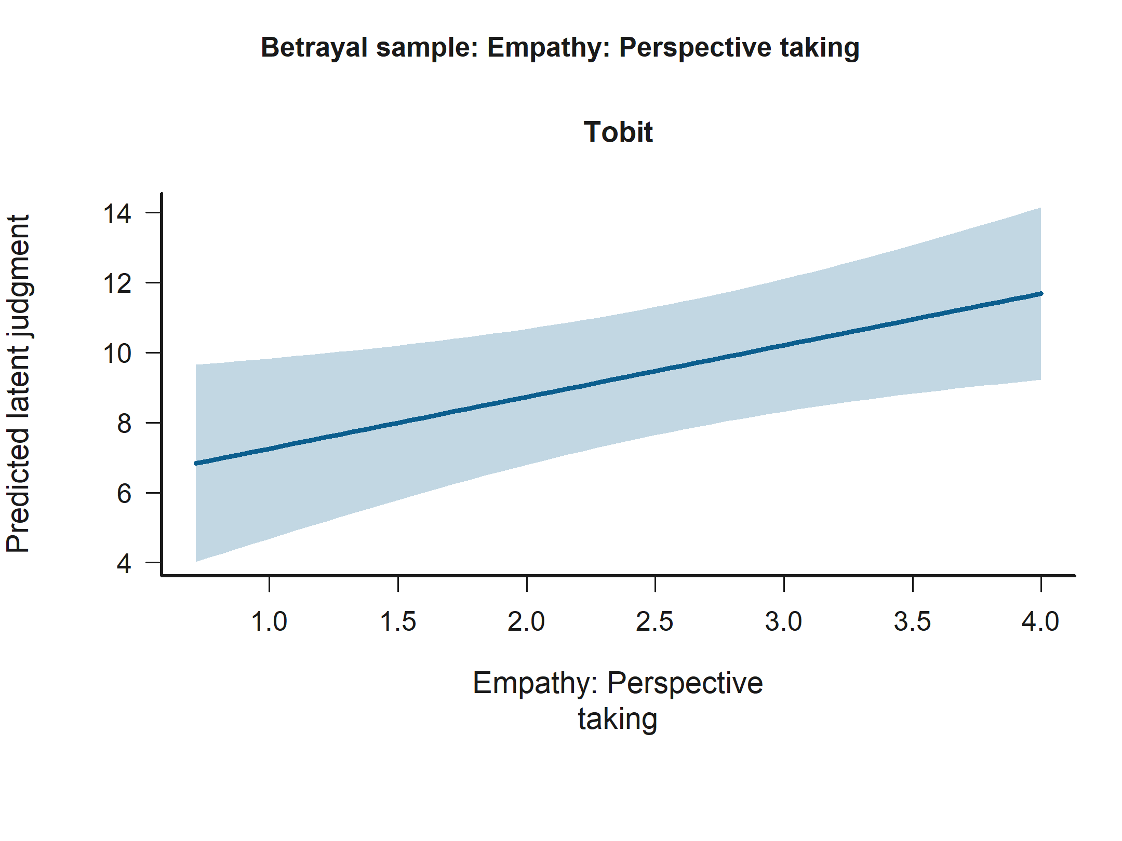
Effect Plot for Empathy: Perspective taking in the Betrayal sample. Statistically significant support appears in H2: Judged-status x decision contrasts Model B (Tobit). The panels show predicted latent judgments with 95% confidence intervals.
Socioeconomic status is statistically significant in: - H2: Judged-status x decision contrasts Model A (Tobit) - H2: Judged-status x decision contrasts Model B (Tobit) The figure below shows that predicted latent judgment is higher for Socioeconomic status 5 than for Socioeconomic status 0.
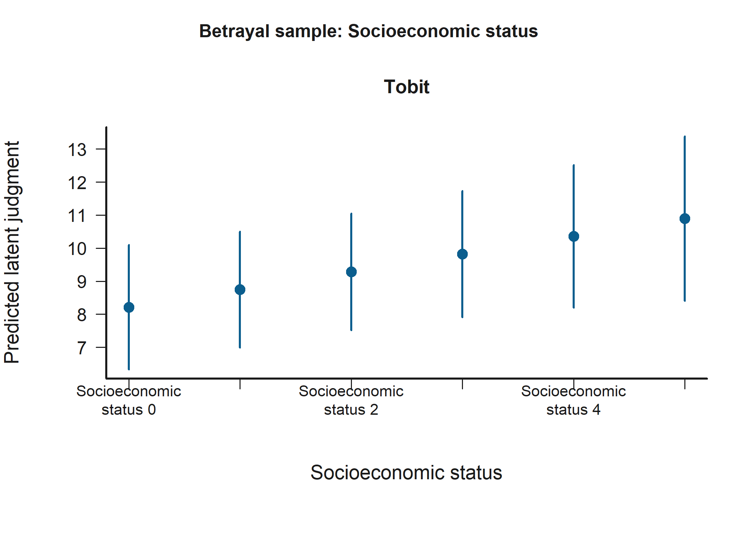
Grouped Prediction Plot for Socioeconomic status in the Betrayal sample. Statistically significant support appears in H2: Judged-status x decision contrasts Model A (Tobit) and H2: Judged-status x decision contrasts Model B (Tobit). The panels show predicted latent judgments with 95% confidence intervals.
Empathy: Empathic concern is statistically significant in: - H2: Judged-status x decision contrasts Model B (Tobit) The figure below shows that across the observed range, higher Empathy: Empathic concern corresponds to lower predicted latent judgment.
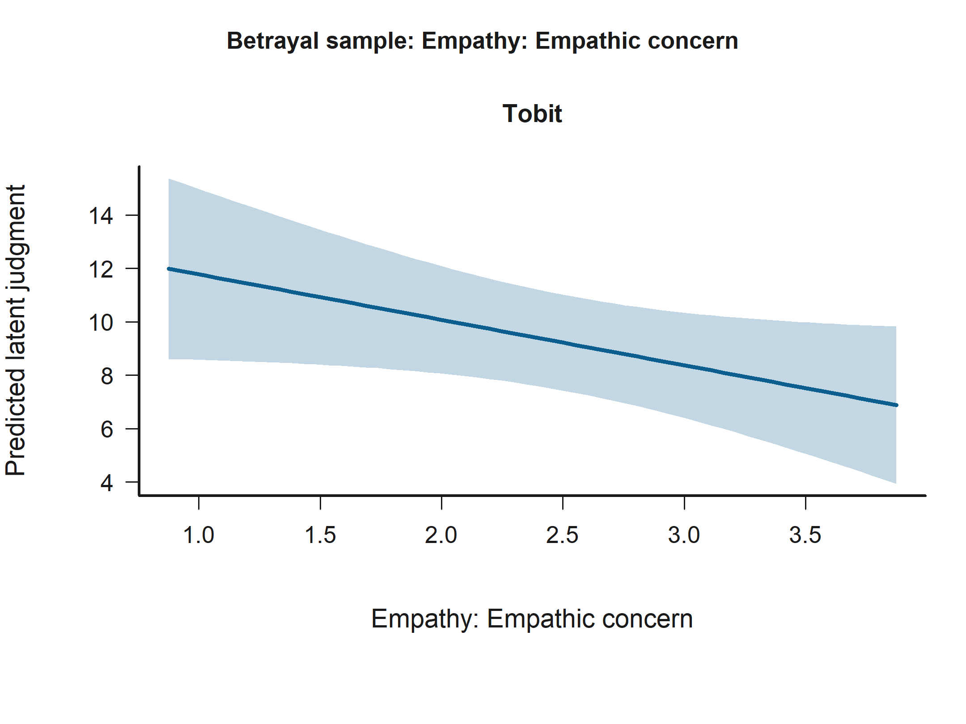
Effect Plot for Empathy: Empathic concern in the Betrayal sample. Statistically significant support appears in H2: Judged-status x decision contrasts Model B (Tobit). The panels show predicted latent judgments with 95% confidence intervals.

Full judgment sample
Negotiator accepted harmful deal is statistically significant in: - H2: Judged-status x decision contrasts Model B (Tobit) - H3: Empathy x judged-status moderation Model B (Tobit) - H2: Judged-status x decision contrasts Model A (Tobit) - H3: Empathy x judged-status moderation Model A (Tobit) The figure below shows that predicted latent judgment is lower for Accept harmful deal than for Reject harmful deal.
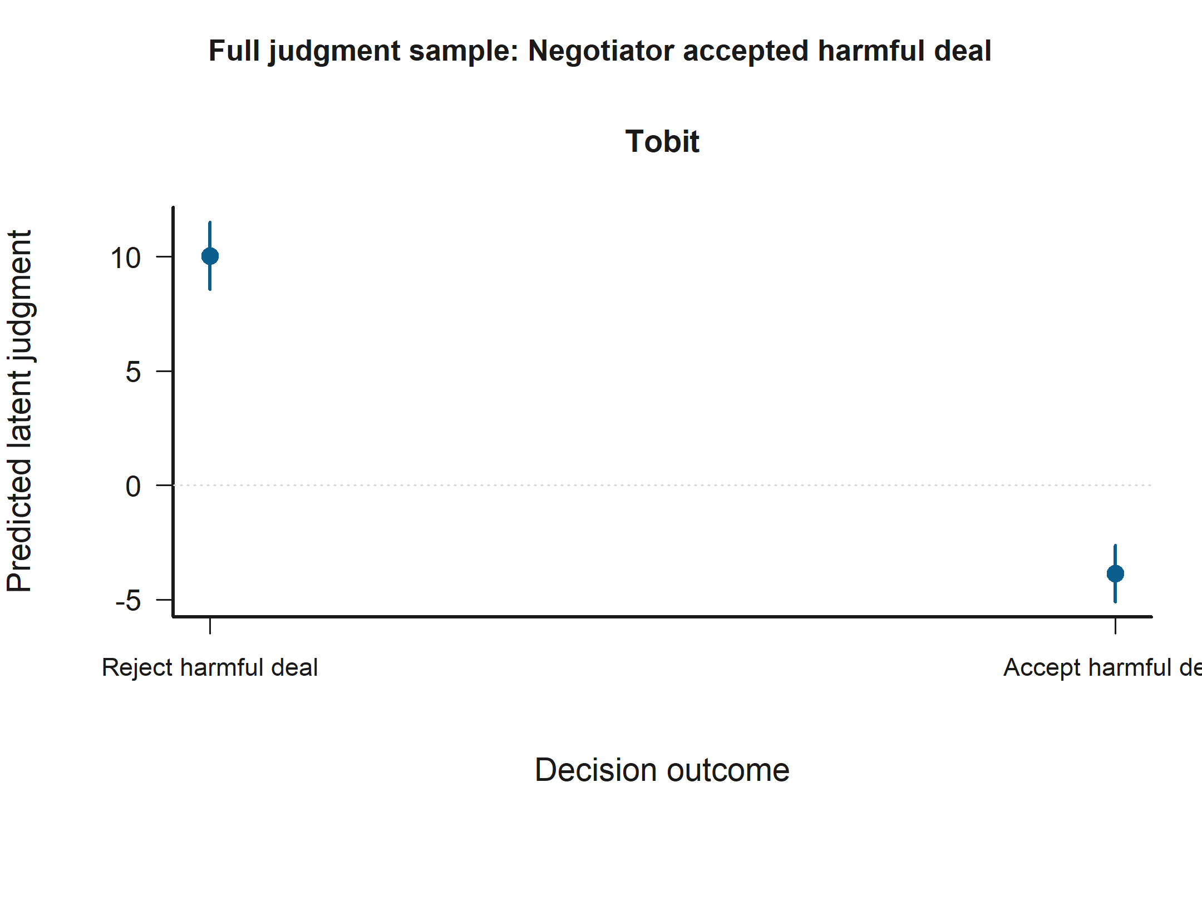
Grouped Prediction Plot for Negotiator accepted harmful deal in the Full judgment sample. Statistically significant support appears in H2: Judged-status x decision contrasts Model B (Tobit), H3: Empathy x judged-status moderation Model B (Tobit), H2: Judged-status x decision contrasts Model A (Tobit), and H3: Empathy x judged-status moderation Model A (Tobit). The panels show predicted latent judgments with 95% confidence intervals.
Personal distress x judged negotiator outgroup is statistically significant in: - H3: Empathy x judged-status moderation Model B (Tobit) The figure below shows that the predicted relationship rises most sharply for Empathy: Personal distress when the condition is Judged negotiator outgroup.
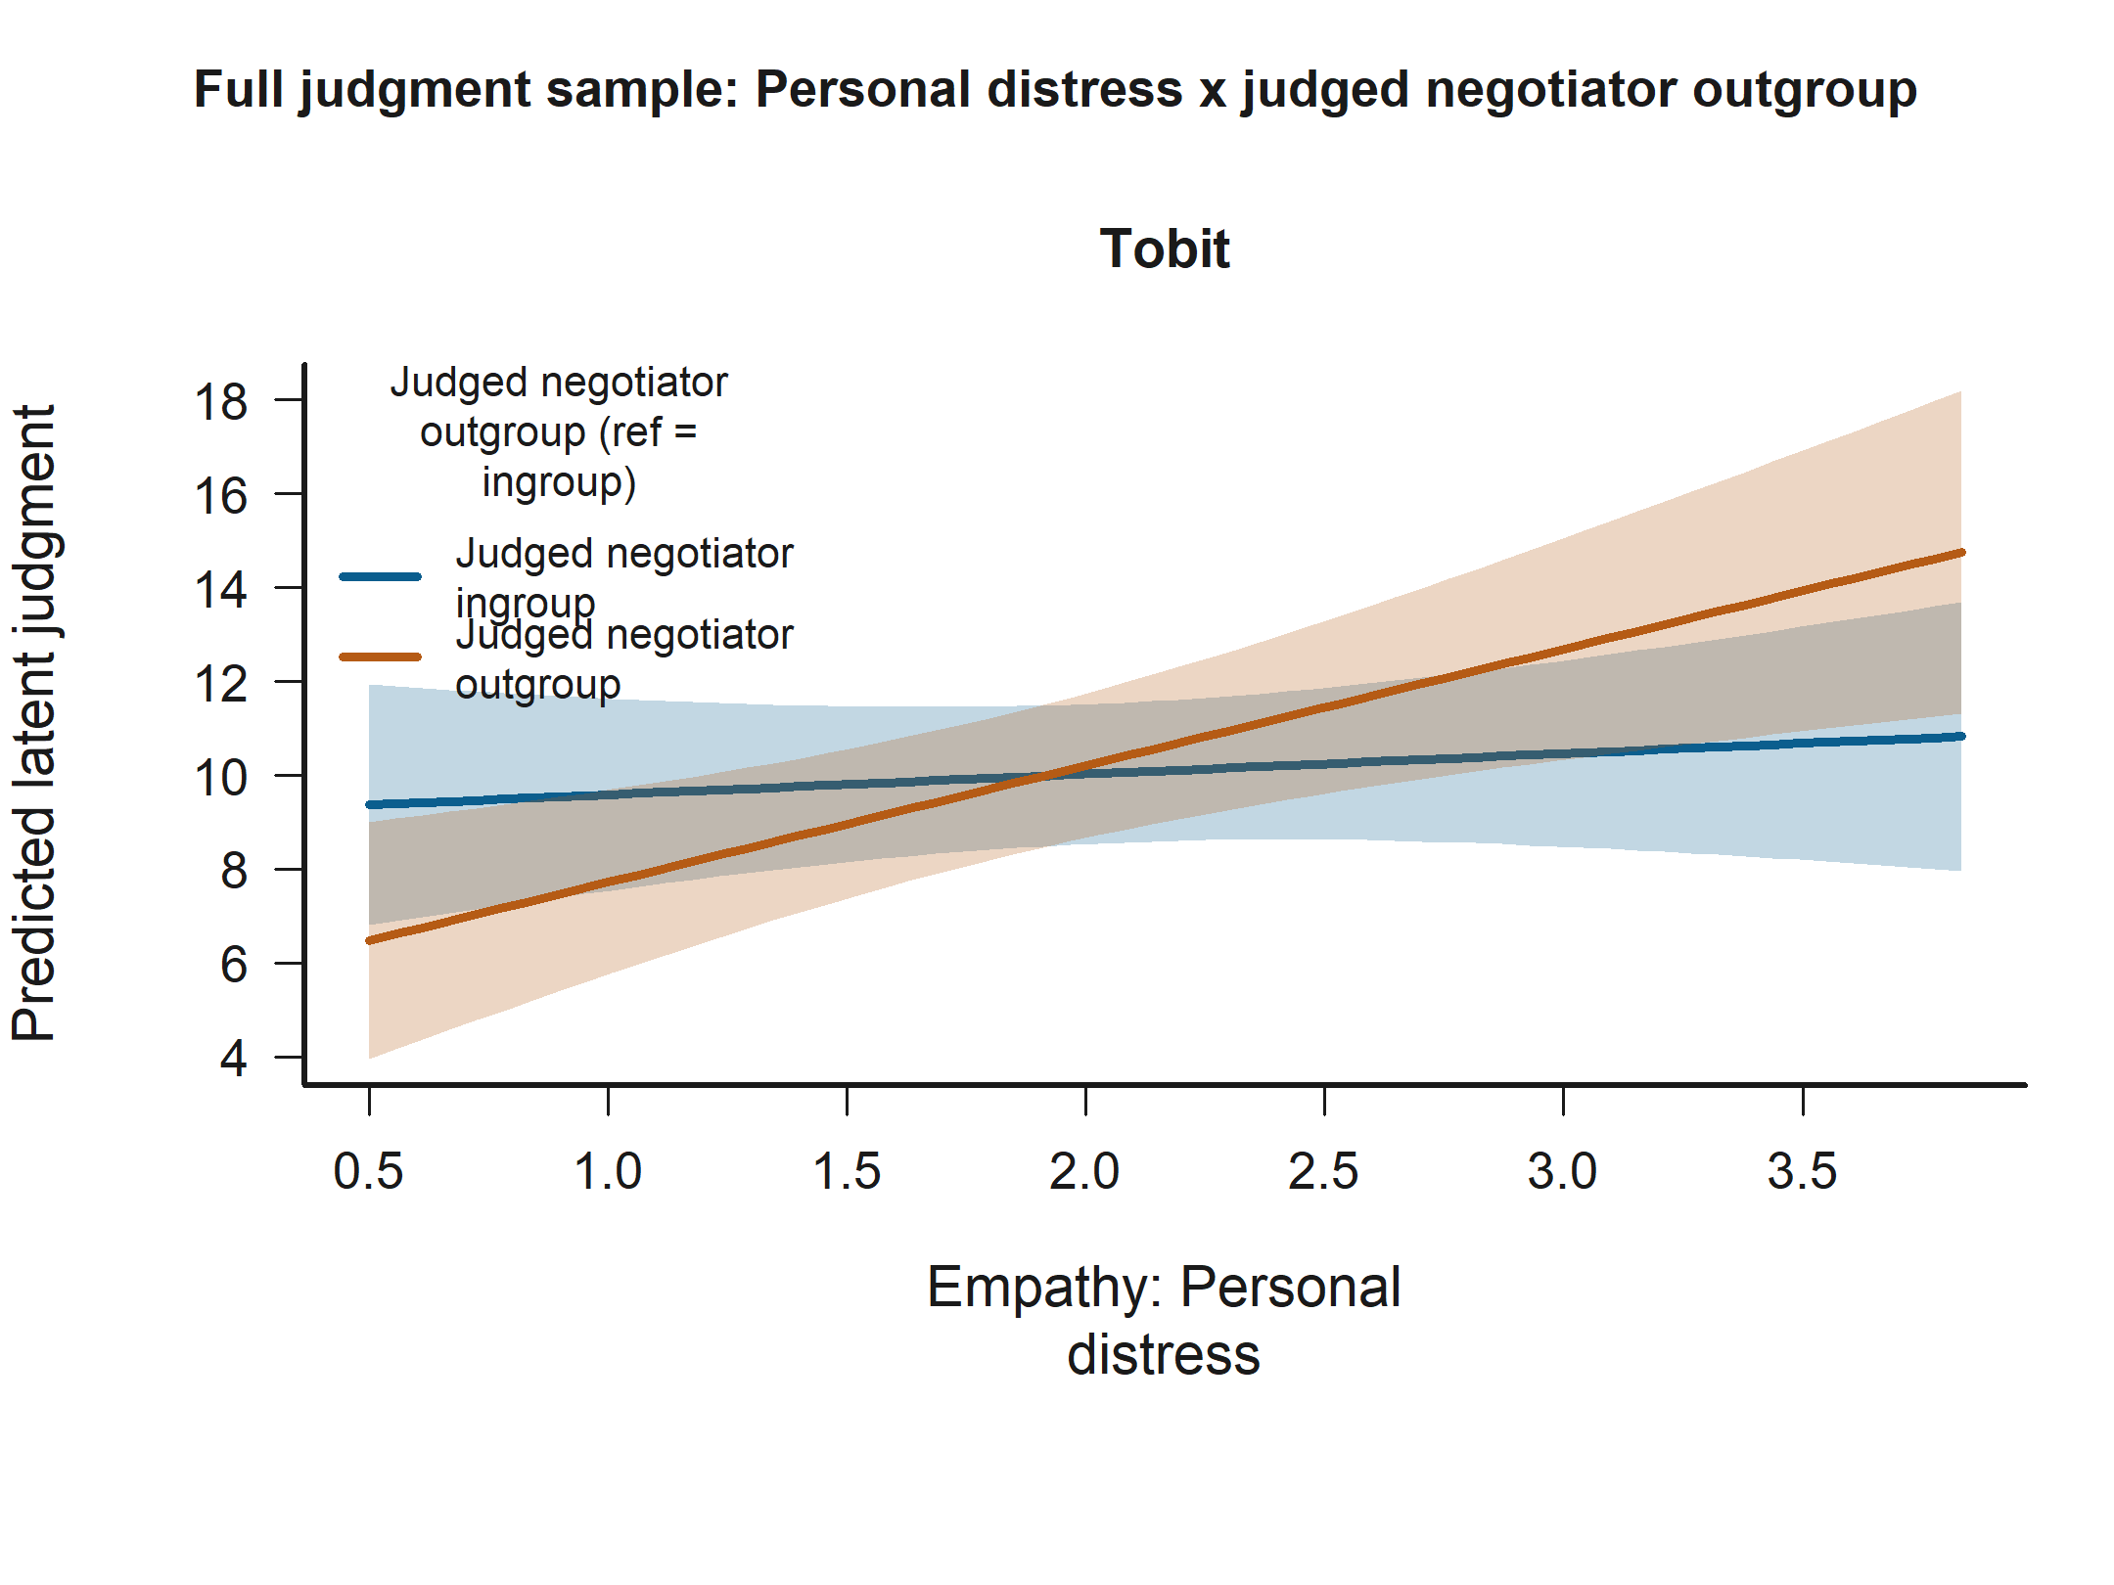
Interaction Plot for Personal distress x judged negotiator outgroup in the Full judgment sample. Statistically significant support appears in H3: Empathy x judged-status moderation Model B (Tobit). The panels show predicted latent judgments with 95% confidence intervals.
Empathy: Perspective taking is statistically significant in: - H2: Judged-status x decision contrasts Model B (Tobit) - H3: Empathy x judged-status moderation Model B (Tobit) The figure below shows that across the observed range, higher Empathy: Perspective taking corresponds to higher predicted latent judgment.
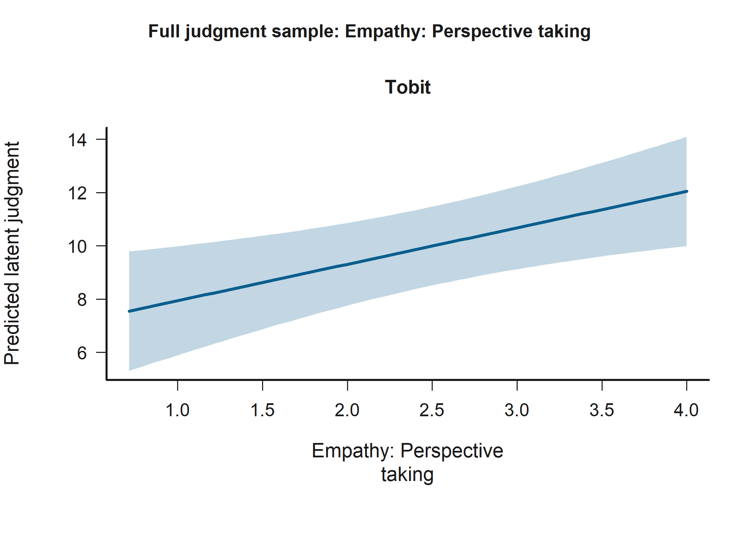
Effect Plot for Empathy: Perspective taking in the Full judgment sample. Statistically significant support appears in H2: Judged-status x decision contrasts Model B (Tobit) and H3: Empathy x judged-status moderation Model B (Tobit). The panels show predicted latent judgments with 95% confidence intervals.
Engineering participant (ref = humanities) is statistically significant in: - H2: Judged-status x decision contrasts Model A (Tobit) - H3: Empathy x judged-status moderation Model A (Tobit) - H3: Empathy x judged-status moderation Model B (Tobit) - H2: Judged-status x decision contrasts Model B (Tobit) The figure below shows that predicted latent judgment is higher for Engineering participant than for Humanities participant.
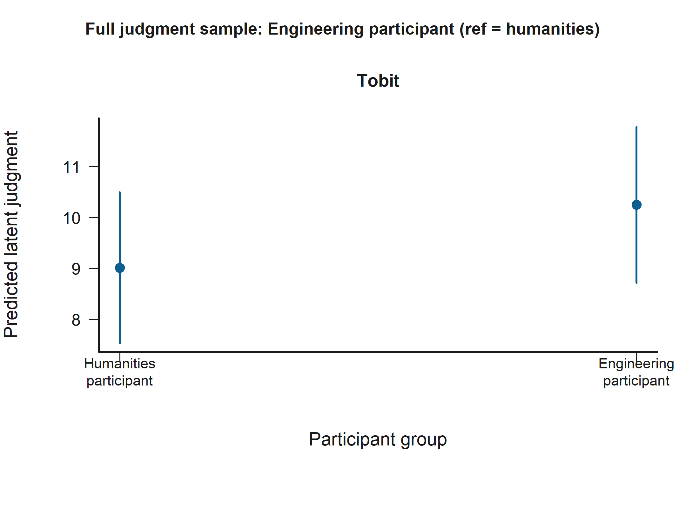
Grouped Prediction Plot for Engineering participant (ref = humanities) in the Full judgment sample. Statistically significant support appears in H2: Judged-status x decision contrasts Model A (Tobit), H3: Empathy x judged-status moderation Model A (Tobit), H3: Empathy x judged-status moderation Model B (Tobit), and H2: Judged-status x decision contrasts Model B (Tobit). The panels show predicted latent judgments with 95% confidence intervals.
Empathic concern x judged negotiator outgroup is statistically significant in: - H3: Empathy x judged-status moderation Model B (Tobit) The figure below shows that the predicted relationship falls most sharply for Empathy: Empathic concern when the condition is Judged negotiator outgroup.
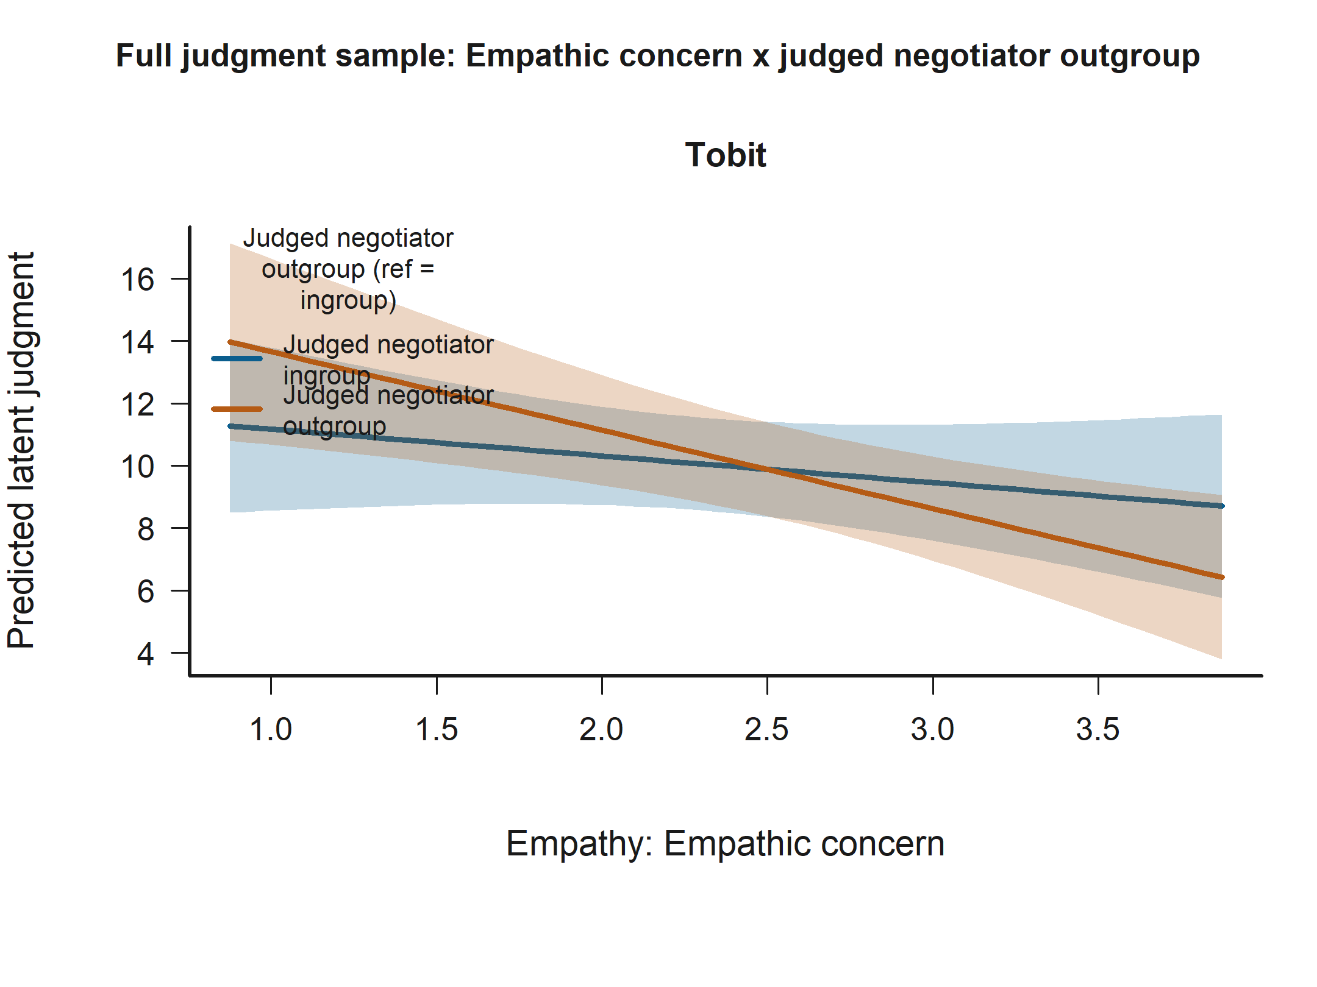
Interaction Plot for Empathic concern x judged negotiator outgroup in the Full judgment sample. Statistically significant support appears in H3: Empathy x judged-status moderation Model B (Tobit). The panels show predicted latent judgments with 95% confidence intervals.
Empathy: Empathic concern is statistically significant in: - H2: Judged-status x decision contrasts Model B (Tobit) The figure below shows that across the observed range, higher Empathy: Empathic concern corresponds to lower predicted latent judgment.
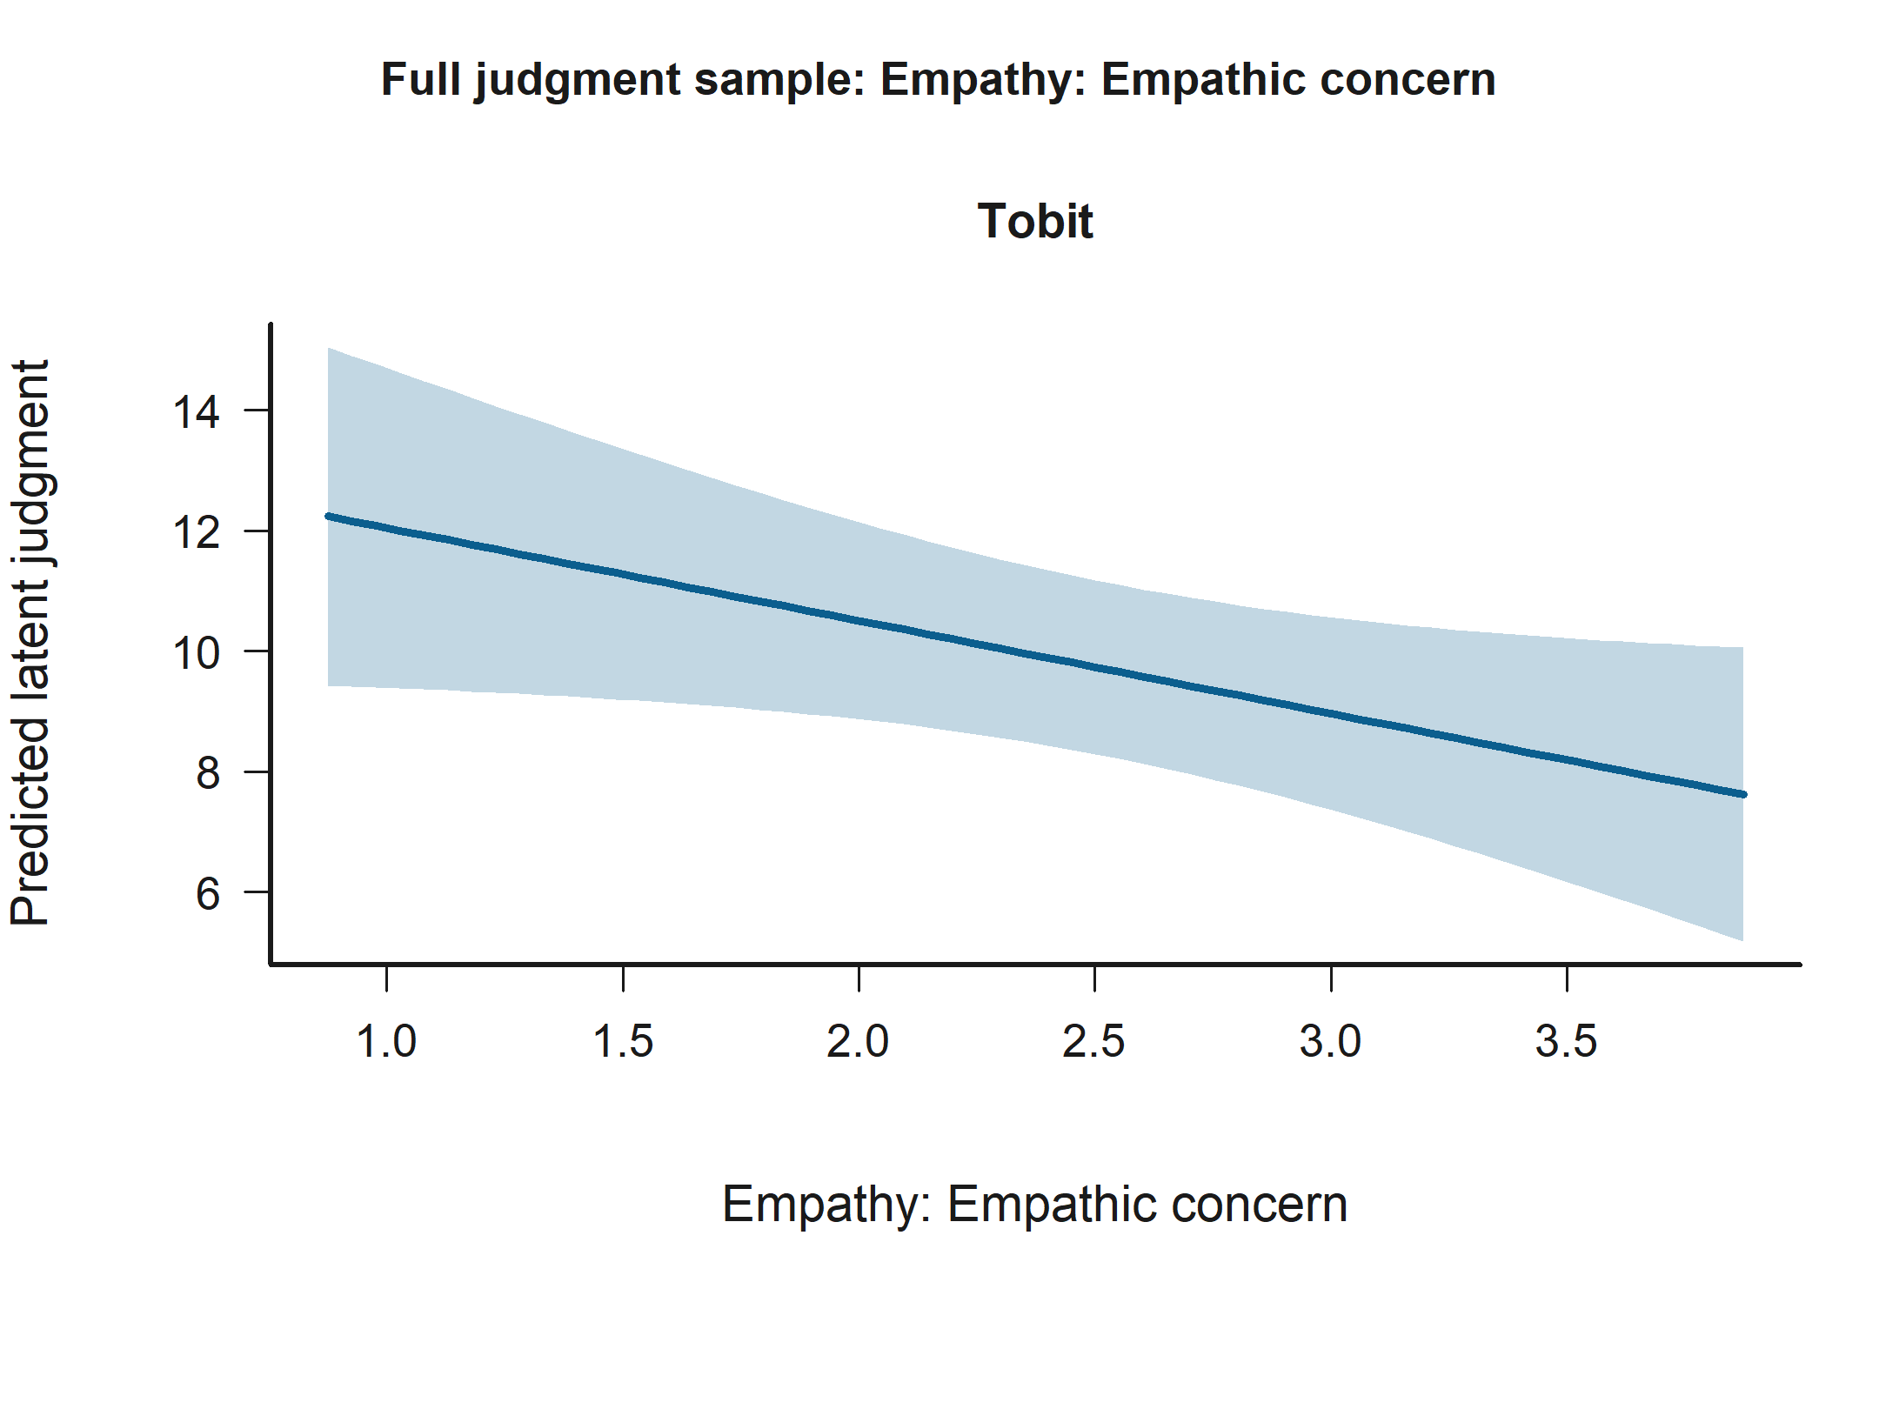
Effect Plot for Empathy: Empathic concern in the Full judgment sample. Statistically significant support appears in H2: Judged-status x decision contrasts Model B (Tobit). The panels show predicted latent judgments with 95% confidence intervals.
Socioeconomic status is statistically significant in: - H3: Empathy x judged-status moderation Model A (Tobit) - H2: Judged-status x decision contrasts Model A (Tobit) The figure below shows that predicted latent judgment is higher for Socioeconomic status 5 than for Socioeconomic status 0.
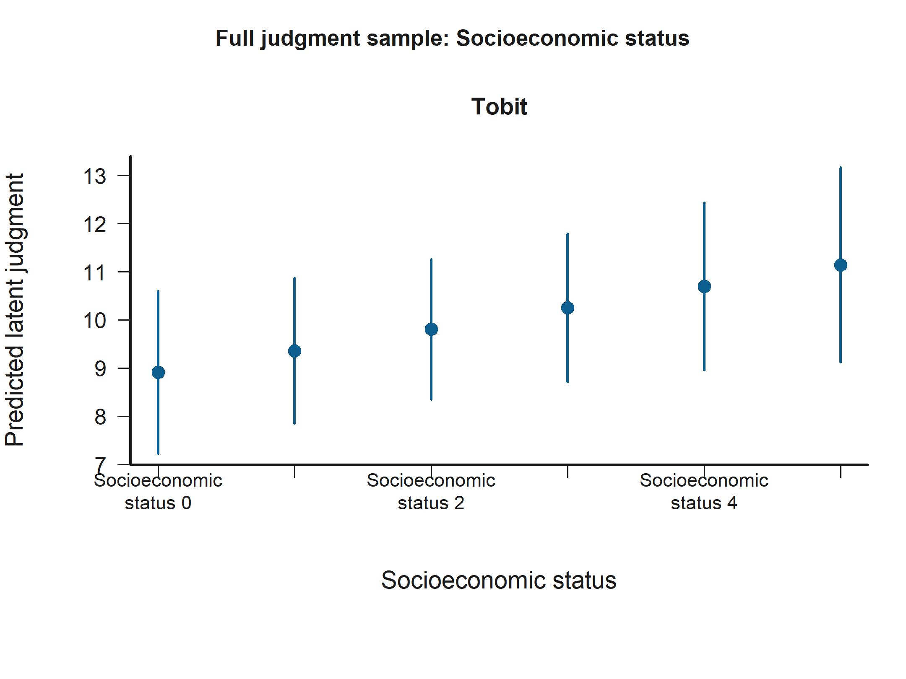
Grouped Prediction Plot for Socioeconomic status in the Full judgment sample. Statistically significant support appears in H3: Empathy x judged-status moderation Model A (Tobit) and H2: Judged-status x decision contrasts Model A (Tobit). The panels show predicted latent judgments with 95% confidence intervals.
Judged negotiator outgroup (ref = ingroup) is statistically significant in: - H3: Empathy x judged-status moderation Model B (Tobit) The figure below shows that predicted latent judgment is higher for Judged negotiator outgroup than for Judged negotiator ingroup.
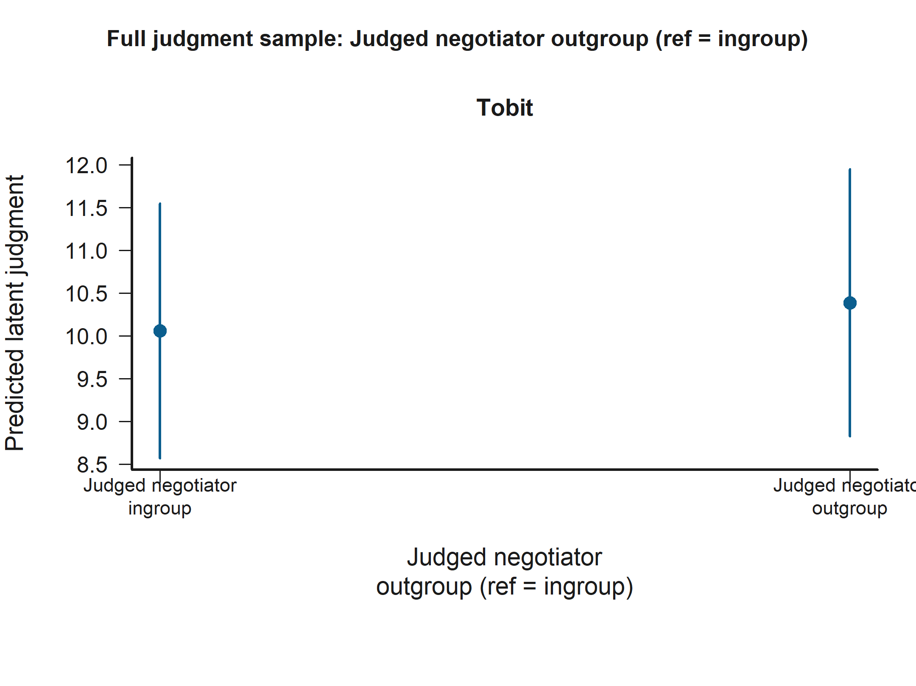
Grouped Prediction Plot for Judged negotiator outgroup (ref = ingroup) in the Full judgment sample. Statistically significant support appears in H3: Empathy x judged-status moderation Model B (Tobit). The panels show predicted latent judgments with 95% confidence intervals.
Empathy: Personal distress is statistically significant in: - H2: Judged-status x decision contrasts Model B (Tobit) The figure below shows that across the observed range, higher Empathy: Personal distress corresponds to higher predicted latent judgment.
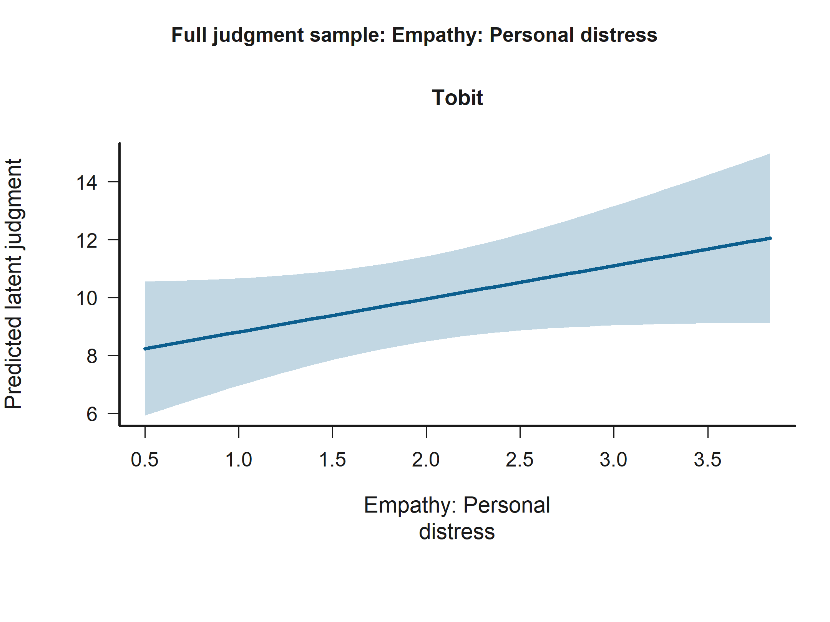
Effect Plot for Empathy: Personal distress in the Full judgment sample. Statistically significant support appears in H2: Judged-status x decision contrasts Model B (Tobit). The panels show predicted latent judgments with 95% confidence intervals.

Hypothesis Conclusion Summary
Each conclusion below is generated from the current coefficient outputs. Non-parametric statements are interpreted when participant-level cluster-bootstrap inference is available and are otherwise labeled explicitly. - H1. Original hypothesis: Higher empathy predicts lower moral-judgment scores for harmful decisions after conditioning on judged-negotiator, counterpart, and observer-side victim relational controls. Tobit conclusion: the evidence is mixed but offers partial support for the hypothesis. Model A does not support the hypothesis; Empathy composite (average) is negative but not statistically significant (p = 0.492). Model B supports the hypothesis through Empathy: Empathic concern with a negative association (p = 0.023). Additional statistically significant signals include Observer role (ref = victim) with a positive association (p = 0.023) and Age with a positive association (p = 0.034). Non-parametric conclusion: no converged second-phase non-parametric model is available, so the robustness check is inconclusive for this hypothesis. - H2a. Original hypothesis: Moral-judgment severity should vary with the judged negotiator’s ingroup-versus-outgroup status, and that relational effect should depend on whether the harmful deal was accepted or rejected. Tobit conclusion: the available models do not support the hypothesis. Model A does not support the hypothesis; none of the judged-negotiator relational-status terms and their decision interaction in the non-control sample are statistically significant, and the closest signal is Judged negotiator outgroup (ref = ingroup) with a negative association (p = 0.706). Model B does not support the hypothesis; none of the judged-negotiator relational-status terms and their decision interaction in the non-control sample are statistically significant, and the closest signal is Accepted harmful deal x judged negotiator outgroup with a negative association (p = 0.896). Additional statistically significant signals include Negotiator accepted harmful deal with a negative association (p < 0.001) and Empathy: Perspective taking with a positive association (p = 0.012). Non-parametric conclusion: no converged second-phase non-parametric model is available, so the robustness check is inconclusive for this hypothesis. - H2b. Original hypothesis: Moral-judgment severity should vary with the judged negotiator’s ingroup-versus-outgroup-versus-control status, and that relational effect should depend on whether the harmful deal was accepted or rejected. Tobit conclusion: the available models do not support the hypothesis. Model A does not support the hypothesis; none of the judged-negotiator relational-status terms and their decision interaction in the full sample are statistically significant, and the closest signal is Accepted harmful deal x judged negotiator outgroup with a negative association (p = 0.396). Model B does not support the hypothesis; none of the judged-negotiator relational-status terms and their decision interaction in the full sample are statistically significant, and the closest signal is Accepted harmful deal x judged negotiator outgroup with a negative association (p = 0.291). Additional statistically significant signals include Negotiator accepted harmful deal with a negative association (p < 0.001) and Empathy: Perspective taking with a positive association (p = 0.005). Non-parametric conclusion: no converged second-phase non-parametric model is available, so the robustness check is inconclusive for this hypothesis. - H3. Original hypothesis: The empathy effect may vary according to whether the judged negotiator is ingroup, outgroup, or control, while decision outcome and the additional relational controls remain explicitly modeled. Tobit conclusion: the evidence is mixed but offers partial support for the hypothesis. Model A does not support the hypothesis; none of the composite empathy x judged-negotiator relational-status interactions are statistically significant, and the closest signal is Empathy x judged negotiator outgroup with a negative association (p = 0.262). Model B supports the hypothesis through Personal distress x judged negotiator outgroup with a positive association (p = 0.002) and Empathic concern x judged negotiator outgroup with a negative association (p = 0.025). Additional statistically significant signals include Negotiator accepted harmful deal with a negative association (p < 0.001) and Empathy: Perspective taking with a positive association (p = 0.007). Non-parametric conclusion: no converged second-phase non-parametric model is available, so the robustness check is inconclusive for this hypothesis.

PDF Comprehensive Report Generated
Please check tobit_analysis_report.pdf in the outputs/report/ folder for the fully documented Tobit and cluster-aware non-parametric mathematical formulations, the Option 2 relational-variable logic, dual-estimator hypothesis testing, and the algorithmically interpreted natural language coefficients. When the run is dataset-specific, a matching alias such as tobit_analysis_report_Buca.pdf is also refreshed.

