Cocoa Price Volatility and Smallholder Vulnerability Across the Supply Chain: Evidence from Colombia, International Benchmarks, and European Downstream Prices (Working Paper)
Abstract
This study examines how cocoa price volatility is transmitted across the supply chain and what that transmission implies for smallholder vulnerability in Colombia. The paper examines whether movements in international cocoa benchmarks are transmitted to Colombian domestic cocoa prices and European downstream chocolate prices, and whether local weather conditions primarily drive price adjustments or serve as contextual factors that intensify vulnerability. To address this question, the study harmonizes monthly data from AgroNet weekly cacao reference prices for Colombia, the World Bank cocoa benchmark, Eurostat chocolate-price indicators, the COP/USD exchange rate, Brent oil prices, and NASA POWER weather variables for San Vicente de Chucurı́, Santander, the major cocoa department producer in Colombia. The empirical design combines long-run descriptive context with an aligned monthly estimation window for August 2021 to December 2025, using transparent block-specific imputation for isolated missing observations. Methods include log-return transformations, stationarity testing, HAC-robust level and return regressions, and exploratory transmission and vulnerability modeling with weather treated as a contextual extension. Preliminary results indicate that international cocoa prices are the dominant short-run driver of Colombian cocoa price changes, whereas the European downstream price index adjusts more slowly and less strongly. Weather variables add limited explanatory power to the core transmission models but strengthen the interpretation of smallholder vulnerability by capturing local environmental stress alongside market volatility.
Keywords: cocoa price volatility; price transmission; smallholder vulnerability; Colombia; European downstream prices; macro controls; weather context

Introduction
Cocoa price volatility is not generated or absorbed at a single point in the supply chain. It emerges from the interaction among international benchmark movements, domestic producer-price adjustments, downstream food-price dynamics, macroeconomic conditions, and local production stress. For smallholder cocoa producers, the relevant question is not only whether prices rise or fall, but also how volatility is transmitted along the chain and how that transmission may intensify vulnerability at the farm level. Addressing that question requires an empirical design that connects the research question, the data architecture, and the estimation strategy in a transparent way.
This paper examines whether movements in international cocoa benchmarks are transmitted to Colombian domestic cocoa prices and European downstream chocolate prices, and whether local weather conditions operate primarily as direct drivers of price adjustments or as contextual stressors that deepen smallholder vulnerability. That question is substantively important because producer exposure depends not only on average price levels but also on short-run volatility, exchange-rate pass-through, downstream adjustment lags, and the coincidence of market shocks with environmental stress. It is also methodologically important because the relevant series do not begin at the same date, do not come from a single source, and do not always exhibit the same frequency or completeness (Acosta et al. 2019; Hakkio and Rush 1991).
To address this problem, the paper develops the data context and the methods in tandem. The dataset combines Colombian domestic cocoa prices from AgroNet’s official weekly cacao reference series (Ministerio de Agricultura y Desarrollo Rural 2026), the World Bank international cocoa benchmark (World Bank Prospects Group 2025), European downstream chocolate-price indicators from Eurostat (Eurostat 2026), macro controls from the COP/USD exchange-rate system and Brent oil prices (Banco de la Republica 2026; U.S. Energy Information Administration 2026), and a local weather block for San Vicente de Chucurı́, Santander, from NASA POWER (National Aeronautics and Space Administration 2026). This structure allows the paper to distinguish between a broader historical context and a shorter aligned monthly window for direct cross-series estimation. That distinction is central to the credibility of the design because it avoids imposing artificial comparability across series with uneven histories while preserving a coherent empirical core.
The paper also treats missingness and temporal alignment as substantive design choices rather than invisible preprocessing steps. In the current aligned sample, missing observations are isolated and limited, allowing transparent comparison of imputation alternatives without obscuring the original block structure. Instead of silently dropping months or filling them without documentation, the workflow preserves explicit imputation candidates and keeps sensitivity analysis open for later model refinement (Troyanskaya et al. 2001; Buuren and Groothuis-Oudshoorn 2011). This is especially relevant in a study that aims to compare transmission across producer, benchmark, downstream, macro, and weather series within a shared monthly framework.
Methodologically, the empirical strategy focuses first on price transmission and then on vulnerability interpretation. The core analysis relies on log transformations, return construction, stationarity testing, and HAC-robust regressions to evaluate short-run transmission across the supply chain. Weather variables are not introduced as substitutes for market analysis, but as local contextual extensions that help distinguish between direct price drivers and vulnerability-amplifying stressors. In this sense, the paper keeps a clear analytical separation between the market-transmission question and the broader sustainability and vulnerability question, while also allowing the two to be interpreted jointly (Engle and Granger 1987; Johansen 1991; Talero-Sarmiento et al. 2025).
Preliminary results suggest that international cocoa prices are the strongest short-run driver of Colombian domestic cocoa price changes, while European downstream prices adjust more slowly and more weakly. Macro controls help frame the transmission environment, whereas the weather block adds more interpretive value to vulnerability than explanatory power to the core transmission equations. These early findings support the title’s emphasis on supply-chain volatility and smallholder vulnerability, while also indicating that the climate dimension is better justified at this stage as local context than as the main engine of price formation.
The rest of the draft is organized as follows. Section 2 presents the data design, transformations, equations, imputation strategy, and the two empirical approaches. Section 3 reports preliminary descriptive, stationarity, transmission, and vulnerability results using the current aligned panel. Section 4 discusses limitations and the implications for the next modeling stage.
Gabriel, here are a few questions and ideas that could help us strengthen the paper with the other co-authors. At this stage, the draft still feels primarily statistical, so we should develop the research side more clearly.
- Why is each data source necessary for our argument?
- What do we mean by smallholder vulnerability here?
- How does volatility relate to sustainability and resilience?
- Are we representing the supply chain too simply?
- What is the exact role of European downstream prices in the paper?
- What is the best way to frame weather variables in the analysis?
- Can we justify the chosen time window more directly?
- What is the main contribution of the paper beyond the empirical exercise?
- Should we emphasize more clearly that the results are still preliminary?
- Would one explicit hypothesis improve the structure of the paper?

Materials and Methods

Data Architecture and Sample Design
The empirical design combines a long historical data repository with a shorter aligned sample for direct cross-series estimation. At the repository level, the merged monthly panel currently contains 795 observations spanning January 1960 to March 2026. This broader panel is useful for historical context, descriptive inspection, and source integration. However, the main econometric analysis cannot rely on the full period because the relevant series do not begin or end at the same time.
The principal constraint comes from the Colombian domestic cocoa series, which begins in August 2021, and the Eurostat downstream chocolate index, which currently extends through December 2025. As a result, the common calendar window for the core transmission system runs from August 2021 to December 2025 and contains 53 monthly observations. Within this interval, the balanced non-imputed core sample contains 52 complete observations for Colombian cocoa prices, the world cocoa benchmark, the EU chocolate index, the COP/USD exchange rate, and Brent oil prices. When the weather block is added, the sample size drops to 51 observations because the solar-radiation series is missing for December 2025.
This distinction between the full historical panel and the aligned estimation window is central to the empirical strategy. The longer span preserves historical depth and permits descriptive context, whereas the shorter common window ensures comparability across the core variables used in the transmission analysis. The design, therefore, avoids conflating broad historical coverage with effective econometric overlap.

Variable Data Card
Table 1 summarizes the main variables used in the manuscript-oriented analysis layer. The first five variables constitute the core supply-chain transmission system: Colombian domestic cocoa prices, the international cocoa benchmark, the European downstream chocolate index, the exchange rate, and Brent oil prices. Together, these series capture the producer-linked, global-benchmark, downstream-consumer, and macroeconomic dimensions of the price-transmission environment.
The weather variables are included as a separate local block centred on San Vicente de Chucurı́, Santander. In the current draft, these variables are used primarily to support the interpretation of vulnerability rather than to define the core transmission system itself. Precipitation, air temperature, maximum and minimum temperature, relative humidity, wind speed, and solar radiation remain available for descriptive analysis, contextual interpretation, and robustness extensions.
Variable data card for the current manuscript draft
Variable | Operational definition | Unit | Source | Usable window
Variable | Operational definition | Unit | Source | Usable window
Colombian cocoa price | Monthly average derived from AgroNet weekly cacao reference prices | COP/kg | AgroNet | 2021-08 to 2026-03
World cocoa benchmark | International cocoa price from the World Bank Pink Sheet | USD/ton | World Bank | 1960-01 to 2026-02
EU chocolate index | EU27 chocolate HICP consumer price index | Index | Eurostat | 2016-12 to 2025-12
COP/USD exchange rate | Monthly average Colombian peso per U.S. dollar | COP/USD | Banco de la República | 1991-11 to 2026-03
Brent oil price | Europe Brent spot price (monthly average) | USD/barrel | EIA | 1987-05 to 2026-03
NASA precipitation | Average precipitation (San Vicente de Chucurı́) | mm/day | NASA POWER | 2000-01 to 2025-12
NASA air temperature | Mean air temperature (San Vicente de Chucurı́) | $​^{∘}$C | NASA POWER | 2000-01 to 2025-12
NASA max temperature | Maximum air temperature (San Vicente de Chucurı́) | $​^{∘}$C | NASA POWER | 2000-01 to 2025-12
NASA min temperature | Minimum air temperature (San Vicente de Chucurı́) | $​^{∘}$C | NASA POWER | 2000-01 to 2025-12
NASA relative humidity | Mean relative humidity (San Vicente de Chucurı́) | % | NASA POWER | 2000-01 to 2025-12
NASA wind speed | Mean wind speed (San Vicente de Chucurı́) | m/s | NASA POWER | 2000-01 to 2025-12
NASA solar radiation | Surface solar radiation; last month imputed in aligned panel | MJ/m$​^{2}$/day | NASA POWER | 2000-01 to 2025-11 (obs.); 2025-12 (imp.)
Sample design and imputation structure
Panel or artifact | Obs. | Date span | Note
Full merged monthly panel | 795 | 1960-01 to 2026-03 | Long-run historical context across merged sources
Shared core calendar window | 53 | 2021-08 to 2025-12 | Core comparison window prior to handling missing values
Balanced non-imputed core sample | 52 | 2021-08 to 2025-12 | Complete observations for Colombia, world cocoa, EU chocolate, FX, and Brent
Climate-augmented complete sample | 51 | 2021-08 to 2025-12 | Complete observations including weather variables
Primary imputed core panel | 53 | 2021-08 to 2025-12 | One Colombian cocoa value imputed (2025-09)
Primary imputed all-series panel | 53 | 2021-08 to 2025-12 | One cocoa and one solar-radiation value imputed
Table 2 reports the sample structure used throughout the analysis. Although the number of missing observations is small, their location matters for the feasibility of aligned estimation. The missing Colombian cocoa price in September 2025 would break the continuity of the shared core panel, while the missing solar-radiation observation in December 2025 would prevent construction of a fully aligned weather-extended sample. For this reason, the workflow reports both KNN and iterative multivariate imputations and adopts the iterative block-specific completion as the primary imputed version for continuity-sensitive figures and selected model variants.
The treatment of missingness is therefore not incidental to the analysis. Rather, it forms part of the broader data architecture by preserving the distinction between the core transmission system and the weather extension, while maintaining transparency about the limited number of completed observations.

Transformations
Let $P_{i,t}$ denote the monthly level of series $i$ at time $t$. For all strictly positive series, the empirical analysis relies on log-return transformations, defined as:
$$r_{i,t}=Δln(P_{i,t})=ln(P_{i,t})-ln(P_{i,t-1}).$$
This transformation is appropriate for the present study for several reasons. First, it places variables expressed in different units, including COP/kg, USD per metric ton, price indices, and USD per barrel, on a comparable proportional-change scale. Second, it reduces the influence of scale differences and helps stabilize variance relative to estimation in raw levels. Third, it directly aligns with the paper’s central research question, which concerns the short-run transmission of price movements across the cocoa supply chain. In this sense, the analysis is not limited to whether prices co-move in levels over time, but also examines whether monthly changes in international cocoa conditions are associated with contemporaneous or near-contemporaneous changes in Colombian domestic prices and European downstream prices.
In addition to mean changes, the analysis considers rolling volatility measures constructed from log returns. These indicators are useful because they shift attention from average price movements alone to the instability of those movements, which is more closely related to the vulnerability dimension emphasized in the paper.

Imputation Strategy
Missing observations are treated as part of the empirical design rather than as a purely technical preprocessing issue. Because the dataset is organized into substantively distinct blocks, the imputation strategy follows the same logic. Let $X_{t}$ denote the core supply-chain block and $W_{t}$ the weather block. Missing values are then completed within a block according to:
$${\tilde{X}}_{t}=I_{X}(X_{t}), {\tilde{W}}_{t}=I_{W}(W_{t}),$$
where $I_{X}(⋅)$ and $I_{W}(⋅)$ represent block-specific imputation operators.
The rationale for this approach is both methodological and substantive. It avoids imposing artificial cross-block relationships during imputation, such as inferring missing weather observations directly from price variables or reconstructing missing price observations from climatic covariates. The preferred approach is iterative multivariate imputation, which preserves the internal correlation structure within each block (Buuren and Groothuis-Oudshoorn 2011). K-nearest-neighbors imputation is retained as a sensitivity benchmark in order to assess whether the completed values are materially dependent on the chosen algorithm (Troyanskaya et al. 2001).
In the current aligned sample, missingness is limited. The main missing observation in the price block occurs for Colombian cocoa in 2025-09 and is estimated at 27,134.89 under KNN and 23,855.55 under iterative imputation. In the weather block, the missing solar-radiation value for 2025-12 is estimated to be 18.392 using KNN and 18.387 using iterative imputation. The relatively small number of missing values allows the study to preserve transparency while maintaining continuity for graphical and econometric analysis.

Core Transmission Equations
The empirical strategy begins with a baseline long-run domestic-price specification:
$$ln(P_{t}^{COL})=α_{0}+α_{1}ln(P_{t}^{WLD})+α_{2}ln(FX_{t})+α_{3}ln(OIL_{t})+u_{t},$$
where $P_{t}^{COL}$ denotes the Colombian cocoa price, $P_{t}^{WLD}$ the world cocoa benchmark price, $FX_{t}$ the COP/USD exchange rate, and $OIL_{t}$ the Brent oil price.
To examine short-run transmission more directly, the analysis then estimates the return-based specification:
$$Δln(P_{t}^{COL})=β_{0}+β_{1}Δln(P_{t}^{WLD})+β_{2}Δln(FX_{t})+β_{3}Δln(OIL_{t})+ε_{t}.$$
Together, these equations distinguish between long-run association in levels and short-run proportional adjustment. This distinction is important because the paper is concerned with both the broader structure of market linkage and the more immediate transmission of volatility-relevant price movements. All baseline models are estimated using HAC-robust standard errors to account for potential heteroskedasticity and serial correlation in monthly data. An analogous specification is estimated for the European downstream block, using the EU chocolate price index as the dependent variable, to assess whether downstream prices respond more gradually or less strongly than producer-linked prices.

Two Weather Strategies
The role of weather is treated cautiously and explicitly in order to avoid overstating what can be inferred from the available overlap. The first strategy treats weather as contextual vulnerability information rather than as a core determinant of the main transmission system. Under this approach, lagged weather indicators are introduced as additional covariates around the domestic-price model:
$$Δln(P_{t}^{COL})=γ_{0}+γ_{1}Δln(P_{t}^{WLD})+γ_{2}Δln(FX_{t})+γ_{3}Δln(OIL_{t})+γ_{4}W_{t-1}+ν_{t},$$
where $W_{t-1}$ contains lagged standardized precipitation, solar radiation, and maximum temperature.
This specification is preferred at the current stage because it preserves the conceptual distinction between market transmission and local environmental stress. In substantive terms, it allows weather to enrich the interpretation of vulnerability without requiring the stronger assumption that climatic variables participate in exactly the same adjustment process as global and domestic price series.
A second, more ambitious strategy considers whether weather variables might be incorporated into an augmented cointegration framework. For that purpose, the relevant state vector is defined as:
$$Z_{t}={\left[\begin{matrix}ln(P_{t}^{COL}) & ln(P_{t}^{WLD}) & ln(P_{t}^{EU}) & ln(FX_{t}) & ln(OIL_{t}) & W_{t}\end{matrix}\right]}^{'},$$
and the corresponding exploratory VECM is written as:
$$ΔZ_{t}=ΠZ_{t-1}+\sum_{k=1}^{p-1}{Γ_{k}}ΔZ_{t-k}+η_{t}.$$
This second approach is conceptually attractive because it asks whether climatic conditions enter the same long-run adjustment mechanism as international benchmarks, domestic producer prices, downstream European prices, and macroeconomic controls. However, the climate-augmented sample currently comprises only 51 complete monthly observations, rendering the system empirically fragile for formal reporting. For that reason, the present draft treats the augmented VECM as an exploratory extension and a possible robustness check rather than as the paper’s main empirical claim (Johansen 1991; Hakkio and Rush 1991).

Exploratory Vulnerability Indicators
To complement the transmission analysis, the paper constructs a set of exploratory indicators intended to support the interpretation of smallholder vulnerability. These indicators are not designed as validated welfare measures, but rather as transparent composite heuristics that combine market volatility, transmission intensity, and local environmental stress.
The first step summarizes contemporaneous climatic conditions using precipitation, surface solar radiation, and maximum temperature. Let $w_{j,t}$ denote weather variable $j$ in month $t$, and let $z(w_{j,t})$ denote its within-sample standardized value. The weather-stress index is defined as:
$${WeatherStressIndex}_{t}=\frac{1}{J}\sum_{j=1}^{J}{\left|z(w_{j,t})\right|},$$
where $J=3$ in the current specification. This index increases with the magnitude of deviations from average local weather conditions, irrespective of direction. For comparability, the index is standardized as:
$${WeatherStressZ}_{t}=z({WeatherStressIndex}_{t}),$$
so that positive values indicate above-average combined weather anomalies within the aligned sample.
The farmer exposure index integrates three standardized components: domestic cocoa price volatility, the magnitude of the fitted market-transmission shock, and local weather stress. Let $σ_{t}^{COL}$ denote rolling domestic return volatility, and let ${\hat{m}}_{t}=\left|\hat{Δln(P_{t}^{COL})}\right|$ denote the absolute fitted value from the core return model. The index is defined as:
$${FarmerExposureIndex}_{t}=z(σ_{t}^{COL})+z({\hat{m}}_{t})+{WeatherStressZ}_{t},$$
and increases when domestic volatility is high, when market-driven price adjustments are large, and when local climatic conditions are unfavorable.
Finally, the livelihood-risk score extends this measure by incorporating an external pressure component linked to global market conditions. Let $σ_{t}^{WLD}$ denote rolling world cocoa return volatility. The resulting indicator is:
$${LivelihoodRiskScore}_{t}={FarmerExposureIndex}_{t}+z(σ_{t}^{WLD}),$$
which captures the joint influence of domestic exposure and international volatility.
At this stage, these indicators should be interpreted as exploratory constructs that organize the joint variation in market and environmental stressors. They are intended to guide vulnerability-oriented interpretation rather than to provide structural or causal estimates of household welfare outcomes.

Hypotheses
The empirical analysis is organized around four working hypotheses. First, increases in world cocoa prices are expected to transmit positively to Colombian cocoa price changes within the aligned monthly sample. Second, European downstream chocolate prices are expected to adjust more slowly and less strongly than Colombian producer-linked prices. Third, weather variables are expected to improve the interpretation of vulnerability, but not to overturn the dominant role of market transmission in the short aligned sample. Fourth, a climate-augmented cointegration system is considered conceptually relevant, although its empirical implementation is constrained by the current overlap in the available data.

Preliminary Results

Descriptive and Statistical Properties
The aligned data already show a strong contrast between the price system and the weather system. The core price levels behave mostly like non-stationary series in the shared window: ADF does not reject a unit root for Colombian cocoa, world cocoa, EU chocolate, COP/USD, or Brent, while KPSS rejects stationarity for all of them except the exchange rate. By contrast, several weather variables are more stable in levels. Precipitation, maximum temperature, minimum temperature, humidity, wind speed, and solar radiation reject the ADF unit-root null at conventional levels in the current aligned window.
Descriptive statistics for the core system and selected weather variables in the imputed aligned window
Series | Mean | Std. dev. | Median | Min | Max
Colombian cocoa price | 17,334.75 | 9,168.37 | 12,536.69 | 7,926.08 | 34,395.33
World cocoa benchmark | 4,943.44 | 2,660.61 | 3,630.14 | 2,239.13 | 10,745.11
EU chocolate index | 128.83 | 19.73 | 125.20 | 104.25 | 164.99
COP/USD exchange rate | 4,147.16 | 302.33 | 4,047.41 | 3,773.38 | 4,926.66
Brent oil price | 82.61 | 13.41 | 80.92 | 62.54 | 122.71
NASA precipitation | 5.73 | 3.59 | 5.08 | 0.03 | 14.67
NASA max temperature | 31.93 | 3.04 | 30.79 | 28.67 | 39.15
NASA solar radiation | 18.24 | 1.19 | 18.18 | 15.68 | 20.62
Selected preliminary statistical properties from the imputed aligned panel
Series | Mean level | Annualized vol. | ADF level $p$ | ADF return $p$ | ARCH-LM $p$
Colombian cocoa price | 17,334.75 | 0.376 | 0.643 | 0.000 | 0.768
World cocoa benchmark | 4,943.44 | 0.367 | 0.648 | 0.000 | 0.013
EU chocolate index | 128.83 | 0.030 | 0.984 | 0.013 | 0.005
COP/USD exchange rate | 4,147.16 | 0.110 | 0.525 | 0.000 | 0.903
Brent oil price | 82.61 | 0.258 | 0.460 | 0.081 | 0.083
NASA precipitation | 5.73 | 3.106 | 0.000 | 0.006 | 0.070
NASA max temperature | 31.93 | 0.152 | 0.018 | 0.003 | 0.438
NASA solar radiation | 18.25 | 0.283 | 0.000 | 0.000 | 0.434
Table 4 highlights two features that matter for the rest of the paper. First, Colombian cocoa and world cocoa returns are both much more volatile than the downstream EU chocolate index, consistent with slower downstream adjustment. Second, weather variables are better treated as a structured environmental context than as obvious drivers of a large multivariate market system in this short sample.
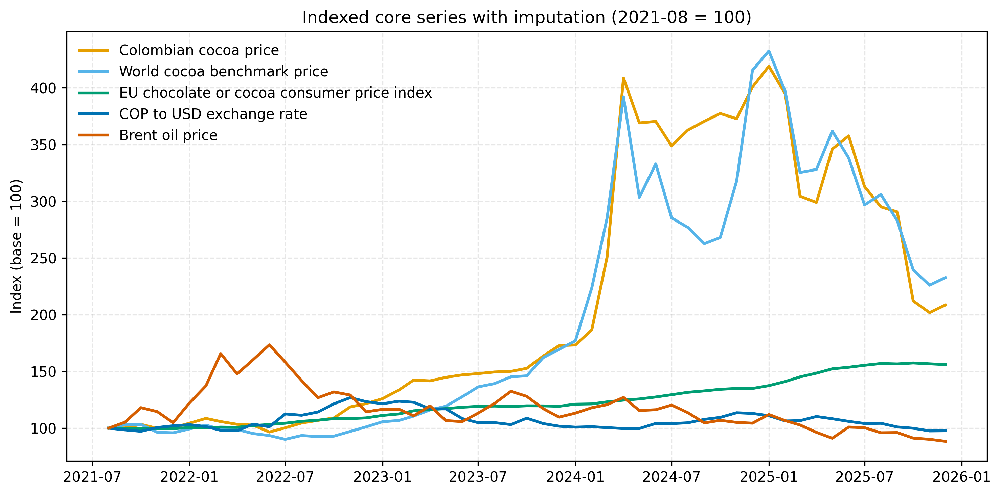
Indexed core series in the imputed shared monthly window. The figure compares proportional movements across Colombian cocoa, the world cocoa benchmark, the EU chocolate index, the exchange rate, and Brent oil in the common aligned sample.
The common-window plot in Figure 1 shows the close comovement between the Colombian and world cocoa series during the aligned period, alongside the smoother evolution of the EU downstream index. The same descriptive stage also reports a level correlation of 0.961 between Colombian cocoa and world cocoa and a log-return correlation of 0.730 between the same pair in the aligned sample.
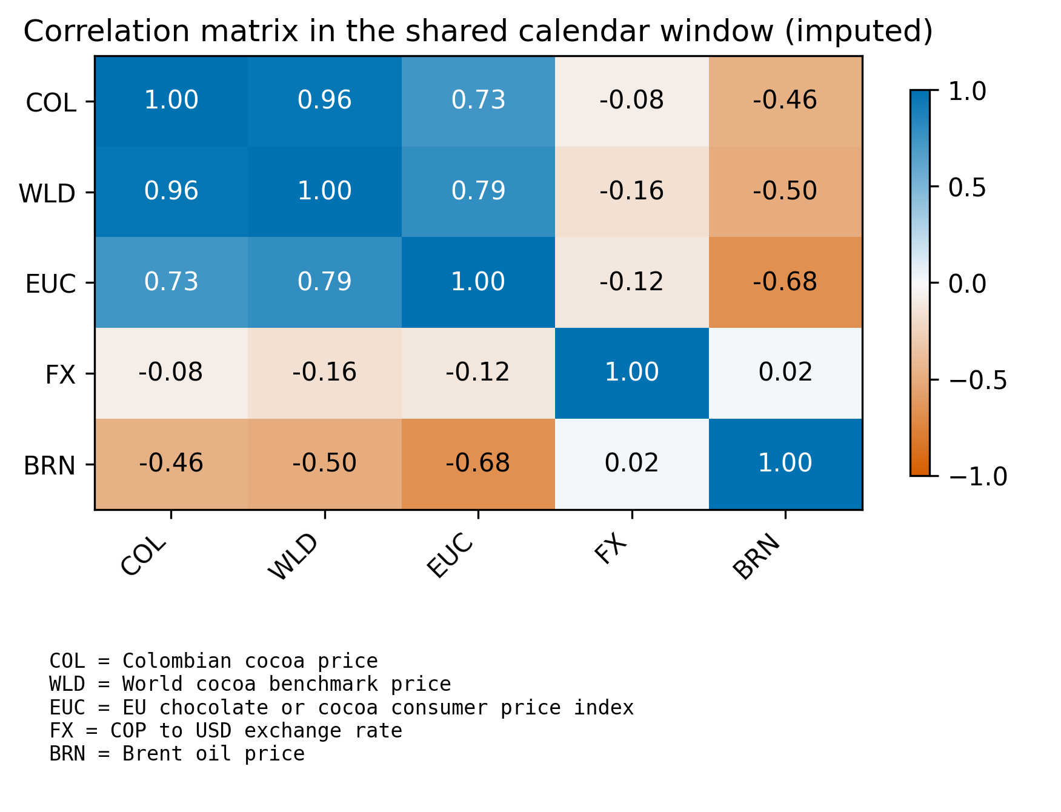
Correlation heatmap for the imputed aligned core system. The strongest relationship is between Colombian cocoa and the world cocoa benchmark, while the exchange rate is weakly associated with the price system in levels over the shared window.
Figure 2 makes the core dependence structure explicit. Colombian cocoa and world cocoa are highly correlated at the level ($0.961$), and both are positively associated with the EU chocolate index. Brent is negatively correlated with the three price indicators in the shared window, while COP/USD is comparatively weak in simple level correlation even though it remains important in the regression-based transmission equations.

Preliminary Core Transmission Results
The baseline transmission chapter provides the strongest evidence in the current draft. In the imputed long-run domestic-price equation, the elasticity on the world cocoa benchmark is 0.990, while the coefficient on the exchange rate is 0.902. In the short-run domestic-return equation, the world cocoa return coefficient is 0.796 with $p<0.001$, whereas the exchange-rate and Brent return coefficients are not conventionally significant. The model fit remains substantial, with adjusted $R^{2}=0.965$ for the level equation and adjusted $R^{2}=0.581$ for the domestic return equation.
Core transmission results from the imputed aligned sample
Model component | Coefficient | Std. error | $p$-value | Adj. $R^{2}$
$$ln(P_{t}^{COL})←ln(P_{t}^{WLD})$$ | 0.990 | 0.037 | $$<0.001$$ | 0.965
$$ln(P_{t}^{COL})←ln(FX_{t})$$ | 0.902 | 0.147 | $$<0.001$$ | 0.965
$$ln(P_{t}^{COL})←ln(OIL_{t})$$ | 0.140 | 0.084 | 0.096 | 0.965
$$Δln(P_{t}^{COL})←Δln(P_{t}^{WLD})$$ | 0.796 | 0.180 | $$<0.001$$ | 0.581
$$Δln(P_{t}^{COL})←Δln(FX_{t})$$ | 0.218 | 0.204 | 0.287 | 0.581
$$Δln(P_{t}^{COL})←Δln(OIL_{t})$$ | 0.029 | 0.067 | 0.665 | 0.581
$$ln(P_{t}^{EU})←ln(P_{t}^{WLD})$$ | 0.296 | 0.126 | 0.018 | 0.727
$$Δln(P_{t}^{EU})←Δln(P_{t}^{WLD})$$ | -0.023 | 0.010 | 0.023 | -0.007
Lag-specific pairwise Granger-causality $p$-values in the imputed aligned core return system
Direction | Lag 1 $p$ | Lag 2 $p$ | Lag 3 $p$ | Best lag ($p$)
World cocoa $→$ Colombian cocoa | 0.050 | 0.075 | 0.023 | 3 (0.023)
Colombian cocoa $→$ World cocoa | 0.013 | 0.076 | 0.027 | 1 (0.013)
Colombian cocoa $→$ EU chocolate | 0.979 | 0.801 | 0.871 | 2 (0.801)
EU chocolate $→$ Colombian cocoa | 0.692 | 0.781 | 0.641 | 3 (0.641)
World cocoa $→$ EU chocolate | 0.678 | 0.597 | 0.364 | 3 (0.364)
EU chocolate $→$ World cocoa | 0.866 | 0.191 | 0.192 | 2 (0.191)
The cointegration and causality diagnostics support a cautious interpretation of the core transmission results. The bivariate Engle–Granger test for world cocoa and Colombian cocoa does not reject the null of no cointegration in the imputed aligned sample ($p=0.132$). Table 6 reports the lag-specific Granger evidence. The strongest predictive linkage is from world cocoa returns to Colombian cocoa returns at lag 3 ($p=0.023$), but the reverse Colombia-to-world pairwise test is also significant at lags 1 and 3. In a short reduced-form sample, these results should be read as predictive precedence rather than as structural proof that domestic prices drive the world benchmark. Taken together with the regression elasticities and the impulse-response evidence, the results still support a world-to-Colombia transmission interpretation more strongly than the reverse.
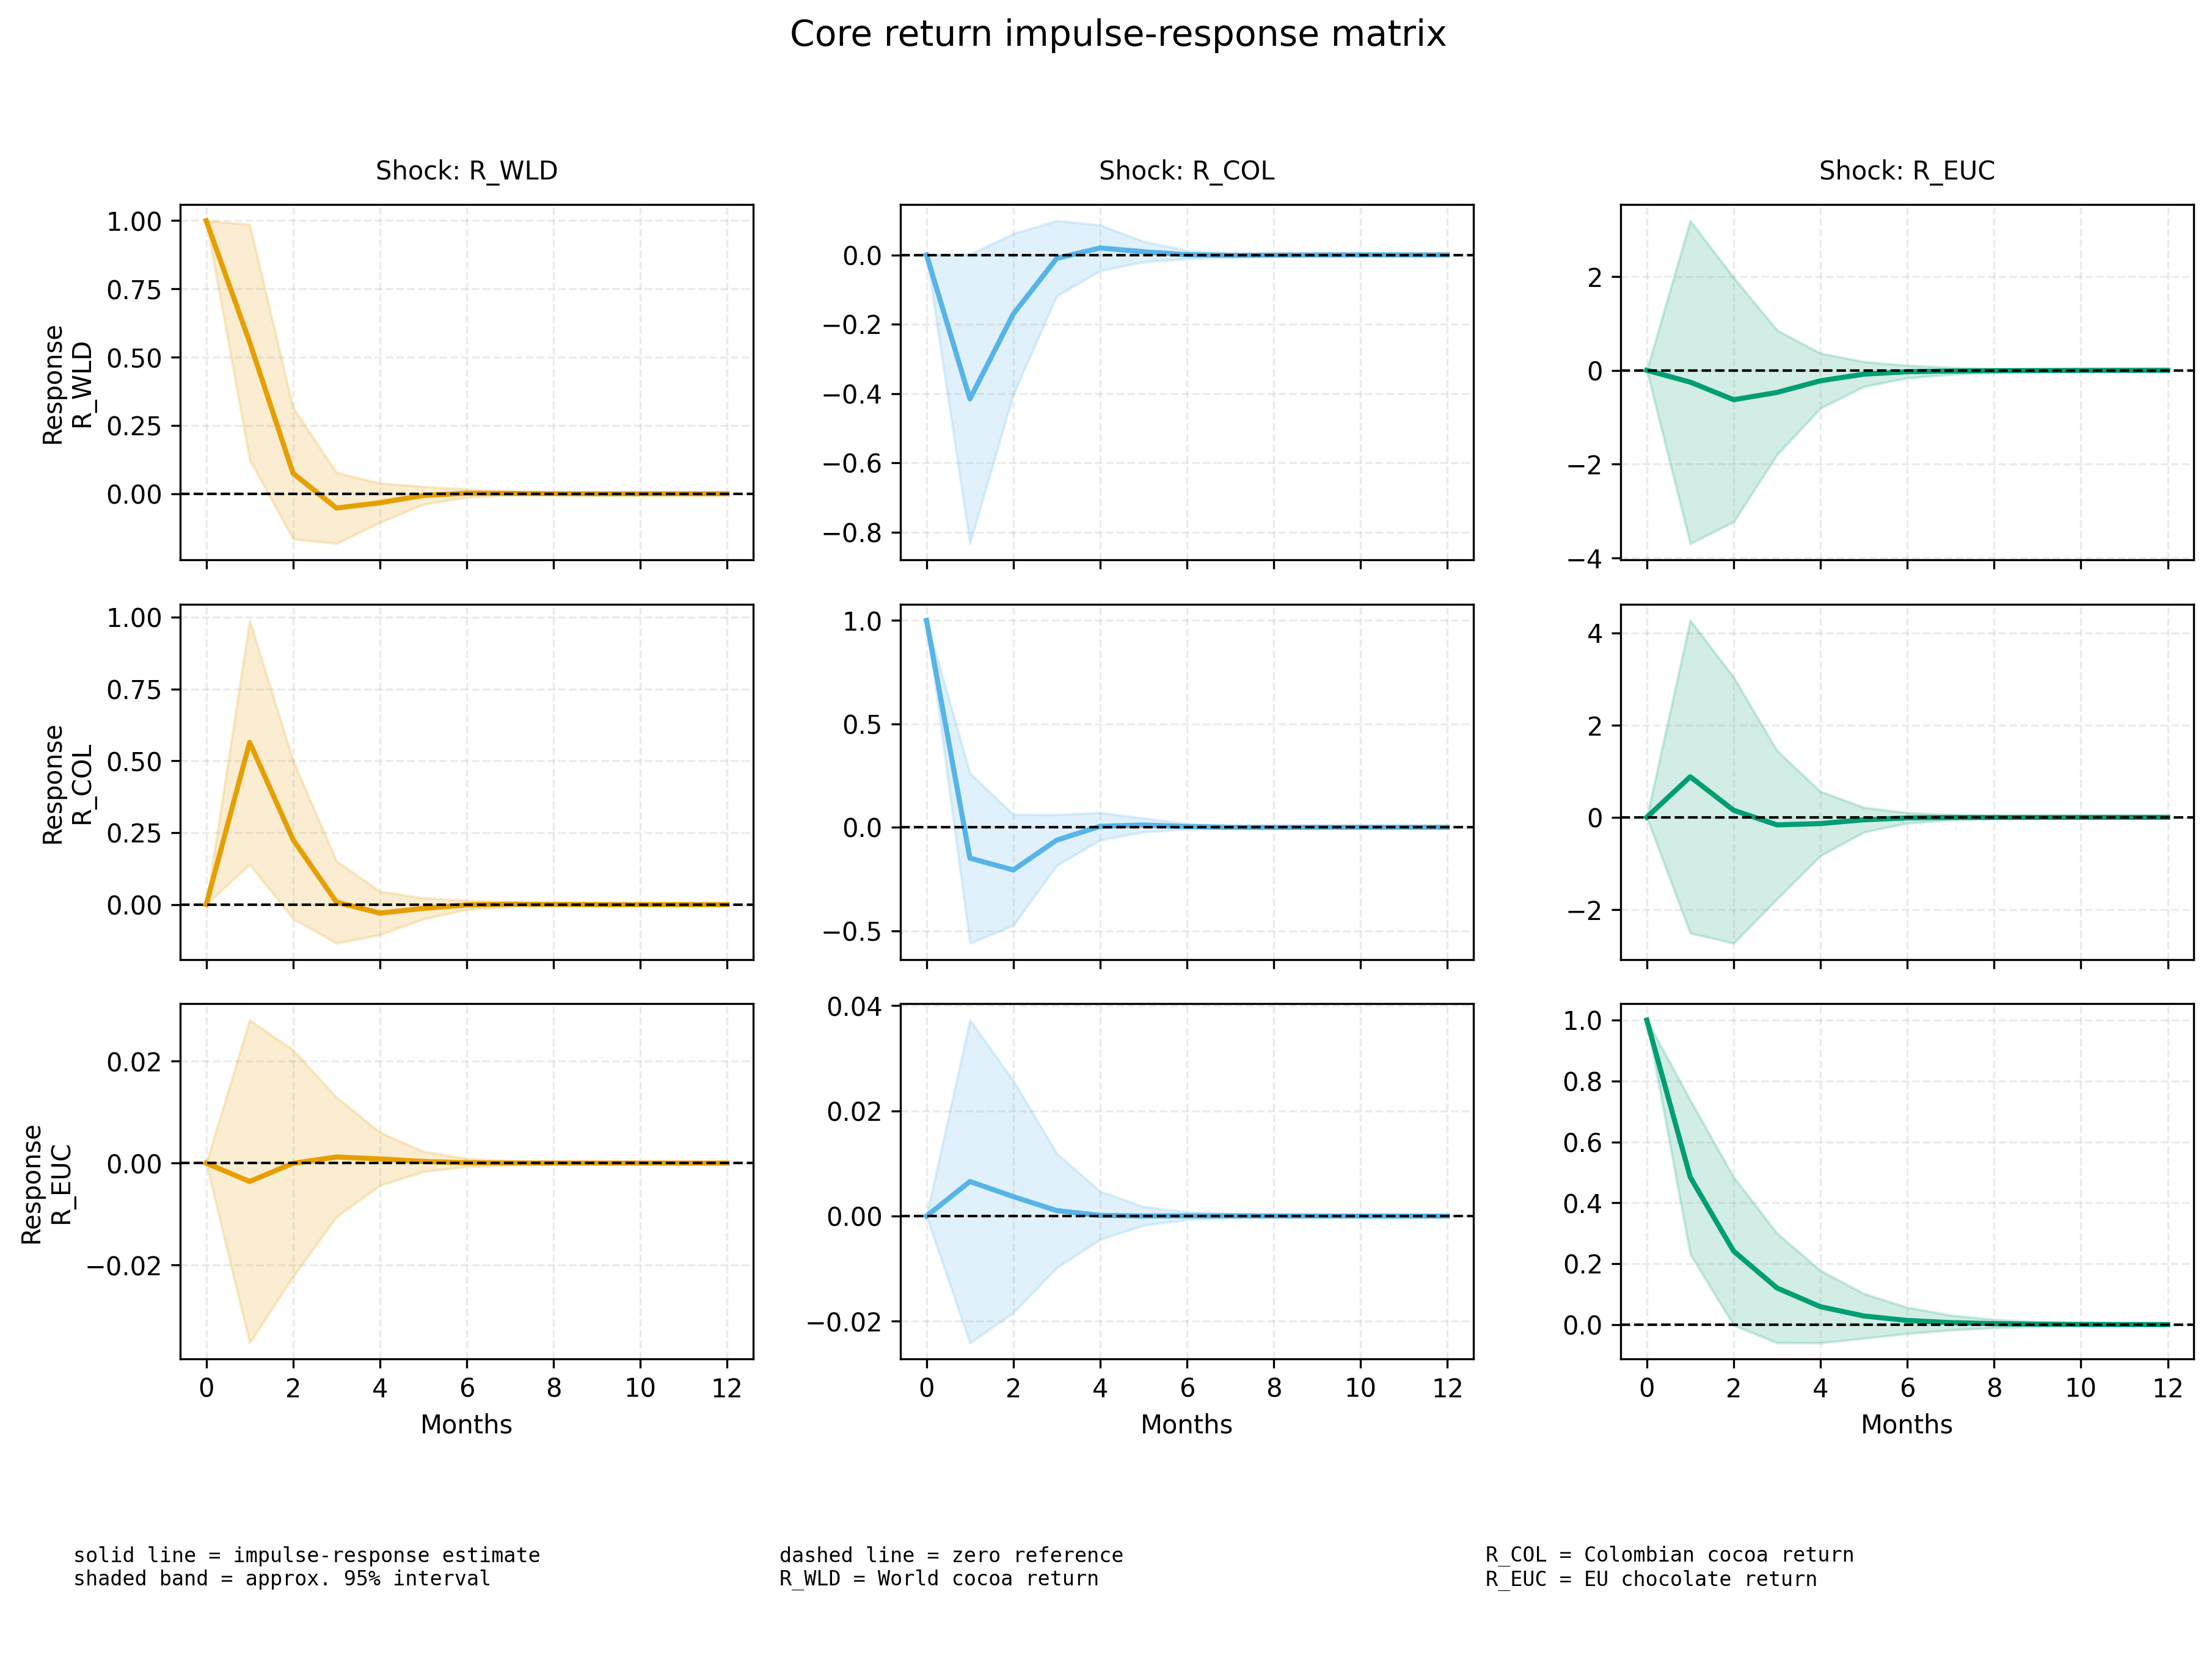
Impulse-response matrix for the core return VAR. Acronyms identify the return series for world cocoa, Colombian cocoa, and the EU chocolate index.

Preliminary Weather-Extended Results
The weather chapter asks a different question. It does not ask whether local weather replaces market transmission. It asks whether local weather stress helps explain how market volatility is experienced in the producing location. The selected weather variables are precipitation, solar radiation, and maximum temperature because they capture hydrological stress, seasonal radiation structure, and heat stress, respectively.
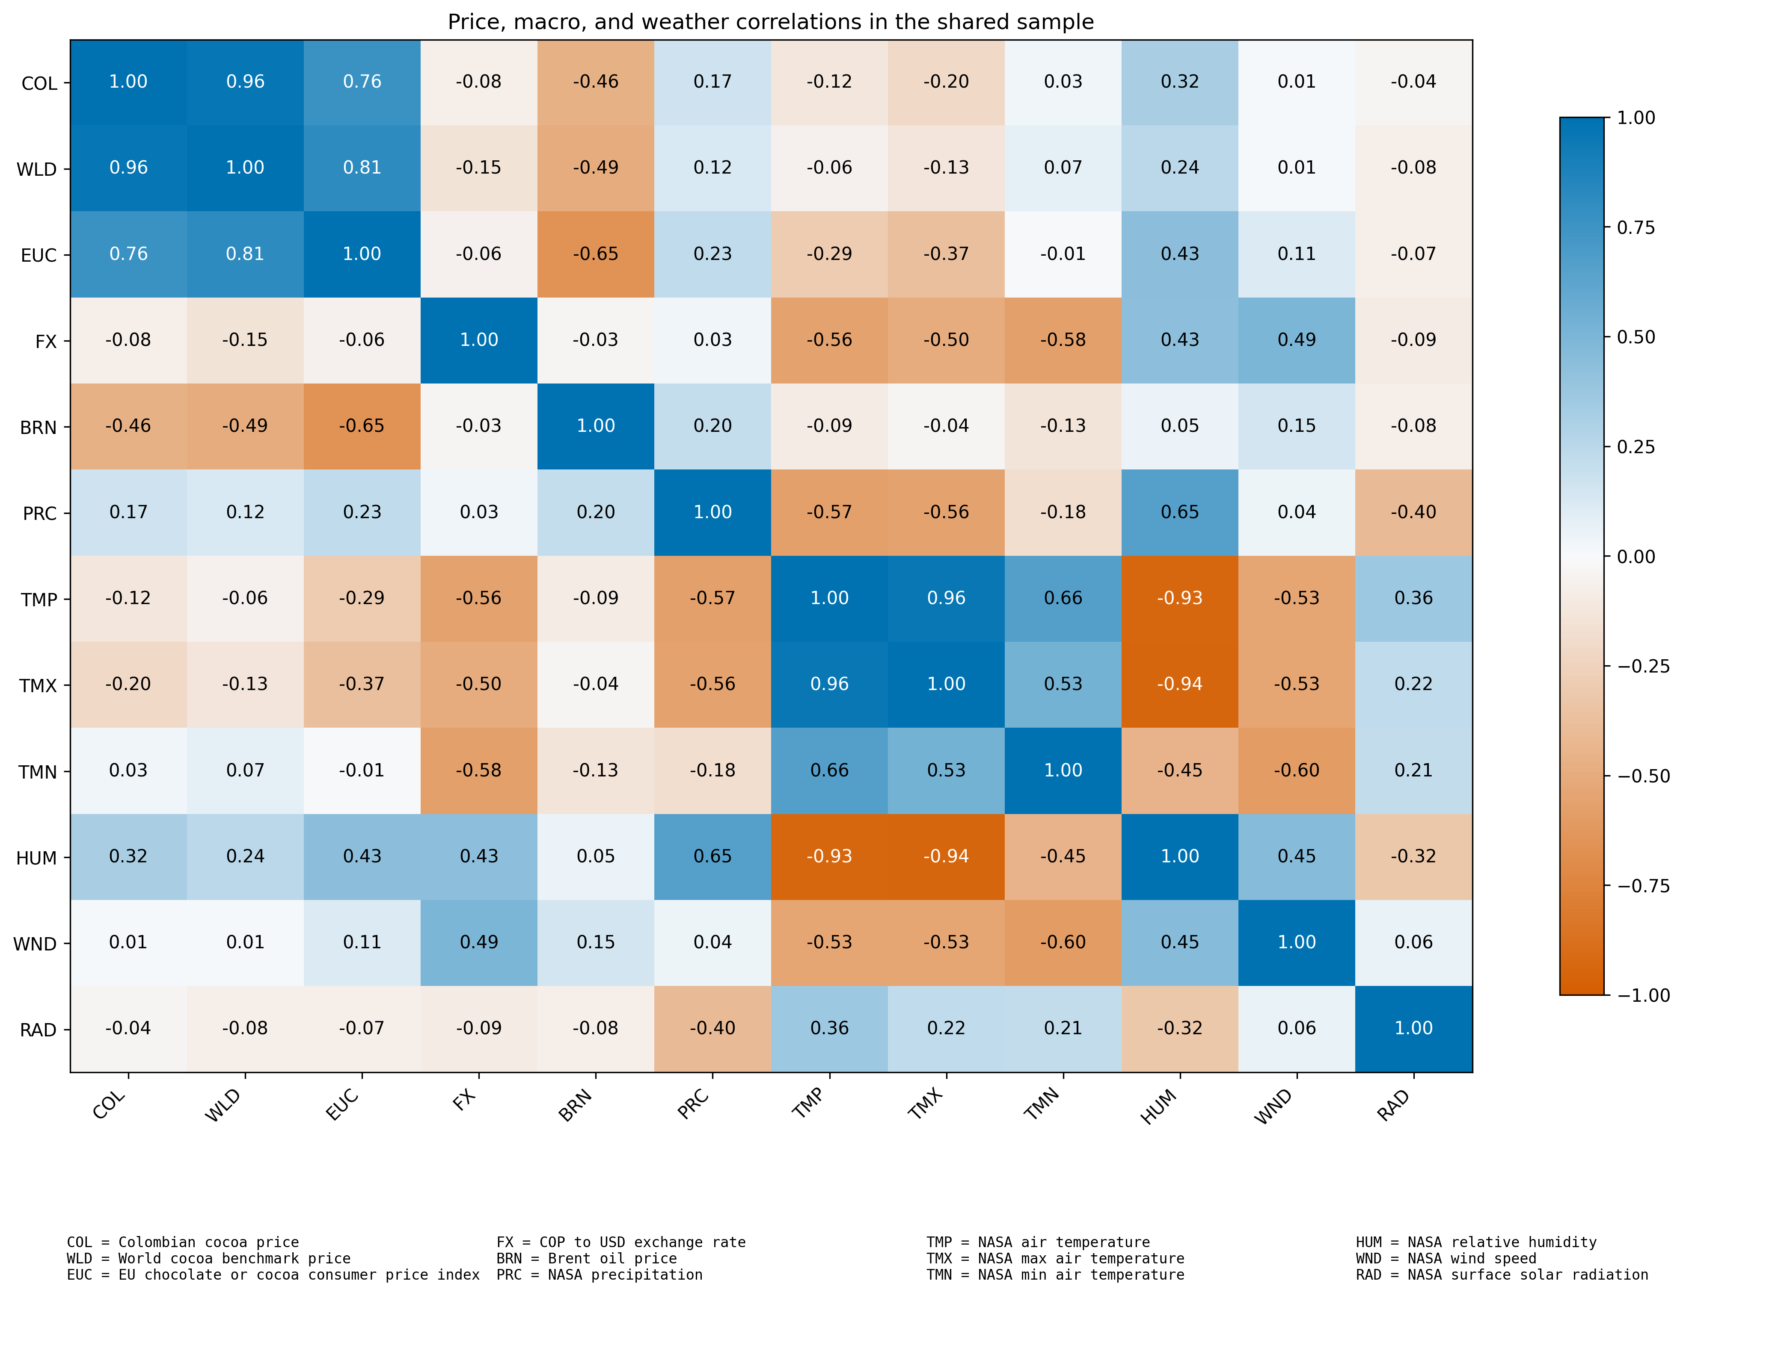
Climate-core correlation matrix in the aligned common sample. This figure plays a parallel role to the impulse-response matrix for the core transmission block: it summarizes how the selected weather variables and the broader climate block relate to the price system without forcing an unstable weather-augmented VAR in a 51-observation complete sample.
Figure 4 is included because the second block is not currently estimated as a full weather-augmented VAR or VECM. Under the current climate-augmented overlap, such a system would be too parameter-heavy for defensible impulse-response analysis. The corrplot, therefore, provides a visual bridge between the weather data and the vulnerability interpretation. It shows, for example, that humidity is positively associated with the three price variables in the aligned sample, while temperature variables are negatively associated with the EU chocolate index and weakly to moderately associated with the core market variables.
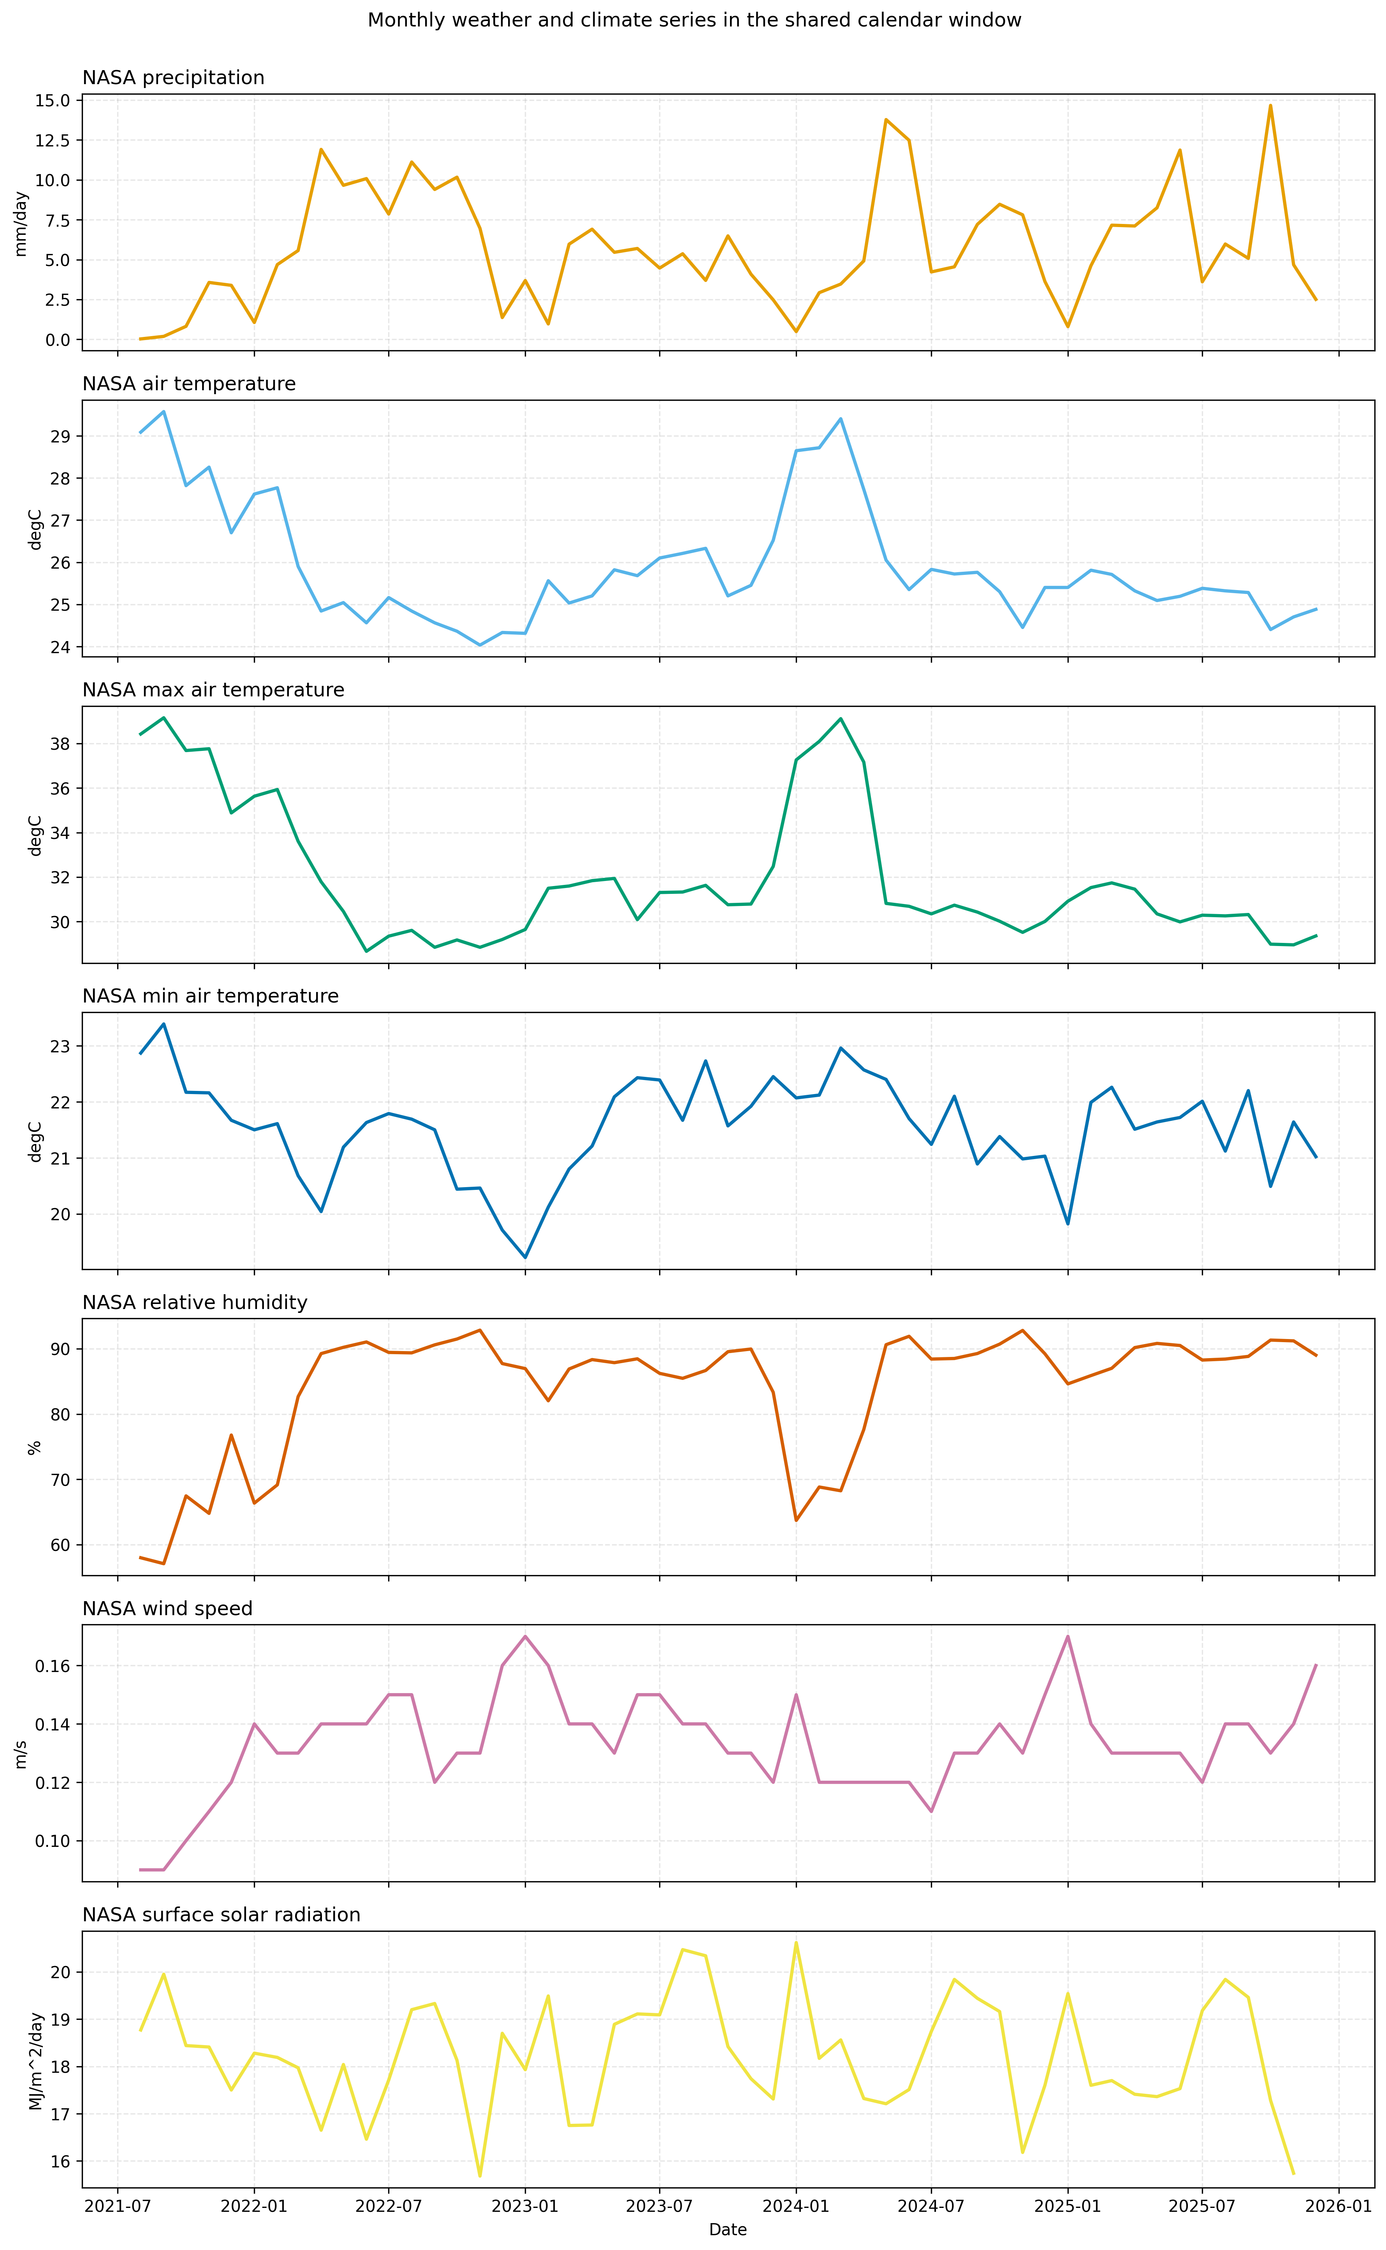
Weather panels for the aligned common window in San Vicente de Chucurı́, Santander. These series provide the empirical context for the vulnerability chapter and for the exploratory climate-augmented approach.
Weather-extended domestic models from the imputed aligned sample
Model component | Coefficient | Std. error | $p$-value | Adj. $R^{2}$
$$ln(P_{t}^{COL})←ln(P_{t}^{WLD})$$ | 0.977 | 0.037 | $$<0.001$$ | 0.966
$ln(P_{t}^{COL})←$ solar radiation$​_{t}$ ($z$) | 0.028 | 0.016 | 0.075 | 0.966
$ln(P_{t}^{COL})←$ precipitation$​_{t}$ ($z$) | 0.024 | 0.020 | 0.247 | 0.966
$ln(P_{t}^{COL})←$ max temperature$​_{t}$ ($z$) | -0.009 | 0.019 | 0.627 | 0.966
$$Δln(P_{t}^{COL})←Δln(P_{t}^{WLD})$$ | 0.773 | 0.157 | $$<0.001$$ | 0.595
$Δln(P_{t}^{COL})←$ max temperature$​_{t-1}$ ($z$) | 0.023 | 0.015 | 0.119 | 0.595
$Δln(P_{t}^{COL})←$ precipitation$​_{t-1}$ ($z$) | 0.003 | 0.010 | 0.725 | 0.595
$Δln(P_{t}^{COL})←$ solar radiation$​_{t-1}$ ($z$) | -0.008 | 0.008 | 0.330 | 0.595
Domestic rolling volatility $←$ world rolling volatility | 0.954 | 0.051 | $$<0.001$$ | 0.917
Domestic rolling volatility $←$ weather stress$​_{t-1}$ | 0.013 | 0.012 | 0.253 | 0.917
The weather extension improves adjusted $R^{2}$ only modestly relative to the core domestic models. The improvement is 0.0017 in levels and 0.0139 in returns. This is substantively useful because it suggests that weather matters more for vulnerability framing than for replacing the benchmark market variables in the core transmission mechanism.
Definition and empirical range of the exploratory vulnerability indicators
Indicator | Construction in the current draft | Mean | Std. dev.
Weather stress index | Mean absolute standardized anomaly across precipitation, solar radiation, and maximum temperature | 0.798 | 0.356
Weather stress ($z$-score) | Standardized weather-stress index; positive values indicate above-average combined weather anomaly in the aligned sample | 0.000 | 1.010
Farmer exposure index | $$z(σ_{t}^{COL})+z({\hat{m}}_{t})+{\text{WeatherStressZ}}_{t}$$ | 0.758 | 1.691
Livelihood risk score | $${\text{FarmerExposureIndex}}_{t}+z(σ_{t}^{WLD})$$ | 0.758 | 2.429
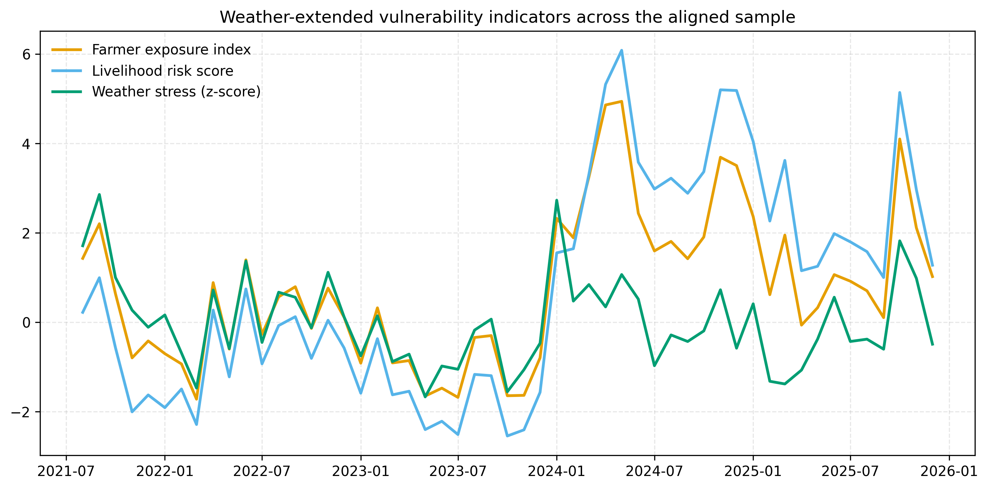
Exploratory weather-extended vulnerability indicators. Weather stress ($z$-score) standardizes the average absolute anomaly across precipitation, solar radiation, and maximum temperature; the farmer exposure index adds domestic volatility and fitted market-transmission shock; the livelihood-risk score additionally incorporates world-cocoa volatility.
Table 8 and Figure 6 clarify the meaning of the exploratory indicators. Weather stress is not a raw climate level; it is a relative anomaly score within the aligned sample. The farmer exposure index should therefore be read as a standardized combination of domestic volatility, predicted market-shock magnitude, and local weather anomaly. The livelihood-risk score adds world-cocoa volatility in order to represent an external market-pressure layer on top of local exposure. The highest-risk months under this exploratory scoring are May 2024, April 2024, November 2024, December 2024, and October 2025. These dates should be interpreted carefully, but they are consistent with the broader idea that vulnerability in this system is produced by the interaction of transmitted market shocks and local stress conditions, not by weather alone.

Preliminary Answers to the Hypotheses
H1 is supported. The clearest result in the draft is the positive and statistically strong effect of world cocoa returns on Colombian cocoa returns.
H2 is partially supported. The EU downstream series moves with the system in levels, but the short-run return response is much weaker and the EU return model has poor fit.
H3 is partially supported. Weather variables do not dominate the market system, but they do improve the vulnerability narrative and contribute modestly to model fit, especially through solar radiation in levels and heat stress in lagged returns.
H4 is provisionally supported. The climate-augmented system remains theoretically attractive but empirically fragile under the current 51-observation complete weather overlap. For now, the manuscript should emphasize weather as contextual vulnerability information and present climate-augmented cointegration as an exploratory extension rather than as the main result.

Discussion and Limitations
The main limitation is sample length. The core aligned monthly window contains only 53 months, and the fully complete climate-augmented overlap contains only 51 months. This is enough for transparent descriptive work and cautious reduced-form analysis, but it is short for strong multivariate cointegration claims in a system that mixes domestic, benchmark, downstream, macro, and climate variables (Hakkio and Rush 1991). That is why the draft distinguishes so carefully between the core transmission chapter and the weather-augmented extension.
A second limitation is the structure of the missing-data problem. Although only two cells needed imputation, any imputed value is still an estimate rather than a recovered observation. The manuscript therefore treats imputation as a continuity device and a sensitivity tool, not as a solution to fundamental data scarcity. The non-imputed balanced sample should remain the main reference for aligned descriptive reporting, while imputed variants are best understood as supportive continuity artifacts.
A third limitation is measurement. The Colombian domestic series is a national weekly reference series aggregated to monthly means, not a farm-gate micro panel. The EU downstream series is a consumer-price index, not a wholesale chocolate margin. The weather block is a location-level NASA POWER climate panel, not a farm-observed yield or disease dataset. These features do not invalidate the analysis, but they shape the type of claim the paper can make. The paper is strongest when it speaks about transmission, volatility, and vulnerability context across linked market layers rather than about farm-level agronomic causality.
The current draft also inherits institutional source transitions. The Eurostat downstream endpoint used here is the legacy COICOP series running through December 2025, after which the classification changes. The Brent monthly series required a March 2026 extension derived from the official daily history because the official monthly page stopped at February 2026 at the time of download. These transitions are documented rather than hidden, but they still matter for replication and future updates.
Finally, the paper should resist over-claiming from the weather chapter. The current evidence does not show that local weather overwhelms international market transmission. Instead, it shows that vulnerability is best read as the interaction of a volatile market chain and a structured environmental setting. That distinction is important both methodologically and substantively.

Conclusion
This paper develops a transparent empirical framework to study cocoa price volatility and smallholder vulnerability across the supply chain. Rather than focusing solely on econometric results, the contribution lies in integrating a clearly documented data architecture with a coherent empirical strategy linking Colombian domestic prices, international cocoa benchmarks, European downstream prices, macroeconomic controls, and local weather conditions.
The preliminary evidence points to three main findings. First, short-run price transmission from international cocoa markets to Colombian domestic prices is strong and statistically robust, indicating that local producer prices are closely tied to global market dynamics. Second, downstream European chocolate prices adjust more slowly and more weakly, suggesting incomplete and lagged transmission along the supply chain. Third, the inclusion of weather variables does not materially alter the core transmission results, but provides additional context for interpreting periods of heightened vulnerability, particularly when local environmental stress coincides with market volatility.
Taken together, these results suggest that smallholder exposure is driven primarily by global price movements and their rapid transmission into domestic markets, while downstream price dynamics and local climatic conditions play a secondary but complementary role. In this sense, vulnerability emerges not only from price levels but from the interaction between volatility, transmission intensity, and local stress conditions.
Acosta, Alejandro, Rico Ihle, and Stephan von Cramon-Taubadel. 2019. “Combining Market Structure and Econometric Methods for Price Transmission Analysis.” Food Security 11 (4): 941–51. https://doi.org/10.1007/s12571-019-00951-w.
Banco de la Republica. 2026. Tasa de Cambio Representativa Del Mercado (TRM). Https://www.banrep.gov.co/es/glosario/tasa-cambio-trm.
Buuren, Stef van, and Karin Groothuis-Oudshoorn. 2011. “mice: Multivariate Imputation by Chained Equations in R.” Journal of Statistical Software 45 (3): 1–67. https://doi.org/10.18637/jss.v045.i03.
Engle, Robert F., and Clive W. J. Granger. 1987. “Co-Integration and Error Correction: Representation, Estimation, and Testing.” Econometrica 55 (2): 251–76.
Eurostat. 2026. Harmonised Index of Consumer Prices (HICP) Metadata. Https://ec.europa.eu/eurostat/cache/metadata/en/prc_hicp_esms.htm.
Hakkio, Craig S., and Mark Rush. 1991. “Cointegration: How Short Is the Long-Run?” Journal of International Money and Finance 10 (4): 571–81. https://doi.org/10.1016/0261-5606(91)90008-8.
Johansen, Soren. 1991. “Estimation and Hypothesis Testing of Cointegration Vectors in Gaussian Vector Autoregressive Models.” Econometrica 59 (6): 1551–80.
Ministerio de Agricultura y Desarrollo Rural. 2026. Precio de Referencia Semanal de Compra de Cacao - Fuente Industria Nacional - Exportadores. Https://www.agronet.gov.co/Noticias/Paginas/Precio-de-referencia-semanal-de-compra-de-cacao---Fuente-Industria.aspx.
National Aeronautics and Space Administration. 2026. NASA POWER Temporal APIs Documentation. Https://power.larc.nasa.gov/docs/services/api/temporal/.
Talero-Sarmiento, Leonardo H., Henry Lamos-Diaz, and Juan D. Marquez-Gonzalez. 2025. “Optimizing Cocoa Biomass Density Through Integrated Irrigation and Drainage Management Under Water Stress: A Linear Programming Approach.” Ecological Informatics 90: 103262. https://doi.org/10.1016/j.ecoinf.2025.103262.
Troyanskaya, Olga, Michael Cantor, Gavin Sherlock, et al. 2001. “Missing Value Estimation Methods for DNA Microarrays.” Bioinformatics 17 (6): 520–25. https://doi.org/10.1093/bioinformatics/17.6.520.
U.S. Energy Information Administration. 2026. Europe Brent Spot Price FOB. Https://www.eia.gov/dnav/pet/hist/LeafHandler.ashx?n=PET&s=RBRTE&f=M.
World Bank Prospects Group. 2025. World Bank Commodities Price Data (the Pink Sheet). Https://thedocs.worldbank.org/en/doc/18675f1d1639c7a34d463f59263ba0a2-0050012025/world-bank-commodities-price-data-the-pink-sheet.

