**Our Project:**

We want to examine the factors that might attribute to the decline rate of vaccinations in elementary schools, specifically in Vancouver. In some cases, herd immunity, where 80 percent of the targeted population is vaccinated, is not in effect anymore due to low vaccination rates. We wanted to examine the following attributes that might affect vaccination rates:

Household income

Religion

Ethnicity

Grade (age of child)

Price of Vaccination

**What We Have So Far:**

We have an interactive map that allows the user to explore certain aspects of the data in a geospatial environment. We felt that a map was necessary because it allowed the user to see the relationship between the school and their environment, and how that might affect vaccination rates.

What we have so far is a choropleth map showing the median household income per neighborhood, and points marking schools that is color coded based on their vaccination rates.

**Code:**

We loaded the following data:

* Elementary school locations in Vancouver
* Neighborhoods in Vancouver
* Average income of neighborhoods in Vancouver
* Percentage of vaccination on children per school

First we merged data:

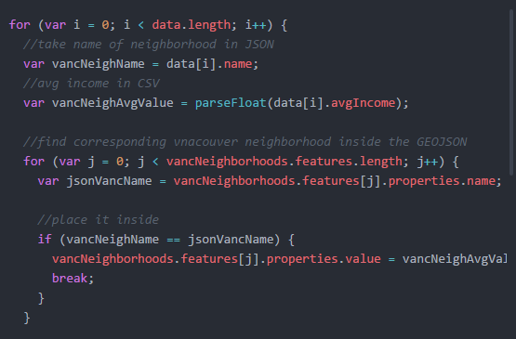

We nested this for loop inside the d3.csv function so that when we load the average income in csv form, we would then add the JSON of the Vancouver neighborhoods to match the data to the proper data set.

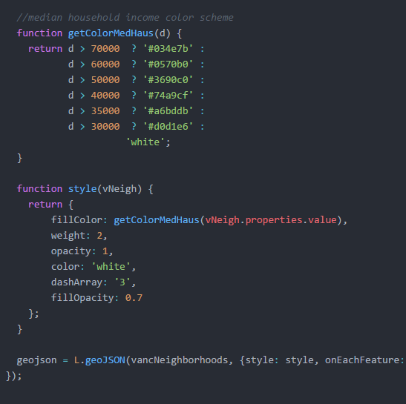

We used these functions to distribute the values into the proper colors to differentiate between values. The higher the income, the bluer a neighborhood is, and vice versa if they have lower income. The first function, getColorMedHaus determined which color would represent a data range, and the second function, style, would apply the color scheme when added to the geojson layer which is displayed below. vancNeighborhood is a variable that is an object which holds the polygons of the neighborhoods in JSON format.

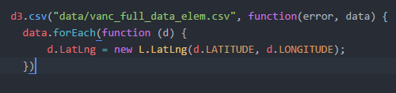

The second step we did was taking in the vaccination rate per elementary schools. To add the points where the school would be, we took the longitude and the latitude of the schools from the csv and loaded them into dLatLng – a variable we will use later to render the points properly.

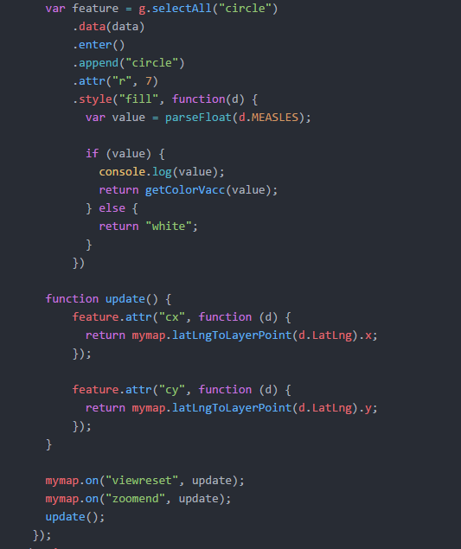

The first function determines that for each data set, a circle is to represent the school, and the color is determined by the function which will be explained later.

We used the second function, update, using the x and y values of d.LatLng we mentioned earlier.