

Norwegian University of Science and Technology

__________________________________________________________________________________________

Composites and Polymers Report Series

__________________________________________________________________________________________

Laminate Python Documentation

Report No. CPR-2018-1809

Revision No. Draft 01

**Confidential DRAFT**

Revision No. 00-Draft

yyy-00.docx

Anybody working on the document should give the file a new number and add his/her initials. Once the work is finished, send an update to everybody. We want to avoid working on parallel versions!

|  |  |  |  |  |  |
| --- | --- | --- | --- | --- | --- |
| **COMPOSITES AND POLYMERS REPORT SERIES** | | | | | |
| Report Title:  YYY | | | | | |
| Report No.:  CPR-2017-1012 | | | NTNU Project No.:  90040400 | | |
| Date of first issue:  yyy | | |  | | |
| Client:  Affordable Composites Project | | | Client reference: | | |
| Summary  **DRAFT**  **This is an incomplete DRAFT report** | | | | | |
| Report written by:  Andreas Echtermeyer +++ | | |  | Distribution: | |
| Work verified by: | | |  | Unrestricted distribution |
| Work approved by: | | |  | No distribution without permission from NTNU - Department of Engineering Design and Materials, Composites and Polymer Group |
| Date of this revision:  yyy | Revision Number:  00 | Number of pages:  yyy | x | No distribution without permission of client |

# Revision History

**Draft Revisions will be deleted from the table later**

|  |  |  |  |
| --- | --- | --- | --- |
| **Revision** | **Date** | **Revised Pages** | **Description of Changes** |
|  |  |  |  |
|  |  |  |  |
|  |  |  |  |
|  |  |  |  |
|  |  |  |  |
|  |  |  |  |
|  |  |  |  |
|  |  |  |  |
|  |  |  |  |
|  |  |  |  |
|  |  |  |  |
|  |  |  |  |
|  |  |  |  |
|  |  |  |  |

# Table of contents

Revision History ii

Table of contents iii

List of Figures iv

List of Tables v

Symbols: vi

Abstract 1

1 Introduction 1

2 Fatigue based on damage accumulation on the micro level 3

3 Fatigue characterization Time-Cycles 1

4 Fatigue based on energy accumulation 14

# List of Figures

Figure 2‑1 Typical SN curve 2

Figure 2‑2 Microfatigue based on the Maxwell model 3

Figure 5‑1 Viscosity vs. Strain Rate 13

Figure 5‑2 Stress vs. Strain Rate 13

Figure 5‑3 Fatigue work vs stress amplitude for R=0. 15

Figure 5‑4 SN curve for R=0. 16

# List of Tables

Table 0‑1 Symbols vi

# Symbols:

Table 0‑1 Symbols

|  |  |  |
| --- | --- | --- |
| **Property** | **Unit** | **Description** |
|  |  |  |
|  |  |  |
|  |  |  |
|  |  |  |
|  |  |  |
|  |  |  |
|  |  |  |
|  |  |  |
|  |  |  |
|  |  |  |
|  |  |  |
| $$\hat{σ_{0}}$$ | Pa | Strength at 0 K |
|  |  |  |

# Abstract

**This is an incomplete DRAFT report**

To be written at the end

# Introduction

# Thin walled intact pressure vessel

The stress state in the cylindrical part of a thin-walled isotropic pressure vessel can be given in its most simple form as:

$$σ_{hoop}^{}=P\frac{D}{2t}$$

$$σ_{axial}^{}=P\frac{D}{4t}$$

For a composite pressure vessel made of plies with hoop and axial fibers the stresses in fiber direction in the hoop and axial plies can be described in a simplified way:

$$σ_{hoop}^{}=P\frac{D}{2t_{hoop}}$$

$$σ_{axial}^{}=P\frac{D}{4t_{axial}}$$

The total thickness of the laminate is:

$$t_{laminate}=t_{hoop}+t_{axial}$$

Stresses transverse to the fibers are ignored in this simple analysis. If the pressure vessel has matrix cracks, which most pressure vessels develop already during the fatigue acceptance test (FAT) the stresses should be low. A typical composite pressure vessel has hoop layers two times as thick as axial layers.

The burst strength of the cylindrical part of the composite pressure vessel is given by the minimum of the burst pressure due to hoop failure or axial failure:

$$P_{bh}={\hat{σ}}_{hoop}\frac{2t_{hoop}}{D}$$

$$P_{ba}={\hat{σ}}_{axial}\frac{4t_{axial}}{D}$$

$$P_{burst}=Min(P_{bh},P_{ba})$$

Pressure vessels have usually not reinforcements running exactly in the hoop or axial direction. Fiber orientations are closer to ±80o and ±10 o degrees. To keep the model simple this aspect is only reflected in the strength of the hoop and axial fibers, but otherwise ignored.

# Description of the impact damage

The impact damage is described her in a simplified way to have an elliptical shape in the plane of a ply and it penetrates the entire thickness $t_{i}$ of a ply. The extend of the damage perpendicular to the hoop direction is called $a_{i}$ and perpendicular to the axial direction is called $b_{i}$.

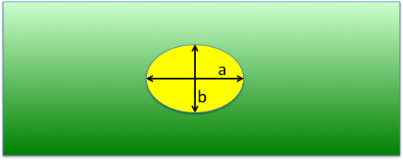

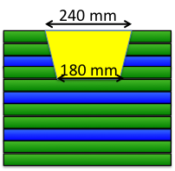

The total damage in a laminate can then be described in the form given in Table yyy.

|  |  |  |  |  |
| --- | --- | --- | --- | --- |
| Ply | Type | a | b |  |
|  |  |  |  |  |
|  |  |  |  |  |
|  |  |  |  |  |
|  | axial |  |  |  |
|  | hoop |  |  |  |
|  | hoop |  |  |  |
|  | axial |  |  |  |
|  | hoop |  |  |  |
|  | hoop |  |  |  |
| 1 | axial |  |  |  |
| 2 | hoop |  |  |  |
| 1 | hoop |  |  |  |

# Strength reduction of layers due to impact damage

If a pressure vessel is exposed to impact matrix cracking and fiber damage in some layers may happen. Delamination between layers may also develop. This simple model ignores matrix cracking in a conservative way, by assuming it is already present. Theoretical work using a more complex 3D analysis has shown that delamination also does not affect the burst strength for internally pressurized vessels. Based on this this simplified model considers only the effect of fiber damage. This means impact damage is described as the region of damaged fibers.

In order to determine the strength reduction of ply number *i* exposed to impact damage the Whitney Nuismer model is used. If a laminate has a crack the stress in front of the crack is given by:

$$σ_{crack}^{i}=σ_{hoop}^{i}\frac{x}{\sqrt{x^{2}-a^{2}}}$$

where a is the half length of the crack and x is the distance from the crack measured from the center of the crack.

The Whitney Nuismer point stress model says a composite will fail if the stress ahead of the crack by a characteristic distance $d_{0}$ reaches the strength of the material. This means hoop layer $i$ will fail if:

$${\hat{σ}}_{hoop}≤ σ_{crack}^{i} at distance d_{0}$$

$${\hat{σ}}_{hoop}≤σ_{hoop}^{i}\frac{a_{i}+d_{0}}{\sqrt{{\left(a_{i}+d_{0}\right)}^{2}-a_{i}^{2}}}$$

The critical distance $d_{0}$ was found by Whitney and Nuismer to be about 0.04´´ ± 0.01´´ for various laminates. We use 1 mm here. The value should be measured for the particular laminate to get better accuracy and validity of the predictions.

Alternatively, the effect of the impact can also be described as reducing the inplane strength of a layer to:

$${\hat{σ}}_{hoop}^{i}={\hat{σ}}_{hoop}\frac{\sqrt{{\left(a_{i}+d_{0}\right)}^{2}-a_{i}^{2}}}{a_{i}+d_{0}}$$

Using the same arguments for the axial layes, the reduced impact strength due to impact damage is given by:

$${\hat{σ}}_{axial}^{i}={\hat{σ}}_{axial}\frac{\sqrt{{\left(b_{i}+d_{0}\right)}^{2}-b_{i}^{2}}}{b_{i}+d_{0}}$$

The impact damage does not only influence the inplane strength of a layer, it also reduces the strength of neighboring undamaged plies. The reduction of strength can be calculated by applying the Whitney Nuismer model in the trough thickness direction. For a hoop layer we get:

$${\hat{σ}}_{hoop}^{neighbor}={\hat{σ}}_{hoop}\frac{\sqrt{{\left(t_{imp,hoop}+d_{0}\right)}^{2}-t_{imp,hoop}^{2}}}{t_{imp,hoop}+d_{0}}$$

$${\hat{σ}}_{axial}^{neighbor}={\hat{σ}}_{axial}\frac{\sqrt{{\left(t_{imp,axial}+d_{0}\right)}^{2}-t_{imp,axial}^{2}}}{t_{imp,axial}+d_{0}}$$

Since it is assumed that the layers have no strength perpendicular to the fiber direction, the effective thickness of the impact damage will be different for the hoop and axial direction. If the impact damage terminates next to a hoop layer, $t_{imp,hoop}$ is the distance from the surface to the hoop layer. The depth of the impact for the axial layer is the distance from the surface up to the next axial layer. If the impact damage terminates next to an axial layer, $t_{imp,axial}$ is the measured distance from the surface and $t_{imp,hoop}$ needs to get increased up to the next hoop layer.

Note that the full depth of the impact damage is used in the equations, because the damage represents an open crack. In the unlikely case that the impact damage should have developed only in the inside of the laminate an upper and lower neighbor laminate would be present and only half of the impact depth should be used in the equations.

# Script Data Flow

# Functions

## Pressure Functions Class

### HoopForce



Gives the laminate force in hoop direction ($N_{y}$, N/mm) of a thin walled pressure vessel according to:

$$σ_{hoop}^{}=P\frac{D}{2t}$$

$$N_{y}=σ_{hoop}^{}*t$$

$$N_{y}=P\frac{D}{2}$$

### AxialLaminateForce



Gives the laminate force in hoop direction ($N_{x}$, N/mm) of a thin walled pressure vessel according to:

$$σ_{axial}^{}=P\frac{D}{4t}$$

$$N_{x}=σ_{axial}^{}*t$$

$$N_{y}=P\frac{D}{4}$$

### ThickWalledHoopSCF

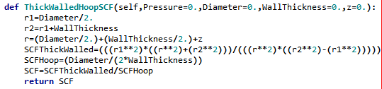

Transists between thin and thick walled tank. Gives the factor to multiply with stress in Hoop direction for a thick walled tank given that the Ny has been calculated based on thin walled assumption, as for the HoopForce function.

## StressConcentrationFunctions Class

### SCFAtXWhitneyNuismer

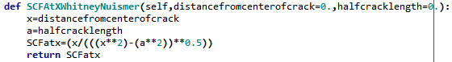

Gives the stress concentration from the Whitney Nuismer function.

## LaminateTheory Class

### WallThickness

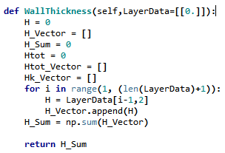

Gives the wall thickness of the layup.

### Local_Strain_from_Global_Strain

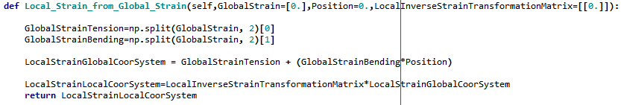

Gives the local strain from the global strain as function of the position in the layup.