# Site Flow and Sketches

## Step 1: Competitive Analysis

|  |  |
| --- | --- |
| Competitor Site 1: <site name here>URL: https://www.instagram.com/?hl=enAnalysisWhat is good about this site?  1. Its simple 2. Friend suggestions 3. Cant post from website  What is bad about this site?  1. Videos can pause but cant rewind 2. Cant preview stories 3. Cant join groups 4. Shows recommendation of friends likes etc | Competitor Site 2s: <site name here> URL: https://www.facebook.com/ AnalysisWhat is good about this site?  1. A lot of features 2. Can react to posts 3. Can play video at any time 4. Stories have preview 5. Can join groups  What is bad about this site?  1. Too much ads and sponsors 2. Stories have preview 3. <type something here> |

### Competitor 1 Pages

#### Page (or Screen) where you ask “What should I do tonight?”

#### 

#### Pages (or Screens) look for the answer

#### 

#### Page where you get an answer

### 

### Competitor 2 Pages

#### Page (or Screen) where you ask “What should I do tonight?”

#### 

#### Pages (or Screens) look for the answer

#### 

#### Page where you get an answer

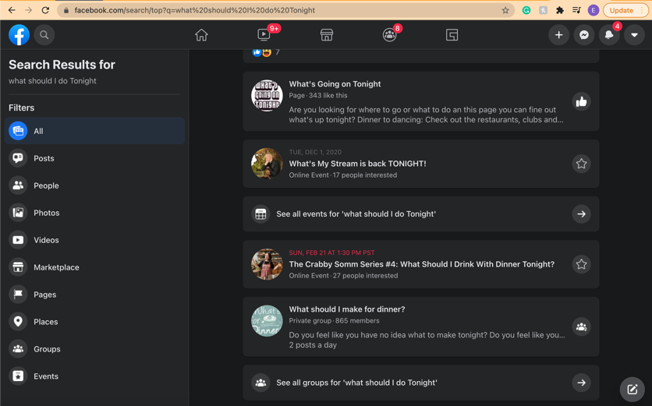

## Step 2: Sketch One Competitor Flow

### Favorite Competitor: Page Flow Sketch

Pages sketched as boxes for the flow between pages (or screens) where you ask “What should I do tonight?”, look for the answer, and get an answer. Arrows drawn between the boxes show how the pages are connected by clicks. Inside the page boxes details include:

* Where you ask the question
* Where the navigation is that allows you to find things to do
* Where the details of the “things to do” are displayed
* Where you click to move from page to page

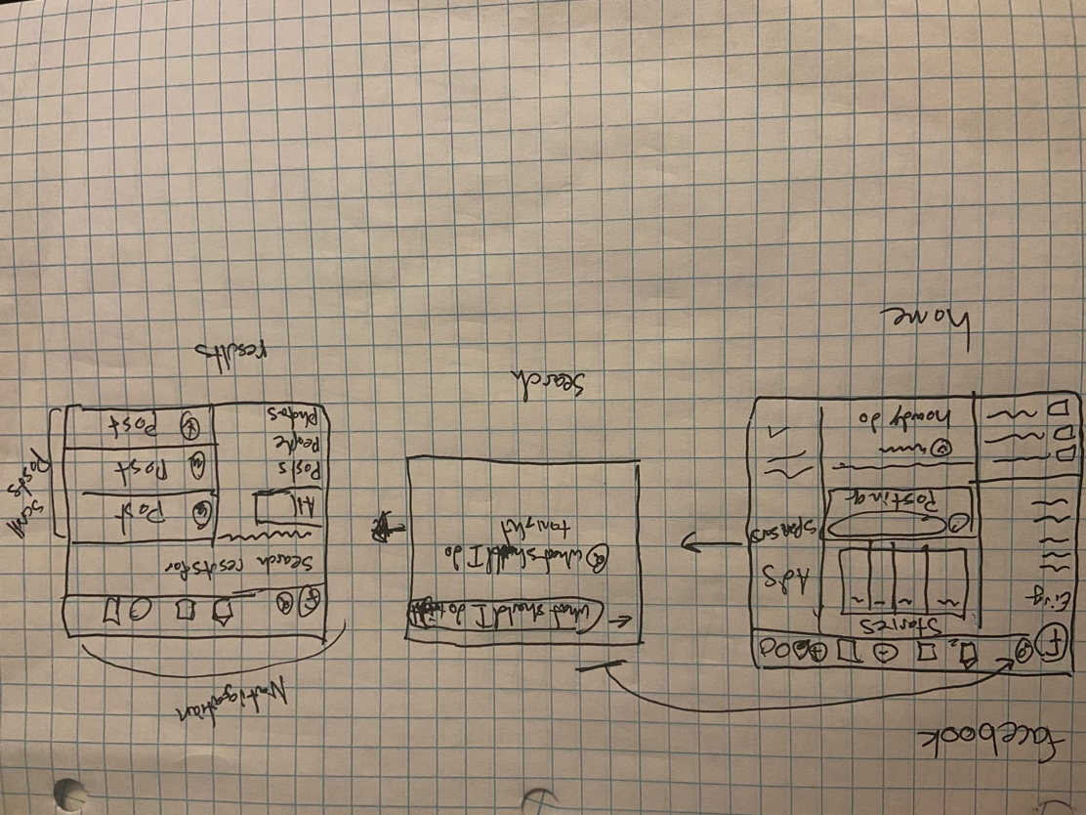

## Step 3: Sketch YOUR Flow

### My Site Name

<type the name of your site here>

#### Sketch of My Page Flow

Pages sketched as boxes for the flow between pages (or screens) where you ask “What should I do tonight?”, look for the answer, and get an answer. Arrows drawn between the boxes show how the pages are connected by clicks. Inside the page boxes details include:

* Where you ask the question
* Where the navigation is that allows you to find things to do
* Where the details of the “things to do” are displayed
* Where you click to move from page to page

<paste screenshot of sketches here>

