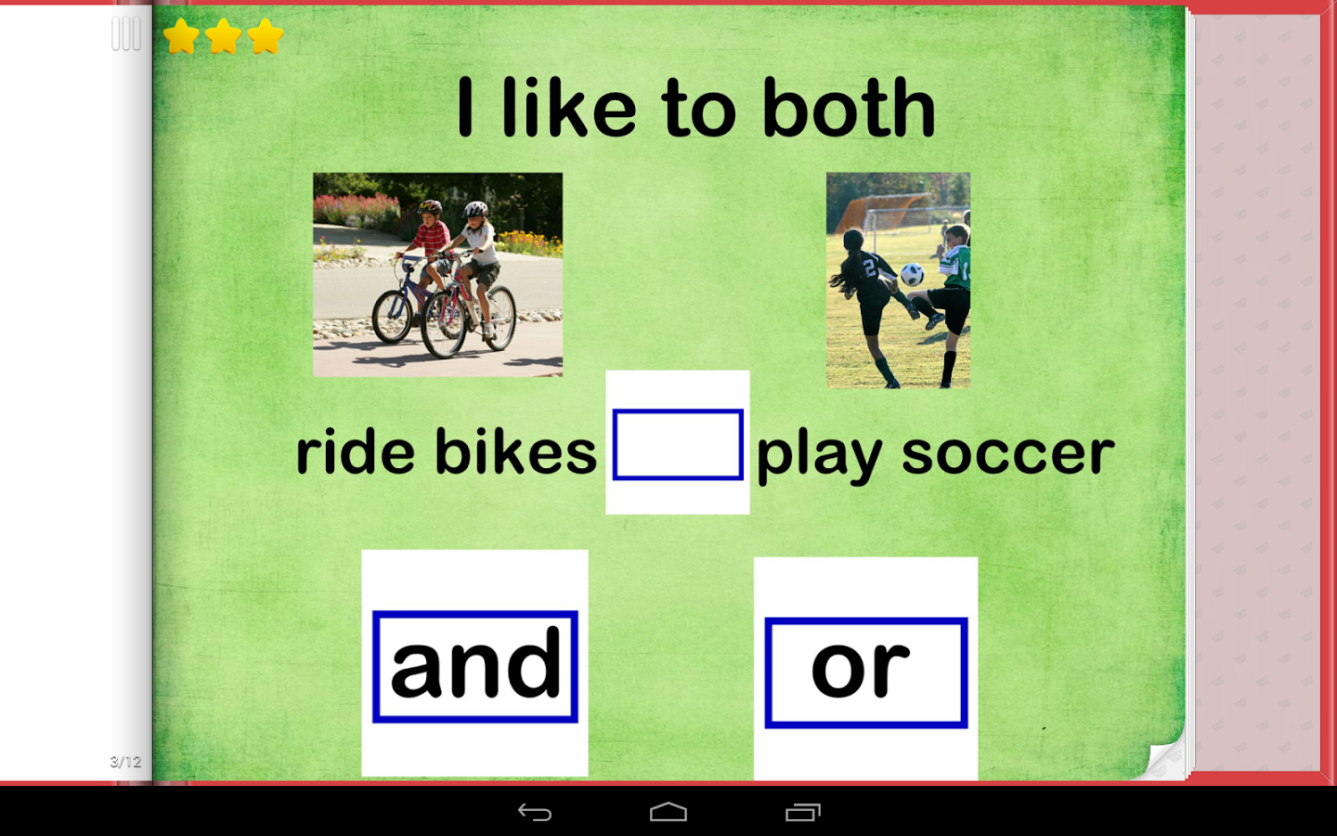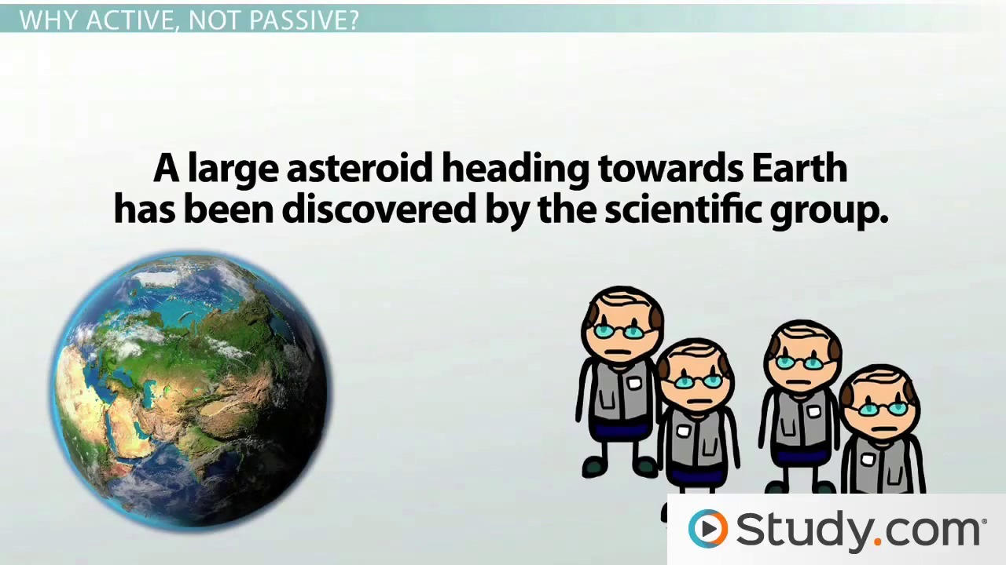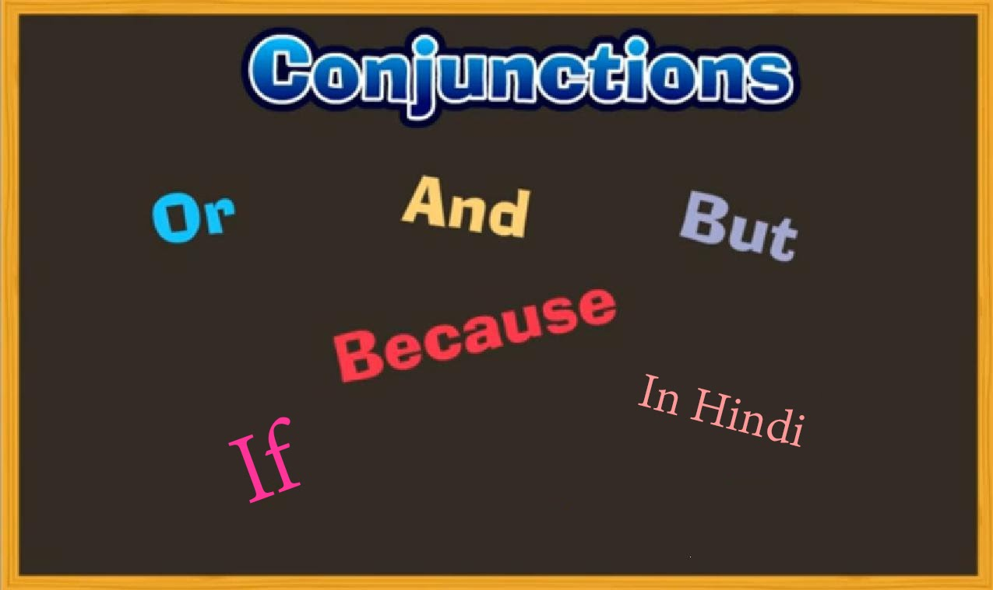

Science of Language System

* Connectors

1. AND

Ex. He is very confident and intelligent.

Ex. Please move all the chairs and tables.

Ex. She will come and meet me at the school.

Ex. My friends and I will be back in an hour.

1. Also

Ex. He discussed the topic, also he shared his understanding.

Ex. He passed his exams, also he become a trainee.

Ex. The new students can speak Malay, also they can speak English.

1. But – Want to but…….

Ex. I studied hard, but couldn’t pass the exam.

Ex. I tried to talk to her, but she refused.

Ex. I went there, but he had left.

Ex. They asked for money, but I can’t fluently English.

Ex. It is very difficult, but I will finish it.

Ex. I don’t care about your feelings, but I do care about your future.

Ex. I want to sing a song, but I am too shy.

Ex. I want to watch a movie, but I feel sleepy.

Ex. He is very kind, but has no belief in himself.

Ex. I want to learn English, but I am too lazy.

1. Because – Reason

Ex. I don’t want to share my ideas in the class, because I am too shy.

Ex. I go to church because I believe in God.

Ex. He learnt English very fast because he was serious.

Ex. I don’t like you because you are very lazy.

Ex. She cannot study properly because she is sick.

Ex. They laughed at me because I looked very funny.

* As

Ex. We had a black- out, as we were watching a movie.

Ex. It started to rain, as we arrived home.

Ex. My teach put on some music, as I was counting beans.

Ex. SOK came and said hello, as we were talking about the trip.

* While

Ex. He studied hard while he was a student.

Ex. I went to the beach, while I was in DILI.

Ex. I felt nervous, while sharing my understanding.

Ex. The law was very strict while MERCY was in charge.

* Since

Ex. I will help you since I am free.

Ex. Please don’t call her, since she is talking exams.

Ex. You can join the class, since you are here early.

Ex. We should keep quiet, since they are in a meeting.

Ex. Can we take a bath since we have finished our work?

* Continuation of a story
* That = (what?)

Ex. I did not realize that we had to pay by the 7th of January.

Ex. They said that SOLS is a fantastic school.

Ex. I heard that you got married.

Ex. I did not know that my friend got married.

Ex. I saw that she was beautiful.

* To = (why?)

Ex. I bought this book, to improve my English.

Ex. I talked to her, to ask her to reconsider her decision.

Ex. I come here to visit my friends.

Ex. I bought this watch to wake up on time.

Ex. We called the police to solve the problem.

* In order to (=why?)

Ex. I bought this book, in order to improve my English.

Ex.