

Version 1. 11/10/2023
Emilio J. Juarez-Perez, ejjuarezperez@unizar.es

Table of Contents
Schematic 2
Bill of Materials 3
Perovskino Shield 2209EJJP 4
Perovskino Shield 2304EJJP 5
Perovskino Perfboard Implementation 6
LSH-7320 Oriel Solar Simulatorn 7
Figures 8

Schematic
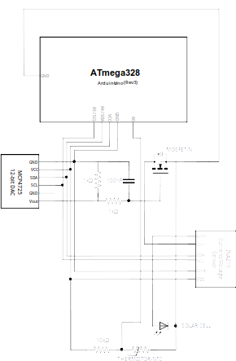

Bill of Materials
Amount | Part Type | Properties
1 | ATmega328 | Atmel microchip as found in Arduino UNO (Rev3) or equivalent
1 | MCP4725 12-bit DAC | chip label MCP4725 Breakout; editable pin labels false; variant variant 2; pins 6
1 | INA219 DC Current Sensor Breakout | variant variant 5
1 | Basic FET N-Channel | package TO220 [THT]; type n-channel, IRLZ34N, IRLI540N
1 | Ceramic Capacitor | voltage 6.3V; capacitance 100nF; package 100 mil [THT, multilayer]
2 | 1kΩ Resistor | bands 4; tolerance ±5%; package THT; resistance 1kΩ; pin spacing 400 mil
1 | 10kΩ Resistor | bands 4; tolerance ±5%; package THT; resistance 10kΩ; pin spacing 400 mil
1 | Temperature Sensor (Thermistor) | resistance at 25° 10kΩ; package THT; type thermistor; thermistor type NTC
2 | Screw terminal - 2 pins | pin spacing 0.197in (5.0mm); hole size 1.0mm,0.508mm; package THT; pins 2

Perovskino Shield 2209EJJP
https://aisler.net/p/VEECBBJB

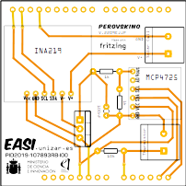

Perovskino Shield 2304EJJP
https://aisler.net/p/SDRQAOGS
Update of the shield to accommodate various commercially available versions of MCP4725:
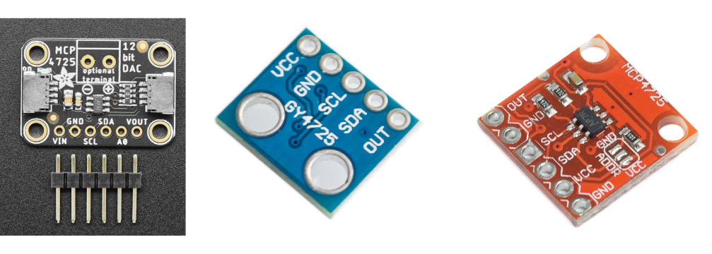
If employing the 5-pin Adafruit pin configuration, solder the pad connecting VGATE and pin 5.

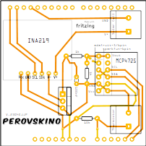

Perovskino Perfboard Implementation

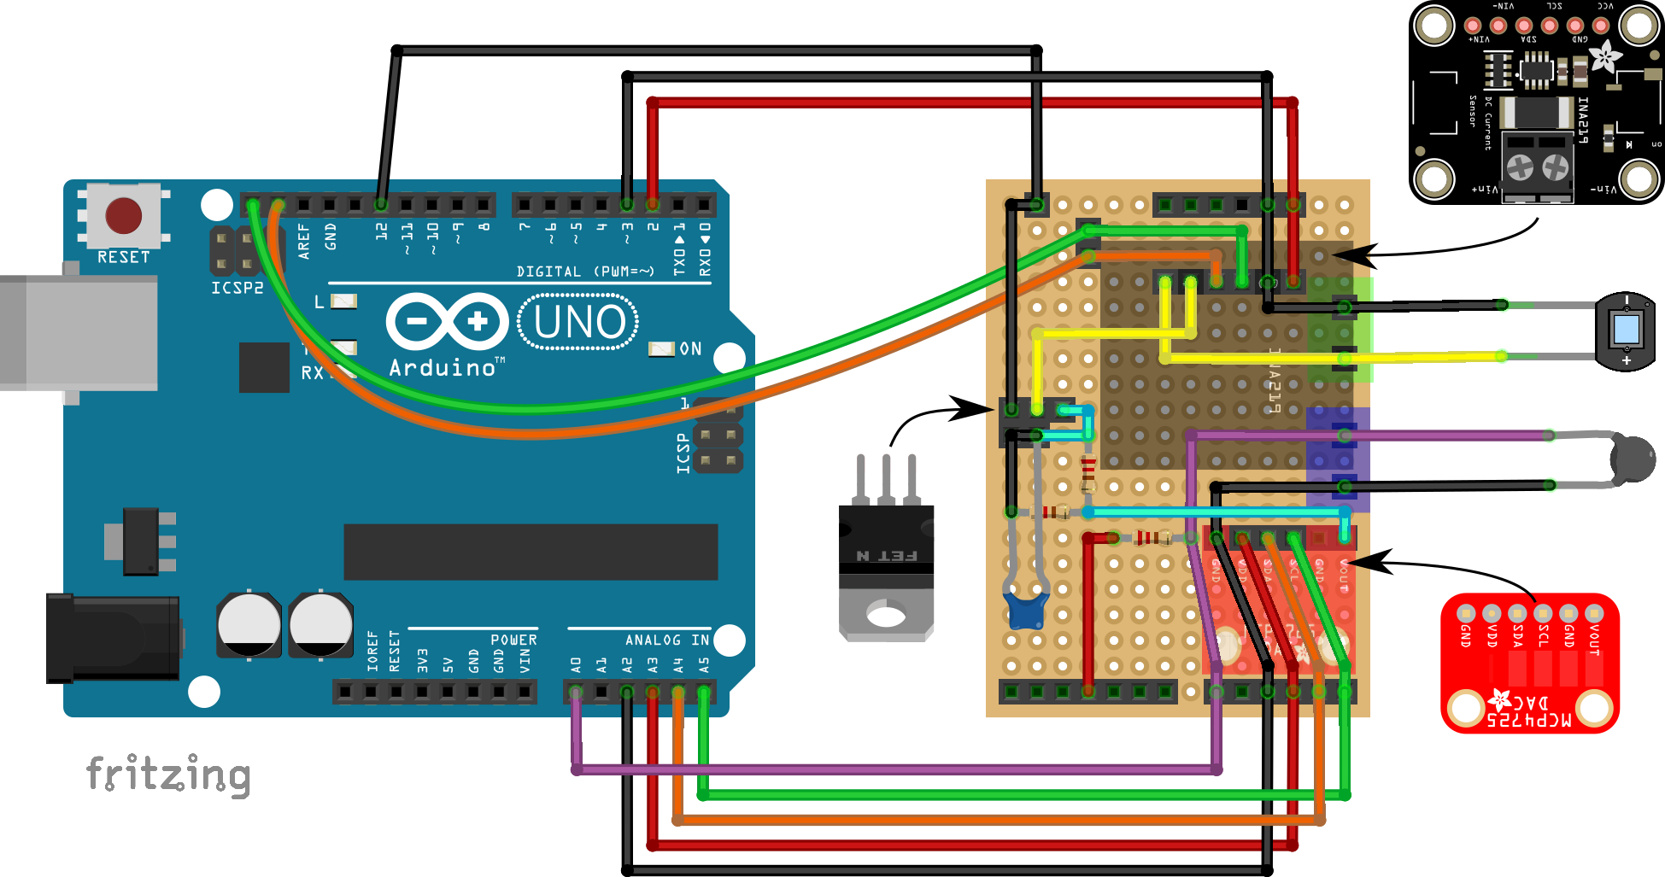

LSH-7320 Oriel Solar Simulator
For inquiries regarding a program to conduct EN50530 illumination cycle tests in the LSH-7320 LED-based Oriel Solar Simulator, please contact ejjuarezperez@unizar.es

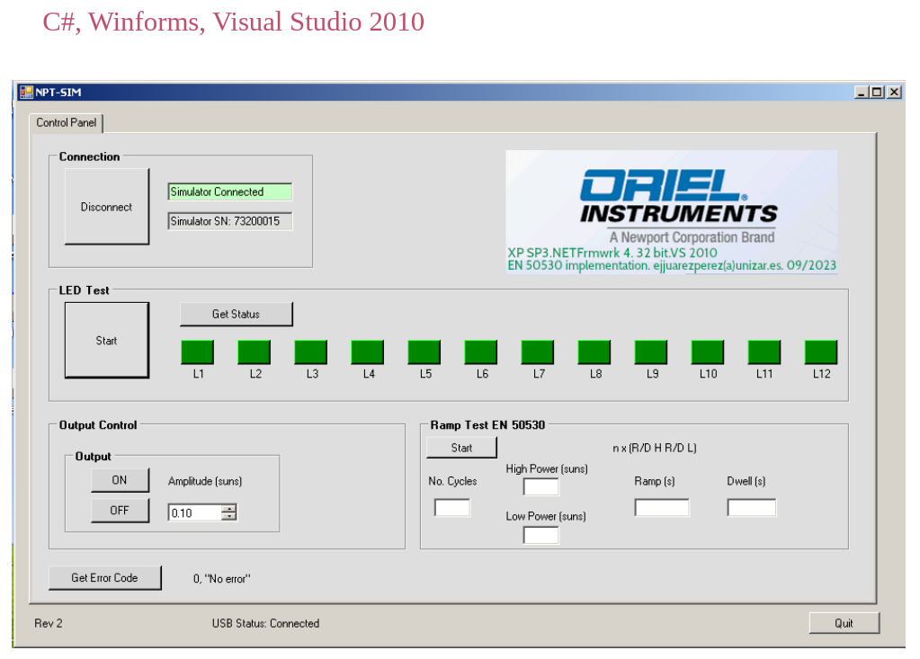

Figures
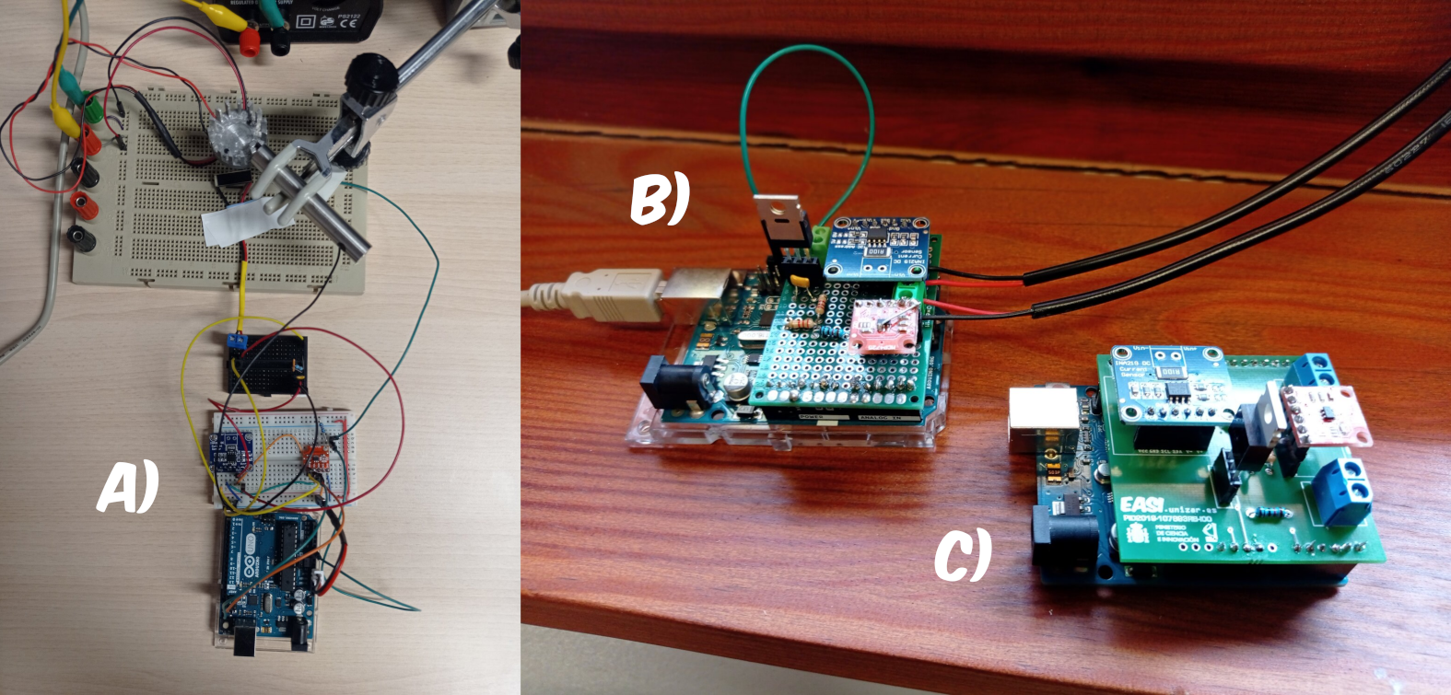
Figure: a) bread-, b) perf- and c) printed circuit- board (PCB) implementations of the perovskino shield.

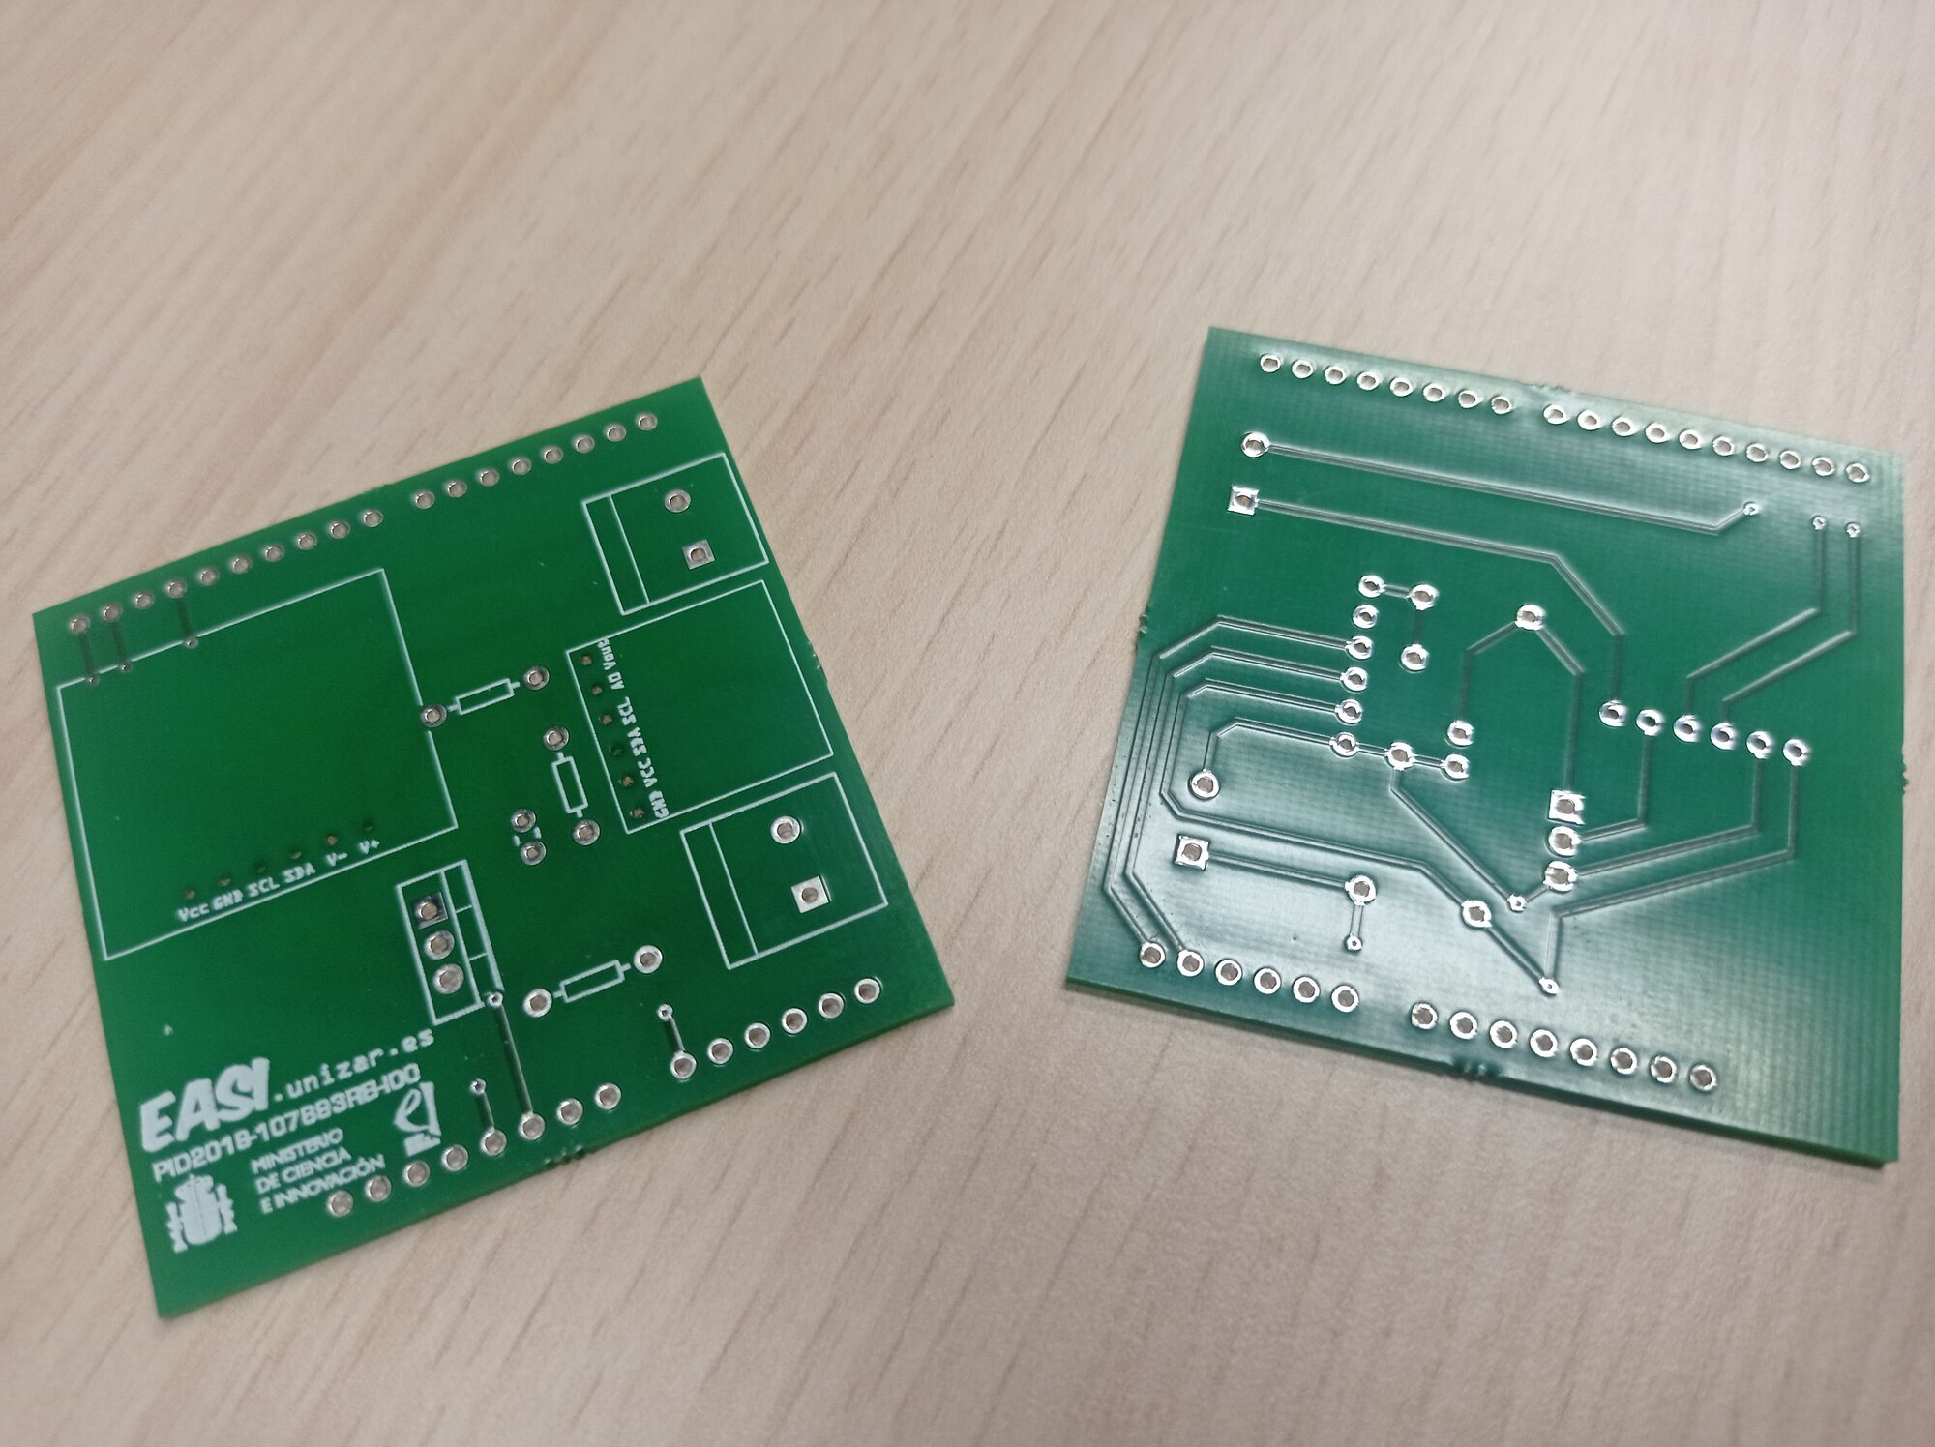
Figure: front and back of the perovskino shield (early version 0).

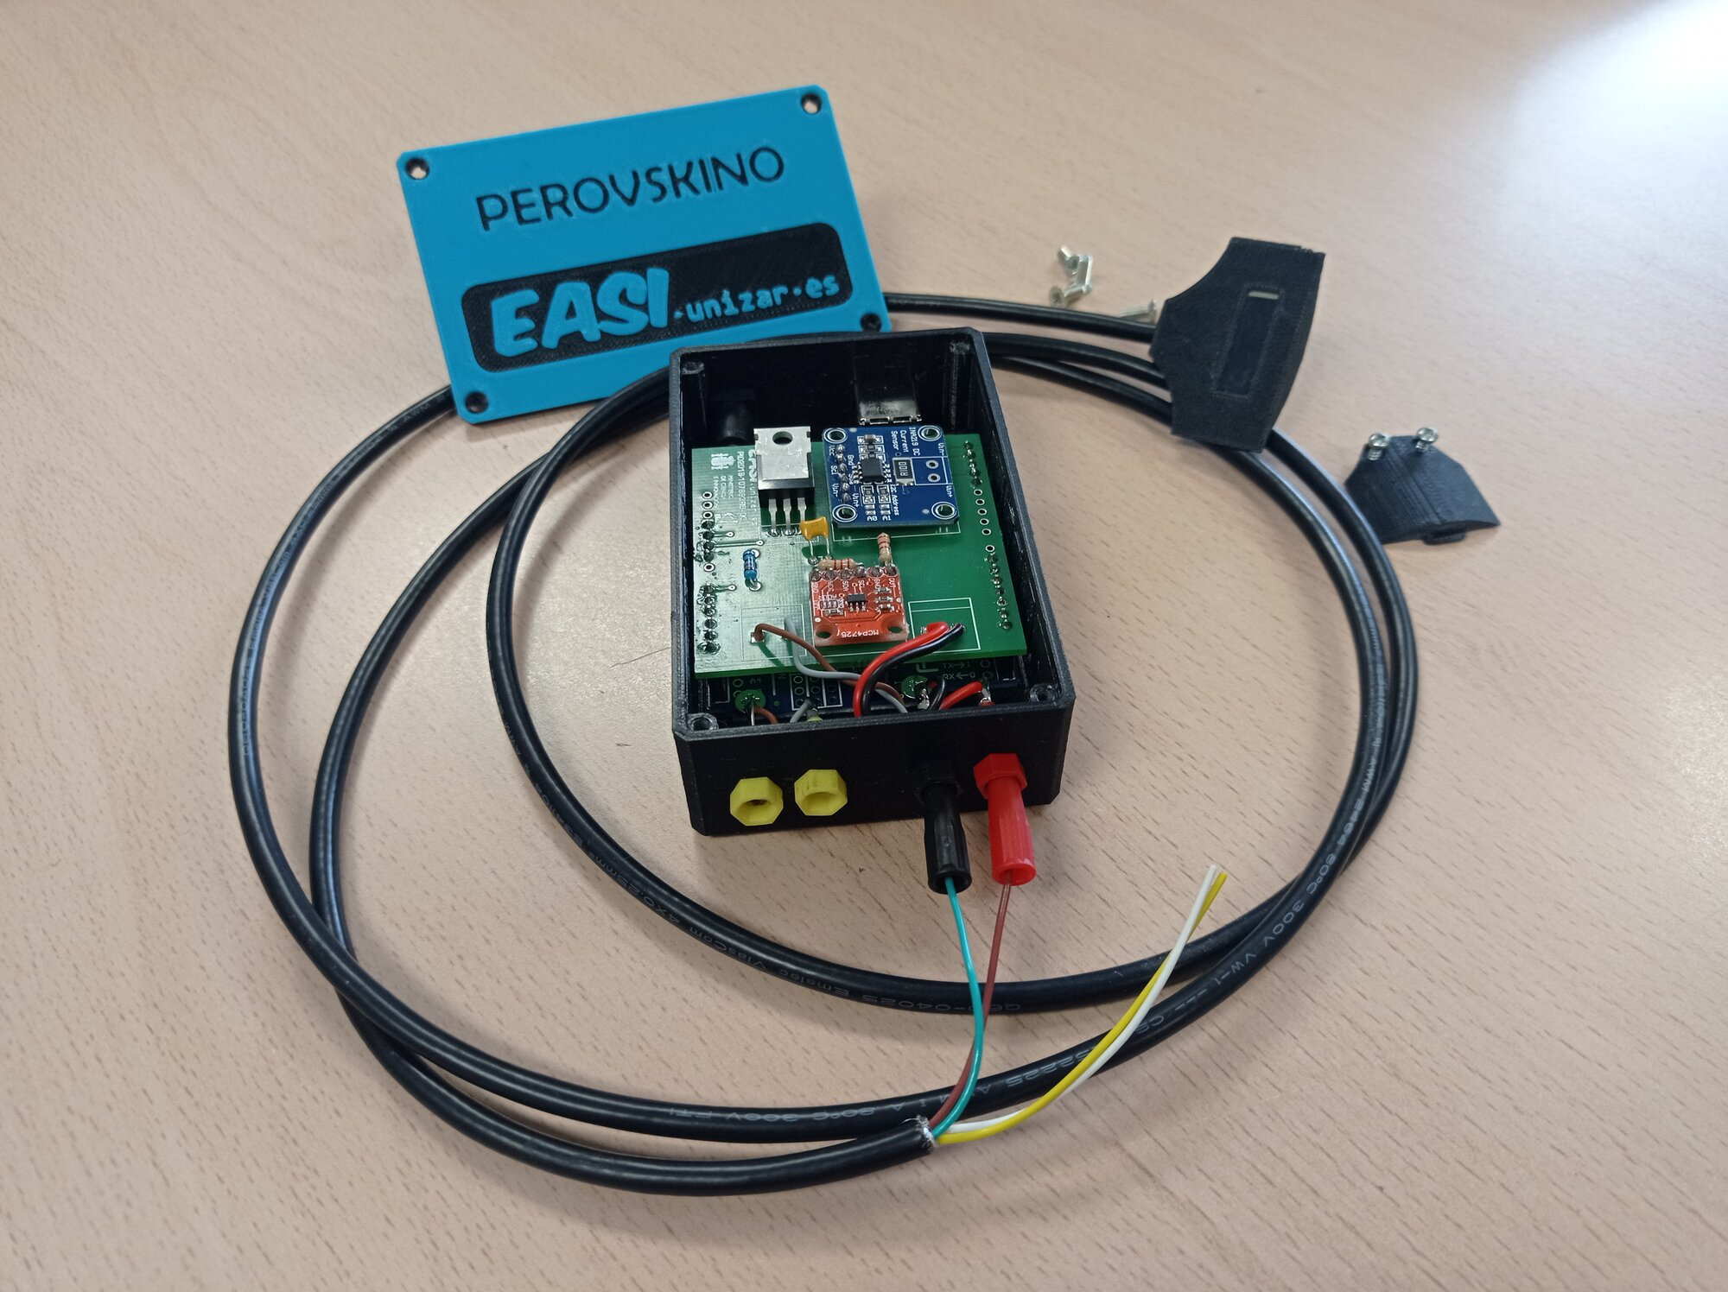
Figure: printed box with banana plugs for the Arduino + Perovskino shield.

