Steps to Install Safe Neighborhood application

1. Open Tomcat in the browser

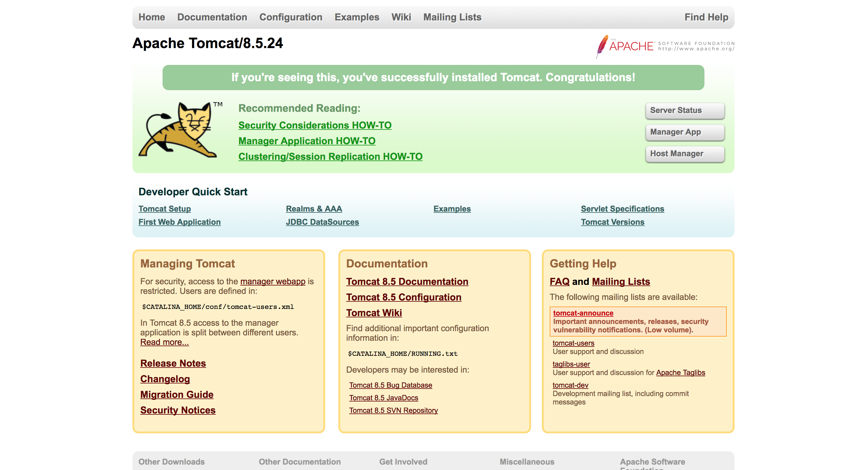

1. Select Manager App, you need to set manager permissions in your Tomcat User settings before doing this.

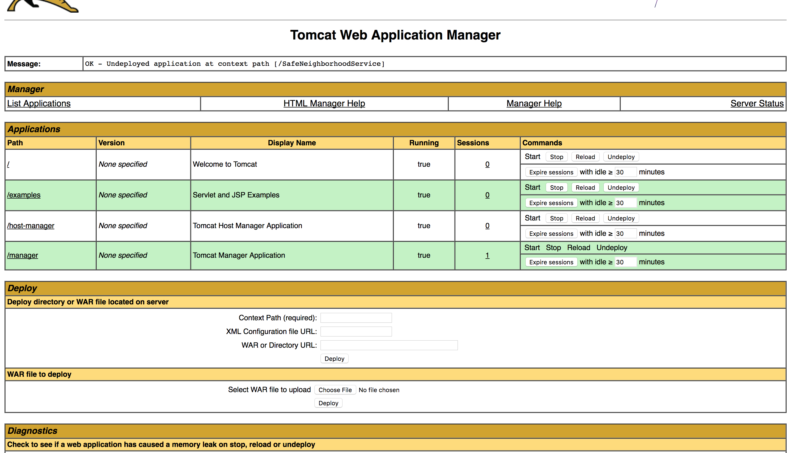

1. Under WAR file to deploy, select the war file from / [Wherever you cloned] /SafeNeighborhood/SafeNeighborhoodService/target/SafeNeighborhoodService.war
2. After this step, you should be able to see your applications under the Applications listing.

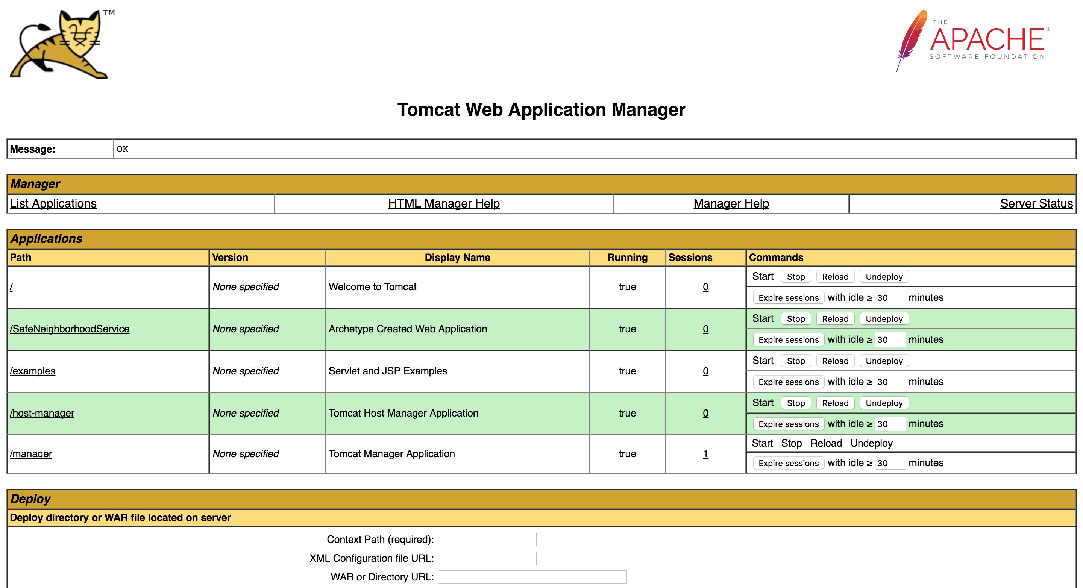

1. The app has been deployed in Tomcat Successfully, You should be able to click on the app link /SafeNeighborhoodService and the app should be running.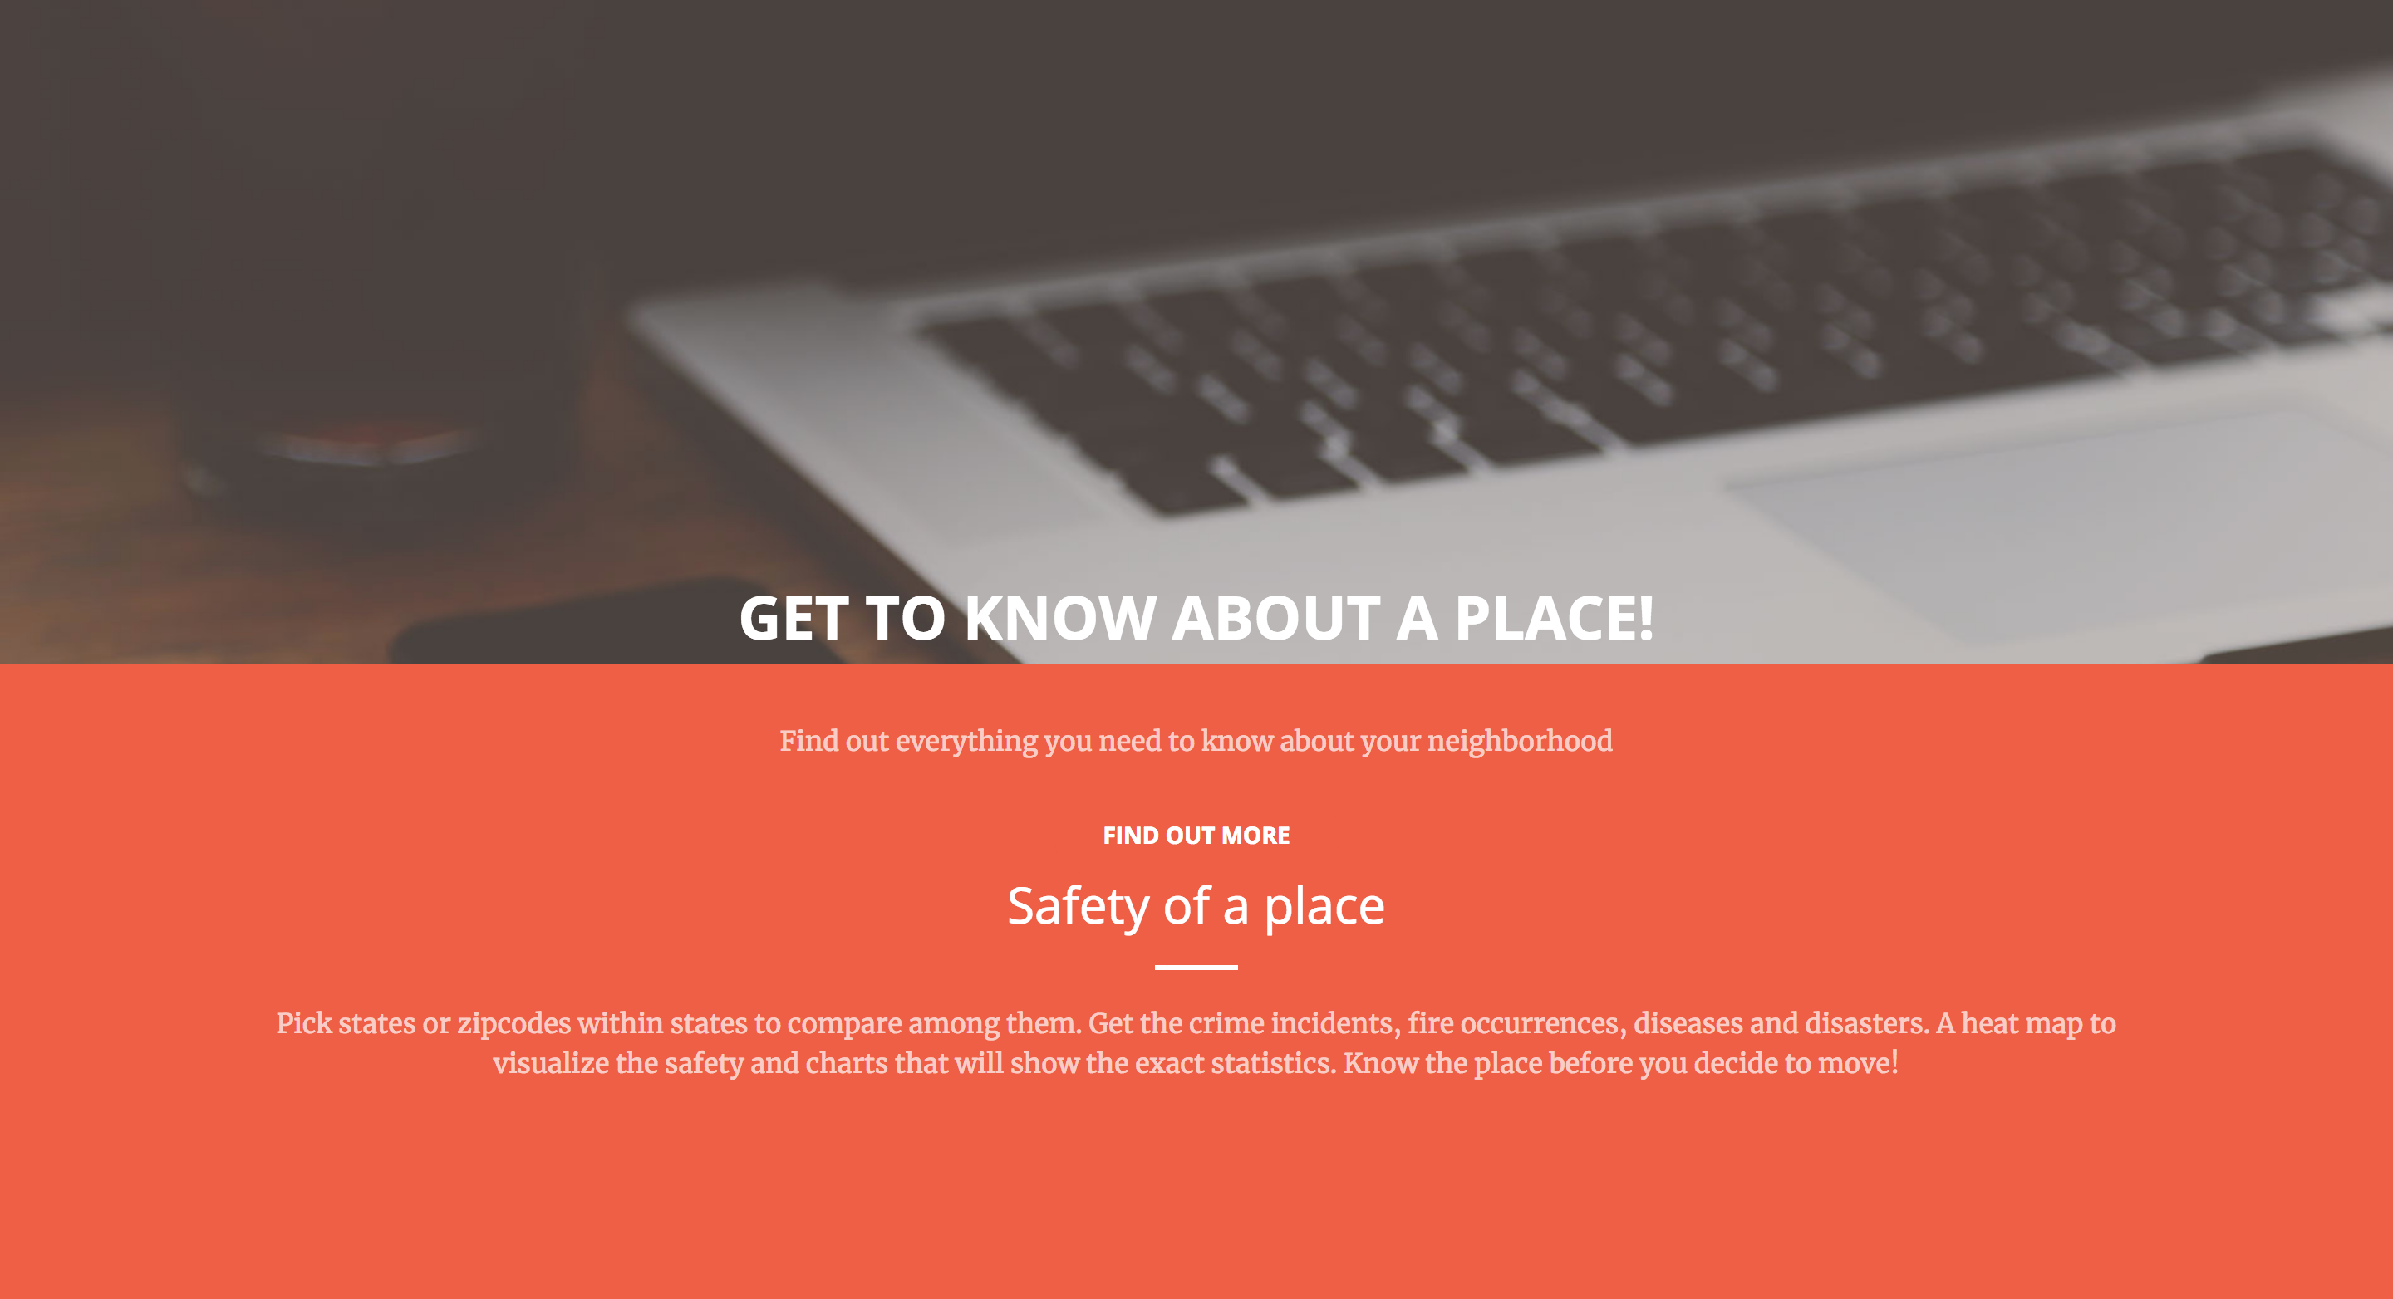

NOTE: For the app to work properly, please Install Apache Fuseki 2.0.0,   
from the fuseki folder in the terminal start the server using the following commands,

* mkdir ./DB
* ./fuseki-server --update --loc=DB /ds

Visit the fuseki server at localhost:3030/ and upload the datafiles in the dataset,

The datafiles are available in Google Drive at <https://drive.google.com/drive/folders/1YT-oPVxgckaIvmUk2d1Yc467sOWqQjtb?usp=sharing>