# 1DV607 Workshop2, Class description

Starting point, creates a control object and call start() in that object.

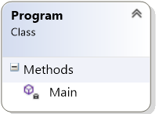

Start() call menu.mainMenu() and run/loop until user ends the program. All other methods are reactions to the main activity the user selects in the mainMenu.

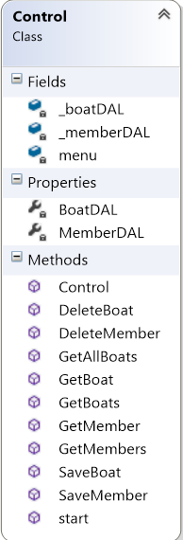

Control object call methods in Menu witch in turn call methods in either MemberMenu or BoatMenu.

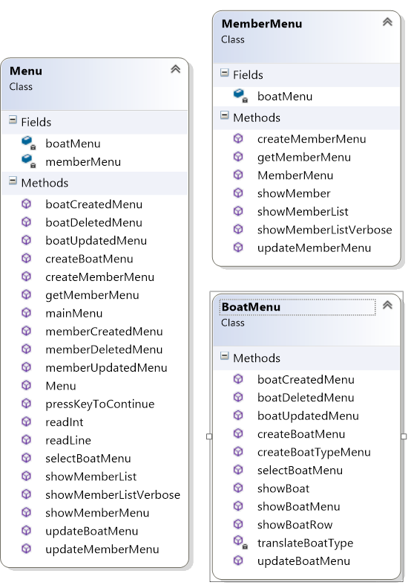

Buissiness model classes. Defined to match representation in the database. Objects are passed from the Control to view and model.

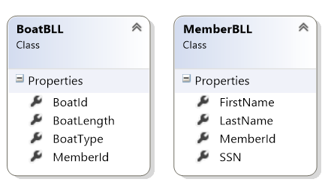

Control object call methods in BoatDAL and MemberDAL to communicate with the MSSQL server. BaseDAL is called to create a connection.

