# Test cases for The 15 puzzle

# Test case 1.1, Navigate to Page

### Input

* Navigate to site with an incognito window

### Output

* The text “Enter your name and start a Game!” is shown
* A form for starting a game is shown

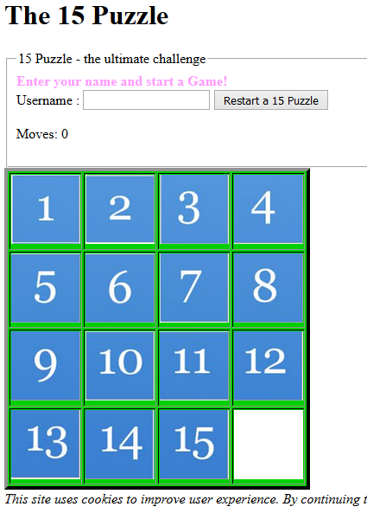

# Test case 1.2, Failed starting a game without user name

### Input

* Test case 1.1
* The user clicks the “Restart a 15 puzzle” button

### Output

* The text “You must enter a name” is shown
* A form for starting a game is shown

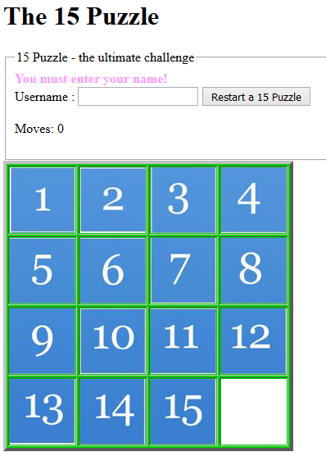

# Test case 1.3, Successful start of a game

### Input

* Test case 1.1
* The user enters a name and clicks the “Restart a 15 puzzle” button

### Output

* The text “Click the number you want to move to the empty slot!” is shown
* A form for restarting a game is shown
* The game table has been shuffled with numbers

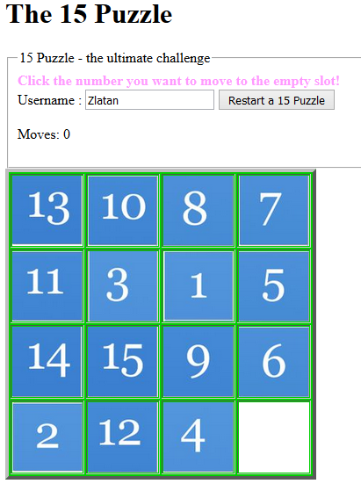

# Test case 1.4, Failed attempt to move a number

### Input

* Test case 1.3
* The user click a number not next to the empty slot

### Output

* The text “You can only move a number directly neighbouring the empty cell” is shown
* A form for restarting a game is shown
* The game table numbers are unchanged

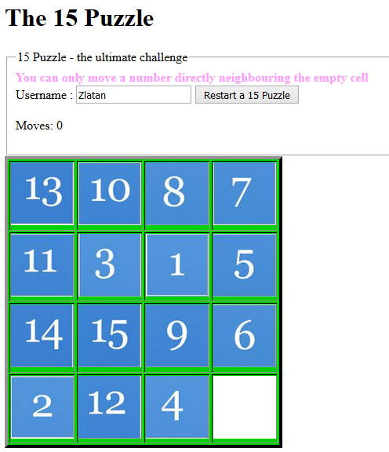

# Test case 1.5, Successful attempt to move a number

### Input

* Test case 1.3
* The user click a number next to the empty slot

### Output

* The text “Click one of the numbers directly neighbouring the empty cell” is shown
* A form for restarting a game is shown
* The number clicked changed place with the empty slot
* The text “Moves” is updated

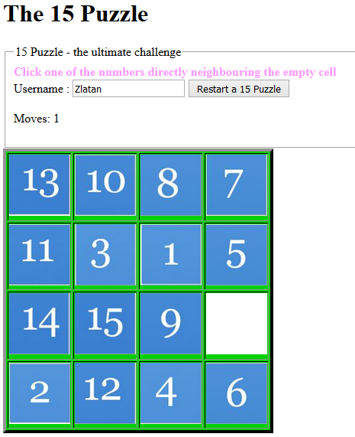

# Test case 1.6, Reload page using F5

### Input

* Test case 1.5
* The user press key F5

### Output

* A form for restarting a game is shown
* The information text may change
* The game table numbers are unchanged
* The text “Moves” is not updated

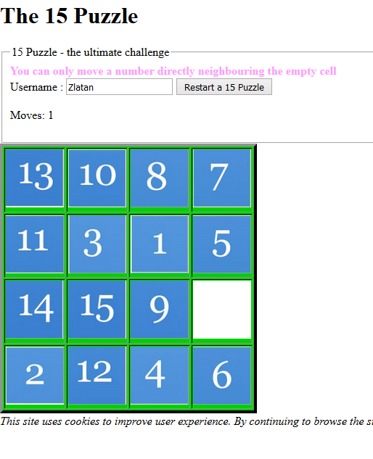

# Test case 1.7, Reload page entering start page in browser address field

### Input

* Test case 1.5
* Enter the start address in the browser address field

### Output

* A form for restarting a game is shown
* The information text may change
* The game table numbers are unchanged
* The text “Moves” is not updated

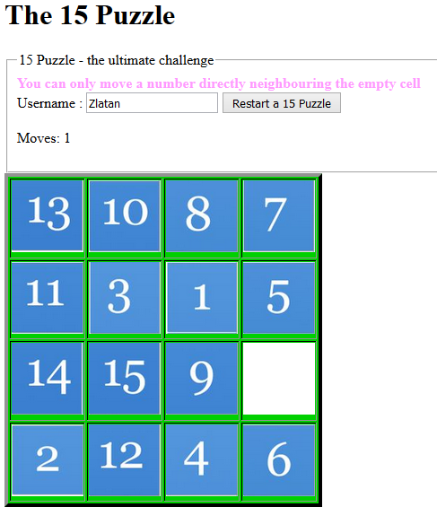

# Test case 1.8, Successful solving the puzzle

### Input

* Test case 1.5
* Iterate > The user click a number next to the empty slot

### Output

* A form for restarting a game is shown
* The text “Congratulation, you solved the puzzle” is shown
* Moves required to solve the puzzle is shown

