

Individual Leadership Development Plan

EGS 4038/6039 - Engineering Leadership

Spring 2019 Semester

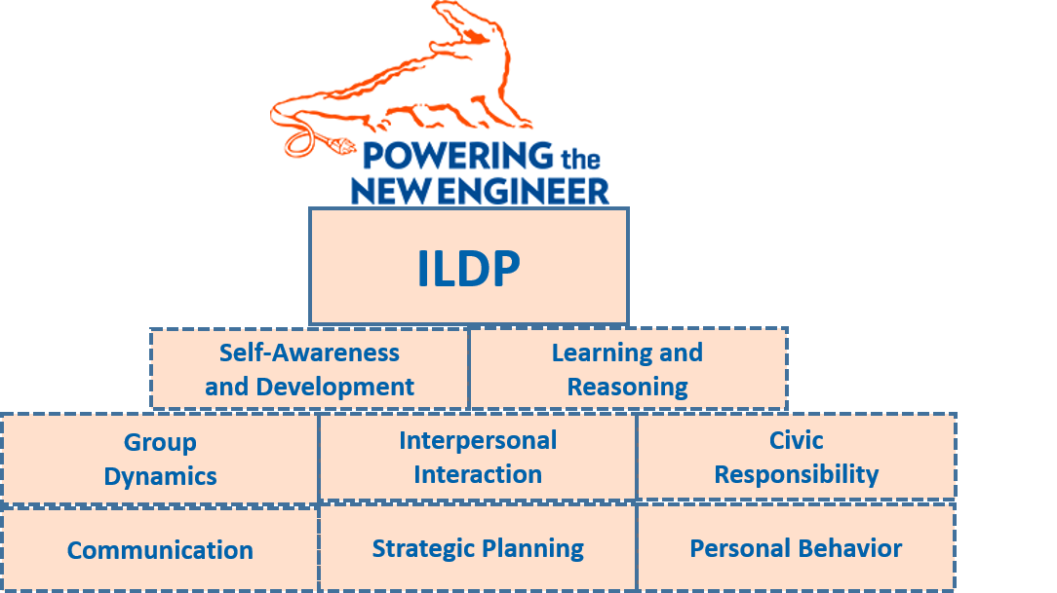

EESH KANT JOSHI



Leadership Experience Description and Initial Self-Assessment of SLCs and Core Values

Describe the leadership experience that you will be completing in terms of the context of the leadership opportunity and the people and issues involved.
I am working in a team of four for my database project this semester. I am from the northern part of India and my other team members are from the southern part of India. In addition, we have different job experiences and educational backgrounds. Therefore, we are a culturally and academically diverse group. In the first meeting, we had a debate over which programming language we should use for our project. We were not able to reach a conclusion. I took the initiative of making a table of pros and cons of all the programming languages. After this, we choose Java as our programming language in unison. I expect more such discussions/conflicts in the future because, in software development, there is no single correct way to implement a thing. So, we would be considering multiple approaches and viewpoints to solve the issues we face.

List your top strengths as identified by the Clifton Strengths Assessment and the VIA character strengths assessments. (Add or delete rows in the table as needed.)

Assessment Approach | Strengths
Clifton StrengthsAssessment | Restorative
Clifton StrengthsAssessment | Futuristic
Clifton StrengthsAssessment | Discipline
Clifton StrengthsAssessment | Analytical
Clifton StrengthsAssessment | Competition
VIA Character Strengths | Humor
VIA Character Strengths | Hope
VIA Character Strengths | Social intelligence
VIA Character Strengths | Spirituality
VIA Character Strengths | Judgment
VIA Character Strengths | Creativity
VIA Character Strengths | Bravery
VIA Character Strengths | Love
VIA Character Strengths | Curiosity

Consider your top strengths with respect to the Student Leadership Competencies (SLCs) outlined in the ILDP Framework document (Appendix A). Identify the Top 5 SLCs that you will be working on during the experience and list them, with a rationale for their selection, in the table below:

Top 5 SLCs | Rationale for Selection
collaboration | Effective collaboration provides every team member with equal opportunities to participate and a good leader always encourages collaboration.
verbal communication | Effective communication causes productivity to increase, errors to decrease and operations to run smoother. It is also essential is a normal life.
initiative | An initiative is important because it results in improvements in the product/service that we are delivering.
positive attitude | A positive attitude brings optimism to life and makes it easier to avoid worries and negative thinking. It also brings constructive changes.
responding to change | Being adaptable means working without boundaries, and being open to finding diverse and unexpected solutions to problems and challenges.

Next, think about and provide a frank assessment of your current capabilities with respect to each of your target SLCs. Place an “x” in the column that reflects the ratings of your current capabilities with respect to understanding, valuing and applying the SLCs. Provide a brief explanation of why the ratings were selected.

Target  SLCs | Rating of Current Capabilities |  |  |  |  | Explanation of Selected SLCs and Ratings
Target  SLCs | 1 (low) | 2 | 3 | 4 | 5 (high) | Explanation of Selected SLCs and Ratings
collaboration |  |  |  | x |  | I am good at collaboration but sometimes I find it difficult to include everyone in a particular thing as they have a contradicting point of views.
verbal communication |  |  | x |  |  | I communicate effectively in small audiences. But, I become nervous while communicating with large audiences.
initiative |  |  |  | x |  | Whenever I find something is not up to the mark, I am the first one to point it out and rectify. But, sometimes I feel I become nitpicky.
positive attitude |  |  | x |  |  | I am that person in the group to whom others look for encouragement. But, when I am facing a lot of problems at the same time, I tend to lose my positive attitude.
responding to change |  |  | x |  |  | I like positive changes but when the changes are negative I lose my confidence.

Identify up to 5 core values that you believe define who you are as an individual and an emerging engineering leader. Briefly discuss how you intend on translating these to your semester leadership experience as well as your engineering leadership career.

Core Values | Discussions
Commitment | I will be committed to the project tasks that are assigned to me and will keep on doing them until they are of acceptable quality.
Efficiency | I will continuously think of ways to make my project more efficient so that it handles more complexity but is still easy to use.
Thoughtful | While working on the project, I will be thoughtful about other member’s point of view and will make them all feel part of the project.
Ethics | At every point when I am making a decision, I would see if it is ethical or not.
Open-mindedness | I will be more open-minded about other’s suggestions and would create an environment that is welcoming for new ideas.

Specific Assessment of SLCs During Leadership Experience

Describe the situation(s) that provided the opportunity to apply the SLCs during the experience.

Target Top 5 SLCs | Descriptions
collaboration | I was working on my DBMS project with three more people. Each of us had different ideas for the common problems in our project and sometimes it became difficult which idea to pick as the solution.
verbal communication | I had to record a video of our group’s presentation for my Engineering Leadership class.
initiative | For the group assignments in Engineering Leadership class, we had to work in a team of four people and had to submit the assignments collectively.
positive attitude | I had to give online quizzes for the Engineering leadership class.
responding to change | In the Engineering Leadership class, we had to do individual assignments until the professor introduced group assignments.

Describe the key issues and outcomes from applying the SLCs to the situation(s).

Target Top 5 SLCs | Descriptions
collaboration | Different people mean different perspectives, which can lead to conflict. In order to collaborate effectively, I came up with the idea that no member will criticize another member’s idea but would build on it. Due to this, ideas are shared in a non-judgmental way and we have completed our project way ahead of our deadline.
verbal communication | I have stage fright so it was very difficult for me to face the camera. I applied the various techniques taught in the class to give effective presentations. I also applied the different persuasion techniques which made my presentation more impactful.
initiative | Nobody used to take the initiative of dividing the tasks. There were times when we started the assignments on the day of the submission. I took an initiative to discuss this openly by calling a meeting. I discussed why we should finish our assignments days before our deadlines and I used to be the first one to plan out our assignment and divide the tasks.
positive attitude | I received fewer marks for the first few quizzes I gave and my grade slipped. I felt very disheartened. But, I did not lose hope. I stayed positive and while reading the assigned reading I started making notes which I used while giving the quizzes. This helped me in scoring better marks and helped me in remaining calm in tough situations.
responding to change | As an international student, I had only worked with people from my community. It was initially difficult for me to embrace the working culture and the perspective of my team members. After our Engineering Leadership lecture, I learned how change is inevitable and how we should be ready for it. I started having meetings with my team members to understand their ideas and make them understand mine. This helped me to move out of my comfort zone and gain confidence.

Place an X in the box that most accurately indicates your level of competency development because of participating in the leadership experience.

Knowledge – My Understanding of the SLCs appropriate to the Situation:
Top 5 SLCs | did not increase | slightly increased | moderately increased | greatly increased
Collaboration |  |  | X
verbal communication |  |  |  | X
initiative |  |  | X
positive attitude |  | X
responding to change |  | X

Value - The value I place on the SLCs appropriate to the situation
Top 5 SLCs | did not increase | slightly increased | moderately increased | greatly increased
collaboration |  |  | X
verbal communication |  |  | X
initiative |  | X
positive attitude |  |  | X
responding to change |  |  | X

Ability - The skills and motivation I need to engage in the SLCs appropriate to the situation:
Top 5 SLCs | did not increase | slightly increased | moderately increased | greatly increased
collaboration |  | X
verbal communication |  | X
initiative |  |  | X
positive attitude |  |  | X
responding to change |  |  | X

If you indicated that, a SLC development did not increase or slightly increased because of participating in this experience, place an X next to the response that best explains why:

_____ I have already developed this competency to the extent it was offered through this experience.

_____ The experience did not address or minimally addressed application of this competency.

_____ The experience did address this competency but I was not engaged or involved to the extent that I could have been.

General Assessment of the Leadership Experience

Re-enter your target SLCs and pre-experience capability ratings (from the initial self-assessment form) with respect to your initial understanding, valuing and applying the SLCs. Then, based on the specific assessment form results for each SLC, place an “x” in the column that critically rates your post-experience capabilities with respect to understanding, valuing and applying the SLCs. Provide a comparative assessment of the pre-and-post ratings for the target SLCs.

Target Top 5  SLCs | Assessment Period |  | Rating of Capabilities |  |  |  |  | Comparative Assessment of Ratings
Target Top 5  SLCs | Pre | Post | 1 (low) | 2 | 3 | 4 | 5 (high) | Comparative Assessment of Ratings
collaboration | √ |  |  |  |  | x |  | By working on the group assignments, I became a more collaborative person and became comfortable in working in teams.
collaboration |  | √ |  |  |  |  | x
verbal communication | √ |  |  |  | x |  |  | My communications skills improved a lot when I did the group presentation. I gained skills on how to impact the audience which in turn made me more confident.
verbal communication |  | √ |  |  |  |  | x
initiative | √ |  |  |  |  | x |  | When nobody in my team wanted to initiate things, I came forward and managed the whole team assignment on my own. It gave men the opportunity to lead.
initiative |  | √ |  |  |  |  | x
positive attitude | √ |  |  |  | x |  |  | Listening to the experiences of the speakers in the class, I developed a positive attitude in dealing with problems. Hearing them, I realized I am not the only one with complex career problems.
positive attitude |  | √ |  |  |  | x
responding to change | √ |  |  |  | x |  |  | This whole semester all of my courses repeatedly brought me out of my comfort zone. This, in turn, helped me to stay calm in situateons which were different from what I had expected.
responding to change |  | √ |  |  |  | x

Briefly discuss specifically what you will do to further build on your Top 5 SLCs as you proceed in engineering leadership experiences.

Target Top 5 SLCs | Development Actions
collaboration | I would take part in lots of group assignments in the next semester. I will also start volunteering so that I can meet many people which will give me more chance to collaborate with people and gain a wide perspective.
verbal communication | I will enthusiastically take part in class discussions and will never shy away from speaking out loud in the class. In order to improve verbal communication, I would start conversing with random strangers in order to reduce my shyness. I will be joining Toastmasters club in the summer also.
initiative | I will always stay excited about my work which will help me in fearlessly taking initiatives. I will take part in organizing events at my workplace which will give me ample opportunities to take initiatives in things outside of my work.
positive attitude | I will read motivating self-help books every day. Even if I am very busy, I will still read at least one page from these books. I will keep myself away from negative people and would spread positivity as much as I can.
responding to change | I will be mentally prepared for sudden changes. I will look out ways to embrace the change rather than complaining about the change. When in doubt, I will seek help from others in order to get better ideas on how to cope up with change.

Discuss your most significant leadership learning and development outcomes associated with this semester experience. Explain how has your self-awareness changed with respect to leadership?
My most significant leadership learning was when I had to prepare a video for the group presentation. I was very scared to go in front of the camera. On the first attempt, my hands were cold and my legs were shaking. I knew I had stage fright and I was very persistent in removing it. So, I practiced in front of the mirror. I also tried to apply all of the persuasion and presentations techniques taught in the class. For that, I revised my class notes and browser the internet on how to make effective presentations. In the 10th try, I delivered my part impeccably. My teammates told me that I did a great job. I felt very happy and confident. But, the thing with stage fright is that it returns. So, to keep it at bay, I will keep practicing and giving presentions. My awareness of my body language has changed a lot. I now know what effect body language has on the audience and I know how to successfully manipulate my body language to become more confident while giving presentations. Due to the Engineering Leadership class, I know how to genuinely become a good leader who is good at making tough decisions and can face the crown with the utmost ease. Reading the NYT articles helped in getting various experiences from industry leaders which taught me how to mold myself to become more like them. During the class, I had always made a habit to speak and contribute to the discussions which the professor initiated. This encouraged me to take initiatives even if I am new to the topic. In a nutshell, this class helped me in becoming a more confident person.

Reflect on and briefly summarize why you want to become a better engineering leader, how you will go about becoming one, and what you need to do to become one.

Questions | Summary
Why? | As I grow my experience in the software industry, I would become the team leader. I want to become a better engineering leader because I love the technology domain and I like to bring different ideas together to solve a problem. Being a good leader will help me in doing it effectively.
How? | For being a better engineering leader I will practice active listening. I will give opportunities to my subordinates and would refrain from micromanagement. I would hone my communication skills so that I can create a big impact on my audience.
What? | I need to network with leaders in the tech industry. This will help me in getting insights on how a successful leader looks like. I can get valuable advice on how to handle tough situations and how to build team spirit. The CEOs/CTOs of the startups will help me in understanding how to influence the culture of a company in a positive way.

Reflect on and briefly discuss your own current leadership framework (e.g., overarching philosophy, approach, style etc.)
My current leadership framework consists of two things: Character and Teamwork.

Character development comes through the exploration of one's identity, integrity, and language of values. Developing reflection skills in order to view one's experience through multiple lens and perspectives is an important part of this dimension. The foundations of character lie in the congruence between values, beliefs, and actions.

Teamwork involves gaining the skills and experiences necessary to effectively communicate and work well with others. This dimension focuses on the development of cultural competency and an understanding of and appreciation for difference. Collaboration inspires one to actively seek diverse voices and multiple perspectives in order to identify, organize, and mobilize their community around common goals.

Write a simple, powerful phrase or statement that describes you as a future ethical engineering leader.

“Ethics is knowing the difference between what you have the right to do and what is right to do.”

