**Index:**

|  |  |  |
| --- | --- | --- |
| **Prac. No.** | **Practical** | **Date** |
| **1** | **Building APT.NET Core MVC Application.** | **15/05/2022** |
| **2** | **Building ASP.NET Core REST API.** | **22/05/2022** |
| **3** | **Working with Docker, Docker Commands, Docker Images and Containers** | **29/05/2022** |
| **4** | **Installing software packages on Docker, Working with Docker Volumes and Networks.** | **05/06/2022** |
| **5** | **Working with Docker Swarm.** | **12/06/2022** |
| **6** | **Working with Circle CI for continuous integration.** | **19/06/2022** |
| **7** | **Creating Microservice with ASP.NET Core.** | **03/06/2022** |

# 

# Practical No: 01

**Aim: Building APT.NET Core MVC Application.**

**Description:**

1. Install .Net Core Sdk (Link: <https://dotnet.microsoft.com/learn/dotnet/hello-worldtutorial/install>) 2)create folder MyMVC folder in D: drive or any other drive

− **open command prompt and perform following operations Command: to create mvc project dotnet new mvc --auth none**

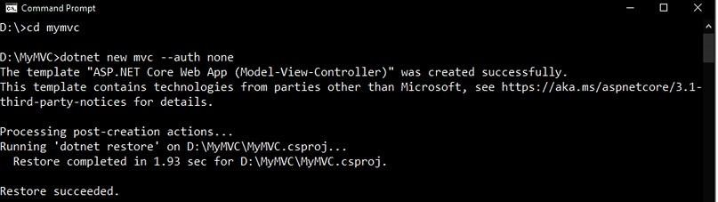

**OUTPUT:**

### − Go to controllers’ folder and modify HomeController.cs file to match following:

using System;

using System.Collections.Generic; using System.Diagnostics;

using System.Linq;

using System.Threading.Tasks; using Microsoft.AspNetCore.Mvc; using Microsoft.Extensions.Logging; using MyMVC.Models:

namespace MyMVC.Controllers

{

public class HomeController : Controller

{

public String Index()

{

return "Hello World"; }

}

}

### Run the project Now open browser and and type URL: localhost:5000

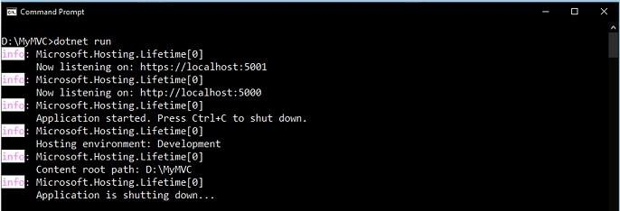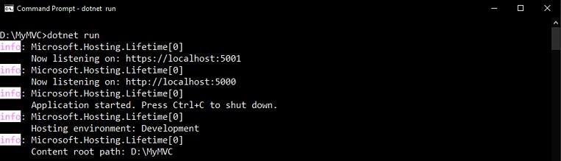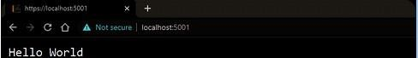

**Now go back to command prompt and stop running project using CTRL+C**

### − Go to models folder and add new file StockQuote.cs to it with following content

using System; namespace MyMVC.Models

{

public class StockQuote

{

public string Symbol {get;set;} public int Price{get;set;}

}

}

### − Now Add View to folder then home folder in it and modify index.cshtml file to match following

@{

ViewData["Title"] = "Home Page";

}

<div>

Symbol: @Model.Symbol <br/> Price: $@Model.Price <br/>

</div>

### − Now modify HomeController.cs file to match following:

using System;

using System.Collections.Generic; using System.Diagnostics;

using System.Linq;

using System.Threading.Tasks; using Microsoft.AspNetCore.Mvc; using Microsoft.Extensions.Logging; using MyMVC.Models;

namespace MyMVC.Controllers

{

public class HomeController : Controller

{

public async Task <IActionResult> Index()

{

var model= new StockQuote{ Symbol='HLLO', Price=3200}; return View(model);

}

}

}

### − Now run the project using

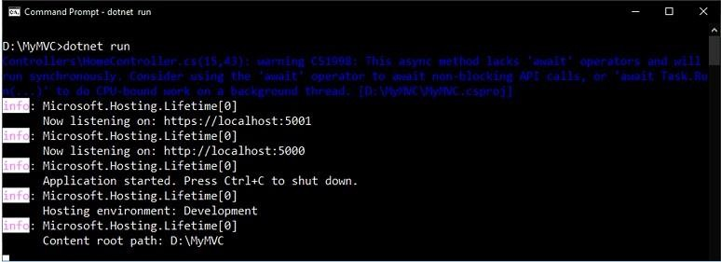

**dotnet run**

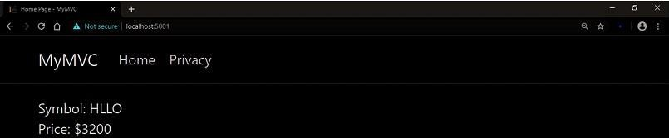

**Now go back to browser and refresh to get modified view response**

# Practical No: 2

**Aim: Building ASP.NET Core REST API.**

**Description:**

### Software requirement: Mr

* 1. **Download and install**

To start building .NET apps you just need to download and install the .NET SDK (Software Development Kit version 3.0

<https://dotnet.microsoft.com/learn/dotnet/hello-world-tutorial/install>

**Check everything installed correctly**

Once you've installed, open a new command prompt and run the following command: Command prompt

> dotnet

### Create your web API

1. **Open two command prompts**

dotnet new webapi -o Glossary

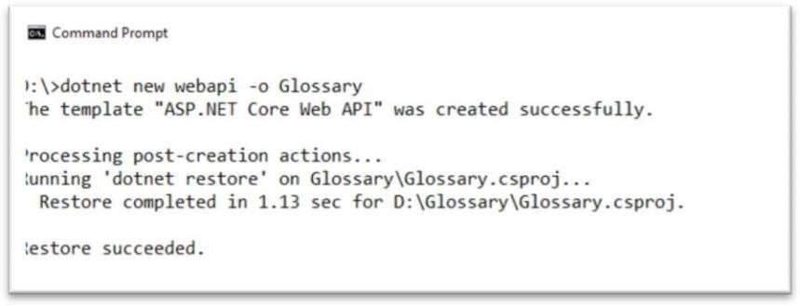OUTPUT:

Command:

Cd Glossary dotnet run

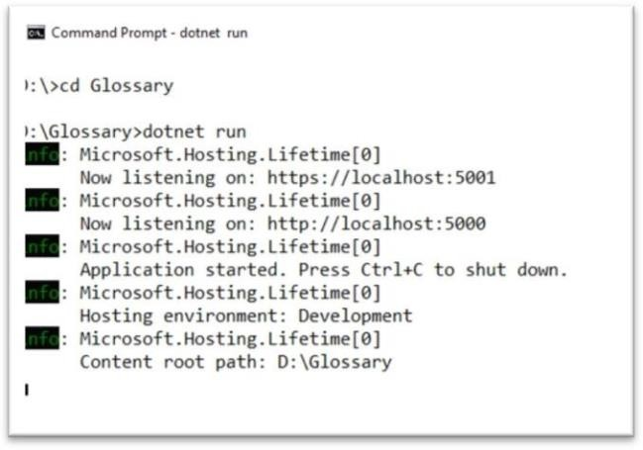

**OUTPUT:**

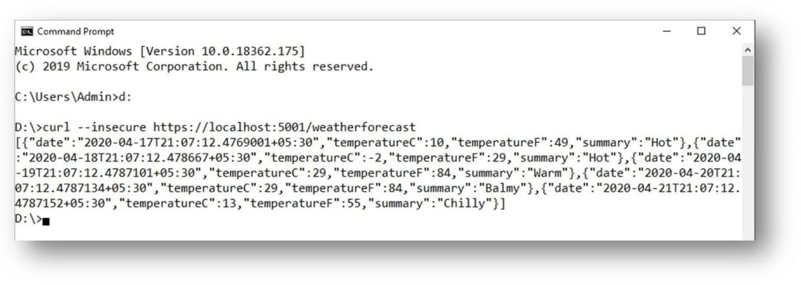**Command Prompt 2: (try running ready made weatherforecast class for testing)** Command: curl --insecure https://localhost:5001/weatherforecast

## OUTPUT:

### Now Change the content:

**To get started, remove the WeatherForecast.cs file from the root of the project and the WeatherForecastController.cs file from the Controllers folder.**

### Add Following two files

* 1. **D:\Glossary\GlossaryItem.cs (type it in notepad and save as all files)**

//GlossaryItem.cs namespace Glossary

{

public class GlossaryItem

{

public string Term { get; set;

} public string Definition { get; set; }

}

}

### D:\Glossary\Controllers\ GlossaryController.cs (type it in notepad and save as all files)

cd Glossary dotnet run //Controllers/GlossaryController.cs using System; using System.Collections.Generic;

using Microsoft.AspNetCore.Mvc; using System.IO;

namespace Glossary.Controllers

{

[ApiController] [Route("api/[controller]")]

{

private static List<GlossaryItem> Glossary

= new List<GlossaryItem> { new GlossaryItem

{

Term= "HTML",

Definition = "Hypertext Markup Language"

},

new GlossaryItem

{

Term= "MVC",

Definition = "Model View Controller"

},

new GlossaryItem

{

Term= "OpenID",

Definition = "An open standard for authentication"

}

};

[HttpGet] public ActionResult<List<GlossaryItem>> Get()

{ return Ok(Glossary);

}

[HttpDelete] [Route("{term}")] public ActionResult<GlossaryItem> Get(string term)

{

var glossaryItem = Glossary.Find(item => item.Term.Equals(term, StringComparison.InvariantCultureIgnoreCase));

if (glossaryItem == null)

{ return NotFound();

} else

{

return Ok(glossaryItem);

}

}

[HttpPost] public ActionResult Post(GlossaryItem glossaryItem)

{

var existingGlossaryItem = Glossary.Find(item => item.Term.Equals(glossaryItem.Term, StringComparison.InvariantCultureIgnoreCase));

if (existingGlossaryItem != null)

{

return Conflict("Cannot create the term because it already exists.");

}

else

{

Glossary.Add(glossaryItem);

var resourceUrl = Path.Combine(Request.Path.ToString(), Uri.EscapeUriString(glossaryItem.Term)); return Created(resourceUrl, glossaryItem);

}

}

[HttpPut] public ActionResult Put(GlossaryItem glossaryItem)

{

var existingGlossaryItem = Glossary.Find(item => item.Term.Equals(glossaryItem.Term, StringComparison.InvariantCultureIgnoreCase));

if (existingGlossaryItem == null)

{

return BadRequest("Cannot update a nont existing term.");

} else

{

existingGlossaryItem.Definition = glossaryItem.Definition; return Ok();

}}

public ActionResult Delete(string term)

{

var glossaryItem = Glossary.Find(item => item.Term.Equals(term, StringComparison.InvariantCultureIgnoreCase));

if (glossaryItem == null)

{ return NotFound();

}

else

{

Glossary.Re move(glossaryIte m); return NoContent();

}

}

}

}

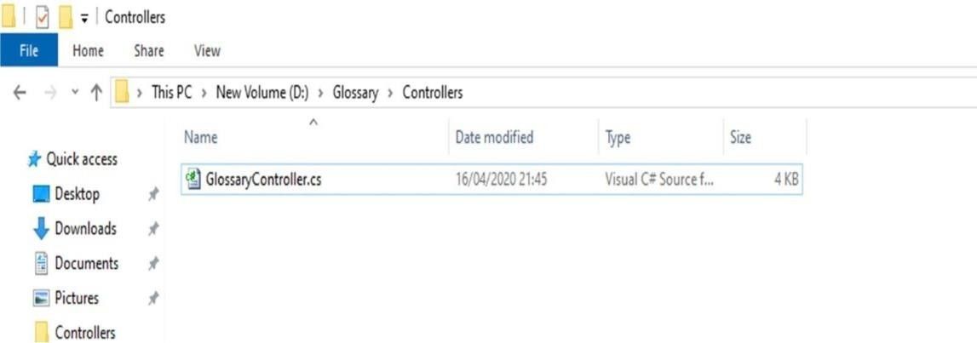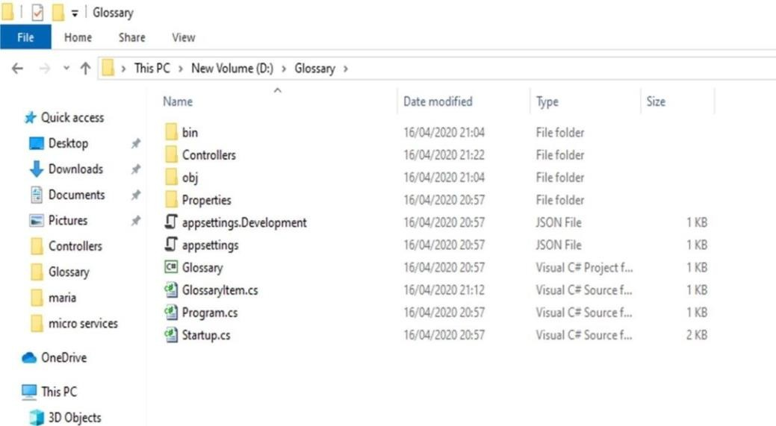OUTPUT:

### 3.Now stop running previous dotnet run on command prompt 1 using Ctrl+C. and Run it again for new code. On Command prompt1:

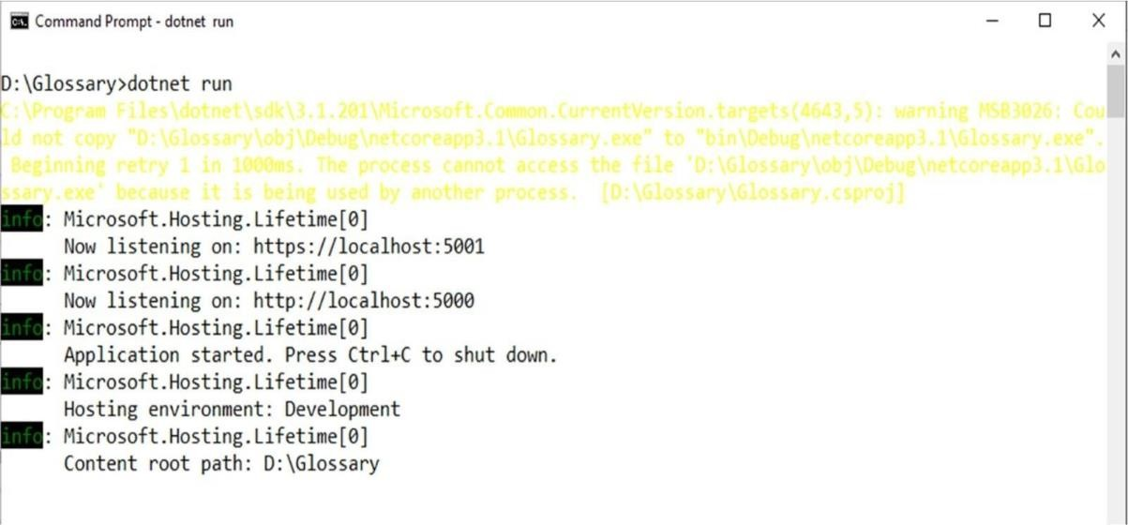Command: dotnet run

## OUTPUT:

### On Command prompt2:

1. **Getting a list of items:**

Command:

curl --insecure https://localhost:5001/api/glossary

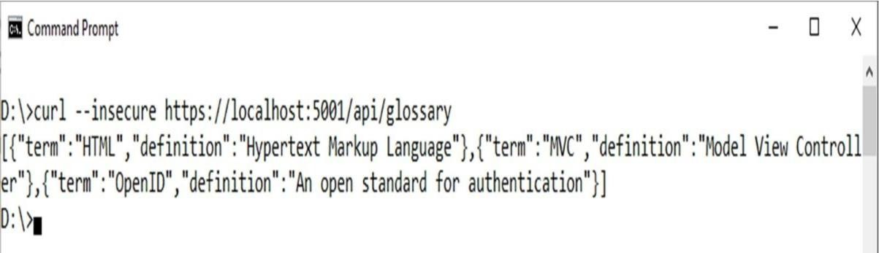

## OUTPUT:

**Getting a single item** Command:

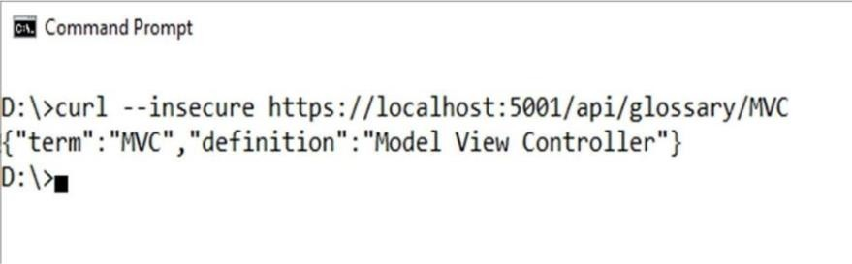curl --insecure https://localhost:5001/api/glossary/MVC

1. **Creating an item** Command:

curl --insecure -X POST -d "{\"term\": \"MFA\", \"definition\":\"An authentication process.\"}" -H "Content- Type:application/json" https://localhost:5001/api/glossary

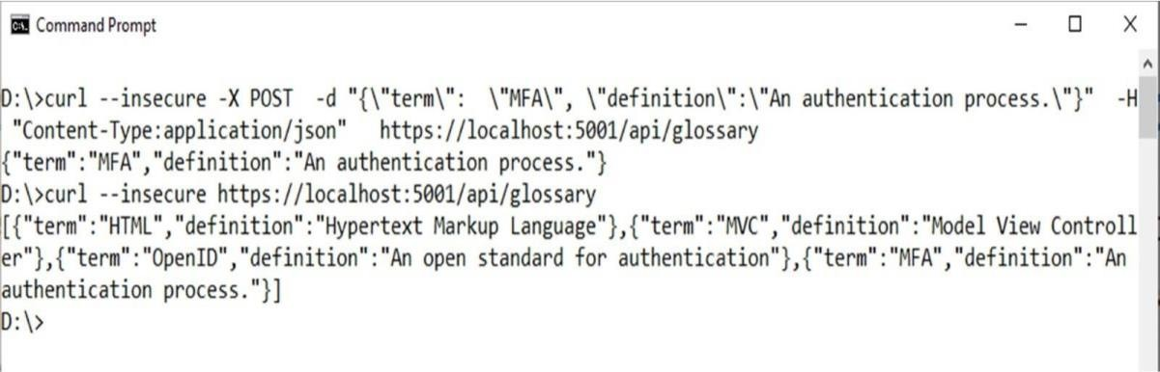

## OUTPUT:

**Update Item** Command:

curl --insecure -X PUT -d "{\"term\": \"MVC\",

\"definition\":\"Modified record of Model View Controller.\"}" -H "Content-Type:application/json" https://localhost:5001/api/glossary

## OUTPUT:

**Delete Item** Command:

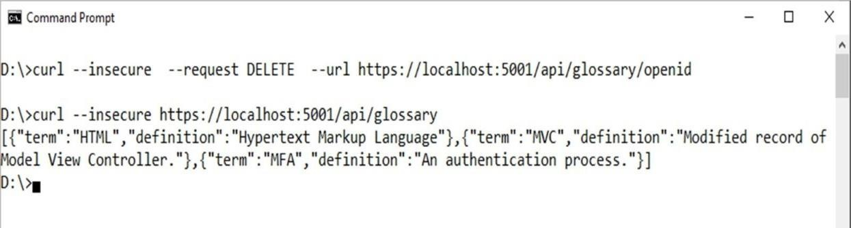curl --insecure --request DELETE --url https://localhost:5001/api/glossary/openid **OUTPUT:**

# Practical No: 3

**Aim: Working with Docker, Docker Commands, Docker Images and Containers Description:**

### Step 1: create Docker Hub account (sign up)

**Step 2 : login to** [**https://labs.play-with-docker.com/**](https://labs.play-with-docker.com/)

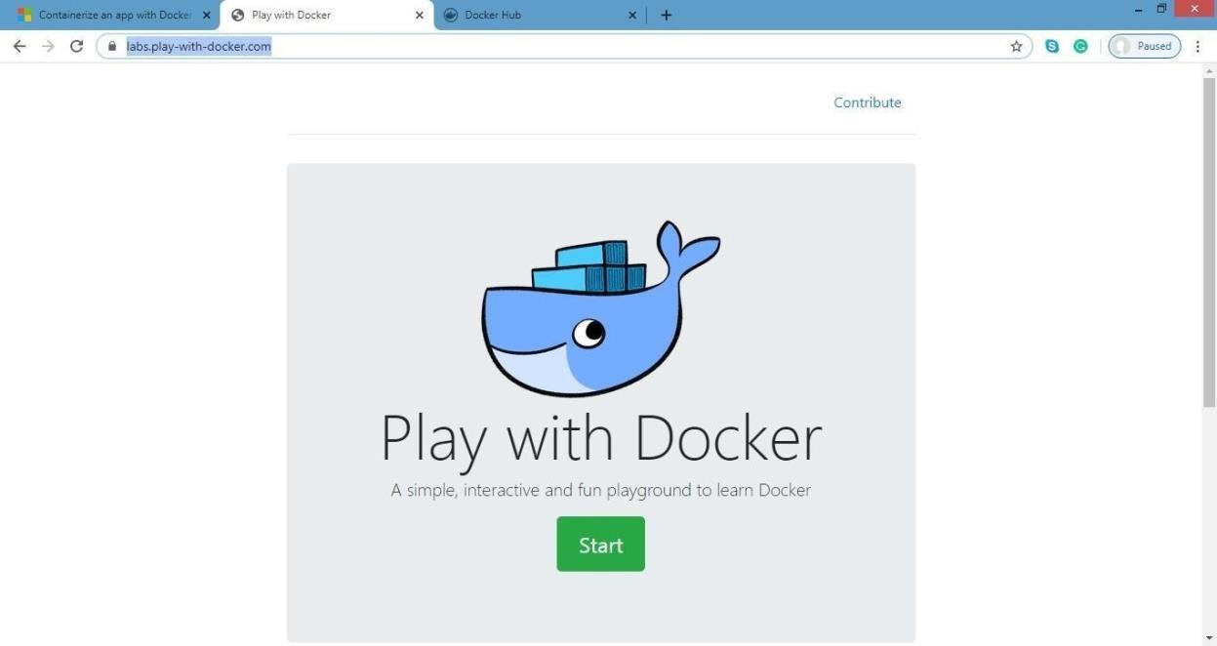

Click on start

### Step 3: Add new instances

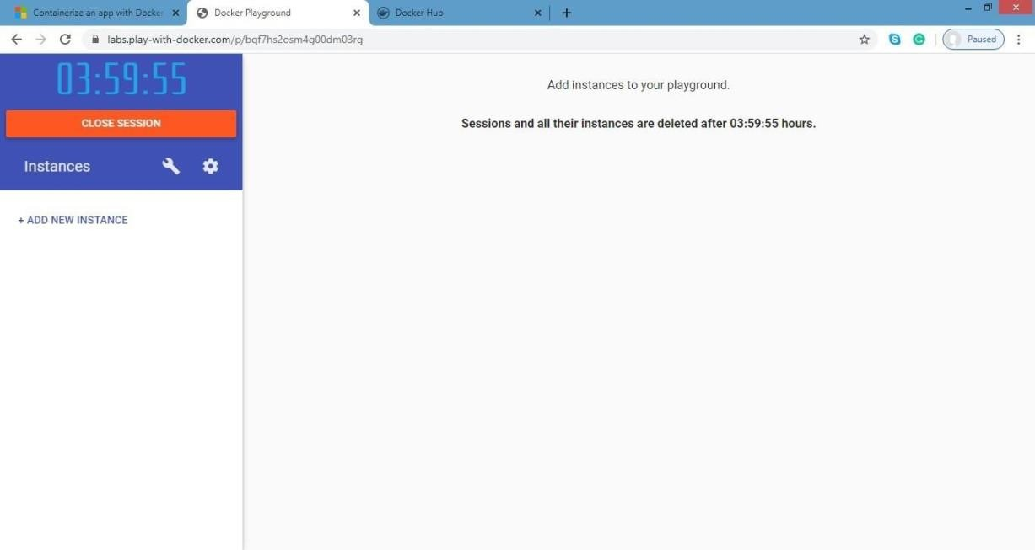

**Step 4: perform following:**

### Method1: To pull and push images using docker

Command: to check docker version docker –version

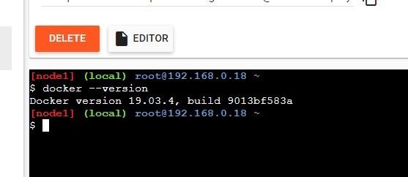**OUTPUT:**

Command: to pull readymade image docker pull rocker/verse

## OUTPUT:

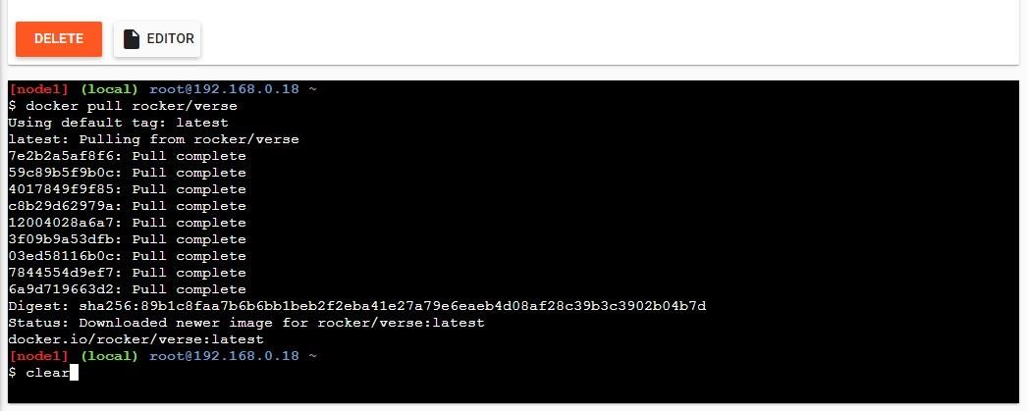

Command: to check images in docker docker images

4) perform following:

### Method1:

**To pull and push images using docker**

Command: to check docker version docker

–version OUTPUT:



Command: to pull readymade image docker pull rocker/verse

## OUTPUT:



Command: to check images in docker docker images

1. perform following:

### Method1:

**To pull and push images using docker**

Command: to check docker version docker

–version **OUTPUT:**



Command: to pull readymade image docker pull rocker/verse

## OUTPUT:



Command: to check images in docker docker images

## OUTPUT:

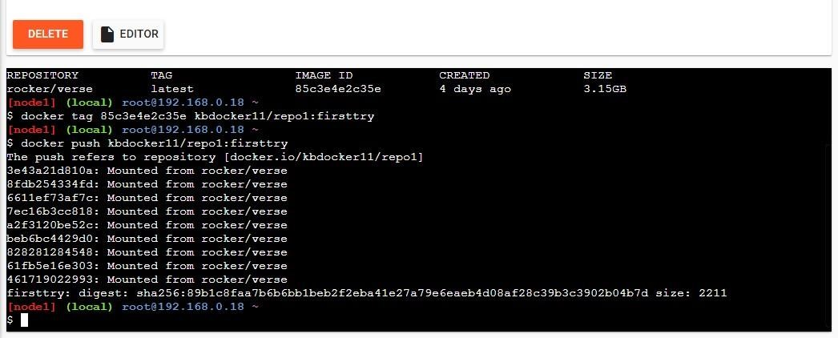

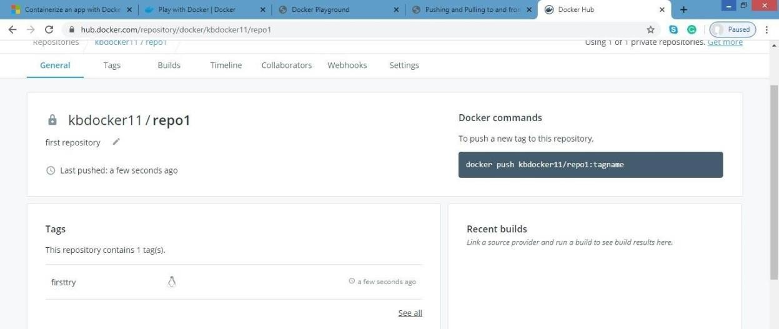Check it in docker hub now

Click on tags and check

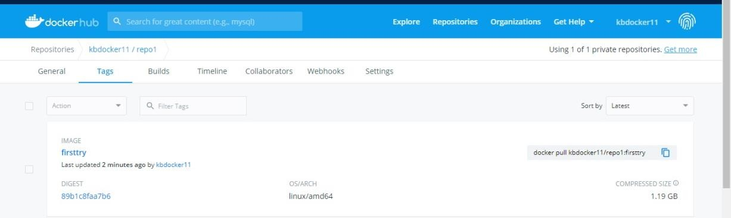

### Method 2:

**Build an image then push it to docker and run it**

Command : to create docker file

* 1. cat > Dockerfile <<EOF
  2. FROM busybox
  3. CMD echo "Hello world! This is my first Docker image."
  4. EOF

## OUTPUT:

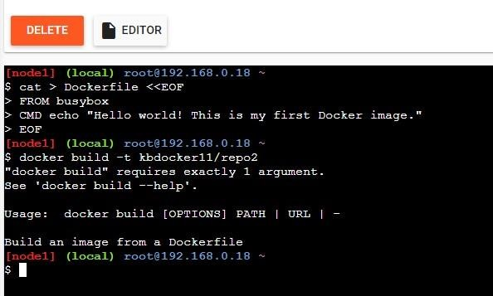

Command : to build image from docker file dokcer build

–t kbdocker11/repo2 .

## OUTPUT:

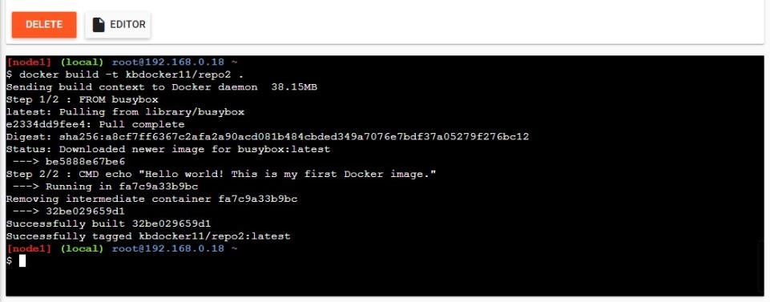

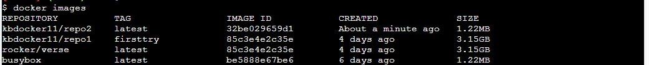Command: to check docker images docker images OUTPUT:

Command: to push image to docker hub docker push kbdocker11/repo2 .

## OUTPUT:

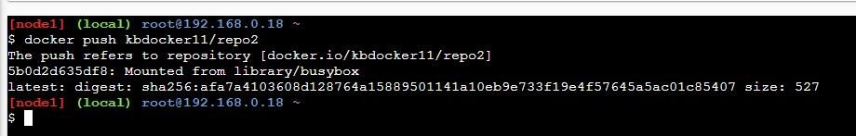

Now check it on docker hub

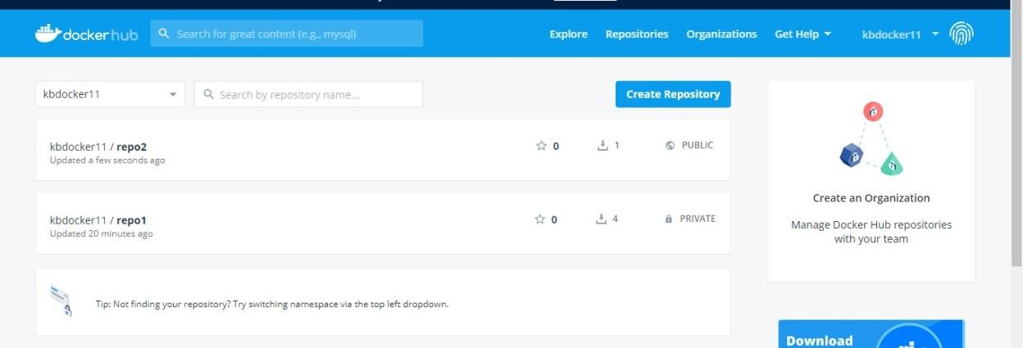

command: to run docker image: docker run kbdocker11/repo2 OUTPUT:

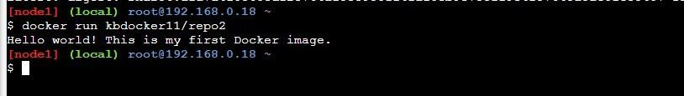

Now close session.

# Practical No: 4

**Aim: Installing software packages on Docker, Working with Docker Volume and Networks.**

**Description:**

If you’ve already run the command to get started with the tutorial, congratulations! If not, open a command prompt or bash window, and run the command:

You’ll notice a few flags being used. Here’s some more info on them:

− -d - run the container in detached mode (in the background)

− -p 80:80 - map port 80 of the host to port 80 in the container

− docker/getting-started - the image to use

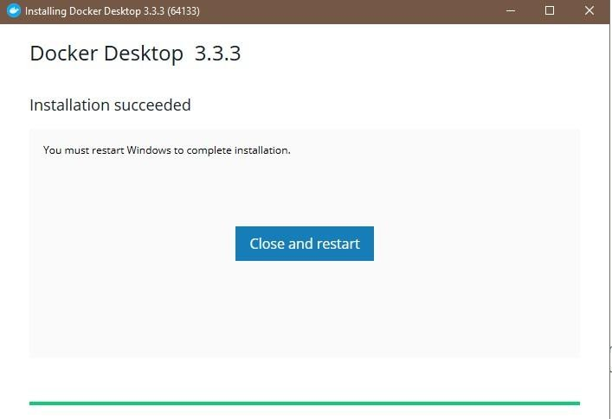

### What is a container?

Now that you’ve run a container, what *is* a container? Simply put, a container is simply another process on your machine that has been isolated from all other processes on the host machine. That isolation leverages [kernel](https://medium.com/@saschagrunert/demystifying-containers-part-i-kernel-space-2c53d6979504) [namespaces and cgroups,](https://medium.com/@saschagrunert/demystifying-containers-part-i-kernel-space-2c53d6979504) features that have been in Linux for a long time. Docker has worked to make these capabilities approachable and easy to use.

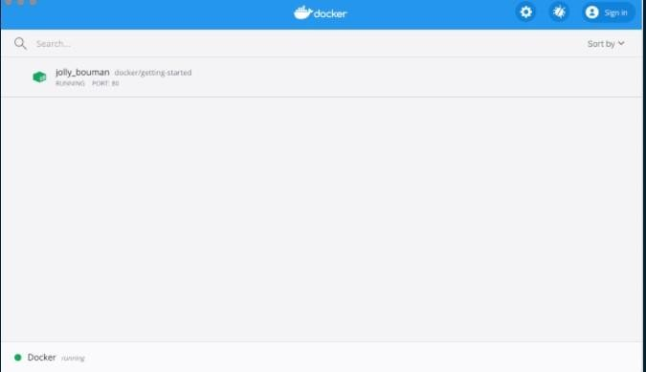

### Step 1: $ docker run -p 8080:8080 dotnetcoreservices/hello-world

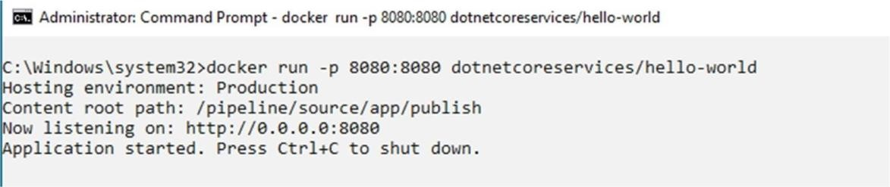

**Step 2: Run Localhost in browser**

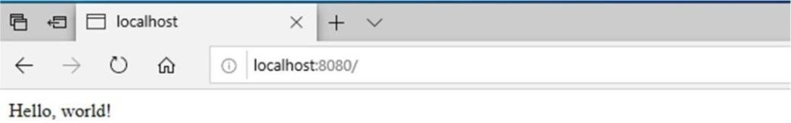

### Step 3: $ docker ps

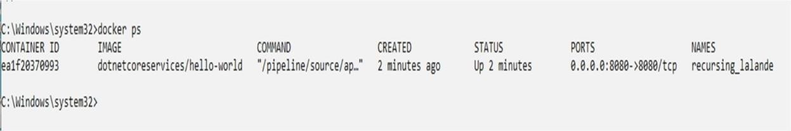

**Step 4: curl http://localhost:8080/will/it/blend?**

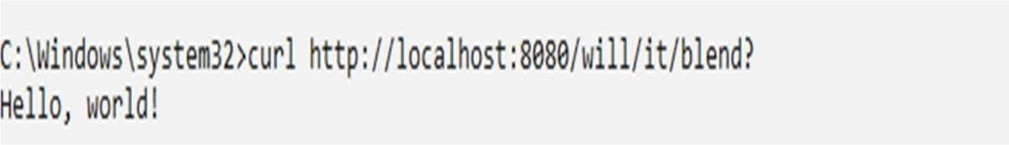

### Step 5: $ docker kill PID (process id of application).

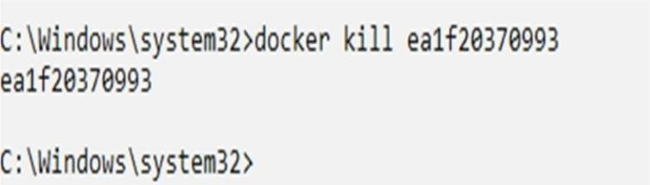

**Step 6 : Process Id terminated**

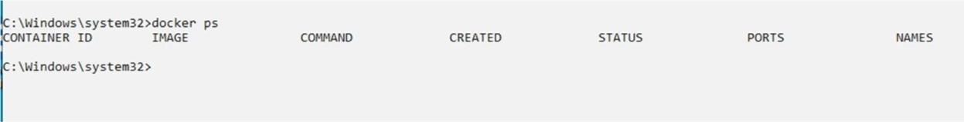

# Practical No: 5

**Aim: Working with Docker Swarm.**

**Description:**

### What is Docker Swarm?

Docker Swarm is an orchestration management tool that runs on Docker applications. It helps end-users in creating and deploying a cluster of Docker nodes.

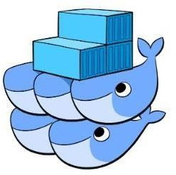

**Step 1: Update Software Repositories** Run the following command on the terminal: sudo apt-get update

### Step 2: Uninstall Old Versions of Docker

Before proceeding, uninstall the old Docker software and use the following command:

sudo apt-get remove docker docker-engine docker.io

### Step 3: Install Docker

To install Docker on Ubuntu, run the following command:

sudo apt install docker.io

### Step 4: Set-up Docker

Set-up and run Docker service by entering the following commands in the terminal window:

sudo systemctl start docker sudo systemctl enable docker

### Step 5: Verify Docker Version

To check the installed Docker version, enter the following command:

sudo docker --version

### Step 6: Run Docker Container

To run a Docker container, it’s important to pull a Docker Image (such as MySQL) from Docker Hub. sudo docker pull mysql sudo docker run -d -p0.0.0.0:80:80

mysql:latest

Now, Docker pulls the latest MySQL image from the hub. List down all the available Docker images on your machine by using the following command:

sudo docker ps -a

### Step 7: Create Swarm

Here, create a cluster with the IP address of the manager node. sudo Docker Swarm init --advertise-addr 192.168.2.151 Subsequently, you should see the following OUTPUT:

### Manager Node

This means that the manager node is successfully configured. Now, add worker node by copying the command of the “swarm init” and paste the output onto the worker node:

sudo Docker Swarm join --token SWMTKN-1- xxxxx

Your worker node is also created if you see the following OUTPUT:

### Worker Node

Now, go back to the manager node and execute the following command to list the worker node: sudo docker node ls

Here, you must see the worker node in the following OUTPUT:

### Swarm Cluster - Docker Swarm

The above image shows you have created the Swarm Cluster successfully. Now, launch the service in Swarm Mode. Go to your the manager node and execute the command below to deploy a service:

sudo docker service create --name HelloWorld alpine ping docker.com

### Service Created - Docker Swarm

By executing the above command, you can access the HelloWorld file from the remote system. To see the output, you can check the services with the following command:

sudo docker service ls

Finally, you should be able to see the following OUTPUT:

# Practical No: 06

**Aim: Working with Circle CI for continuous integration.**

**Description:**

### Prerequisites

To follow along with the tutorial, a few things are required:

1. Python installed on your local system
2. A Circle CI account
3. A GitHub account

### Building the app

For simplicity, we will create a Flask application. Flask is a microframework for Python. For our exercise, minimal knowledge of the framework is necessary.

First, create a project directory (folder) and cd into it. Type this into Terminal:

### mkdir python_app && cd $_/

Next, open your favorite editor and create a hello.py file. Then, copy the following lines into that file: from flask import Flask app =

Flask( name ) @app.route("/") def hello():

return "Hello World!"

### Running the app

Now it is time to create a requirements.txt file in our editor. Add the word **Flask** to the file and save it. Then, within the virtual environment, install the package by running:

The final command to run this application is:

### FLASK_APP=hello.py flask run

You can see the application running on your browser at http://localhost:5000/.

### CircleCI config file

Create a .circleci folder and inside of that create a [config.yml f](https://circleci.com/docs/2.0/sample-config/)ile. Then, copy these lines into it:

### version: 2 jobs: build:

**docker:**

### image: circleci/python:3.6 steps:

* **checkout - restore_cache: key: deps1-{{ .Branch }}-{{ checksum "requirements.txt" }} - run:**

### command: | python3 -m venv venv . venv/bin/activate pip install -r requirements.txt - save_cache:

**key: deps1-{{ .Branch }}-{{ checksum "requirements.txt" }} paths: - "venv" - run:**

### name: Running tests command: |

**. venv/bin/activate python3 tests.py - store_artifacts: path: test-reports/ destination: python_ap**

### Pushing to GitHub

Using the philosophy of committing your code early and often, we should have initialized Git earlier in this process, and we would have atomic commits. Because this tutorial is about integration of CircleCI and GitHub, I intentionally put it on hold until now.

Our current code structure looks like this:

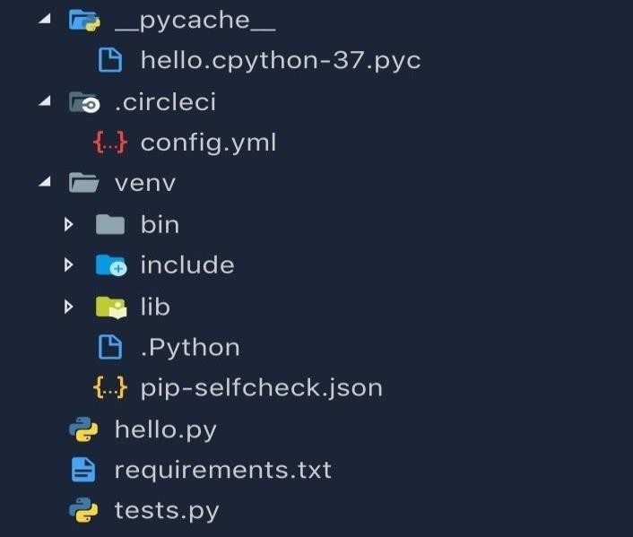

We can now commit our code by running the following commands:

|  |
| --- |
| **git add .** |
| **git commit -m "Initial commit"** |

### Creating GitHub Repository

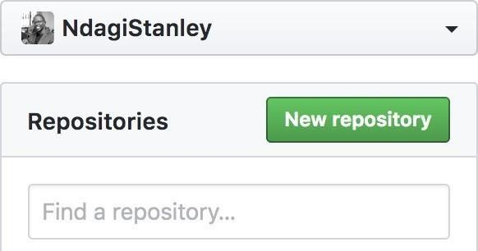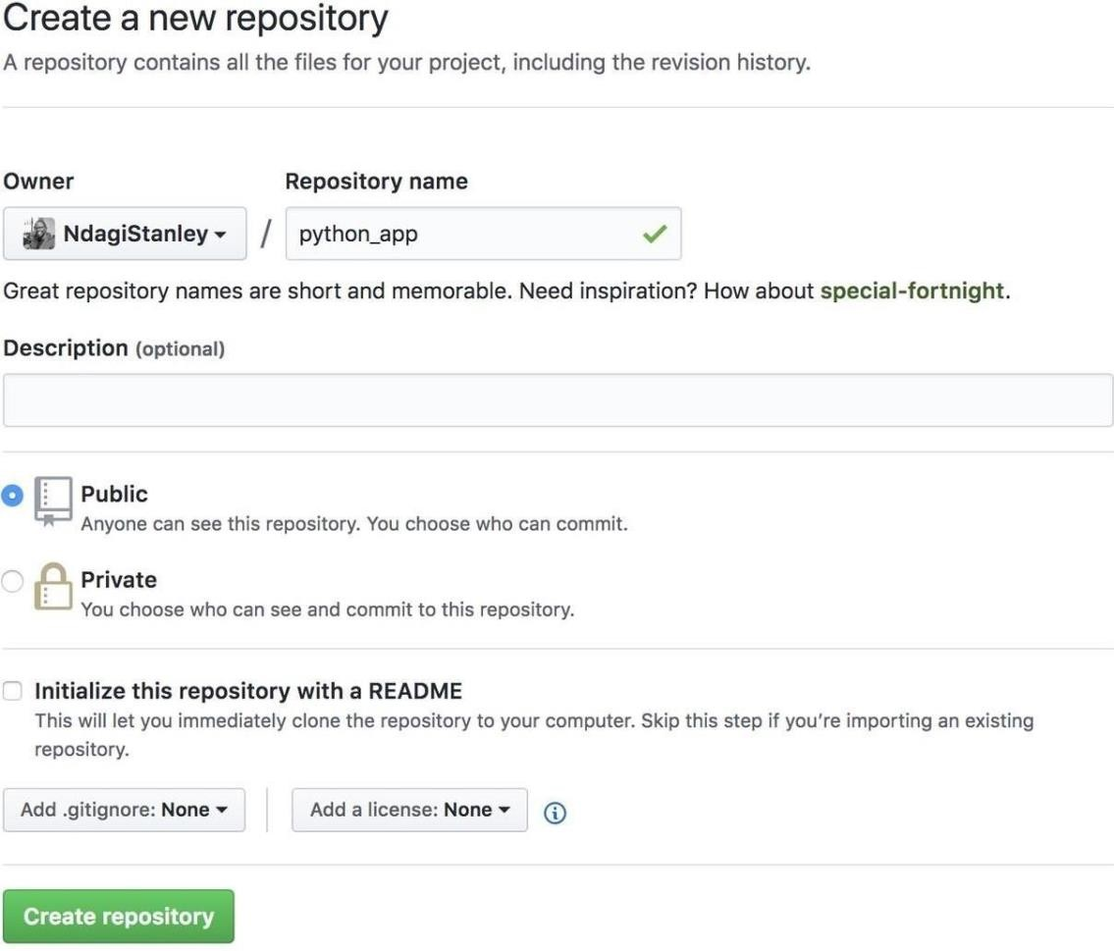

After creating your new repository, you will get to a page like this one:

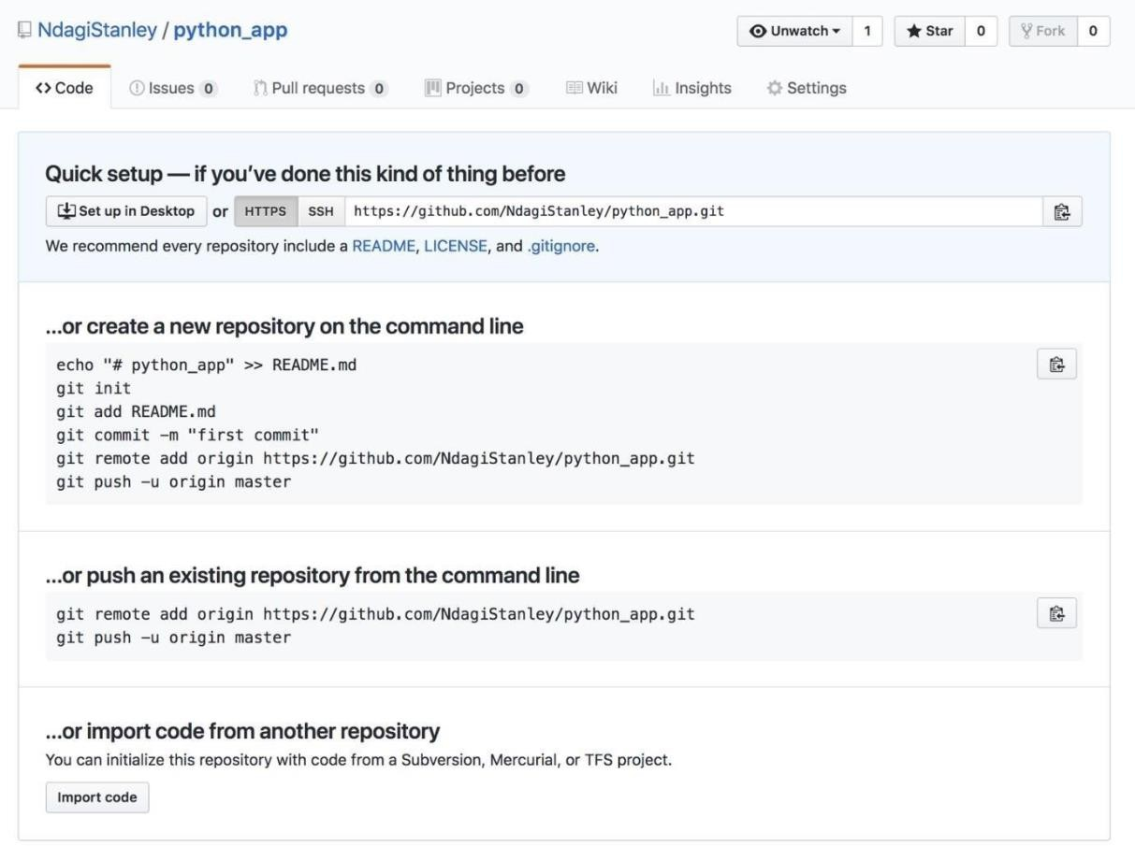

We will go with the second option, …push an existing repository. Run:

|  |
| --- |
| **git remote add origin** [**https://github.com/NdagiStanley/python_app.gi**](https://github.com/NdagiStanley/python_app.git)**t** |
| **git push -u origin master** |

### Configuring CircleCI

Now that the repo is on GitHub, we can finalize the CI by configuring CircleCI. Head on over to the CircleCI sign up page. Sign up for CircleCI with your GitHub account.

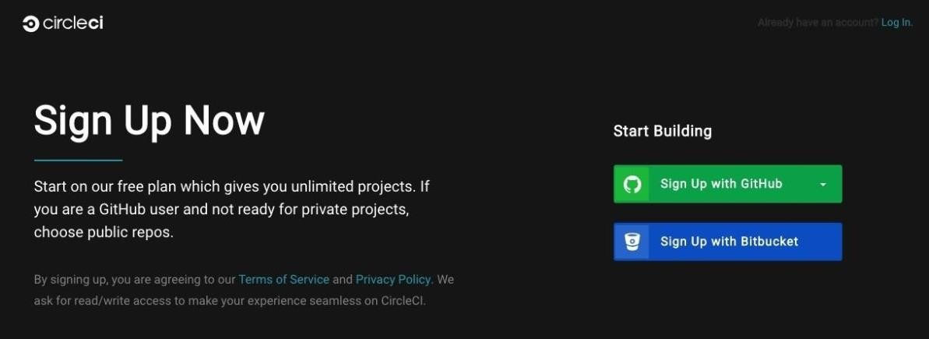

Once you are logged in, make sure that your personal GitHub account is active. If you are in several GitHub organizations, one of them might be active. Just click the drop-down menu (top left) and select your GitHub username. Then, click Add Projects. The most recent project, ‘python_app’, is listed there.

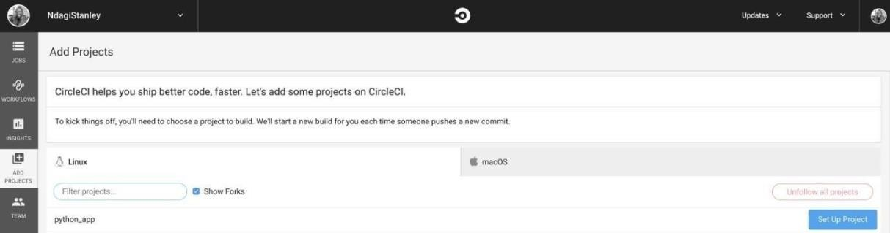

Click Set up Project at the right side of the row that includes our project. On the redirected page, you will notice the Next Steps section. Had we not had our own .circleci/config.yml file, we would have started at No.

1. Because we do have the config.yml file, we can just scroll to No. 5 and click Start building.

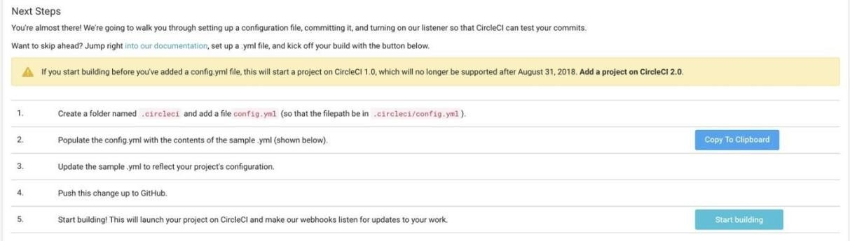

Within no time, the build passes. Success!

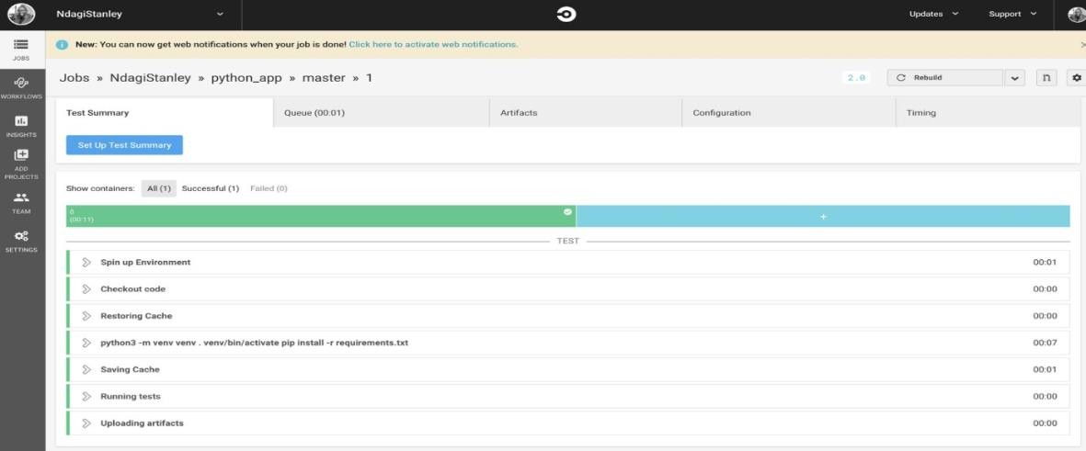

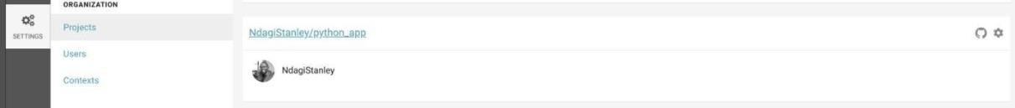In the top right corner, click the Settings cog. Then click Projects on the left, and finally, python_app.

You will be on a path like this one: circleci.com/gh/<username>/python_app. Mine is [https://circleci.com/gh/NdagiStanley/python_app.](https://circleci.com/gh/NdagiStanley/python_app) Click the settings cog next to the repo name: python_app.



It is important that you become familiar with the settings that you can change for this project. I will touch on what is relevant to us now.

In Advanced Settings, notice that Only build pull requests is turned off. This means that every push to GitHub will run on CircleCI, including PRs. **ReadME - status badge**

On our local machine, check out to another Git branch by running:

### git checkout -b add_readme

Open your editor and create a README.md file. Copy and paste the following lines into this file:

### README.md

**# PYTHON APPLICATION**

### This Python application repo was created to showcase the integration between GitHub and CircleCI. [![CircleCI](https://circleci.com/gh/NdagiStanley/python_app.svg?style=svg)](https://c ircleci.com/ gh/NdagiStanley/python_app)

I added a title and a brief description to mine. Now, run the following commands:

### git add .

**git commit -m "Add README" git push -u origin add_readme**

If you go to [https://github.com//python_app](https://github.com/python_app) you will notice that we have a new branch:

`add_readme`. We can go ahead and click Compare and pull request.

### Opening a pull request

This is how I set up my PR:

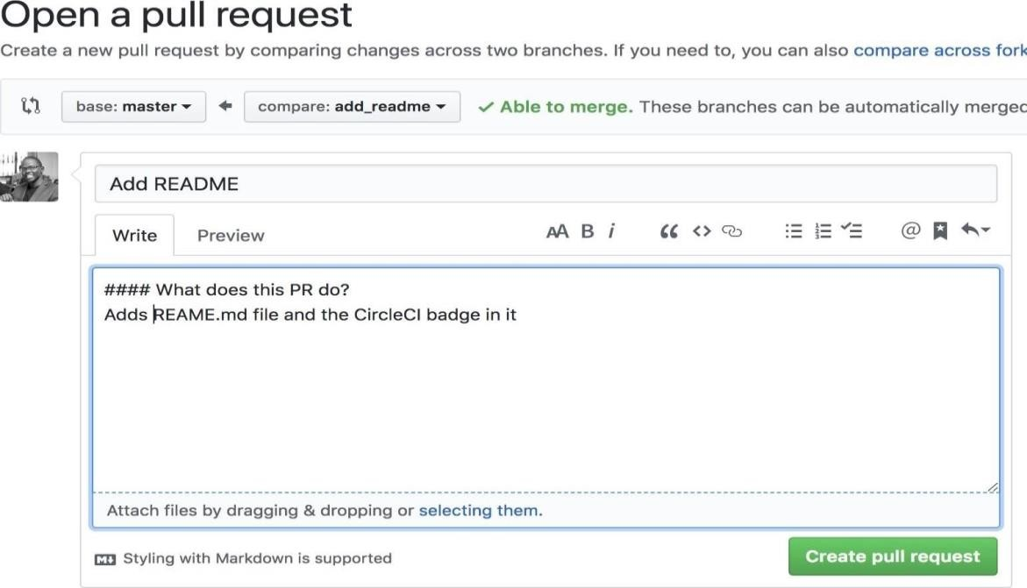

Click Create pull request and in no time, this is what we get:

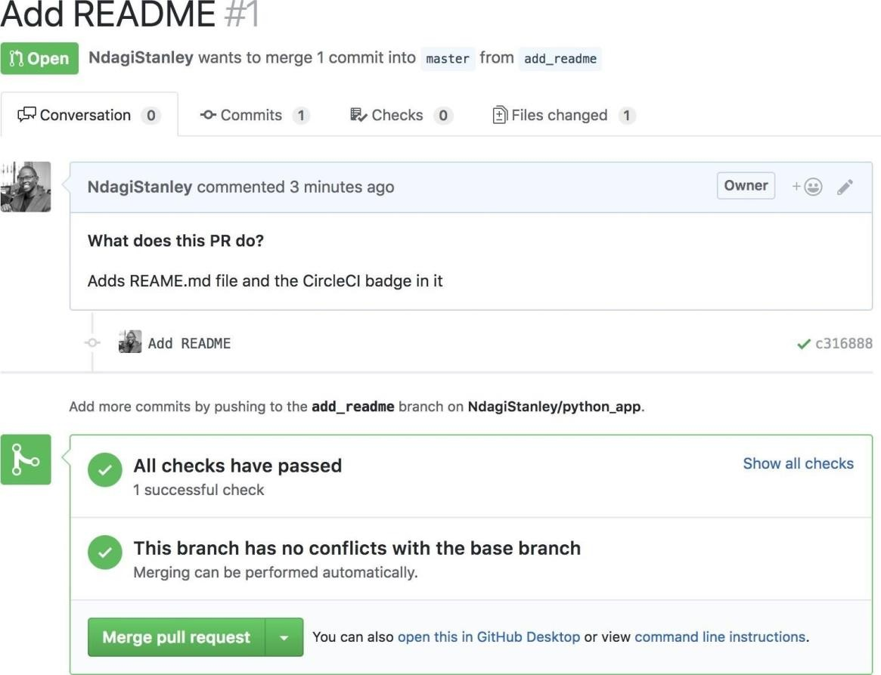

A successful build! Now, click Show all checks. Notice that the check is from CircleCI.

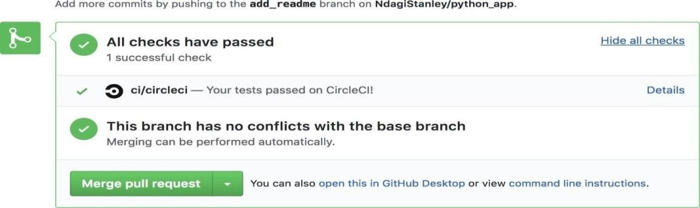

Even the browser’s tab favicon shows a tick for the successful run. If you click Details, this will redirect you to the build on CircleCI:

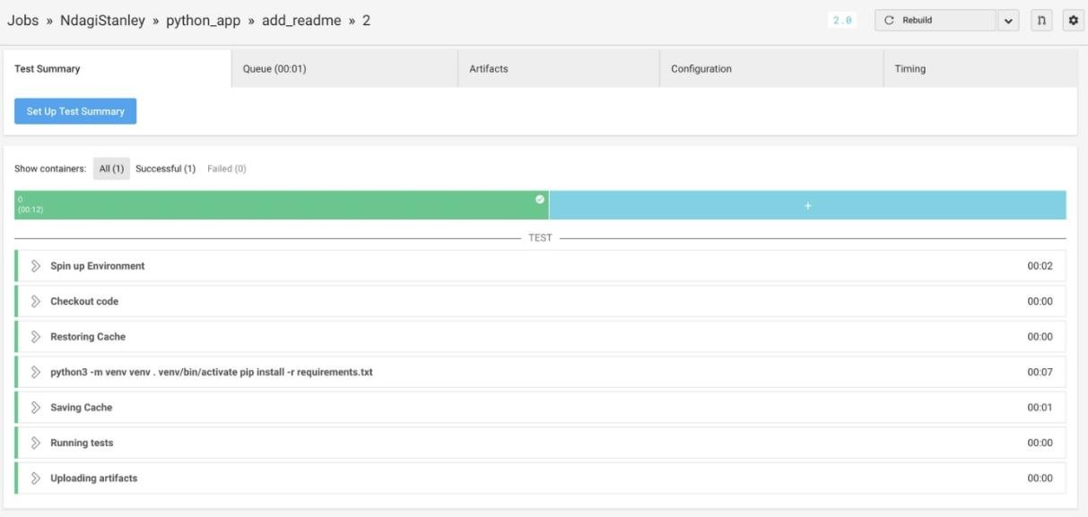

Notice that the favicon here also shows that the build is successful:

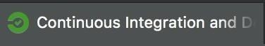

At the top, click python_app.



You will be redirected to the builds for this project:

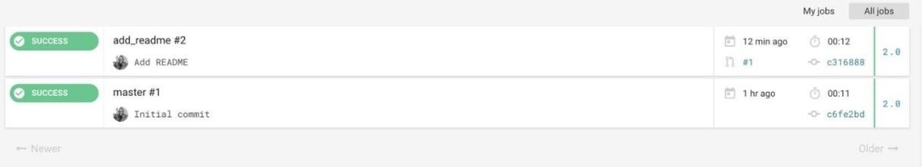

### Conclusion

There you have it! We have enabled continuous integration with CircleCI.

# Practical No: 07

**Aim: Creating Microservice with ASP.NET Core.**

**Description:**

Create a new ASP.NET Core project. I called mine Hello Microservice (and the [full source](https://github.com/couchbaselabs/blog-source-code/tree/master/Groves/126MicroserviceDocker/src/HelloMicroservice) code is available on [GitHub](https://github.com/couchbaselabs/blog-source-code/tree/master/Groves/126MicroserviceDocker/src/HelloMicroservice) for your reference

### Step 1: Create a new solution

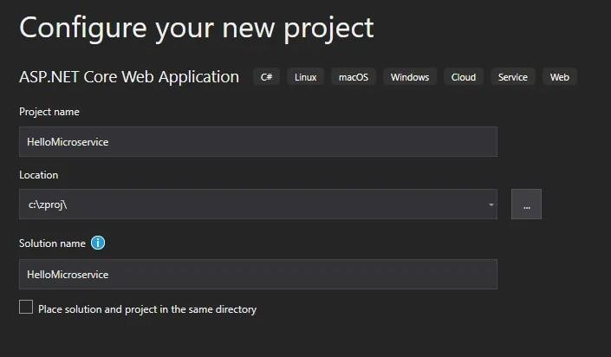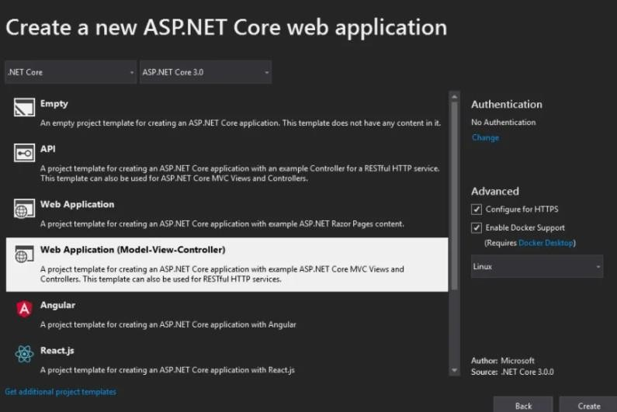

**Step 2: Add docker-compose support**

Right click on the **project** and click “Add” and then “Container Orchestrator Support”.

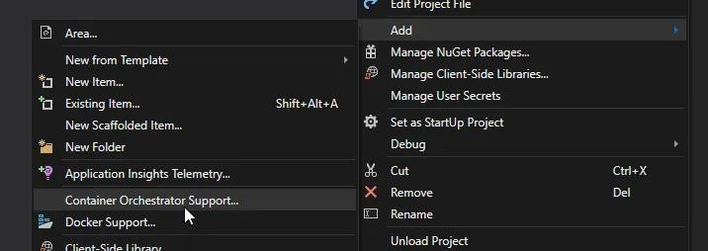

Keep in mind that the sole purpose of this project is to start development for a proof of concept for ASP.NET Core Microservices. Docker-compose is easier to deal with than Kubernetes for local machine development. This is why I’m choosing the “Docker Compose” option, even though I may eventually want to **deploy** to Kubernetes.

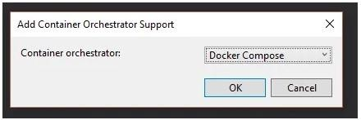

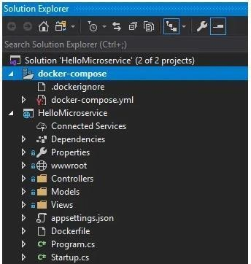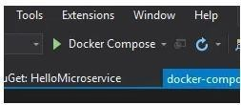

At this point, you can hit CTRL+F5 to run. Visual Studio will use Docker Compose to create an image of your project and run it within Docker. Your browser should open automatically, and you’ll see the standard “Welcome” screen

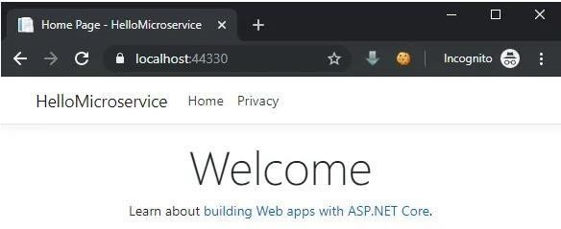

**Step 3: Add database orchestration to docker-compose**

Couchbase makes [official container images available on Docker Hub.](https://hub.docker.com/_/couchbase) To use these images, lets add another service under services: in the docker-compose.yml file:

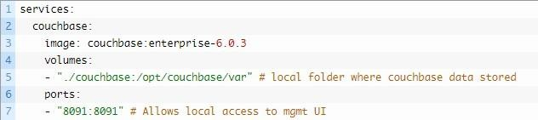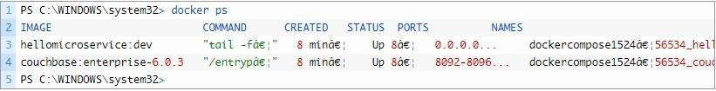

**Step 4: Configuration changes**

Because I’ve used the stock couchbase: enterprise-6.0.3 Docker image, I still need to open the Couchbase UI (http://localhost:8091) and setup the cluster manually. See “next steps” at the end for some options to automate.

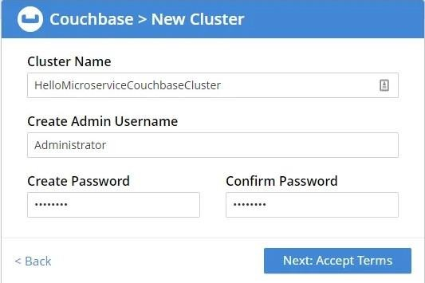

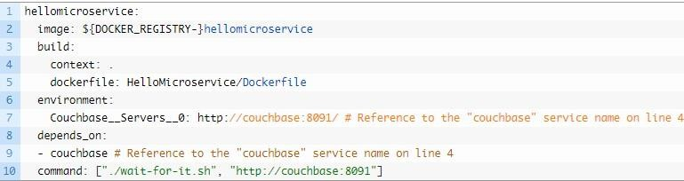

Using wait-for-it **is optional**, but when you’re right in the middle of development, this may save you some headaches. Finally, to make the ASP.NET Core project talk to Couchbase, I used the [Dependency Injection](https://blog.couchbase.com/dependency-injection-aspnet-couchbase/) [Extension](https://blog.couchbase.com/dependency-injection-aspnet-couchbase/) from NuGet



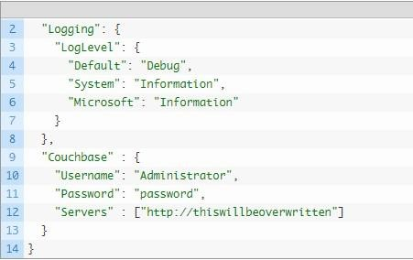

**Step 5: Using the database**

Finally, let’s make sure that the ASP.NET Core application is able to communicate with the database. I added a very simple Insert and Get to the HomeController Index method:

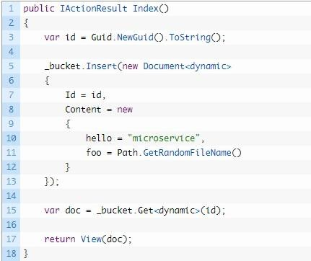

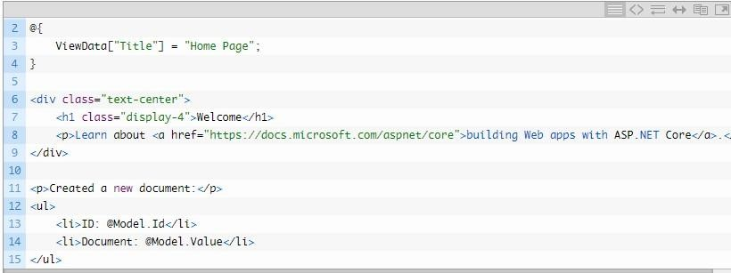

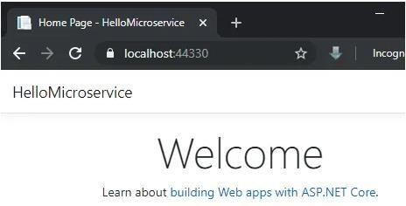And now, we have the basics of ASP.NET Core Microservices in place. Hit CTRL+F5 to run the service. When the browser opens, you should see something like this: