**4566_BB_test_plan_review**

**0538 Code Following 4566 Test Plan**

**Critique**

Code plan lacked proper test cases, because it didn’t specify the result of each test, Figure 1. There needs to be a predetermination of the results, so the tester knows what to expect and not making up their own results. The tests that followed Test 10 were outside of the scope because it was testing for conditions that were being tested in the Table class and not the methods that were required to be tested. Test 10 was not feasible due to the time a system would take to sort an unsorted array of MAXINT length is too long.

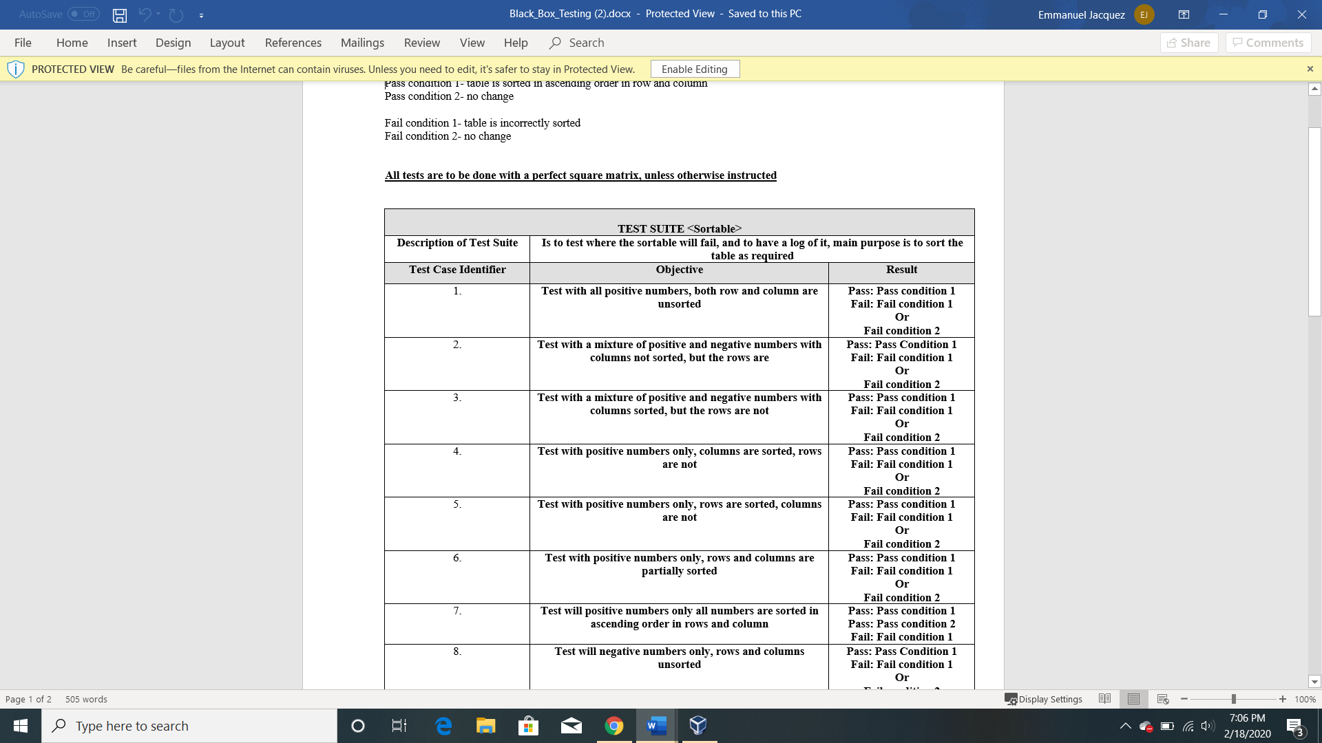

**Figure 1: Test plan not specifying what result is expected**

**Comments**

Plan was very simple to follow

Don’t test so many test cases that are so close together or expand the scope of the testing rather than just descending or ascending.

**Improvements**

Provide tables to use for tester instead of having them come up with their own, which can be time consuming and some testers can find difficult to carry out.