Test Plan
Black Box Testing

<<author name redacted>>

Test 1
The main purpose of this section is to test the TableSorter class that was created for Assignment 1 in the Validation and Verification course. Assignment 1 contains a program which will sort a set of numbers from a specified file in ascending order. As the tester you will be required to carry out a series of tests in order to ensure that the program is doing what it was designed to do. Tester will be using Intellij and JUnit in order to carry out the test. The primary purpose of this section is to:
- Document test inputs, specific test procedures, and outcomes.
- Establish test protocols
- Detail and explain the nature of each test

Test 01

Objective: Tests a list of positive integers to see if sortTable() is sorting
Notes: Using IntelliJ, tester will access the TableSorterTest.java class. Once the class has been accessed, tester will carry out each test starting from top to bottom using the Run Test function that pops out on the left side of the test code in the form of a green icon, Figure 1. Left-click on icon and select Run ‘sortTable()’

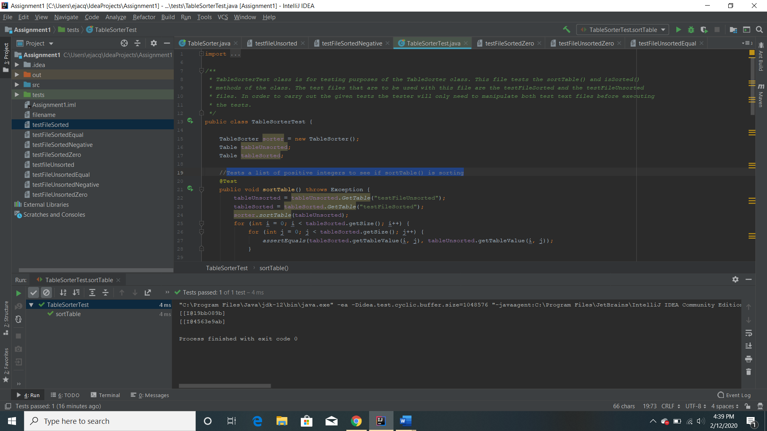
Figure 1: Run Test Icon

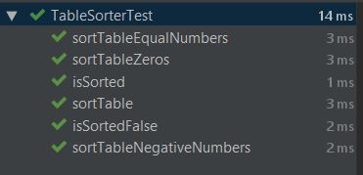

Figure 2: Shows all passing test after execution of the TableSorterTest.java

Test No.: 01 |  |  |  | Current Status: Pass
Test title: sortTable()
Testing approach: Junit was used in order to carry out the test. Each test is labeled as to what it is testing. The text files being used are labeled with the type of integers that are going to be found in such file. E.g. testFileUnsorted, which contains an unsorted set of integers

STEP  1 | OPERATOR ACTION  Left click Run Test Icon found next to the sortable() test method. | PURPOSE  Tests a list of positive integers to see if sortTable() is sorting |  |  | EXEPCTED RESULTS  Test should pass because we are comparing the a presorted list of integers to a list that needs to be sorted by the sortable() method in the TableSorter class. If test fails, the sortable method is failing to sort set of positive integers. | COMMENTS
Concluding Remarks:
Testing Team: |  |  | Date Completed: 2/12/2020

Test 02

Objective: Tests sortTable() with a list of integers that are both positive and negative
Notes: Using IntelliJ, tester will access the TableSorterTest.java class. Once the class has been accessed, tester will carry out each test starting from top to bottom using the Run Test function that pops out on the left side of the test code in the form of a green icon, Figure 1. Left-click on icon and select Run ‘sortTableNegativeNumbers()’

Test No.: 02 |  |  |  | Current Status: Pass
Test title: sortTableNegativeNumbers()

Testing approach: Junit was used in order to carry out the test. Each test is labeled as to what it is testing. The text files being used are labeled with the type of integers that are going to be found in such file. E.g. testFileUnsortedNegative, which contains an unsorted set of integers that includes negative numbers.

STEP  1 | OPERATOR ACTION  Left click Run Test Icon found next to the sortTableNegativeNumbers() test method. | PURPOSE  Tests sortTable() with a list of integers that are both positive and negative |  |  | EXEPCTED RESULTS  Test should pass because we are comparing the a presorted list of integers with negative numbers to a list that needs to be sorted by the sortable() method in the TableSorter class. If test fails, the sortable method is failing to sort set of positive and negative integers. | COMMENTS
Concluding Remarks:
Testing Team: |  |  | Date Completed: 2/12/2020

Test 03

Objective: Tests a list of integers, including 0, to see if sortTable() is sorting
Notes: Using IntelliJ, tester will access the TableSorterTest.java class. Once the class has been accessed, tester will carry out each test starting from top to bottom using the Run Test function that pops out on the left side of the test code in the form of a green icon, Figure 1. Left-click on icon and select Run ‘sortTableZeros()’

Test No.: 03 |  |  |  | Current Status: Pass
Test title: sortTableZeros()

Testing approach: Junit was used in order to carry out the test. Each test is labeled as to what it is testing. The text files being used are labeled with the type of integers that are going to be found in such file. E.g. testFileUnsorted, which contains an unsorted set of integers

STEP  1 | OPERATOR ACTION  Left click Run Test Icon found next to the sortTableZeros() test method. | PURPOSE  Tests a list of integers, including 0, to see if sortTable() is sorting |  |  | EXEPCTED RESULTS  Test should pass because we are comparing the a presorted list of integers to a list that needs to be sorted by the sortTable() method in the TableSorter class. If test fails, the sortable method is failing to sort set of positive integers including 0. | COMMENTS
Concluding Remarks:
Testing Team: |  |  | Date Completed: 2/12/2020

Test 04

Objective: Tests sortTable() with a list of integers that contains repeat numbers
Notes: Using IntelliJ, tester will access the TableSorterTest.java class. Once the class has been accessed, tester will carry out each test starting from top to bottom using the Run Test function that pops out on the left side of the test code in the form of a green icon, Figure 1. Left-click on icon and select Run ‘sortTableEqualNumbers()’

Test No.: 04 |  |  |  | Current Status: Pass
Test title: sortTableEqualNumbers()
Testing approach: Junit was used in order to carry out the test. Each test is labeled as to what it is testing. The text files being used are labeled with the type of integers that are going to be found in such file. E.g. testFileUnsorted, which contains an unsorted set of integers

STEP  1 | OPERATOR ACTION  Left click Run Test Icon found next to the sortTableEqualNumbers() test method. | PURPOSE  Tests sortTable() with a list of integers that contains repeat numbers |  |  | EXEPCTED RESULTS  Test should pass because we are comparing the a presorted list of integers to a list that needs to be sorted by the sortable() method in the TableSorter class. If test fails, the sortable method is failing to sort set of positive integers that includes repeat integers. | COMMENTS
Concluding Remarks:
Testing Team: |  |  | Date Completed: 2/12/2020

Test 05

Objective: Tests isSorted() against a sorted list of integers to see if it returns True
Notes: Using IntelliJ, tester will access the TableSorterTest.java class. Once the class has been accessed, tester will carry out each test starting from top to bottom using the Run Test function that pops out on the left side of the test code in the form of a green icon, Figure 1. Left-click on icon and select Run ‘isSorted()’

Test No.: 05 |  |  |  | Current Status: Pass
Test title: isSortedFalse()

Testing approach: JUnit was used in order to carry out the test. Each test is labeled as to what it is testing. The text files being used are labeled with the type of integers that are going to be found in such file. E.g. testFileSorted, which contains an unsorted set of integers

STEP  1 | OPERATOR ACTION  Left click Run Test Icon found next to the sortable() test method. | PURPOSE  Tests isSorted() against a sorted list of integers to see if it returns True |  |  | EXEPCTED RESULTS  Test should pass because we are comparing a presorted list of integers. If test fails, the isSorted() method is failing to identify a sorted list of integers properly.  Test returns True if testFileSorted is found to be sorted | COMMENTS
Concluding Remarks:
Testing Team: |  |  | Date Completed: 2/12/2020

Test 06

Objective: Tests isSorted() against an unsorted list of integers to see if it returns false
Notes: Using IntelliJ, tester will access the TableSorterTest.java class. Once the class has been accessed, tester will carry out each test starting from top to bottom using the Run Test function that pops out on the left side of the test code in the form of a green icon, Figure 1. Left-click on icon and select Run ‘isSorted()’

Test No.: 06 |  |  |  | Current Status: Pass
Test title: isSortedFalse()

Testing approach: JUnit was used in order to carry out the test. Each test is labeled as to what it is testing. The text files being used are labeled with the type of integers that are going to be found in such file. E.g. testFileUnsorted, which contains an unsorted set of integers

STEP  1 | OPERATOR ACTION  Left click Run Test Icon found next to the sortable() test method. | PURPOSE  Tests isSorted() against an unsorted list of integers to see if it returns false |  |  | EXEPCTED RESULTS  Test should pass because we are comparing a presorted list of integers. If test fails, the isSorted() method is failing to identify a sorted list of integers to an unsorted list of integers properly.  Test returns false if testFileUnsorted is found to be unsorted | COMMENTS
Concluding Remarks:
Testing Team: |  |  | Date Completed: 2/12/2020

