TableSorter
Test plan
Version 1.1
02/12/2020
Document Control
Approval
The Guidance Team and the customer shall approve this document.
Document Change Control
Initial Release: | 02/11/2020
Current Release: | 02/12/2020
Indicator of Last Page in Document: | &
Date of Last Review: | 02/12/2020
Date of Next Review: | 02/19/2020
Target Date for Next Update: | 02/19/2020
Distribution List
This following list of people shall receive a copy of this document every time a new version of this document becomes available:
Guidance Team Members: Dr. Steve Roach

Customer: Dr. Steve Roach

Software Team Members: <<author name redacted>>
Change Summary
The following table details changes made between versions of this document

Version | Date | Modifier | Description
1.0 | 02/11/2020 |  | Started document.
1.1 | 02/12/2020 |  | All sections in document completed.

Note: The template presented in this document was taken from:
Donaldson, S., and S. Siegel, Successful Software Development. Upper Saddle River, NJ: Prentice Hall, 2001, pp. 321-323.

Note: The template presented in this document was taken from: Donaldson, S., and S. Siegel, Successful Software Development. Upper Saddle River, NJ: Prentice Hall, 2001, pp. 321-323 and modified by Humberto Mendoza and Steve Roach.

Supplementary information is from:
Pfleeger, S. Software Engineering, Theory and Practice. Upper Saddle River, NJ: Prentice Hall, 1998, p. 365.

Table of Contents
Document Control ii
Approval ii
Document Change Control ii
Distribution List ii
Change Summary ii
1. Introduction 1
1.1. Purpose 1
1.2. Scope 1
1.3. System Overview 1
1.4. Suspension and Exit Criteria 1
1.5. Document Overview 1
1.6. References 1
2. Test Items and Features 2
3. Testing Approach 3
4. Test TableSorter 4
4.1. Test TS1 4
4.2. Test TS2 4
4.3. Test TS3 2
4.4. Test TS4 2
4.5. Test TS5 2
4.6. Test TS6 2
4.7. Test TS7 2
5. Test Schedule 3
6. Other Sections 4
7. Appendix 5

Introduction

The overview of the project and test plan is explained in this section, with more in depth details explained in sections two through six. This section is comprised of the following sub-sections: Purpose, Scope, System Overview, Suspension and Exit Criteria, Document Overview and References.

Purpose

The purpose of the Test Plan document is to provide detailed information on the testing approach and schedule conducted for the TableSorter according to the requirements specified by the client, using a system test plan that describes the system from the customer’s point of view.

Scope
The project software version encompassed by the test plan will be TableSorter version 1.2, which represents the latest released version.

System Overview
The requirement from our client is the following: Create a Java class TableSorter with two instance methods: public boolean isSorted(Table t) returns true if every row and every column of the table t is sorted in ascending order and public static void sortable(Table t) sorts a Table so that isSorted() is true. Use the Table class provided. You may not modify the Table class. Note that the table class is in the package cs5387. Other than I/O, no other library methods are allowed (e.g., no iterators) [1].

Suspension and Exit Criteria
The suspension and exit criteria implemented for the test plan will be applied as follows:
  - Suspension criteria:
    - All test cases will be executed.
    - Test cases that would prevent further testing and that will enforce fixing problems before going forward are:
      - Creating a new table – If table cannot be created, all tests will fail.
  - Exit criteria:
    - Critical tests must pass – 100% passing rate

Document Overview
The remainder of the Test Plan document is comprised of the following sections:
Section 2 – Test Items and Features, describes the test items and the features to be tested.
Section 3 – Testing Approach, describes the approach to be used to the test the system.
This description includes specifying the types of tests to be performed.
Section 4 – Test, this area provides general notes concerning the test procedure.
Section 5 – Test Schedule, specifies the schedule for testing activities.
Section 6 – Other Sections, other sections that may appear in a test plan.
Section 7 – Appendix, might provide explicit directions for analysis of output.

References
[1] S. Roach, “Programming Assignment 1”, PDF, El Paso, TX, USA, January 22, 2020.

Test Items and Features
The test items such as classes to be tested are shown in Figure 1, which depicts the TableSorter class.

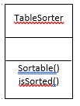
Figure 1 TableSorter Class

Testing Approach

The testing approach that will be implemented is Black-box testing. This approach will examine the functionality of the TableSorter java class without focusing on its internal structure. The pair wise testing method was utilized to decide all possible discrete combinations of input parameters.

Table 1: Test Plan
TEST SUITE TABLE SORTER
Description of Test Suite
Test Case Identifier | Objective | Criticality
TS1 | Test if number of input integers is valid to create table | Critical
TS2 | Test if number of input integers is invalid to create table. | Critical
TS3 | Test 4 positive integers to create table | Critical
TS4 | Test 4 negative integers to create table | Critical
TS5 | Test 2 positive integers, one negative integer and a zero | Critical
TS6 | Test if values are in sorted sequence | Critical
TS7 | Test if values are not in sorted sequence | Critical

Test TableSorter
The purpose of this section is to:
- document test input, specific test procedures, and outcomes.
- establish test methods,
- explain the nature and extent of each test

Test TS1
Objective: Test if number of input integers is valid to create table.
Notes: This test will validate minimum number of input integers needed to create a table. JUnit is needed for testing.

Test No.: TS1 |  |  |  | Current Status: Pending
Test title: Test valid size
Testing approach: This test will be performed using JUnit. A specific set of inputs will be used for testing purposes.
STEP  1 | OPERATOR ACTION  Begin testing using JUnit. | PURPOSE  Initial condition to perform test. |  |  | EXEPCTED RESULTS | COMMENTS
2 | Open file valid_size.txt | Read input 9,8,7,6, from file valid_size.txt in a table format of 2 x 2 (n x n) |  |  | Read input and perform operation to validate table size. | Input file text can be modified within valid specifications. Same number of integers and space between them.
3 | No action. | Use number of input integers to create table. |  |  | PASS  Number of inputs is equal to 4 (2 x 2)
Concluding Remarks:
Testing Team:  Unit tester |  |  | Date Completed:

Test TS2
Objective: Test if number of input integers is invalid to create table.
Notes: This test will validate number of input integers that will not create a table. JUnit is needed for testing.

Test No.: TS2 |  |  |  | Current Status: Pending
Test title: Test invalid size
Testing approach: This test will be performed using JUnit. A specific set of inputs will be used for testing purposes.
STEP  1 | OPERATOR ACTION  Begin testing using JUnit. | PURPOSE  Initial condition to perform test. |  |  | EXEPCTED RESULTS | COMMENTS
2 | Open file valid_size.txt | Read input 9,8,7,6,5,4 from file invalid_size.txt in a table format of 3 x 2 (n x n) |  |  | Read input and perform operation to validate table size. | Input file text can be modified within valid specifications. Add a space between integers.
3 | No action. | Use number of input integers to create table. |  |  | FAIL  Number of inputs is equal to 6 (3 x 2)  Valid input must be in the form of n x n
Concluding Remarks:
Testing Team:  Unit tester |  |  | Date Completed:

Test TS3

Objective: Test 4 positive integers to create table.
Notes: This test will validate creating a table with four positive integers as input. JUnit is needed for testing.

Test No.: TS3 |  |  |  | Current Status: Pending
Test title: Test 4 positive integers
Testing approach: This test will be performed using JUnit. A specific set of inputs will be used for testing purposes.
STEP  1 | OPERATOR ACTION  Begin testing using JUnit. | PURPOSE  Initial condition to perform test. |  |  | EXEPCTED RESULTS | COMMENTS
2 | Open file ts3_positive.txt | Read input 5,7,9, and 8 from ts3_positive.txt file. |  |  | Read input and perform operation to create table using set of inputs. | Input file text can be modified within valid specifications. Add a space between integers.
3 | No action. | Use four positive integers 5,7,9, and 8 to create table. |  |  | PASS  Table is created using set of integer inputs. | Results will be shown on console.
Concluding Remarks:
Testing Team:  Unit tester |  |  | Date Completed:

Test TS4
Objective: Test 4 negative integers to create table
Notes: This test will validate creating a table with four negative integers as input. JUnit is needed for testing.

Test No.: TS4 |  |  |  | Current Status: Pending
Test title: Test 4 negative integers
Testing approach: This test will be performed using JUnit. A specific set of inputs will be used for testing purposes.
STEP  1 | OPERATOR ACTION  Begin testing using JUnit. | PURPOSE  Initial condition to perform test. |  |  | EXEPCTED RESULTS | COMMENTS
2 | Open file ts4_negatives.txt | Read input -9, -8, x-4 and -3 form s4_negatives.txt from file. |  |  | Read input and perform operation to create table using set of inputs. | Input file text can be modified within valid specifications. Add a space between integers.
3 | No action. | Use four negative integers -9, -8, x-4 and -3 to create table. |  |  | PASS  Table is created using set of integer inputs. | Results will be shown on console.
Concluding Remarks:
Testing Team:  Unit tester |  |  | Date Completed:

Test TS5
Objective: Test 2 positive integers, one negative integer and a zero to create table
Notes: This test will validate creating a table with 3 positive integers and a zero as input. JUnit is needed for testing.

Test No.: TS5 |  |  |  | Current Status: Pending
Test title: Mixed integers
Testing approach: This test will be performed using JUnit. A specific set of inputs will be used for testing purposes.
STEP  1 | OPERATOR ACTION  Begin testing using JUnit. | PURPOSE  Initial condition to perform test. |  |  | EXEPCTED RESULTS | COMMENTS
2 | Open file ts5_mixed.txt | Read input 5,1,0 and -3 from file ts5_mixed.txt. |  |  | Read input and perform operation to create table using set of inputs. | Input file text can be modified within valid specifications. Same number of integers and space between them.
3 | No action. | Use two positive integers5, 1, one negative integer -3 and a 0 to create table. |  |  | PASS  Table is created using set of integer inputs. | Results will be shown on console.
Concluding Remarks:
Testing Team:  Unit tester |  |  | Date Completed:

Test TS6
Objective: Test if values are in sorted sequence.
Notes: This test will validate if a set of input values are in order sequence. JUnit is needed for testing.

Test No.: TS6 |  |  |  | Current Status: Pending
Test title: Test if sorted
Testing approach: This test will be performed using JUnit. A specific set of inputs will be used for testing purposes.
STEP  1 | OPERATOR ACTION  Begin testing using JUnit. | PURPOSE  Initial condition to perform test. |  |  | EXEPCTED RESULTS | COMMENTS
2 | Open file ts6_sorted.txt | Read –1, 0, 2 , 3 from file ts6_sorted.txt. |  |  | Read input and validate if set of inputs is in order sequence. | Input file text can be modified within valid specifications for testing purposes. Add a space between integers.
3 | No action. | Verification of sorted sequence is terminated. |  |  | PASS  If set of inputs is in order sequence expected output is TRUE
Concluding Remarks:
Testing Team:  Unit tester |  |  | Date Completed:

Test TS7
Objective: Test if values are not in sorted sequence.
Notes: This test will validate if a set of input values are not in order sequence. JUnit is needed for testing.

Test No.: TS7 |  |  |  | Current Status: Pending
Test title: Test if not sorted
Testing approach: This test will be performed using JUnit. A specific set of inputs will be used for testing purposes.
STEP  1 | OPERATOR ACTION  Begin testing using JUnit. | PURPOSE  Initial condition to perform test. |  |  | EXEPCTED RESULTS | COMMENTS
2 | Open file ts7_not_sorted.txt | Read 1, 9, 2, 8, 0. 7  -5, 4, 6 from file ts7_not_sorted.txt. |  |  | Read input and validate if set of inputs is not in order sequence. | Input file text can be modified within valid specifications for testing purposes. Add a space between integers.
3 | No action. | Verification of sorted sequence is terminated. |  |  | FAIL  If set of inputs is not in order sequence. | Test result FAIL is due to sequence not being in sequential sort order.
Concluding Remarks:
Testing Team:  Unit tester |  |  | Date Completed:

Test Schedule

Task and date | People | Description
02/12/2020 | Unit tester | Perform all tests

Other Sections
- Software Requirements: JAVA JUnit

Appendix
Screen shots for expected output.

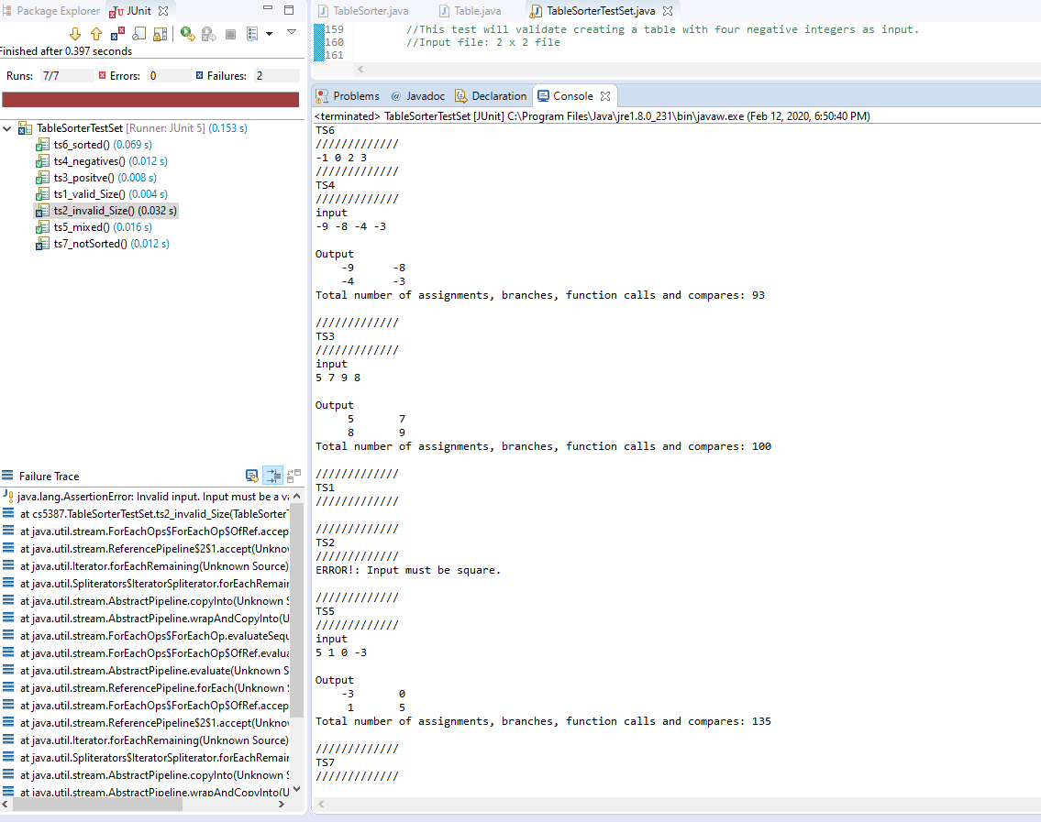

Figure 2 Screen shot of console results.

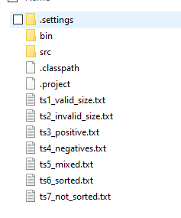

Figure 3 Structure of directory with text files.

&

