tart with GenAI
As a UX or product designer

Claude's Artifacts feature changes the early-stage design loop. Interactive HTML mockups, generated from descriptions, iterated by conversation, with accessibility audited inline. Then handed to engineering, where Copilot turns approved designs into components. This guide shows you the workflow that lets you ship more design work, with stronger accessibility, in less time — without giving up the craft.

your mission

W H Y TH IS IS FOR YOU

What's in it for Designers
Designers spent the last decade in Figma. The next change is happening right now: the early-stage exploration that used to require a Figma file now happens in a conversation. Claude's Artifacts feature renders interactive HTML inline — you describe the screen, Claude builds it, you iterate by talking. Faster than Figma for discovery; harder for high-fidelity polish (so Figma is still your final-stage tool). Used together, you ship more design with stronger accessibility.

The three biggest wins for your day

- Early-stage mockups in 10 minutes. Interactive HTML, sample data, empty/loading/error states all generated together. Iterate by conversation. Move to Figma only when the direction is settled.
- Accessibility audits become routine. A prompt runs WCAG checks across keyboard nav, ARIA, contrast, focus management. Catches what a manual audit usually misses, in 5 minutes.
- Engineering handoff stops being a translation problem. Your HTML mockup IS the spec. Engineers feed it to Copilot, which generates the production component matching their stack. The design intent survives.

What you should NOT expect

✗ That Figma is dead. It isn't. Figma still wins for high-fidelity polish, design systems, and stakeholder review. Claude wins for early-stage exploration.
✗ That AI replaces design judgement. The mockups Claude generates are competent and generic. The taste, the brand, the user empathy — still you.
✗ That accessibility happens automatically. You still have to ASK for the audit. AI will gladly generate a beautiful, inaccessible UI if you don't prompt for it.

T WO TOOLS, D IFFER EN T STR EN GTH S

Claude or Copilot — when to use which

For designers, this is mostly Claude — specifically Claude.ai with Artifacts. The interactive HTML rendering is the unlock. Copilot has a smaller role: when your approved mockups become production components, the engineering team uses Copilot to translate. You stay involved for accessibility QA and visual review, not implementation.

CLAUDE

Better for: mockups, accessibility audits, design exploration
Claude.ai with Artifacts is your daily home. Generate interactive HTML mockups, iterate by conversation, run accessibility audits inline. Use Claude Projects to keep your design system tokens, brand guidelines, and previous design work available across conversations.
Best for: Interactive mockups, accessibility audits, design exploration, copy-and-microcopy iteration, design rationale write-ups.
How to access: claude.ai. Sign in with account. Make sure Artifacts is enabled (Settings → Features).

GITHUB COPILOT

Better for: visual QA on production components
Once engineering builds the production component, Copilot in VS Code helps you review the implementation. Open the component, ask Copilot Chat to compare it to your mockup HTML, flag where the implementation diverged. A small role for designers, but real if you're hands-on in code review.
Best for: Component-level visual QA, comparing implementation to design intent, suggesting microcopy in production code.
How to access: Copilot extensions in VS Code. Optional unless you participate in code review.

T H E S I M P L E R U L E F O R Y O U R R O L E
Design in Claude. QA the implementation in Copilot if you review code. Most designers will spend 95% of their AI time in Claude. Copilot is optional unless you're hands-on in the codebase.

E N D - TO- EN D EXA M PLE

From user flow to accessibility-audited mockup

Five steps, mostly in Claude. The output: a user journey, an interactive HTML mockup with sample data and all states, an accessibility audit, and a clean handoff to engineering. The early-stage design work that used to take a week, in an afternoon.

STEP 01

Map the user journey before drawing pixels
CLAUDE
Claude is your discovery partner. Before any visual design, talk through who the user is, the job they're trying to do, the steps in their flow, and where the friction points are. The mockup is downstream of the flow; if the flow is wrong, the prettier mockup just hides it.

P R O M P T — C L A U D E . A I
You are a senior UX designer at OpenBlue. I'm designing for: .
- Map the user journey from trigger (what makes them open the app) to outcome (what's true when they leave).
- For each step: what they're thinking, what they need, what might go wrong.
- The 3 highest-friction points in this journey today.
- The 1-2 places where the experience needs to feel effortless or the user disengages.

Don't propose UI yet. Flow first.

STEP 02

Sketch the primary screen as an interactive HTML mockup
CLAUDE
Claude.ai's Artifacts feature renders interactive HTML in the chat. Describe the screen with specifics — sample data, brand palette, sober enterprise tone — and iterate by talking, not by editing files. This is faster than Figma for early-stage exploration.

P R O M P T — C L A U D E . A I ( A R T I FA C T S O N )
Build an interactive HTML mockup for .

User:
Primary task:

Show:
- Realistic sample data (6-8 rows, varied severity, plausible values)
- Filter bar with the filters that actually matter
- Header with summary stats
- Empty state, loading state, error state for the same screen

Use the brand palette:
- Primary blue #152EA9
- Dark blue #000070
- Accent green #75E600
- Cyan #00ADFF

Sober enterprise tone — no gradients on body text, no emojis, no lifestyle photography. Tailwind for styling.

STEP 03

Iterate by talking, not editing
CLAUDE
This is the biggest unlock for designers. Don't open the artifact and edit code. Tell Claude: "make severity more prominent", "add a 7-day trend sparkline next to each row", "the filter bar feels heavy — try left rail navigation instead". Claude regenerates. You iterate three times in the time it would take to do one Figma round.

STEP 04

Run the accessibility audit — non-negotiable
CLAUDE
Once the design is in good shape, run the audit. Keyboard nav, ARIA labels, screen reader announcement, contrast ratios, focus management. Get a list of issues with severity and fix. Apply the high-severity ones; document the trade-offs for the rest.
P R O M P T — A C C E S S I B I L I T Y A U D I T
Audit this design for accessibility:
For each issue:
- WCAG 2.1 criterion violated
- Severity (Block / Should-fix / Nit)
- The fix in concrete terms (not just "add ARIA")
- The cost of the fix (5 min / hour / day)

Cover:
- Keyboard navigation and tab order
- Focus management (where does focus go on submit?)
- Screen reader announcement of dynamic content
- Colour contrast (WCAG AA at minimum)
- Touch target sizes
- Error messages — visible AND announced

End with the 3 highest-severity issues that block ship.

STEP 05

Hand off to engineering — Copilot picks up where you stop
GITHUB COPILOT
Once design is approved, the engineer takes the mockup HTML into VS Code. Copilot turns it into a real React/ Vue/whatever component matching the team's stack. Your job ended at design; the engineer's job picks up. You stay involved on accessibility and visual QA, not on implementation.

D E S I G N E R - S P E C I F I C S U P E R P O W E R
Designers are the role where Claude's Artifacts feature creates the biggest workflow change. Iterating on an interactive mockup by talking — not editing files — collapses the discovery loop from days to minutes. The early-stage exploration that used to require a Figma file is now a conversation.

M OR E PATTER N S TO R EU SE

Five everyday wins

Smaller, focused workflows you can drop into your week starting tomorrow. Each one is a 10–15 minute task that pays back forever.

WIN 01

Generate the empty / loading / error states alongside the happy path
CLAUDE — Artifacts
Designers always mean to design these states; they usually ship to engineering with only the happy path. Claude can generate all four states in one prompt. Now there's no excuse.
P R O M P T — C L A U D E — A R T I FA C T S
For this screen, generate all four states as separate sections in one HTML artifact:

- Happy path — populated with realistic data
- Empty state — no data yet, with onboarding microcopy
- Loading state — skeleton or spinner with appropriate hierarchy
- Error state — what the user sees when the API fails
Use palette. Sober enterprise tone. Each state should be visually distinct so an engineer or PM
can compare them side by side.

WIN 02

Microcopy iteration without Figma comments
CLAUDE
Stuck on a button label? An empty-state message? An error sentence? Paste the context and ask for 5 alternatives, each with a one-line rationale. Pick one. Done in 2 minutes instead of 20.

P R O M P T — C L A U D E
I need 5 alternatives for this microcopy:

Current:
Context:
Tone:

For each alternative:
- The copy itself
- One-line rationale (why this works)
- One-line risk (when it would fall flat)

Keep them genuinely different — don't give me 5 versions of the same sentence.

WIN 03

Accessibility audit on existing screens
CLAUDE
Take a screenshot of an existing screen (or describe it) and ask Claude for a WCAG 2.1 AA audit. Severity-ranked, with fixes. Submit as a list of design tickets. Easier than scheduling an external audit; covers most of the issues.
P R O M P T — C L A U D E
Audit this screen for WCAG 2.1 AA accessibility:
For each issue:
- WCAG criterion violated (e.g. 1.4.3 Contrast Minimum)
- Severity (Block / Should-fix / Nit)
- The fix in concrete terms
- Cost of the fix (5 min / 1 hour / 1 day)

Cover: contrast, keyboard nav, focus order, ARIA, screen reader behaviour, touch target size, error visibility, motion sensitivity.

Don't pad with generic items — focus on what could fail given THIS screen's structure.

WIN 04

Design rationale write-up for stakeholder review
CLAUDE
After a design decision, write up the rationale: what we considered, what we chose, why, the trade-offs accepted. Stakeholders deserve this; you usually don't have time to write it. Claude drafts; you edit.

P R O M P T — C L A U D E
Help me write up the design rationale for stakeholder review.

The decision:
The options considered:
The trade-offs:
The input:

Draft a 1-page rationale with:
- The decision in 1 sentence
- Options considered (1 line each + why rejected)
- The chosen approach with reasoning
- Trade-offs accepted (be honest)
- What we'll measure to know if it worked

Tone: confident, not defensive. No design jargon a PM wouldn't follow.

WIN 05

Component variation explorer
CLAUDE — Artifacts
Designing a card component? A toolbar? A modal? Ask Claude for 4 distinct visual approaches — same content, different structures. Iterate from the one that feels closest. Faster than starting from a blank Figma frame.
P R O M P T — C L A U D E — A R T I FA C T S
I need to design a for this content:
Generate 4 distinct visual approaches as a single HTML artifact, side by side:
- Conventional / safe
- Information-dense
- Visual-led / hierarchy-driven
- Minimal / ambient
For each, add a one-line caption explaining the design intent. Use palette. Tailwind. No emojis.

B U ILD TH E H A B IT

Day 1, Week 1, Month 1

A staged adoption plan. Don't try everything in week one — that's the most common reason people drop off. Start small, build proof, then expand.
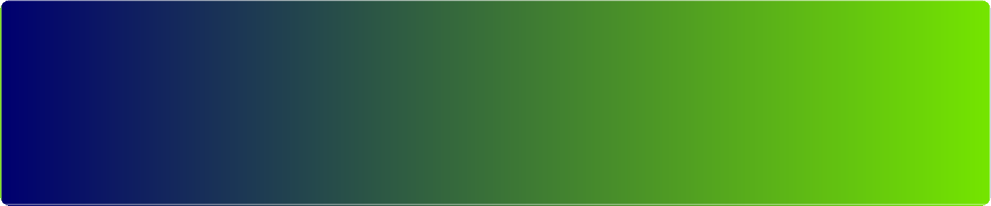
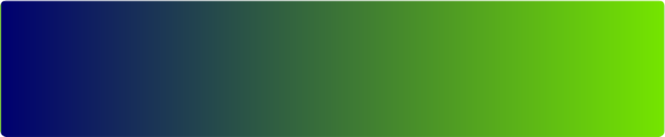
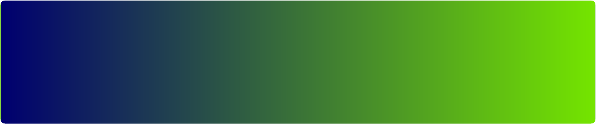

D A Y 1 — T O D A Y
Run an accessibility audit on a screen you already shipped
Today: pick one screen you've designed in the last quarter. Open Claude.ai, take a screenshot or describe it in detail, run the accessibility audit prompt. You'll find at least 2-3 issues that didn't make your manual audit. That's your proof of value — and a list of design tickets for tomorrow.

W E E K 1
Build one early-stage mockup in Claude before opening Figma
This week: take your next discovery brief. Instead of opening Figma, open Claude. Run the user-journey prompt, then the mockup prompt. Iterate by conversation. Once direction is clear, THEN move to Figma for high-fidelity polish. Compare the speed to your usual flow. You'll feel the difference by the second iteration.

M O N T H 1
Make accessibility audits routine. Build your prompt library.
By month's end, every screen you ship has run through the accessibility audit prompt at least once. You also have your own prompt library — empty/loading/error states, microcopy alternatives, component variations, design rationale write-up — saved in Claude Projects. Reuse, don't rewrite.

What to avoid as a beginner

✗ Skipping the accessibility audit because the design 'looks fine'. The most common a11y issues are invisible to sighted users without disabilities. Run the audit. Always.
✗ Letting AI generate a 'modern' UI with gradients, animations, and emojis. Default AI design is loud and consumer-flavoured. Specify sober enterprise tone, palette, no emojis — every time.
✗ Iterating in code instead of in conversation. The unlock with Artifacts is talking. If you're editing the HTML directly, you've fallen back into the old workflow.
✗ Skipping empty / loading / error states because the prompt didn't ask for them. Always ask. Engineering will discover them at the demo otherwise.
✗ Pasting customer screenshots with PII into prompts. Anonymize. Always. Real names and real building IDs are not test data.
✗ Treating Claude's mockup as the final design. It's competent and generic. The brand, the polish, the considered animation — still your job, in Figma.



Faster discovery. Sharper accessibility.
The early-stage design work that used to take a week now takes an afternoon. Spend the time you save on the parts of design only you can do — taste, craft, brand, user empathy. Claude handles the structure; you handle the soul.

