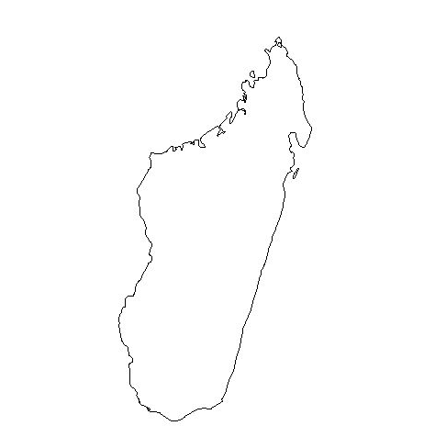

Nosy Boraha
200 km

Antananarivo

Antsirabe

Fianarantsoa

Manakara

Mananjary

Mahanoro

Nosy Varika

Toamasina

Nosy Boraha
200 km

Antananarivo

Antsirabe

Fianarantsoa

Manakara

Mananjary

Mahanoro

Nosy Varika

Toamasina

Nosy Boraha
200 km

Antananarivo

Antsirabe

Fianarantsoa

Manakara

Mananjary

Mahanoro

Nosy Varika

Toamasina

Nosy Boraha
200 km

Antananarivo

Antsirabe

Fianarantsoa

Manakara

Mananjary

Mahanoro

Nosy Varika

Toamasina

Nosy Boraha
200 km

Antananarivo

Antsirabe

Fianarantsoa

Manakara

Mananjary

Mahanoro

Nosy Varika

Toamasina

Nosy Boraha
200 km

Antananarivo

Antsirabe

Fianarantsoa

Manakara

Mananjary

Mahanoro

Nosy Varika

Toamasina

Nosy Boraha
200 km

Antananarivo

Antsirabe

Fianarantsoa

Manakara

Mananjary

Mahanoro

Nosy Varika

Toamasina

Nosy Boraha
200 km

Antananarivo

Antsirabe

Fianarantsoa

Manakara

Mananjary

Mahanoro

Nosy Varika

Toamasina

Nosy Boraha
200 km

Antananarivo

Antsirabe

Fianarantsoa

Manakara

Mananjary

Mahanoro

Nosy Varika

Toamasina

Nosy Boraha
200 km

Antananarivo

Antsirabe

Fianarantsoa

Manakara

Mananjary

Mahanoro

Nosy Varika

Toamasina

Nosy Boraha
200 km

Antananarivo

Antsirabe

Fianarantsoa

Manakara

Mananjary

Mahanoro

Nosy Varika

Toamasina

Nosy Boraha
200 km

Antananarivo

Antsirabe

Fianarantsoa

Manakara

Mananjary

Mahanoro

Nosy Varika

Toamasina

Nosy Boraha
200 km

Antananarivo

Antsirabe

Fianarantsoa

Manakara

Mananjary

Mahanoro

Nosy Varika

Toamasina

Nosy Boraha
200 km

Antananarivo

Antsirabe

Fianarantsoa

Manakara

Mananjary

Mahanoro

Nosy Varika

Toamasina

Nosy Boraha
200 km

Antananarivo

Antsirabe

Fianarantsoa

Manakara

Mananjary

Mahanoro

Nosy Varika

Toamasina

Nosy Boraha
200 km

Antananarivo

Antsirabe

Fianarantsoa

Manakara

Mananjary

Mahanoro

Nosy Varika

Toamasina

Nosy Boraha
200 km

Antananarivo

Antsirabe

Fianarantsoa

Manakara

Mananjary

Mahanoro

Nosy Varika

Toamasina

Nosy Boraha
200 km

Antananarivo

Antsirabe

Fianarantsoa

Manakara

Mananjary

Mahanoro

Nosy Varika

Toamasina

Nosy Boraha
200 km

Antananarivo

Antsirabe

Fianarantsoa

Manakara

Mananjary

Mahanoro

Nosy Varika

Toamasina

Nosy Boraha
200 km

Antananarivo

Antsirabe

Fianarantsoa

Manakara

Mananjary

Mahanoro

Nosy Varika

Toamasina

