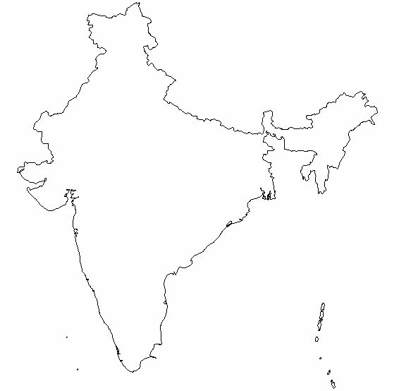
Dharmsala
Amritsar
Delhi
Jaipur
S. Madhopur
Mandu
Agra
Bhopal
Sanchi
Indore
Aurangabad
Ajanta
Bangalore
Mysore
Kodaikanal
Kumily
Alleppey
Varkala
Trivandrum
Ponmudi
300 km
Dharmsala
Amritsar
Delhi
Jaipur
S. Madhopur
Mandu
Agra
Bhopal
Sanchi
Indore
Aurangabad
Ajanta
Bangalore
Mysore
Kodaikanal
Kumily
Alleppey
Varkala
Trivandrum
Ponmudi
300 km
Dharmsala
Amritsar
Delhi
Jaipur
S. Madhopur
Mandu
Agra
Bhopal
Sanchi
Indore
Aurangabad
Ajanta
Bangalore
Mysore
Kodaikanal
Kumily
Alleppey
Varkala
Trivandrum
Ponmudi
Dharmsala
300 km
Dharmsala
Amritsar
Delhi
Jaipur
S. Madhopur
Mandu
Agra
Bhopal
Sanchi
Indore
Aurangabad
Ajanta
Bangalore
Mysore
Kodaikanal
Kumily
Alleppey
Varkala
Trivandrum
Ponmudi
300 km
Dharmsala
Amritsar
Delhi
Jaipur
S. Madhopur
Mandu
Agra
Bhopal
Sanchi
Indore
Aurangabad
Ajanta
Bangalore
Mysore
Kodaikanal
Kumily
Alleppey
Varkala
Trivandrum
Ponmudi
300 km
Dharmsala
Amritsar
Delhi
Jaipur
S. Madhopur
Mandu
Agra
Bhopal
Sanchi
Indore
Aurangabad
Ajanta
Bangalore
Mysore
Kodaikanal
Kumily
Alleppey
Varkala
Trivandrum
Ponmudi
300 km
Dharmsala
Amritsar
Delhi
Jaipur
S. Madhopur
Mandu
Agra
Bhopal
Sanchi
Indore
Aurangabad
Ajanta
Bangalore
Mysore
Kodaikanal
Kumily
Alleppey
Varkala
Trivandrum
Ponmudi
300 km
Dharmsala
Amritsar
Delhi
Jaipur
S. Madhopur
Mandu
Agra
Bhopal
Sanchi
Indore
Aurangabad
Ajanta
Bangalore
Mysore
Kodaikanal
Kumily
Alleppey
Varkala
Trivandrum
Ponmudi
300 km
Dharmsala
Amritsar
Delhi
Jaipur
S. Madhopur
Mandu
Agra
Bhopal
Sanchi
Indore
Aurangabad
Ajanta
Bangalore
Mysore
Kodaikanal
Kumily
Alleppey
Varkala
Trivandrum
Ponmudi
300 km

Dharmsala
300 km
Amritsar
Delhi
Jaipur
S. Madhopur
Mandu
Agra
Bhopal
Sanchi
Indore
Aurangabad
Ajanta
Bangalore
Mysore
Kodaikanal
Kumily
Alleppey
Varkala
Trivandrum
Ponmudi
300 km
Dharmsala
300 km
Amritsar
Delhi
Jaipur
S. Madhopur
Mandu
Agra
Bhopal
Sanchi
Indore
Aurangabad
Ajanta
Bangalore
Mysore
Kodaikanal
Kumily
Alleppey
Varkala
Trivandrum
Ponmudi
300 km
Dharmsala
300 km
Amritsar
Delhi
Jaipur
S. Madhopur
Mandu
Agra
Bhopal
Sanchi
Indore
Aurangabad
Ajanta
Bangalore
Mysore
Kodaikanal
Kumily
Alleppey
Varkala
Trivandrum
Ponmudi
300 km
Dharmsala
300 km
Amritsar
Delhi
Jaipur
S. Madhopur
Mandu
Agra
Bhopal
Sanchi
Indore
Aurangabad
Ajanta
Bangalore
Mysore
Kodaikanal
Kumily
Alleppey
Varkala
Trivandrum
Ponmudi
300 km
Dharmsala
300 km
Amritsar
Delhi
Jaipur
S. Madhopur
Mandu
Agra
Bhopal
Sanchi
Indore
Aurangabad
Ajanta
Bangalore
Mysore
Kodaikanal
Kumily
Alleppey
Varkala
Trivandrum
Ponmudi
300 km
Dharmsala
300 km
Amritsar
Delhi
Jaipur
S. Madhopur
Mandu
Agra
Bhopal
Sanchi
Indore
Aurangabad
Ajanta
Bangalore
Mysore
Kodaikanal
Kumily
Alleppey
Varkala
Trivandrum
Ponmudi
300 km
Dharmsala
300 km
Amritsar
Delhi
Jaipur
S. Madhopur
Mandu
Agra
Bhopal
Sanchi
Indore
Aurangabad
Ajanta
Bangalore
Mysore
Kodaikanal
Kumily
Alleppey
Varkala
Trivandrum
Ponmudi
300 km
Dharmsala
300 km
Amritsar
Delhi
Jaipur
S. Madhopur
Mandu
Agra
Bhopal
Sanchi
Indore
Aurangabad
Ajanta
Bangalore
Mysore
Kodaikanal
Kumily
Alleppey
Varkala
Trivandrum
Ponmudi
300 km
Dharmsala
300 km
Amritsar
Delhi
Jaipur
S. Madhopur
Mandu
Agra
Bhopal
Sanchi
Indore
Aurangabad
Ajanta
Bangalore
Mysore
Kodaikanal
Kumily
Alleppey
Varkala
Trivandrum
Ponmudi
300 km
m
Dharmsala
300 km
Amritsar
Delhi
Jaipur
S. Madhopur
Mandu
Agra
Bhopal
Sanchi
Indore
Aurangabad
Ajanta
Bangalore
Mysore
Kodaikanal
Kumily
Alleppey
Varkala
Trivandrum
Ponmudi
Dharmsala
300 km
Amritsar
Delhi
Jaipur
S. Madhopur
Mandu
Agra
Bhopal
Sanchi
Indore
Aurangabad
Ajanta
Bangalore
Mysore
Kodaikanal
Kumily
Alleppey
Varkala
Trivandrum
Ponmudi
Dharmsala
300 km
Amritsar
Delhi
Jaipur
S. Madhopur
Mandu
Agra
Bhopal
Sanchi
Indore
Aurangabad
Ajanta
Bangalore
Mysore
Kodaikanal
Kumily
Alleppey
Varkala
Trivandrum
Ponmudi
Dharmsala
300 km
Amritsar
Delhi
Jaipur
S. Madhopur
Mandu
Agra
Bhopal
Sanchi
Indore
Aurangabad
Ajanta
Bangalore
Mysore
Kodaikanal
Kumily
Alleppey
Varkala
Trivandrum
Ponmudi
Dharmsala
300 km
Amritsar
Delhi
Jaipur
S. Madhopur
Mandu
Agra
Bhopal
Sanchi
Indore
Aurangabad
Ajanta
Bangalore
Mysore
Kodaikanal
Kumily
Alleppey
Varkala
Trivandrum
Ponmudi
Dharmsala
300 km
Amritsar
Delhi
Jaipur
S. Madhopur
Mandu
Agra
Bhopal
Sanchi
Indore
Aurangabad
Ajanta
Bangalore
Mysore
Kodaikanal
Kumily
Alleppey
Varkala
Trivandrum
Ponmudi
Dharmsala
300 km
Amritsar
Delhi
Jaipur
S. Madhopur
Mandu
Agra
Bhopal
Sanchi
Indore
Aurangabad
Ajanta
Bangalore
Mysore
Kodaikanal
Kumily
Alleppey
Varkala
Trivandrum
Ponmudi
Dharmsala
300 km
Amritsar
Delhi
Jaipur
S. Madhopur
Mandu
Agra
Bhopal
Sanchi
Indore
Aurangabad
Ajanta
Bangalore
Mysore
Kodaikanal
Kumily
Alleppey
Varkala
Trivandrum
Ponmudi
Dharmsala
300 km
Amritsar
Delhi
Jaipur
S. Madhopur
Mandu
Agra
Bhopal
Sanchi
Indore
Aurangabad
Ajanta
Bangalore
Mysore
Kodaikanal
Kumily
Alleppey
Varkala
Trivandrum
Ponmudi

