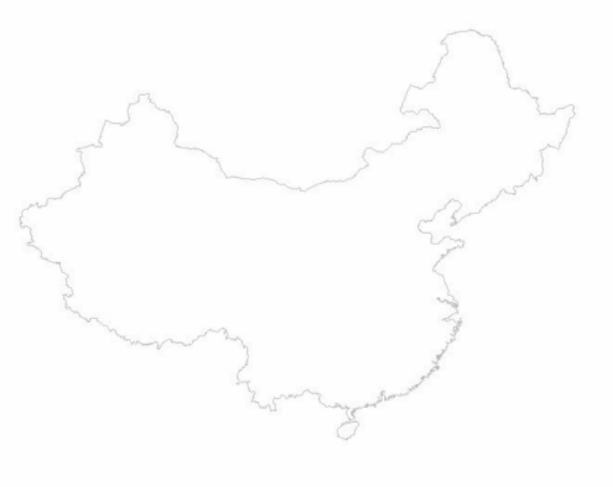
250 km

Beijing

Shanghai

Xi'an

Chengdu

Emei

Kangding

Litang

Xiancheng

Dali

Kunming

Shilin

Guilin

Yangshuo

Guangzhou

Hong Kong

