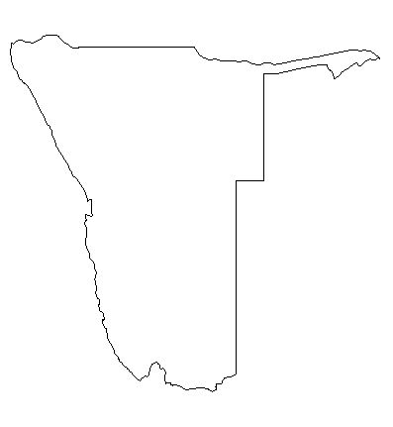
100 km

Windhoek

Okavango Delta

Ghanzi

Swakopmund

Rundu

Twyfelfontein

Etosha

Skeleton Coast

Namib Desert

Kalahari

Cape Cross

Sesriem

Sossusvlei

Caprivi Park

