Harveer Singh ------------

Ekta Jain ------------

Course: CSIS 3380

Section: 003

Instructor: Reza Ghaeli

Final Project

Cocktail Cards using API

Due: December 10th, 2022

1. Installation

To install the project, first open terminal in your visual studio and run command ‘npm install’ to install the required dependencies. It will create a folder called ‘node_modules’ which will have all the references.

Now, go to the terminal and run the command ‘npm start’

This will start the project and run it on port: 3000. A tab from the browser will open where we can test the application.

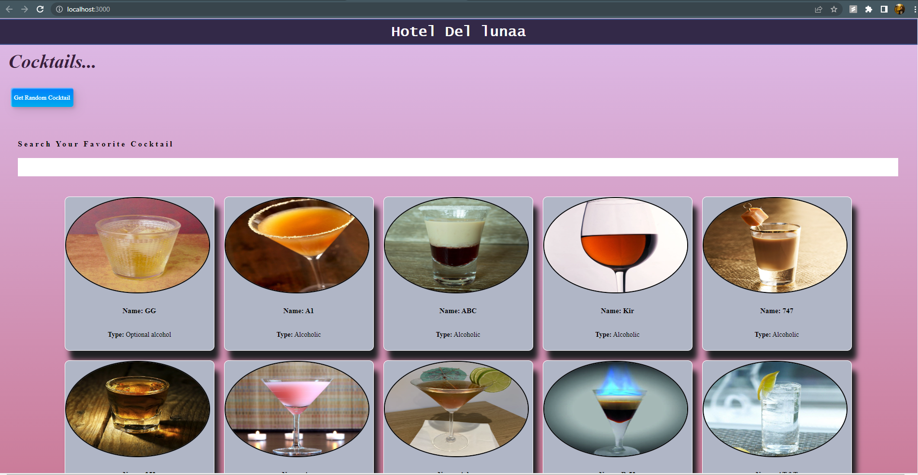

1. Features

Search your favourite cocktail with responsive search bar.

Add a new cocktail using ‘Get Random Cocktail’ button.

1. Links

Github: <https://github.com/Harveer-kalkat/cocktail-cards>