**Ref STECF 2572 – Ad hoc contract data preparation before STECF EWG 25-09 for stock NEP 9 & 5**

**Report – NEP 5**

**Compiled by**: Enrico Nicola Armelloni

**Date**: 04/09/2025

**ToR 1**

To compile and provide the most updated information on stock identification and boundaries, length and age composition, growth, maturity, feeding, essential fish habitats including spawning grounds and seasonality as well as natural mortality.

**ToR 2**

To compile and provide complete sets of annual data on landings and discards as well as the standardized MEDITS Index for the longest time series available up to and including 2024, including length frequency distribution over time. To provide a complete and updated stock assessment input file in the format of those used in 2024.

Contents

ToR 1 1

Material and methods 2

Essential Fish Habitat and spatial distribution of the spawning grounds 2

Stock identification and boundaries 2

Biological parameters 2

Results 3

Essential Fish Habitat and spatial distribution of the spawning grounds 3

Stock boundaries 4

Biological parameters 4

ToR 2 8

Material and Methods 8

Commercial data 8

Survey 8

Results 9

Commercial data 9

Survey 13

Stock assessment input files 15

References 16

ToR 1

## Material and methods

Essential Fish Habitat and spatial distribution of the spawning grounds

A summary of the main life history traits influencing the distribution of Norway lobster (NEP) is provided based on literature. In addition, it is reported the results of a request of STECF in 2023 to map the persistent hot spot for NEP in the Western Mediterranean. The methodology and results were reported to STECF-PLEN-23-02. The hotspot map is based on model predictions. A spatial distribution model for NEP spawners was implemented under model as a Zero-altered (or hurdle) models - with a binomial presence-absence model (i.e., binomial(link = "logit") and another model for the positive catches only with a Gamma observation distribution and a log link (i.e., Gamma(link = "log")). Predictions were made on a grid of 2.5 nm x 2.5 nm and intersecting the western Mediterranean GSAs and the bathymetric contour of 850 m (MEDITS bottom trawl survey data do not exceed a depth of 800 m). The Getis’ G statistic was calculated for each year with a radius of 2.5-5 km, and hotspots were identified in grid cells with Z values greater than the 90° percentile by year. An Index of Persistence (PIx) - measuring the relative persistence of the cell i as an annual hotspot - was calculated by counting the number of times grid cell i was identified as a hotspot and classified in 5 levels: 1 (0-20%]; 2 (20-40%]; 3 (40; 60%]; 4 (60;80%]; 5 (80-100%]. Models were implemented by sub-areas: Balearic (ESP), Tyrrhenian (TYR), and Sardinia (SAR).

Stock identification and boundaries

Stock identification information base on the results of a recent genetic population study conducted at Mediterranean scale (MED_units, (Spedicato, 2022), which compared the genetic structure of Norway lobster samples across the European GSAs. This information is complemented with literature on spatial connectivity.

Biological parameters

To the present report we briefly review factors influencing life history traits of Norway lobster. The sets of parameters reported in the DCF database are summarized and, when possible, we propose re-analysis and additional parameters from literature.

***Growth parameters:*** The sets of VBGF parameters reported in the medbs dataset are summarised accounting for sampling size and the correlation between parameters. We labeled and excluded from following analysis those sets of parameters which sample size was below the 25th percentile of the available sampling intensity (number of individuals measured). The internal correlation in the VBGP is addressed by treating them as multivariate distributions (Scott et al., 2016). Mean of each parameter and their covariance matrix were calculated from those sets with sampling intensity higher than the entry threshold. Mean and covariances were then used to draw 2000 multivariate samples from a multivariate normal (MVN) distribution. Summary statistics are generated by calculating the median values, the 5th and the 95th percentiles. We also report and summarize other sets of growth parameters found in literature by applying the same method (MVN).

***Length weight relationship:*** The sets of lenght-weigth (LW) parameters reported in the medbs dataset are summarised accounting for sampling size and the correlation between parameters. We labeled and excluded from following analysis those sets of parameters which sample size was below the 25th percentile of the available sampling intensity (number of individuals measured). The internal correlation is addressed by treating them as multivariate distributions (Scott et al., 2016). Mean of each parameters and their covariance matrix were calculated from those sets with sampling intesity higher than the entry threshold. Mean and covariances were then used to draw 2000 multivariate samples from a multivariate normal distribution. Summary statistics are generated by calculating the median values, the 5th and the 95th percentiles. Single draws from the MVN distribution can be used to perform sensitivity test.

***Sex ratio: a***nnual sex ratio vectors were also filtered by sampling intensity, borrowing the numbers available in the lw distribution dataset. Those sets with sampling intesity higher than the entry threshold were analyzed using a generalized additive model (GAM). The response variable, sex ratio, was modelled as a smooth function of size class to account for the non-linear response.

***Maturity (maturity at age, spawning seasonality, other fecundity data):*** We summarize the maturity at length and maturity at age data provided in the medbs datasets, along with some re-analysis and data from literature. An overall maturity at size curve is calculated from the annual maturity at size (proportion of mature individuals) provided in the medbs dataset. A number *n* of individual observations per year and length class are generated for each year and as *Xi ~ Bernoulli(p*), *i= 1, … , n*, where *n* is the sample size and *p* is the proportion of mature reported in the data. A generalised linear model for proportion of mature as a function of length class, with binomial link function (link = logit), is fit to the individual observations using the glm function from the mgcv R package. The predicted proportion of mature by lengthclass is used as a maturity at size curve. L50 is also calculated from the model. Maturity at age vectors reported in the medbs data were summarised by calculating the mean proportion of mature at age over the dataset. A new vector was also re-estimated after estimating numbers at age based on the VBGP calculated in the present report, to check for coherency with medbs data. The annual length frequency distributions were divided by sex based on the aggregated sex-ratio vector. To each size class *l* it was associated a probability to fall in one or more age classes based on the VBGP estimation. Number of mature individuals at age *a* for each year *y* was obtained as , where is the probability to be mature at length *l* and is number at length *l* in year *y*.

***Natural mortality:*** natural mortality by sex and age are calculated using the Chen and Wattanabe method. A natural mortality vector was estimated by sex using the Chen and Watanabe equation and the growth parameters described above. A combined natural mortality vector was then computed as a weighted average of the vectors by sex. In addition, point estimates of natural mortality by sex were computed using the Barefoot ecologist toolbox[1], by taking the median value of several methods (Then, Hamel, Jensen, ZM).

***Other relevant biological parameters:*** this section includes any additional source of information that might be relevant for the stock assessment.

Results

Essential Fish Habitat and spatial distribution of the spawning grounds

Norway lobster highest concentrations can be found between 200 and 500 m (SIBM, 2017). Distribution is influenced by hydrological conditions and bottom types, more than depth, with a preference for cold waters with relatively high oxygen concentrations (SIBM, 2017). Muddy-sandy bottoms characterized by the presence of compact mud are preferred by the species, since they represent the optimal substrate for the construction of burrows. It digs burrows in such substrates and spends most of its time lying in such burrows. Its behavior when it emerges, makes it vulnerable to bottom trawling. The spatial distribution model fitted on the MEDITS data were used to build hotspot persistency maps. It emerges that in the Balearic Sea, persistent spawning ground has been mostly identified around the Ibiza and Formentera islands. Some minor spawning grounds are scattered around Mallorca Island. The spawning grounds in the contiguous GSA 6 are separated by deep waters.

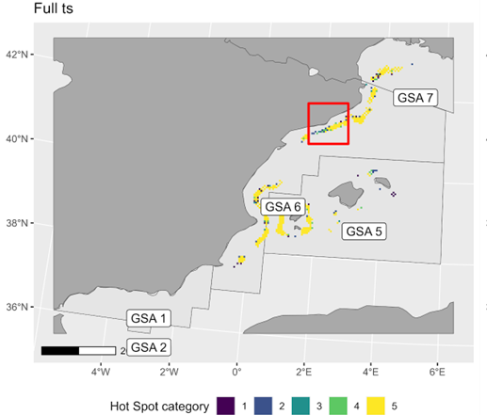

Figure 1 Persistent spawning areas of Norway lobster in the Thyrrenian Sea

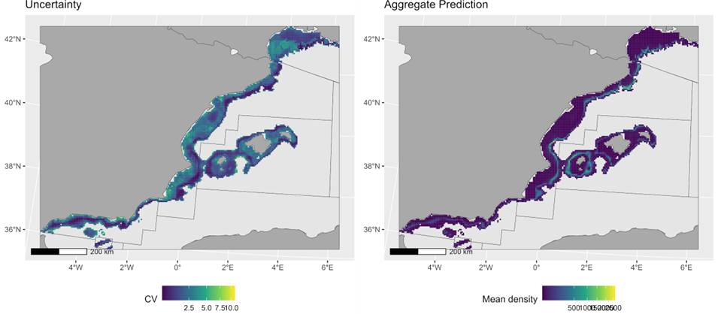

Figure 2: model spatial uncertainty and mean predictions

Stock boundaries

The results of the MED_units project suggested genetic continuity over the western Mediterranean from the Alboran Sea to the Thyrrenian Sea. Nevertheless, studies performed in other areas of the Mediterranean suggests that the ecological characteristics of the species might favor the existence of sub-populations that are even smaller than the current statistical areas (GSAs) (Melaku Canu et al., 2021). The spatial distribution of Spawner grounds suggests that the deep waters between the Balearic Archipelago and the continental shelf of Spain mainland can act as a biogeographic barrier. The present stock assessment has historically considered the population confined in the GSA 5. There are no evidences that suggests a revision of the actual stock configuration.

Biological parameters

***Growth parameters:*** The estimation of the Von Bertalanffy growth parameters (VBGP) poses challenges in Norway lobseter. Methods commonly used to indirect estimations of size at age (i.e.: tracking modal progression in length frequency data) are of difficult because of the absence of clear cohorts (Castro et al., 1998; Chiarini, 2023). The spawning behavior (continuous recruitment) cause the length frequency distribution to be the sum of multiple overlapping cohorts with poor or absent modal distinction (Castro et al., 1998; Chiarini, 2023). All the VBGP that we could identify in literature and in the medbs dataset base on some variation of modal progression tracking. Other challenges associated with VBGP calculation are linked to species ecology and spawning behavior. Literature highlights that growth parameters can vary depending on local environmental conditions and density of burrows (negative correlation). The decreased catchability of berried females, which mainly remains in their burrows, implies less vulnerability to bottom trawl and to the sampling. The low representation of females in trawling samples can have an effect on the estimation of female growth parameters (SIBM, 2017). Due to the challenges here summarized it is recommended to include explicit considerations of growth parameters uncertainty in the stock assessment.

Growth parameters are only available as sex combined for GSA 5, and no annual re-estimation of the growth paraneters is available in the medbs dataset. We include in table the values used in the most recent stock assessment and literature estimations for the catalan Sea from early MEDITS data (Mytilineou *et al.*, 1998; Sardà *et al.*, 1998). These early estimations are highly variable, and caution is required when they are used for deterministic slicing. Nevertheless, they can serve to highlight the magnitude of sexual dimorphism observed in this area.

Table 1: sets of VBGP from the official data collection and from literature, along with summaries elaborated in the present report. Values in bracket are 5% and 95% confidence intervals.

|  |  |  |  |  |  |
| --- | --- | --- | --- | --- | --- |
| Source | id | Sex | Linf (mm) | k | t0 |
| STECF 24-09 | 1 | C | 86.1 | 0.126 | 0 |
| (Mytilineou et al., 1998) | 2 | M | 72.9 | 0.14 | -1.43 |
| 2 | F | 54.9 | 0.18 | -1.36 |
| 3 | M | 85.7 | 0.1 | -0.52 |
| 3 | F | 71.4 | 0.12 | -0.53 |
| (Sardà et al., 1998) | 4 | M | 86.8 | 0.1 | -0.3 |
| 4 | F | 67 | 0.15 | -0.89 |
| This report | 5 | M | 81.64 (67.66-97.94) | 0.11 (0.08-0.16) | -0.75 (-1.93-0.36) |
| 5 | F | 63.97 (48.85-85.14) | 0.15 (0.1-0.22) | -0.93 (-1.77—0.08) |

***Length weight (LW) relationship:*** parameters are available as sex combined for GSA 5. We include in table the values used in the most recent stock assessment and the estimates produced for this report, as well as some recent literature estimate for sex separated evaluation (Vigo et al., 2024). Observing the values estimated there is no clear in the parameters. Also, no larges differences are observed by sex and among the reported sources.

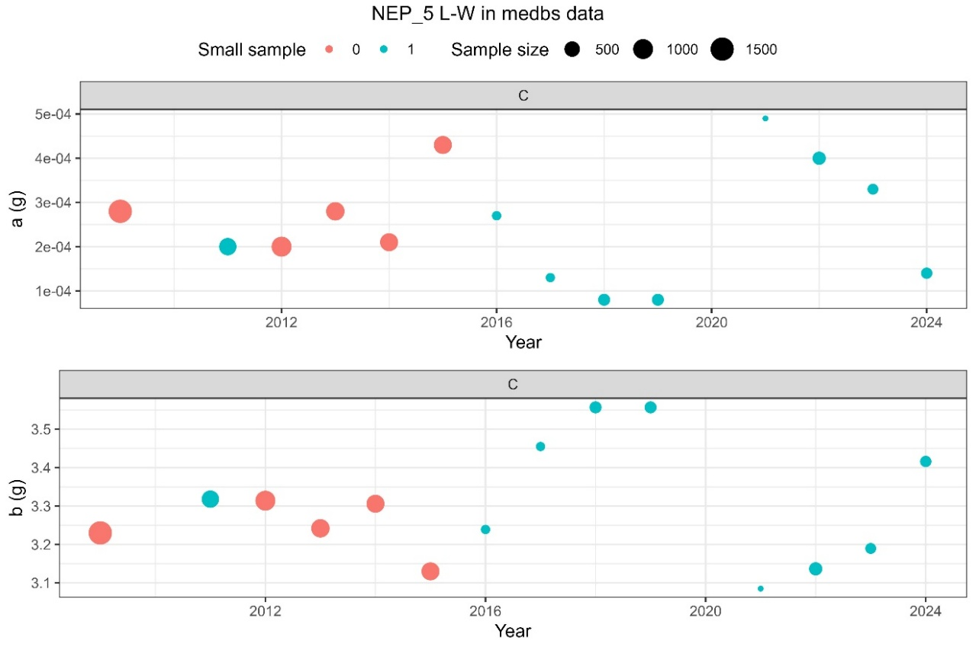

Figure 3: time series of the LW parameters. Colors indicate whether the sample size was below (blue) or above (red) the 25th percentile of the overall sampling intensity

Table 2: sets of LW parameters from the official data collection, along with summaries elaborated in the present report. Values in bracket are 5% and 95% confidence intervals.

|  |  |  |  |  |
| --- | --- | --- | --- | --- |
| Source | Id | Sex | a (mm/g) | b (mm/g) |
| EWG 24 10 | 1 | C | 0.000398 | 3.136 |
| This report | 2 | C | 0.00024 (0.00004 – 0.00046) | 3.31 (3.01 – 3.56) |
| (Vigo et al., 2024) | 3 | C | 0.0005 | 3.116 |
| 4 | M | 0.004 | 3.176 |
| 4 | F | 0.004 | 3.1736 |

***Sex ratio***: data where filtered at the 75th percentile to exclude suspicious values.The sex ratio estimated for this area include a low amount of data for small sizes (< 20 mm) and for large sizes (> 60 mm CL). Years with low sampling intensity (blue) were excluded. A low number of extremely high sex ratios for individuals > 60 mm CL drives the model fit, which is therefore fixed equal to SR 20 mm for low sizes. SR is fixed as exponential decline between 60 mm CL and the maximum size for which a female individual is observed.

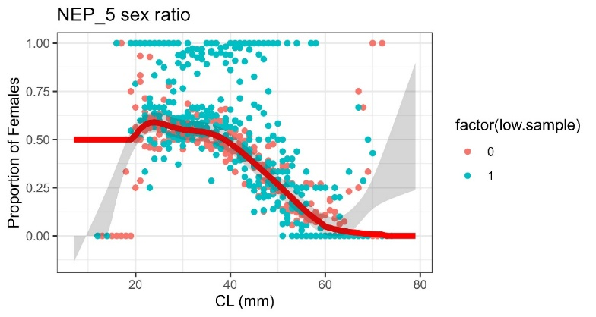

Figure 4: observed and modeled sex ratio at length. Colors indicate whether the sample size was below (blue) or above (red) the 75th percentile of the overall sampling intensity.

***Maturity (maturity at age, spawning seasonality, other fecundity data):*** Norway lobster females follows seasonal maturation cycles, while spermatogenesis in males ocurr thoughout the year. Orsi Relini et al., 1998 summarizes the main reproductive features of Norway lobster in the Mediterranean Sea, taking the Ligurian Sea (GSA 9) as a key study. Maturation of the ovary starts in late spring and peaks during summer, and spawning peak in late summer (Orsi Relini et al., 1998; SIBM, 2017). For the purpose of the stock assessment, a key feature of the Norway lobster reproductive cycle is the long (4-6 months in the Mediterranean) incubation period. After spawning the “berried” females carries the eggs and spend most of the time burrowed. The hatching takes place between october and march of the following year (Orsi Relini et al., 1998). As a result, the individuals are born over a large time window that spans over different calendar years. When the population has to be divided into age classes it is recommended to use the conventional birthday at January 1st (Orsi Relini et al., 1998). Fort the Balearic Sea we report observations for the neighbouring Catalan Sea (Rotllant et al., 2005; Vigo et al., 2024). Spawning peak is in late summer (August) and berried females are found though the winter untile march of the subsequent year. The main difference from the Ligurian Sea seems a sligth delay in spawning (more shifted toward august-september) and hatching (peak ocurrs around december-march). Fecundity (number of eggs) increases with animal size, a summary of fecundity parameters is extracted from literature (Orsi Relini et al., 1998). The construction of a maturity-at-age vector is complicated by the difficulty of estimating age in first principle. Based on empirical observations, Orsi Relini et al., 1998 concludes that maturity onset in age 2+ females and that majority of females are capable to spawn at the age of 4 years. The maturity at size data shows only a limited amount of outliers (females around 20 mm CL fully mature). From the data summary emerges a L50 equal to 32 mm, which is coherent to what reported in old literature (Orsi Relini et al., 1998) and higher to what reported in recent literature (Vigo et al., 2024). No maturity at age data are reported in the medbs dataset for this area. We provide here the maturity vector used in previous assessment and we compared with with our estimation. The maturity vector estimated in this report is not considered of sufficient quality to be included in the stock assessment.

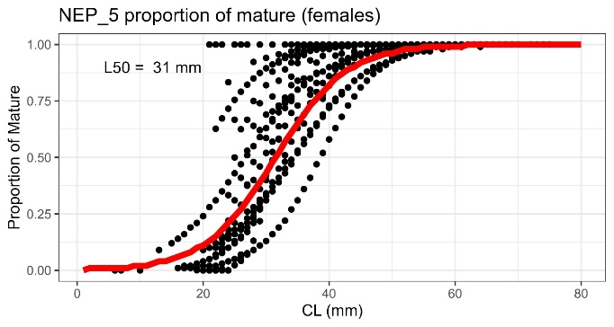

Figure 5: left) observed and modeled maturity at length; maturity at age from the last stock assessment (red) and estimated in this report (blue).

Table 3: sets of maturity vectors from the official data collection, along with summaries elaborated in the present report.

|  |  |  |  |  |  |  |  |  |  |  |  |
| --- | --- | --- | --- | --- | --- | --- | --- | --- | --- | --- | --- |
| **Maturity** | **ID** | **0** | **1** | **2** | **3** | **4** | **5** | **6** | **7** | **8** | **9+** |
| STECF 24-10 | 1 | 0 | 0.1 | 0.25 | 0.8 | 1 | 1 | 1 | 1 | 1 | 1 |
| **This report – summary** | 2 | 0.04 | 0.13 | 0.27 | 0.39 | 0.54 | 0.69 | 0.8 | 0.87 | 0.9 | 0.93 |

***Natural mortality (compilation of sources):*** natural mortality was estimated using the Chen Wattanabe formula as a vector of mortality at age. Combined vector base on set of VBGP 1, vector by sex base on set 5.

Table 4: natural mortality vectors

|  |  |  |  |  |  |  |  |  |  |  |
| --- | --- | --- | --- | --- | --- | --- | --- | --- | --- | --- |
| Mortality | method | 1 | 2 | 3 | 4 | 5 | 6 | 7 | 8 | 9+ |
| Combined | CW | 0.73 | 0.46 | 0.35 | 0.29 | 0.25 | 0.23 | 0.21 | 0.19 | 0.18 |
| Males | CW | 0.5 | 0.37 | 0.29 | 0.25 | 0.22 | 0.2 | 0.18 | 0.17 | 0.16 |
| Females | CW | 0.49 | 0.37 | 0.31 | 0.27 | 0.24 | 0.22 | 0.21 | 0.20 | 0.19 |

ToR 2

Material and Methods

The data on landings, discards and MEDITS index are checked and standardized following methodology proposed by EWG 2501, reported in Figure 7. The only difference that we adopt is the use of growth parameters calculated within this ad hoc contract (see ToR 1). The issues identified are addressed and, when possible, solved. Additional checks, as well as other relevant data that are not part of the *medbs* data call are also eventually introduced. Stock assessment input files are also prepared following the guidelines proposed by EWG 2501, along with a few additional consistency checks. The stock assessment input are compared to the most recent available stock assessment files and briefly described.

Figure 6: workflow diagram illustrating the data review process and object creation preceding the stock assessment

### Commercial data

The commercial data are processed using the script “Checking_DCF_NEP_5.Rmd”. The resulting document contains all the relavant figures and numbers, and is provided as Annex 1. In this report are only addressed the inconsistencies detected. These are manually inspected, and when possible solved. Reconstruction of LFD (filling gaps) is implemented when necessary, justification is provided otherwise. The effect of eventual residual data inconsistency is addressed and discussed.

### Survey

The medits survey data are processed using the script “Checking_SURVEY_NEP_5.Rmd The resulting document contains all the relavant figures and numbers, and is provided as Annex 2. In this report are only addressed the inconsistencies detected, and any other sort of data issue that can have a negitive impact on the stock assessment. The inconsistencies detected are manually inspected, and when possible solved. The effect of eventual residual data inconsistency is discussed. Seasonality and sampling distribution are commented.

Stock Assessment inputs

Stock assessment inputs for the a4a model are created and compared to the stock assessment inputs used in EWG 24 09. Eventual differences are discussed. In this report is provided a brief summary of the model assumptions and an exploration of the cohort consistency. The “base run” is considered the starting point for the stock assessment and the terminology used to save the files follows recommendations provided by the JRC (i.e.: [STK]_[GSA]_STK.rds; [STK]_[GSA]_IDX.rds). When considered necessary are also provided alternative versions to be used for sensitivity analysis. These follows the nomenclature [STK]_[GSA]_STK_S1.rds; [STK]_[GSA]_STK_S2.rds etc.).

The Stock synthesis modeling platform has also considered a candidate approach by EWG 24 XX. The input files are provided for a base run.

## Results

### Commercial data

DTMT

Table 5 reports the DTMT file originated from the commercial data checks (only relevant columns shown) and highlights the need to follow up with these (column “To be transmitted”).

Table 5: relevant columns from the DTMT file. The column “to be transmitted” indicates whether these issues should be included in the final DTMT.

|  |  |  |  |  |
| --- | --- | --- | --- | --- |
| Issue Id | Data_request | Issue | Issue_type | To be transmitted |
| 1 | Landings | NEP_5. Check before report. Check if some shifts have been applied. | QUALITY | No |
| 2 | Landings | NEP_5. There are landings in weight equal to zero having length class filled in | QUALITY | Yes |
| 3 | Landings | NEP_5. Check before report. 122 cases in which length class number are zero if landing>0 | QUALITY | No |
| 4 | Discards | NEP_5. Check before report. Check if some shifts have been applied. | QUALITY | No |
| 5 | Discards | NEP_5. There are discards in weight equal to zero having length class filled in. | QUALITY | No |
| 6 | Discards | NEP_5. Check before report. 30 cases in which length class number are zero if discards>0 | QUALITY | No |
| 7 | Catch | NEP_5. Check before report. There are 125 cases of landings >0 but not nb or weight. | QUALITY | No |
| 8 | Catch | NEP_5. Check before report. There are SOP values above and/or below threshold | QUALITY | No |
| 9 | Catch | NEP_5. Check before report. There are 30 cases of discards >0 but not nb or weight. | QUALITY | No |
|  | Catch | NEP_5. Check before report. There are SOP values above and/or below threshold | QUALITY | No |

***Id 1***

*Status*: solved

*Explanation:* the column only contains information regarding the sampling. Cases detected where: "NOOCCURENC", "SPENOTARG", "WITHOUTMET", "METNOTARG", "NOSAMPLED".

***Id 2***

*Status:* checked and not relevant BUT to be fixed

*Explanation:* OTB DWS in season 4 in 2011 reports landings = 0, but it has length frequency distribution filled. The numbers reported in the LFD (0.065) are so low that it is considered to not be relevant for the stock assessment. Perhaps, the landings = 0 is due to a rounding issue. Nevertheless, this is an error/issue that should be checked by member state.

***Id 3***

*Status:* checked and not relevant

*Explanation:* missing LFD where due to low occurrence or lack of sampling, reflecting the cases reported in id1.

***Id 4***

*Status:* solved

*Explanation:* the column only contains information regarding the sampling. Cases detected where: ""NODISCARD", "-1", "NOOCCURENC", "METNOTARG", "DIS<10%W", "NOSAMPLED", "WITHOUTMET")

***Id5***

*Status:* solved

*Explanation*: the issue raised because an error in the script.

***Id6***

*Status:* checked and not relevant

*Explanation*: discards LFD not available because of no sufficient information.

***Id7***

*Status: checked and not relevant*

*Explanation*: missing catch at age where due to low occurrence or lack of sampling, reflecting the cases reported in id1.

***Id8***

*Status: checked and not relevant*

*Explanation*: all the SOP were contained in the 0.8 – 1.4 range.

***Id9***

*Status: checked and not relevant*

*Explanation*: missing discards at age where due to low occurrence or lack of sampling, reflecting the cases reported in id1.

***Id10***

*Status: checked and not relevant*

*Explanation*: all the SOP were equal to 1.08%.

**Additional checks**

A closer look at the seasonal length composition evidenced suspicious very high bins in 2012 (seasons 3 and 4), 2015 (season 4) and 2019 (season 1). A closer look revealed that these values are exclusively due to the DWS fishery, which has extremely low sampling intensity (2 individuals sampled in 3rd quarter of 2012 for DWS fishery, 13 records based on less than 30 individuals measured). The sampling intensity largely improved in recent years.

Acknowledging that we chose an arbitrary threshold, we excluded all those seasonal LFDs when the number of sampled individuals was smaller than 100. Figure 10 shows the corrected LFDs.

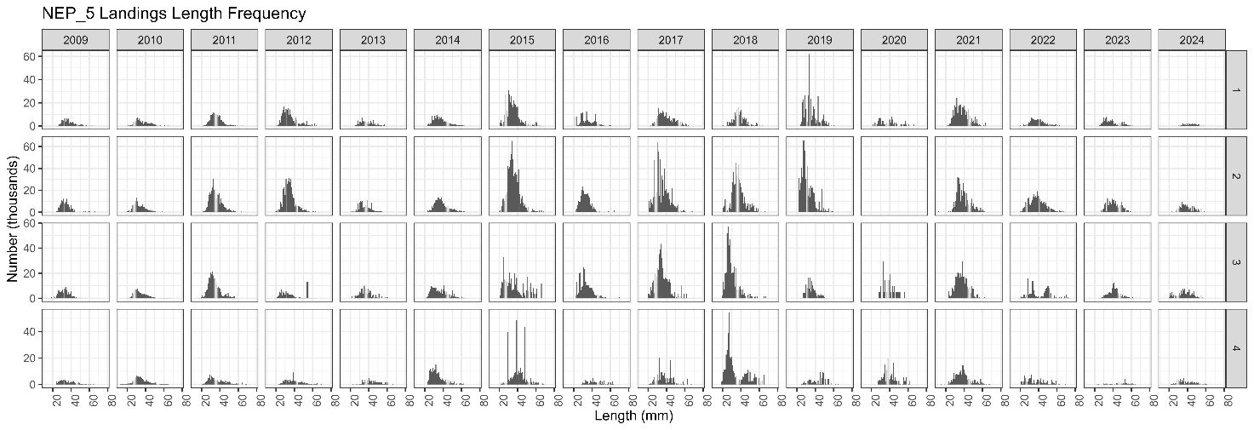

Figure 7: uncorrected length frequency distributions by season.

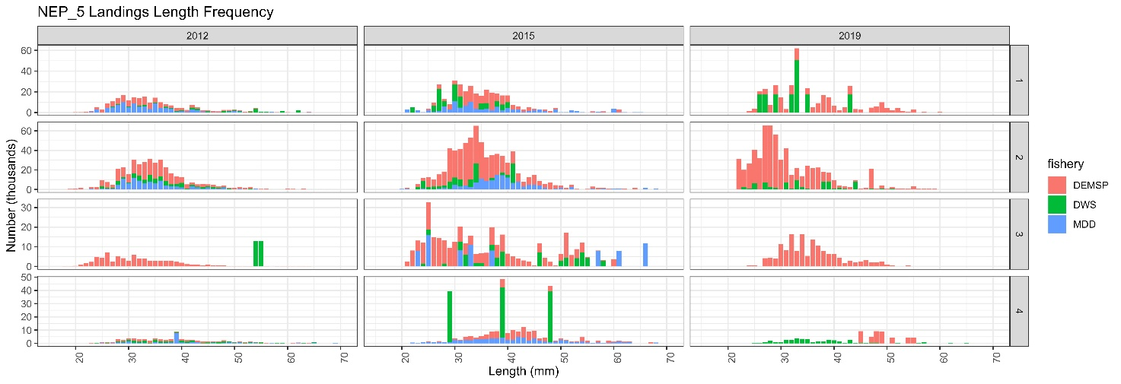

Figure 8: uncorrected length frequency distributions by season. Focus on some years with suspicious values.

Figure 9: sampling intensity by season, year and metier

Figure 10: length frequencies distributions calculated over those metier, year and season with at least 100 individuals measured.

**Data reconstruction**

LFD reconstruction of the landings data was applied by running the JRC script, using as input data only those LFD which sampling intensity was > 100 individuals.

Figure 11: proportion of missing length composition by year and metier.

Figure 12: comparison of reconstructed LFD with those missing the data highlighted in figure 11.

### Survey

**DTMT**

Table 6 reports the DTMT file originated from the survey data checks (only relevant columns shown) and highlights the need to follow up with these (column “To be transmitted”).

Table 6: relevant columns from the DTMT file. The column “to be transmitted” indicates whether these issues should be included in the final DTMT.

|  |  |  |  |  |
| --- | --- | --- | --- | --- |
| Issue Id | Data_request | Issue | Issue_type | To be transmitted |
| 1 | Medits TA | Medits TA | NEP_5. Check before report. There are 43 cases of diferences between distances declared and estimated | Yes |
| 2 | Medits TC | Medits TC or TB | NEP_5. Check before report. There are 2 cases of incosistencies between TB and TC weight and/or number. Check if the error is in TB or TC | Yes |
|  |  | Medits TC | NEP_5. Check before report. There are 28 cases of lengths below minimum and above maximum values observed | No |

***Id 1***

*Status*: checked, not addressed

*Explanation*: the dataset resulting from the data checks was inspected. It is recommended to have the unit involved in data collection to check for this issue.

***Id 2***

Status: checked, not addressed

*Explanation*:

First issue is haul 271 in 2022. The error is likely to be in TC file: pechan is reported equal to pfrac, and it is ~300 grams. Ptot in TB is ~1300 grams. Calculating the expected weight of the 32 individuals reported in the TC, the estimation is much closer to the weight reported in TB. It is not considered relevant for the stock assessment.

Second record is haul 232 in 2024. The error is in TC file: pechan differs from pfrac. In the haul there was a single individual and therefore this might be an error. It is not considered relevant for the stock assessment.

***Id 2***

Status: solved

*Explanation*: the dataset resulting from the data check was inspected. There are occasionally small values (6mm CL), there are no objective reason to discard them.

**Additional comments**

Sampling intensity in GSA 5 was very low in the first years of the time series (Figure 13). As recognised in previous EWG, the sampling intensity stabilizes in 2007. The biomass index also stabilizes in 2007, while it is evident a large oscillation in the first part of the time series.

Figure 13: sampling intensity of the MEDITS survey in GSA 5

Figure 14: biomass index in the medits survey

### Stock assessment input files

The stock assessment platform selected for NEP 5 is a4a. Input files are provided for a base run and for two sensitivity runs.

***Base run***

The base run considers sex combined and time series 2007-2024. The biological parameters are identical to what used in EWG 2409: VBGP set 1 (Table 1); LW set 1 (Table 2), maturity set 1 (Table 3). The differences are (*i*) the data treatment as described in this report and (*ii*) the time series duration. The most recent available stock assessment input considers the time series 2009-2023, because the lack of commercial LFD data prior to 2009. Considering the MEDITS trend, we highlight that cutting the time series in 2009 makes the survey index to be essentially a flat line. We consider that a base run can start in 2007, including two years of reconstructed LFDs. It is acknowledged that these LFD are not representative of the respective years, nevertheless these can inform the scale of landings.

Figure 15: cohort consistency of catch at age (left) and survey (right)

***Sensitivity 1***

The sensitivity 1 considers sex separated and time series 2007-2024. The biological parameters by sex were set 5 (Table 1); LW set 4 (Table 2), maturity set 1 (Table 3). Sexual dimorphism is an important life history trait for NEP. We acknowledge that some of the parameters identified can be outdated, nevertheless we recommend to try this input files configuration given the best cohort consistency among the runs.

Figure 16: cohort consistency of catch at age (left) and survey (right)

***Sensitivity 2***

This run replicates base run, except for not including any data reconstruction. The time series is therefore 2009-2024..

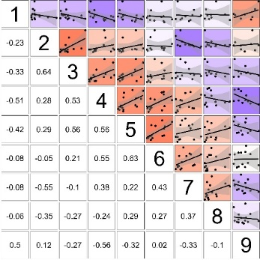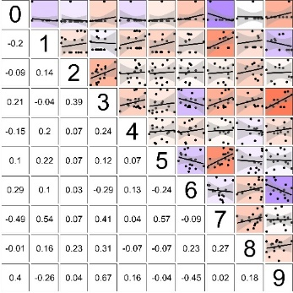

Figure 17: cohort consistency of catch at age (left) and survey (right)

# References

Castro, M., Mytilineou, C., and Gancho, P. 1998. Methodological considerations concerning the use of length frequency analysis for growth studies in the Norway lobster, *Nephrops norvegicus* (L.). Scientia Marina, 62: 61–69.

Chiarini, M. 2023. Stock Assessment Form Demersal Species - Norway lobster in the southern Adriatic Sea (GSA 18).

Melaku Canu, D., Laurent, C., Morello, E. B., Querin, S., Scarcella, G., Vrgoc, N., Froglia, C., *et al.* 2021. Nephrops norvegicus in the Adriatic Sea: Connectivity modeling, essential fish habitats, and management area network. Fisheries Oceanography, 30: 349–365.

Mytilineou, C., Castro, M., Gancho, P., and Fourtouni, A. 1998. Growth studies on Norway lobster, *Nephrops norvegicus* (L.), in different areas of the Mediterranean Sea and the adjacent Atlantic. Scientia Marina, 62: 43–60.

Orsi Relini, L., Zamboni, A., Fiorentino, F., and Massi, D. 1998. Reproductive patterns in Norway lobster (Nephrops norvegicus L., Crustacea Decapoda Nephropidae) of different Mediterranean areas. Scientia Marina, 62: 25–41.

Rotllant, G., RIBES, E., COMPANY, J. B., and DURFORT, M. 2005. The ovarian maturation cycle of the Norway lobster Nephrops norvegicus (Linnaeus, 1758) (Crustacea, Decapoda) from the western Mediterranean Sea. Invertebrate Reproduction & Development, 48: 161–169. Taylor & Francis.

Sardà, F., Lleonart, J., and Cartes, J. E. 1998. An analysis of the population dynamics of Nephrops norvegicus (L.) in the Mediterranean Sea. Consejo Superior de Investigaciones Científicas (España). https://digital.csic.es/handle/10261/23394 (Accessed 31 August 2025).

Scott, F., Jardim, E., Millar, C. P., and Cerviño, S. 2016. An Applied Framework for Incorporating Multiple Sources of Uncertainty in Fisheries Stock Assessments. PLOS ONE, 11: e0154922. Public Library of Science.

SIBM. 2017. Sintesi delle conoscenze di biologia, ecologia e pesca delle specie ittiche dei mari italiani / Synthesis of the knowledge on biology, ecology and fishery of the halieutic resources of the Italian seas. erredi. 608 pp.

Spedicato, M. T. 2022. Study on advancing fisheries assessment and management advice in the Mediterranean by aligning biological and management units of priority species MED_UNITs: final report. Publications Office, LU. https://data.europa.eu/doi/10.2926/909535 (Accessed 6 July 2023).

Vigo, M., Galimany, E., Poch, P., Santos-Bethencourt, R., Sala-Coromina, J., Bahamón, N., Aguzzi, J., *et al.* 2024. An update on the biological parameters of the Norway lobster (Nephrops norvegicus) in the northwestern Mediterranean Sea. ICES Journal of Marine Science, 81: 426–439.

1. http://barefootecologist.com.au/shiny_m