1. **INTRODUCTION**
   1. **Overview of the system**

The internet have spread across millions of household, so naturally it has become by far the best platform for selling used books. Now days when everything is online, it possible not possible to leave behind online used bookstore. There are lot of e-commerce website through which we can buy books. But the idea of developing this bookstore is to allow people to sell and buy used books. This is not a widely popular idea but in future, they have large scope of growth. This is a website through which individuals can buy or sell books. The sellers can post the book they have read and want to sell and buyers can find the book of their choice for a lesser price than the original price. It provides the user with a catalogue of different books available for purchase in the store. In order to facilitate online purchase a shopping cart is provided to the user. At checkout time, the items in the shopping cart will be presented as an order. The system is very useful for the bookstores as well as individuals who sells their book.

* 1. **Problem definition and objective**

Most of the e-commerce website have other products or new books which are costly and the individual’s buys these books for that high price. On the other hand, the motive of this Online Used Bookstore is to allow the individuals to sell the books they have read or wants to get rid of which in turn gains them a small profit. Another important factor in the design of an e-commerce website is feedback. The interactive cycle between a user and a web site is not complete until the web site responds to a command entered by the user. Most of the websites today doesn’t have any interactive feedback mechanism. Website feedback often consists of a change in the visual or verbal information presented to the user. Simple examples include highlighting a selection made by the user or filling a field on a form based on a user's selection from a pull down list and completed orders should be acknowledged quickly. This may be done with an acknowledgment or fulfilment page. Finally, feedback should not distract the user. Actions and reactions made by the web site should be meaningful. Feedback should not draw the user's attention away from the important tasks of gathering information, selecting products, and placing orders.

**2. REQUIREMENT ANALYSIS**

**2.1 Problem definition**

There are large numbers of online bookstore offers a suite of books that are available for purchase. These online marketplaces have thousands of books for sale under various categories including fiction, adventure, Sci-Fi etc. Their purpose it to attract community of readers including students as well as series junkies, fiction fanatics etc. This scenario helps the buyers to have a look at the available books with all its photographs, necessary specification and description, this website is an effort to provide such a web interface with some attractive and innovative features using the latest technologies the motive of this Online Used Bookstore is to allow the individuals to sell the books they have read or wants to get rid of which in turn gains them a small profit. Most of the websites today doesn’t have any interactive feedback mechanism. Website feedback often consists of a change in the visual or verbal information presented to the user. Simple examples include highlighting a selection made by the user or filling a field on a form based on a user's selection from a pull down list and completed orders should be acknowledged quickly. This may be done with an acknowledgment or fulfilment page. Finally, feedback should not distract the user.

**2.2 Select the Software Development Model**

There are different approaches for the development of a software. A software model is an abstract representation of software process. It shows the flow of software development. The different types of software development models are waterfall model, iterative model, spiral model, agile model etc. Among these models I choose waterfall model for my project. Hence it is very simple to understand and more suitable for small projects.

Waterfall model help me to move from one phase to another sequentially, as it is a linear sequential life cycle model and the output of one phase becomes the input of the next. This type of model is basically used for a project which is small and there is no uncertain requirements. In this model testing starts only after the development is completed. In waterfall model phases do not overlap

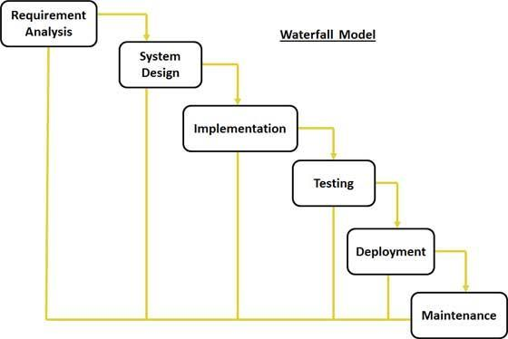

This model is absolute way for correcting problems or implementing proposed system.

The sequential phases in waterfall models are**:**

* **Requirement analysis:** All possible requirements of the parking system to be developed are gathered, analyzed and documented in this phase.
* **System design:** In this phase the system design is prepared from the requirement specification which are studied in the first phase. System design helps in specifying software and hardware requirements and also helps in defining overall system architecture. The output of this phase serves as the input for next phase.
* **Implementation:** On receiving system design documents, the work is divide in modules and actual coding started. This is the longest phase of the Software Development Life Cycle.
* **Testing:** After the code is developed it is tested against the requirements to make sure that the product is actually solving the needs addressed and gathered during requirement phase. During this phase unit testing, integrated testing, system testing, acceptance testing are done.
* **Deployment:** After successful testing the product is delivered to the customers for their use.
* **Maintenance:** Once when the customers start using the developed system then the actual problems comes up and need to solve from time to time. This process where the care is taken for the developed product is known as maintenance.

**2.3 Requirement Specification**

Currently, there is no any system to store the details of used books. So, a website is required for the efficient and secure functioning of used bookstore.

**2.3.1 Existing system**

One of the basic problems with the existing systems is the non-interactive environment they provide to the users. Most of the e-commerce website have other products or new books which are costly and the individual’s buys these books for that high price. There are lot of e-commerce website through which we can buy books. But the idea of developing this bookstore is to allow people to sell and buy used books. These application are not widely popular but in future, they have large scope of growth.

**2.3.2 Proposed system**

The proposed system provides facilities to access the book system from anywhere in the community. The customer can visit the site and purchase the book according to their requirements. The main advantage of the system is that all transactions can be done through a common network. Many features of e-commerce have been implemented here. Thus making it more economical. The sellers can post the book they have read and want to sell and buyers can find the book of their choice for a lesser price than the original price. It provides the user with a catalogue of different books available for purchase in the store. In order to facilitate online purchase a shopping cart is provided to the user. At checkout time, the items in the shopping cart will be presented as an order. The system is very useful for the bookstores as well as individuals who sells their book. The motive of this Online Used Bookstore is to allow the individuals to sell the books they have read or wants to get rid of which in turn gains them a small profit. The current system contains mechanisms that provide interactive user feedback which is an important factor.

**2.3.3 Justification of the proposed system**

The motivation of the project is to digitalize our daily life and to make things easier. The proposed system is designed to overcome the problems of existing system.

The project aims to:

* It provides more efficiency and flexibility
* Provide security to data
* It utilizes the advantage of E-commerce
* Ease of access of information
* Save time
* 24 hours accessibility to the site
* Ease of use
* Have proper storage space for users

**2.3.4 Benefits of the proposed system**

The proposed system is to automate the existing manual system that can eliminate all the limitations of the current system using a user-friendly design.

Some of the benefits are:

* Users can easily post their books.
* Time saving: useful and simple search options help to get required properties and it help in time consuming.
* User friendly: The proposed system is fully computerized and its make user friendly.
* Data security
* Graphical user interface

**2.4 Project Planning**

Project planning is the most importance phase of a software development life cycle. The project plan discusses what should be done and how it should be done to reach the final goal. It is unlike any other project activity because software is contracted in mind and one personnel interpretations are not the same as another’s, even both are involved in the same software project. These differences in options are the core of software errors. Therefore, a specific, detailed project plan must be developed.

Project planning means plotting activities against a time frame and developing a network based on an analysis of the tasks that must be performed to complete the project. The basic goal of planning is to look into the future, identify the activities that need to be done to complete the project successfully. A good plan is flexible enough to handle the unforeseen events that inevitably occur in lagged project.

The approximate time and date planning is as follows:-

|  |  |  |  |
| --- | --- | --- | --- |
| **TASK** | **START DATE** | **DURATION** | **END DATE** |
|  |  |  |  |
| Logic design | 26-DEC-2018 | 3 Days | 29-DEC-2018 |
| System selection | 30-DEC-2018 | 2 Days | 31-DEC-2018 |
| System study | 01-JAN-2019 | 7 Days | 07-JAN-2019 |
| Initial report | 08-JAN-2019 | 6 Days | 14-JAN-2019 |
| Form design | 15-JAN-2019 | 7Days | 22-JAN-2019 |
| Coding | 23-JAN-2019 | 15 Days | 7-FEB-2019 |
| SQL | 7-FEB-2019 | 9 Days | 16-FEB-2019 |
| Testing | 17-FEB-2019 | 8 Days | 25-FEB-2019 |
| Documentation | 26-FEB-2019 | 7 Days | 05-MAR-2019 |
|  |  |  |  |

**2.5 Project Scheduling**

Project scheduling is the process of converting project steps, resources and estimates to a series of sequential and parallel tasks that can be spread across a calendar to determine the start, intermediate milestone and completion dates for project.

A *Gantt chart*, commonly used in project management, is one of the most popular and useful ways of showing activities (tasks or events) displayed against time. On the left of the chart is a list of the activities and along the bottom is a suitable time scale. Each activity is represented by a bar; the position and length of the bar reflects the start date, duration and end date of the activity. The Gantt chart is prepared using the above information.

|  |  |  |  |  |
| --- | --- | --- | --- | --- |
| **TASK** | **DECEMBER** | **JANUARY** | **FEBRUARY** | **MARCH** |
| **Requirement gathering** |  |  |  |  |
| **System analysis** |  |  |  |  |
| **System design** |  |  |  |  |
| **Form design** |  |  |  |  |
| **Coding** |  |  |  |  |
| **Testing** |  |  |  |  |
| **Build** |  |  |  |  |

**2.6 Feasibility Study**

Feasibility study is conducted to determine whether the proposed system is feasible or not. The purpose of feasibility study is to investigate the present system, evaluate the cost and effectiveness of the proposed system, evaluate the possible applications of computer based methods, select a tentative system, evaluate the impact of the proposed system on existing personnel and ascertain the need for new personnel.

There are four aspects in the feasibility study of the preliminary investigation

* Economic feasibility
* Technical feasibility
* Operational feasibility
* Behavioral feasibility

**2.6.1 Economic Feasibility**

Economic feasibility study presents tangible and intangible benefits from the project by comparing the development and operational cost. The technique of cost benefit analysis is used as a basis of attaining economic feasibility. Presently the Company activities require lots of paper works and manpower are needed in this context. Presently the activities are computerized, it checks the matching property and client implementing the proposed system can eliminate these drawbacks which save time, money and manpower. Thus the proposed system is economically feasible.

**2.6.2 Technical Feasibility**

The assessment of technical feasibility must be based on an outline design of system requirements in terms of input, output, files, programs and procedures. This can be qualified in terms of volumes of data, trends, frequency of updating, cycles of activities … in order to give an introduction of the technical system. It was found that the Company currently uses mobiles for viewing properties. If they get trained with the designed software, new appointments can be avoided and the system will run smoothly. This system can support the later versions of android operating system. So the proposed system is technically feasible.

**2.6.3 Operational Feasibility**

Since the software is designed in a user friendly manner, it is easy to understand the working process of a computer aware person. Training is provided for the users of this software. It seems that the system can be used if it is developed and implemented. So the system is operationally feasible.

**2.6.4 Behavioral feasibility**

In today’s world, where mobile is an inevitable entity, the systems like auction site, which requires no special efforts than surfing the net are enjoying wide acceptance. Thus the organization is convinced that the system is feasible. An estimate should be made about the reaction of the user towards the development of a computerized system. Mobile installations have something to do with turnover, transfers and changes in the job status.

1. **SOFTWARE REQUIREMENT**

**SPECIFICATION**

**3.1 Introduction**

**3.1.1 Purpose**

The purpose of this document is to describe Online Used Bookstore. This document contains the functional, behavioral and non-functional requirements of the project and it also contains the guidelines for system engineers and designers to start working the project. . The main purpose of this project is to maintain easy circulation system using mobile in this firm.

**3.1.2 Scope**

The scope of the project “Online Used Bookstore” is to enable the buyers to search for property listings online. The motive of developing this application is to design a website to sell only used books.

**3.1.3 Definitions, Acronyms and Abbreviations**

ER – Entity Relationship

DFD – Data Flow Diagram

SRS – Software Requirement Specification

PHP – Software Requirement Specification

* + 1. **References**

1. Internet & Web Technologies, Raj Kamal, Tata Mc Graw_ Hill

2. Web Programming, Chris Bates, 3 rd Edition; Pub: John Wiley & Sons

3. Reference Text.HTML Black Book, Steven Holzner, Dreamtech Publishers

4. K K Aggarwal, Yogesh Singh Software Engineering (Third Edition) New Age

International Publications.

5. Ian Sommerville Software Engineering VII th Edition Pearson Education

* + 1. **Overview**

The document contains the detailed documentation of the requirements and functions of ‘Online Used Bookstore’ like product function, functional requirements, constraints, dependencies etc. The SRS is organized as it’s discuss the product description first then the requirements of the products, and the dependencies that will face by the systems.

The developer is responsible for:

* Developing the system.
* Installing the software.
* Maintaining the system.
  1. **Overall Description**

**3.2.1 Product Perspective**

Online Used Bookstore is a replacement of the existing manual system in which people have to search here and there for finding book. The proposed system would be more efficient and easy for managing and manipulating these actions.

**3.2.2 Product Function**

The product function can be represented using ER diagram. The main purpose of this system is to reduce complexity of existing system. This software is capable of managing the customer details and the details of various properties.

**3.2.3 User Characteristics**

The users of the application is the customers who manage this the authorities and administrators should have a basic knowledge of computers. Users can view the books posted by other users and choose the books according to their preferences. If they have any books to sell they can post it in the website.

* + 1. **Constraints**
* Correct username and password must be provided for login.
* User must be aware to enter correct data into databases.
  + 1. **Assumptions and Dependencies**

The assumptions are:

* The coding should be error free
* The system should be user friendly so that the users can easily access data
* The system should have more storage capacity and provide fast access to database
* The system should provide system search facilities and provide quick search results
* The system should save money and time unlike the existing system
* The user must provide correct user name and password to enter to the system.

The dependencies are:

* The specific hardware and software due to which the product will run
* On the basis of listing requirements and specification, the system will be developed and run
* The end-users should have knowledge about the system
* Updates are to be made correctly and data entered without any mistakes
  1. **Specific Requirements**

**3.3.1 External Interfaces**

**GUI**

The software provides good graphical interface for the user. All the modules provided with the software must fit into this graphical user interface and accomplish to the standard defined. The design should be simple and all the different interfaces should follow a standard template.

**Login interface**

The system is provided with a user name and password. If the user gives an incorrect user name or password, an error message occurs.

**Search interface**

The authorized person can search for a particular book which he is interested in. The search can be done using name of the book.

**Hardware Interfaces**

Only the recommended configuration no other specific hardware is required to run the software.

**Software Interfaces**

Software will depend on the security features provided by the operating system. The application will have a direct connection with the database MySQL. The data’s are stored in the database and retrieved as per requirements

**3.3.2 Functional Requirements**

* Insert properties :-

If the user have books which they want to sell, then it could be inserted into the website.

* Buy books :-

If a user want to buy a book he can check its availability and purchase.

* Search book :-

The user can search for a books according to their requirements.

**3.3.3 Performance Requirement**

The proposed system that we are going to develop will be used as the Chief performance system. Therefore, it is expected that the database would perform functionally all the requirements that are specified by the application.

* The performance of the system should be fast and accurate.
* Response of the system to an operation should be within reasonable time.
* The system should be able to handle large amount of data.
* The system should be capable for updating the data such as consumer details very frequently.

**3.3.4 Logical Database Requirement**

A database requirement is dealing with the requirements for the collection of data. Some of major tasks, using a computer system are to store and manage data. To handle these tasks, you need a specialized computer program known as a database management system (DBMS).A DBMS stored, process, and retrieve data. The database used in this project is SQL.

|  |  |  |  |
| --- | --- | --- | --- |
| **Table Name** | **Primary Key** | **Foreign Key** | **Description** |
| admin_login | admin_id |  | Admin login details |
| signup | user_id | cat_id | Sign up details |
| post_ad | ad_id | user_id | Ad details |
| myorder | order_id | user_id, ad_id | Order history |
| cart_temp | temp_id | user_id, ad_id | Temporary cart until checkout |
| cat | cat_id |  | Category |
| orderd_items | oitem_id | temp_id, order_id | Details of single item booked |
| order_enquiry | enq_id | ad_id, | Complaints about order |
| order_payment | pay_id | order_id | Payment details |
| seller_payment | payed_id | user_id | Payment to the seller |

**3.3.5 Design Constraints**

The program is designed for and will only operate on web browser. Before accepting the website the developer will have to show through test cases that all conditions are satisfied.

**3.3.6 Software System Attributes**

* Reliability

The software should not have any reliability issues. The software will be thoroughly tested and any issues resolved.

* Availability

The software will execute as a standalone system so as long as the machine is running, the program will be available. The key to maintaining availability will be by ensuring a connection to the database server is available. Failure to connect to the database will make data unavailable.

* Security

This software is intended to communicate over an internal network; therefore security is of little concern. The user will have to enter the username and password so the program can connect to the database server. The username and password will not be stored because encryption of such information is outside the scope of the project.

* Maintainability

The software will be composed of various modules decreasing the complexity of expansion.

* Portability

As states previously, this software can run under in browser with internet connection. The setup file, setup.info, can be copied to multiple machines so that each program does not have to be setup separately.

**3.3.7 Organizing the specific requirements**

In this system the overall functionality is organized by Data flow diagrams and E-R diagrams. Based on these diagrams, data relationships and dependencies are found and a functional hierarchy is made for organizing the specific requirements.

1. **SOFTWARE AND HARDWARE**

**REQUIREMENT**

**4.1 Software requirement**

To development application software, we use different types of software. The software for the development has been selected based on several factors such as:-

* Support and Stability
* Cost effectiveness
* Development Speed

The software’s used for new system are:

Server side:-

* Windows Xp or above, any Server OS
* Net beans IDE 8.0.2
* mySQL

Client side:-

* Windows Xp or Above
* Internet Explorer 5.0 or Above
* Google Chrome
* Mozilla Firefox

**4.2 Hardware requirement**

The hardware requirement for developing and implementing the proposed system is given below

**HARDWARE:**

Processor Pentium-II or higher

Processor Speed 533 MHZ

Hard Disk Space 20 GB (min.)

Ram Memory 32 MB (64 MB recommended)

1. **SYSTEM DESIGN**

**5.1** **Introduction**

The system design is a solution to “how to” approach to the creation of new system. The basis for the system design is a good system analysis. The important phase is composed of several steps. The first step is to determine how the output should be produced and in what format. Second the database, the input data and the master files have to be designed to meet the requirements of the proposed system. It provides for the understanding and procedural details necessary for implementing the system recommended in the feasibility study. It refers to the technical specifications that will be applied in implementing the candidate system. It also includes the construction of programs and program testing. Finally the details related to justification of the system and estimate of the impact of the candidate system on the user and the organization are documented and evaluated by the management as steps towards implementation. System design goes through phases of development, logical and physical design.

DFD shows the logical flow of a system and defines the boundaries of the system. For a candidate system, it describes the inputs, outputs, database and procedures. The design covers the review of the current physical system, prepares output specifications, prepares input specifications and specifies the implementation plan, reviews benefits, costs, target dates and constraints.

System design objectives include specify logical design elements, support business activities ensure that system features meet user requirements, provides a system engineered for ease of use by people, provides detailed software development specification, confirm to design standards.

The logical design specifies output, input file and screen layout. The physical design produces the working system by defining the design specification that tells the programmer exactly what the candidate system must do.

**5.2 Input Design**

In input design, user oriented data are converted to a computer based format. It is the link between user and the information system. The input design involves determining what the inputs are, how the data should be performed, how to validate data, how to minimize data entry and how to provide a multiuser facility.

The main objectives of the input design are:  
 1. Produce cost effective method of input  
 2. Achieve highest possible level of accuracy  
 3. Ensure that the input is acceptable to and understood by employee.

The goal of designing input data is to make entry easy, logical and free from errors as possible. The entering data entry operators need to know the allocated space for each field; field sequence and which must match with that in the source document. The format in which the data fields are entered should be given in the input form**.**

1. Login

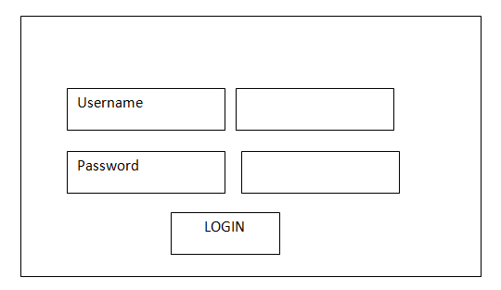

1. 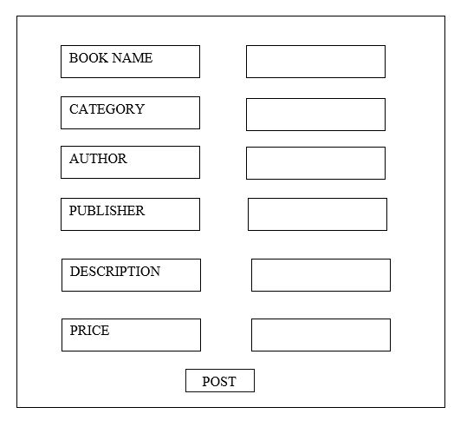Add Book

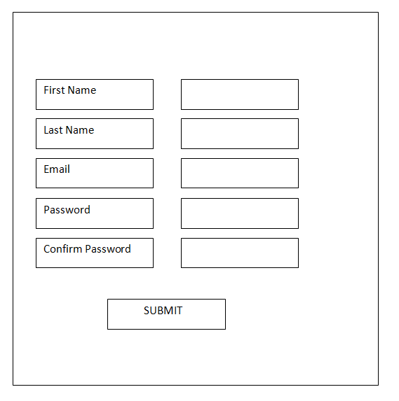3. Sign up

**5.3 Output Design**

Efficient, intelligible output design improves the system relationship with the user and help in decision making. Allowing the user to review sample screen is important because the user is the ultimate judge of the quality of the output.

Computer output is the most important and direct information source to the user. Output design is a process that involves designing necessary outputs in the form of reports that should be given to the users according to the requirements.

1. List of Books

BOOK

IMAGE

BOOK

IMAGE

BOOK

IMAGE

BOOK

IMAGE

Details of Book

Details of Book

Details of Book

Details of Book

**5.4 Module Description**

Modules for online bookstore are:

* Admin

The admin has overall control over the website and manages the website. He has the authority to block and unblock users. He adds category. He can approve or reject ads based on their credibility. No ads are displayed without admins permission. He manages the payment to the users. He also manages the complaint of users.

* User

The can sign in using the email id and password provided at the time of registration. He can then search for books he wish for or browse through categories. If he needs to sell a book he can do the same by posting an ad but should note that the ads should be credible for the admin to approve them.

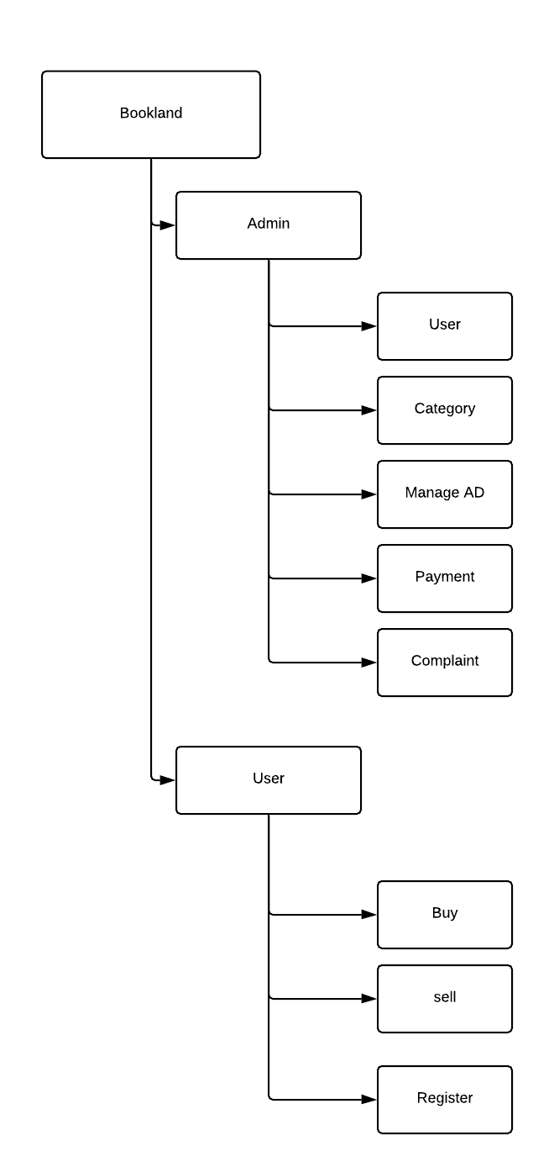**5.5 Functional Diagram**

**5.6 Database design**

Database consists of a collection of data managed by a database management system. Which keeps track of the data storage with the help of information stored in the system table space. In order to identify the tables in the system table space we apply first normal form and second normal form on the entities of our system to identify following set of tables:

**Admin Login**

|  |  |  |  |
| --- | --- | --- | --- |
| **Field** | **Data type** | **Constraints** | **Description** |
| admin_id | int(11) | Primary key | id |
| admin_username | varchar(250) | Not null | username |
| admin_password | varchar(250) | Not null | password |
| admin_img | text | Not null | profile picture |

**Signup**

|  |  |  |  |
| --- | --- | --- | --- |
| **Field** | **Data type** | **Constraints** | **Description** |
| user_id | int(11) | Primary key | user id |
| name | varchar(250) | Not null | user name |
| email | varchar(250) | Not null | email adress |
| phone | varchar(250) | Not null | phone number |
| gender | varchar(15) | Not null | gender |
| dob | varchar(20) | Not null | date of birth |
| password | varchar(250) | Not null | password |
| hname | varchar(250) | Not null | house name |
| hlocality | varchar(250) | Not null | house locality |
| hplace | varchar(250) | Not null | place |
| hlandmark | varchar(250) | Not null | landmark |
| pincode | varchar(10) | Not null | Pin code |
| city | varchar(150) | Not null | city |
| state | varchar(150) | Not null | state |
| status | int(1) | Not null | admin to disable user |

**Post Ad**

|  |  |  |  |
| --- | --- | --- | --- |
| **Field** | **Data type** | **Constraints** | **Description** |
| ad_id | int(11) | Primary key | ad id |
| cover | text | Not null | cover photo |
| title | varchar(255) | Not null | book title |
| author | varchar(255) | Not null | book author |
| cat | int(10) | Not null | category |
| descp | varchar(300) | Not null | book description |
| oprice | varchar(100) | Not null | original price |
| uprice | varchar(100) | Not null | user price |
| addit | varchar(100) | Not null | additional details |
| seller | varchar(100) | Foreign key | seller of book |
| pstatus | int(1) | Not null | disable ad by user |
| date | varchar(255) | Not null | date of posting |
| status | int(1) | Not null | approving ad by admin |

**Myorder**

|  |  |  |  |
| --- | --- | --- | --- |
| **Field** | **Data type** | **Constraints** | **Description** |
| order_id | int(11) | Primary key | order id |
| user_id | int(11) | Foreign key | id of user |
| order_date | varchar(255) | Not null | date of order |
| shipping_adress | Text | Not null | shipping address |
| grand_total | Varchar(255) | Not null | total of order |
| order_status | int(1) | Not null | status of order |
| payment_status | int(1) | Not null | status of payment |

**Cart_temp**

|  |  |  |  |
| --- | --- | --- | --- |
| **Field** | **Data type** | **Constraints** | **Description** |
| temp_id | int(10) | Primary key | temporary car id |
| buyerid | Varchar(255) | Foreign key | user id |
| cart_id | int(10) | Not null | cart id |
| book_id | int(10) | Foreign key | id of book |
| price | Varchar(255) | Not null | price of book |

**Cat**

|  |  |  |  |
| --- | --- | --- | --- |
| **Field** | **Data type** | **Constraints** | **Description** |
| cat_id | int(20) | Primary key | category id |
| name | varchar(30) | Not null | category name |
| status | int(11) | Not null | status of category |

**Orderd_items**

|  |  |  |  |
| --- | --- | --- | --- |
| **Fieldaname** | **Datatype** | **Constraints** | **Description** |
| oitem_id | Int(11) | Primary key | ordered item id |
| myorder_id | Int(11) | Foreign key | myorder id |
| book_id | Int(11) | Foreign key | book id |
| price | Varchar(255) | Not null | price |

**Orderd_enquiry**

|  |  |  |  |
| --- | --- | --- | --- |
| **Fieldaname** | **Datatype** | **Constraints** | **Description** |
| enq_id | Int(11) | Primary key | ordered item id |
| enq_sender | Int(11) | Foreign key | user id |
| enq_order | Int(11) | Foreign key | order id |
| enq_item | Int(11) | Foreign key | item details |
| enq_message | Text | Not null | message |
| enq_date | Varchar(255) | Not null | date |
| enq_sendername | Varchar(255) | Not null | date of sending |

**Orderd_payments**

|  |  |  |  |
| --- | --- | --- | --- |
| **Fieldaname** | **Datatype** | **Constraints** | **Description** |
| pay_id | Int(11) | Primary key | payment id |
| pay_orderid | Int(11) | Foreign key | order id |
| pay_amount | Varchar(255) | Foreign key | amount |
| pay_ref_nos | Text | Not null | payment reference |
| pay_date | Varchar(255) | Not null | date of payment |

**Seller_payment**

|  |  |  |  |
| --- | --- | --- | --- |
| **Fieldaname** | **Datatype** | **Constraints** | **Description** |
| payed_id | Int(11) | Primary key | payment id |
| payed_seller | Int(11) | Foreign key | order id |
| payed_date | Varchar(255) | Foreign key | amount |
| payed_amount | Varchar(255) | Not null | payment reference |

* 1. **Data Flow Diagram**

**Level 0 DFD (Context Diagram)**

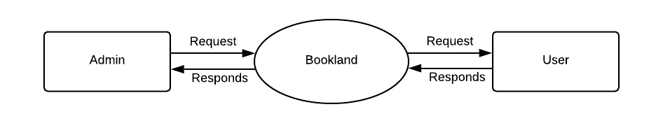

**Level 1 DFD**

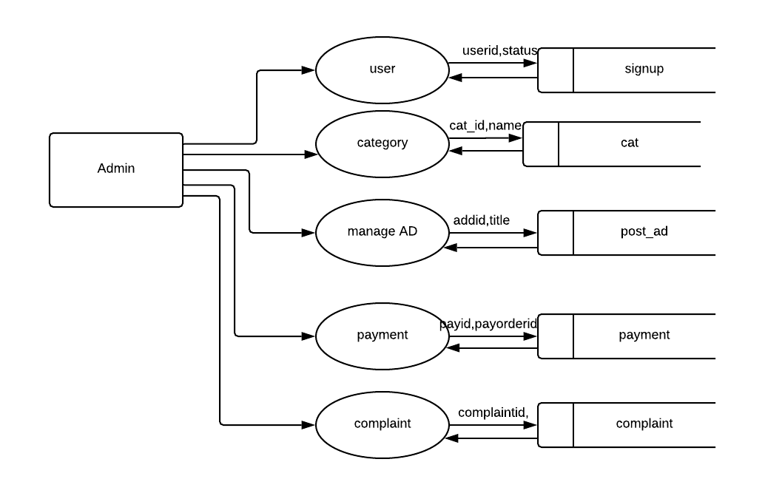**Admin**

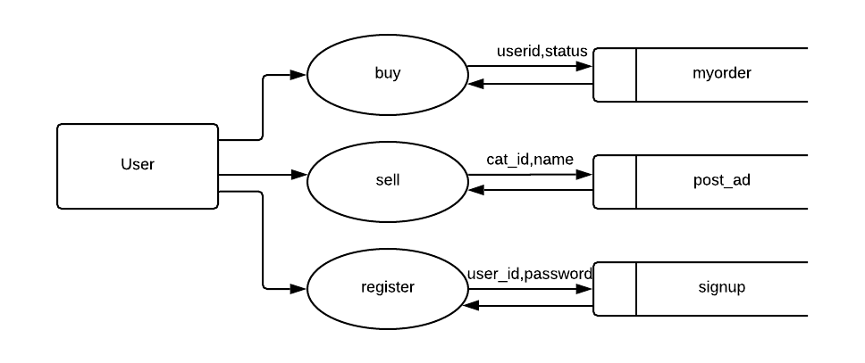**User**

**Level 2DFD**

**Admin**

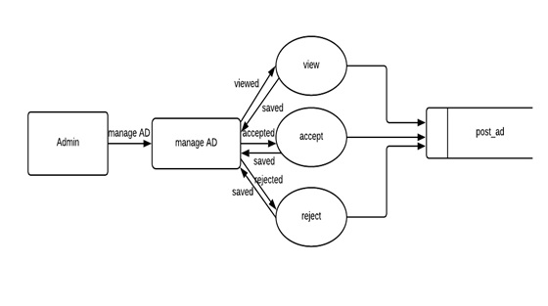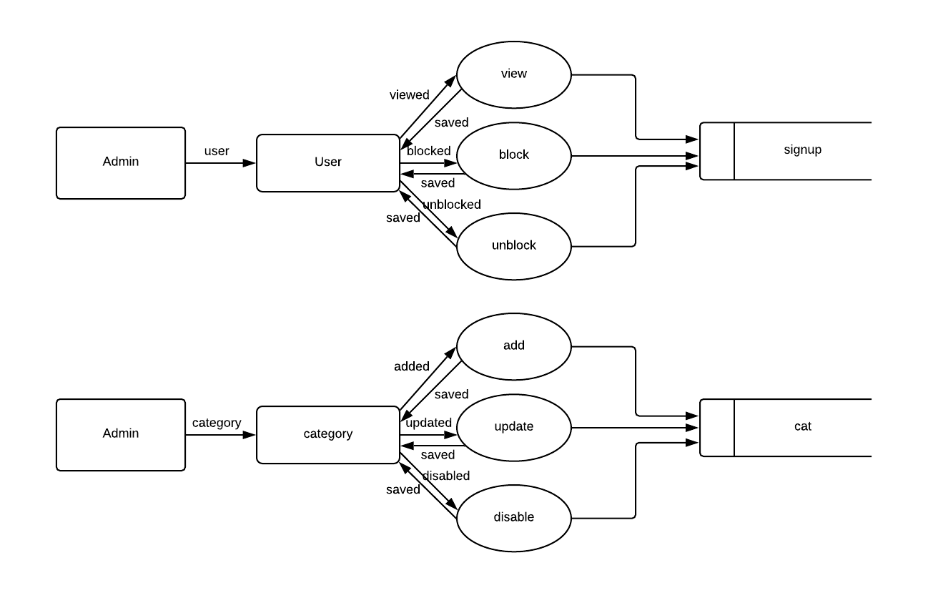

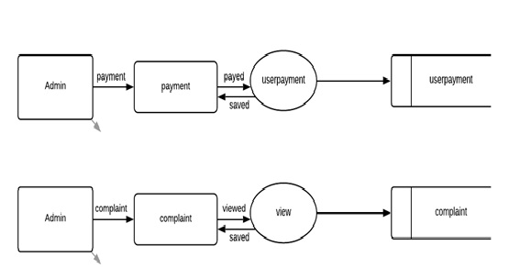

respond

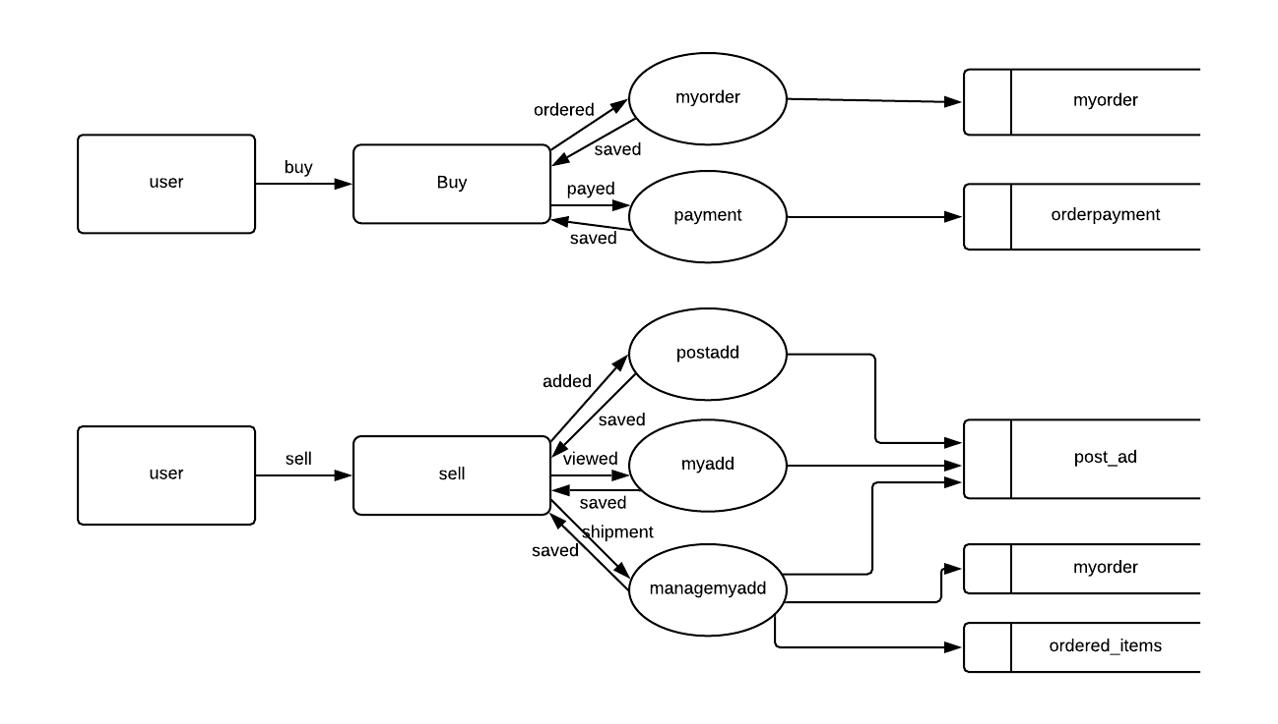**User**

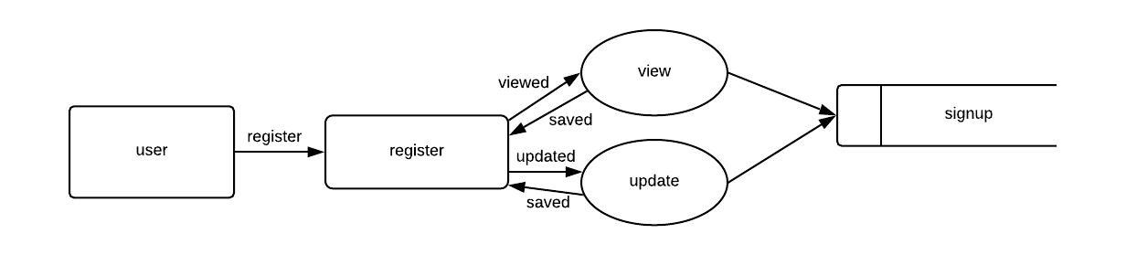

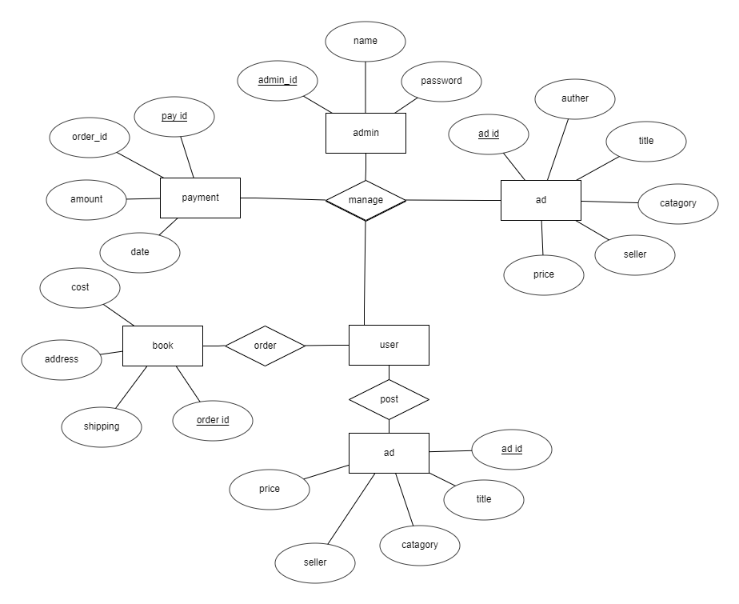**5.8 ER Diagram**

**6. SYSTEM DEVELOPMENT**

**6.1 PROCESS DESCRIPTION**

Admin side starts with a login page through which the admin can enter the admin dashboard to view overall status of the website. He can manage the user’s means he can view their entire details, block them and unblock them. He can add categories as well as edit or disable them. He should verify and approve the ads posted by user to be able to display them on the website he can also reject ads. He manages the payment to be distributed to the users. He can view and respond to the user complaints about any order.

User side begin with a login/signup page from which a existing user can login where as a new user can sign up by filling out the details then he arrives at another page where he should fill other relevant personal as well as address. After filling it they are brought to the home page from where he can browse through available books view their specific details, search them and add them to cart and proceed with payment. He can see his order history from my order menu from dropdown. If he wishes to sell a book he can choose the post ad menu from dropdown and fill in the details as provided by the about page to be approved by admin. He can see the ads posted by him through my ads menu in dropdown and he can also choose to delete the ad. He is also displayed the details of user such as address when one of his book is brought by him and he need to send the book to the provided address. The payment process is specified in the about page. He can also contact the admin about any other complaints or suggestions through contact us page.

**6.2 Pseudo code**

**Index page**

<?php

include 'admin/dbcon.php';

include 'pgheader.php';

$trend=mysql_query("select * from post_ad where pstatus=1 ORDER BY RAND() limit 4");

$nw=mysql_query("select * from post_ad where pstatus=1 order by ad_id desc limit 4");

$bd=mysql_query("select *, (`oprice`-`uprice`) AS `offerprice` from post_ad where pstatus=1 order by offerprice desc limit 4");

?>

<div class="carousel slide" data-ride="carousel">

<ol class="carousel-indicators">

<li data-target="#carouselExampleIndicators" data-slide-to="0" class="active"></li>

<li data-target="#carouselExampleIndicators" data-slide-to="1"></li>

<li data-target="#carouselExampleIndicators" data-slide-to="2"></li>

</ol>

<div class="carousel-inner">

<div class="carousel-item active">

<img class="d-block w-100" src="images/slider/sl1.jpg" alt="First slide">

<div class="carousel-caption d-none d-md-block">

<h5>...</h5>

<p>...</p>

</div>

</div>

<div class="carousel-item">

<img class="d-block w-100" src="images/slider/sl2.jpg" alt="Second slide">

<div class="carousel-caption d-none d-md-block">

<h5>...</h5>

<p>...</p>

</div>

</div>

<div class="carousel-item">

<img class="d-block w-100" src="images/slider/sl3.jpg" alt="Third slide">

<div class="carousel-caption d-none d-md-block">

<h5>...</h5>

<p>...</p>

</div>

</div>

</div>

</div>

<div class="container-fluid">

<div class="rowcmn dividor">

<div class="col-md-6">

<div class="headcont"><p>TRENDING</p></div>

</div>

</div>

</div>

<div class="container-fluid">

<div class="row td">

<?php while($row_trend=mysql_fetch_array($trend))

{ ?>

<div class="col-md-3">

<div class="cont">

<a href="book-details.php?bookid=<?php echo base64_encode($row_trend['ad_id']);?>" class="bkdt"><img src="<?php echo $row_trend['cover'];?>">

<h6><?php echo $row_trend['title'];?></h6>

<p><?php echo $row_trend['author'];?></p>

<h6><s> ₹<?php echo $row_trend['oprice'];?> </s> <span>₹<?php echo $row_trend['uprice'];?></span></h6>

</a>

</div>

</div>

<?php } ?>

</div>

</div>

<div class="container-fluid">

<div class="rowcmn dividor">

<div class="col-md-6">

<div class="headcont"><p>NEW ARRIVALS</p></div>

</div>

</div>

</div>

<div class="container-fluid">

<div class="row na">

<?php while($nwsh=mysql_fetch_array($nw))

{ ?>

<div class="col-md-3">

<div class="cont">

<a href="book-details.php?bookid=<?php echo base64_encode($nwsh['ad_id']);?>" class="bkdt"><img src="<?php echo $nwsh['cover'];?>">

<h6><?php echo $nwsh['title'];?></h6>

<p><?php echo $nwsh['author'];?></p>

<h6><s> ₹<?php echo $nwsh['oprice'];?> </s> <span>₹<?php echo $nwsh['uprice'];?></span></h6>

</a>

</div>

</div>

<?php } ?>

</div>

</div>

<div class="container-fluid">

<div class="rowcmn dividor">

<div class="col-md-6">

<div class="headcont"><P>BEST DEALS</P></div>

</div>

</div>

</div>

<div class="container-fluid">

<div class="rowcmn bd">

<?php while($bdsw=mysql_fetch_array($bd))

{ ?>

<div class="col-md-3">

<div class="cont">

<a href="book-details.php?bookid=<?php echo base64_encode($bdsw['ad_id']);?>" class="bkdt"><img src="<?php echo $bdsw['cover'];?>">

<h6><?php echo $bdsw['title'];?></h6>

<p><?php echo $bdsw['author'];?></p>

<h6><s> ₹<?php echo $bdsw['oprice'];?> </s> <span>₹<?php echo $bdsw['uprice'];?></span></h6>

</a>

</div>

</div>

<?php } ?>

</div>

</div>

<?php

include 'pgfooter.php';

?>

**Edit Profile**

<?php

include 'admin/dbcon.php';

include 'pgheader.php';

$view=mysql_fetch_array(mysql_query("select * from signup where user_id='$_SESSION[user_id]'"));

$msgpr='';

$msgad='';

if(isset($_POST['pdtbtn']))

{

$name=$_POST['name'];

$email=$_POST['email'];

$phone=$_POST['phone'];

$gender=$_POST['gender'];

$dob=$_POST['dob'];

if($name && $email && $phone && $gender && $dob)

{

$sql=mysql_query("update signup set name='$name',email='$email',phone='$phone',gender='$gender', dob='$dob' where user_id='$_SESSION[user_id]'");

if(mysql_affected_rows())

{

$msgpr='Profile updated succesfully';

echo "<meta http-equiv='refresh' content='0;url=profile.php'>";

exit;

}

}

else

{

$msgpr='insert value in all fields';

}

}

elseif (isset($_POST['addtbtn']))

{

$hname=$_POST['hname'];

$hlocality=$_POST['hlocality'];

$hplace=$_POST['hplace'];

$hlandmark=$_POST['hlandmark'];

$pincode=$_POST['pincode'];

$city=$_POST['city'];

$state=$_POST['state'];

if ($hname && $hlocality && $hplace && $hlandmark && $pincode && $city && $state)

{

$sql=mysql_query("update signup set hname='$hname',hlocality='$hlocality',hplace='$hplace',hlandmark='$hlandmark', pincode='$pincode',city='$city',state='$state' where user_id='$_SESSION[user_id]'");

if(mysql_affected_rows())

{

$msgad='Adress updated succesfully';

echo "<meta http-equiv='refresh' content='0;url=profile.php'>";

exit;

}

}

else

{

$msgad='insert value in all fields';

}

}

?>

<div class="container-fluid">

<div class="row na">

<div class="col-md-12">

<div class="cathd">

<h3>my profile</h3>

</div>

</div>

</div>

</div>

<div class="container-fluid">

<div class="row na">

<div class="col-md-6">

<div class="pdedit">

<h5>personal details</h5>

<form method="post">

<div class="pdtinput"><p>Name</p><input placeholder="Name" type="text" name="name" value="<?php echo $view['name'];?>"></div>

<div class="pdtinput"><p>Email</p><input placeholder="Email" type="email" name="email" value="<?php echo $view['email'];?>"></div>

<div class="pdtinput"><p>Phone</p><input placeholder="Phone Number" type="Number" name="phone" value="<?php echo $view['phone'];?>"></div>

<div class="pdtinput"><p>Gender</p><select style="margin-left: -65px;

width: 150px;" class="gender" name="gender"> <option>SELECT</option> <option value="Male">Male</option> <option value="Female">Female</option> <option value="Other">Other</option></select></div>

<div class="pdtinput"><p>Date of birth</p><input style="margin-left: -20px;" placeholder="Date Of Birth" type="date" name="dob" value="<?php echo $view['dob'];?>"></div>

<div class="pdtinput"><a href="">CHANGE PASSWORD</a></div>

<button type="submit" name="pdtbtn">Apply Changes</button>

<?php if($msgpr){?> <p><?php echo $msgpr; ?></p><?php }?>

</form>

</div>

</div>

<div class="col-md-6">

<div class="adedit">

<h5>adress/shipping details</h5>

<form method="post">

<div class="ainput"><p>House No/Name</p><input placeholder="House No/Name" type="text" name="hname" value="<?php echo $view['hname'];?>"></div>

<div class="ainput"><p>Locality</p><input placeholder="Locality" type="text" name="hlocality" value="<?php echo $view['hlocality'];?>"></div>

<div class="ainput"><p>Place</p><input placeholder="Place" type="text" name="hplace" value="<?php echo $view['hplace'];?>"></div>

<div class="ainput"><p>Landmark</p><input placeholder="Landmark" type="text" name="hlandmark" value="<?php echo $view['hlandmark'];?>"></div>

<div class="ainput"><p>Pincode</p><input placeholder="Pincode" type="Number" name="pincode" value="<?php echo $view['pincode'];?>"></div>

<div class="ainput"><p>City</p><input placeholder="City" type="text" name="city" value="<?php echo $view['city'];?>"></div>

<div class="ainput"><p>State</p><input placeholder="State" type="text" name="state" value="<?php echo $view['state'];?>"></div>

<button type="submit" name="addtbtn">Apply Changes</button>

<?php if($msgad){?> <p><?php echo $msgad; ?></p><?php }?>

</form>

</div>

</div>

</div>

</div>

<?php

include 'pgfooter.php';

?>

**My order**

<?php

include 'admin/dbcon.php';

include 'pgheader.php';

$ssn=$_SESSION['user_id'];

$dis=mysql_query("select * from myorder where user_id='$ssn'");

?>

<div class="container-fluid">

<div class="row">

<div class="col-md-12">

<div class="maintheading"><h4><b>my orders</b></h4></div>

</div>

</div>

</div>

<div class="container-fluid">

<div class="row crt">

<?php while($roworder=mysql_fetch_array($dis))

{

?>

<div class="col-md-12">

<div class="crttable">

<table class="table table-borderless" align="center">

<thead>

<tr class="trow">

<th scope="col" width="40%">order id :<?php echo $roworder['order_id'];?></th>

<th scope="col" width="20%">order date : <?php echo $roworder['order_date'];?></th>

<th scope="col" width="20%">grand total : <?php echo $roworder['grand_total'];?></th>

</tr>

</thead>

<tbody>

<tr>

<td>product details :</td>

<td>price :</td>

<td></td>

</tr>

<?php $resitems=mysql_query("select * from orderd_items where myorder_id='$roworder[order_id]'");

while($rowitems=mysql_fetch_array($resitems))

{

$item=mysql_fetch_array(mysql_query("select * from post_ad where ad_id='$rowitems[book_id]'"));

$seller=mysql_fetch_array(mysql_query("select * from signup where user_id='$item[seller]'"));

?>

<tr>

<td><div class="cartout">

<div class="cartimg"><img src="<?php echo $item['cover']; ?>"></div>

<div class="cartheading"><h4><b><?php echo $item['title']; ?></b></h4>

<h6><small><?php echo $item['author']; ?></small></h6><p>Seller : <?php echo $seller['name']; ?></p></div>

</div>

</td>

<td>₹<?php echo $rowitems['price']; ?></td>

<td> <a href="need-help.php?orderid=<?php echo base64_encode($roworder['order_id']); ?>&itemid=<?php echo base64_encode($rowitems['book_id']); ?>" class="issue" target="_blank"><i class="fas fa-exclamation-triangle"></i> need help</a> </td>

</tr>

</tbody>

<?php } ?>

</table>

</div>

</div>

<?php } ?>

</div>

</div>

<?php

include 'pgfooter.php';

?>

**7. VALIDATION CHECKS**

Data validation checking is done to see whether the corresponding entries made in different tables are done correctly. Proper validations are done in case of insertion and updating of tables, in order to see that no duplication of data has occurred. If any such case arises proper warning messages will be displayed.

Authentication such as in login and authorization where a user can only see his data are used to prevent any other user from accessing the website and to only allow users to see the data that the admin has given permission to. Validation checks are used to ensure that all necessary fields are not empty before submitting the form and if found warning messages are displayed and these are used in all essential fields to specify the same. Checking is done to ensure that data inserted into the correct table and data in each field is valid.

**8. SYSTEM IMPLEMENTATION**

**8.1 System Testing**

System testing is actually a series of different testes whose primary purpose is to fully exercise the computer based system. All though each test has a different purpose, all work to verify that all system elements have been properly integrated and perform all allocated functions. The following are the main objectives of testing.

1. Testing is process of executing a program with the intent of finding errors.

2. A new test case is one that has a high probability of finding an undiscovered error.

3. It is a set of activities that can be planned in advance and conducted automatically

During testing I tried to make sure that the product does exactly what is supposed to do. Testing is the final verification and validation activity within the organization itself. In the testing stage I tried to achieve the following goals, to affirm the quality of the product, to find and eliminate any residual errors from previous stages, to validate the software as a solution to organization problem, to demonstrate the presents of all specified functionality in the product, to estimate the operational reliability of the system.

**TYPES OF TESTING:**

* Unit Testing
* Integration Testing
* Validation Testing
* Output Testing

**8.1.1 Unit Testing**

Unit testing focuses verification effort on the smallest unit of the software design- the module, this is known as module testing. Since the proposed system has modules the testing is individually performed on each module. Using the details description as a guide, important control paths are tested to uncover errors within the boundary of the modules. This testing was carried out during programming stage itself. In this testing step each module is found to be working satisfactorily as regards to the expected output from the module. In my system I want to check the information like whether the inputs are saved to back end correctly. So every form includes this testing because I wanted to maintain my database, because information like document to be saved, the personal information, security features are so sensitive and should check it perfectly by each module from the beginning. These are checked in the programming step itself.

**8.1.2 Integration Testing**

Data can be test across an interface; one module can have adverse effect on another, sub function when combined may not produce the desired function. Integration testing is a systematic technique for constructing the program structure while at the same time conducting test to uncover errors associated within the interface.

The objective is to take unit tested modules and built a program structure that has been dictated by design. All modules are combined in this testing step. The entire program is tested as a whole. Correction is difficult at this stage because the isolation of causes is complicated by the vast expense of the program. Thus in the integration testing step all the errors uncover are corrected for the next testing step. Primarily I had met with several errors like data saving and table linking. These were corrected well. There were some simple mistakes like setting the startup page and all. Finally I fixed login page as startup page and run again. So the integration testing was done well.

**8.1.3 Validation Testing**

Interfacing errors have been uncovered and corrected and a final series of software test-validation testing begins. Validation testing can be defined in many ways, but a simple definition is that validation succeeds when the software functions in manner that is reasonably expected by the user. Software validation is achieved through a series of tests that demonstrate conformity with requirement. After validation test has been conducted, one of two conditions exists.

* The function or performance characteristics confirm to specifications and are accepted.
* A validation from specification is uncovered and a deficiency created.

Deviation or error discovered at this step in this project is corrected prior to completion of the project with the help of the user. Thus the proposed system under consideration has been tested by using validation testing and found to be working satisfactorily.

**8.1.4 Output Testing**

The next step is output testing of the proposed system since no system could be useful if it does not produce the required output in the specific format. The output generated or displayed by the system under consideration is tested asking the users about the format required by them. Here, the output is considered in two ways: one is on the screen and the other is printed format.

The output format on the screen is found to be correct as the format designed according to the user needs. For the hard copy also, the output comes out as specified by the user. Hence output testing doesn’t result in any connection in the system

**8.2 System Implementation**

Implementation is the stage in the project where the theoretical design is turned into a working system and is giving confidence on the new system for the user that it will work efficiently and effectively. It involves careful planning, investigation of the current system and its constraints on implementation, design of methods to achieve the changeover, an evaluation, of change over methods. Apart from planning major task preparing the implementation are education and training of users. The more complex system being implemented, the more involved will be the system analysis and the design effort required just for implementation.

An implementation co-ordination committee based on policies of individual organization has been appointed. The implementation process begins with preparing a plan for the implementation of the system. According to this plan, the activities are to be carried out, discussions made regarding the equipment and resources and the additional equipment has to be acquired to implement the new system

**8.3 Security**

Proper security checking is done so that no external intruders enter into the overall system and make changes in it. To implement this we should supply a login screen to enter the password. The password can be letters, digits, special characters or combination of them. The user cannot see the password while entering it. If the entered password is correct then he can proceed with the program, else an error message is provided to him and the control goes back to the login window. As a result of this the number of users using the software can be controlled. This makes our program more compact. Here, in this system admin and council are the users who are provided with the login.

**9. FUTURE SCOPE OF THE PROJECT**

This application can be easily implemented under various situations. We can add new features as and when we require. Reusability is possible as and when require in this application. There is flexibility in all the modules.

**SOFTWARE SCOPE:**

**Extensibility:** This software is extendable in ways that its original developers may not expect. The following principles enhance extensibility like hide data structure, avoid traversing multiple links or methods, avoid case statements on object type and distinguish public and private operations.

Reusability: Reusability is possible as and when require in this application. We can update it next version. Reusable software reduces design, coding and testing cost by amortizing effort over several designs. Reducing the amount of code also simplify understanding, which increases the likelihood that the code is correct. We follow up both types of reusability: Sharing of newly written code within a project and reuse of previously written code on new projects.

**Understandability:** A method is understandable if someone other than the creator of the method can understand the code (as well as the creator after a time lapse). We use the method, which small and coherent helps to accomplish this.

Cost-effectiveness: Its cost is under the budget and make within given time period. It is desirable to aim for a system with a minimum cost subject to the condition that it must satisfy the entire requirement.

**10. CONCLUSION**

The software development is never completed. There is always a need for modification. There could have been other approaches to implement the system. The Software developed is found to be working efficiently and effectively user can find or sell books more easily and efficiently. Normally these types of sites expect here administrator and registered users. The administrator has the power to edit any part of the site and also to add or delete any details from the site And the admin can have view block and unblock user, can add categories, validate to accept or reject ads before they appear on the website and make payment to user. User can register to this site and they can easily buy or sell. They can see their order history as well as the history of ads they posted. Everything about using the website including posting an ad or buying to payment is provided as guide in about page. User can register complaint with admin about orders and it is very easy to contact admin. The website is easy to navigate and it is designed to make users more comfortable

**11. APPENDIX**

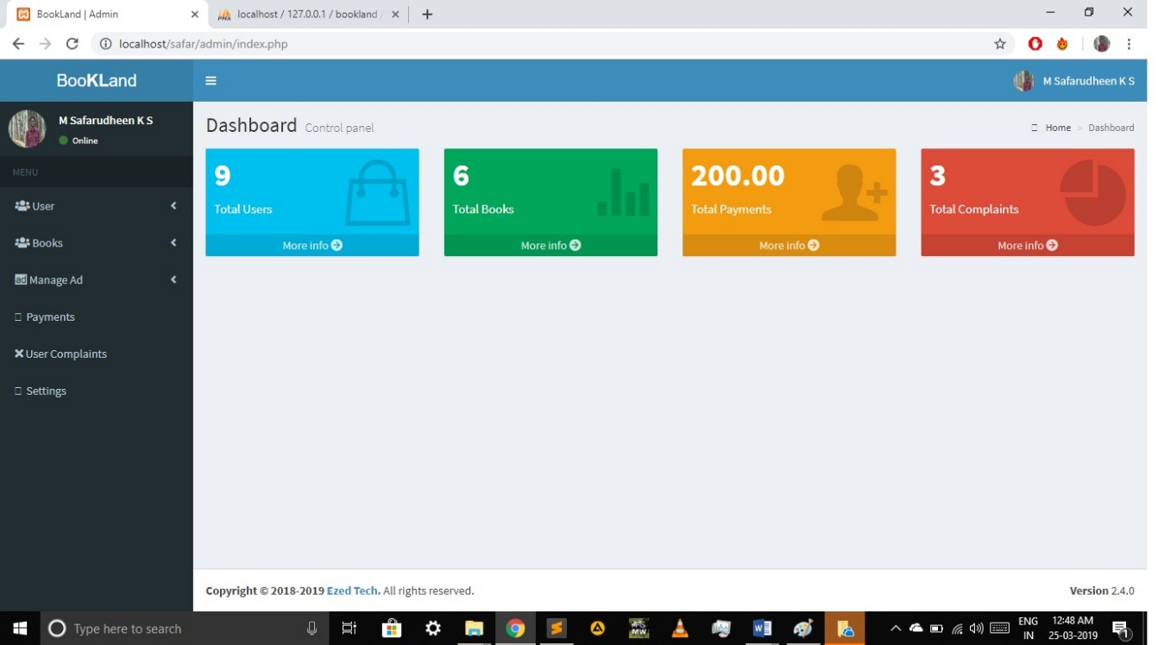**11.1 Sample Input Design**

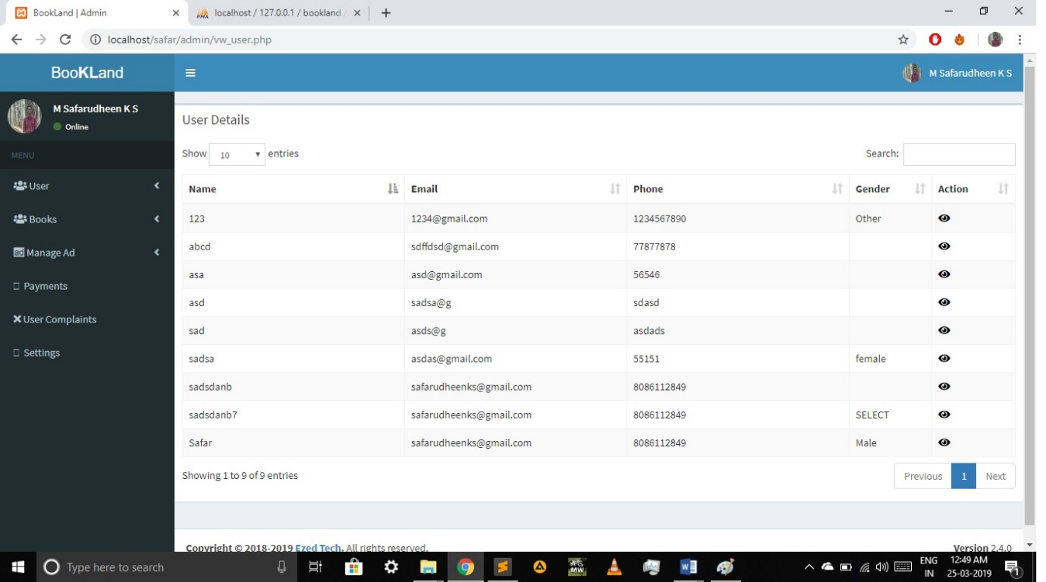

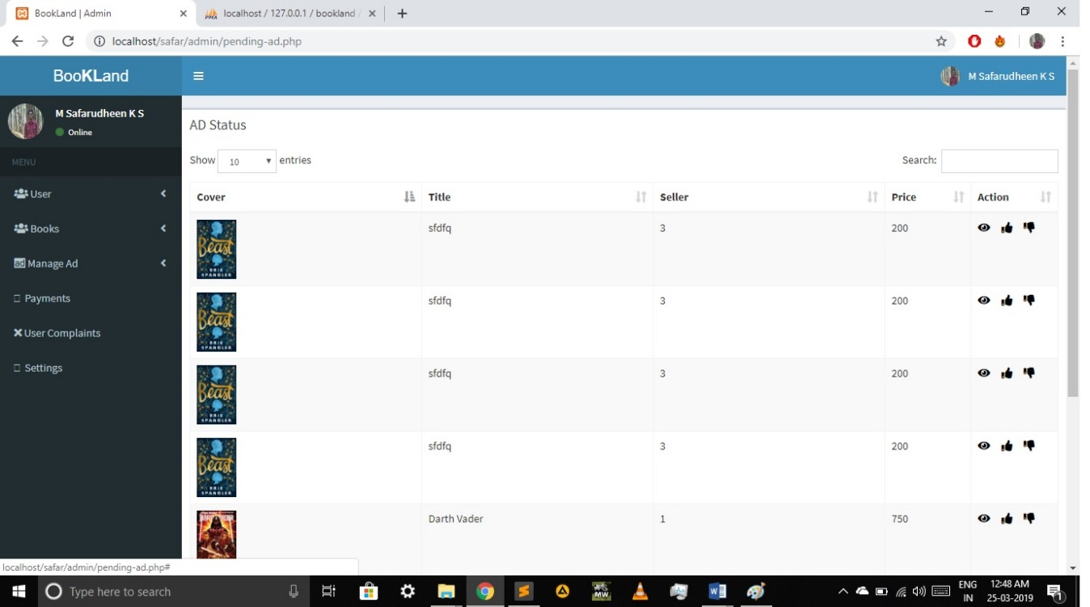

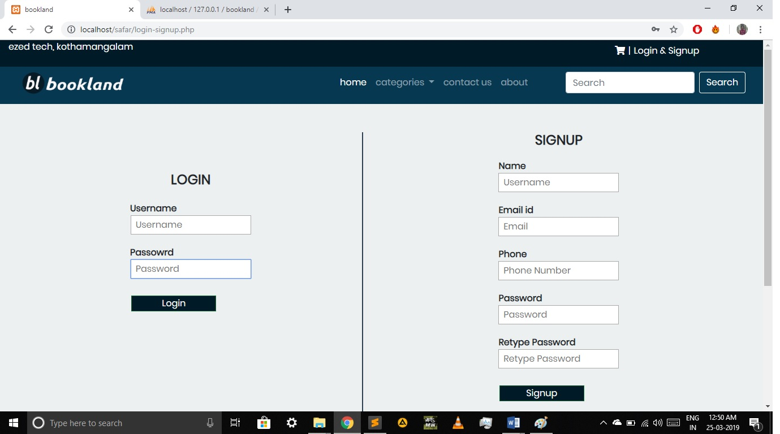**11.2 Sample output Design**

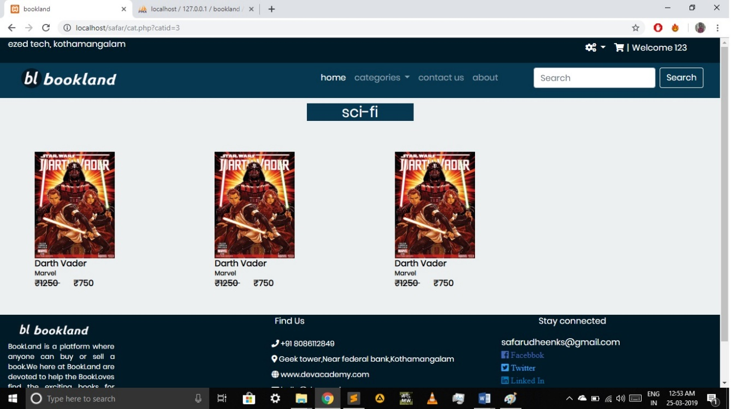

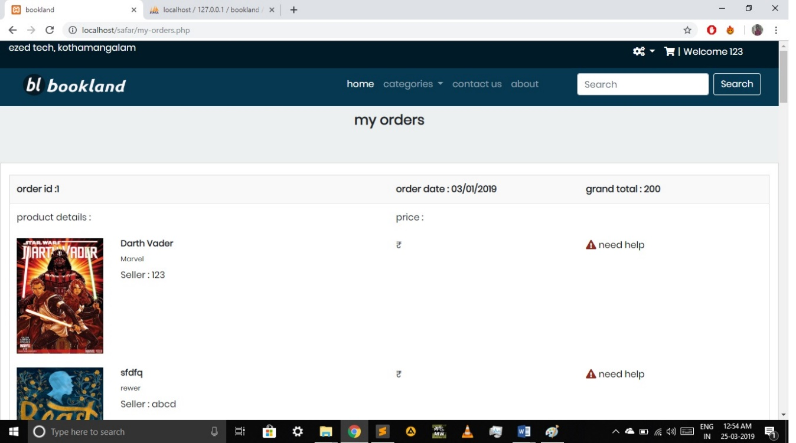

**12. BIBLIOGRAPHY**

**Print Materials**

1. Internet & Web Technologies, Raj Kamal, Tata Mc Graw_ Hill
2. Web Programming, Chris Bates, 3 rd Edition; Pub: John Wiley & Sons
3. Reference Text.HTML Black Book, Steven Holzner, Dreamtech Publishers
4. K K Aggarwal, Yogesh Singh Software Engineering (Third Edition) New Age

International Publications.

1. Ian Sommerville Software Engineering VII th Edition Pearson Education

**Electronic Materials**

**Websites**

1. www.w3schools.com/html
2. www.w3schools.com/css
3. www.w3schools.com/jquery
4. www.w3schools.com/php
5. getbootsrtap.com
6. stcakoverflow.com